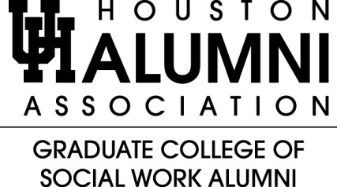

Charlotte Campbell Scholarship Announcement

Ms. Campbell was a committed staff member of our very own Graduate College of Social Work for many years. Due to her long-term dedication to serving students, the Alumni Association and friends of Ms. Campbell are proud to be able to present this scholarship in her name.

Two scholarships, in the amount of $1,000 each, will be awarded for the Spring 2014 semester. The recipients will be acknowledged at the
Annual Social Work Awards Breakfast held in March.

Requirements for the scholarship include:
- A GPA of at least 3.25.
- A minimum of 28 SCH (15 SCH for Advanced Standing students) by December 31, 2012.
- Applicants can be part-time or full-time students.

***Deadline for Applications is December 21, 2013***

Email to receive the application:
Rosalind Rolls
rrrolls1@gmail.com

