2022 UH ENERGY TRANSITION INSTITUTE GRANT PROGRAM APPLICATION FORM

PROPOSAL GUIDELINES

Proposal Submission Deadline
Monday, October 24, before noon (Central Time)
- Combine all files of the completed proposal into a single PDF, name the file LAST_FIRST_2022 where the LAST is your last name and the FIRST is your first name, and email the complete application to ramanan@uh.edu.

OVERVIEW: The UH Energy Transition Institute (UH ETI) was recently launched to lead the transition to a net zero, circular economy by leveraging Houston’s position as a global leader in energy and chemicals, and University of Houston’s role as The Energy University.

Purpose of Proposal: The UH ETI will use a collaborative cross-disciplinary approach to address areas of science and technology, engineering, law, policy and business needed to impact the energy transition. We specifically seek proposals to address four issues:

Circularity of Wind Turbine Blades

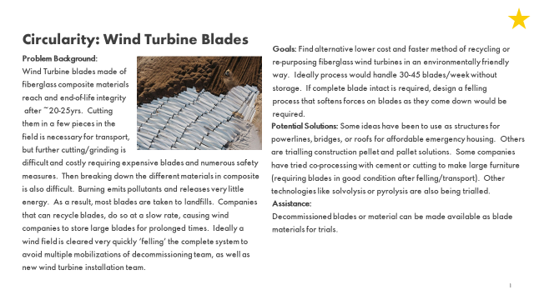

Circularity of Electronics

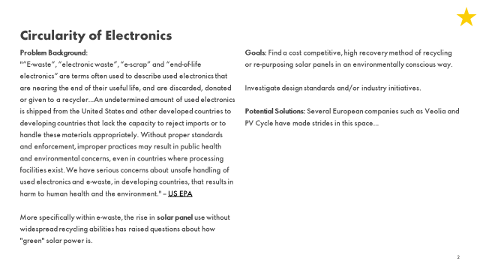

Specification of Carbon Dioxide Quality for Carbon Sequestration Projects

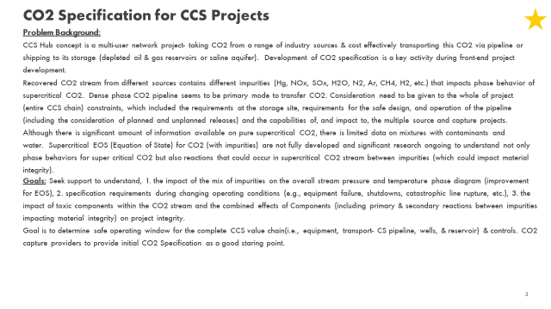

Techno-Economic Assessment of Decarbonization

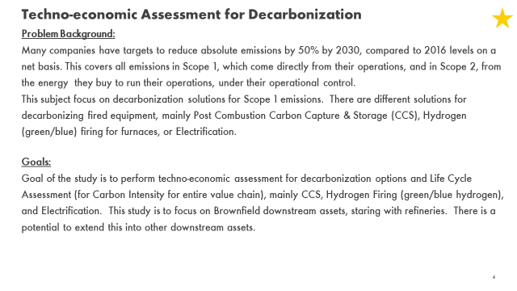
ELIGIBILITY: Full-time tenured or tenure-track faculty and non-tenure track research faculty from UH are eligible to submit proposals. Proposals may include external participants, but external participants may not receive funding from UH ETI.
FUNDING AMOUNT: Grants are limited to $250,000 (typically $80,000) total per proposal (with a funding total across all grants of $250,000). No indirect costs are to be applied. Funds should not be used for the purchase of equipment exceeding $5,000. Up to three grants will be funded under this call for proposals. Funding is contingent on availability of funds.
DURATION: All projects are 18-month projects.
The Center will not support any requests for no-cost extensions for proposals awarded through this mechanism, except for circumstances that would also lead to extension of the tenure clock, such as illness or parenting responsibilities.
EVALUATION: A review panel that includes representatives from the UH ETI Advisory Board and UH will evaluate the proposals based on the criteria provided below. We may require a short list of proposers to make an oral 15-minute presentation. Decisions will be announced prior to November 15, 2022.
We will select proposals based on the:
- Relevance of the proposal to the project descriptions provided above
- Quality of the proposed research
- Experience and track record of investigators
- Appropriateness of the budget request.

Reporting Requirement Grantees must provide short quarterly written progress reports, half-yearly oral presentations, and a final report at the end of the project term. Failure to provide timely reporting will lead to termination of project funding. The grantees must also acknowledge funding from UH ETI in any publications resulting from the research undertaken through this grant.

PROPOSAL FORMAT
Applicants must submit one PDF file of the complete application to ramanan@uh.edu by Noon on October 24, 2022. Late applications will not be considered. Only proposals that meet the criteria for awards, as stated in the guidelines, will be considered and/or reviewed for funding.

COVER PAGE (use attached form)

- PROPOSAL NARRATIVE
Limit to five (5) double-­‐spaced, 12-­‐point font. The following outline should be used for the narrative portion of the proposal and is part of the 5-­‐page limit.
  - Abstract. Provide a brief, clear statement of the purpose and significance of the project (200 words or less, single-spaced).
  - Introduction. Emphasize the importance of the project and summarize previous research in the field.
  - Objectives. Describe the targeted goals and expected outcomes of the project.
  - Approach. Provide details of how the research will be conducted including tasks and timelines associated with tasks.
  - Outcomes and Time Frame. Outline the anticipated outcomes and project schedule. Funds will be available for expenditure for 18 months, beginning November 15, 2022.
  - Progress and Management Reporting. Grantees must provide short quarterly written progress reports, half-yearly oral presentations, and a final report at the end of the project term.
  - Equipment and Facilities. Describe the equipment and facilities available for the project. Justify any equipment requested in your budget.
  - Internal and External Funding. Summarize any prior internal and/or external funding over the previous 48 months that you have received for this area of research. Include project title, amount, sponsor, and project start and end dates.

CURRICULUM VITAE
  - Include vitae for all professional personnel who will work on the project using NSF format. Do not exceed two pages for each individual. The curriculum vitae should list the five most significant publications that relate to the proposed research.
  - Include a list of all current and pending support for each investigator, both external and internal (no page limit).

REFERENCES
1-page limit; references may be single-­‐spaced.

BUDGET
Provide an overall budget and justification for the expenditure of the funds by general category using the attached template. Faculty summer salary is allowed.
Requests for the following will NOT be funded:
- Purchase of computer hardware (e.g. monitors, keyboards, printers, various peripherals).
- Generic computer software for which UH has a license, except for packages directly related to the project such as mathematical toolboxes.
- Graduate student tuition and fees (those costs should be covered by GTF).

Cost center establishment following a successful review process will require congruency review. Additional paperwork may be required to complete the congruency review.

APPENDIX (Optional)
Include attachments or other information that is important for proposal evaluation (1-page limit).

All questions regarding this Grant Program may be directed to
Ramanan Krishnamoorti, ramanan@uh.edu

I. COVER PAGE

PI Name: |  | PI Employee ID#:
PI Department: |  | PI  College:
PI Email: |  | PI Phone:
Co-­‐PI Name: |  | Co-­‐PI Employee ID#:
Co-­‐PI Department: |  | Co-­‐PI  College:
Co-­‐PI Email: |  | Co-­‐PI Phone:
Other Investigators (Include their Dept/College/Email and Phone)
External Partners
(attach letters of collaboration/ recognition)
Project Title:
Total Funds
Requested:
Select Research Area (mark all that apply)
☐ Circularity ☐ Carbon Management
Does this proposal involve (mark all that apply)?
☐ Animals ☐ Human Subjects ☐ Radioisotopes
☐ Research Involving Recombinant DNA Molecules or other biological materials

If so, indicate submission and approval status:

SIGNATURE or E-SIGNATURE
:

Principal Investigator Date

II. OVERALL BUDGET

 | Funds  Requested | Other  Funds** | Total
SALARIES & WAGES
(Identify function)
Faculty Salaries
Research Assistants
Student Wages
Non-­‐Student Wages
FRINGE BENEFITS
MAINTENANCE & OPERATIONS
(Example: chemicals, supplies, services)
TRAVEL
(May be subject to State guidelines)
Equipment (No equipment above $5000 will be supported)
(Specify items over $1,000 each)
TOTAL PROJECT COST
** No matching funds or external funds are required to be shown.
BUDGET JUSTIFICATION: (Justify all costs)

