# Hewlett-Packard Enterprise Data Science Institute Visualization Lab at the

# **University of Houston**

The HPE DSI Visualization Lab is located in room 201 of the Agrawal Engineering Research Building on the University of Houston’s Main Campus. The configurable room has rolling tables and seating for up to 33 people. The room is uniquely designed to support a variety of research, workshops, trainings, and presentation projects. This room design incorporates a “pod” collaboration structure. Each display in the room can be assigned to a breakout group or pod that will allow the members to collaborate in real time on a larger shared display including the Visualization Lab’s large video wall. The pods can work together with multiple devices on any of the room’s displays. The Visualization Lab will support wireless video connections from most devices including laptops and or mobile phones/tablets including Windows, Apple, iOS or Android operating systems. The furniture in the Visualization Lab is all modular and can be configured to support a varied array of scenarios. There is power and Ethernet wired connections available in flush mounted ports in the floor as well as the walls. The Visualization Lab includes dedicated wireless networking (Wi-Fi).

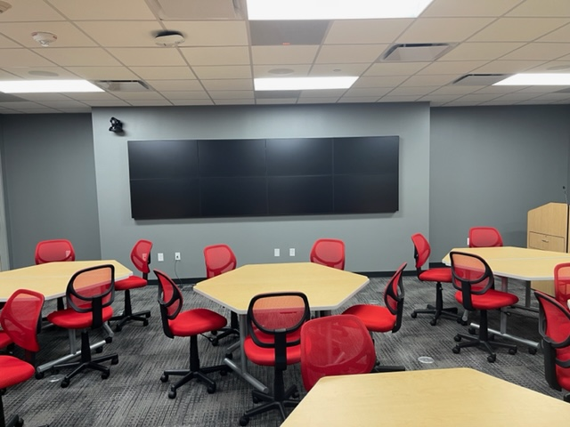

The main presentation display in the Visualization Lab is a Planar Systems LCD Video Wall 4x2 LX46X-L capable of up to an 8K resolution of 7680 x 2160 pixels (Ultrawide 32:9 aspect ratio) across all panels. This video wall can be split into two 2x2 panels that can support 4K UHD resolution screens of 3840 × 2160 pixels each (16:9 aspect ratio). Mounted to the other walls in the Visualization Lab on retractable and adjustable display mounts are four 55” Planar displays. The Planar displays can be used individually for pod collaboration or mirrored to the main video wall. The Visualization Lab has a lectern for the presenter that can control all of the room’s capabilities via large wall mounted touch panel. The Visualization Lab lectern has video source configurations options that include the in-room visualization computer, HDMI connection or wireless video options for users who bring their own devices. The visualization workstation available in the room is an HP Z4 G4 graphics workstation. Audio and Video conferencing is available in the Visualization Lab as well. The Visualization Lab has two mounted cameras with pan, tilt and zoom capabilities. There is a camera located in the front of the Visualization Lab to capture video from attendees as well as one in the back of the room to focus on the presenter. The microphones in the Visualization Lab consist of a mounted microphone on the lectern, a wireless microphone system and in ceiling mounted panel microphones throughout the room with noise cancellation abilities. Visualization Lab audio is controlled from the lectern with ceiling mounted speakers throughout the room.

Visualization Lab technical details

* Planar Systems LCD Video Wall 4x2 LX46X-L up to 7680 x 2160 resolution (Ultrawide 32:9 aspect ratio)
* Visualization workstation HP Z4 G4 workstation with an Intel Core i9 10900X, 64GB of RAM, NVIDIA RTX A4500 Graphics, 1TB M2 SSD drive, and 10GbE network card
* Four recessed and wall mounted articulating Planar SL5564K 55" Class 4K UHD LED displays
* Extron 15" Wall Mount TouchLink Pro Touchpanel
* Extron DTP CrossPoint 108 4K matrix video switcher
* Six ShareLink Pro 500s for wireless video links
* Two Vaddio RoboSHOT® Elite 12E HDBT PTZ cameras for video links
* Shure MX418 Microflex Gooseneck microphone at the podium
* Shure QLX-D wireless microphone system for mobile presenters
* ClearOne BMA CT Ceiling Tile Beamforming Mic Arrays for audience microphones
* Multiple Extron SF 26CT ceiling speakers
* Audio processing through a ClearOne Converge Pro 2 DSP providing next-gen Acoustic Echo Cancellation processing, Distributed Echo Cancellation® on every mic input, Noise Cancellation with Adaptive-Ambience, Acoustic Intelligence with faster convergence, DARETM feedback elimination and advanced microphone gating
* Assistive listening audio is provided by a ListenIR iDSP Level I System LS-90