
uh.edu/factoolkit

Powerhouse Faculty
Benefits and Resources

Office of the Provost
Faculty Recruitment, Retention, Equity and Diversity
University of Houston

Contents
Introduction 4
Recruitment___________________________________________________________________5
Recruitment Workflow _____________________________________________________________________5
Search Committee ________________________________________________________________________6
Job Description ___________________________________________________________________________6
Special Efforts to Identify Women and Underrepresented Minority Applicants ________________________7
Advertisement and Resources ______________________________________________________________10
UH Points of Pride 13
Houston Points of Pride 14
Campus Visit 15
Assessment ____________________________________________________________________________ 15
Evaluation Rubric Templates_______________________________________________________________ 17
Appropriate and Inappropriate Interview Questions 23
Veteran’s Hiring Preference 25
Closing The Deal _________________________________________________________________________26
Benefits and Resources for UH Powerhouse Faculty ________________________________________27
Contact Information __________________________________________________________39 Office of the Provost __________________________________________________________________________39
Office of Equal Opportunity Services 39

Introduction
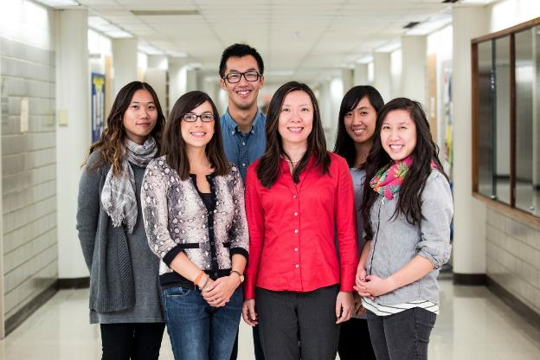
Great universities are comprised of a wide range of faculty members who have developed as a diverse community of teacher-scholars. The University of Houston is poised to become a prominent educational force globally, and as such, holds the responsibility for recruiting and retaining a diverse Powerhouse Faculty that will advance the University’s national competitiveness, student success, and community engagement goals.
The Office of the Provost through its office of Faculty Recruitment, Retention, Equity, and Diversity strives to ensure that the University of Houston recruits and retains excellent and diverse faculty. This is accomplished by partnering with search committees and stakeholders to identify and hire the best talent and making sure it is diverse and representative of the talent pool and the UH student population. This toolkit includes resources, guidelines and practical suggestions that will help make this task more productive and successful.

RECRUITMENT
Recruitment Workflow
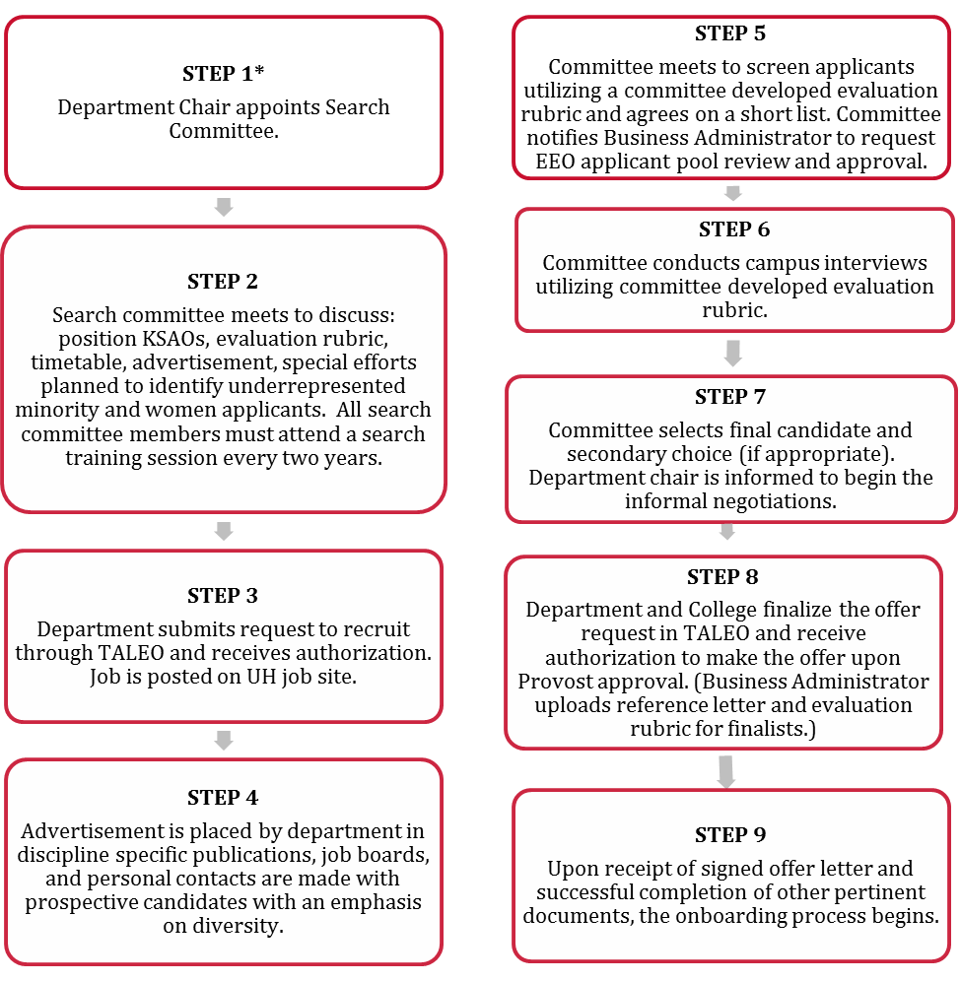

Search Committee

A search committee is an integral part of an effective faculty search process. The committee should be comprised of individuals who understand the requirements of the position and who are committed to the mission and goals of the department and the university. Having a diverse search committee helps in gaining access to and evaluating candidates of different backgrounds, it also makes it less likely that the committee will overlook talented individuals with nontraditional kinds of experiences. Departments and schools with low numbers of women and minority faculty should consider inviting faculty of color and female colleagues from related departments or schools to serve on search committees.
The search committee should be prepared to be proactive and go beyond just placing advertisements and waiting for applications. They will need to energetically seek out promising prospects through their network of colleagues and scholars at other institutions and also explore the numerous online resources to search for PhD students and postdoctoral scholars from groups that are historically underrepresented in higher education.

Job Description
Efforts should be made to define the position in the widest possible terms consistent with the department’s needs. Make sure that the position description does not needlessly limit the pool of applicants. Some position descriptions may unintentionally exclude women or minority candidates by focusing too narrowly on subfields in which few specialize. The committee should establish selection criteria and procedures for screening and interviewing candidates before advertising the position. Examples of candidate evaluation rubrics (Tenure/Tenure-track, Instructional/Clinical, and Research) are available on page 17.

Special Efforts to Identify Women and Underrepresented Minority Applicants
A special effort is a recruitment strategy that specifically targets underrepresented minorities and women. Therefore, a strategy that does not specifically target these groups would not qualify as a special effort. Examples of a special effort would be one where the search committee members deliberately and intentionally solicit applications, nominations, or referrals from:
- Minority and women scholar organizations
- Minority and women scholars/ professionals on- and off-campus
- Women and minority program offices
- Professional caucuses or organizations that are organized around women or minority concerns
- Internet discussion groups
- Community agencies related to underrepresented groups
- Meetings of professional organizations
- Journals targeted at women and minority readerships
- Ethnic Studies departments (for relevant disciplines)
- Minority and women doctoral or post-doctoral directories
- Departments in HBCUs and other predominantly minority institutions
Listed below are examples of special efforts:

Example 1: Women and minority candidates will be encouraged in all advertisements, which will appear in highly visible publications that are specifically marketed to minority audiences and those with extensive national and international circulations. In addition, women and minority applicants will be identified via position announcements circulated to all schools and colleges of Optometry and via personal contacts with leaders in the field of eye care. The members of the Faculty Recruitment and Search Committee, as well as the faculty at large, will be solicited to nominate underrepresented minorities and women for consideration.
Example 2: The department will send an announcement that encourages women and minority candidates to apply to all Engineering Department Chairs including minority serving universities. The department will also post the ad on the National Society of Black Engineers, Society of Hispanic Professional Engineers, and the Society of Women Engineers online job boards.
Example 3: Special efforts will be made by asking colleagues to help identify women and minority candidates; distributing the advertisement specifically to women and minority leaders; and searching resume banks of organizations targeting women and underrepresented minorities.

Advertisement and Resources

REQUIRED LANGUAGE FOR POSITION ANNOUNCEMENTS
UH Position Announcements must include:

- The University’s Equal Employment Opportunity and Affirmative Action Policy statement.

“The University of Houston is an equal opportunity/affirmative action employer. Minorities, women, veterans and persons with disabilities are encouraged to apply.”

- Dual Career statement.

“The University of Houston is responsive to the needs of dual career couples.”

PROACTIVE DIVERSITY LANGUAGE

Research indicates that there is a positive correlation between including proactive diversity language and the diversity of the applicant pool. “Adding an explicit criterion in the job description for experience and success in working with diverse groups of students has significant potential to broaden the qualities being considered.” (Smith et al, 2004). The diversity of the UH student body demands that job descriptions stress experience in teaching different kinds of students as well as skill in developing classroom environments that facilitate learning for all students.
Proactive language can be included as a specific job qualification or as a summary statement at the end of job announcements. Examples of proactive language include the following:
- The University of Houston, with one of the most diverse student bodies in the nation, seeks to recruit and retain a diverse community of scholars.
- We welcome candidates whose experience in teaching, research, or community service has prepared them to contribute to our commitment to diversity and excellence.
- Individuals with a history of and commitment to mentoring students from underrepresented minorities are encouraged to apply.
- The department is seeking outstanding candidates with the potential for exceptional research, excellence in teaching, and a clear commitment to enhancing the diversity of the faculty, graduate, and undergraduate student population.
- A demonstrated commitment to improving access to higher education for disadvantaged students through teaching or mentoring activities is desired.
- The Department is particularly interested in candidates who have experience working with students from a diverse background and a demonstrated commitment to improving access to higher education for disadvantaged students.
- Experience in mentoring women and minorities in STEM fields is desired.
- The University of Houston is an ADVANCE institution, one of a select group of universities in receipt of National Science Foundation funds in support of our commitment to increase the number and success of women faculty in the STEM fields.
- The University of Houston is responsive to the needs of dual career couples.
POSTING THE JOB ANNOUNCEMENT
Circulating ads in traditional scholarly publications remains useful but can result in a relatively homogenous pool of applicants. To enlarge the applicant pool, consider posting ads in a variety of publications and on listservs, job boards, websites, or social media sites of relevant professional organizations, including those aimed specifically at underrepresented minorities and women. This should not only help enlarge the potential pool of applicants, but also help convey the department’s commitment to diversity, equity, and inclusion.
UH faculty jobs are automatically posted on 6 websites: UH website, Chronicle of Higher Education, INSIGHT Into Diversity, Texas Workforce Commission, Higher Education Recruitment Consortium (HERC), Indeed and Glassdoor.

Dual-Career Program
Recognizing dual-career partner assistance is a crucial element in recruiting and retaining excellent faculty, the University of Houston has established a program that offers assistance to qualified couples. The UH Dual-Career Program is a partnership between the departments, deans, the Provost’s Office and the broader community. The program is administered by the Office of Faculty Recruitment, Retention, Equity and Diversity.
Although there is no guarantee of job placement, we will help facilitate the job search process at UH and in the local community. Career searches are most successful when the partner takes a great deal of initiative. Spouses/domestic partners are urged to conduct an active job search, using the Dual-Career Program.
The Dual-Career Program applies to the spouse/domestic partner of an individual who has either accepted a tenure/tenure-track faculty position or who is selected to receive an offer for a tenure/tenure-track faculty employment. Due to resource constraints, dual-career support can only be provided for spouses/domestic partners of individuals who are selected to receive an offer or who have accepted an offer, but not for individuals who are among multiple finalists.
UH commits to making every effort to assist with the employment search for spouses/domestic partners of recruited candidates.
- We encourage spouses/domestic partners to be open to a host of employment settings and locations across the Houston area to enhance the likelihood of a successful placement.
- The program does not create any entitlement or contractual rights to employment or to a particular type of position on campus or off campus.
- Career searches are most successful when the spouse/domestic partner takes an active role in the job search both with the assistance offered by UH and independently.
Basic Principles:
- Must be an appropriate fit between spouse/domestic partner's qualifications and position.
- Academic positions offers for spouses/domestic partners are only extended if strong support exists in target unit or department.
- In the case of internal hires, the spouse/domestic partner hire must comply with UH policies and receive all appropriate approvals.
- UH will provide search support, but is unable to guarantee placement.
Process:
- Departments encourage candidates to disclose whether their spouse/domestic partners will be in need of dual career support. Without this disclosure the process cannot be activated.
Partner Seeking Faculty/Academic Positions:
- Once a candidate is selected as the finalist for a position and extended an offer, the department chair is responsible for contacting the Office of Faculty Recruitment, Retention, Equity and Diversity with any questions and to initiate the search at 713-743-3213 or fac-rred@uh.edu.
- The spouse/domestic partner will provide information regarding their academic background and job experience utilizing the online Dual Career Program Request form https://uhacademicaffairs.co1.qualtrics.com/jfe/form/SV_6YJbMSzT8nhQTnT
- The Office for Recruitment, Retention, Equity and Diversity reviews the completed form and contacts the spouse/domestic partner to schedule a consultation session.
- Under circumstances defined by the Provost, the Provost will provide funding on a case by case basis for a spousal/domestic partner hire in a Tenure/Tenure-track position, if the hire meets the receiving unit criteria, and if funds are available and the unit faculty are in agreement with the hire.
- 'Bridge' funding of a position for a preliminary period may be possible if relevant Deans provide necessary support.
- The Greater Houston area has 14 major institutions of higher learning. UH has partnerships with many of these institutions and will continue to expand on these partnerships. The Assistant Provost for Recruitment, Retention, Equity and Diversity will assist with disseminating the spouses/domestic partners’ credentials to partner institutions.
- This policy only applies during twelve-month period after a new faculty member is offered a position.

Partner Seeking Staff Positions On-Campus:
- Spouses/domestic partners seeking a staff position on-campus are encouraged to explore and apply for on-campus staff positions that match their skill set utilizing UH’s job web portal.
- Once a candidate is selected as the finalist for a position and extended an offer, the department chair is responsible for contacting the Office of Faculty Recruitment, Retention, Equity and Diversity with any questions and to initiate the search at 713-743-3213 or fac-rred@uh.edu.
- The spouse/domestic partner will provide information regarding their academic background and job experience utilizing the online Dual Career Program Request form https://uhacademicaffairs.co1.qualtrics.com/jfe/form/SV_6YJbMSzT8nhQTnT
- The Office for Faculty Recruitment, Retention, Equity and Diversity reviews the completed form and resume and contacts the spouse/domestic partner to schedule a consultation session.
Partner Seeking Positions Off-Campus:
- Once a candidate is selected as the finalist for a position and extended an offer, the department chair is responsible for contacting the Office of Faculty Recruitment, Retention, Equity and Diversity with any questions and to initiate the search at 713-743-3213 or fac-rred@uh.edu.
- The spouse/domestic partner will provide information regarding their academic background and job experience utilizing the online Dual Career Program Request form https://uhacademicaffairs.co1.qualtrics.com/jfe/form/SV_6YJbMSzT8nhQTnT
- The Office for Faculty Recruitment, Retention, Equity and Diversity reviews the completed form and resume and contacts the spouse/domestic partner to schedule a consultation session.
The University of Houston is a member of the South-Central-Gulf Texas Higher Education Recruitment Consortium (HERC), which is a non-profit consortium of colleges and universities. One of HERC’s primary goals is to help the spouses/domestic partners of faculty and staff members to secure employment. They have a web-based search engine that is free and includes faculty and staff job listings at all 19 Greater Houston member institutions.
For additional information, please contact the Office of Faculty Recruitment, Retention, Equity, and Diversity at 713-743-3213 or fac-rred@uh.edu.

UH Points of Pride


Please let the prospective UH Powerhouse Faculty know that The University of Houston is more than a Carnegie-designated Tier One public research university; we are a community of groundbreakers and innovators. We are marketplace leaders. We are thought provokers. We are transforming education. This is Cougar nation.
- The University of Houston is ranked as the second most ethnically diverse major research universities in the United States (U.S. News & World Report, 2018).
- Ranked among Best colleges in the United States (U.S. News & World Report, 2017, 2018).
- #2 on Top 25 Best Undergraduate Programs for Entrepreneurship (The Princeton Review, 2018).
- One of “Best Engineering Schools” (U.S. News & World Report, 2017, 2018).
- University of Houston is designated a Hispanic Serving Institution.
- University of Houston is designated an Asian American and Native American Pacific Islander-Serving Institution.
- University of Houston (Bauer) is ranked No. 85 (tie) in Best Business Schools. Schools are ranked according to their performance across a set of widely accepted indicators of excellence (U.S. News & World Report, 2018).
- 3 Law School Programs ranked in the Top 10 (U.S. News & World Report, 2018).
- Students come to UH from more than 137 nations and from across the world.
- University of Houston is ranked #5 in Best Online Graduate Education Programs. Schools are ranked according to their performance across a set of widely accepted indicators of excellence (U.S. News & World Report, 2018).

Houston Points of Pride

Please let the prospective UH Powerhouse Faculty know that Houston, the country’s fourth largest city with 2.3 million residents, is a vibrant, international community committed to cultural and commercial progress, with an extraordinary mix of world-class arts, affordable housing, excellent school districts, booming business, diverse population and a time-honored spirit of enterprise.
- Houston has more than 500 cultural, visual and performing arts organizations, 90 of which are devoted to multicultural and minority arts and is one of five U.S. cities that offer year-round resident companies in all major performing arts.
- More than 145 languages are spoken throughout the Houston area.
- With more than 10,000 restaurants, representing over 70 countries and American regions, to choose from, Houston has you covered with a variation of eateries.
- 92 countries have consular offices in Houston, the third highest in the nation.
- It is the fourth most populous city in the nation with about 2.3 million residents.
- Houston has an underground pedestrian tunnel system.
- Houston has professional teams representing football, baseball, men’s basketball, and men and women’s soccer.
- Third-largest Hispanic and third-largest Mexican population in the United States.
- Houston boasts more than 40 colleges, universities and institutions - offering higher education options to suit all interests.
- Houston is home to the Texas Medical Center, the largest medical center in the world, with a local economic impact of $20 billion. More than 106,000 people work within its facilities, which encompass 50 million square feet. Altogether 4.8 million patients visit them each year.
- When comparing Houston's economy to a national economy, only 21 countries excluding the United States have a gross domestic product exceeding Houston's regional gross area product.

- Houston ranks second in employment growth rate and fourth in nominal employment growth among the 10 most populous metro areas in the U.S.
- Home to over 5,000 energy related firms, Houston is considered by many as the energy capital of the world.
- Houston's economy has a broad industrial base in the energy, aeronautics, and technology industries: only New York City is home to more Fortune 500 headquarters.

Campus Visit
Campus visits are a critical step in the evaluation and selection process for the hiring department and in the decision-making process for candidates. Therefore, it is important to make the interview experience as positive as possible. In a competitive recruitment environment, it is important to consider all aspects of the candidate’s visit: the accommodations; transportation; free time to see the campus and community; a well-scheduled interview day; well-attended seminar; pleasant meals; and an opportunity for them to get questions answered about UH research and teaching programs, as well as the city of Houston. With thoughtful planning, a campus visit can provide adequate opportunities to gather information about and provide information to the candidates.

Assessment
There is more than one appropriate approach to assess applicants, and it may be useful for the search committee to conduct multiple levels of screening. Typically the initial screening will be for the minimal, objective qualifications that are gleaned from the application and the vita (e.g. highest degree). Thereafter, screening interviews may be conducted (via Skype) to further assess candidates before determining which candidates will be invited for a campus interview. Whatever approach is adopted, the following guidelines should be adhered to:
- The evaluation of applicants should be objective and equitable, based solely on the qualifications that are noted in the position description.
- The utilization of an evaluation rubric to ensure that all candidates are subject to the same evaluation criteria, and to ensure that members of the search committee apply section criteria consistently. Listed below are evaluation rubric templates that the committee members can modify as necessary for their own use.
- All candidates should be asked the same initial questions, with follow-up questions as needed to clarify the applicant’s experience or qualifications as related to the initial question.
- Everyone participating in the interview process should be made aware of the interview questions that are either illegal to ask, or otherwise raise a risk of creating a legal claim.
- All interview methods should be consistent for each candidate that the committee screens. For example, if the first round of interviews are conducted via Skype, conduct all interviews via Skype regardless of the geography of any candidate.

Evaluation Rubric Templates

Evaluation Rubric Template- Tenure/Tenure-track Faculty Search 2018
Candidate_____________________________ Rate________________________________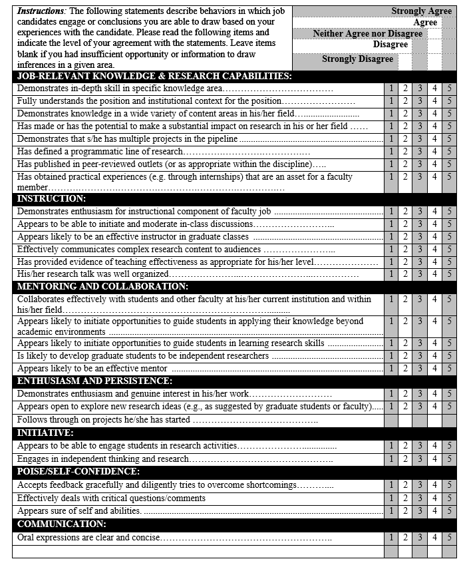

Evaluation Rubric Template - Tenure/Tenure-track Faculty Search 2018
Candidate ________________________________ Rater_______________________________
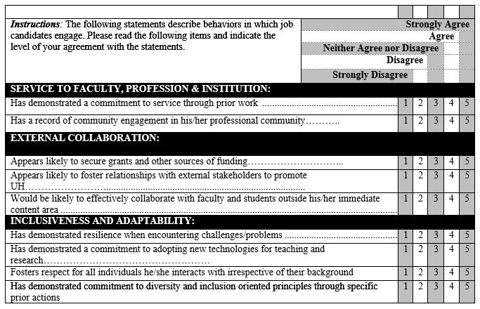OVERALL ASSESSMENT – An evaluation of the candidate’s overall performance and prediction of their future contribution as a faculty member at UH. Please indicate the extent to which you recommend hiring this candidate by circling the appropriate number.

1 2 3 4 5 6 7 8 9 10
Definitely Definitely
Not Hire Hire

What factors, in addition to those above, support the hiring of this candidate?

______________________________________________________________________________

What factors, in addition to those above, do not support the hiring of this candidate?

______________________________________________________________________________

What type of contact did you have with the candidate? (Check all that apply):

__Transportation __Meal/Dining __Poster Session

__Job Talk __Informal Conversation __Interview __Other

Evaluation Rubric Template - Instructional/Clinical Faculty Search 2018
Candidate ________________________________ Rater_______________________________
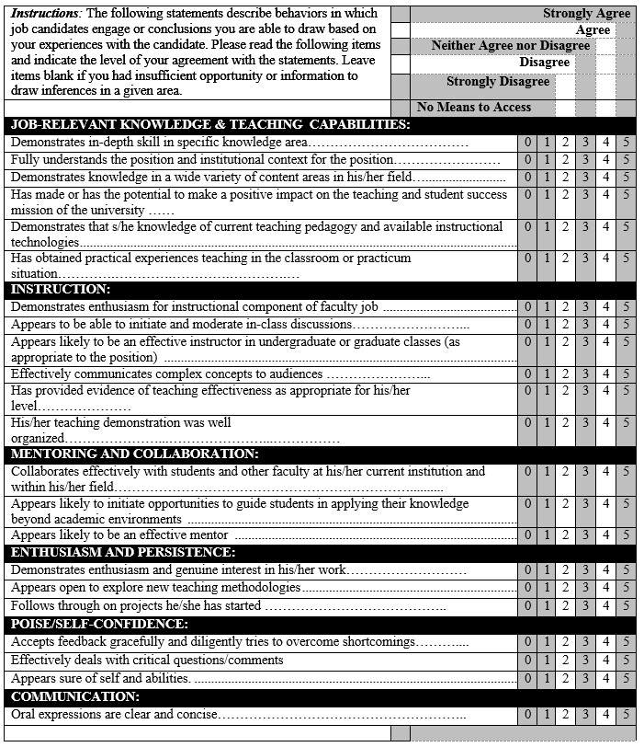

Evaluation Rubric Template - Instructional/Clinical Faculty Search 2018
Candidate ________________________________ Rater_______________________________
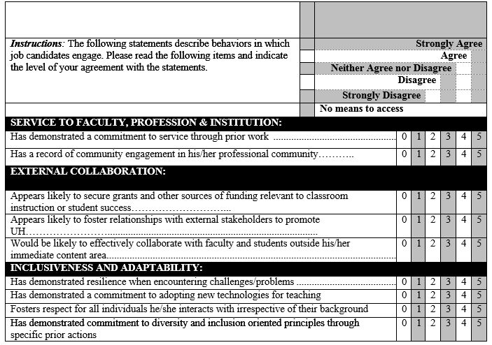OVERALL ASSESSMENT – An evaluation of the candidate’s overall performance and prediction of their future contribution as a faculty member at UH. Please indicate the extent to which you recommend hiring this candidate by circling the appropriate number.

1 2 3 4 5 6 7 8 9 10
Definitely Definitely
Not Hire Hire

What factors, in addition to those above, support the hiring of this candidate?

______________________________________________________________________________

What factors, in addition to those above, do not support the hiring of this candidate?

______________________________________________________________________________

What type of contact did you have with the candidate? (Check all that apply):
__Transportation __Meal/Dining __Poster Session

Evaluation Rubric Template - Research Faculty Search 2018

Candidate ________________________________ Rater_______________________________
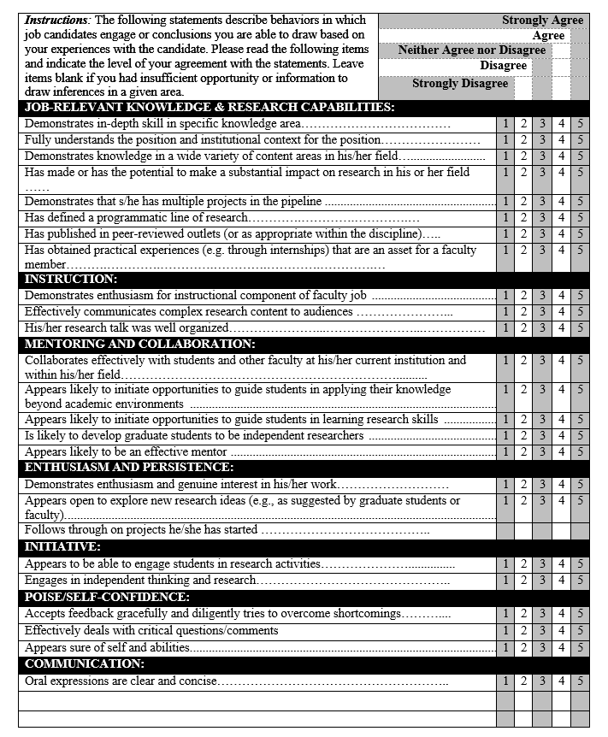

Competency Assessment Form- Research Faculty Search 2018
Candidate ________________________________ Rater_______________________________
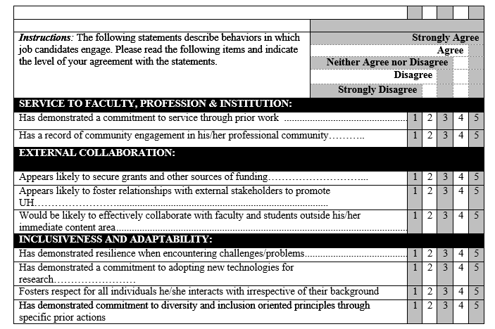OVERALL ASSESSMENT – An evaluation of the candidate’s overall performance and prediction of their future contribution as a faculty member at UH. Please indicate the extent to which you recommend hiring this candidate by circling the appropriate number.
1 2 3 4 5 6 7 8 9 10
Definitely Definitely
Not Hire Hire

What factors, in addition to those above, support the hiring of this candidate?

____________________________________________________________________________

What factors, in addition to those above, do not support the hiring of this candidate?

____________________________________________________________________________

What type of contact did you have with the candidate? (Check all that apply):

__Transportation __Meal/Dining __Poster Session

__Job Talk __Informal Conversation __Interview __Other

Appropriate and Inappropriate Interview Questions

Rules to Remember
- Ask only what you need to know, not what you would like to know.
  - Need to know: affects the day-to-day requirements of the job.
  - Like to know: does not pertain to the job, usually personal in nature.
- If you have any questions about the appropriateness of the question, don’t ask it.
- If you ask a question to one candidate, you must ask the question to ALL candidates.
Subject | Inappropriate | Appropriate
AGE | Questions about age, dates of attending school, dates of military service, request for birth certificate. | Questions about age are only permitted to ensure that a person is legally old enough to do the job.
ARREST RECORD AND CONVICTIONS | Questions about arrests, pending charges and convictions that do not relate substantially to the job.  Example: Have you ever been arrested?
CITIZENSHIP | Any question about citizenship.  Examples: Are you a U.S. Citizen? Where were you born? Are you an American? What kind of name is that? | May ask about legal authorization to work in a specific position, if all applicants are asked.
DISABILITY | Questions about disability are not appropriate.  Examples: Do you have a disability? What is the nature or severity of your disability? Do you have a health condition? Do you require accommodations? | Questions about ability are appropriate.  Example: Are you able to perform the essential functions of this job with or without accommodations?
FAMILY OR MARITAL STATUS | Any inquiry about marital status, pregnancy, children, or child care plans. | Questions about whether an applicant can meet work schedules or job requirements if asked of all candidates, both men and women.
HEALTH | Any question about health.  Examples: How is your health? How is your family’s health? | None.
NAME | Questions about national origin, ancestry, or prior marital status.  Examples, What kind of name is that? Is that your maiden name? | May ask about current legal name.  Example, Is additional information, such as a different name or a nickname necessary in order to check job references?
NATIONAL ORIGIN | Any questions about national origin or citizenship.  Examples: Are you legally eligible to work in the U.S.A.? Where were you or your parents born? What is your native language? | May ask if legally authorized to work in this specific position, if all applicants are asked this question.
ORGANIZATIONS | Inquiries about membership in organizations that might indicate race, sex, religion, or national origin. | Inquiries about membership in professional organizations related to the position.
RACE, COLOR, HEIGHT, WEIGHT | Questions about complexion, color, height, or weight. | None.
SEXUAL ORIENTATION | Any question about sexual orientation.  Examples: Are you gay? Why do you wear an earring? | None.
Source: Fine, E., & Handelsman, J. (2012). Searching for excellence and diversity: A guide for search committees. WI: WISELI. (p. 98-99)

Veteran’s Hiring Preference
In compliance with Texas State Senate Bill (S.B.) 805, the University of Houston is committed to providing a preference in employment to eligible veterans, disabled veteran, surviving spouse/domestic partner of veteran and orphan of veteran applicants who meet minimum qualifications and any special qualifications for the position to which they apply. The required preferences do not compel the University to appoint a veteran, disabled veteran, surviving spouse/domestic partner of a veteran or orphan of a veteran. However, they do require that those who meet the veteran preference eligibility be appointed when their application assessment, combined with the veteran's preference, is equal to, or higher than that of a non-veteran.

Who's covered?
A person who served in the active military, naval, or air services (including Air National Guard and National Guard) and who was discharged or released under honorable conditions only or who later received an upgraded discharge under honorable conditions, notwithstanding any action by the United States Department of Veterans Affairs on individuals discharged or released with other than honorable discharges.
- a veteran with a disability whose disability is service connected;
- a veteran;
- a veteran's surviving spouse/domestic partner who has not remarried; and
- an orphan of a veteran if the veteran was killed while on active duty.
Is there a special interview process for veterans who qualify for this preference?
An individual who qualifies for a Veteran's Preference in employment is entitled to a preference in the interview process over other applicants for the same position who do not have a greater qualification. However, the Veteran's Preference statute does not guarantee the veteran (or those who qualify) a job. Positions at the University of Houston are filled with the best qualified candidate as determined by the hiring manager.
Also, please note that all offers of employment are tentative and based upon successful completion of a background check. As such, all individuals who qualify for a Veteran's Preference and are extended a job offer will be required to provide a copy of his or her DD214 (or equivalent certification from the Department of Veterans Affairs) as part of the background check.
For more details or questions regarding the Veteran's Preference in Employment, please contact our Veteran's Employment Liaison in Human Resources:
MJ Jackson
(713) 743-0339
majacks8@central.uh.edu

CLOSING THE DEAL
The University of Houston has a great deal to offer. In addition to competitive salaries, candidates will be impressed with the wide range of resources and benefits that are available at UH and in Houston.
- Take all reasonable measures to speed up the search process by effectively managing the request for offer process, so offers can be made in a timely fashion.
- If for any reason, the department cannot respond to the final candidate in a timely manner, maintaining communication with them is critical.
- After the new faculty member is hired, members of the search committee should make them feel welcome by introducing them to other colleagues and check-in ever so often.

Benefits and Resources for UH Powerhouse Faculty
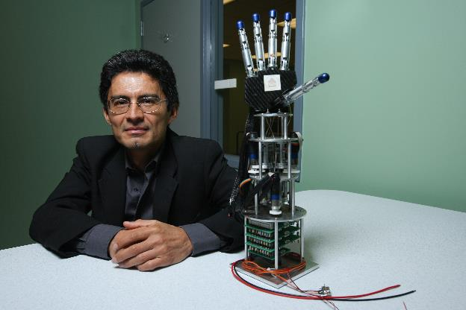
The University of Houston Powerhouse Faculty enjoy a number of both personal and professional benefits. As university employees, they are offered an excellent benefits package, which includes medical, dental, life, accident, short-term disability, long-term disability, and short-term disability, long-term care insurance and flexible spending accounts. Optional benefits include accident, cancer, critical illness and hospital protection plans as well as universal life with long-term care. Medical coverage is provided through Employees Retirement System of Texas (ERS) at no cost to full-time benefits eligible faculty and staff. Dependent medical coverage and other insurance coverage are available at group rates. Effective June 26, 2015, same-sex spouse/partners and dependent children of those spouse/partners became eligible for medical/dental and life insurance coverage. Progressive policies are in place to assist faculty men and women who become parents. UH offers a variety of tax-deferred and post-tax retirement savings options, and numerous resources to support your overall well-being.
In addition to the personal benefits noted above, there are professional resources and benefits that may influence a prospective Powerhouse Faculty member’s decision to accept a position at UH. At the University of Houston they will have access to a world-class library and research facilities, technology and graduate student assistance, and numerous programs to help orient them as new faculty members.
Please see the following link http://www.uh.edu/provost/faculty/ for a listing of benefits and programs that are summarized below to help search committees market the University of Houston to job candidates.

Professional Development
Office of Faculty Engagement and Development (FED) http://www.uh.edu/provost/faculty/current/fed/ FED provides resources to support growth in teaching proficiency and effectiveness, successful faculty career progress, research productivity, and service to the University. Professional development is supported at all stages of faculty careers and for all faculty groups, including actively promoting existing opportunities for professional development.
Provost's Travel Fund http://www.uh.edu/provost/faculty/current/grants/ A source of support for Tenured/Tenure-track faculty and librarian travel when presenting peer-reviewed work at important professional meetings.
Global Faculty Development Fund http://www.uh.edu/provost/faculty/current/grants/global-fund/ This Provost initiative helps faculty to defray the costs of engaging in innovative global activities.

National Center for Faculty Development and Diversity (NCFDD) http://www.uh.edu/provost/faculty/current/fed/services/ncfdd/ A source of support to faculty providing professional development, training, and mentoring. The services are provided by highly trained and successful mentors that offer a confidential “safe space” for problem solving and can be accessed 24 hours a day, 7 days a week, 365 days a year. It’s all about learning the secrets to increasing your research productivity, getting control of your time, and living a full and healthy life.

Cougar Chairs Leadership Academy (CCLA) http://www.uh.edu/provost/faculty/current/ccla/
CCLA is dedicated to developing a network of problem solvers in all UH departments who will work together to produce and sustain high quality programs through the leadership of faculty.

Provost Visiting Scholars Program http://www.uh.edu/provost/faculty/current/grants/visiting-scholars/ Supports visits by faculty who are potential candidates for current or future faculty hires, and contributes to increasing Tier One excellence, student success, and equity and diversity at UH.

Learning and Talent Development (LTD) http://www.uh.edu/human-resources/LTD/ The Department of Human Resources’ Learning and Talent Development unit offers staff and faculty classes and resources on leadership and management.

Faculty Awards http://www.uh.edu/provost/faculty/current/awards/ The Office of the Provost is proud to sponsor a number of awards for faculty, with the vision of promoting and recognizing excellence at the University of Houston.

Magna Commons http://www.uh.edu/provost/faculty/current/fed/services/magna-commons/
This online tool provides access to a cloud-based professional development resource for faculty and administrators.

Research
The Office of Research Development (ORD) http://www.uh.edu/research/about/organization/ ORD advances research by identifying relevant funding opportunities for faculty; working with research teams to successfully apply to opportunities; providing workshops and resources on grantsmanship; and seeking collaborative opportunities across local, regional and national entities for faculty.
Office of Contracts and Grants (OCG) http://www.uh.edu/research/about/organization/ocg/
The Office of Contracts and Grants (OCG) assists faculty in submitting proposals and managing their awards. As such, OCG plays a role in helping the University fulfill its research, instruction and public service missions. OCG Post-Award negotiates and accepts awards, communicates sponsor terms and conditions to faculty, establishes cost centers, assists with submission of progress reports, approves expenditure reallocations, assists faculty with financial monitoring of the sub-recipient, and assists with general award management. OCG Research Financial Services handles billing, financial reporting, and effort reporting and closeout for sponsored projects.
Office of Policies, Compliance and Committees (ORPCC) http://www.uh.edu/provost/faculty/current/benefits/research/ ORPCC works with faculty to ensure compliance with federal regulations in areas concerning human subjects, animal subject, conflicts of interest, grant congruency, and responsible conduct of research. ORPCC conducts congruency reviews prior to award set up (verification of IRB, IACUC, COI, safety approvals).
Office of Tech Transfer and Innovation http://www.uh.edu/research/tech-transfer/ip/ The Office of Tech Transfer and Innovation manages patents, copyrights and trademarks, and works with faculty and the Intellectual Property Committee to file patents for inventions. The principal goal is to foster research and scholarship through the effective transfer of University-wide technology to industry.
Animal Care Operations (ACO) http://www.uh.edu/research/about/core-facilities/aco/ ACO provides professional veterinary and husbandry services to support animals used in biomedical and behavioral research, including the maintenance of standards for animals, facilities, equipment and procedures. ACO provides such services to faculty, such as animal procurement, training, veterinary consultation in research design, transportation of animals and veterinary care. ACO also provides professional veterinary medical, husbandry and proposal review services to support animals used in biomedical research.

Teaching
Faculty and Departmental Instructional Support (FDIS) http://www.uh.edu/fdis/ FDIS provides professional support services to the University of Houston faculty community with guidance in the use of technology needed in the online environment as well as in the traditional classroom.
Innovative Teaching http://www.uh.edu/fdis/grants/tip-grant/ Innovative Teaching includes funding resources such as Teaching Innovation Program (TIP), a grant award opportunity for departments to develop and implement a plan for new and innovative approaches to teaching in the online and hybrid environments. The Provost and Office of Academic Affairs is committed to providing resources and support to departments and faculty who can present a collaborative and innovative plan for accomplishing the TIP program objectives.
Learning Opportunities http://www.uh.edu/fdis/faculty-learning-opportunities/index.php The FDIS office provides the consultations, workshops, and knowledge base services to UH faculty or graduate teaching assistants.
UH Writing Center http://writingcenter.uh.edu/ The UH Writing Center staff can assist in designing discipline-specific writing assignments that effectively communicate your expectations, developing rubrics that ensure workable feedback and reduce the grading workload, and training TAs on an individual and departmental basis.
UH Libraries http://libraries.uh.edu/services/ The UH Libraries offers services such as teaching support, course reserves, distant education support, off campus access, open educational resources and research services.
Libraries' Technology Training Program http://libraries.uh.edu/services/training/ Offers free technology courses. Classes are offered year-round.
UH Bookstore https://uh.bncollege.com/webapp/wcs/stores/servlet/BNCBHomePage?storeId=19067&catalogId=10001&langId=-1 The UH Bookstore offers Faculty Enlight which makes it easier for faculty to research, discuss, discover, and adopt learning materials.
University Information Technology (UIT) http://www.uh.edu/infotech/services/facilities-equipment/ UIT offers classroom equipment, telephone service, and video conferencing assistance.
Dean of Students (DOS) http://www.uh.edu/dos/ The DOS office is available to help faculty promote positive behavior in the classroom. The office aims to help students chart a path toward success, overcoming barriers as they arise and ensuring that the proper support services are being utilized as needed. The Office also provides Student Advocacy Services and is dedicated to helping students find answers and resolutions to any barriers to their success. Faculty and staff can refer students to the Dean of Students office or advocacy@uh.edu.
Center for Students with DisABILITIES (CSD) http://www.uh.edu/csd CSD provides individual and departmental consultation and assistance to faculty and staff regarding student ADA accommodations and disability-related issues. CSD offers faculty and staff customized training on working with students who have disabilities. The services and resources include a dedicated testing center, adaptive equipment, and computer labs.
Veteran Services Office www.uh.edu/veterans Veteran Services is a hub for info and services that address the needs and concerns of our nation’s Military, Veterans and their dependents who attend UH. Veteran Services has a wealth of knowledge and resources that can assist faculty in the classroom to support Veterans.

DIVERSITY RESOURCES:
Center for Advancing UH Faculty Success http://www.uh.edu/advance/ The University of Houston is the recipient of a National Science Foundation Institutional Transformation (IT) ADVANCE grant to create a Center for ADVANCING UH Faculty Success. The goal of the NSF ADVANCE program is to increase the number and success of women faculty in the science, technology, engineering, and mathematics (STEM) fields. The five-year ADVANCE grant supports sustainable activities and programs that are part of a systemic effort that will transform the institution.
Center for Diversity and Inclusion (CDI) http://www.uh.edu/cdi/ CDI fosters an inclusive university community by providing services, programs, and support that engages, empowers, and educates our highly diverse student population and campus partners.
LGBTQ Resource Center http://www.uh.edu/lgbtq/ The LBGTQ Resource Center is committed to cultivating safe spaces on campus and providing LGBTQ friendly policies. The center also offers monthly Cougar Ally workshops to assist faculty, staff and students in increasing their awareness of issues that Lesbian, Gay, Bisexual, Transgender and Queer people face.
Women and Gender Resource Center http://www.uh.edu/wgrc/ The Women and Gender Resource Center (WGRC) promotes gender equity, and justice through advocacy, education, and support services. The WGRC serves students, faculty, and staff of all gender identities and expressions.

Work-life balance

FAMILY RELATED RESOUCES:

Dual Career Program http://www.uh.edu/provost/faculty/current/benefits/work-life-balance/dual-career/ Recognizing dual career partner assistance is a crucial element in recruiting and retaining excellent faculty, the University of Houston has initiated a program that offers customized assistance to qualified couples. The UH Dual Career Program is a partnership between the departments, deans, the Provost's Office and broader community. For additional information, please contact the Office of Faculty Recruitment, Retention, Equity, and Diversity at 713-743-3213 or fac-rred@uh.edu.

Lactation Rooms http://www.uh.edu/wgrc/resources/lactation-information/ Recognizing the importance and benefits of breastfeeding for working mothers and their infants and in promoting a family-friendly work environment, UH has accessible lactation rooms across campus.
Family and Medical Leave http://www.uh.edu/human-resources/payroll/leave/fml/ The Family and Medical Leave Act (FMLA) provides faculty and other employees with up to twelve (12) weeks of job protection for covered family and medical situations.
Parental Leave http://www.uh.edu/human-resources/payroll/leave/fml/ Individuals who do not qualify for Family and Medical Leave because they are new to UH or work a part time schedule that does not meet the FMLA minimum, may qualify instead for Parental Leave, which provides up to twelve (12) weeks of job protection for the birth of a child or the adoption or foster placement of a child under 3.
Extension of Probationary Period for Childbirth or Adoption http://www.uh.edu/provost/policies-resources/faculty/_document-faculty/2017-pt-guidelines.pdf (page 9) An untenured tenure-track faculty member who becomes a parent due to the birth or adoption of a child and who is responsible for the primary care of that child will be given upon request a one-year extension of the probationary period. The policy details are listed in the UH Faculty Handbook.
Childbirth and Adoption Workload Redistribution Program http://www.uh.edu/provost/policies-resources/faculty/programs/child-workload-distribution/ The workload redistribution program is designed to provide flexibility in the teaching obligations of tenured and tenure-track faculty members at UH who are the primary or co-equal caregiver to a newborn infant, or to a newly adopted infant or child.
Sick Leave http://www.uh.edu/af/universityservices/policies/mapp/02/020203.pdf Full-time faculty earn sick leave hours at the rate of eight hours per month. Part-time faculty earn sick leave hours at a rate proportionate to the scheduled work hours for their position.
Sick Leave Pool http://www.uh.edu/af/universityservices/policies/sam/2HumanResources/2D2.pdf The sick leave pool provides a source of additional paid sick leave for employees who have suffered a catastrophic illness or injury and have exhausted all accrued leave. If sick leave pool hours are needed the employee or their designee must submit an application to Human Resources.
Teaching Relief http://www.uh.edu/human-resources/policies/teaching-relief/ Full-time Tenured/Tenure-track faculty who are primary caregivers of an infant or newly adopted child may apply for one semester of teaching relief, during which time other duties will be assigned in lieu of teaching. The policy details are listed in the UH Faculty Handbook http://www.uh.edu/provost/faculty/handbook/index.
Back-Up Care http://www.careadvantage.com/UH Provides temporary care when regular child or adult/elder care arrangements are not available. Care reservations are required and requests can be made one month in advance or up to the day the care is needed in your safety net, subsidized by your employer, for when disruptions to your regular dependent care arrangements (for children or adult/elders) happen and you need to get to work. Through this arranged temporary care for you, quickly and conveniently, at one of our high-quality child care centers or find a fully screened and credentialed caregiver to come to you, where and when you need one.
Collaborative for Children http://www.collabforchildren.org/families/find-child-care Finding quality child care is important and Collaborative for Children is a rich resource for finding the right provider. Collaborative for Children is a nonprofit that strengthens early education throughout Greater Houston.
UH Children’s Learning Centers (CLC) http://www.uh.edu/clc/ Conveniently located on campus, the Children’s Learning Centers provides a nationally accredited exemplary early childhood program. The staff is dedicated to ensuring that every child's needs are met in a stimulating and developmentally appropriate environment that is joyful, safe, warm and secure. To assist in the recruitment of Tenured/Tenure-Track faculty and as a hiring incentive, the Provost has reserved 15 slots prior to the start of each fall semester. In addition, current Tenured/Tenure-Track faculty have access to a spot at the CLC if they apply one semester in advance and are interested in a beginning of semester start date.
UH Charter School (UHCS) http://www.uh.edu/charter-school/ The UHCS is a Texas Education Agency Recognized Public school serving kindergarten through fifth grade students in a model constructivist program. They provide a student-centered curriculum that enhances the intellectual development, technological fluency and leadership ability of students.
UH Summer Camps http://www.uh.edu/about/community/summer-camps/ UH offers summer camps for all ages, in a wide range of interests and specialties including sports, music, STEM, pharmacy, art, business and recreation. Many UH summer camps offer discounts for the children of faculty members.
Houston Area Summer Camps http://houston.kidsoutandabout.com/content/week-week-guide-summer-camps-houston-area This searchable resource is a rich resource for camps of all types throughout the Houston area.

Health and Wellness Resources:
A.D. Bruce Religion Center http://www.uh.edu/adbruce/ The A.D. Bruce Religion Center is a non-denominational facility offering programs and activities in many different spiritual traditions with an emphasis on Interfaith Dialogue. No religious affiliation is required to host or attend an event at the A.D. Bruce Religion Center.
Campus Recreation & Wellness Center http://www.uh.edu/recreation The UH Campus Recreation and Wellness Center is a vibrant facility with indoor and outdoor pools, spas, and a sauna; a fitness zone comprised of weight, cardio, and functional training spaces; an indoor track, climbing wall, multi-purpose rooms for group fitness, and courts for volleyball, soccer, basketball, racquetball, and squash. Faculty membership rates are available.
Counseling and Psychological Services (CAPS) http://www.uh.edu/caps/resources/faculty_staff.html The CAPS staff consists of licensed psychologists, doctoral and masters level mental health professionals, and advanced graduate trainees in counseling and clinical psychology. CAPS recognizes the critical roles of faculty and staff at the university, as you are often the frontline contact with students. We offer crisis triage and consultative support to UH faculty and staff. For more details, including self-help resources, please visit the faculty and staff page of our website.
Wellness Education http://www.uh.edu/wellness UH Wellness seeks to empower the campus community to make healthy choices across all dimensions of wellness through evidence-based programs and services that contribute to student success. The office offers educational programs on-request to classrooms, student organizations, and other campus events. UH community members can also take advantage of free educational materials and brief wellness consultations with staff.
Dental Services https://campus-smiles.com/UH/ The UH Health Center offers high quality, convenient dentistry to the University community, and the UH PPO Dental Insurance is accepted.
Dining Services Nutrition Information https://new.dineoncampus.com/uh/nutrition-links The UH Dining Services offers free nutritional news and tips on a variety of topics such as vegetarian menu options, understanding food allergies, dietary sodium and the importance of hydration.
Employee Assistance Program (EAP) http://www.uh.edu/human-resources/benefits/eap/ The (EAP) is a service that is designed to help employees find balance between their personal and professional life. The EAP is available to all faculty and staff and provides free and confidential access to: Licensed Counselors, Financial Advisers, Legal Services, Referral Services, Online Development Tools, and an Online Savings Center.
UH Health Center http://www.uh.edu/healthcenter/ The UH Health Center has been accredited by the Accreditation Association for Ambulatory Health Care (AAAHC) since 2012 and offers general medical, immunization and pharmacy services to faculty and staff.
Campus Pharmacy http://www.uh.edu/healthcenter/services/pharmacy.html The Health Center Pharmacy's limited formulary carries a variety of both prescription and OTC medication at competitive prices. Pharmacy services are available to all currently enrolled students, faculty and staff.
Powerup Employee Wellness http://www.uh.edu/human-resources/PowerUP-Wellness/ Human Resource’s Powerup Employee Wellness website offers monthly wellness tips on such topics as eye health, nutrition, and cholesterol and stress reduction. Power Up is a wellness initiative that offers weight management programs such as Naturally Slim and Real Appeal, online weight loss programs available to HealthSelect (Blue Cross Blue Shield of Texas) plan members.
University Eye Institute http://www.opt.uh.edu/patient-care/uei/ The University Eye Institute has been serving the vision needs of the city of Houston since 1952. Faculty who are insured with HealthSelect (Blue Cross Blue Shield of Texas) are eligible for one free eye exam per year. The clinic also offers competitive pricing for glasses and contact lenses.
UH Wellness http://www.uh.edu/wellness UH Wellness seeks to empower the campus community to make healthy choices across all dimensions of wellness through evidence-based programs and services that contribute to student success. The office offers educational programs on-request to classrooms, student organizations, and other campus events. UH community members can also take advantage of free educational materials and brief wellness consultations with staff.
Medical Insurance http://www.uh.edu/human-resources/benefits/ University of Houston faculty and staff enjoy a comprehensive choice of insurance plans including medical, dental, vision care, life, accident, short-term disability, long-term disability, long-term care insurance and flexible spending accounts. Optional benefits include accident, cancer, critical illness and hospital protection plans as well as universal life with long-term care. Medical coverage is provided through Employees Retirement System of Texas (ERS) at no cost to full-time benefits eligible faculty and staff. Dependent medical coverage and other insurance coverage are available at group rates.

Campus Life:
Things to do in Houston http://www.uh.edu/work-life/Things%20to%20do%20in%20Houston/ UH offers links to a variety of information about Houston shopping, museums, sports venues and parks. A searchable local event guide is also linked.
UH Calendars and Events http://www.uh.edu/calendar/ The UH Arts and Athletics calendars are available in one place so faculty can plan for upcoming campus events such as football games, theatre performances and concerts. Many campus events are free or offer faculty discounts.
UH Athletics http://www.uh.edu/athletics/ The University of Houston Athletics is the home of a wide variety of varsity team sports played on campus. Men’s sports include: Baseball, Basketball, Cross Country, Football, Golf, and Track and Field. Women’s sports include: Basketball, Cross Country, Golf, Soccer, Softball, Swimming and Diving, Tennis, Track and Field, and Volley Ball.
Blaffer Art Museum http://blafferartmuseum.org/ The Blaffer Art Museum furthers the understanding of contemporary art through exhibitions, publications, and public programs of merit and distinction. Its exhibitions and programs are free and open to the public.
Cynthia Woods Mitchell Center for the Arts http://www.mitchellcenterforarts.org/ The Cynthia Woods Mitchell Center for the Arts is an interdisciplinary collaboration in the performing, visual and literary arts. Many events are free.
Moores School of Music http://www.music.uh.edu The Moores School’s primary purpose is to educate and train professional performers and teachers, but it also serves the community at large with public concerts and class offerings. Priced affordably.
School of Theatre and Dance http://www.uh.edu/cota/theatre-and-dance/ The School of Theatre and Dance offers a full schedule of performances each year. With Tony award nominated faculty, and nationally renowned dance faculty, the program provides an opportunity to see wonderful works on stage. Priced affordably.
Faculty-in-Residence Program http://www.uh.edu/housing/faculty-in-residence/ Faculty members from an array of disciplines live on campus and work closely with Student Housing & Residential Life staff members to provide opportunities where residents can interact with professors outside the classroom environment.
Houston Association of Realtors (HAR) http://www.har.com HAR is the most frequently visited website for Houston real estate.

Employee Perks:
Parking and Transportation http://www.uh.edu/af-university-services/parking/transportation-options/ In an effort to better serve UH’s ever-growing campus and community, Parking and Transportation Services now offers eligible faculty, staff and students the opportunity to join COAST (Coogs on Alternative and Sustainable Transportation), a new incentive program for individuals who carpool or utilize alternative and sustainable options, such as METRO to get to campus.
Employee Discounts http://www.uh.edu/work-life/employee-perks/employee-discount-program/ As an employee of the university and the state of Texas, faculty have access to discounts with various external vendors.
Passport for Coogs http://www.uh.edu/learningabroad/passport-for-coogs/ The Learning Abroad office has been officially designated as a U.S. Passport Facility Acceptance Facility by the U.S. Department of State. As such, they are authorized to receive and execute faculty applications for a U.S. passport book and/or passport card.
Flex Spending Plans http://www.uh.edu/human-resources/benefits/flexible-spending-plans/ The Flex Spending plans allow our UH employees to enroll in a TexFlex day care account if they have eligible expenses. Health Care account maximum is $2,500.00, Dependent Care account maximum is $5,000.00.
Dependent Care http://www.uh.edu/human-resources/benefits/flexible-spending-plans/dependent-care/ Tex-Flex Flexible Spending Accounts let you pay for planned out-of-pocket dependent care costs tax-free. The minimum contribution to a Dependent Care FSA is $180 per year and the maximum is $2,500. If you and your spouse both have dependent care accounts, you can contribute up to $5,000 between the two of you. You can only spend what has been taken from your paycheck.
Commuter Spending Accounts (CSAs) http://www.uh.edu/human-resources/benefits/benefits-updates/ CSAs are similar to flexible spending accounts such as TexFlex in that they allow you to set money aside on a pre-tax basis for work-related parking or mass transit.
Cougar Gear https://uh.bncollege.com/webapp/wcs/stores/servlet/BNCBHomePage?storeId=19067&catalogId=10001&langId=-1 UH employees can enjoy a 15% discount on apparel, accessories and souvenirs when they present their Cougar Card ID at the campus bookstore when checking out.

UH RETIREMENT TRS & ORP SUPPLEMENTAL:

Teacher Retirement System (TRS) http://www.uh.edu/human resources/benefits/retirement/trs/ All TRS-eligible employees at Texas public institutions of higher education and Texas public educational institutions (e.g., K-12 ISDs) are automatically enrolled in the Teacher Retirement System (TRS) on their first day of employment. TRS is a traditional defined benefit pension plan that provides formula-bases retirement annuities. Vesting occurs after 5 years of participation.

Optional Retirement Program (ORP) http://www.uh.edu/human-resources/benefits/retirement/optional/ ORP-eligible employees at Texas public institutions of higher education may elect to participate in the Optional Retirement Program (ORP) as an alternative to TRS. ORP is a defined contribution plan that is similar to a 401(k) plan with employer “matching” contributions. The vesting period is after a year and a day of participation.
403(b) Plan http://www.uh.edu/humanresources/benefits/retirement/supplemental/contribution-limits/ The tax deferred annuity program or supplemental retirement annuity is offered to all employees, upon date of hire or anytime thereafter. Investments are through life insurance companies and mutual fund companies licensed to do business in the State of Texas. You may defer monies into the plan as either before-tax or Roth contributions or both.
457 Plan http://www.uh.edu/human-resources/benefits/retirement/supplemental/contribution-limits/ The TexaSaver is a voluntary retirement savings program offered through ERS to all employees, upon date of hire or anytime thereafter. You may defer monies into the plan as either before-tax or Roth contributions or both.
Contact Information

Office of the Provost
Erika J. Henderson, Ed.D.
Assistant Provost for Faculty Recruitment, Retention, Equity and Diversity
ejhenderson@uh.edu

Sarah Castillo
Senior Faculty Affairs and Assessment Analyst
slopez4@uh.edu

Office of Equal Opportunity Services
Richard A. Baker, Ph.D.
Assistant Vice President, Equal Opportunity Services
rabaker4@uh.edu

