PROCEDURE TO CREATE A BUDGET JOURNAL – PROJECT COST CENTER

STEPS:

- Click Main Menu > Commitment Control > Budget Journals > Enter Budget Journals.

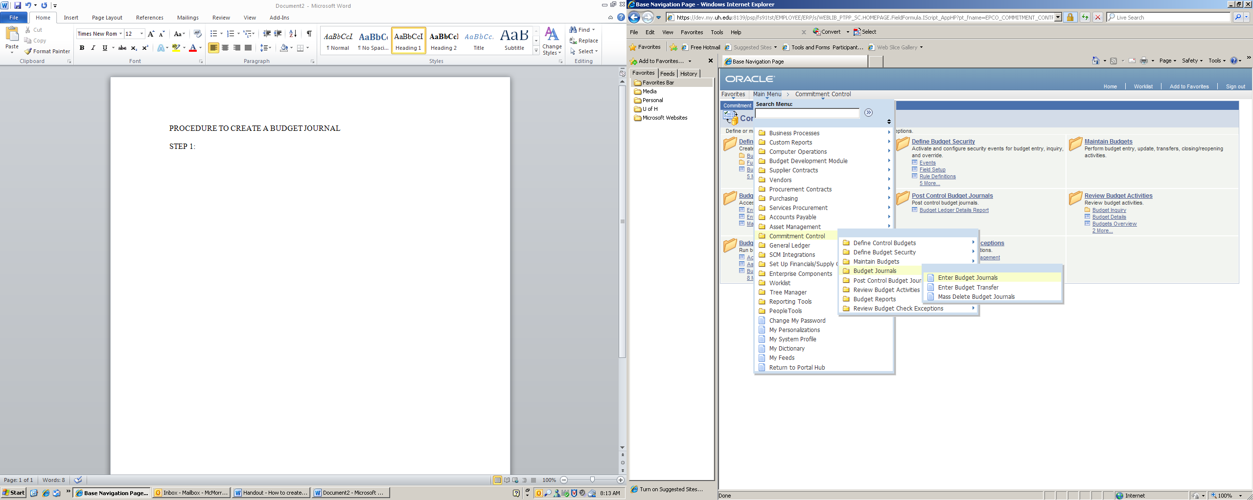

- Change “Business Unit” and “Date” if applicable. “Add”.
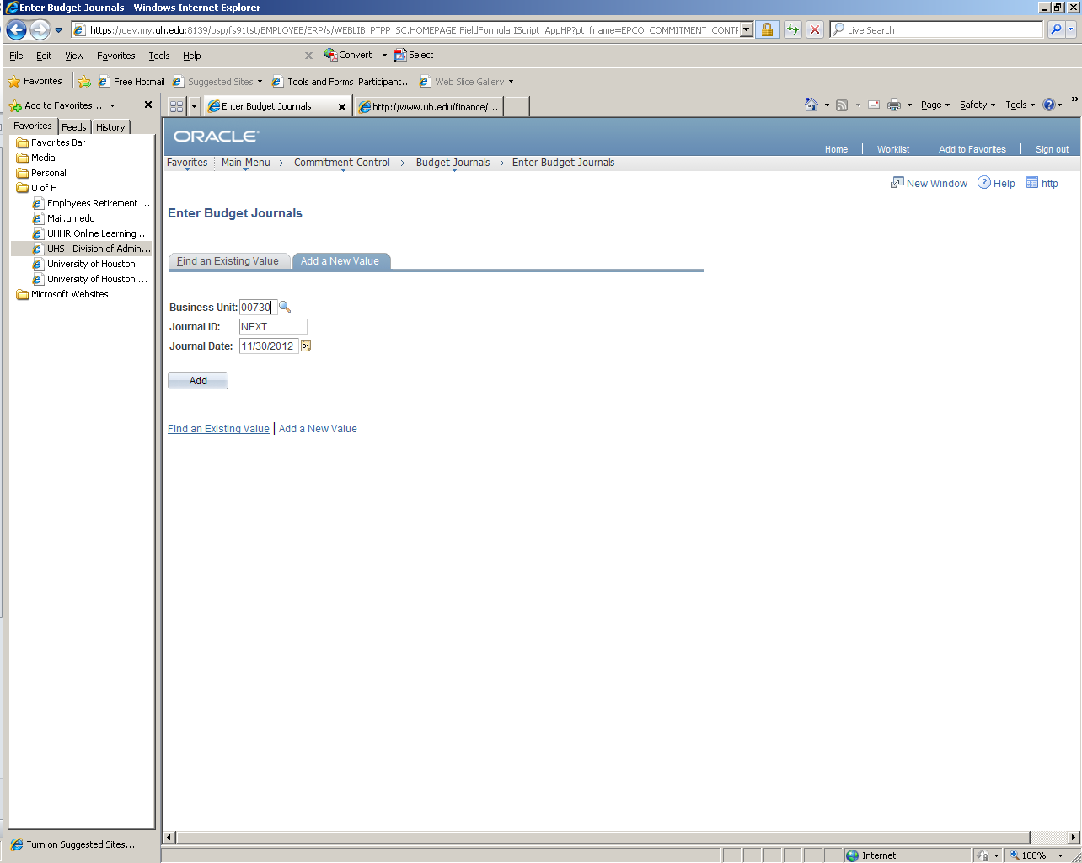

- Select “PROJ_GRT” on Ledger Group from the Look Up Ledger Group.

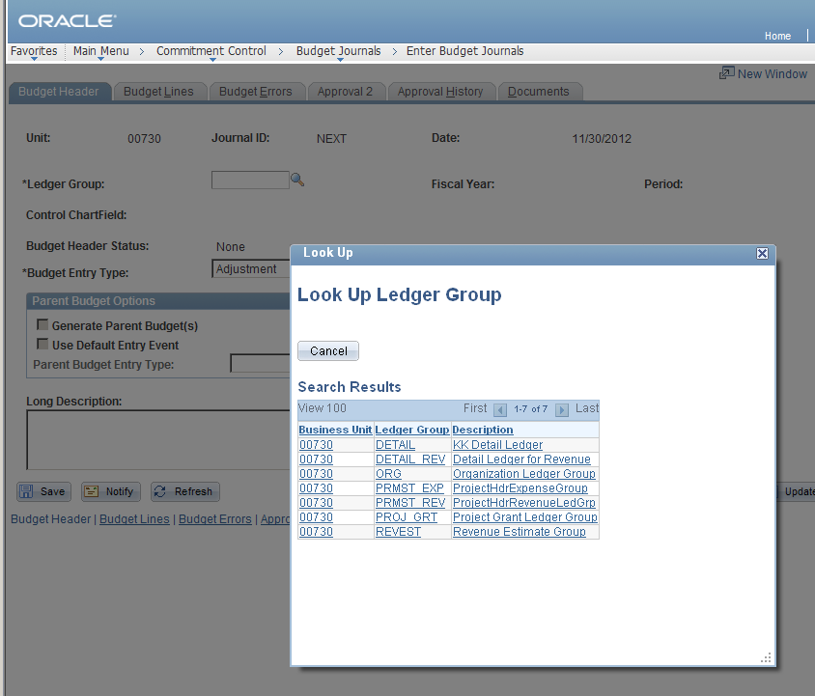

- Select Budget Entry Type from the drop down menu

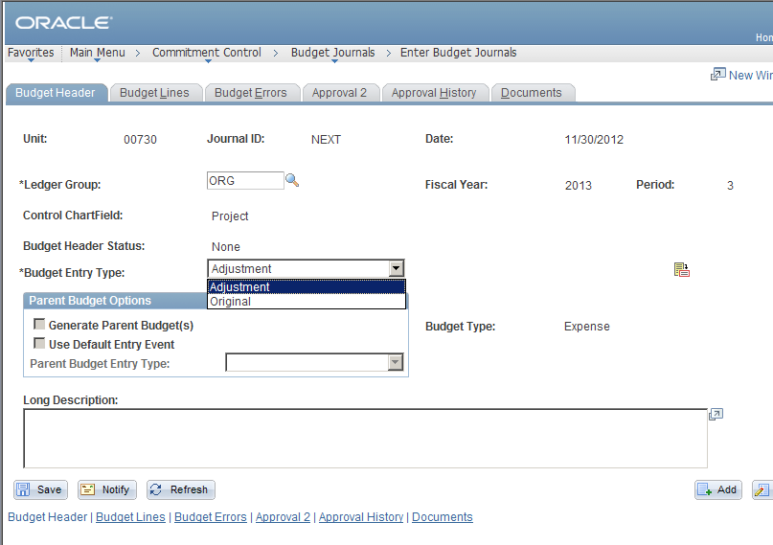
- An added feature on the PS upgrade is the “Parent Budget Options” of which the creator can generate parent budget when processing the project budget instead of creating two separate budget journals.

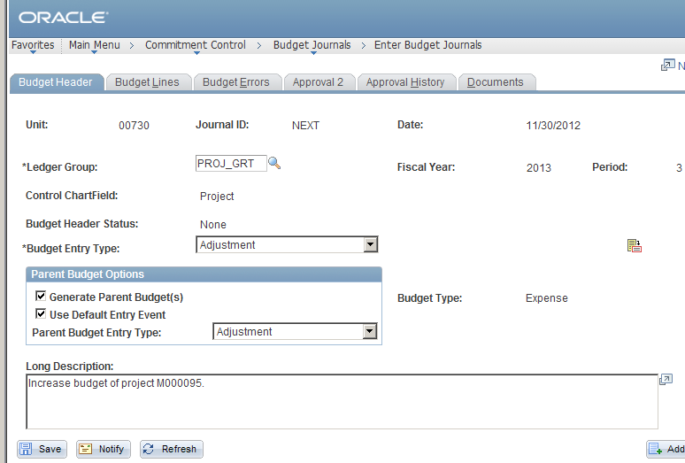

6. Master budget before the budget journal is posted.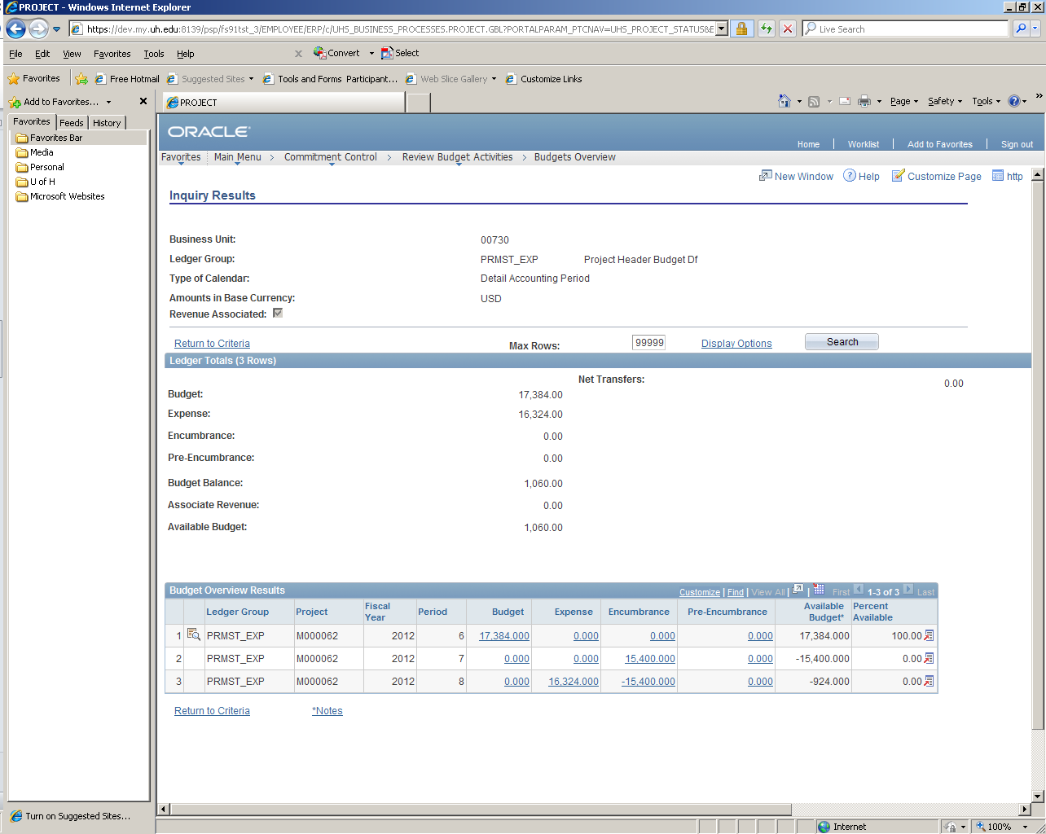
- Enter the “Long Description” stating the purpose of the project budget journal.

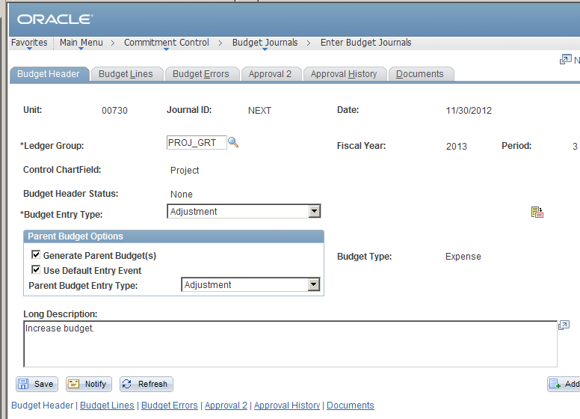

8. On the “Budget Lines” tab, enter either the Speed Type or cost center combo”, “Budget Node” and the amount.

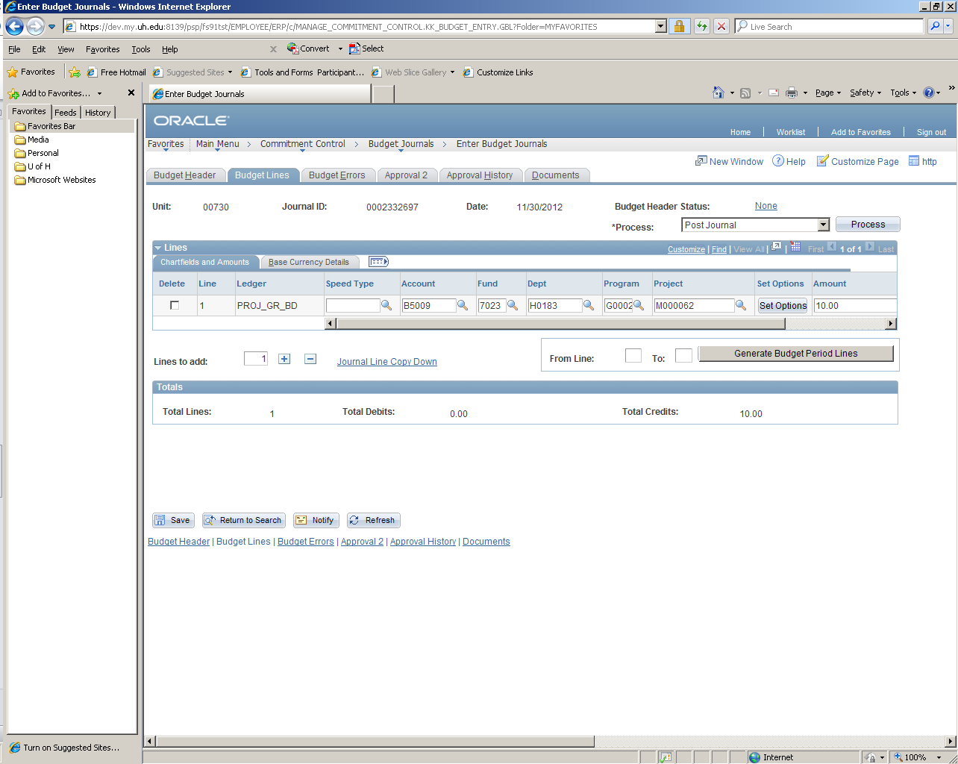

9. Process – Budget Pre-Check first and then select “Process” button

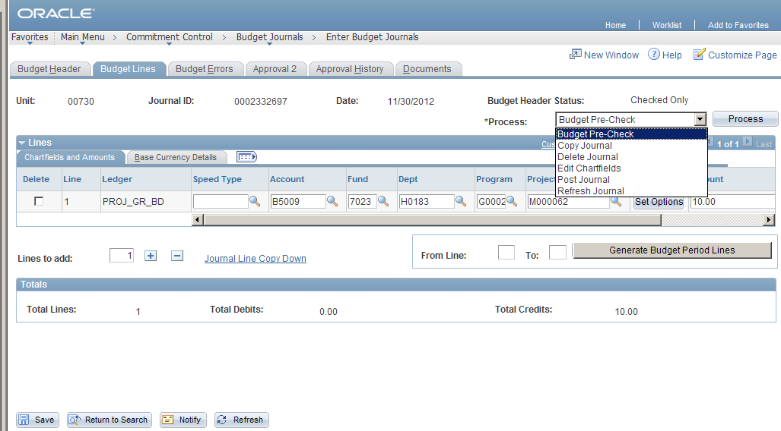

Save

10. Select the appropriate tab on ‘Approval 2’ tab. Budget Office chooses “Approve/deny/recycle” from the drop down and selects “Apply”.
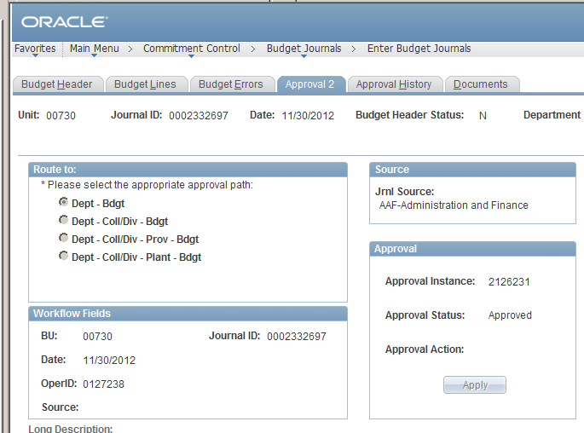

- The budget office will post the journal by selecting the “Post Journal” process and “Yes”.

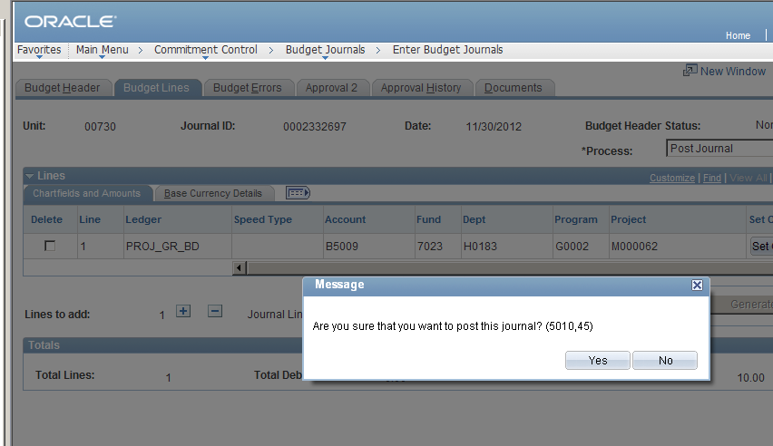

- The budget journal is then posted.

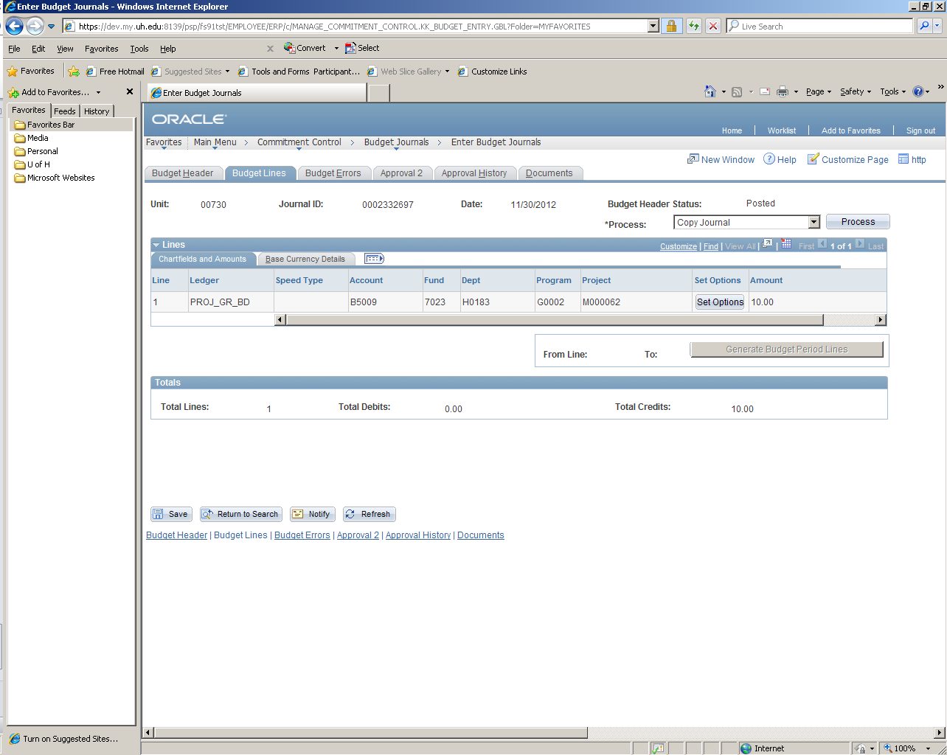

- Master budget after the $10.00 budget journal is posted.

