Transferring Non-Payroll Expenses between State and Local Funds

1. Create a voucher to reimburse the cost center that originally paid the expense. Choose the correct vendor and address as follows:

Transfer Expense From (Credit) | Transfer Expense To (Debit) | Voucher Payable To | Vendor ID | Address
State UH Cost Center | Local Cost Center | Texas Comptroller | 0000026730 | 006
State UHSA Cost Center | Local Cost Center | Texas Comptroller | 0000026730 | 009
State UHCL Cost Center | Local Cost Center | Texas Comptroller | 0000026730 | 010
State UHD Cost Center | Local Cost Center | Texas Comptroller | 0000026730 | 007
State UHV Cost Center | Local Cost Center | Texas Comptroller | 0000026730 | 008
Local UH Cost Center | State Cost Center | University of Houston | 0000026780 | 041
Local UHSA Cost Center | State Cost Center | UH System Administration | 0000026798 | 009
Local UHCL Cost Center | State Cost Center | UH Clear Lake | 0000026794 | 001
Local UHD Cost Center | State Cost Center | UH Downtown | 0000026799 | 011
Local UHV Cost Center | State Cost Center | UH Victoria | 0000026796 | 001

- Enter the cost center that will receive the expense (debit) on the Invoice Information page.

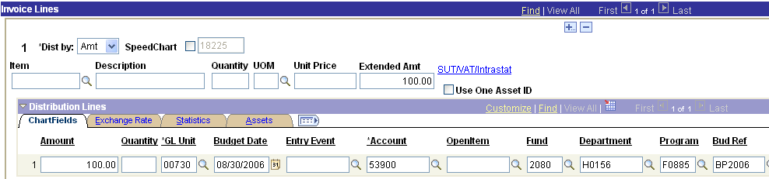

3. Select PCC 8 on the UHS Data Line page and complete the 3rd Party Vendor Information, which is the vendor paid for the original expenditure. If transferring a service center expense, choose the appropriate UH campus as the 3rd party vendor. In the example below, the original vendor was Today’s Business Solutions.

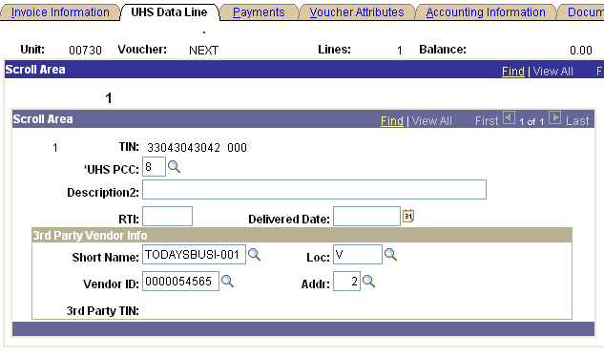

- Select SH (Special Handling) as the Handling code on the Payments page.

- Enter the cost center and account to be reimbursed in Payment Comments.

