No. | Action | Notes/Additional Information
1 | Tuition and Fee payments on sponsored projects are done via SC Vouchers.  These instructions are for payments on sponsored projects in fund group 5 only.  These payments use unique GL accounts to ensure proper reporting on sponsored projects and accurate information for tracking the tuition and fee payments.
2 | SC Voucher payments for tuition and fees on sponsored projects require a completed Tuition Reimbursement Request Form for Sponsored Projects.  This form is available on the Finance References Page (http://www.uh.edu/finance/pages/References.htm) and also in the Office of Contracts and Grants guidance pages.  This process is allowed for the Fall 2015 term forward. This process is unallowable for payments for terms prior to the Fall 2015 term. | 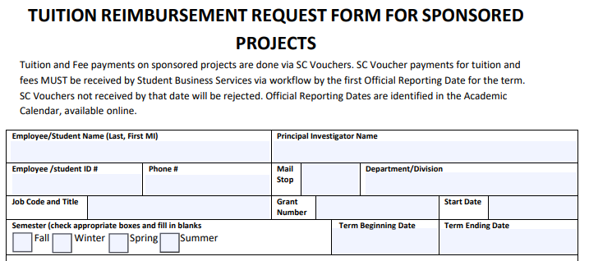
3 | SC Voucher payments for tuition and fees MUST be received by Student Business Services via workflow by the first Official Reporting Date for the term. SC Vouchers not received by that date will be rejected.  Official Reporting Dates are identified in the Academic Calendar, available online. (http://www.uh.edu/catalog-redirects/academic-calendar-undergraduate/). | Academic Calendars: http://www.uh.edu/catalog-redirects/academic-calendar-undergraduate/
4 | Log in to Finance (my.uh.edu)
5 | Go to:  Main Menu  Accounts Payable  Vouchers  Add/Update  Regular Entry
6 | Select “Add A New Value”  Use Business Unit: SC730  Voucher ID = NEXT  Voucher Style = Regular Voucher  Select Vendor ID 0000000034 (Student Business Services) from the Vendor ID Search. This will cause a number of fields to fill in.  Invoice Number = Any department numbering for the payments  Invoice Date = date of the SC Voucher  Enter the Gross Invoice Amount of “0”  Estimated No. of Invoice Lines: minimum is 2; you can add more  Select “Add” | 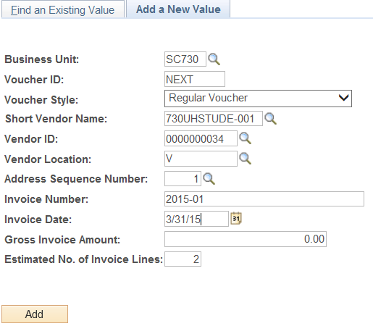
7 | In the “Invoice Information” tab, in the second section, select the “Comments” link and write a description of the transaction.  The comments must include “Tuition and Fee Payment on a Sponsored Project” | 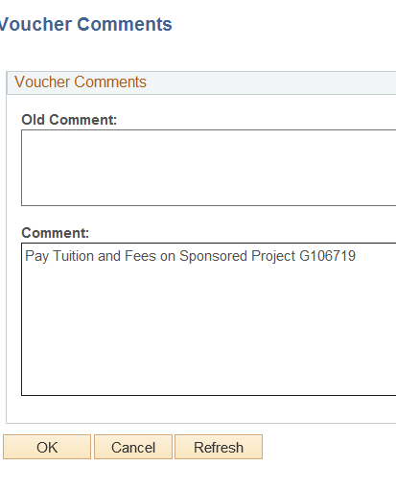
8 | In the “Invoice Information” tab, go to the middle of the page.  In the Invoice Line box, enter 0.  In the Description, add a description for the transaction.  In the first Distribution line, enter the standard GL Account and cost center: 00730 3057 H0167 I0391 NA, 16119. This cost center will appear in Vendor description, but the account listed is 16114. Always use 16119 for Tuition and Fee Payments on sponsored projects. | 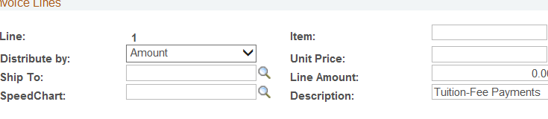  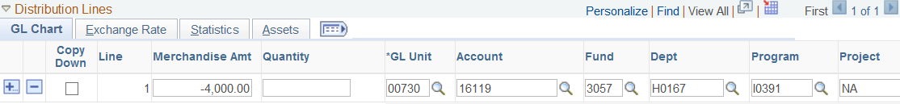
9 | Add a line (select the “+” symbol next to the first line)  Enter the amount of the Tuition and Fee Payment, the correct GL account for the type of payment, and the sponsored project cost center to be used.  GL Accounts are critical, as they will define what Tuition and Fee Payment is applied to the student’s account:  - 55320 – UH-TUIT/MAND FEES – UG (undergraduate students only)  - 55321 – UH-TUIT/MAND FEES – GR (graduate students that are NOT PhD or MFA only)  - 55322 – UH-TUIT/MAND FEES – PHD (PhD students only)  - 55323 – UH-TUIT/MAND FEES – MFA (MFA students only)  Add lines until you have recorded all of the Tuition and Fee payments.  Please note: The four GL accounts (55320 - 55323) are restricted to use on Fund Group 5 cost centers only. | 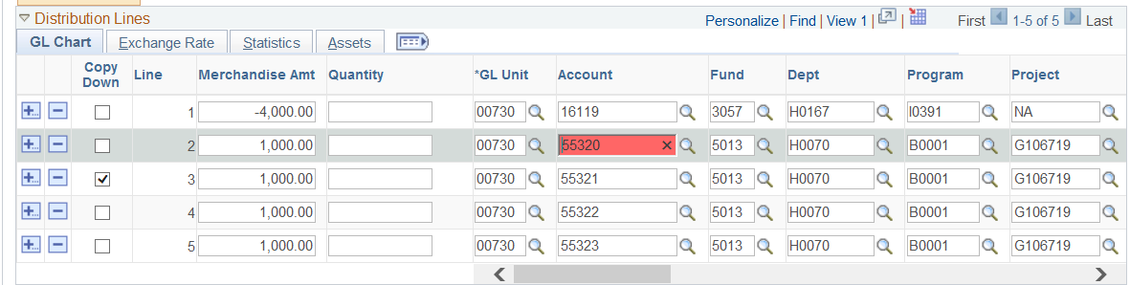
10 | Once the SC Voucher lines are filled in, go to the “Documents” tab and upload the required documentation.  The SC Voucher must have attached an Excel list of students and awards:  - 7-digit Student ID Number  - Amount of their award for each Student ID
11 | Go back to the “Invoice Information” page and select “Budget Checking” action, then “Run. | 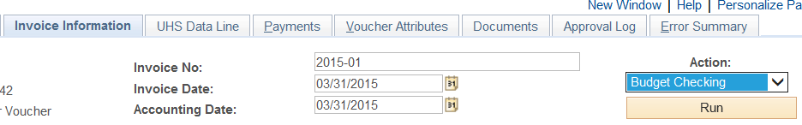
12 | A completed Reimbursement Request Form for Sponsored Projects MUST be attached as documentation. SC Vouchers received with incomplete forms will not be processed. | Form at http://www.uh.edu/finance/pages/References.htm under “SC Voucher Information”
13 | Submit the SC Voucher to workflow.

