No. | Action | Notes/Additional Information
1 | If a scholarship or award was made to a student account using an SC Voucher and the student returns the funds, a reversing SC Voucher must be created.
2 | Log in to Finance (my.uh.edu)
3 | Go to:  Main Menu  Accounts Payable  Vouchers  Add/Update  Regular Entry
4 | Select “Add A New Value”  Use Business Unit: SC730  Voucher ID = NEXT  Voucher Style = Regular Voucher  Select Supplier ID 0000000034 (Student Business Services) from the Supplier ID Search. This will cause a number of fields to fill in.  Invoice Number = Any department numbering for the payments  Invoice Date = date of the SC Voucher  Enter the Gross Invoice Amount of “0”  Estimated No. of Invoice Lines: minimum is 2; you can add more  Select “Add” | 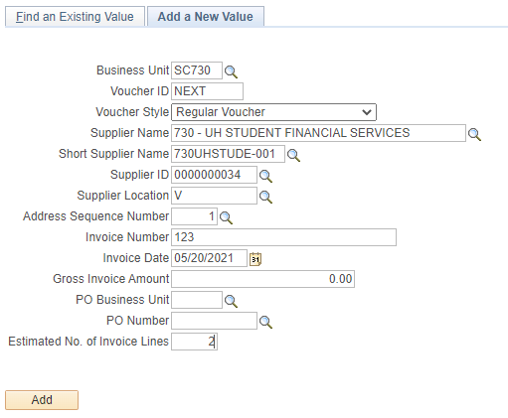
7 | In the “Invoice Information” tab, in the second section, select the “Comments” link and write a description of the transaction.  The comments must include “Return of Funds by Student, paid on SC Voucher XXXXXXX, xx/xx/xxxx” where “XXXXXXXX” is the original SC Voucher ID and “xx/xx/xxxx” is the original SC Voucher date. | 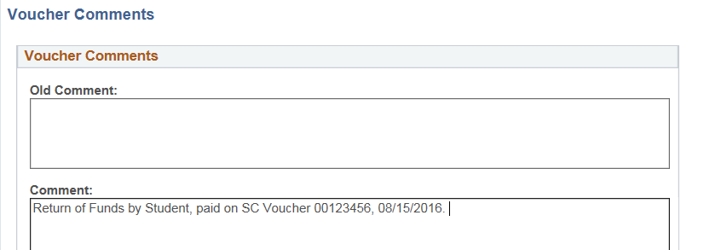
8 | In the “Invoice Information” tab, go to the middle of the page.  In the Invoice Line box, enter 0.  In the Description, add a description for the transaction.  In the first Distribution line, enter the standard GL Account and cost center: 00730 3057 H0167 I0391 NA, 16114.  The amount to this account is the debit (positive number) | 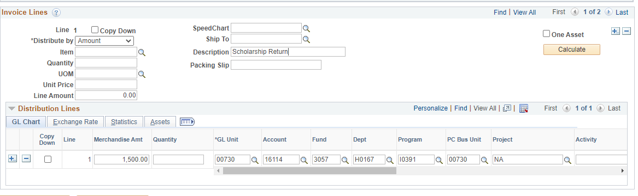
9 | Add a line (select the “+” symbol next to the first line)  Enter the amount of the Scholarship Return, the original GL account used for the original SC Voucher, and the original cost center to be used. | 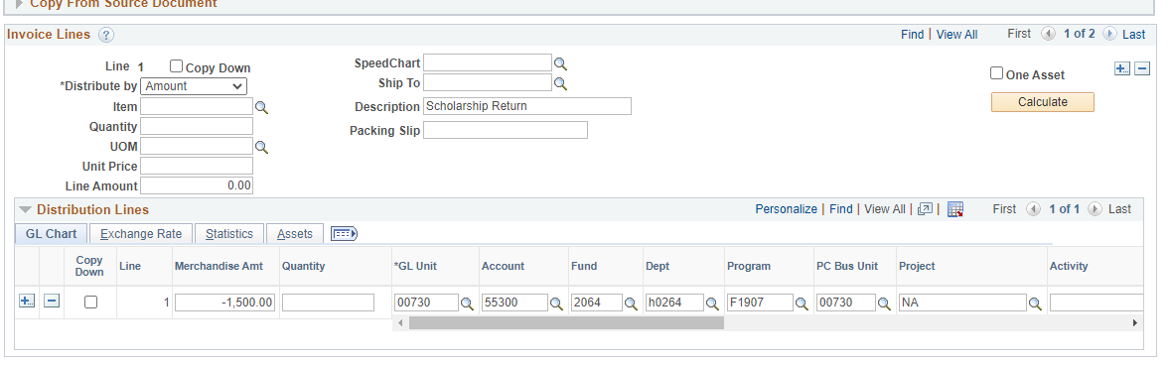
10 | Once the SC Voucher lines are filled in, go to the “Documents” tab and upload the required documentation.  The SC Voucher must have attached:  - 7-digit Student ID Number  - Amount of the original award and return for each Student ID  - Copy of the original Voucher | 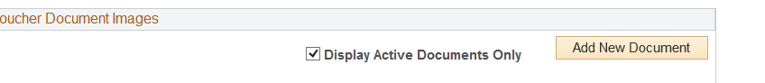
11 | Go back to the “Invoice Information” page and select “Match, Doc Tol, Bdgt” action, then “Run”.
12 | Submit the SC Voucher to workflow.

