SAP Fiori with Horizon Visual Design Theme

Concur has adopted SAP Fiori with Horizon Visual Design Theme as its default as of April 10th, 2024. The SAP Fiori with Horizon visual theme will not change any features or functionality. It is primarily a change in the look and some navigation within Concur. Below is what the home page looks like now:

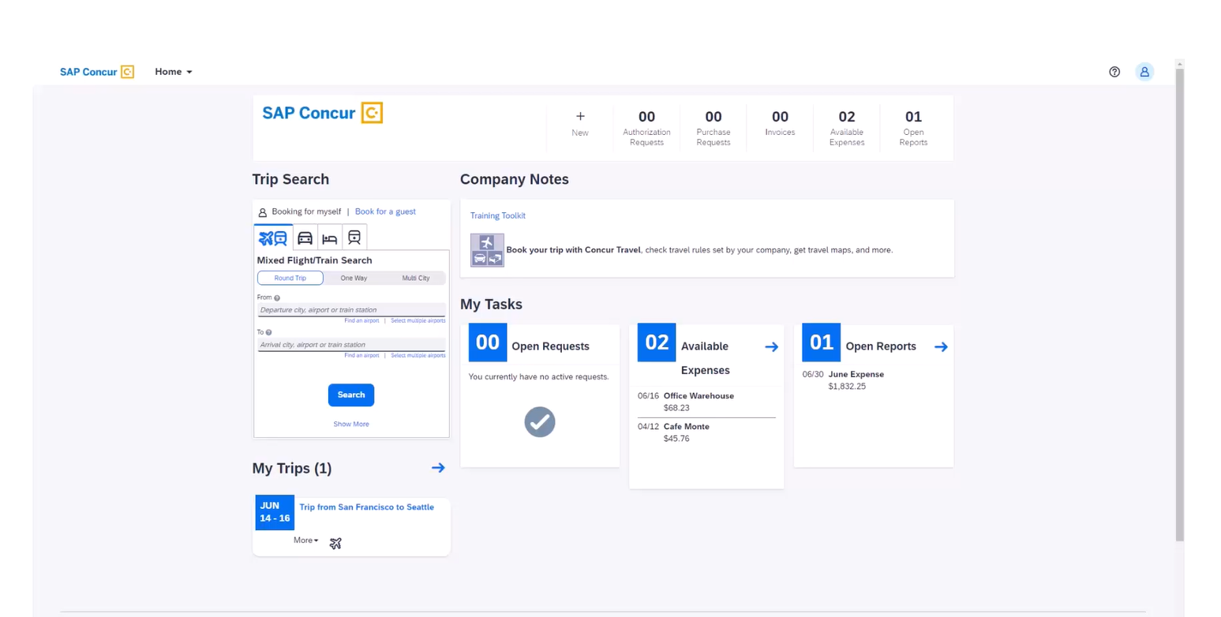

The navigation menu is slightly modified. Below are the screenshots of the changes:
- Concur solutions such as Request, Travel, Expense are organized under the “Home” drop down menu.

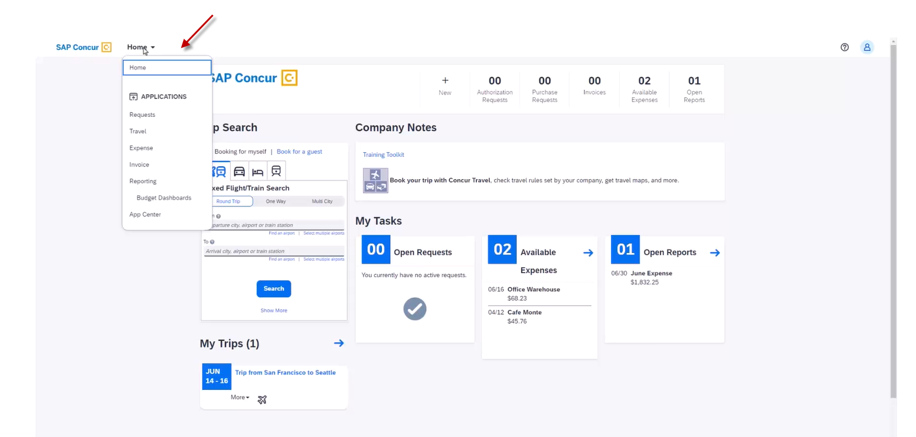
- The help section is no longer titled “Help”, but rather is represented with a question mark symbol; the profile section is no longer titled “Profile”, but rather is represented with a symbol of a person.
