**Concur Log-in Updates (via mobile app)**

Effective November 20th, the following steps are required to log into Concur.

1. Go to SAP Concur app home page and enter cougarnet e-mail address

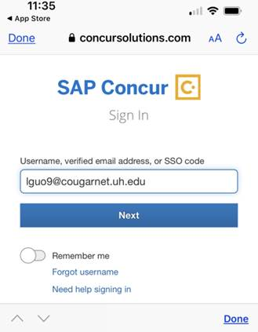

1. Select “UH CougarNet – IDP”.

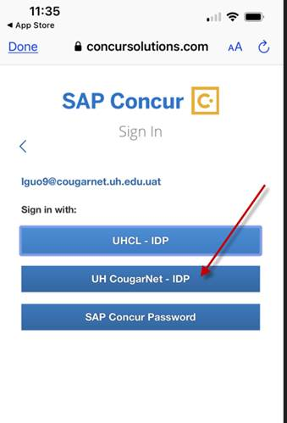

1. Sign in with your CougarNet e-mail address and password.

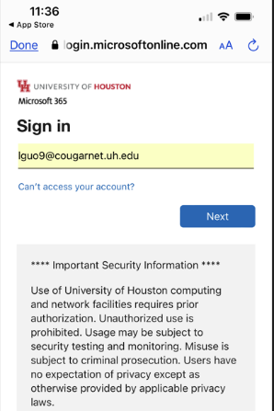 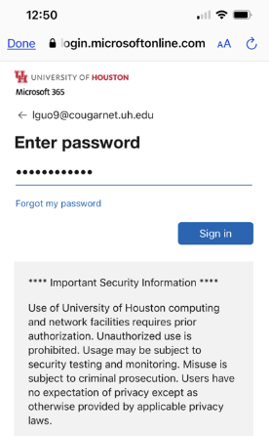

1. The system will require the second factor authentication, select “Enter a Passcode”.

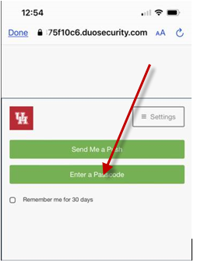

1. Go to your “Duo” app, copy the passcode.



1. Go back to Concur login page and paste the passcode, feel free to check “Remember me for 30 days”, and then click “Log in”

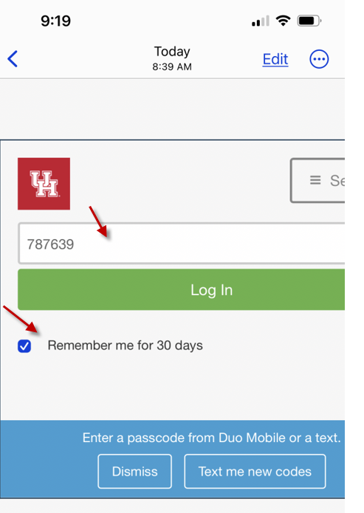

1. You will be directed to SAP Concur app home page.

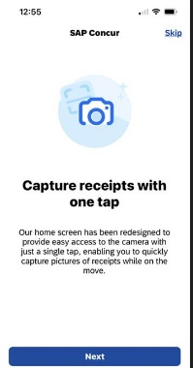

1. The system will ask you to enable or cancel the Face ID function. Once you enable or cancel you will be logged in.

