**Concur Log-in Updates (via computer)**

Effective November 20th, the following steps are required to log into Concur.

1. Log into Access UH, and select the Concur tile.

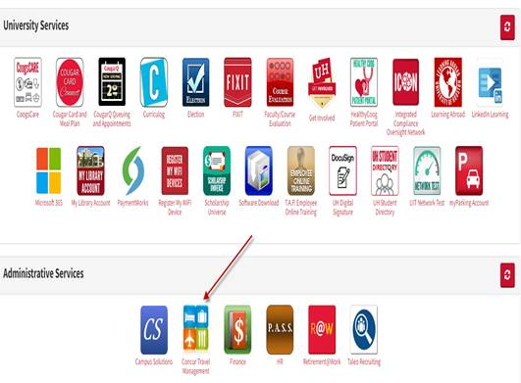

1. You will be routed to the Concur website: [www.concursolutions.com](http://www.concursolutions.com).

Enter your CougarNet e-mail address and click “Next”.

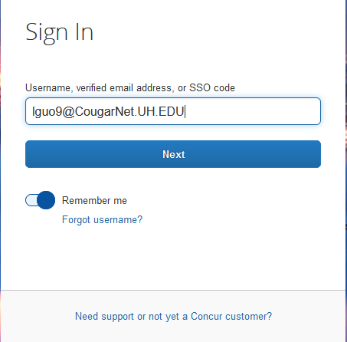

1. Select “Sign in with UH CougarNet – IDP”.

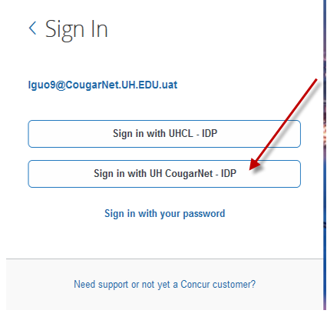

1. Select your account.

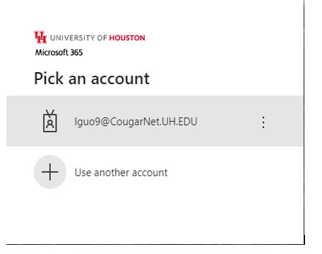

1. Enter CougarNet password and click on “Sign in”.

