**How to run reports for outstanding Travel Card Transactions**

Note: Only a limited number of people have access to run these reports. At least one person in each college/division has been given access.

You can run the following Concur Reports to identify outstanding Travel Card transactions:

**Travel Card Transactions – No Expense Reports created**

This report will generate a list of Travel Card Transactions that are not assigned to any Expense Reports.

**Travel Card Transactions – Expense Reports created but not approved by AP**

This report will generate a list of Travel Card transactions that are assigned to Expense Reports, but the Expense Reports are not approved by Accounts Payable yet.

1. From the Concur home page under **Reporting**, click on **Intelligence**



1. Click on **Team Content >** then click on **University of Houston System**

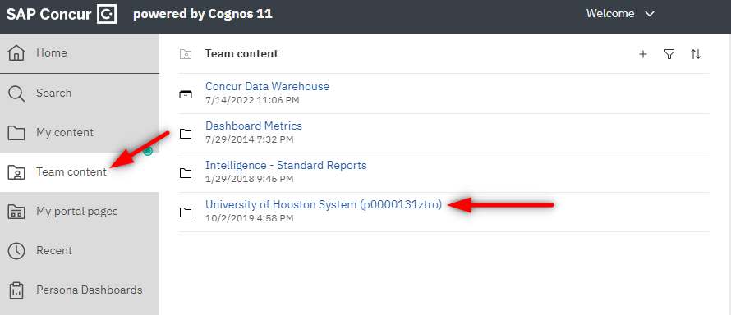

1. Open folder **User Reports**

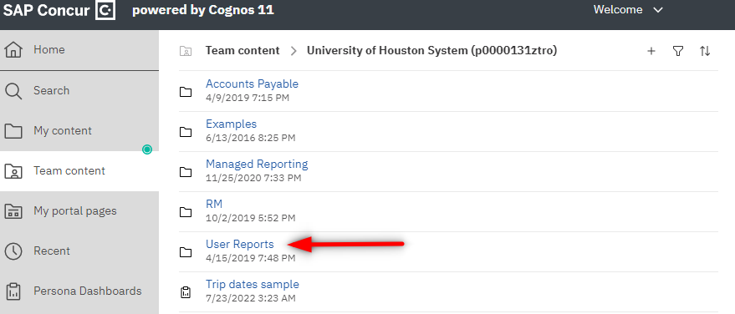

1. Click on “**Travel Card Transactions – No Expense Reports created**” to see outstanding Travel Card transactions that are not assigned to Expense Reports. Click on “**Travel Card Transactions – Expense Reports created but not approved by AP**” to see outstanding Travel Card transactions which Expense Reports need AP approval.

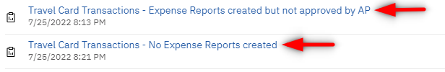

1. From the report, click on the **Run as ** icon, then click on **Run Excel** in order to run the report in Excel

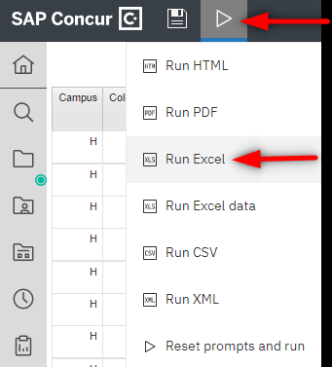

Note: Concur Reports pulls the information as of the previous day. Therefore, if you run the above reports today, you will see the results listed as of yesterday.