Concur for Mobile

Getting Started

- Login to Concur Travel Management and click on the App Center tab

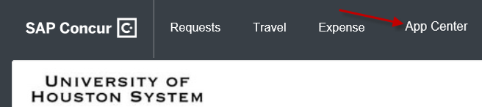

- In the App Center, click on Concur for Mobile

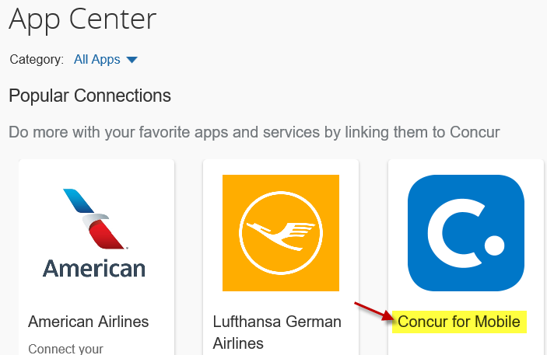

- Once you click on Concur for Mobile, click on Visit our Website
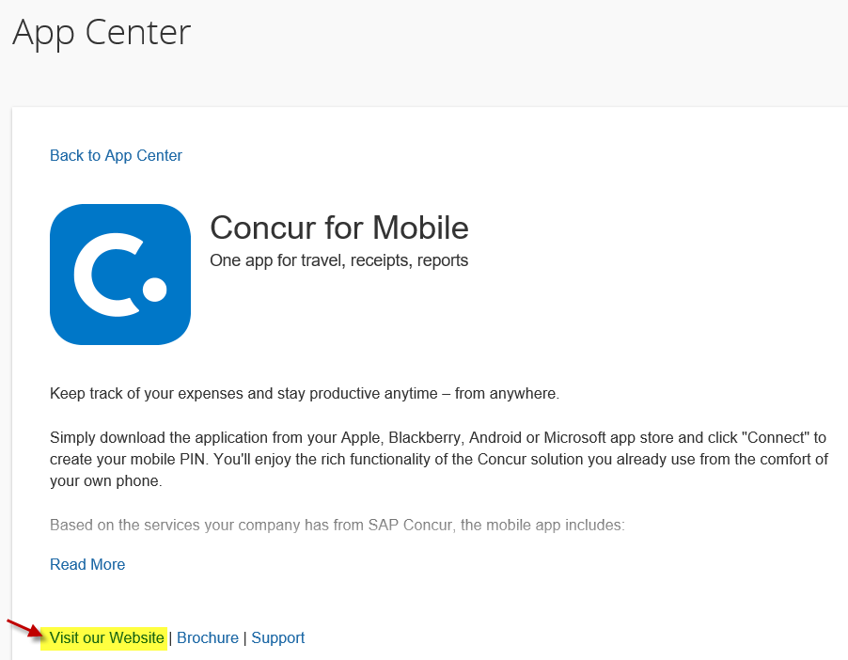

- Now click on the Try the demo button
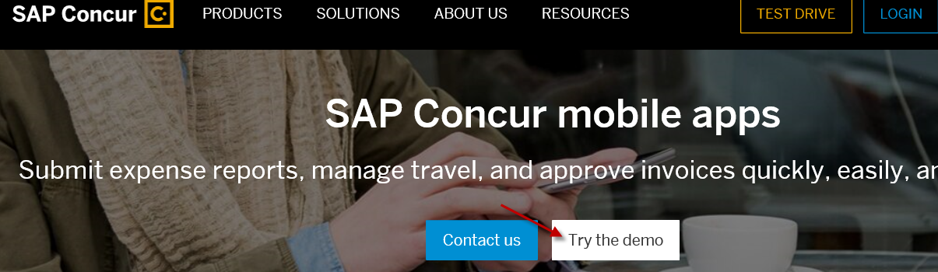

- This will now take you the self-guided demo, go ahead and click on the Start button to begin
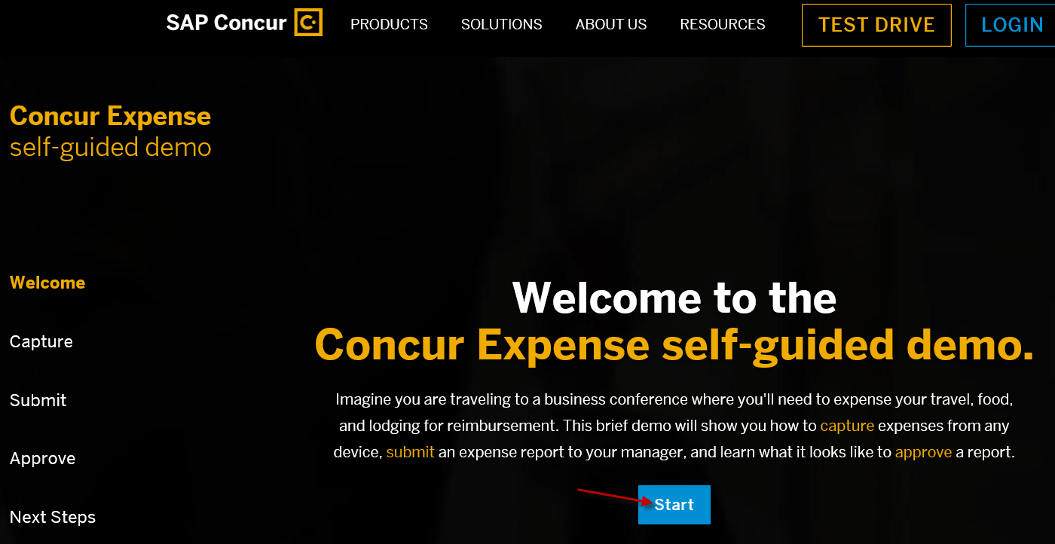

- The following is the direct link to this page: https://www.concur.com/self-guided-demo-expense#/
  - The information provided on this page will go over the Concur for Mobile app in detail.
  - This app is available for both Apple and Android users.
  - Great app for maintaining receipts and uploading directly to your Concur profile for easier Expense Report processing.

