Topic | Exploring Weather Maps and Symbols and Predicting Weather
Level | Introduction More Practice Review Other:

TEKS # | TEKS Student Expectation | Sample TAKS Problem or STAAR Problem
4.8 (A) | Measure and record changes in weather and make predictions using weather maps, weather symbols, and a map key. | 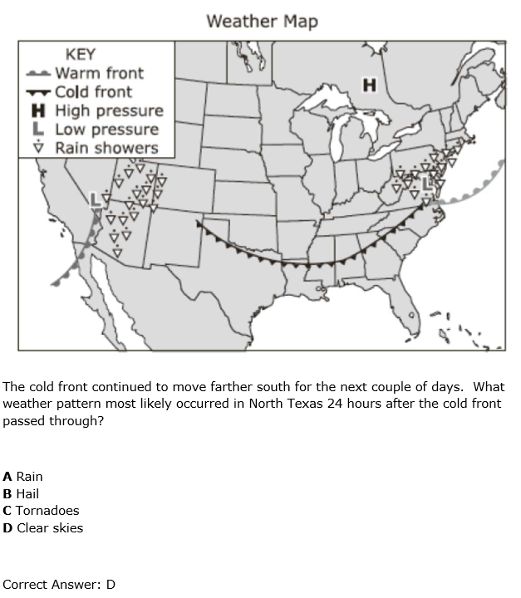

 | Lesson Objectives  Using the TEKS student expectations, write lesson objectives in SWBAT form. Be sure to use a performance verb. |  | Evaluation Questions (Real World Applications)  Write 3 real-world evaluation questions (i.e., 1 multiple choice, 1 open-ended/explanation question, and 1 griddable) that are aligned to each lesson objective and provide correct answers for each. Refer to the sample TAKS/STAAR problems as a guide for your multiple choice question, but do not copy it verbatim. Note: These questions are the SAME questions for the Pre and Post Tests.
1 | SWBAT determine true (and false statements) about a weather map. | Which statement about this weather map is true?  - There is a warm front south of Seattle.  - The weather will be rainy in Billings and New York.  - Detroit and Minneapolis will have the same weather.  - There is low pressure system between Houston and Miami.  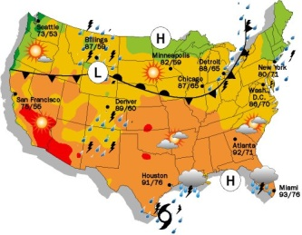  Answer: B
2 | SWBAT describe weather using map information about pressure, fronts, temperature, and precipitation. | 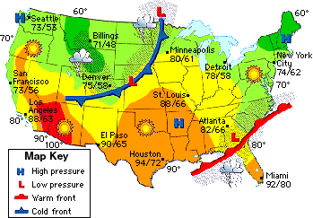  Using the weather map below, describe the weather in Denver. Include information about pressures, fronts, temperature, and type of precipitation.  Answer:  In Denver, there is low pressure, a cold front, and rainy weather. The temperature will be between 58 and 75 degrees.
3 | SWBAT to make predictions using weather maps of temperature. | 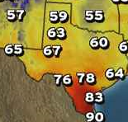  The temperature map below is for today. If the temperature increases by 2 degrees tomorrow, how many major Texas cities would be between 60° and 70°F tomorrow? Bubble in your answer on the grid below.  Answer: 6

Student-Centered Activities for a 5E Lesson (Embed handouts if necessary)
Describe the fun and motivating student-centered activities for each E. Be specific as possible with a description of the activity, directions for the activity and what the student should be doing. Refer to resources reviewed via embedded handouts or inserted hyperlinks, if applicable. Include 2-3 examples of the types of questions you might ask during each E.
Engage | Activity: Magic Weather Rock & True/False Weather  The teacher will ask students questions about weather and temperature (see below for questions). The teacher will tell the students about the Magic Weather Predicting Rock. Then, the teacher will present an anticipation guide to have students think about what they will be learning today. Students will vote as a class on whether each of the 3 statements of the anticipation guide is true or false. (Should you count the # of people who say T/F or just get an overall… most kids chose True?) The students will revisit the anticipation guide at the end of the lesson to check their answers.  Questions to be asked: * How do you know if the weather tomorrow will be rainy or sunny? (listen to the news, my mom’s knees hurt) * How do you know it will be hotter or colder tomorrow than today? (watch the forecast, seasons) * What do you call the people on the news who tell us about the weather? (meteorologists)  Materials Needed: PPT, dry erase marker, rock
Explore | Activity: Weather Or Not  In this section, students will create and describe weather maps of temperature, precipitation, and fronts with high and low pressure. In pairs, students will receive a communicator with inserted US and Texas maps and a sheet protector with weather descriptions and answers. The worksheet will have 2 weather descriptions and maps with a map key. Students will read the weather descriptions and write symbols on the maps using the dry erase marker. Students will take turns being the writer. Answers will be available on the back of the paper for students to self-check. The teacher will walk around and ask students what the different symbols mean.  Questions to be asked: * How do you which symbol represents a cloudy day? (no sun or rain, just clouds) * What weather pattern seems to be connected to warm fronts? (Thunderstorm)  Materials Needed: Per Pair: colored dry erase marker, communicator w/ inserts; sheet protector w/ inserts
Explain | Activity: A Meteorologist’s Cheat Sheet  The teacher will create a foldable with 4 flaps using the MS Word Document. In the foldable, students will be given weather maps and write descriptions (3 with fill-in-the-blanks and 1 entirely blank) of the maps. The teacher will facilitate a discussion of the fill-in-blanks and then tell the students what to write on the front flap (i.e., Weather Symbols, Pressure and Fronts, Temperature, Combination). A couple of student volunteers will act like meteorologists and share their blank descriptions using the document camera. The class will determine what is accurate and what needs to be changed.  Questions to be asked: * Why do you agree with that student’s answer? * What information in the description is accurate? * What information in the description could be clearer?  Materials Needed: 1 per student: Foldable (color copy and cut) and pencil;  1 for class: Document Camera
Elaborate | Activity: Who are the best meteorologists?  Students will work in pairs to notice patterns to predict weather. The powerpoint will have the maps showing changes over days. Using the communicator, students will draw what they expect to happen next. Teams will trade dry erase markers and check answers. Student with communicator will stand on the periphery of the classroom to show answers.  Questions to be asked: * Why do you expect the specific weather to occur on Day 4? * Who has a different map drawing? Why? * Who has a similar map drawing? Why?  Materials Needed: 1 per pair: communicator, dry erase marker, tissue  Print: Slides 3, 5, 7 for each pair (staple as a packet)
Evaluate | Note: SAME questions as written for Evaluation Questions section (orange) above.  Fix the left-hand side question #2 map so it looks the same as the right side.

