Topic | Stem and Leaf Plots
Level | Introduction More Practice Review Other:

TEKS # | TEKS Student Expectation | Sample TAKS Problem or STAAR Problem
4.9 (A) | Represents numerical data on a dot plot or stem and leaf plot marked with whole numbers | 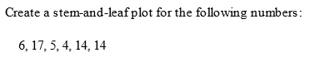

 | Lesson Objectives  Using the TEKS student expectations, write lesson objectives in SWBAT form. Be sure to use a performance verb. | Evaluation Questions (Real World Applications)  Write 3 real-world evaluation questions (i.e., 1 multiple choice, 1 open-ended/explanation question, and 1 griddable) that are aligned to each lesson objective and provide correct answers for each. Refer to the sample TAKS/STAAR problems as a guide for your multiple choice question, but do not copy it verbatim. Note: These questions are the SAME questions for the Pre and Post Tests.
1 | SWBAT explain parts of a stem and leaf plot. | 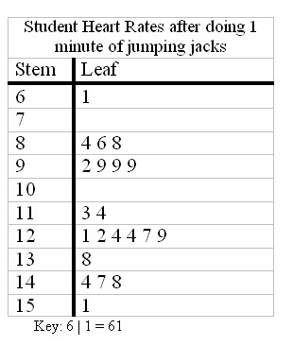  Why are there no leaves in stem 10?  Answer: There are no leaves in stem 10 because there were no students with heart rates between 100 and 109.
2 | SWBAT determine frequency information from a stem and leaf plot. | In the same stem-and-leaf plot above, how many students had a heart rate of at least 120 beats? Fill in your response in the griddable.  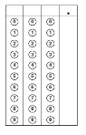Answer: 11.0
3 | SWBAT interpret data in a stem and leaf plot. | If the stem and leaf plot key is 5|7|0 means 75 degrees in Midland and 70 degrees in El Paso, what is the range of high temperatures for El Paso from Sept. 9-15?  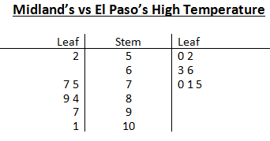  - 52 to 101  - 52 to 75  - 50 to 101  - 50 to 75  Answer: D

Student-Centered Activities for a 5E Lesson (Embed handouts if necessary)
Describe the fun and motivating student-centered activities for each E. Be specific as possible with a description of the activity, directions for the activity and what the student should be doing. Refer to resources reviewed via embedded handouts or inserted hyperlinks, if applicable. Include 2-3 examples of the types of questions you might ask during each E.
Engage | Activity: Quick Temperature  The teacher will present students with data of temperatures arranged randomly. The teacher will ask students questions about the data and allow them 10 seconds to raise their hands to answer each question. The teacher will ask students about the strategies used to answer the questions and consider a way to organize the data to answer the questions more quickly.  Questions: * What is the highest temperature? * How many data points are listed? * How many temperatures are above 88 degrees? * What strategies did you use to answer these questions? * How could you organize this data to make it easier to answer these questions?  Materials Needed: None
Explore | Activity: Best Buds: Stems and Leaves  For this activity, students will work with their shoulder partner to explore the data represented as stem and leaf plots. Each pair of students will share the handout that has stem and leaf plots on one side and back-to-back stem and leaf plots on the other side. Each student will receive their own question bank to write answers. One partner will read the questions while the other partner looks for the answer in the stem and leaf plots. Both partners should be writing down the answers on their own sheets. If there are an odd number of students, then he/she works alone. After 4 minutes, the teacher will lead students to check their answers to the single stem and leaf plot. Teacher will note top partners with correct answers.  For the back-to-back stem and leaf plots and corresponding questions, the partners will switch roles. After 4 minutes, the teacher will facilitate a discussion to check students’ answers. Teacher will note top partners with correct answers to parts 1 and 2 and the top 3 students get the prize. The bonus questions can act as tie breakers. An additional tie breaker can be found on the PowerPoint slide (update with correct answer).  Questions: * How are the numbers in the stem column organized? * How do you know? * Why are there 2 leaf columns? * Why are there no leaves in the stem of 6 for Midland’s temperature?  Materials Needed: PPT: insert a 4-minute timer. Per Pair: Stem and Leaf Plot printed on colored paper, folded, and glued down. Each student: Best Buds Handout printed on white paper and folded (optional to glue down). 6 prizes for 3 teams.
Explain | Activity: Fill in the Blanks Foldable  During the explain, students will fill out a foldable about stem and leaf plots. Using the paper, students will fill in the blanks on the “Stem” and “Leaf” flaps. The teacher will facilitate having students provide answers to the blanks. (In order to review the answers on the PPT for the blanks on the foldable, click on the answer you want to show to reveal it!) Then, on the back of the outside of the foldable, students will copy a list of data. On the front of the flaps, students will write the values for the stem and leaf plot from the data table and include the key. Finally, in pairs, students will fill in the blanks of the middle section to ask and answer questions about the stem and leaf plot. The teacher will facilitate students sharing out their questions and answers.  Questions: * Why are there no leaves on some stems? * How do you know? * Why is it necessary to have a key?  Materials Needed: Each student: Print Page 3 (in color).
Elaborate | Activity: All or Nothing (or Something)  Students will play the “All or Nothing (or Something)” game. The goal is for the class to earn at least 100 points. Students will work in pairs to decide if the answer to a question is A, B, C, or D. There are 10 multiple choice problems in this game ranging in difficulty and points from easiest (10 points) to challenging (40 points). The class will have 30 seconds to read the problem and to come up with an answer. Each student will use a folded paper with answer choices A, B, C, and D to indicate their answer choice. If the class has the same correct answer, then the class earns full credit. If there is 1 different answer and the student can explain why that answer is correct, then the class can earn half the points. If there are 3 or 4 different answers, then the class earns no points. The teacher will keep track of the score on the board.  Questions: * Which could be a key to this stem and leaf plot? * How many values are between 65 and 101? Why? * Which value is not possible to have hidden behind the blue rectangle? Why?  Materials Needed: Each pair: ABCD Paper. Dry Erase Marker to keep score
Evaluate | Note: SAME questions as written for Evaluation Questions section (orange) above.

