Math Topic: Review of decimals

List of appropriate TEKS (learning standards):
(4.1) Number, operation, and quantitative reasoning. The student uses place value to represent whole numbers and decimals. The student is expected to
(B) use place value to read, write, compare, and order decimals involving tenths and hundredths, including money, using [concrete objects and] pictorial models.
(5.1) Number, operation, and quantitative reasoning. The student uses place value to represent whole numbers and decimals. The student is expected to
(B) use place value to read, write, compare, and order decimals through the thousandths place.
List of appropriate TEKS:
TEKS # | Student Expectation | Sample TAKS or STAAR Problem: See BB
4.1.B | Use place value to read, write, compare, and order decimals involving tenths and hundredths, including money, using [concrete objects and] pictorial models | 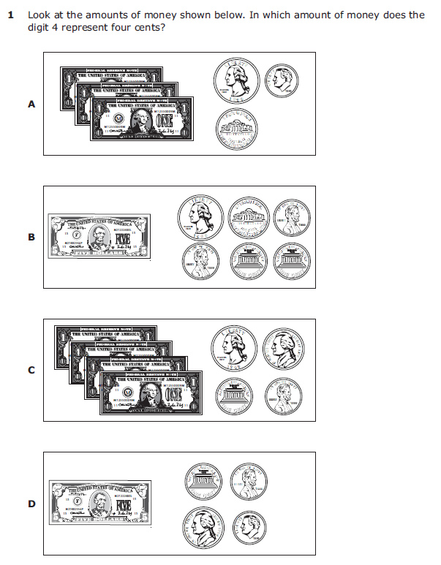
5.1.B | Use place value to read, write, compare, and order decimals through the thousandths place. | 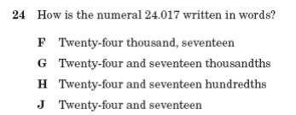

Objectives  Write objectives in SWBAT form | Evaluation Questions  Each question should match the written objective.
1. Translate between decimals presented in different forms: money, pictorial, and numerical forms.
  1. Your partner shaded the grid below. If the grid is one whole, what is the value of the shaded region?
  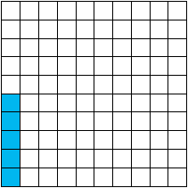 | - Five tenths  - Five hundredths  - Five thousandths  - Five wholes
  Answer:
  b) Five hundredths
2. Write decimals through the hundredths place, using place value. | 2. Your teacher has this much money. How many tenths is this?  Answer:  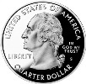  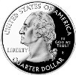  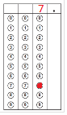  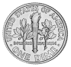
3. Order and compare decimals through the hundredths place. | 3. Your friends are playing “War” with the decimal cards. John has .09 and Sue has .90. Are their cards equal? If not, who has the larger decimal? Why?  __Sue has the larger decimal because 9 tenths is bigger than 9 hundredths. ____________________________________________________  ______________________________________________________

Resources, Materials, Handouts, and Equipment List in the form of a table:
Option 1: Teach From Doc Cam Option 2: Teach From PPT/Smart Board
ITEM | Quantity | Source | List who this is for (teacher, student, group)
Evaluation Worksheet | 24 | Teacher | Students
Decimal Cards, cut and in baggies for each group | 12 | Teacher | Groups of Students

Handouts and Powerpoint (inserted as an Object):

5E Lesson Plan
Objective Statement: Today class, we will be “reading, writing and comparing decimals” using place value.
ENGAGEMENT Time: 5 minutes
What the Teacher Will Do | Probing/Eliciting Questions and Students Responses | What the Students Will Do
The teacher will display slide 2 and read the objective statement.  The teacher will ask students if they ever felt lucky.  The teacher will ask students to read the slide about Maria, Minnie and Martin.  Teacher will have students discuss who has the most money with their shoulder partner.  After students discuss, the teacher will ask students to vote for the person with the most money.  The teacher will choose a student to explain their thinking.  Using slide 3, the teacher will ask students “how can you show in numbers who has the most money?”  Using slide 4, the teacher will ask students what a decimal is and review decimals using the Frayer Model. | Raise your hand if you’ve ever been lucky? What happened to make you feel lucky?  [Student tells a story.]  Who found the most money? Why?  [Minnie has the most money because she has 30 cents which is more than Maria with 25 cents and Martin with 12 cents]  How much is a quarter?  [25 cents]  How much are three dimes? How do you know?  [30 cents; 1 dime is 10 cents, so 3 dimes is 30 cents]  How much are 12 pennies?  [12 cents]  How many pennies are in a dollar?  [100 pennies are in one dollar]  What part of a dollar is a cent? How do we know?  [0.01 or one hundredth, because one penny in decimal form is 0.01]  How would you write the coins above in terms of dollars?  [25 cents or 25 hundredths of a dollar, 30 cents or 30 hundredths of a dollar, 12 cents or 12 hundredths of a dollar]  Other than the dollar signs, what do these numbers have in common?  [They all have a dot or decimal]  What are not examples of decimals?  [Percents and Fractions]  How do you say this (17.59) number?  [seventeen and fifty-nine hundredths  The number 17.59 has a decimal, what are the place values of the 1 and 7 in front of the decimal?  [1 is in the tens place; 7 is in the ones or units place]  What are the place values of the 5 and 9 after the decimal?  [5 is in the tenths place, 9 is in the hundredths place] | Students will answer engaging questions.  A student volunteer will read Slide 2.  With their shoulder partner, the students will discuss who has the most money.  Students will vote on who they think has the most money.  Student volunteers will respond to teacher questions.  Students will review what a decimal is using the Frayer model.
Transition Statement
“We have looked at money to introduce decimals. We are going to continue using place value to learn more about decimals. There are other ways to represent decimals. You are going to play a matching game among them.”

EXPLORATION Time: 10 minutes
What the Teacher Will Do | Probing/Eliciting Questions and Student Responses | What the Students Will Do
Using slide 5, the teacher will give directions to the matching cards game.  The teacher will pass out a set of decimal cards to students and will pair students up with a partner.  Teacher will pick on a student volunteer to read the directions out loud.  After reading the directions and demonstrating the game, the teacher will pick on students to repeat the instructions once again for the class, but in their own words.  The teacher will walk around the class while students work in groups to monitor progress and ask open-ended questions to probe student understanding.  The teacher will be monitoring whether the students are matching the cards correctly while walking around. If the students are not matching the cards correctly, they will ask questions to lead the students in the right direction.  The teacher will instruct the students to sort the cards from biggest to smallest if the students finish early. | (After the teacher reviews the directions, these questions can clarify the cards.)  What does a decimal card look like?  [It looks like a number with a decimal point.]  What does a grid card look like?  [A grid card is the card that has a 10x10 grid with squares shaded in.]  What does the grid represent?  [Each square inside the grid represents one hundredth of the whole large square.]  How is this related to a decimal?  [A decimal is a part of a whole and the squares of the grid are part of a whole also.]  What does the money card look like?  [It is the card that has money on it.]  How can money be related to a decimal?  [A whole dollar is made up of a hundred pennies so the number of cents is related to part of a whole dollar.]  What does a word card look like?  [It’s the card that has words on it.]  What do the words on the card mean? How can they be related to a decimal?  [The words on the card describe a decimal number by stating how many hundredths there are. A whole number is made up of 100 hundredths.]  If you are given a decimal card how can you figure out what the rest of the forms are that represent the same number?  [A decimal card shows us the decimal so by looking at it we can see how many parts to a whole we have and figure out how many hundredths make up the number, how many cents are part of the whole, and how many squares would need to be shaded in the grid.]  If you are given a word card how can you figure out what the other forms that represent the number are?  [The word card tells us how many hundredths there are which represent part of a whole number so we would know how many squares to shade in the grid, what the decimal would look like, and how many cents would be needed to make part of the whole.]  If a money card is placed down how can you use that card to match the rest of the forms with it?  [The money card tells us how many cents make up a whole dollar and since a dollar is made up of a hundred cents we can get the word form that tells us how many hundredths there are. Then we could get the decimal form and figure out how many squares we would have to shade in the grid to get the grid form.]  How can you use a grid card to figure out the other forms that match with it?  [The grid card will show us how many squares make up a whole hundred so we can get the decimal representation of the grid, then get how many cents would represent the same part of the whole number, and then get how many hundredths would make up a whole also.] | Students will determine whose name is closest to the letter M to assign who is Student 1 and 2.  Students will take out the category name cards.  4th Grade  Student will volunteer to read the directions out loud.  Selected students will repeat the instructions of the game in their own words.  Students will take out the 4 category name cards and lay them at the top of the table. Students will sort the cards by category. Then students will align all equivalent forms in the same row and then find the matching forms of each decimal.  The group members will ensure that the card matches by asking the question, “how do you know that your card matches?” and making suggestions.  Students play the matching cards game until all cards have been played.  After the game, the students are expected to put the cards in order from biggest to smallest.
Transition Statement
“You have matched the grid, word, money, and decimal form on cards. You will now explain why a set of card belongs together using place value to help with your explanation.”

EXPLANATION Time: 10 Minutes
What the Teacher Will Do | Probing/Eliciting Questions and Student Responses | What the Students Will Do
The teacher will ask a pair of partners how they know that the given cards match.  The teacher will call on different students for each set of cards.  Teacher will remind students to keep place value in mind when explaining their answers and strategies.  Teacher will have the students discuss their strategies for matching the cards with their partners and then will share with the class.  The teacher will call on students to order the decimal values from least to greatest.  The teacher should call on a different student each time.  Teacher will have students explain why they put the decimals in that order. | 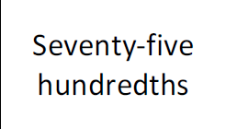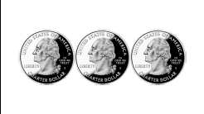  Why do these two cards match?  [3 quarters is the same as 75 cents which is 75 hundredths of a dollar.]  What is this value in decimal form?  [0.75]  Why is there a zero in the ones place?  [Because there are no wholes. We have less than 1 dollar]  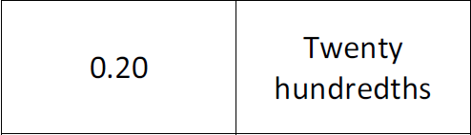  Why do these two cards match?  [You read the number card as twenty and the last digit is in the hundredths place, so it is twenty hundredths.]  What number is equivalent to 0.20? Why?  [0.2 or two tenths; Twenty hundredths is like 20 little squares and that’s two rows of 10 or two tenths.]  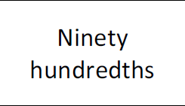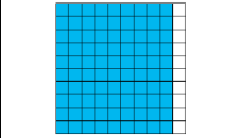  Why do these two cards match?  [There are 90 squares shaded blue and each square is one hundredth, so there are 90 hundredths of the whole shaded.]  What are two ways that this value can be written in decimal form?  [0.9 and 0.90]  Why are there two ways that this value can be written?  [0.9 is equivalent to .90; nine tenths is the same as 90 hundredths; there are 9 rows of ten squares or nine tenths and there are 90 small squares or 90 hundredths]  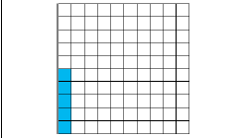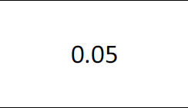  Why do these cards match?  [There are 5 squares shaded and each square is one hundredth, so there are five hundredths. The five goes in the hundredths place.]  Why is there a zero between the decimal point and the 5?  [Because there are only five hundredths, then the 0 is a place holder.]  What would the number be if we didn’t put the 0? And, what would that look like in the grid?  [0.5, this would be five tenths or 50 squares, not 5 squares]  What is the order of the decimals from least to greatest?  [0.05, 0.50, 0.75, and 0.95]  Hey Thomas, why does your value have a zero in the ones place?  [Because I am less than 1 dollar. If I was worth $3.05, I would have a 3 in the ones place (and a 5 in the hundredths place).  Twin Roosevelt, what other decimal numbers are equivalent to us? Why?  [0.2 or .20. In a tenths grid, 2 tenths is 2 rows. In a hundredths grid, 20 hundredths is 20 squares.]  Hey George, if the large square represents 1 whole, what are two ways that the shaded region can be written?  [It can be written as 0.9 or 0.90.]  Abraham, in our values, why is there a zero between the decimal point and the tenths place?  [Because our values are less than 1 tenth. You are 5 hundredths and I am 1 hundredth.] | Students will respond to teacher questions.  The students will volunteer to participate.  Students will share their answers with the class and justify their responses.  Students will discuss with their partner their strategies to matching the cards and then they will share as a class discussion.  If students are struggling with answers, the students can confer with their partners.
Transition Statement
“You explained how to match the different representations of decimals. In this next activity, you will work in pairs to play the “War” card game and compare decimals.”

ELABORATION Time: 10 minutes
What the Teacher Will Do | Probing/Eliciting Questions and Student Responses | What the Students Will Do
The teacher will divide students into partners once again. (Teacher can decide on new partners or the same partners as from the previous activity).  The teacher will go over the instructions for the “War” card game.  The teacher will instruct students to remove all title cards from the stack of decimal cards. Then, the teacher will instruct students that they are to shuffle the cards and then divide the cards equally amongst the two players while keeping the cards face down. Each person will flip one card and the player with the higher value wins. If the two cards are of equal value, then both players will flip one more card and then whoever has the highest card will win all 4 cards. The game continues until one player runs out of cards or until 5 minutes is up. After 5 minutes the teacher will instruct students to count their cards and the player with the most cards wins.  The teacher will review the directions by having the students repeat the directions in their own words.  Then, the teacher will walk around and ask students questions as they are playing the game.  Teacher will announce to students to count their cards when time is up. The teacher will then proceed to ask how many people won the game. Then, the teacher will instruct students to put all of the cards back together in the bag, and will have a student volunteer to pick up all of the cards. | (These questions can be asked as the teacher walks around the room.)  Who has played the game “War” before?  -Students will raise their hands.  Can anyone explain the concept of the game?  [The card of the highest value wins. The player with the most cards at the end wins the game.]  If you were given the word form of a decimal, what strategies can you use to find the other forms?  [I could say the word out loud and find the decimal form. Once I have the decimal form I can find the grid form of the decimal and what sum of coins I can use to get the decimal.]  What strategies can you use if you were given the decimal form to find the other forms?  [I can read the decimal to myself and write it out in words that represent the decimal. Then I correctly shaded in the amount of squares out of a hundred that represent the decimal. Using the decimal form, I can make the amount of coins equal to the decimal shown on the worksheet.]  When you were given the grid form, what strategies can you use to find the other forms?  [I can count the number of squares shaded and write the decimal that corresponds to the squares shaded. From the decimal form, I can correctly write the decimal in words and make the correct amount of change.]  When you were given the money form, what strategies did you use to find the other forms? [I counted up the money on the card and wrote the decimal. From the decimal, I can easily shade in the correct number of squares and write the decimal in words.]  Which forms were the hardest to compare as you were playing the game?  -Money and graph form  -Word and money form  Which forms were the easiest to compare?  -Both cards of the same form  -Decimal and word form  What were the trickiest cards you and your partner came across?  -Graphs of .05 and word form of .05 | Students will be divided up into partners once again.  Students will listen to teacher instructions. Then, selected students will repeat the game directions in their own words.  Students will shuffle the decimal cards and then will divide the cards equally amongst the two partners, while keeping the cards face down.  Each person will flip one card, and the person with the higher value will win both cards.  Students will continue to play the “War” game until one partner runs out of cards or until 5 minutes is up. After 5 minutes, students will count their cards and the player with the most cards wins the game.  Students will count up their cards. Students that won will raise their hands.  Students will put away all cards as one student picks up all of the decimal cards.
Transition Statement
“We explored, explained, and elaborated our understanding of reading, writing and comparing decimals. Now, we will work individually to evaluate your understanding of this topic.”

EVALUATION Time: 5 minutes
What the Teacher Will Do | Probing/Eliciting Questions | What the Students Will Do
Teacher distributes the evaluation for students to complete.  Teacher will instruct students that they have 5 minutes to complete the evaluation assessment on their own. | Did you write your name on the top of the paper? | Students will complete evaluation on their own.

