Reconciliation Verification Notices (Transaction Verification Form)
I have verified transactions for the following cost centers during the indicated time periods, which were sent to me via email as the reconciliations were completed over the time period indicated.
Cost Centers Verified:
41119, 49381
Accounting Period Verified: Fiscal Year:2011 Month: March, April, May, June, July, August, 998
Name of Verifier: Jeff Morgan___________ Title: ____Professor
Date Verification was Completed: _____________ Initials of Verifier: ___________
Are any corrections/adjustments needed to the cost centers verified? (Y/N) _________
For each correction or adjustment needed, note the following below: (1) cost center, (2) account, (3) amount, (4) date of original transaction, and (5) description of correction/adjustment needed.

You can find corrections already in progress within your reports:
All payroll concerns would be noted on the Payroll Report attached to your reconciliations, e.g.:
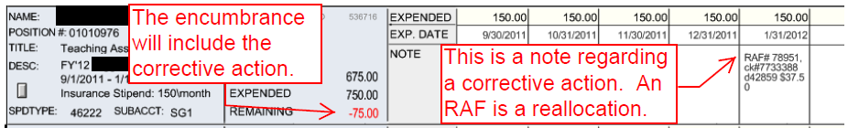
All non-payroll concerns that are already reflected in the balance will have a correcting entry within the outstanding report.
Any financial concerns that are not reflected in the balance would be noted on the Cost Center Status Summary in the Comments section, e.g.:
