Reconciliation Verification Notices
Every six (6) months the department is required to send out reconciliation verification notices to ensure PIs have reviewed their monthly reconciliations. These verifications are run for Period 1-6 and Period 7-998.
- In PeopleSoft finance run a 1074 report for all cost centers for department codes H0110, H0111, H0474, and Speed Type 31415
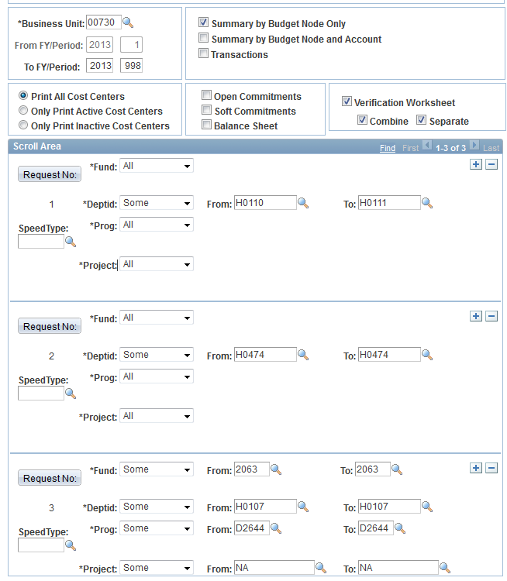
- After the report is posted, choose verification worksheet
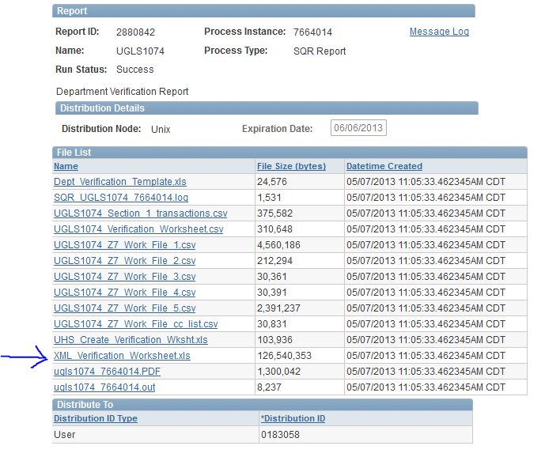
- Save the verification worksheet to R:\Reconciliations FY XX\Approved Reconciliations\Period X-Y for the period you are working on.
- Go to the Review tab of the Ribbon and choose Unprotect Sheet
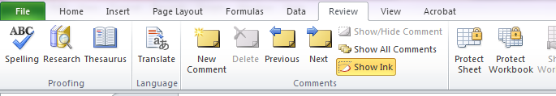
- Go to the “Cost Center List” tab
- Add a column that titled Cost Center
- Add a column titled Speed Type
- Add a column titled PI
- Add a column titled Cost_Center_Verified
- Add a column titled Months
- Add a column titled Fiscal_Year
- Add a column titled Title
- In the Cost Center tab use the function Concatenate on columns B, C, D, and E to create a cost center string. Copy this function down to all of the cells in the column
- In PS run query UHS_CC_LOOKUP. You will need to run this query for all of the department codes (H0110, H0111, H0474, and ST 31415)
- Add another worksheet to the Verification workbook. Add the information form the CC_Lookup queries
- Add a column at the beginning of the workbook titled Cost Center. Use the function Concatenate on columns C, D, E, and F to create a cost center string. Copy this function down to all of the cells in the column
- Return to the “Cost Center List” tab
- In the Speed Type column use the function VLookup. 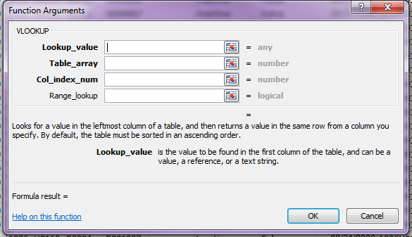
- The Lookup_value will be your cost center column.
- The Table_array is the worksheet with the CC_Lookup query information. Be sure to use the absolute value of the first cell to the absolute value of the last cell
- The Col_index_num is the column on the CC_Lookup query where the speed type is located
- The Range_lookup should be FALSE
Copy this formula to the entire column
- Sort the Cost Center Manager column in alphabetical order. If there are any blank cells gather the Manger name from File Maker Pro Budget Award Entry.
- In the PI column add the name of the PI to the last row that the PI has, i.e. if the PI has 18 rows that they are the manager of only add their name to the last row.
- In the Cost_Center_Verified column insert the Speed Type cells 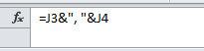
- In the Months Column add the six (6) months that are being verified.
- In the Fiscal_Year column add the fiscal year being verified
- In the Title column add the PIs title from FileMaker Pro
- Use this spreadsheet as the data table for a mailmerge on the Reconciliation Verification Notices. The Word document is already set up as a mailmerge.
- Go to the Mailings tab of the Ribbon. Choose Select RecipientsUse existing List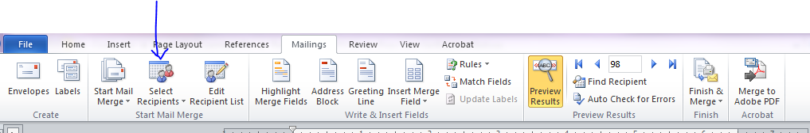
- Select the worksheet saved in R:\Reconciliations FY XX\Approved Reconciliations\Period X-Y for the period you are working on
- Print all notices as a PDF and save to R:\Reconciliations FY XX\Approved Reconciliations\Period X-Y for the period you are working on
- Print a copy and place in the PIs mailbox.
- For the Department Business Administrator create a form and type “All H0110, H0111, and H0474 cost centers” in the Cost Centers Verified section.
- When notices are returned scan and save to to R:\Reconciliations FY 13\Approved Reconciliations\Period X-Y with file name FY.Period.X-Y.Verification.notice.approval.PILastName.MMDDYY

