

Heritage Room
Operations Manual

Turning on the TVs

Press the “ON” button on the Extron controller.

Extron Location | Extron Controller
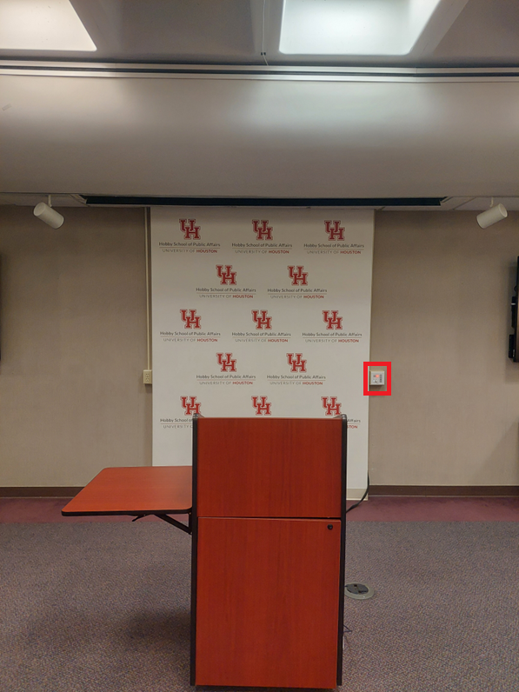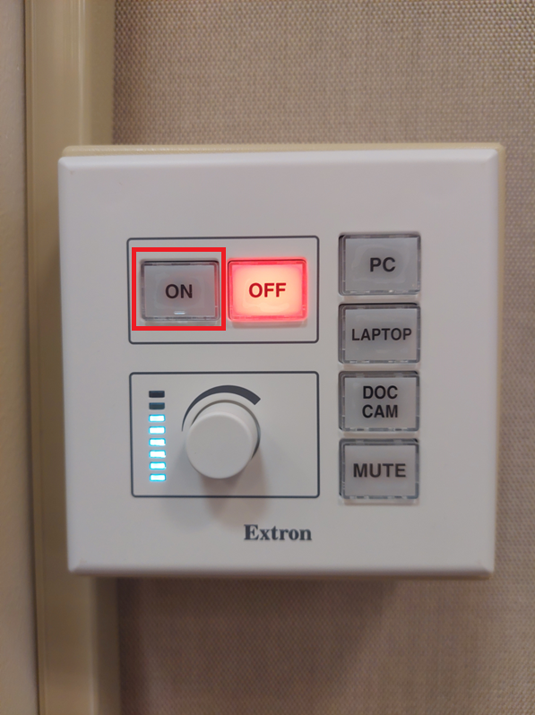

Turning on the PC

Press the power button on the PC.

PC Location | PC
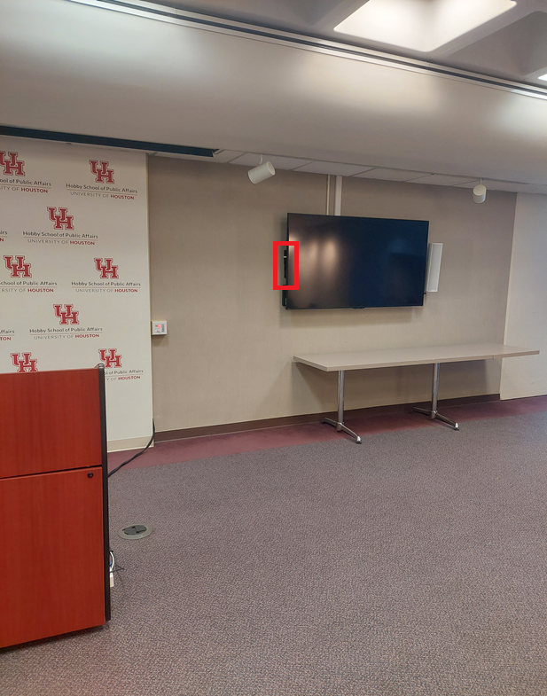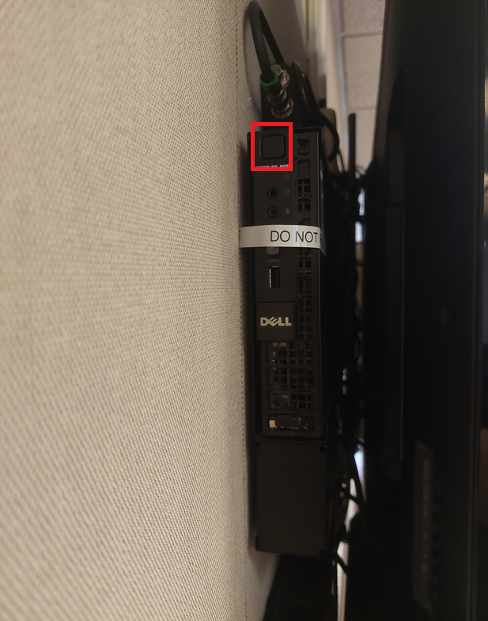

Click “OK” at this screen to log in to the Hobby Guest account.

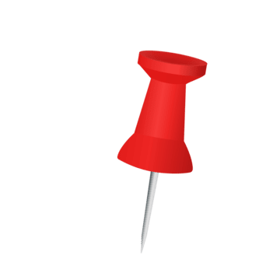
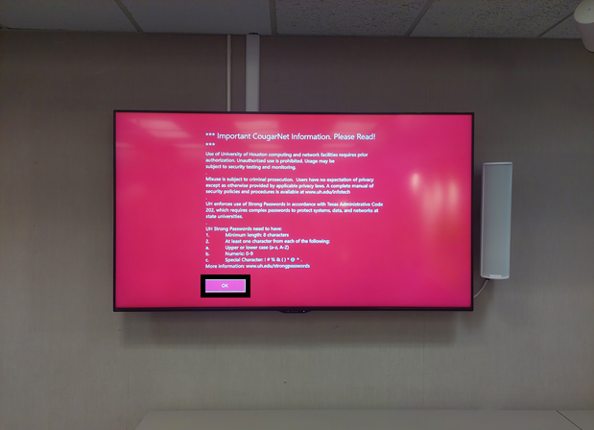

Note: CougarNet credential logins are unavailable using this system.
Camera Operations

Camera Location

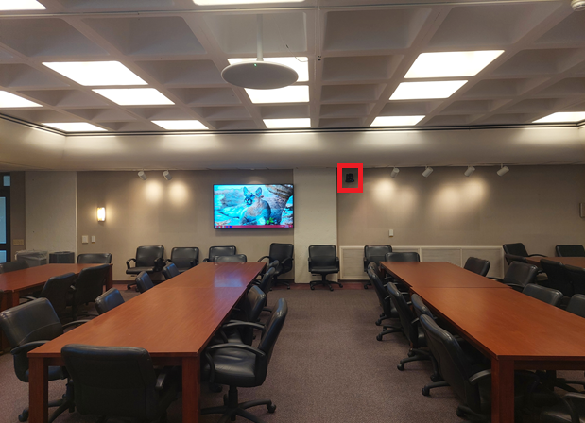

To turn on the camera, press the “Doc Cam” button on the Extron controller.

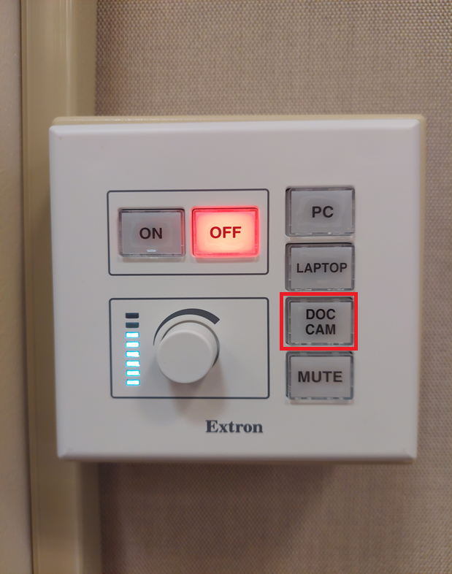

Note: the camera will start auto tracking the presenter at the podium, meaning it will follow the person where they move in the room.

To turn off auto-tracking, press “1” and then “off” on the camera remote.

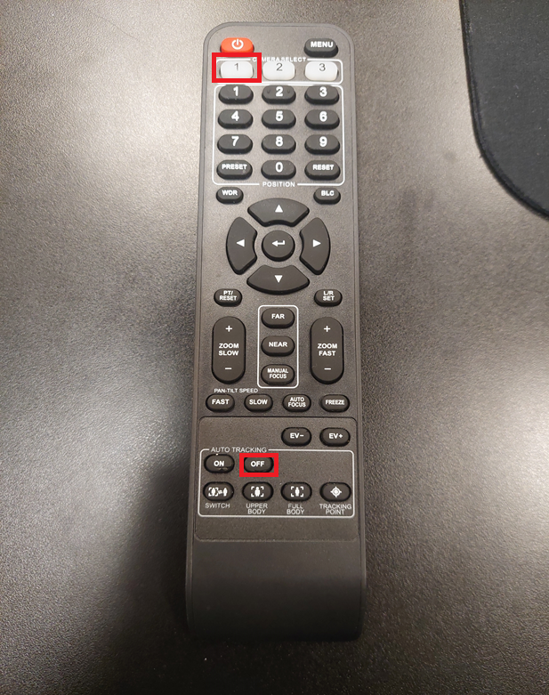

To adjust the camera position, press “1” and then use the arrows on the remote to move the camera around. Use “zoom in” and “zoom out” to adjust the view. Slow zoom is on the left and fast zoom is on the right.

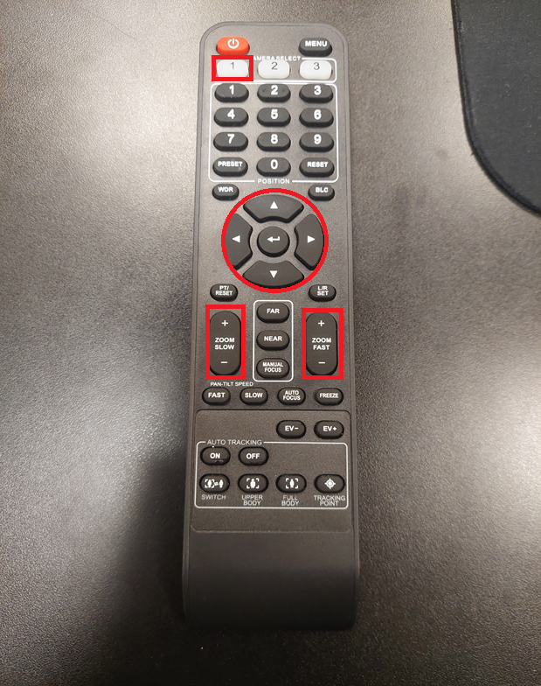
Shutting Down

Turn the PC off by clicking start, power, shut down as you would on your personal system. Please shut down the system when you are finished using it.

Turn off the screens by pressing “off” on the Extron controller.

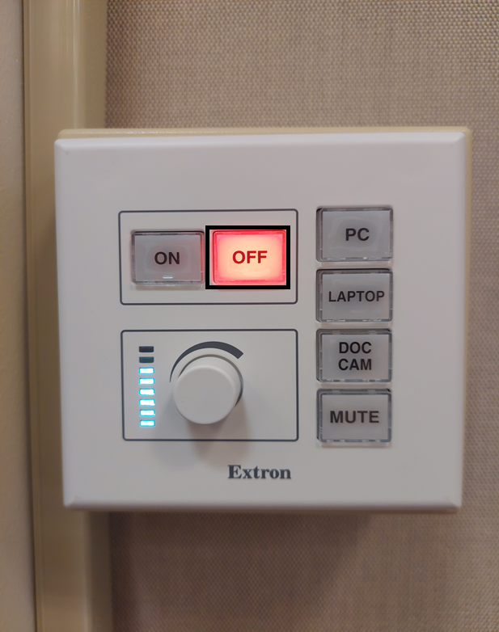

Using a Laptop

To use a laptop to connect to the screens, simply plug the HDMI cable on the podium into the laptop.

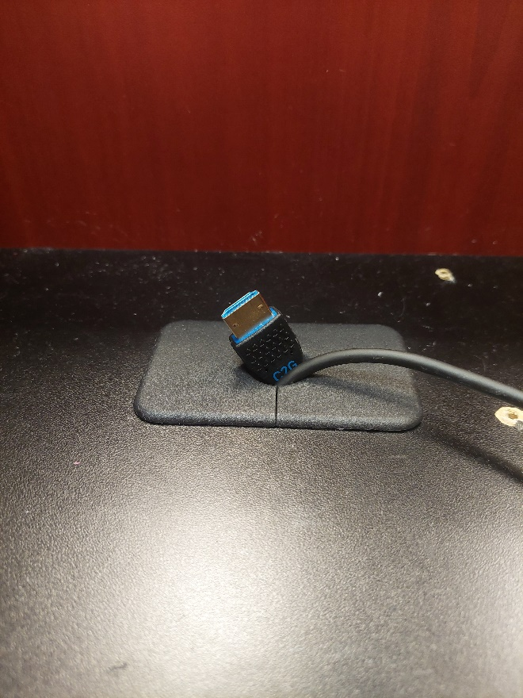

Press “LAPTOP” on the Extron controller.

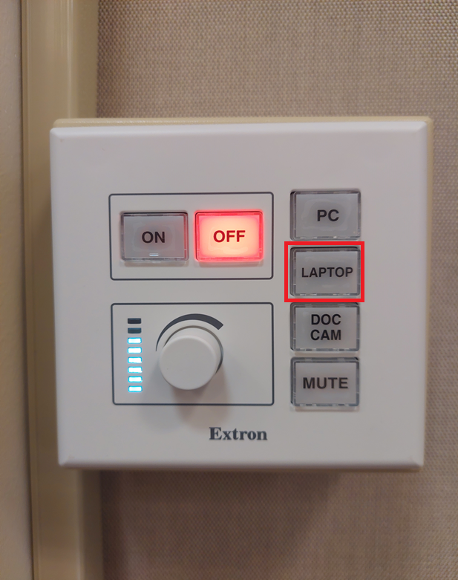

Note: use of the camera is not possible with the laptop connection.

Audio

There are two main speakers at the front of the room.

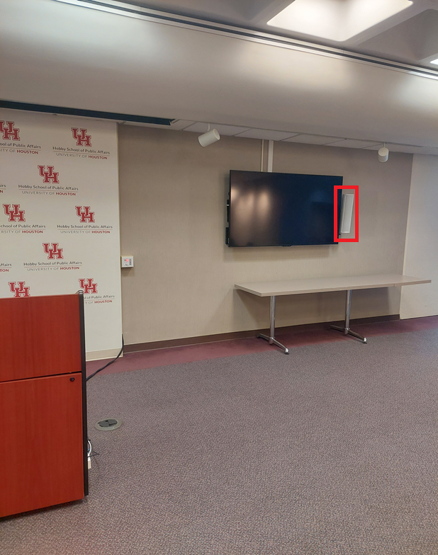

To adjust the volume levels, rotate the knob on the Extron controller.

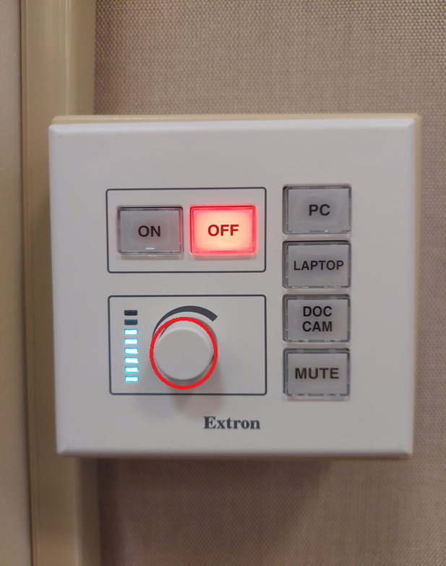

The microphone is in the center of the room. The green light means it is on, and a red light means it is off/muted. The microphone will pick up audio from the entire room.

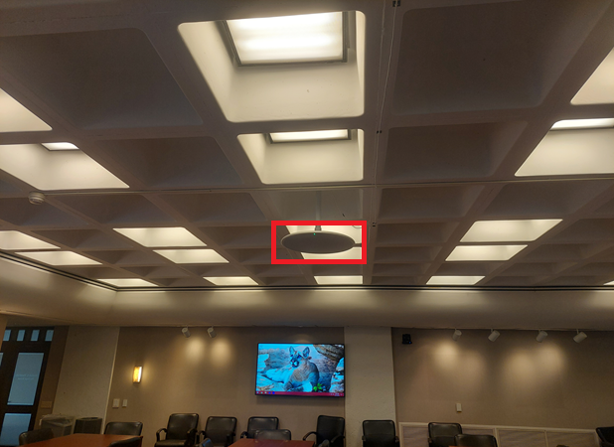

To mute the microphone, either press mute on the software you are using or press the “MUTE” button on the Extron controller.

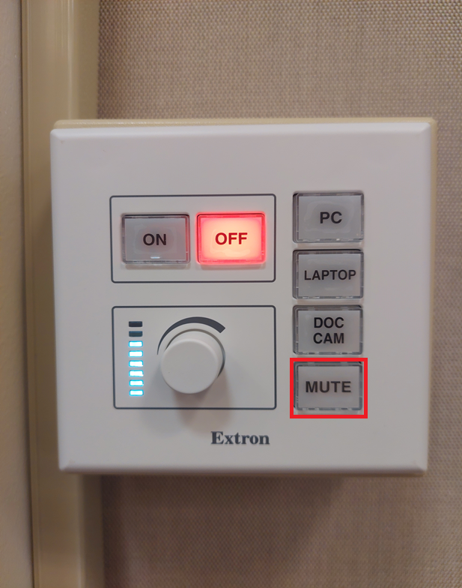

To use the microphone on the podium, press the “PUSH” button.

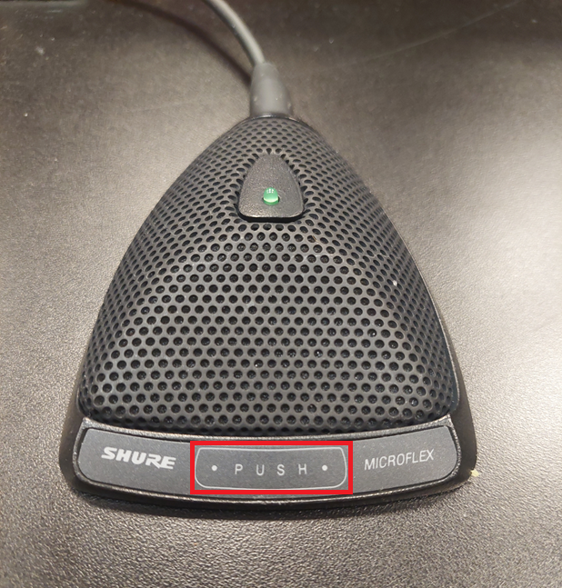

Note: DO NOT use the microphone if you are having a virtual meeting, as it will cause interference. The microphone is only intended to amplify the voice from the person at the podium to those in the room.

Please test all systems at least 30 minutes prior to a scheduled event.

Questions? Want to schedule a walkthrough at least 3 business days before your event?

Contact Isaiah Warner, Hobby School IT Manager, at inwarner@uh.edu.

