LELAND FELLOWS provides University of Houston undergraduate students the opportunity to learn and serve as government interns in Washington, D.C. during the spring semester.  Leland Fellows work full-time from January through the first of May. A monthly stipend is provided through corporate and private sponsors. Leland Fellows also provides paid housing and round-trip airfare.  See www.uh.edu/hobby/interns/leland-fellows for more information. | 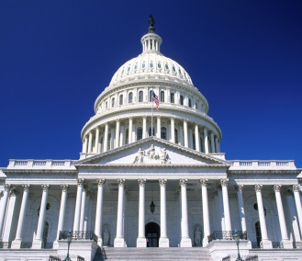
Eligibility Requirements
- Must be a junior or senior at the University of Houston during the fall 2021 semester.
- Must be in good academic standing with a minimum grade point average of 3.0 on a 4.0 scale

Ideal candidates will possess
- Outstanding academic achievement
- Strong writing ability
- Excellent interpersonal skills
- Demonstrated dedication to public service through volunteerism in school and/or community activities
- Government internship or campaign experience

Personal interviews, academic achievement, writing ability, community and school activities, previous internship and/or professional experience, financial hardship, and first generation college status are factors in the selection process.

Program Requirements
Leland Fellows work a minimum of 40 hours per week, participate in meetings and seminars, and complete various academic assignments, making them eligible for 3-12 academic credit hours. All Leland Fellows must be enrolled for the appropriate hours/classes at UH before the initial stipend is issued. Proof of enrollment is required.

Application Deadline: SEPTEMBER 24, 2021

Applications must be typed. Incomplete or late applications will not be accepted.

Submit applications to:
Isaiah Warner
306 McElhinney Hall
Houston, TX 77204-5021
inwarner@uh.edu

Personal information

Name:

Permanent Address:

Current Address:

Email Address:

Telephone:

Age:

UH ID Number:

Major(s):

Minor(s):

Cumulative GPA:

Classification:

Projected date of graduation:

EDUCATION, EXPERIENCE & SKILLS

What courses have you completed that are relevant to a congressional internship?

List experience in political campaigns, governmental internships, and/or community service.

List any technical skills that you have which may be beneficial to a legislative office including all software proficiencies.

List and describe any leadership roles you have held on campus, with community organizations or in employment.

Are you a first generation college student (your parent(s)/legal guardian(s) have not completed a bachelor’s degree at a four-year college or university)?

PERSONAL STATEMENT

Explain why you are applying to Leland Fellows in an essay no more than two pages or 500-750 words (submit as a separate document).

- Discuss your interests in specific public policy issues and community service projects.
- Describe how the internship will benefit your current academic endeavors as well as your long-term career plans.
- Also describe how you could be an asset to a congressional office.

ADDITIONAL DOCUMENTS

Please submit the following along with this document:

□ Resume
□ Official academic transcripts (digital delivery is acceptable; more information here)
□ Two letters of recommendation (up to 3 will be accepted)
□ Proof of financial aid status (screenshot of the current year in myUH Self Service)

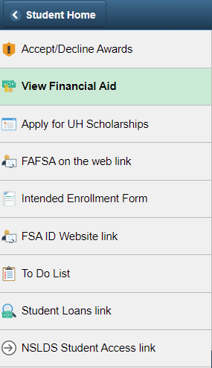

CONFIRMATION & ACKNOWLEDGEMENTS

I understand, that if selected for the program: (please initial)

___ I am required to be enrolled in the mandatory 3 credit hour POLS internship course.

___ I am not allowed to be enrolled in non-internship courses during my time in this program.

___ I will begin my internship the week of on January 18 and my last day will be April 29.

___ I will attend a mandatory orientation prior to the start date.

___ I am required to work the hours that my host office sets, which may include nights and/or weekends and over 40 hours per week.

___ If I am unable to fulfill the responsibilities of this internship program (including academic responsibilities assignments), all funds received as a stipend are subject to being returned to the Hobby School.

The information given in this application is complete and accurate to the best of my knowledge. I am aware that any misrepresentation will result in the disqualification of my application. I hereby give permission to the members of the Leland Fellows selection committee to review this information for purpose of evaluating my eligibility for a position as a Leland Fellows intern.

Signature Date

The University of Houston provides equal treatment and opportunity to all persons without regard to race, color, national origin, sex, age, disability, veteran status, or sexual orientation except where such distinction is required by law. This statement reflects compliance with Titles VI and VII of the Civil Rights Act of 1964 and Title I of the Educational Amendment of 1972 and all other federal and state regulations.

For more information about the Hobby School of Public Affairs and its activities, go to www.uh.edu/hobby.

