1. Log in to Access
2. Select the Faculty/Course Evaluation icon in the screen shot below

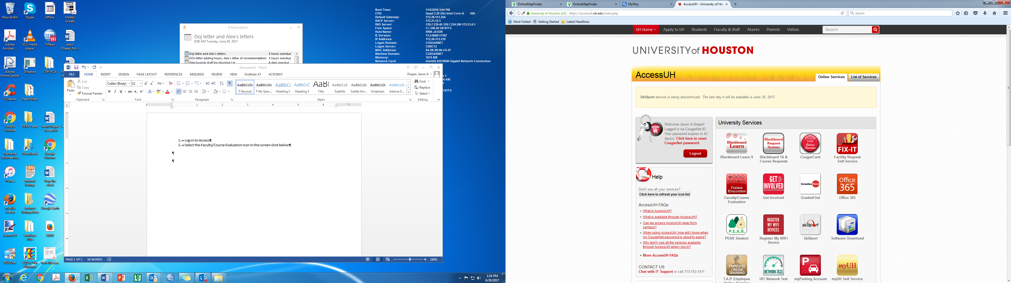

1. Select “Faculty (Additional COUGARNET authentication is required)” from screenshot below

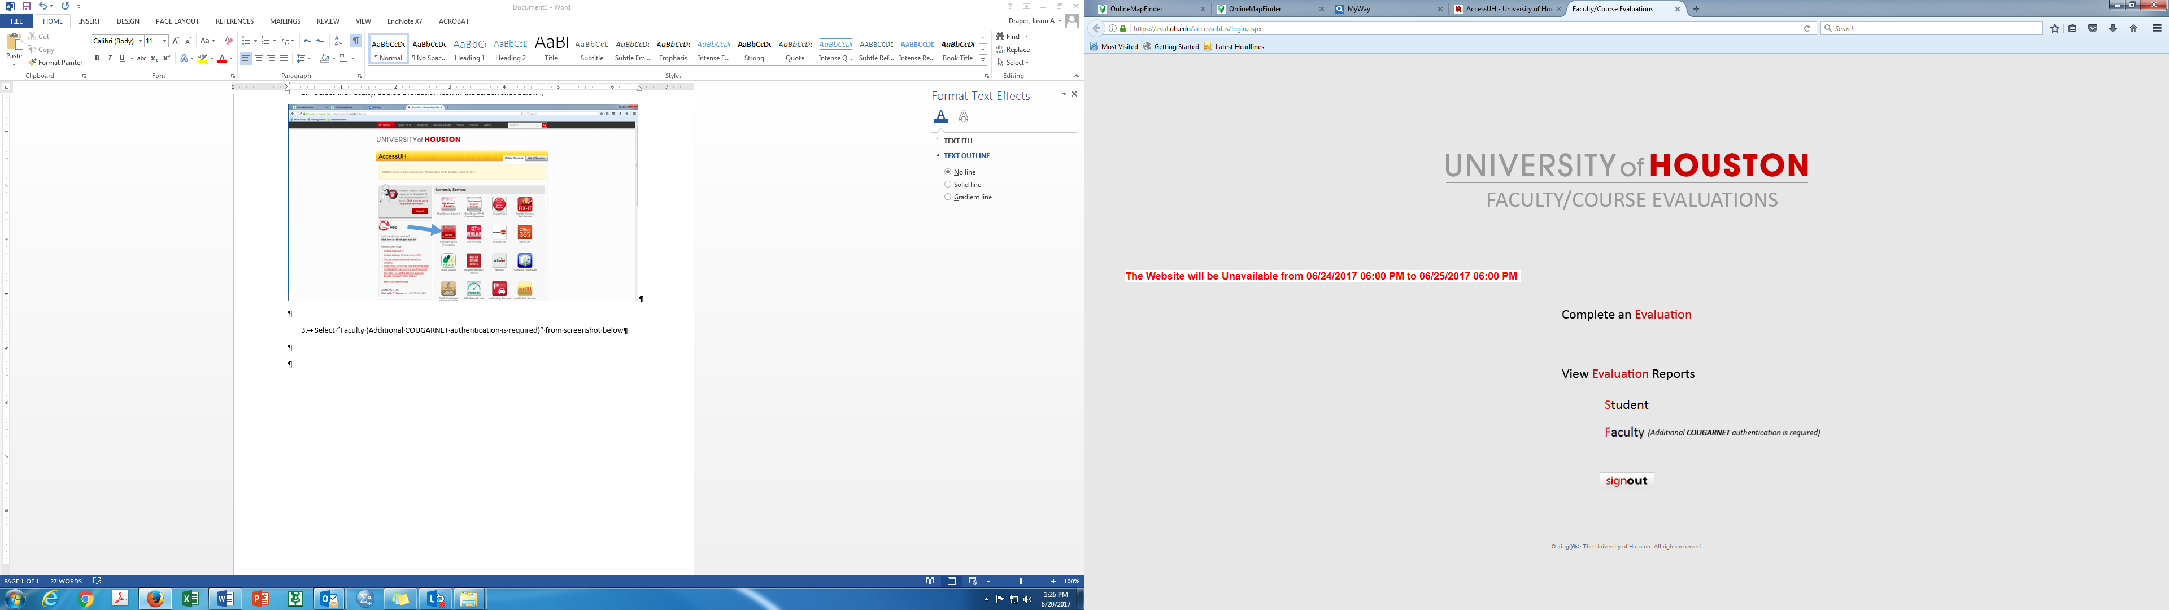

1. On the next screen select Conrad N. Hilton College of Hotel and Restaurant Management
2. On the next screen login using your Cougarnet login
3. On the screen below select “View” under the Faculty Reports section

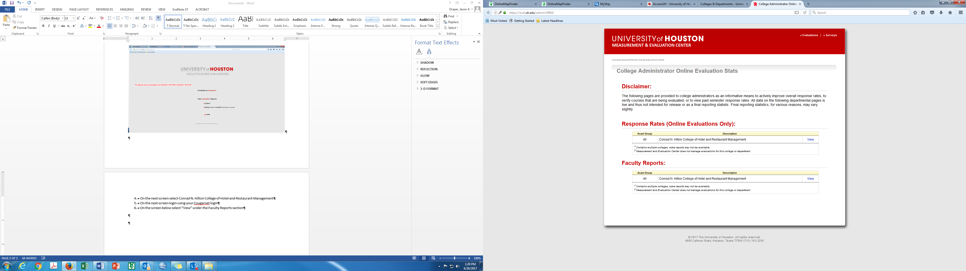

1. Just click “View” for each course listed on the screenshot below. You can also change the semester to get previous evaluation scores using the pull down menu under “Faculty/Course Evaluation Report”

