Reviewing Requests for Information (RFIs)
Overview: RFIs submitted by vendors require review prior response. The process includes the ability for A/Es to get UH reviewer comments use the TEAM INPUT feature.
Reference: N/A

- Click on FORMS  2  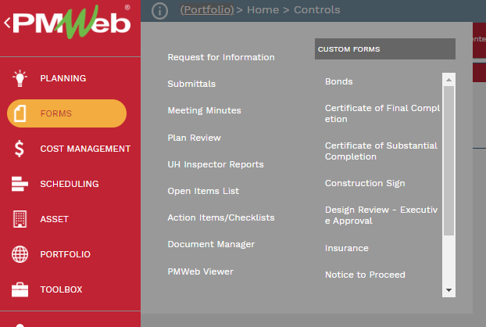  1 | - Click on Request for Information
- OR, click on the link provided in the PM Web notification e-mail.
- OR, select from the Workflow Inbox in your PM Web home screen
Design Team Reviewer
- Select the MAIN tab and review the QUESTION and PROPOSED SOLUTION boxes submitted.
- Select the ATTACMENTS tab and review any attached documents.
- If the RFI requires UH review, use the TEAM INPUT feature in workflow – go to step 12 for TEAM INPUT steps.
- When review is complete, enter a response in the ANSWER box on the MAIN tab.
- Add any necessary attachments in the ATTACHMENTS tab.
- Under the WORKFLOW tab, select the SUBMIT button.
- Select the appropriate action from the ACTION list (RESUBMIT, RETURN, FINAL APPROVE), then click on SAVE.
TEAM INPUT
- To forward the submittal for input from additional team members with PM Web accounts, under the WORKFLOW tab, select the TEAM INPUT button
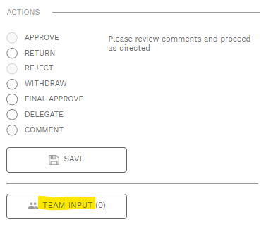
- In the popup window, select team members to receive edit rights for the record. You can start typing a name to refine the list.
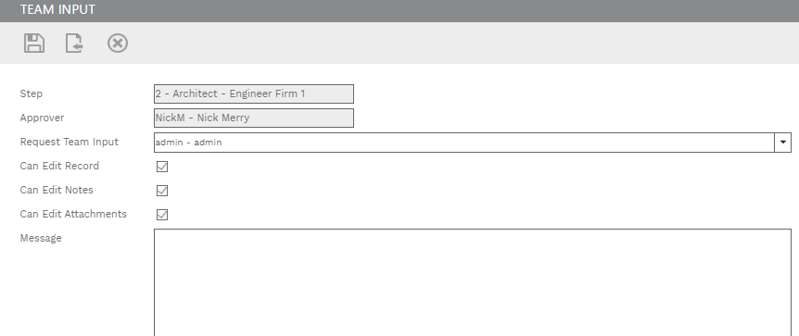
16
13
14

15
- Check boxes for edit rights to be given.
- Enter any comments in the Message box
- Click on the Save & Exit button.
- IMPORTANT, you MUST then click on the SAVE button under ACTIONS for the TEAM INPUT to be sent.

