**Establishing a Project Agreement (Commitment) from a CSA**

**(Master Commitment)**

Overview: Master Commitment records are used for managing Continuing Service Agreements within PM Web. The Master Commitment can then be used to establish individual Service Agreement by establishing Commitments against it.

Reference: N/A

|  |  |
| --- | --- |
| 1. Click on **Cost Management** | 1. Click on **Master** **Commitments** under CONTRACTS     **2** |

1. Review the list of CSAs and select the desired CSA by clicking on the **RECORD #**.

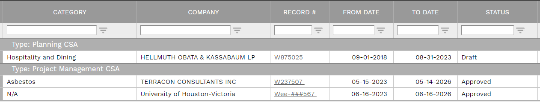

1. After the Master Commitment record opens, select ‘**+ Add Commitment’** from the lower menu.

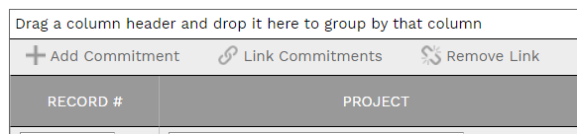

|  |  |
| --- | --- |
| **5**  **6**  **7**  **8**  **9**  **10**  **11**  **12**     1. **Project** field – Select the project from the drop down. Can filter by typing part of the project name. 2. **Record #** field – Enter “Proposed” followed by the next sequential number – i.e. “**Proposed 07**”. If migrating a record enter the project agreement number from the executed project agreement. 3. **Company** field – Auto Populates from Master Commitment 4. **Description** field – Enter a brief description. **If the record is for migration of an executed Project Agreement, type ‘migration’ in the description field to trigger a shortened workflow that approves the record upon starting workflow.** 5. **Type** field- Auto populates. 6. **Agreement Type\*** field – Select ‘Project Agreement’ 7. **Effective Date** field – Leave blank 8. **Days** field – Enter the period of performance. 9. In the **USER DEFINED FIELDS** section on the right, select the Vendor Project Manager from the dropdown menu and enter contact information. 10. Leave remaining fields blank. |  |

|  |
| --- |
| 1. From the top bar, click on the **Save** icon.   14 |

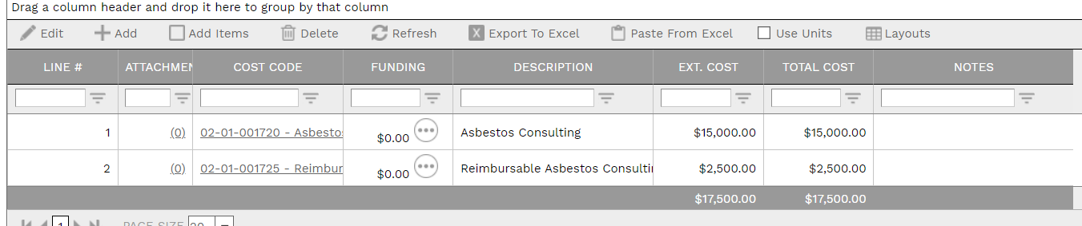

1. Within the Details section at bottom, click on **+Add**.
2. Under the **COST CODE** column, select the appropriate cost code. You can start typing the cost code number or description to narrow the selection.
3. Under the **EXT. COST** column, enter the cost.
4. Click on the **Save** icon.
5. Under the FUNDING column, click the icon to assign funding cost centers.

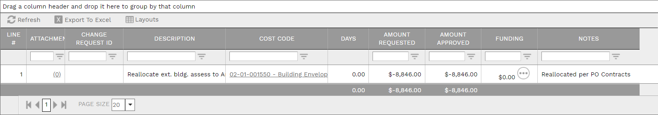

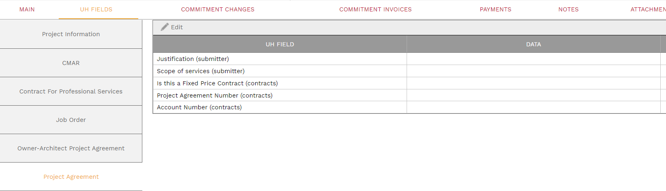

1. Under the **UH FIELDS** tab, select **Project Agreement** on the left.
2. Enter the Justification and Scope of services information in the data fields.

21

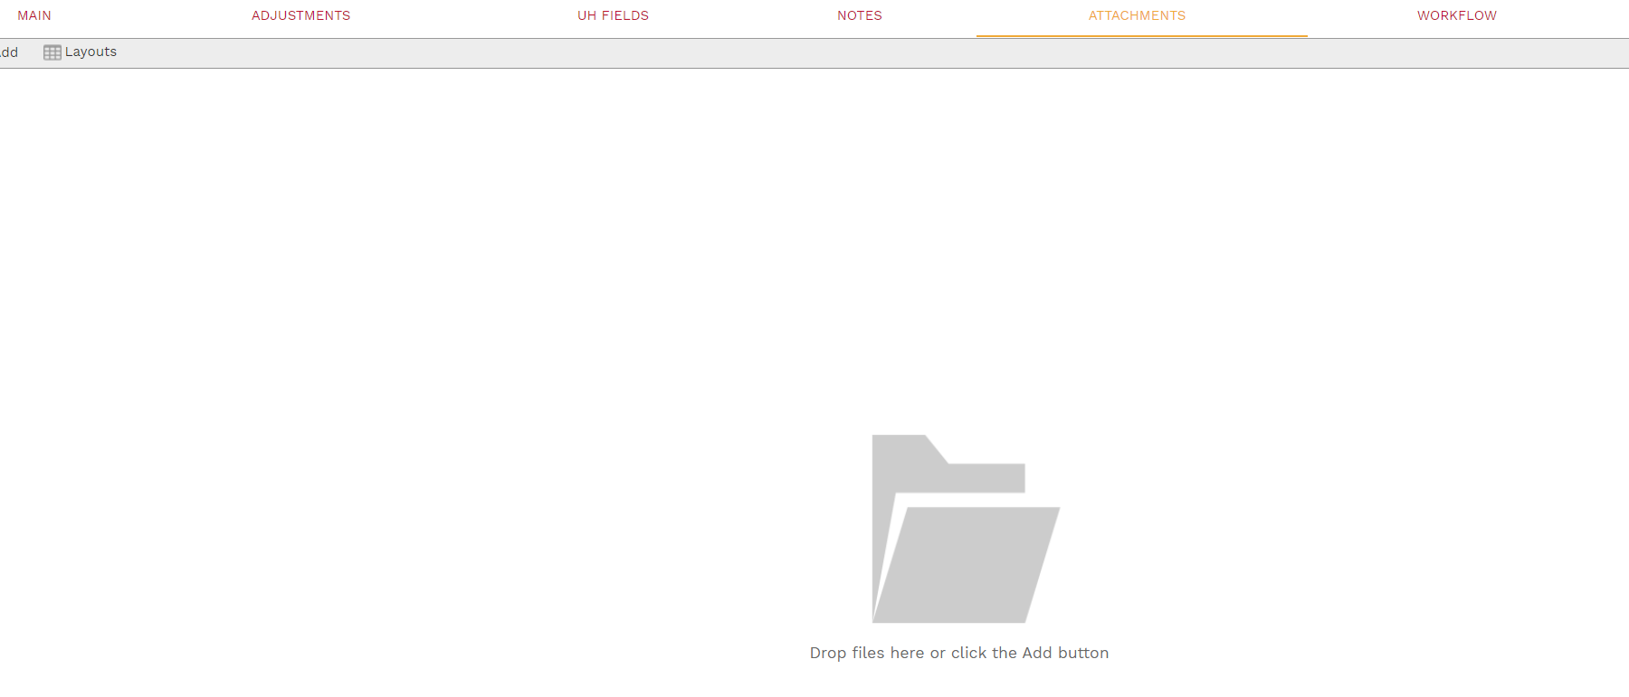

1. Under the ‘**ATTACHMENTS’** tab, add appropriate attachments.

|  |
| --- |
| 1. Under the **‘Workflow’** tab on the top bar, click the **SUBMIT** button.   A picture containing text  Description automatically generated  23 |

|  |
| --- |
| 1. If desired, type any comments in the **Comments** field**.**   24    24   1. Click the **SAVE** button in the Action box. 2. **The Project Manager may also need to complete a budget realignment to ensure adequate budget amounts in applicable cost codes.** |

**Contract Coordinator**

1. Navigate to the record.
2. Review MAIN, UH FIELDS and ATTACHMENTS tabs.



1. Under the **UH FIELDS** tab, select **Project Agreement** on the left.
2. Enter data in the ‘Is this a Fixed Price Contract’.
3. Under the **UH FIELDS** tab, select **Signatories** on the left.
4. Enter data for the name and title of signatories.
5. Click on the **Save** icon to save edits.
6. Edit the **Record #** field to the final number to be routed for electronic signature i.e. “**07”**.

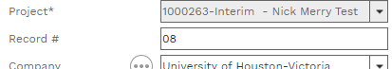

**31**

1. Prepare the final project agreement package and route for electronic signature.
2. Upon final signature, update any information including if **Record #** has changed, and attach the executed package using the ATTACHMENTS tab.
3. Click on the **Save** icon to save edits.
4. Under the ‘**WORKFLOW**’ tab on the top bar, select Approve, and click the **SAVE** button.

**PM Sending the Executed Project Agreement to the Service Provider**

1. To send a copy of the executed Project Agreement to the Service Provider, select the **NOTIFICATIONS** tab and then **+Add**.



1. **To** field – Click on the  icon then select Service Provider contacts. To narrow the list, type the company name in the company filed and click on the three lines.

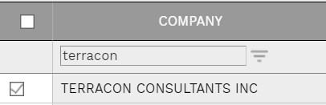

1. **CC** field – Click on the  icon to add PM Web Users as CCs.
2. **Manual CC** field – Enter any e-mail address for persons not in PM Web. Include “poctract@central.uh.edu" as a manual CC.
3. **Notification type** field – Select ‘Fully Executed Contract Document’ from the drop down list.
4. **Subject** field – Enter the following: ”WXXXXXX [*vendor name*] CSA ([*CSA Category*]) Fully Executed Project Agreement *[Record* #].” For example “W247007 Aviles CSA (Materials Testing) Fully Executed Project Agreement 07”
5. **Include Link** check box – Ensure this box is NOT checked.
6. Remaining fields can be blank/unchecked.
7. Under the ‘SELECT TO ATTACH TO EMAIL’ list, select the Fully Executed SP Copy attachment.
8. Click on the **Send** icon

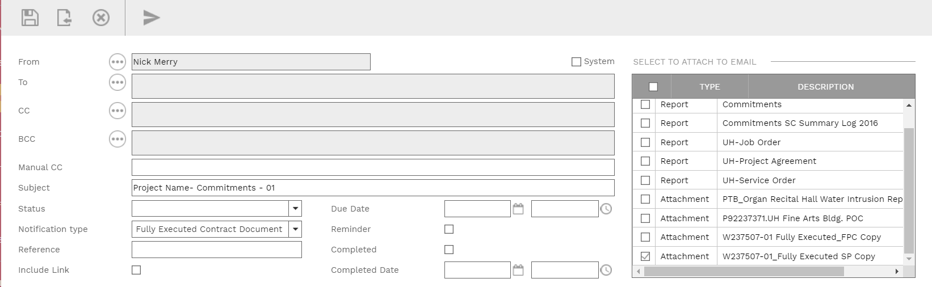

**45**

1. Under the ‘**WORKFLOW**’ tab on the top bar, select Final Approve, and click the **SAVE** button.
2. Process complete