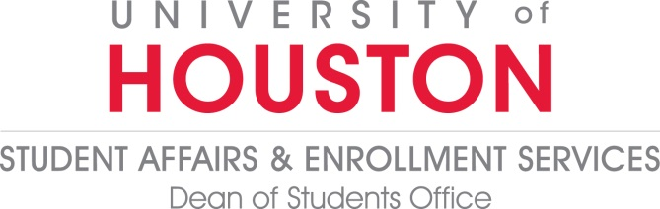

Goals: 2018 - 2019

- Identify and implement innovative practices that improve and enhance DOS programs and services (DSAES Value: Transparency & Accountability)
  - Launch targeted and intentional social media plan in August, 2018
  - Leverage DOS Leadership Council in spearheading major campus project (i.e. food pantry, etc.)
  - Explore options for making student conduct process paperless.
  - Integrate a Dean-on-call Online accessibility option
  - Translate pertinent online and public-facing documents to Spanish and other languages
  - Align Student Outreach and Support services with professional Case Management Standards
  - Explore utilizing Mapworks and SharePoint with SOS Collaboratives (Coordinated Care, Self-Care Coaching and Las Comadres College Mentoring Program)
  - Develop and launch the Student Outreach and Support newsletter
  - Coordinate tabling schedule at different venues for DOS outreach, including display and presentation materials
  - Work with campus partners to build “student profile” information ahead of time-of-service appointment with SOS and Student Advocacy (i.e. Maxient, PeopleSoft, MapWorks, Advisor portals, etc.)
  - Assess student learning that occurs as a student employee within the Dean of Students office

- Collect benchmark data to improve customer service experience within DOS programs, services, and staff. (DSAES Value: Transparency & Collaboration)
  - Continue to collect customer service feedback through survey
  - Conduct focus groups and/or secret shopper experience
  - Collect feedback on content and open rate for Student Outreach and Support Newsletter
  - Continue to collect assessment data on Student Outreach and Support Collaborative
  - Reach out to at least three departments on-campus and do presentations informing them about the services provided by DOS
  - Utilize commuter survey data to create commuter profile that will be distributed to campus partners
- Enhance campus partnerships and grow off-campus relationships to develop and improve UH student experience. (DSAES Value: Accountability)
  - Develop a Sugarland presence/integrate our involvement to support UHSL students
  - Partner with UHPD to establish an MOU regarding student behavior, development, and discipline to ensure best practices are in place for students
  - Develop strategic partnerships with campus and community organizations to participate in SOS CARE Fair
  - Develop strategic SOS partnership to support (through sponsorship) an existing or new program focused on student support
  - Assist UHSL faculty and staff with the interpretation and implementation of UH Policies and Procedures
  - Empower SHRL to place and remove 100% of their own conduct holds
  - Create a campus partners advisory/work group for Parent & Family Programs
  - Partner with faculty (academic affairs) to create strategic partnership opportunities that enhance faculty member awareness of DOS programs and services

