DIRECTIONS TO THE COGNITIVE DEVELOPMENT LAB
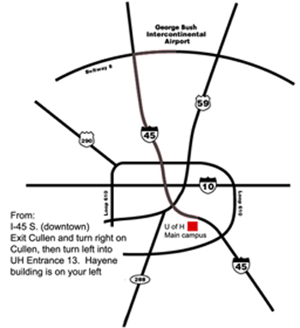
Cognitive Development Lab is located in the Heyne Building on the University of Houston, main campus. The building is located on the side of Cullen Blvd. (Cullen Blvd. and Entrance 13) Please call if you need further assistance to get to Cullen Blvd. at 713-743-4876.
Turn onto Cullen (LEFT if coming from I-45 South OR RIGHT if coming from I-45 North). Then make a turn onto Cougar Place Drive (LEFT if coming from I-45 OR RIGHT if coming from N. MacGregor). At the stop sign, follow the curve towards the left. The Cognitive Development Lab reserved parking spot should be the first spot to your right.

CONTACT INFORMATION

