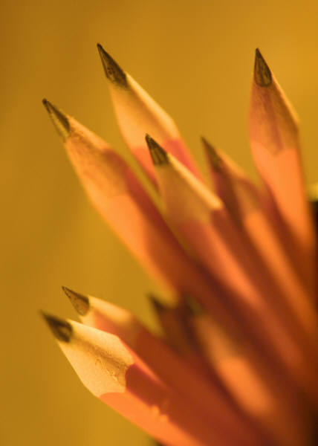
Writing Sample

Fall 2013

Date: Monday December 9th

Location: Conrad Hilton Ballroom UH Hilton
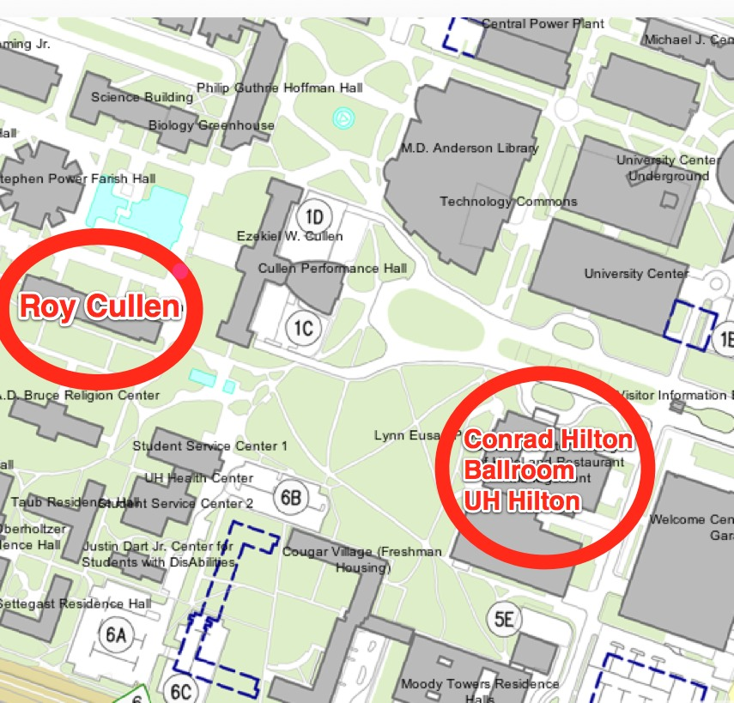
Time:
- Levels 1-2: 9:00-10:00am
- Level 3: 10:00-11:00am
- Level 4: 11:00am-12:00pm
- Levels 5-6: 12:00-1:00pm

You MUST have a picture ID in
order to take the Writing
Sample!



