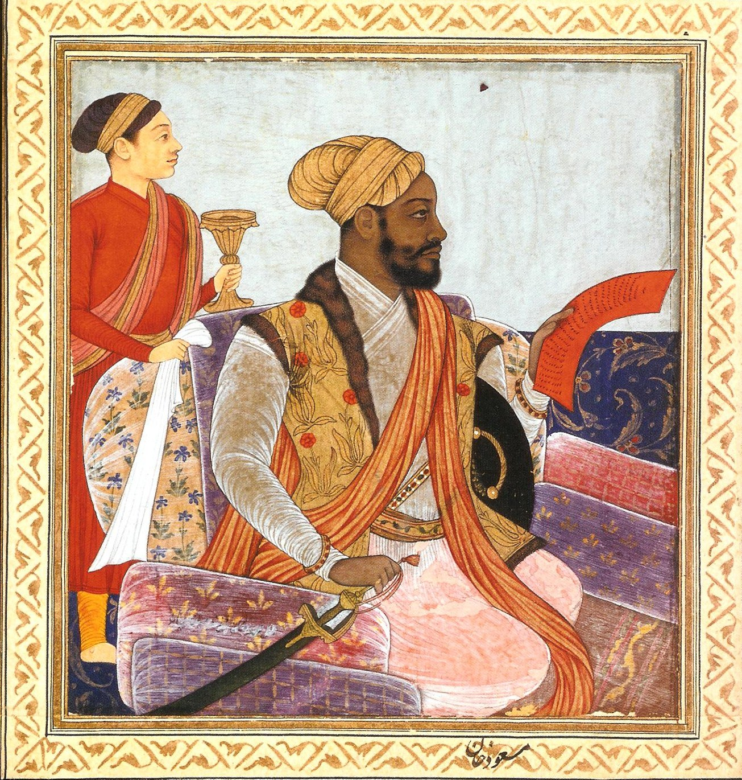
Contact Dr. Klieman for any questions:

kklieman@uh.edu
History 3391/CCS 3394:
Africans and
the Indian Ocean World

Who is this African and how did he come to rule an Indian Empire?

Find out in History 3391!

TOPICS INCLUDE:
-Africans and the Indian Ocean Trade Systems, 300-1900 CE

-Islam as a World System

-Egyptian, Ethiopian, and Swahili History

-The African Diaspora
in: India
Pakistan
Iraq
Oman
Kuwait

History 3391-Section 36969
Africans and the Indian Ocean World
M/W 2:30PM TO 4:00 PM
AH 104
Dr. Kairn Klieman

