CARIBBEAN DIASPORA
LITERATURES

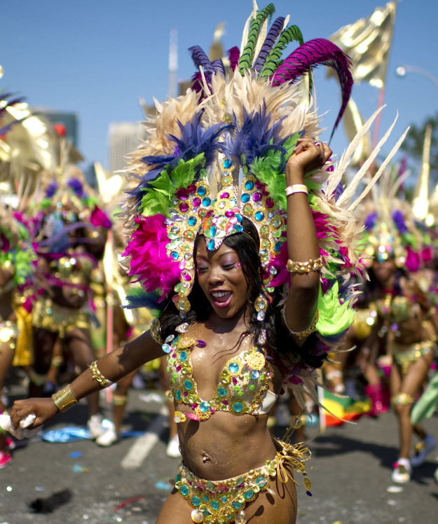
ENGL 3369
Course #: 24033

WCL 3397
Course #: 26327

CCS 3394
Course # 25807

Tuesday and Thursday
10am-11:30am

Instructor:
Dr. Kavita Singh

Questions? Write:
kasingh@uh.edu

It may call to mind beaches, reggae, and voodoo, but the Caribbean is also a nexus of rich literary production. This course will introduce students to fiction, poetry, drama, and other genres of literary creation from the Caribbean and the Caribbean diaspora in Europe and North America. We will explore how colonization and anticolonial resistance has demanded innovations in form and language in Caribbean writing. How cultural and literary creativity has emerged despite a history of enslavement, repression, and alienation. How the far-flung diaspora impacts the development of national Caribbean literatures, making this regional tradition also inherently global. And throughout, we will ask how gender and sexuality are represented, suppressed, or voiced through and with these dominant themes, confronting the violence and productivity of both inherited practices and of newly created ones.

Students can receive credit for: World Cultures and Literatures (WCL); African-American Studies (AAS); Women’s and Gender Studies (WGS); and Comparative Cultural Studies (CCS).

In English (ENGL), this course meets the Category 6 requirement
and the post-1950 requirement.

