Yearly Campus Solutions Security Access Audit Instructions
This document provides instructions on running the yearly Campus Solutions Security Access Audit.
HR and Finance have their separate Yearly Access Audit. This document is regarding Campus Solutions.
Please note that the audit instructions have changed, starting May 2022, specifically for the “Business Administrators/Authorized Signers Responsibilities” section.

University of Houston System
Campus Solutions Services
Contact the CSS Security Team (Javaria Saeed) at
SA-Security@uh.edu or at 713-743-8582 for questions or concerns.

Last updated: May 17, 2021

The Campus Solutions Services (CSS) Security team is requesting your review and acknowledgement of Campus Solutions (CS) security access for employees in your division/college/department. This review is to ensure that users are active employees/Persons of Interest and that access is appropriate for their job duties. The Roles by Operid is a report located in Campus Solutions that shows Campus Solutions access assigned to employees in your division/college/department. Instructions for running the report, as well as a guide to security roles, are below.

Business Administrators/Authorized Signers Responsibilities:
- Please have the managers verify that the Campus Solutions access for their direct reports is appropriate.
- If any access should be removed, the manager or the manager’s designated reviewer should strike through the role on the report and write “REMOVE” to note removal. Security roles will be removed when we receive the report.
Please note, additional access cannot be granted during this audit. Access will be removed only. If a user needs additional access they should complete the Campus Solutions Access Request form.
The report has a summary page that lists all the departments that the report includes. If the list contains more departments than you reviewed, please strike a link through any departments that you did not review and write “DID NOT REVIEW.” Please sign and fill out the information on the last page of the report. Please see example below:
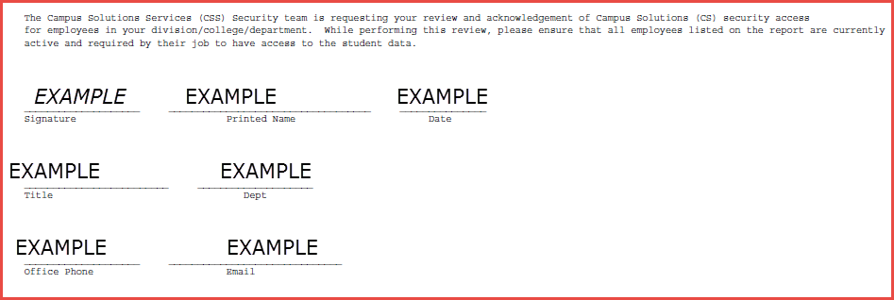
If you received the report from somebody else (meaning someone else ran it for you) and there is no summary page, please write all the department IDs that you have reviewed. Also, sign, print your name, date and include your title, your department ID, office phone and email. By signing the CS SECURITY AUDIT REPORT, you are ensuring that all employees listed on the report are currently active and required by their job to have the access identified on this report.

Reports should no longer be emailed to SA-Security@uh.edu. CBAs are expected to upload reports to the CS Security Access Audit Report to the Key Dates SharePoint folder.
This change in business practice was made at a high level by College Business Owners and Administration and Finance, in order to streamline the yearly review for Campus Solutions, HR and Finance.
Here is the link to the SharePoint site:

https://uofh.sharepoint.com/sites/cfa/controlleroffice/FY20202021/Forms/AllItems.aspx

If you need access to the ControllerOffice Sharepoint Site, please contact Andrew Hoang.
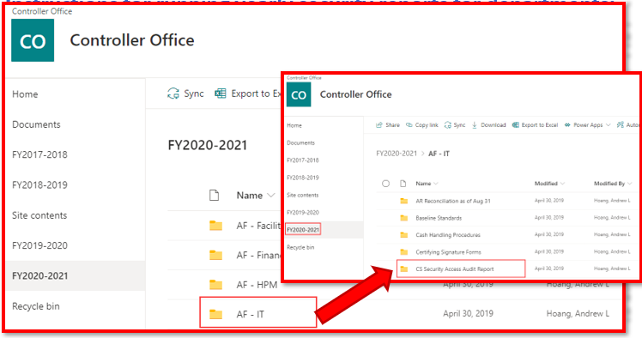

Instructions for running yearly security reports for departments:

- Log into Access UH or my.uh.edu and be sure to click on the Campus Solutions icon. 

- Navigate to Main Menu > PeopleTools > UHS PT Custom > UHS Security Reports > Security Audit Report CS
If you ran this report before, please find your Run Control ID. If you have never run this report, please click on the tab ‘Add a New Value’ and add your own unique Run Control ID and click Add. A screenshot is below:
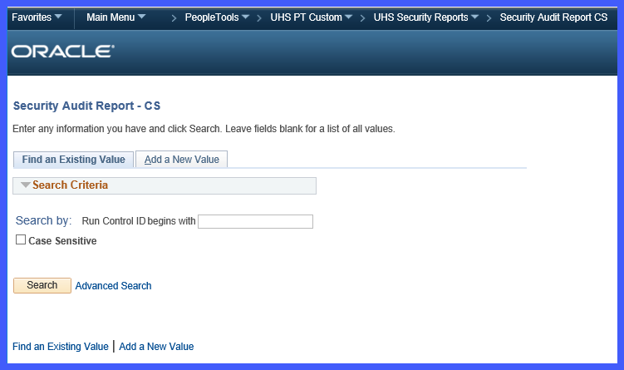

- Enter all appropriate fields on the left hand. The more fields that are filled out, the more specific the report will be. For example, if only business unit is filled out, the report will include all divisions, colleges, and departments, and employees under that business unit. If business unit and division id are filled out, the report will include only the colleges, departments and employees under that division. If business unit, division id and college id are filled out, the report will include only the departments and employees in that college. Finally, if department is filled out, the report will include only the employees in that department. Alternatively, the ‘Quick Fill’ box will automatically fill in the fields if you put in your college id or department id.

- With all the parameters, except for Emplid, filled out, select the Roles by Operid report (the middle radial button). And click the Run button on the top right of the page. Click OK on the following screen

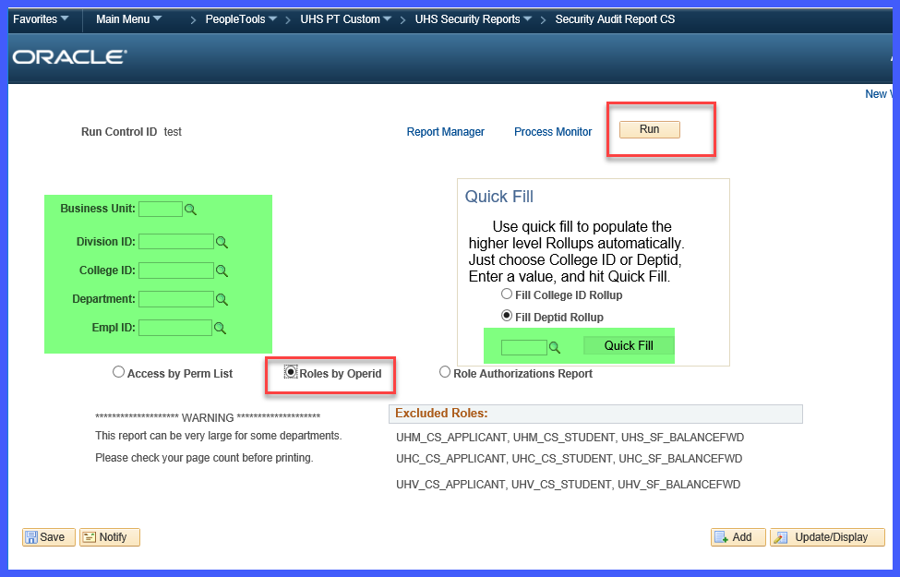

- After clicking OK, it will take you back to the previous page where you set up the report. Click on Process Monitor. Note the Process Instance number.
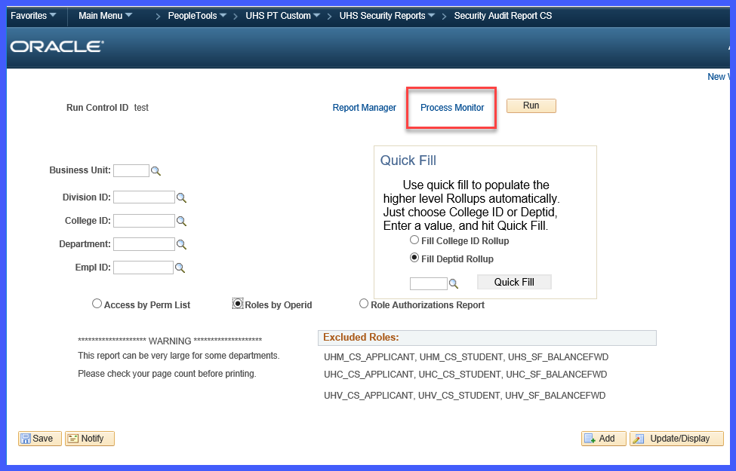

- On the screen that pulls up, make sure your ID is in the User ID field. Make sure the Date Range includes the date that the report was run. Click the Refresh button and wait for the Run Status to state ‘Success’ and Distribution Status to state ‘Posted’. Click Details link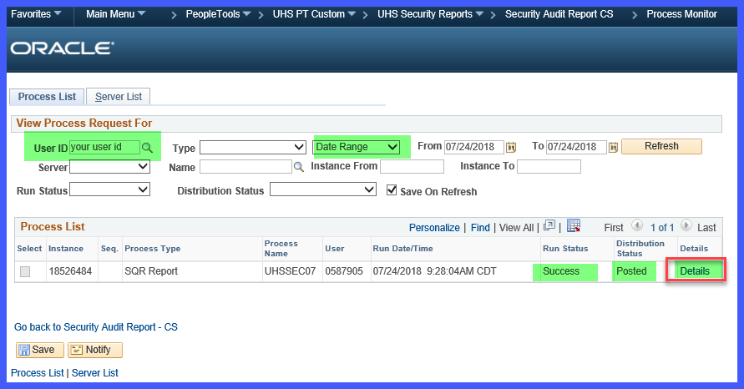

- On the next page, Click View Log/Track link.
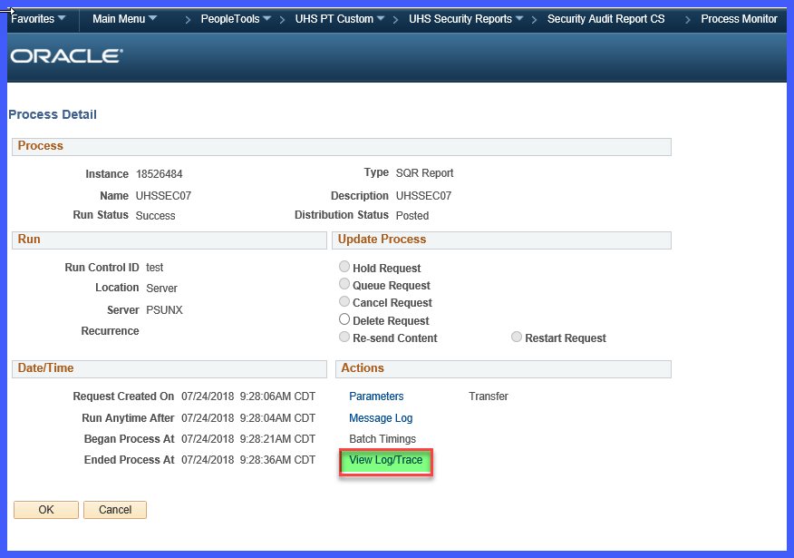

- On the next page, Click on the PDF report as in the image below.
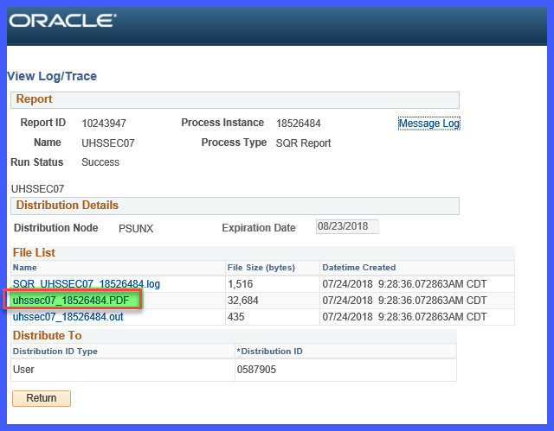

- Once you’ve opened your PDF, make sure your report says “SAPRD” instead of “HRPRD.” Please see image below.

- Now that you have the report, refer to the Business Administrators/Authorized Signers Responsibilities section on the first page of this documentation to complete the review.
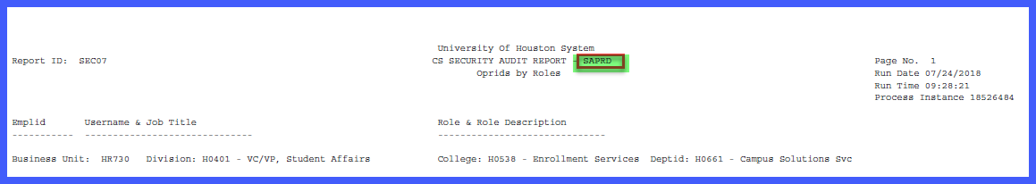

The guide below lists the most common Campus Solution roles and access. Roles have access to numerous pages within Campus Solutions and the level of access varies from viewing data, updating data, adding new data, and correcting historical data. Your signature at the end of the report signifies that you approve the user access. For any questions on roles, contact sa-security@uh.edu.
The following roles are assigned to Instructors, who have taught and/or are teaching a class to access Self-Service to enter grades, view student data, etc. After an instructor’s term is complete they can longer add/edit grades. They can only view past terms.

UHC_CS_INSTRUCTOR | UH Clear Lake Instructor
UHM_CS_INSTRUCTOR | UH Main Campus Instructor
UHV_CS_INSTRUCTOR | UH Victoria Instructor

The following roles are common roles given to users who have requested the access through the Campus Solutions security form. The roles require approval by the module business owner at time of request and may have View, Add, Update, or Correction access.

UHCSM_CC_GENERAL | View only access to basic student bio/demo data
UHCSM_SF_GENERAL | View only access to student account data
UHCSM_SR_GENERAL | Basic level view access to Student Records data
UHCSM_CC_BIODEMO_VW | View only access to non-student bio/demo data
UHCSM_AD_GENERAL | Basic level view access to Admissions data
UHCSM_AA_ADVISOR | Basic level view access to Academic Advisement data
UHCSM_SR_ADVISOR | View access to Student Records data for advising
UHCSM_AA_CHKIN_FRNTDSK | Access to check in student in advising check in system
UHCSM_SR_ENROLL | Update access to enroll students
UHCSM_AA_CHKIN_RPTS | View access to check in system reports
UHCSM_CC_3C_UPD | Update access to checklist, comments, communications
UHCSM_AA_UH4_MGMT | Add/update access to UH4 setup
UHCSM_AA_APPT_FRNTDSK | Access to check in students in appointment system
UHCSM_SR_CLSS_SCHEDLR | Update access to create/maintain class sections and generate permission numbers.
UHCSM_CC_BIODEMO_STDNT_UPD | Update access to student bio/demo data
UHCSM_SR_PRG_PLN_UPD | Update access to update program/plan.
UHCSM_AA_APPT_ADMIN | Add/update access to appointment system setup
UHCSM_FA_GENERAL | Basic level view access to Financial Aid data
UHCSM_SR_GRAD_PROC | Update access to graduation tracking functionality
UHCSM_SR_GRDCHG_APPRV | Update access for grade change approval, particularly grade change list
UHCSM_AD_APPL_MAINT | Update access to maintain applications
UHCSM_CC_SVC_IND_MASS_PROC | Update access to mass assign/release service indicators
UHCSM_AA_CHKIN_ADMIN | Add/Update access to check in system setup
UHCSM_CC_EVENT_SETUP_VIEW | View access to Event setup pages
UHCSM_CC_3C_SETUP | Add/Update/Correct access to 3C setup
UHCSM_PT_SECADMIN_VW | View access to PeopleTools/Security pages
UHCSM_AD_TRNSFR_VW | View access to admissions transfer credit data
UHCSM_SR_STUGRPS_CORR | Correct access to Student Group data
UHCSM_CC_BIODEMO_UPD | Update access to non-student bio/demo data
UHCSM_FA_ASSISTANT | Update access low-level financial aid pages
UHS_CS_QRYRR / UHS_CS_REPORT | View queries
UHS_CS_QRYRC | Write queries
UHCSC_CC_GENERAL | View only access to basic student bio/demo data
UHCSC_SR_GENERAL | Basic level view access to Student Records functionality
UHCSC_SR_CLSS_ROSTER_VW | Class roster view access.
UHCSC_SR_REPORT | Common Student Records Reports
UHCSC_AD_GENERAL | Basic level view access to Student Admissions functionality
UHCSC_SR_ADVISOR | View access for student advisement pages
UHCSC_CC_BIODEMO_STDNT_UPD | Access to update student biodemo data
UHCSC_CC_BIODEMO_UPD | Access to update non-student biodemo update role
UHCSC_AA_ADVISOR | Basic level view access to Academic Advisement functionality
UHCSC_CC_3C_UPD | 3C update and setup role
UHCSC_AA_RPTS | Access to academic advisement reports
UHCSC_SF_GENERAL | View only access to student account data
UHCSC_SR_CLSS_VW | Access to view class schedule
UHCSC_SR_CLSS_UPD | Access to Upd class schedule
UHCSC_SR_PRG_PLN_VW | view program/plan
UHCSC_SR_PRG_PLN_UPD | Program Plan Update
UHCSC_AD_PR_MAINT | Access to maintain prospects functionality
UHCSC_AA_CHKIN_ADMIN | Add/Update access to check in system setup
UHCSC_SR_ENROLL | Update access to enroll students
UHCSC_AA_CHKIN_FRNTDSK | Access to check in student in advising check in system
UHCSV_SR_GENERAL | Basic level view access to Student Records functionality
UHCSV_CC_GENERAL | View only access to basic student bio/demo data
UHCSV_SR_CLSS_ROSTER_VW | Class roster view access.
UHCSV_SR_CLSS_VW | Access to view class schedule
UHCSV_SR_ADVISOR | View access for student advisement pages
UHCSV_AD_GENERAL | Basic level view access to Student Admissions functionality
UHCSV_CC_3C_UPD | 3C update and setup role
UHCSV_SF_GENERAL | View only access to student account data
UHCSV_SR_ENROLL | Update access to enroll students
UHCSV_FA_GENERAL | Basic level view access to Financial Aid functionality
UHCSV_PT_HELPDESK_UPD | Access to change password through Help Desk Page
UHCSD_CC_BIODEMO_VW | View only access to non-student bio/demo data
UHCSD_CC_3C_UPD | 3C update and setup role
UHCSD_CC_GENERAL | View only access to basic student bio/demo data
UHCSD_AA_ADVISOR | Basic level view access to Academic Advisement data
UHCSD_AD_APPL_MAINT | Update access to maintain applications
UHCSD_FA_CUSTOMER_SVC | Basic level view access to Financial Aid functionality
UHCSD_AD_GENERAL | Basic level view access to Student Admissions functionality

