Peoplesoft Financials 8.4

Module: GL AP PO AR BI AM PC INV
Training Guide | GL235
DESCRIPTION | Run an Existing Query to Excel  Instructions for Internet Explorer
PATH | Reporting Tools, Query, Query Viewer  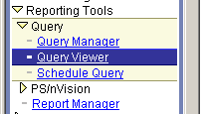

INSTRUCTIONS  STEP 1 | Navigate to the desired page (see above path) and select Query Viewer.  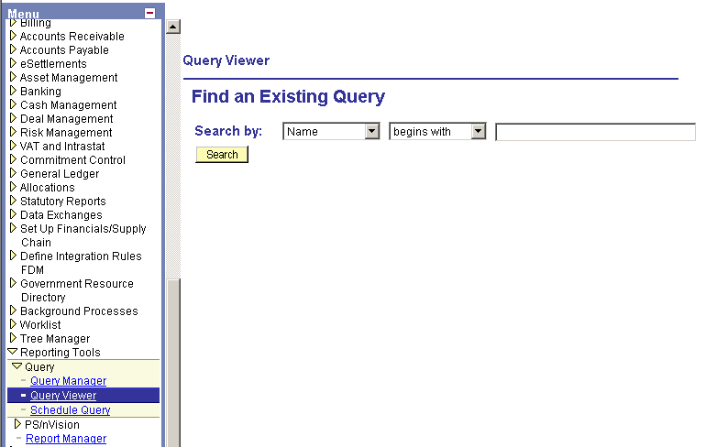

STEP 2 | Enter the query name UHS_BUD_INQ_ADJUSTMENT_PUB.  Click Search.  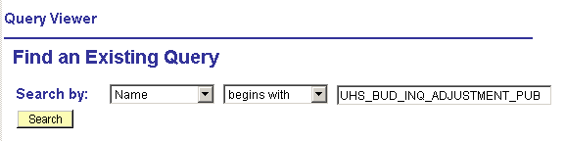  Note: Use the drop-down boxes to search by Name or Description; begins with or contains.

STEP 3 | The search results appear. Click on the Run link for the query.  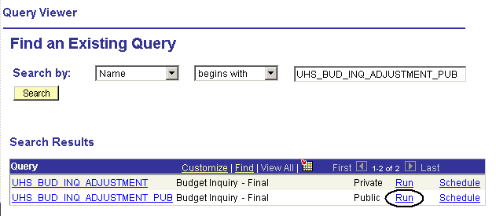  Note: If Browse in the same window is deselected in your Excel settings (see separate instructions), you can click on either the query name hyperlink or the Run hyperlink.

STEP 4 | The query prompt page appears. Enter your Business Unit, Ledger, Budget Reference, DeptID, Fund, Program and Project values. Click the View Results button.  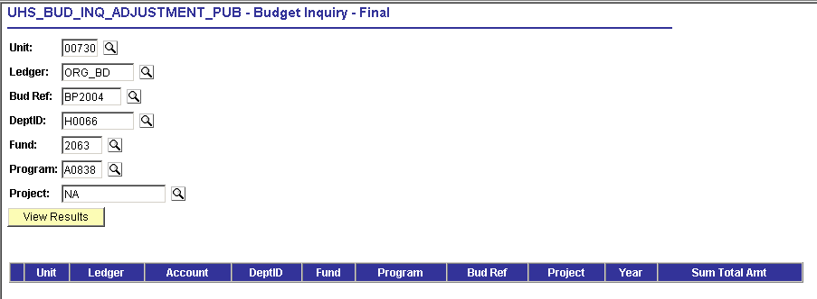

STEP 5 | The query results display beneath the entered criteria. To send the query results to an Excel spreadsheet, click on the Excel SpreadSheet link located above the query results.  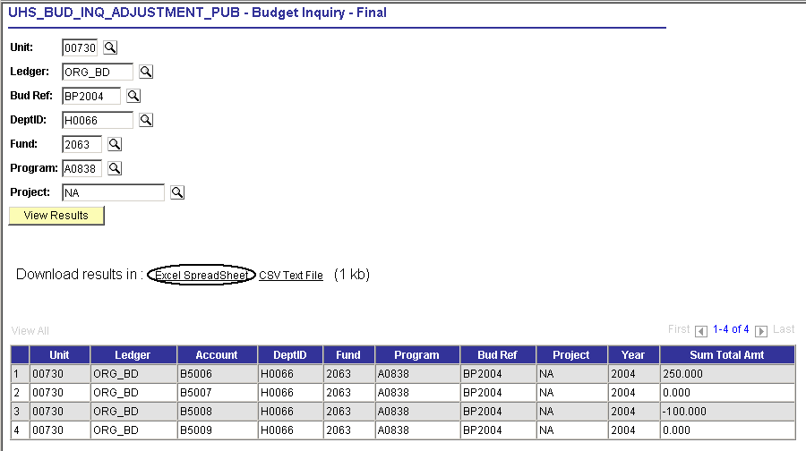

STEP 6 | The File Download window appears. Click on the Save button.  Choose the Open button to view results in Excel without saving the file.  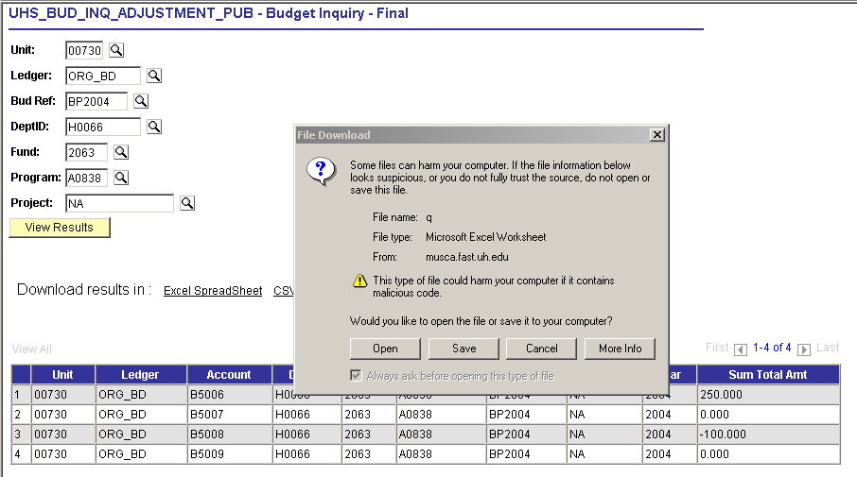  Note: The File Download window will not open if your Excel settings are not set to confirm opening after downloads. In this case, you would skip Step 6 and go straight to Step 7.
STEP 7 | Select the save location (drive & folder), enter a File name and Save as type of Microsoft Excel Worksheet. Click Save.  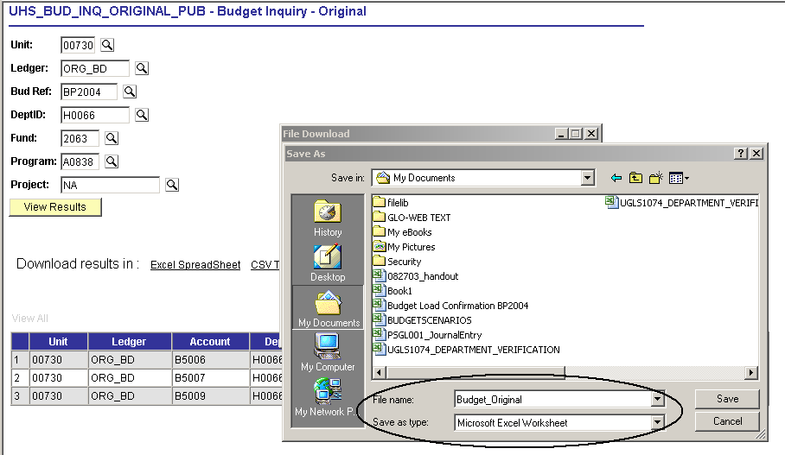

STEP 8 | Once the Download is complete, click on the Open button.  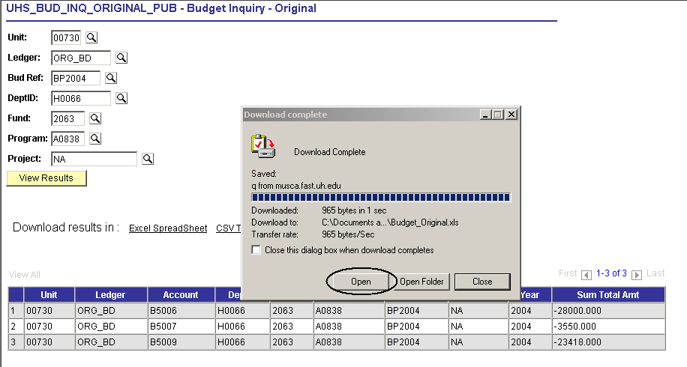
STEP 9 | Excel is launched and the results have been saved to an Excel file.  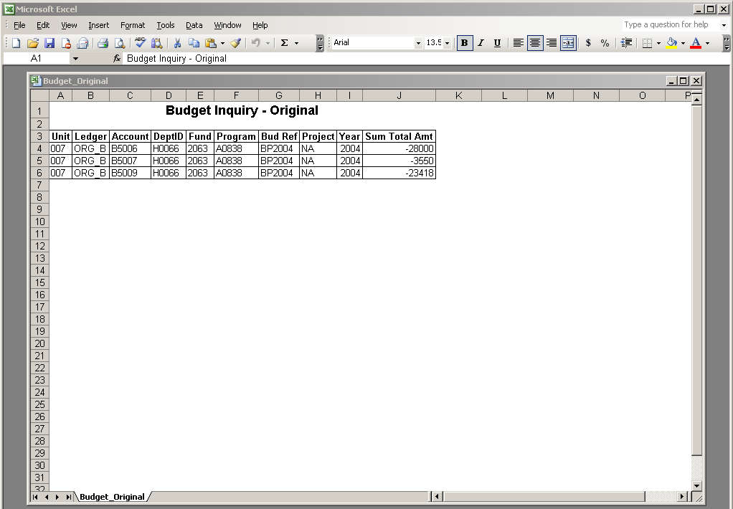
EXPECTED RESULTS  (attach copies of supporting reports or panel shots, if desired) | User can successfully run a public query and download the results to an Excel spreadsheet.

