Normal Distributions

Family of distributions, all with the same general shape

Symmetric about the mean

The y-coordinate (height) specified in terms of the mean and the standard deviation of the distribution

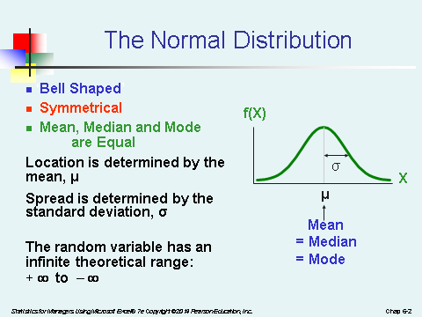

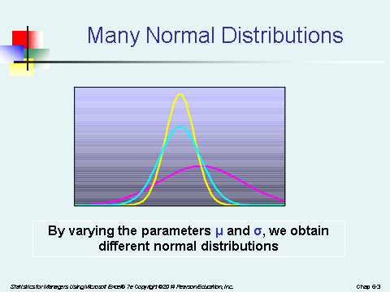

Note the properties of the normal curve and note that probabilities associated with it are represented by the area above the axis and under the curve. The total area under the curve is 1 (i.e. 100%). The curve is symmetric about a line that extends up from the mean (plotted on the axis) – so the area above the curve on each side of the line is 0.5.

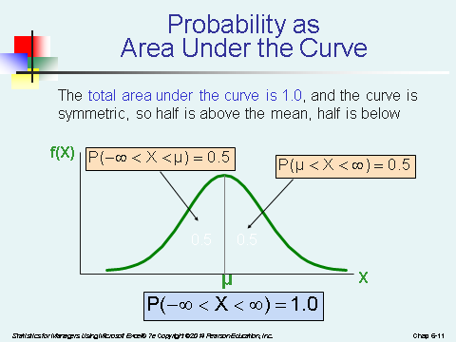

To find understand probabilities associated with the normal curve, it is best to sketch the curve and indicate the area that shows the probability of interest.

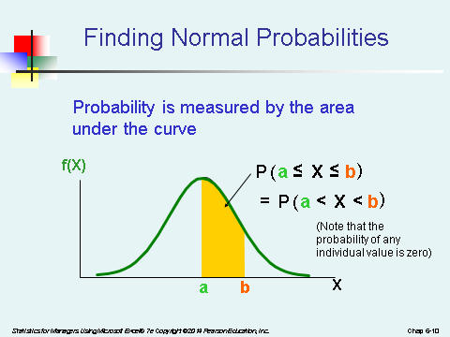

Standard Normal Distribution

The standard normal distribution is a particular normal distribution with μ =0 and σ =1. It is typically used to find probabilities associated with the normal distribution.

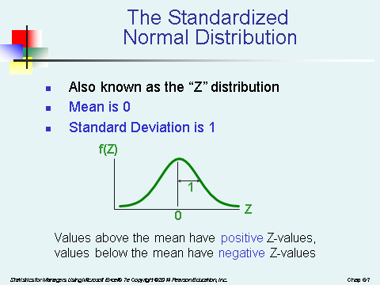

Transformations

Normal distributions can be transformed to the standard normal. We use what is called the z-score which is a value that gives the number of standard deviations that X is from the mean.

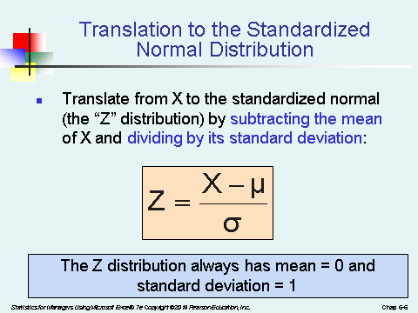

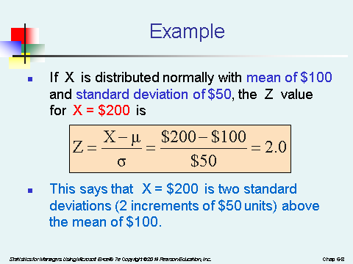

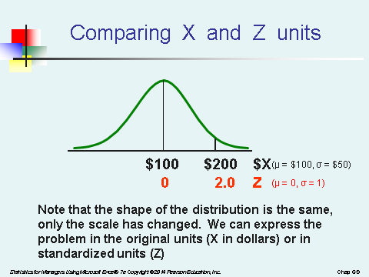

Finding Probabilities Associated with the Normal Distribution
Draw the normal curve for the problem in terms of X. Translate X-values to Z-values
Use the normal table or Excel to find the probability.

Example
Let X represent the time it takes, in seconds to download an image file from the internet.
Suppose X is normal with a mean of 18.0 seconds and a standard deviation of 5.0 seconds. Find P(X < 18.6) sec.

Using XL, you can solve the problem directly or by transforming the X value to a z value.
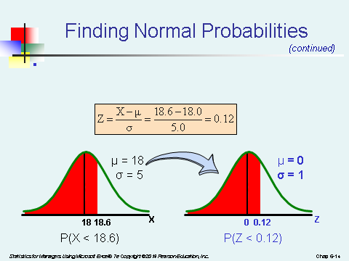
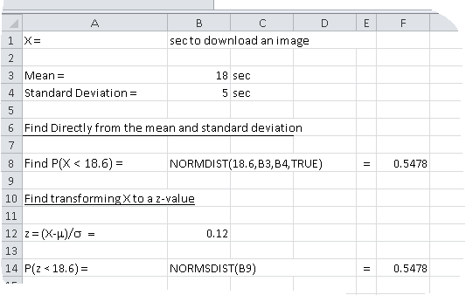

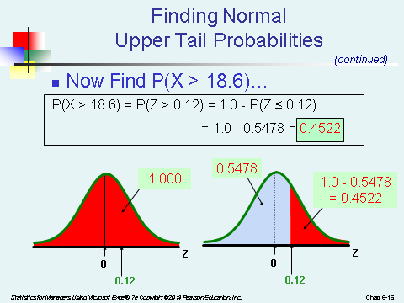

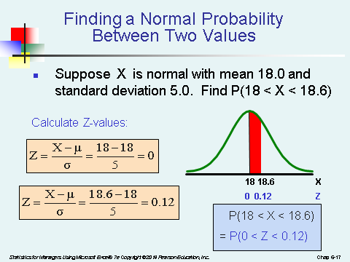

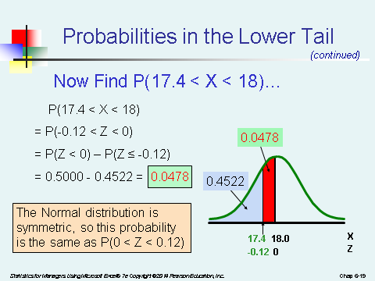

Example

The amount of instant coffee that is put into a 6 oz. jar has a normal distribution with a standard deviation of 0.03 oz. What proportion of the jar contain:

a) less than 6.06 oz?

b) more than 6.09 oz?

c) less than 6 oz?

Assume μ = 6 and σ = .03.

The problem requires us to find: P(X < 6.06)

Convert x = 6.06 to a z-score

z = (6.06 - 6)/.03 = 2

Find P(z < 2) = .9773

So 97.73% of the jars have less than 6.06 oz.

Again μ = 6 and σ = .03.

The problem requires us to find P(X > 6.09)

Convert x = 6.09 to a z-score:

z = (6.09 - 6)/.03 = 3

Find P(z > 3) = 1- P(x < 3) = 1- .9987= 0.0013

So 0.13% of the jar have more than 6.09oz.

Assessing Normality

To judge whether your data is normal, try the following.

- Box Plot – Does the data appear symmetrical?
- Histogram – Does the data appear to be symmetrical and approximately bell shaped?
- Compare the mean, median and mode. Are they approximately equal?
- How does the data compare with the Emperical Rule?

- About 65% of the observations within mean ±1 standard deviation
- At least 75% % of the observations within mean ±1.28 standard deviations
- At least 95% of the observations within mean ±2 standard deviations

- Review a normal probability plot of the data to see if the plot is approximately linear. Is it a straight line with positive slope?

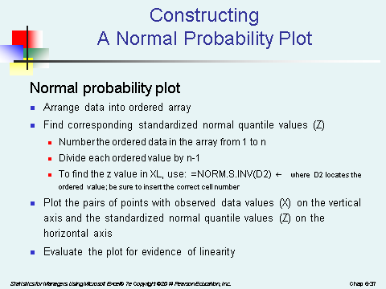
See the following for an example using XL:

http://www.uh.edu/~tech132/6360qq.xls

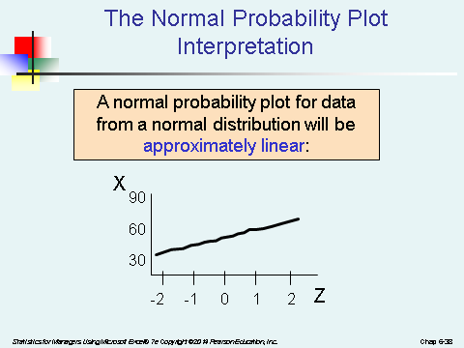 | 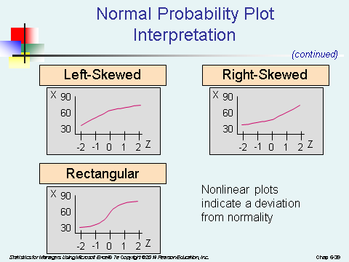

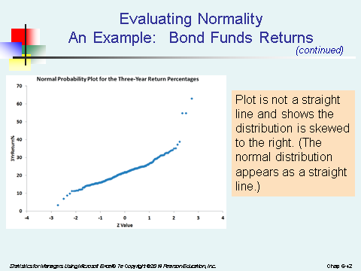 | 