Outline of the Paper

Introduction
Objective
NPD Life-Cycle and Stage Gate Processes

Historical Perspective on NPD Failure Rates

Fault Tree Representation of New Product Development Failure
NPD Fault Tree Assembly and Diagram
NPD Simulation: Partial Life-Cycle Responsibilities
Discussion
Conclusion

Introduction

Even though technology has steadily advanced, the probability of New Product Development (NPD) success has not [44]. Despite the rapidly increasing amount of attention that NPD has received over the last decade, NPD projects have not had a high rate of successful completion; between 33% and 60% of all new products that reach the market place fail to generate desired economic returns [37]. Two-thirds of industrial product firms view their NPD success rate as disappointing or unacceptable [14]. According to Cooper and Kleinschmidt [9], 46% percent of the resources devoted to product development and commercialization go to unsuccessful projects. Considering another perspective, if NPD were done reliably and efficiently, almost twice the number of new products would be introduced to the market with no increase in design resources.

The importance of NPD has further increased with the globalization of markets; this has resulted in increased competition, requiring companies to look to new products and new businesses for growth and sustained competitive advantage [37,7]. In order to be competitive, the first preference of the company is to reach the market with a new product quickly and reliably. To sustain competitive advantage in a dynamic and competitive industrial environment, companies must continue introducing high quality new products that meet customer needs. There is a continuous need to reduce cycle times, control costs, effectively implement new technologies, and maintain high quality standards. NPD is thus receiving increasing attention by industry.

During the past ten years industry has emphasized the value of sharing information and collaborating with partners up and down the supply chain. These efforts increase profitability, reduce inventory, and improve success rate. The results are impressive for more stable products that have long lifecycles and predictable demand, but success remains elusive for “New Products” or “Innovative Products” that are typified by short life-cycles and unpredicted demands [20].

Objective

Several studies address the NPD process and its deficiencies [e.g. 7, 10, 24, 37], but little exists that relate NPD failure rates to NPD life cycles. This study addresses the relationship of new product failure events with the life-cycle phases to demonstrate how risks shift with life-cycle phases and how proper management of risks can lead to successful new product development. This study seeks to accomplish the following:

- Develop a fault tree model of NPD failure as a mechanism to understand various failure elements and modes.
- Understand the dynamic nature of failure in NPD as life-cycle progresses.
- Analyze causes of failures and map these failure elements according to their occurrence in the phase of the development cycle and according to basic functional modes.
- Demonstrate how responsibilities and priorities shift as the NPD progresses.

This is accomplished by first understanding the background and the past research done on new product development. This information is used as a base for developing a fault tree. This tree is analyzed according to the occurrence of failure in different phases of the life-cycle.

NPD Life-Cycle and Stage Gate Processes

Formal NPD processes have had a profound impact on the way that some firms’ development efforts are managed, controlled, and measured while producing good results [8]. These processes were developed as the need for more organized and well-managed development efforts were identified. Over time these processes have changed because of the changes in needs and requirements.

Cooper [8] has discussed the evolution of these processes (Figure 4.1) in some detail. According to him, the initial model of the process was the First Generation Process, developed by NASA in the 1960s, also called the Phase Review Process. The models currently used are the Second Generation Processes. The Third-Generation New Product Development Process has already been evolving from Second Generation Processes. Description of the various generations is as follows:

First Generation Process – In the 1960s, NASA developed a design procedure referred to as the Phased Review Process (PRP). PRP breaks the development process into discrete phases. Each phase is reviewed at the end to confirm the satisfactory completion of all the activities of the preceding phase before commencing the next phase. This process is similar to a relay race, with one group of specialists passing the baton to the next group [39]. This system brought discipline to a chaotic process and helped to ensure the successful completion of tasks; however, with many checkpoints, PRP was a cumbersome, slow, and expensive process.

Second Generation Process - The Second Generation Process, also referred to as the Stage Gate System, divides the innovation process into a predetermined set of stages and gates [7,8]. Each stage consists of a set of prescribed, cross-functional and often parallel activities. The gates function as quality control checkpoints. Unlike PRP, Stage Gate activities are often accomplished concurrently rather than sequentially and the gates have rigorous acceptance criteria and metrics. While the process is detailed and tends to be bureaucratic [8], it is also cross-functional with overlapping of stages being impossible.

Third Generation Process - The Third Generation Process is evolving from the second-generation process with the objective of greater flexibility and less rigidity. It includes fuzzy gates, permitting conditional Go decisions, depending on the situation. The process will have overlapping stages and built-in techniques that leads to project prioritization and sharper focus. Nonaka and Taguchi [39] discuss a similar process emphasizing speed and flexibility. This process had a rugby approach where a team tries to go a distance as a unit, passing the ball back and forth. This process used a “sashimi” approach rather than linear approach. (Sashimi-slices of overlapping raw fish arranged in a plate)

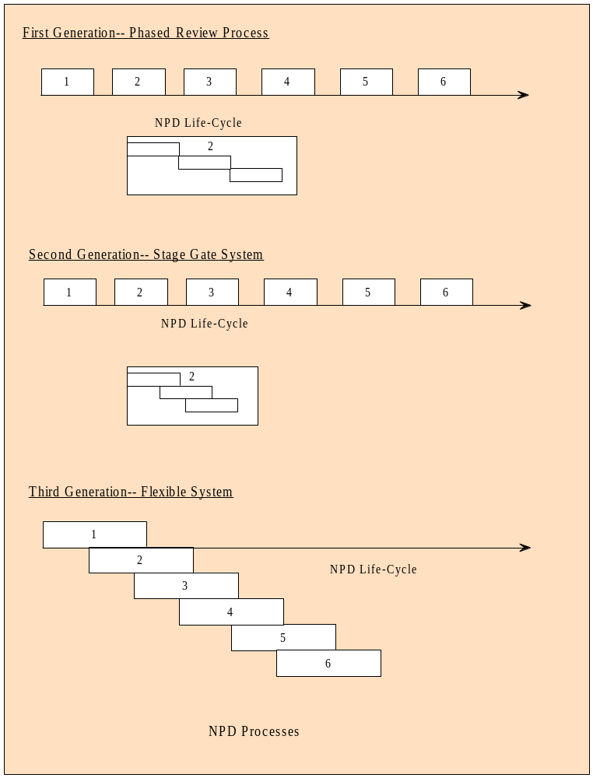
Figure 1: NPD Processes
Of these processes, the Stage-Gate system (Second Generation Process) is the most common; nearly 69 % of surveyed US companies use the multi-functional stage gate process for NPD [20]. Accordingly, NPD reliability modeling in this thesis considers the stage gate approach.

The New Product Development process described by Cooper is a suitable blueprint for evolving a new product project from idea stage to market launch and field support [8]. The development process requires a combination of tasks depending on the nature of technology, market, available experienced professionals and requirements of the organization. Although a single preferred way to innovate has not been identified, several NPD process life-cycles have been proposed. One of the most widely cited, by Crawford, is comprised of six phases in NPD process [31]. Cooper and Kleinschmidt have proposed a 13 stage NPD process, which includes numerous sub activities [10]. The process developed by Ulrich and Eppinger has five phases [43]. Souder has divided the NPD process into eight stages [38]. Essentially all the processes are the same. Some have divided the process into the broad stages whereas some have divided the process to a lower level of details. The most broadly applicable view predicated upon the review of others is by Rabuya [32], who has divided the process into six stages – Quest, Project Conceptualization, Review and Approval, Execution, Integration, Sustain.

Many studies have linked project outcomes with the NPD process; even the existence of such a process and following it has been found to be an important determinant of the outcome [13]. Several studies assert that the success of NPD efforts is contingent upon the NPD process from idea to launch [3]. Cooper and Kleinschmidt [10, 2] found that NPD success is closely related to the proficiency with which various tasks are accomplished and on the completeness of these tasks (and the process). With one more stage added to it (Stage 7 – After Market Activities), this study closely follows the six-step process defined by Mallengada [40] for NPD. The stages in this study include Idea Generation, Conceptual Design, Detail Design, Validation and Testing, Initiation of Production, Market Launch, and After Market Activities.

- Idea Generation – The NPD is initiated by an idea. Ideas are composed of functions (user needs) and their relation to forms (solutions). They may result from an opportunity or from a corrective need. Ideas may be market derived, from customer, salesperson, the competitor, or they may also be technology driven. The majority of the ideas are market driven.
- Conceptual Design – This stage includes developing a Requirement for Proposal (RFP), generating and evaluating alternative concepts, and selecting a single concept. The output of this stage is a product concept and a business plan. The product concept is a description of the form, function and features of a product and is usually accompanied by a set of specifications, an analysis of competitive products, and a justification of economical and production feasibility of the project. This stage details the product and thus the direction for the project. It also determines whether or not the company requires additional manufacturing resources.
- Detail Design – In this stage product architecture is defined, and the product is configured into subsystems and components. The other activities in this stage are specifying the geometry, materials, and tolerance of all the unique parts in the product and identifying the standard parts to be purchased from suppliers. The output of this stage is a geometric layout of the product, a functional specification of each product’s subsystems and a process flow diagram. In this stage, reliability and reparability of the product is included in the product architecture. Also, in this phase, procedures for manufacturing, testing, assembly and maintenance are usually generated. Output of the stage is control documentation for the product that includes drawings and process plans.
- Test and Validation – The product design and production process is confirmed by using the developed product and production testing procedures. Promotional and market launch plans are usually developed in this stage. There are two types of prototypes that are tested 1) early alpha prototypes and 2) later beta prototypes.

Alpha prototypes are tested to determine whether the product will work as designed and to confirm that the customer’s needs will be satisfied. These prototypes are usually built with production-intent, but components are not necessarily fabricated with the actual production processes. Beta prototypes are tested to determine performance and reliability in order to identify needed adjustments for the final product design. Beta prototypes are usually built with parts supplied by the intended production process but may not be assembled using the intended final assembly process. These prototypes are evaluated internally as well as by customers in a real world environment.
- Initiation of Production: This phase starts with the training of the work force and extends to the follow-up of any problems with the production process. Later, the mass manufacturing of the products is done using the intended production process. Products produced may be checked with preferred customers to identify remaining flaws.
- Market Launch: Market plan is implemented in this phase. The implementation of the market launch includes the marketing, advertising, and sales of the product. Products from the manufacturing site reaches customers through proper distribution channels.
- After Market Activities: Provides after sales services and support to the product. The quality plans and the procedures developed for maintenance are used to provide scheduled maintenance and/or onsite support needed because of the problems with the product, throughout its life cycle.
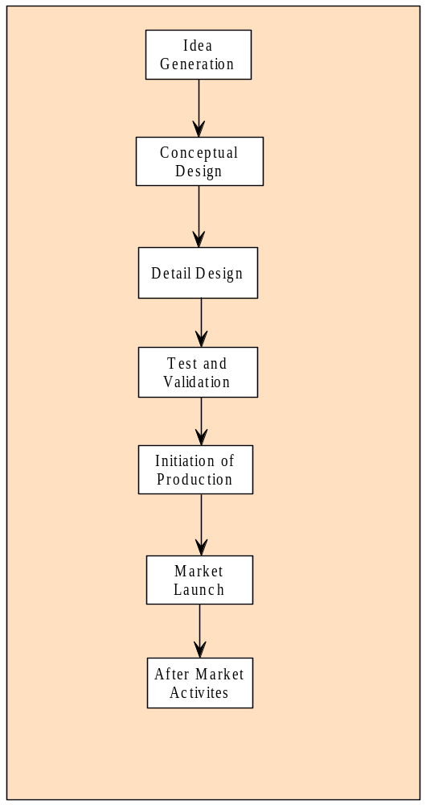
Figure 2: New Product Development Life-Cycle

Historical Perspective on NPD Failure Rates

As previously stated, the success rate of NPD efforts remains unsatisfactory; only one in four product development projects fully succeeds [7]. Increasing complexity, time, and cost of product development all serve to threaten success.

Much emphasis has been placed on reducing the risk of product development, but progress remains elusive [6]. Several comparative studies identify the critical factors contributing to success (or failure) of NPD projects, yet it remains difficult to predict why only a few of the new product efforts succeed [1]. Based on the studies accomplished regarding the determinants of NPD success and failure, it is found that the key elements usually involve combinations of strategy, technical, marketing, organizational, design and development process factors. Studies done by Balachandra [1], Cooper and Kleinschmidt [6], Montoya-Weiss and Calantone [27], Hopkins [21] and three studies by Cooper [6, 11, 12] talk in detail about the various causes and effects of NPD failures.

Cooper [6] proposes that there are three main causes behind a product failure: general causes, specific causes, and latent causes. Corresponding to each general cause is a set of specific causes. Latent causes precede specific causes of failures and are not immediately visible. Cooper claims that the main general reason for the product failure is that sales fail to materialize. Underestimating competitive strength, overestimating number of potential users and overestimating price are three dominant causes of insufficient sales. He notes that in a majority of cases, market related activities more often cause failure than technical or production activities. Cooper asserts that companies must balance expenditures between R&D and market research. Subsequently, Cooper [11] offers a conceptual model for product development which lists a set of variables that influence NPD effort. The variables are distributed between two broad categories: controllable and environmental factors. Moreover in the same study, Cooper asserts that the outcome of NPD is more dependent on variables that are controlled by the firm during NPD than on situational or environmental factors. In contrast to this study, Link [28] specifies that the determinants of success or failure on NPD are highly situation specific and are correlated to the level of innovation realized. According to Link, factors related to failure are competition, market research, marketing and sales, product advantage, and novelty of the product. He also states that factors related to success are marketing and technical synergy, product quality, product advantage, distribution support, and marketing.

Cooper and Kleinschmidt [10] have also investigated the various ways companies manage the product development process. Their work reveals that most of companies have deficient product development processes; some activities are poorly controlled while others are omitted altogether. They conclude that new product success is determined by 1) product development process followed, 2) proficiency with which different activities of the process are executed, and 3) completeness of the development process. Furthermore, Davis [19], in his three case studies proposes that risk of failure will be reduced if NPD properly follows a seven-stage process: 1) Idea, 2) Preliminary assessment, 3) Concept, 4) Development, 5) Testing, 6) Trial, and 7) Launch. Schmidt [35] supports this view with Cooper and Kleinschmidt and state that proficiency with various categories of NPD are accomplished determines the level of success of new industrial products.

Cooper and Kleinschmidt [10] emphasize that the market related and the pre-development activities should be carefully accomplished because they are important for the success of the product. Hopkins [25] supports these findings and claims that market related activities are closely related to the NPD outcome. His study also asserts that technical problems in design and production were the second most cited, and improper timing of product introduction was the third most cited cause of NPD failure. In contrast to these studies, Schmidt [35] emphasizes that the technical activities and the post-development activities are more critical than marketing and pre-development activities respectively. However, Calantone and Benedetto [5] concluded that both marketing and technical activities are important for the product’s success.

Cooper and Kleinschmidt [9] propose a series of ten hypotheses (Appendix- B) regarding NPD success and failure. The two most important factors related to the success are product advantage and proficiency of the pre-development activities. They emphasize that most critical steps in the NPD are those accomplished prior to the actual product development effort. According to Cooper and Kleinschmidt, both marketing and technical synergy are important for success.

Crawford [5] identifies three broad categories for failure: 1) products do not meet the buyer’s needs, 2) products lack demanded features and 3) marketing support is weak or poorly managed. In another study, Cooper and Kleinschmidt [15] characterize new product success in three dimensions: 1) financial performance, 2) opportunity window, and 3) market impact. The significance of categorizing these factors of success into three dimensions is to prove which factors leads to success.

Wind and Mahajan [44], in their study completed in 1988 note that “greater sophistication does not lead to improved new product performance.” They found that only a fraction of all new products are innovative.

Weiss and Calantone [31] conducted a review of literature on the factors influencing the outcome of the NPD. From the literature they identified a list of 18 comprehensive factors related to four categories (market environment, new product strategy, development process, and organization), which describes most of the determinants of new product performance. In other work, Jhone and Snelson [27] have focused on factors of new product success at the program level. They have used McKinsey’s “seven Ss” framework to analyze product development procedure at the program level. The “seven Ss”- skills, strategy, structure, shared values, styles, staff and system are the principal factors associated with the efficient product development.

In their benchmarking study of “firm level factors” of the NPD, Cooper and Kleinschmidt [13], emphasize that for overall understanding of NPD, in addition to project level factors, firm level factors should also be studied. According to them, overall new product performance depends on process, organization, strategy, culture, and commitment. This study proposes nine factors that separate winners (solid performers) from (losers) dogs; high quality NPD process, new product strategy, adequate resources for NPD, management commitment, entrepreneurial climate, senior management accountability, strategic focus and synergy, high quality development teams and cross functional teams.

Balachandra and Friar [1], provide a good overview of research as of 1997, and, as all others, note that NPD is an important, yet complex and difficult task. They reviewed 60 articles related to success and failure studies of NPD and found that the list of the factors affecting the NPD process was long. Their study shows that the significance and meaning of each factor was contextual and the importance of each factor varied with the type of project.

In his latest work in 1999, Cooper [12] claims that even though NPD process research has been ongoing for a number of years, NPD process has not improved. The cited remedies of how companies and senior management can stop making common mistakes include:
- Up-front homework
- Built in voice of customer
- Superior products
- Early product definition
- Strong market launch
- Tough go-kill decisions
- Good organizational structure
- International orientation in product development.

Samli and Weber [34] indicate that because NPD is a difficult, risky, and costly task, it should be differentiated from incremental product development and thus managed differently. They proposed and tested a set of hypotheses. Their study reveals that new products which are unique, fulfill customer needs, and have more customer benefits have a greater chance of success. They specify that the companies who can overcome consumers’ aversion to new technology and spend more money on NPD have a greater probability of success.

Fault Tree Representation of New Product Development Failure

Projects customarily have many ways they can fail and only a few in which to succeed; thus the challenge is to identify all possible causes of failure and then avoid them. For this reason the study of failure mechanisms is more helpful than the study of success mechanisms. The realization of success requires understanding of all the vulnerabilities in the process such that they can be analyzed and avoided.

The fault tree provides a clear, logical method to relate elemental failure components to system/mission failure; it provides the means with which to analyze failure and risk. Such analyses help in understanding and minimizing the vulnerabilities associated with each of the modes or component of failures.

This study investigated the success histories of new product development for developing a fault tree model of NPD failure. This model depicts how contributing failure events map to the top event (Failed NPD). The model is shown useful in three ways: 1) it improves understanding of the logical relationship between failure events and the top event failure, 2) it provides a ranking of basic failure events according to their contribution to top event failure, and 3) it demonstrates how the relative contribution of failure events/modes vary as the NPD project proceeds from one phase to the next.
Fault tree construction is pursued in two ways; top down starting with NPD failure as the top event and bottom up commencing with basic failure events. The top down approach helps in clarifying dominant failure modes (the top branches of the fault tree). The bottom up approach incorporates information regarding basic failure events that lead to the top event. Logical relations are constructed to depict causality among basic events and the top event. This study follows both approaches. Failure modes are selected and then all the basic events are selected and logically incorporated into the appropriate failure modes.

Top Event – NPD Failure: In fault tree construction, the top event is the system failure. In this study, the system failure is defined as Failed NPD Effort (top event for this study is labeled Failed NPD or NPD Failure). The fault tree, once developed, shows how the top event is related to all of the possible causes of failure.

Selecting Dominant Failure Modes: The process of New Product Development has been an active and important area of research; factors have been identified (Basic Events, Intermediate Events , etc.) that influence the outcome of successful NPD (6, 28, 12, 25). To evaluate the significance of these studies some research considers the performance of selected specific NPD projects [19,25,30], while other studies look at the importance of various factors based upon survey data [4,27,31,35]. This study use information from both type of studies.

A fault tree for any system (with a top event and associated logic) may be constructed in a number of ways, each with its own logic. Once the array of failure causes (basic events) is identified, usually a first priority is to identify failure modes that will best characterize fault tree structure. Failure modes are selected to provide a clear perspective with which NPD process can be assessed. This study of NPD failure with the perspective of failure mode is important, as it helps in 1) segregating failure accountability, and 2) clarifying the division of management responsibility. Various NPD Failure Modalities were considered:
- Life-cycle phases
- Failure by the organization’s functional area: technical, marketing, and organizational
- Product Subsystems
- Project Performance, Cost, and Revenue
Life-cycle phases: The development of a new product is evolutionary. In other words, it progresses through a series of life-cycle phases. Failure can be considered according to where in the life-cycle it occurs. This will help in understanding how and when the failure occurs in the life-cycle phase and also highlights vulnerable life-cycle phases. The life-cycle phases are described with their activities in the following table.

Table 1: Life-Cycle Phases

PHASE | ACTIVITIES
Idea Generation | NPD is initiated by an idea; idea is combination of user needs and solution to that problem. Ideas may be market oriented or technology generated.
Conceptual Design | Extension, elaboration and substantiation of the generated idea. Output of this stage consists of a business plan and a product concept accompanied by a set of general specifications.
Detail Design | Product architecture with subsystems is defined. Output of this stage is a geometric layout of the product. Procedures for manufacturing, testing, assembly, and maintenance are also developed.
Test and Validation | Entire viability of the product and production process is checked. Design specifications are finalized.
Initiation of Production | With all the problems cleared mass manufacturing of the product begins.
Market Launch | Start of distribution and sales of the product.
After Market Activities | Follow-on activities: scheduled maintenance and on-site support of new product.

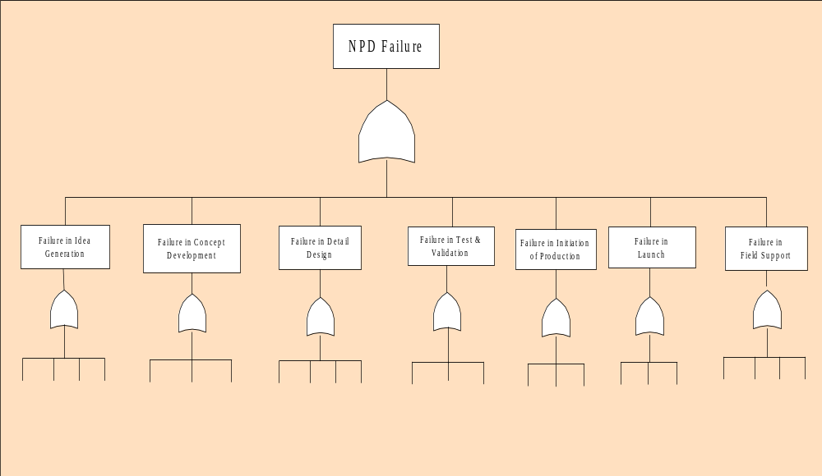
Figure 3: NPD Failure Modes: Life-Cycle Phases

Organizational Functions: This view (Figure 4) represents the failure responsibility with respect to various functional departments (Marketing, Production, R&D etc.). This set of failure modes is essential for understanding the failure responsibility, and will help in resource planning and management according to the functional department responsible for the failure.

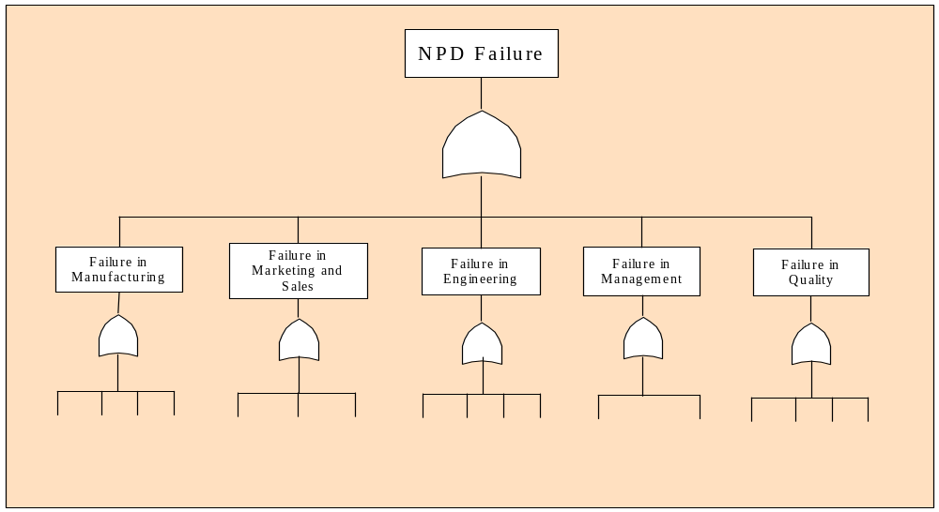
Figure 4: NPD Failure Modes: Organizational Functions
Subsystems: Any product sub-system (suspension, ignition and/or power train etc.) failure will cause the top event (car fails to start) (Figure 5-3). This set of modes helps in isolating the nature of the failure and helps in identifying the areas where reliability improvement is required.
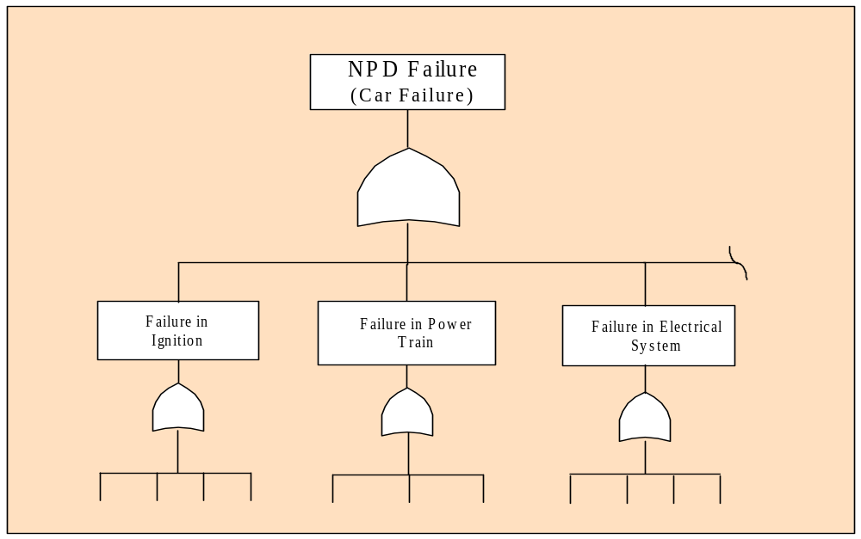
Figure 5: NPD Failure Modes: Subsystems

Performance, Cost, and Revenue: This set of modes represents the primary objectives of the project (Figure 5-4). Perhaps these modes represent the clearest view of how and in what mode the new product development effort fails.

The fourth modality considered includes Performance, Cost, and Revenue. This perspective is selected for this study for the following reasons:
- The issue of the product performance, cost, and revenue is central to organizational objectives, thus making them important components to be analyzed.
- These three components align to the failure components for which the consistent information was available.
- For many organizations these three components are measures of success or failure.
- These three components are related to the main functional departments of the organization, engineering and design, marketing, and management.
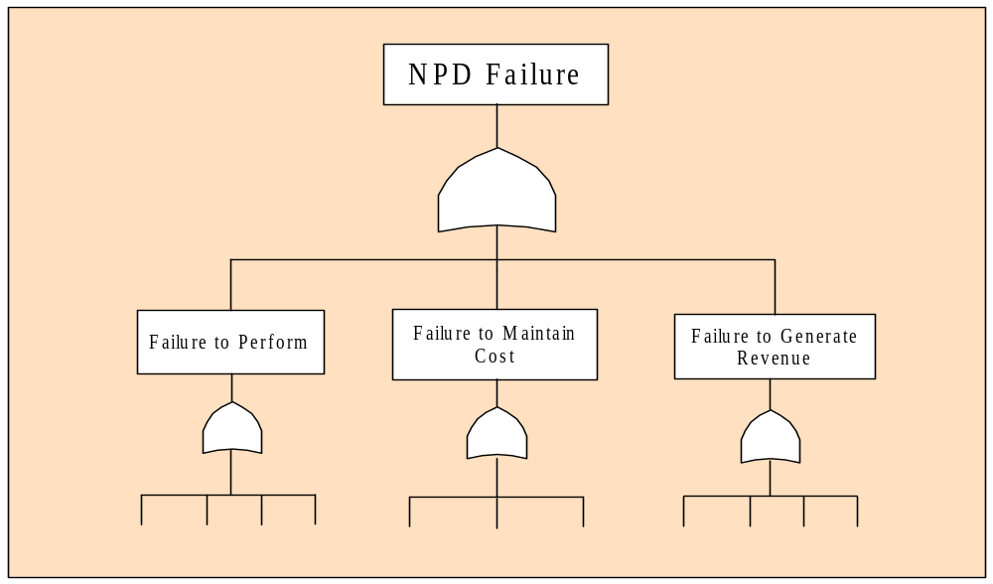
Figure 6: NPD Failure Mode: Project Functions
Various functional areas are responsible for product, cost, and revenue performance. The selected set of modes thus takes into consideration the second set of modes (organizational functions). Studying the performance as a mode of failure takes a third set of modes (subsystems) into consideration. For example, checking the flaws in performance, will lead to subsystem analysis of the system. Life-cycle phases as failure modes helps in understanding the flaws in the management of the NPD process, and thus it is considered as the second set of failure modes in the study. Eventually, from the top, the fault tree structure is studied with performance, cost, and revenue as set of failure modes, but then within each of these modes how the contribution of each failure event changes as the new product development process progresses through its Life-cycle phases is studied.

Identify Basic Events: Four primary (6,28,12,25) studies provide information on new product development failure and have helped determining various causes of failure. When reviewed closely, three observations and solutions are offered: a) there is considerable overlap among these lists; b) some events are too broad, needing a partition to provide appropriate clarity and detail in the fault tree model; and c) some events are detailed or go beyond the needs of this study, so that they are to be combined into a single descriptive event.

Final List of Basic Events: As discussed, some events from these studies are further detailed to establish a more clear understanding while others are consolidated since they are too detailed. This consolidated list (Table 9) is selected as the basis for this study’s fault tree model. This list of failure events also shows the mapping of failure events to the modes of failures and relates them to the project phase in which they occur.

This list also acknowledges the stage gate events (italicized in the list) of the NPD life-cycle. The stage gate events are decision points that may or may not allow a project to proceed if the stage is not finished satisfactorily. These events are checkpoints and thus in a fault tree act as redundant events. This redundancy reduces the probability of failure of the top event, i.e. reducing the failure rate NPD.
Table 2: Consolidated List of Failure Events
No* | Basic Events | Stage Gate | Failure Modes
31 | Misleading or Vague RFP | 1 | FTP,FTGR
32 | Proposal Fails to Satisfy RFP Requirements | 1 | FTP
33 | Failure to Check inadequate or erroneous Proposal | 1(Stage Gate) | FTP
34 | Engineering and Design: Mismatch of Resource and Needs | 3 | FTP,FTMC
35 | Failure to Check Design to Performance Specification | 3(Stage Gate) | FTP
36 | Failure to Check the Prototype for Performance Specifications | 4(Stage Gate) | FTP
37 | Failure to correct design Problems During Prototype testing | 4 | FTP
38 | Failure to Maintain Quality in Design | 3 | FTP
39 | Failure to Check Manufacturability and Reliability of the Product | 3(Stage Gate) | FTP
40 | Failure to Maintain Quality in Manufacturing | 5 | FTP
41 | Reparability Failure | 3 | FTP
42 | Failure to Check Quality Standards | 4(Stage Gate) | FTP
43 | Failure to Match Resources and Needs in Manufacturing | 5 | FTP,FTMC
44 | Failure to Identify Problems in Developed Procedures | 4(Stage Gate) | FTP
45 | Failure to Develop Adequate and Qualified Procedures for Manufacturing and Inspection & Testing | 4 | FTP
46 | Failure to Correct Prototype Performance Problems | 4 | FTP
47 | Failure to Identify Problems in Developed Procedures | 4(Stage Gate) | FTP
48 | Failure to Qualify Procedures for Operating, Maintenance, and Training | 4 | FTP
49 | Erroneous Conceptual Design Estimates | 2(Stage Gate) | FTMC
50 | Failure to identify Conceptual Design Cost Estimate Errors | 2(Stage Gate) | FTMC
51 | Failure to Identify Proposal Cost Estimate Errors | 1(Stage Gate) | FTMC
52 | Erroneous Proposal Estimates | 1 | FTMC
53 | Failure to Confirm Design Requirements | 2 | FTMC
54 | Failure to Confirm Production Plan | 4(Stage Gate) | FTMC
55 | Erroneous Manufacturing Cost Estimates | 4(Stage Gate) | FTMC
56 | Market Launch Cost Overruns | 6 | FTMC
57 | Failure to Confirm Market Demands | 2(Stage Gate) | FTGR
58 | Faulty Proposal | 1 | FTGR
59 | Failure to Keep Up with Market Changes | 6 | FTGR
60 | Failure to Communicate to the Market | 6 | FTGR
61 | Failure to Identify Problems with Launch Strategy | 6(Stage Gate) | FTGR
62 | Failure to Confirm the After-Market Plans, Resources and Preparations | 6(Stage Gate) | FTGR
63 | Inadequate availability of Repair Parts | 6 | FTGR
64 | Inadequate availability of Skilled People | 6 | FTGR
65 | Inadequate availability of Procedures and Information | 6 | FTGR
66 | Failure to develop market launch plan | 6 | FTGR
* No. 1-31 are the intermediate events (see Appendix C for intermediate events and Appendix D for the list of intermediate events)

NPD Fault Tree Assembly and Diagram

As discussed in section 5.2, the selected fault tree configuration consists of three main branches with each branch representing a failure mode:
- Failure to Perform
- Failure to Control Cost
- Failure to Generate Revenue

Each mode has its own tree-like structure comprised of additional intermediate and basic events. Basic events were selected from various prior studies of the NPD success (see Section 5.3), listed in Table 5.9. Intermediate events were identified which would most clearly relate basic components with the top event (list of intermediate events is presented in Appendix D). The resulting fault tree represents the failure of the NPD effort. This tree also acknowledges the stage gate system of the NPD life-cycle and thus in figures 5-5,5-6, and 5-7 shaded boxes represent stage gate events.

Failure to Perform occurs when the product fails to perform to the specifications or does not comply with the user’s performance needs. This branch of the tree has four intermediate events linking the failure mode to different basic events and intermediate events. In Figure 5-5 failure to identify design and performance specification is an intermediate event related by an OR gate to two basic events [Event No. 1(inadequate proposal accepted) and Event No. 2 (failure to check inadequate or erroneous proposal)]. Inadequate proposal accepted is another intermediate event which is itself related by an AND gate to two basic failure events.

Failure to control cost describes a situation when money spent on the project exceeds cost estimates. This may result from any number of reasons that range from erroneous estimates in the beginning of the process to cost overruns in any of the life-cycle stages. As seen in Figure 5-6, this failure mode has four intermediate events with the first event, erroneous estimates for design cost, occurring when the cost of an activity is erroneously estimated. The remaining three events occur when money spent exceeds the estimated cost. These intermediate events connect basic events to the top event.

Failure to generate revenue (Figure 5-7) is the third failure mode. It describes the failure of market related activities, understanding market requirements, developing the right concept, selecting marketing strategies, etc. This mode of the fault tree has two intermediate events (inadequate production revenue and inadequate After-market revenue). These events define the failure happening due to failure in initial and later stages of the NPD process respectively.

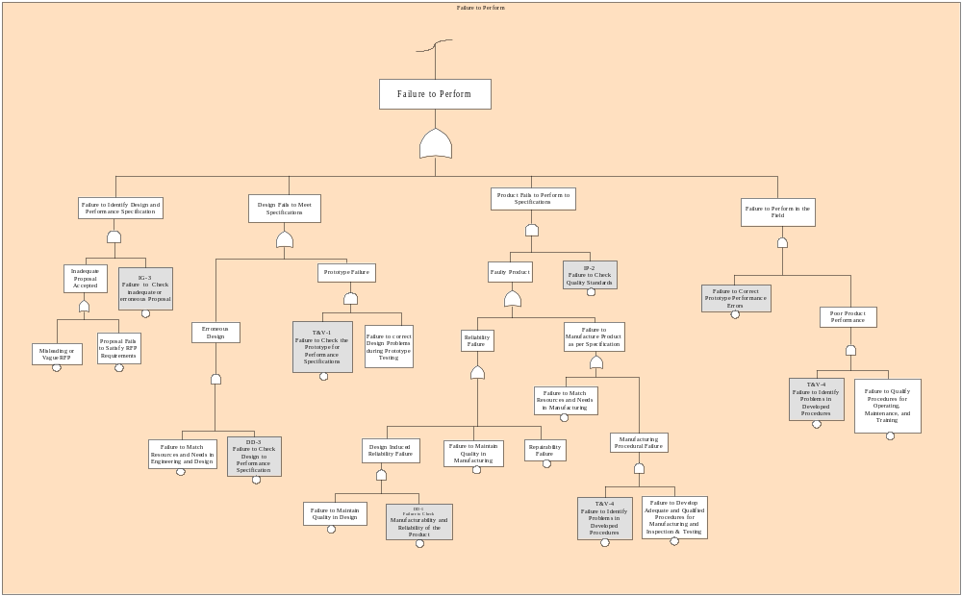
Figure 3: Fault Tree: Failure to Perform
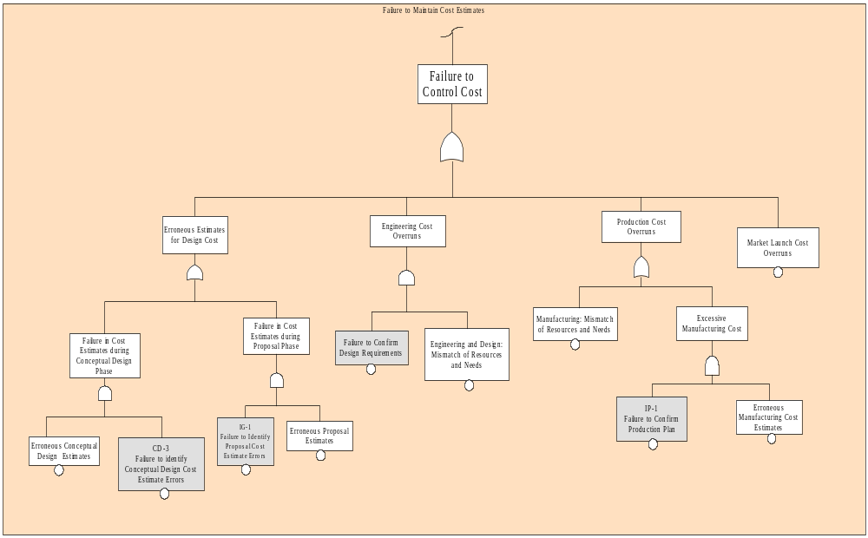

Figure 4: Fault Tree: Failure to Control Cost
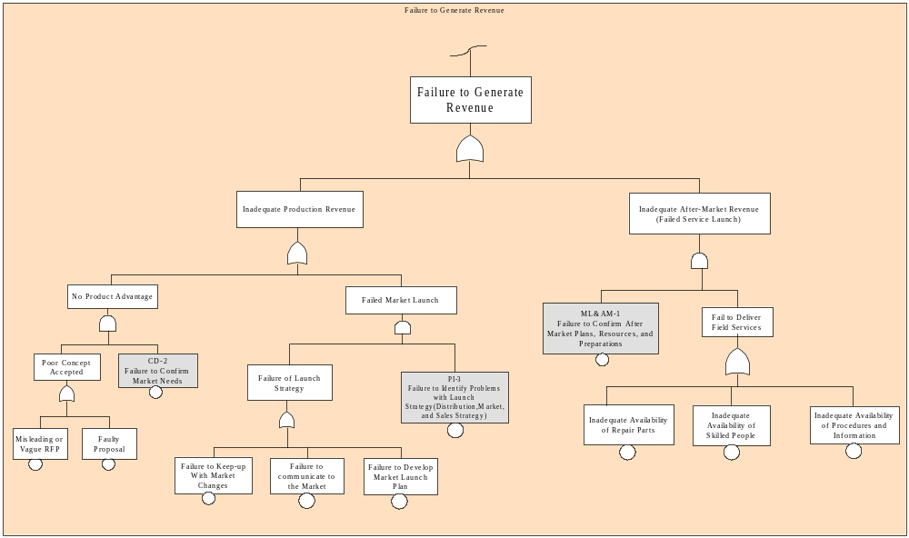
Figure 5: Fault Tree: Failure to Generate Revenue

Estimating Basic Event Failure Probabilities

There is limited quantitative information published regarding the causes of NPD failure, as competing firms will not release proprietary project performance. Nevertheless, studies have been published that estimate the probabilities of various failure modes [2,5,26]. Using those studies as a starting point, probabilities of basic events used in this research are estimated such that they are compatible with prior work in published failure rates. The estimated probabilities are used to demonstrate fault tree response. The following observations are made from the available literature:
- Limited data is published regarding the causes of NPD failure; only some general data is available.
- Failure performance will vary from company to company and from application to application; one firm’s model cannot be assumed to be transferable.
- There is some literature that enlightens various causes of failure and their occurrence rate.

Taking these various facts into consideration the process of estimating component failure probabilities is pursued as follows:

- Estimating failure probability of the top event.
- Estimating approximate failure probabilities for each basic failure mode.
- Failure probabilities of basic events are adjusted such that top event failure rate is compatible with published results.
Table 3: Published Failure Probabilities

 | Description | Published Range | Estimated Failure Rate
Intermediate Event No.
1 | NPD failure | 0.59 [24] - 0.90 [3], 0.75 [7] | 0.75
3 | Failure to Maintain Cost | 0.13 - 0.57 [6] | 0.35
4 | Failure to Generate Revenue | 0.33 - 0.66 [31,43,44] | 0.50
7 | Design Fails to Meet Specifications | 0.12 - 0.2[6] | 0.15
11 | Defects in the Product | 0.10 - 0.33[6] | 0.2
25 | No Product Advantage | 0.2 [6] | 0.2
Basic Event No.
34 | Engineering and Design: Mismatch of Resource and Needs | 0.08 - 0.24 [6] | 0.165
56 | Market Launch Cost Overruns | 0.13 [6] | 0.1
59 | Failure to Keep Up with Market Changes | 0.14 - 0.33[6] | 0.26
60 | Failure to Communicate to the Market | 0.14 - 0.27[6] | 0.19
64 | Inadequate availability of Skilled People | 0.12 - 0.27[6] | 0.12

From Cooper [2], Griffin [24], Schilling and Hill [37], Booz-Allen & Hamilton [3] Table 5-10 shows the failure rates which may be derived for selected intermediate and basic events. Failure probability of the top event (intermediate event 1) is based on Cooper’s recent study [2], which is within the range of other published research [19,45]. Similarly, published failure rates for some of the other events were identified [Table 5-10]. All other intermediate and basic events lacked estimated failure rates. So they were deduced using the available data (Table 5-10) such that basic event failure rate meets the target failure rates of intermediate and top event. For example, failure rate of the top event (Event 1) is known and failure probabilities of two (Event 3 and Event 4) of the three connecting events are known. Accordingly, failure probability of the remaining event (Event 2) is deduced.
Let, P₁ = Probability of the top event (Event 1) failure = 0.75
P₂ = Probability of Event 2 failure =?
P₃ = Probability of Event 3 failure = 0.35
P₄ = Probability of Event 4 failure = 0.50
From Figure 5-4, the three failure modes are related to the top event through an OR gate, thus probability of top event is:
P₁ = P₂ + P₃ + P₄ - P₂ P₃ - P₃P₄ - P₂ P₄ + P₂ P₃ P₄ , or
0.75 = P₂ + 0.35 + 0.50 – P₂ x 0.35 – 0.35 x 0.50 – P₂ x 0.50 + P₂ x 0.35 x 0.50
Thus, P₂ = 0.25
Similarly, failure rate estimates for other events were determined where failure probabilities of some related events were known. In many cases where multiple contributors had unknown failure rates, the unknown failure rates were assumed to be equal. This process does not validate the model, rather it allows the model to be representative of failure experience in published literature. Similar calculations were done for events connected by AND gate. For example if two events B and C are connected to other event A by an AND gate, then probability P_{A} is defined as,

P_{A} = P_{B} x P_{C}

Where, P_{A} = Probability of event A failure

P_{B} = Probability of event B failure

P_{C} = Probability of event C failure

The following table (Table 5-11) shows the estimated failure probabilities of all the basic events. This table is essential in developing the fault tree model. This model is defendable as an example and cannot be used for a particular industry or company.

Table 4: Failure Events with Estimated Failure Probabilities
BE No. * | Basic Events | Probabilities
31 | Misleading or Vague RFP | 0.100
32 | Proposal Fails to Satisfy RFP Requirements | 0.100
33 | Failure to Check inadequate or erroneous Proposal | 0.200
34 | Engineering and Design: Mismatch of Resource and Needs | 0.165**
35 | Failure to Check Design to Performance Specification | 0.500
36 | Failure to Check the Prototype for Performance Specifications | 0.280
37 | Failure to correct design Problems During Prototype testing | 0.280
38 | Failure to Maintain Quality in Design | 0.200
39 | Failure to Check Manufacturability and Reliability of the Product | 0.200
40 | Failure to Maintain Quality in Manufacturing | 0.040
41 | Reparability Failure | 0.040
42 | Failure to Check Quality Standards | 0.200
43 | Failure to Match Resources and Needs in Manufacturing | 0.090
44 | Failure to Identify Problems in Developed Procedures | 0.160
45 | Failure to Develop Adequate and Qualified Procedures for Manufacturing and Inspection & Testing | 0.160
46 | Failure to Correct Prototype Performance Problems | 0.200
47 | Failure to Identify Problems in Developed Procedures | 0.450
48 | Failure to Qualify Procedures for Operating, Maintenance, and Training | 0.450
49 | Erroneous Conceptual Design Estimates | 0.200
50 | Failure to identify Conceptual Design Cost Estimate Errors | 0.200
51 | Failure to Identify Proposal Cost Estimate Errors | 0.200
52 | Erroneous Proposal Estimates | 0.200
53 | Failure to Confirm Design Requirements | 0.600
54 | Failure to Confirm Production Plan | 0.039
55 | Erroneous Manufacturing Cost Estimates | 0.038
56 | Market Launch Cost Overruns | 0.100**
57 | Failure to Confirm Market Demands | 0.550
58 | Faulty Proposal | 0.200
59 | Failure to Keep Up with Market Changes | 0.260**
60 | Failure to Communicate to the Market | 0.190**
61 | Failure to Identify Problems with Launch Strategy | 0.400
62 | Failure to Confirm the After-Market Plans, Resources and Preparations | 0.300
63 | Inadequate availability of Repair Parts | 0.120
64 | Inadequate availability of Skilled People | 0.120**
65 | Inadequate availability of Procedures and Information | 0.120
66 | Failure to develop market launch plan | 0.670
*See footnote for table 5-9
** Probabilities from published literature

NPD Failure Simulation
Because the NPD process is both complex and contains considerable risk, there are various ways in which a developed model may be analyzed. This study considers several approaches and proceeds with the following steps:
- Ascertain that the model performed within the parameters (failure probabilities) indicated by published NPD failure research.
- Analyze changes in system reliability by sequentially eliminating the possibility of failure in each successive life-cycle phase.
- Assess the influence of each basic event on the system’s reliability and relative contribution of improved component reliability to the system reliability.
- Estimate the benefit of improving several of the dominant failure contributors on system performance.

NPD Simulation: Original Model

This simulation run provides the best overall indication of the NPD model performance; it is accomplished to determine if the results are compatible to published literature. This model was run with the original component failure probabilities and the detailed results are presented in Appendix- F. The importance of this model simulation is to 1) understand how the system performs and to determine if the developed model fits within the published failure probabilities (Table 5-10), and 2) analyze whether the indicated performance is compatible with the published literature.

Figures 4 and 5 illustrate fault tree performances using the original estimates of failure probabilities presented in Section (**). In general, the results appear to be compatible to what is published in research literature (**).

The bar chart of original system (Figure 4) shows that the risk of failure in Phase 2 and Phase 6 is more that than in other phases. It also shows that the third failure mode, failure to generate revenue, is the mode that proposes the highest risk of failure. Though Phase 7 is important for many companies and many projects, this model does not entail a failure event in Phase 7 as: a) there was not much published information about this stage, and b) NPD and after market activities are mutually exclusive.

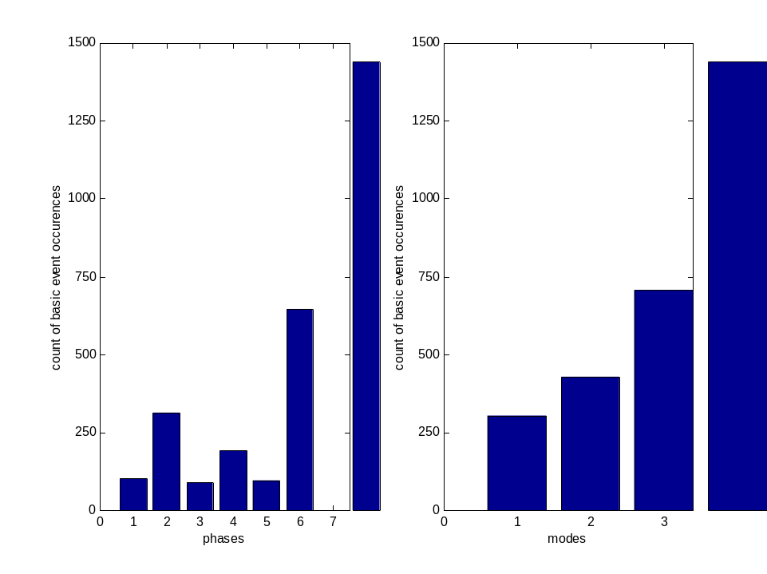
Figure 6: Original Failure Incidence: Contribution of each Phase and Mode to the System Failure

[Phases: 1 – Idea Generation, 2 – Conceptual Design, 3 – Detail Design, 4 – Prototype Testing, 5 – Initiation Of Production, 6 – Market Launch, 7 – After Market Activities, Modes: 1 – Failure To Perform, 2 – Failure To Control Cost, 3 – Failure To Generate Revenue]
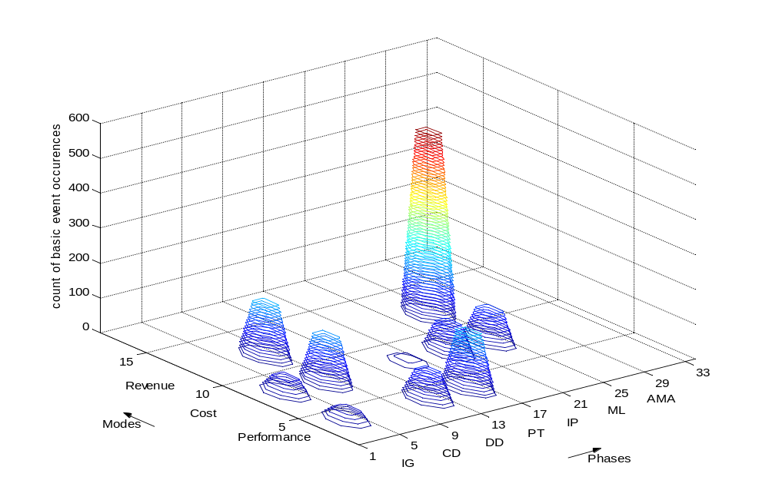
Figure -7: Original Failure Incidence: by Phase and by Mode

Figure 5 displays the count of failure occurrences of the basic cutsets (a cutset is the smallest irreducible collection of basic events required to insure occurrence of the top event) along the life-cycle phases and modes. This plot shows that the dominant mode of failure is revenue generation and the dominant failure phase is Phase 6, market launch. This can also be illustrated by pie charts as shown below. These pie charts show the relative contribution of each phase and mode towards NPD failure.

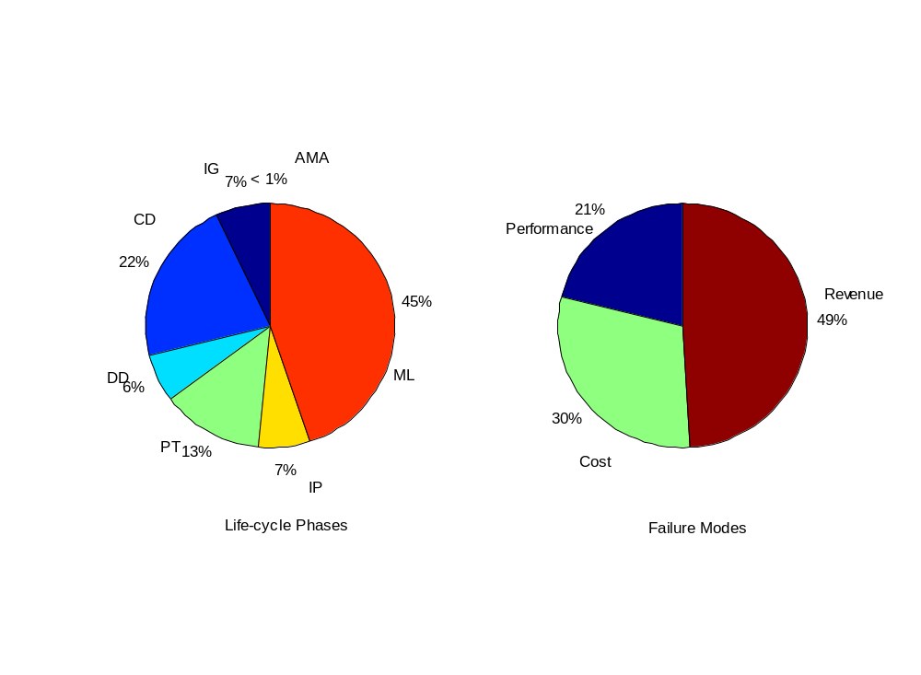

Figure 8: Original Failure Incidence: Relative Contribution of Phases and Modes to System Failure

NPD Simulation: Partial Life-Cycle Responsibilities

This simulation considers the entire NPD process and then looks at the partial life-cycle from mid-project to the end. The purpose of this model is to analyze how the balance of responsibilities (e.g. engineering, manufacturing, design, cost control, and marketing) shifts from one phase to the next. Although not altogether realistic, an assumption is made that no failure occurs in and before the phase under consideration (performed by decreasing the probabilities of failure to zero for all failures in the preceding phases).

This simulation study looks at the entire project for comparison, and further studies the project, after Phase 1 and more so after Phase 4. The pursuit is with a purpose of determining only those failures that occur thereafter. The results are shown in Figure 7. The first two figures show the original model; in the second case failure in Phase 1 is ruled out, and then in third case failure in Phases 1, 2, 3, and 4 is ruled out. This simulation is done to study causes of failure that relates to responsibilities. It is noted that as the project proceeds relative balance shifts towards the revenue problems.

Figure 7 compares three models a) original, b) failure in Phases 2 to 7, and c) failure in phases 5-7. It is illustrated that after Phase 1, there is noticeable reduction in failure for all the modes, but more noticeable for the third mode (Revenue Generation). It is also noted that when there is no failure in Phase 1, failures in Phase 2 reduce (due to the fact that certain cutsets overlap phases). After Phase 4, it is prominent that there are no failures due to performance, and failures related to cost (mode two) reduce considerably.

Figure 8 illustrates the relative contribution of phases and modes to the NPD failure as the project proceeds. It can be observed that the model with failures in Phases 2 to Phase 7 (Figure 8b) the failure contribution of both performance and cost slightly increases while there is a small decline in relative contribution of revenue to NPD failure. As for the model with failures only in Phase 5 to Phase 7 (Figure 8c) it is seen that the most dominant failure mode is revenue generation. In comparison to the original model its contribution to failure of NPD increased from 46% to 73%. It is also seen that for this model relative contribution of performance to system failure is nil, this is because all the activities related to performance and costs are completed by the end of Phase 4 (prototype testing) and Phase 5, respectively.

(a. Original)

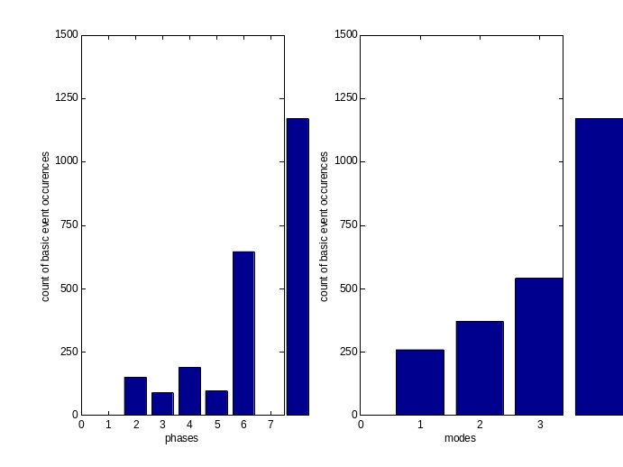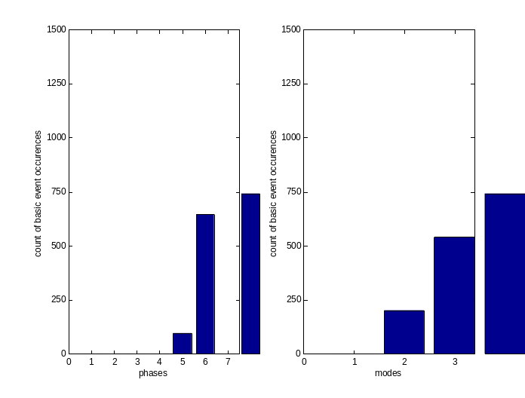
(b. Failure in Phases 2-7) (c. Failure in Phases 5-7)
Figure 9: Partial Life-Cycle Failure Responsibilities
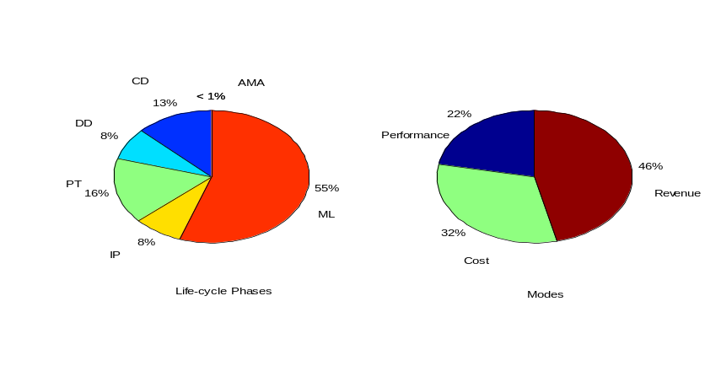

(a. Original System) (b. Failure in Phases 2-7)
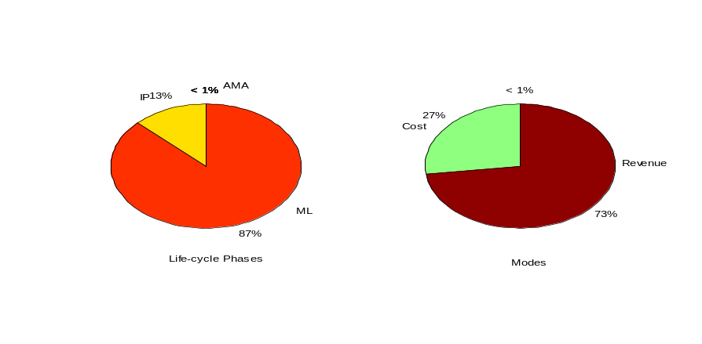

(c. Failure in Phases 5-7)
Figure 10: Partial Life-Cycle Responsibilities: Relative Balance of Failure

Similar methodology is applied to develop the output for other phases. From the other results, it can be noted that relative contribution of failures due to revenue generation increases as the project proceeds. This is because as the project proceeds the performance and cost related activities are completed in the early part of the project.

Discussion
The results for partial life-cycle responsibility simulation are summarized in Table 5. The second column shows how the failure incidence of system decreases when failure probabilities of each phase is reduced to zero one by one as the project proceeds.

Table 5: Output Results – Partial Life-Cycle Phases
Life-Cycle Phases | Failure Incidence of Top Event
Failure only in Phase 1-7 | 721
Failure only in Phase 2-7 | 621
Failure only in Phase 3-7 | 574
Failure only in Phase 4-7 | 522
Failure only in Phase 5-7 | 436
Failure only in Phase 6-7 | 381
Failure in Phase 7 | 0

Three-dimensional models, for a project, show how the failure rate is distributed along the life-cycle phases and failure modes. These graphs illustrate the responsibilities according to the phases and thus help in resource management. For example, the three-dimensional plot for original system shows that the failure in Phase 1 is due to first two modes, failure to perform and failure to control cost. As engineering and design departments are predominantly related to these modes, it is their responsibility in phase one to manage the process successfully. Similarly, Phase 6 shows that failure is due to modes two and three, failure to control cost and failure to generate revenue. The responsible departments for these modes are primarily marketing, thus major work responsibilities in Phase 6 lies in marketing department. These models also depict phases where improved component performance will be most helpful.

The pie charts (Figure 8) show that when the project proceeds while negating failure of all the phases in sequence, there is growing dominance of revenue problems. These charts depict that as the project proceeds, more and more emphasis should be on revenue related activities including marketing, advertising, distribution, and understanding market dynamics.

Conclusion
NPD is an active area for research and it is acknowledged that much has been published regarding the various facets of NPD. The purpose of this thesis effort has been to further investigate the failure mechanism existing within new product development, and to investigate the relationship between the design life-cycle and NPD failure history.

This research successfully resulted in a model that provides a more integrated and unified view of the design process for product development; at least from a perspective of reliability. This point of view provides, for the first time, a fundamentally important perspective with which to understand the structure of failure causality (logic behind the failed NPD).

The understanding of project failure with respect to life-cycle phases offers management necessary insight for better managing NPD projects. It relates functional responsibilities to the life-cycle phases and can benefit dynamic resource planning and management. Collectively this probabilistic model provides a sufficient basis for important future work in risk analysis. The understanding of life-cycle flows and the propagation of risk through a fault tree will help in associating cost with each of the failure event. Such risk assessment will provide a mechanism to help management better identify and justify the investment necessary to improve design processes.

Reference:
- Balachandra, R. and Friar, J.H. “Factors for success in R&D Projects and New Product Innovation: A contextual Framework,” IEEE Transactions on Engineering Management, Vol. 44, No. 3, pp. 276 – 287, August 1997.
- Barclay, I. and Dann, Z. “New-Product-Development performance evaluation: a product-complexity-based methodology,” IEE Proc. –Sci. Meas. Technol., Vol. 147 No. 2, pp. 41 – 55, 2000.
- Booz-Allen & Hamilton. New Product Management for the 1980’s, New York: Booz-Allen & Hamilton, Inc.1982.
- Calantone, R. J., Benedetto, C. A., “An Integrative Model of the New Product Development Process an Empirical Validation,” Journal of Product Innovation Management, Vol. 5 No. 3, pp. 201 – 215, 1988.
- Calantone, R. J., Schmidt. J. B., Song, X. M., “Controllable Factors of New Product Success: A Cross-National Comparison,” Marketing Science, Vol. 15 No. 4, pp. 341 – 358, 1996.
- Cooper, R.G. “Why New Industrial Products Fail,” Industrial Marketing Management, Vol. 4 No. 6, pp. 315 – 326, 1975.
- Cooper, R.G., “Stage Gate Systems: A New Tool for Managing New Products,” Business Horizons, Vol. 33 No. 3, pp. 44 –54, 1990.
- Cooper, R.G., “Third Generation New Product Processes,” Journal of Product Innovation Management, Vol. 11 No. 1, pp. 3 – 14, 1994.
- Cooper, R.G. and Kleinschmidt, E.J. “New Products: What Separate Winners from Losers?,” Journal of Product Innovation Management, Vol. 4 No. 3, pp. 169 - 184, 1987.
- Cooper, R.G. and Kleinschmidt, E.J. “An Investigation into the New Product Process: Steps, Deficiencies and Impact,” Journal of Product Innovation Management, Vol. 3 No. 2, pp. 71 – 85, 1986.
- Cooper, R.G., “Identifying Industrial New Product Success: Project NewProd,” Industrial Marketing Management, Vol. 8 No. 2, pp. 124 – 135, 1979.
- Cooper, R.G., “From Experience: The Invisible Success Factors in Product Innovation,” Journal of Product Innovation Management, Vol. 16 No. 3, pp. 115 – 133, 1999.
- Cooper, R.G. and Kleinschmidt, E.J. “Benchmarking the firm’s Critical Success Factors in New Product Development,” Journal of Product Innovation Management, Vol. 12 No. 3, pp. 374 – 391, 1995.
- Cooper, R.G. “New Product Success in Industrial Firms,” Industrial Marketing Management, Vol. 11 No. 3, pp. 215 – 223, 1982.
- Cooper, R.G. and Kleinschmidt, E.J. “Success Factors in Product Innovation,” Industrial Marketing Management, Vol. 16 No. 3, pp. 215 – 223, 1987.
- Cooper, R.G. and Kleinschmidt, E.J. “New Product Performance: What distinguishes the star products,” Australian Journal of Management, Vol. 25, No. 1, pp. 17 – 45, June 2000.
- Cooper, R.G. and de Brentani, U. “Criteria for screening new industrial products,” Industrial Marketing Management, Vol. 13 No. 4, pp. 149 – 156, 1984.
- Crawford, C.M. “New Product failure rates – facts and fallacies,” Research Management, (September), pp. 9 – 13, 1979.
- Davis, J.S., “New Product Success & Failure: Three Case Studies,” Industrial Marketing Management, Vol. 17 No. 2, pp. 103 – 109, 1988.
- Fisher, M. and Raman, A., “Managing Short-Lifecycle Products,” http://www.ascet.com/wp/wpFisher.html
- Foster, R. “Managing Technological Innovation for Next 25 Years,” Research Technology Management, (January – February), pp. 29 – 31, 2000.
- Francis, P.H, Product Creation, The Free Press, 2000.
- Frankel, E. Systems Reliability and Risk Analysis, Kluwer Academic Publishers, 1988.
- Griffin, A., “ PDMA Research on New Product Development Practices: Updating Trends and Benchmarking Best Practices,” Journal of Product Innovation Management, Vol. 14 No. 6, pp. 429 – 458,1997.
- Hopkins, D. S., “New-Product Winners and Losers,” Research Management, Vol. 24 No. 3, pp. 12 – 17, 1981.
- Ireson, W. and Coombs, C. Jr., Handbook of Reliability Engineering and Management, Mc Graw Hill, Inc. 1988.
- Johne, A. F. and Snelson, P. A., “Success Factors in Product Innovation: A selective Review of the Literature,” Journal of Product Innovation Management, Vol. 5 No. 3, pp. 114 – 128, 1988.
- Link, P.L. “Keys to New Product Success and Failure”. Industrial Marketing Management, Vol. 16 No. 4, pp. 109 – 118, 1987.
- McCormick, N. Reliability and Risk Analysis Methods and Nuclear Power Applications, Academic Press, Inc, 1981.
- Metz, P.J., “Demystifying Supply Chain Management,” Supply Chain management Review, pp. 46 – 55, Winter 1998.
- Montoya-Weiss, M. M. and Calantone, R. J. “Determinants of New Product Performance: a review and meta analysis,” Journal of Product Innovation Management, Vol. 11 No. 5, pp. 397 – 417, 1994.
- Rabuya, L, “Virtual Teams in New Product Development,” Unpublished M.Sc thesis, University of Houston, 2001.
- Rosenau, M. D, Successful Product Development, John Wiley & Sons, Inc. 2000.
- Samli, C, and Weber. J, “A theory of successful product breakthrough Management: learning from success,” Journal of Product and Brand Management, Vol. 9 No. 1, pp. 35 – 47, 2000.
- Schilling, M. A. and Hill, C.W. l., “Managing the New Product Development Process: Strategic Imperatives,” IEEE Engineering Management Review, pp 55 – 68, Winter 1998.
- Schmidt, J.B., “New Product Myopia,” Journal of Business & Industrial Marketing, Vol. 10 No. 1, pp. 23 – 33, 1995.
- Smith, P. and Reinertsen, D, Developing Products in Half the Time, New York: Van Nostrand Reinhold, 1991.
- Souder, William. Managing New Product Innovations, Lexington Books, 1987.
- Takuchi, H. and Nonaka, I., “The new product development game,” Harvard Business Review, Vol. 64 No. 1, pp 137 – 146, 1986.
- Thimmahia, M, “Knowledge Management in New Product Development ”, Unpublished M.Sc. thesis, University of Houston, 2001.
- Thomke, S., “Enlightened Experimentation: The New Imperative for Innovation”, Harvard Business Review, pp 67 – 75, Feb 2001.
- Thomkovick, C. and Miller, C. “ Perspective- Riding the Wind: Managing New Product Development in an Age of Change,” Journal of Product Innovation Management, Vol. 17 No. 6, pp. 413 – 423, 2000.
- Ulrich, K.T., and Eppinger, S.D., Product Design and Development, McGraw-Hill, 1995.
- Wind, Y. and Mahajan, V., “New Product Development Process: A Perspective for Reexamination,” Journal of Product Innovation Management, Vol. 5 No. 4, pp. 304 – 310, 1988.
- 3M Annual Report, 2000.

