Grade (s): | 5th
Topic: | Colonial America
Content Objective (Aligned with TEKS):
The student will compare and contrast Colonial American life for children to their own lives.
The student will create and be able to read a physical map of the thirteen original U.S. colonies.

TEKS:

§113.16.b.1.A History. The student understands the causes and effects of European colonization in the United States beginning in 1565, the founding of St. Augustine. The student is expected to explain when, where, and why groups of people explored, colonized, and settled in the United States, including the search for religious freedom and economic gain.

§113.16.b.6.A. Geography. The student uses geographic tools to collect, analyze, and interpret data. The student is expected to apply geographic tools, including grid systems, legends, symbols, scales, and compass roses, to construct and interpret maps.

§113.16.b.24. Social studies skills. The student applies critical-thinking skills to organize and use information acquired from a variety of valid sources, including electronic technology. The student is expected to:
(B) analyze information by sequencing, categorizing, identifying cause-and-effect relationships, comparing, contrasting, finding the main idea, summarizing, making generalizations and predictions, and drawing inferences and conclusions;
(C) organize and interpret information in outlines, reports, databases, and visuals, including graphs, charts, timelines, and maps.

§113.16.b.25.D. Social studies skills. The student communicates in written, oral, and visual forms. The student is expected to create written and visual material such as journal entries, reports, graphic organizers, outlines, and bibliographies.
CCRS:
I.A.1. Use the tools and concepts of geography appropriately and accurately.
I.A.3. Analyze how physical and cultural processes have shaped human communities over time.
I.B.2. Identify and evaluate sources and patterns of change and continuity across time and place.
IV.A. Critical examination of texts, images, and other sources of information.
Vocabulary:  Colony, pilgrim |  | Visuals, Materials, & Texts:  Texts: Samuel Eaton’s Day: A Day in the Life of a Pilgrim Boy  OR Sarah Morton’s Day: A Day in the Life of a Pilgrim Girl Both Authored by Kate Waters  United States Atlas  Links:  http://www.youtube.com/watch?v=gVxad8R4Nig  http://www.socialstudiesforkids.com/graphics/13mapnew.htm
Essential/Research Question:
What was life like for children in Colonial America?
Activities |  | Review & Check for Understanding:
(Response Signals, Writing, Self-Assessment, Student Products, etc.)

Through active participation and engagement, students will demonstrate their level of prior knowledge.
Activating Prior Knowledge (Processes, Stems, & Strategies):

Read one of the two book options to the class: Samuel Eaton’s Day: A Day in the Life of a Pilgrim Boy
OR Sarah Morton’s Day: A Day in the Life of a Pilgrim Girl. After the Read-Aloud spend 10 minutes discussing what the students found interesting and what new information they learned. Then ask them to come up with questions they would like to research about Colonial America. Record these responses on the board. Explain to them that in the centers they will be exploring different aspects of colonial life for children.
Completion of the Venn Diagram will demonstrate that students have an understanding of the similarities and differences in how pilgrims lived versus how we live today.

A summary will demonstrate the students reading comprehension ability and knowledge of New England Food and Cooking.

By creating a travel brochure, students will demonstrate their ability to synthesize information and acquire knowledge about one of the thirteen original U.S. colonies.

By marking a map of the thirteen U.S. colonies, students will demonstrate their ability to read a map.

Presentation time should be 5 -7 minutes.

Students will apply their new knowledge of Colonial America by writing journal entries from the viewpoint of a colonial child.

Through active participation and engagement, students will demonstrate their level of new knowledge.
Building Vocabulary & Concept Knowledge (Processes, Stems, & Strategies):

Center 1: Watch the Video: Life as a Child in the 18th Century
http://www.youtube.com/watch?v=gVxad8R4Nig

After watching the video the student(s) will complete a Venn Diagram to compare and contrast life in colonial times to present day. Ask them to think about the clothes children wore, what they learned in school, what their homes were like, what chores they did, and what they did for fun. Tell the students they can watch the video more than once if they need help coming up with similarities and differences.

Center Activity 2: Refer to the worksheet: New England Food and Cooking. Students will read the information and answer the questions. Ask the students to discuss what they have read. On index cards write down these questions: Do we still eat these foods? Do we eat them differently or the same as the pilgrims did? Would you like to try these foods? As a group the students should write a summary of their discussion on a separate piece of paper. The summary should include responses to the questions above.

Center Activity 3: For this activity, each group will choose one of the thirteen colonies and create a travel brochure that will encourage others to visit. Have the students conduct research on the Internet, through books, and the link provided below. Ask them to include information about who founded the colony, what they discovered crops/food sources, natural resources, weather, events/activities, tourist spots, and any other information that would attract people to visit. Each group will present their brochure for the class at a later time.

Resource Link: http://www.socialstudiesforkids.com/graphics/13mapnew.htm

Center Activity 4: Students will be given a map of the thirteen original U.S. colonies and a set of instructions that will tell them how to add geographic details to the map.
Structured Converstion & Writing (Processes, Stems, & Strategies):

Before starting the writing lesson, have each group of students briefly present their travel brochure to the class.

The students will write from the perspective of a child in the colonial period. In this writing lesson, each student will create a fictional character living in the colonial period and write about daily life from their perspective. They will write 3-5 journal entries and illustrate them with drawings.

Closure to Lesson: Refer back to the questions written on the board. Ask the students if they found the answers to their questions and what new information they learned. If they didn’t have their question answered, ask them how they can go about finding an answer. Encourage the students to conduct research on their own and report back to you at a later time.

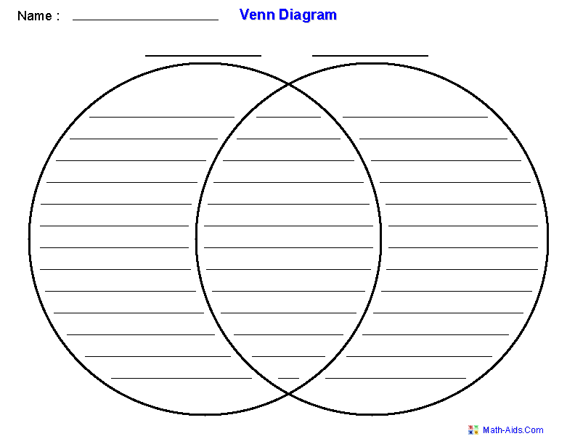

Name______________________________________________ Date__________________

New England Food & Cooking

Directions: Read the information below and then fill out the chart with your group.

The problems the early New England colonists faced were many. They had to struggle for survival in the midst of a land of plenty. Despite grueling hardships, within a short period of time homes were built, fields were cleared and sowed, and orchards and gardens were planted.
Although their food supplies were limited at first, colonial cooks learned to make some very tasty dishes. As soon as they began to receive such imported items as baking powder, yeast, and sugar, many delicious recipes developed. Some of the finest cooking in American history has come from Colonial New England.

Basic Foods
Everyone who arrived during the early 1600s had to become accustomed to three foods available in this new land. These foods included corn, pumpkins, and beans. For the early colonists, corn and pumpkins were often the difference between survival and starvation. Colonial cooks learned how to use them in ingenious and inventive ways. Meat, fish, and bread were an important part of the early settlers' diet, as well.

Meat: The early colonists were surprised by the abundance of game. In England hunting was a privilege reserved for the rich. The Indians taught the colonists how to hunt game and catch fish. Some of the animals eaten were deer, duck, turkey, rabbit, geese, and pigeon. A common meat dish was New England boiled dinner, a one-pot meal that simmered all day over an open fire. It consisted of vegetables cooked with meat and broth. Common vegetables included turnips, carrots, onions, and cabbage. Later potatoes were added.

Seafood: In New England waters, seafood was plentiful—especially lobster, clams, oysters, and cod fish. A popular soup made from seafood was fish chowder. New England fish chowder consists of some kind of seafood in a thick, creamy soup flavored with salt pork and diced potatoes.

Breads: The most common bread was known as cheate bread, a thick sourdough version, and cornbread, made from cornmeal, flour, and water.

Vegetables: The term "vegetable" was not used in the 16th century. Edible plants were called "sallets." The most widely used sallets included onions, artichokes, carrots, turnips, cabbages, and beets.

Fruits: The Pilgrims found a number of native fruits that included blueberries, cranberries, blackberries, raspberries, and gooseberries. As soon as they could, they planted apple orchards. In addition, the colonists also found walnuts, chestnuts, and hickory nuts.

Desserts: Puddings and pies were two basic types of desserts made by early cooks. Especially popular was Indian pudding, an authentic American treat made from cornmeal, milk, and molasses. In the fall season, pumpkin pies were a favored treat. Fruit pies, made from native fruits, were also baked. During the early years in America, an apple pie was rare because apples were unknown in America at that time and needed to be imported from England. Sweeteners included molasses and maple syrup.

© Pearson Education, Inc. All Rights Reserved.

Name______________________________________________ Date__________________

New England Food & Cooking Worksheet

Three Earliest Foods:
Meats:
Seafoods:
Breads:
Vegetables:
Fruits:
Nuts:
Desserts:
Sweeteners:
Common meat dish:
Common seafood dish:

© Pearson Education, Inc. All Rights Reserved.
Name:_________________________ Date:_____________________

Thirteen Colonies Map Activity

Directions: Identify the thirteen colonies and their geographical features using COLOR and SYMBOLS. Follow the instructions on the checklist below, and check the box when you have completed the step.

Step | Done
- Neatly label all of the Thirteen Colonies.
- Create a map key color to show each colonial region (New England, Middle, & Southern).
- Using the key, color the colonies appropriately.
- Using an atlas, draw and label the Delaware River, Hudson River, and Connecticut River.
- Label the Chesapeake Bay and Massachusetts Bay.
- Create a symbol for the Appalachian Mountains in your key and draw them on the map.
- Find Jamestown and label it.
- Label the Atlantic Ocean.

