SECTION 28 0600 - TESTING FOR ELECTRONIC SAFETY AND SECURITY

Maintain Section format, including the UH master spec designation and version date in bold in the center columns of the header and footer. Complete the header and footer with Project information.

Verify that Section titles referenced in this Section are correct for this Project's Specifications; Section titles may have changed.

Delete hidden text after this Section has been edited for the Project.

Designer is required to adhere to the University’s “Network Infrastructure Design Standards,” “UH System IT Facilities: Baseline Standards,” and “Electronic Access Control Design Guide” available in Owner’s Design Guidelines on the University Information Technology and Facilities Planning and Construction web sites.
These specifications provide basic minimum criteria to be met in preparing the final specifications for this Section, which is the responsibility of the Designer. Revise this Section by deleting and inserting text to meet Project-specific requirements.
Maintain Section format, including the UH Master Spec designation and version date in bold in the center columns in the header and footer. Complete the header and footer with Project information.
Designer is required to adhere to the University’s “Electronic Access Control Design Guide” and “Network Infrastructure Design Standards” available in Owner’s Design Guidelines on the Facilities Planning and Construction website, and to “Electronic Safety and Security Design Guide: Electronic Access Control and Intrusion Detection,” “Electronic Safety and Security Design Guide: Surveillance and Call Stations” and “Design Deliverable Checklist: Security” available in IT Facilities Standards on University Information Technology website.
This Section uses the term "Architect" or “Engineer.” Change this term to match that used to identify the design professional as defined in the General and Supplementary Conditions.
Verify that Section titles referenced in this Section are correct for this Project's Specifications; Section titles may have changed.
Delete hidden text after this Section has been edited for the Project.
- GENERAL
  - RELATED DOCUMENTS
    - Drawings and General Provisions of the Contract, including General and Supplementary Conditions and Division 01 Specification sections, apply to work of this Section.
    - The Contractor's attention is specifically directed, but not limited, to the following documents for additional requirements:
      - The current version of the Uniform General Conditions for Construction Contracts, State of Texas, available on the web site of the Texas Facilities Commission.
      - The University of Houston’s Supplemental General Conditions and Special Conditions for Construction.
  - SECTION INCLUDES
    - Deliverables.
    - Scope of Testing.
    - Test Procedures.
    - Field Quality Control.
    - Manufacturer's Field Services.
    - Demonstration.
  - DELIVERABLES
    - Submit the following prior to System Acceptance Testing:
      - Complete, end-to-end test results for all copper STP, UTP and fiber optic cables installed for use on Security Devices. Refer to Sections 27 1500 “Communications Horizontal Cabling” and 27 1300 “Communications Backbone Cabling” for testing requirements.
      - As-Built drawings in .rvt and .dwg formats with device locations and labels that coincide with test result information.
      - Formal Request for Electronic Access Control (EAC) Acceptance Testing.
        - Owner’s EAC Representative will schedule system commissioning and distribute two documents to Contractor for completion:
          - Access Control Programming form
          - Card Access Programming form
        - Return both forms to the Campus EAC Representative.
      - Surveillance System Acceptance Test, included as Appendix A in this Section.
      - Intrusion Detection System Acceptance Test, included as Appendix B in this section.
      - Personal Protection System Acceptance Test, included as Appendix C in this section.
  - SCOPE OF TESTING
    - Data cabling: Test per Section 27 1500 “Communications Horizontal Cabling.”
    - Access Control — Verify proper operation of the following as applicable:
      - Card Reads: Valid Credential, Invalid Credential
      - Door Status: Open, Closed, Held Open, Forced Open
      - Audible Alarm: Valid exit (no alarm), Invalid exit (alarm)
      - Door Opener and ADA push plate integration.
      - Intercom and Door Release Integration
      - Parking System Integration
      - Elevator Integration
    - Surveillance
      - Verify camera connectivity and operation.
      - Verify and adjust camera views per Owner request.
    - Intrusion Detection — Verify operation and alarm reporting status of:
      - Duress Buttons
      - Intrusion points
    - Personal Protection Devices — Verify operation and alarm reporting status of:
      - IP Intercom Plate
      - Lights
      - Associated Cameras and other accessories
- PRODUCTS (NOT APPLICABLE)
- EXECUTION
  - TEST PROCEDURES
    - Test each component and sensor and verify the proper functioning of each component within a particular sub-system.
    - Test each sub-system until all detection zones, alarm assessment components, alarm reporting and display, and access control functions have been verified. Correct any deficiencies prior to final functional and operational tests of the system.
    - Test the entire system to assure that all elements are compatible and function properly as a complete system.
    - Conduct a continuous, 72-hour “System Operational Test”, in which all components and sub-systems of the security system are demonstrated to operate together as a system.
    - Upon successful completion of the “System Operational Test,” request an Owner Acceptance Test. Refer to Article 3.4 below.
  - FIELD QUALITY CONTROL
    - Perform demonstration and testing for Owner personnel in accordance with Section 01 7900, “Demonstration and Training.”
  - MANUFACTURER'S FIELD SERVICES
    - Include services of technician to supervise installation, adjustments, final connections and system testing and to train Owner personnel.
  - ACCEPTANCE TEST – REQUEST AND SCHEDULING
    - Prior to requesting the Owner’s Acceptance Test, conduct a final quality control inspection. Pre-test all equipment and system features. Correct any deficiencies discovered as the result of the inspection and pre-test.
    - Submit completed Requests for Acceptance Test to the Owner’s Representatives, to include UIT Project Manager, EAC, Lock Shop and Campus Safety Representatives. Refer to Appendix A for standard request forms.
    - Allow a minimum of 5 days between the Request submission date and Requested Date of Test.
    - Plan Acceptance Test scheduling to allow for free access to unoccupied Work area.
    - Submittal of Request for Acceptance Test constitutes a certification of completion of the Work in conformance with the Contract Documents and manufacturer’s guidelines.
  - ACCEPTANCE TEST
    - Provide the services of two or more technicians to perform the Acceptance Test.
      - Technicians performing the Acceptance Test are required to have been involved in the installation of this Project and to be thoroughly familiar with all aspects of the Work.
      - Provide portable two-way radios for use during the test.
    - Provide all ladders, tools, test equipment, and other equipment needed to accomplish the Acceptance Test.
    - During the Acceptance Test, demonstrate all equipment and system features to Owner’s Campus Safety and EAC Representatives.
      - Fully cooperate with the Owner’s Campus Safety and EAC Representatives and assist with the Owner’s inspection and Acceptance Test.
      - Remove and reinstall covers, open and restore wiring connections, operate equipment, and perform other reasonable work as requested by the Owner’s Campus Safety and EAC Representatives.
      - Document the Acceptance Test using an approved Acceptance Test Checklist. An example is provided as Appendix D in this Section. Contractor may use alternative checklists and/or documentation methods as approved by the Owner’s Campus Safety and EAC Representatives.
    - Any portions of the Work found to be deficient or not in compliance with the Contract Documents will be rejected.
      - Owner’s Campus Safety and EAC Representatives will prepare a list of any deficiencies observed during the Acceptance Test.
      - A copy of this list will be provided to the Contractor, who shall promptly correct all deficiencies.
  - Project Close-out

    - As-Built drawings in .rvt, .dwg and .pdf formats with device locations and labels that coincide with test result information.

Appendix A
UNIVERSITY OF HOUSTON
REQUEST FOR SURVEILLANCE SYSTEM ACCEPTANCE TEST

Building: ____________________________________________
Contractor: ___________________________________________
I hereby certify that:
1. The surveillance installation at the above-mentioned building is complete and has been provided in accordance with the Contract Documents.
2. All systems and devices have been thoroughly pre-tested and all necessary corrections have been made.
3. All project documentation, including As-Built Drawings, System Documentation including IP Address, MAC Address and Network Port and other such information, has been submitted in accordance with the Contract Documents.
I request that a Surveillance System Acceptance Test be conducted

on (date)___________________________.

By:_______________________________________________________

Title:______________________________________________________

Company:__________________________________________________

Date of Request:______________________________________________________
Appendix B
UNIVERSITY OF HOUSTON
REQUEST FOR INTRUSTION DETECTION SYSTEM ACCEPTANCE TEST

Building: ____________________________________________
Contractor:___________________________________________
I hereby certify that:
1. The intrusion detection system installation at the above-mentioned building is complete and has been provided in accordance with the Contract Documents.
2. All systems and devices have been thoroughly pre-tested and all necessary corrections have been made.
3. All project documentation, including As-Built Drawings, System Documentation including and other such information, has been submitted in accordance with the Contract Documents.
I request that an Intrusion Detection System Acceptance Test be conducted

on (date)___________________________.

By:_______________________________________________________

Title:______________________________________________________

Company:__________________________________________________

Date of Request:______________________________________________________

Appendix C
UNIVERSITY OF HOUSTON
REQUEST FOR PERSONAL PROTECTION SYSTEM ACCEPTANCE TEST

Building: ____________________________________________
Contractor:___________________________________________
I hereby certify that:
1. The personal protection system installation at the above-mentioned building is complete and has been provided in accordance with the Contract Documents.
2. All systems and devices have been thoroughly pre-tested and all necessary corrections have been made.
3. All project documentation, including As-built Drawings, System Documentation including and other such information, has been submitted in accordance with the Contract Documents.
I request that a Personal Protection System Acceptance Test be conducted

on (date)___________________________.

By:_______________________________________________________

Title:______________________________________________________

Company:__________________________________________________

Date of Request:______________________________________________________

Appendix D- Example of Acceptance Test Checklist
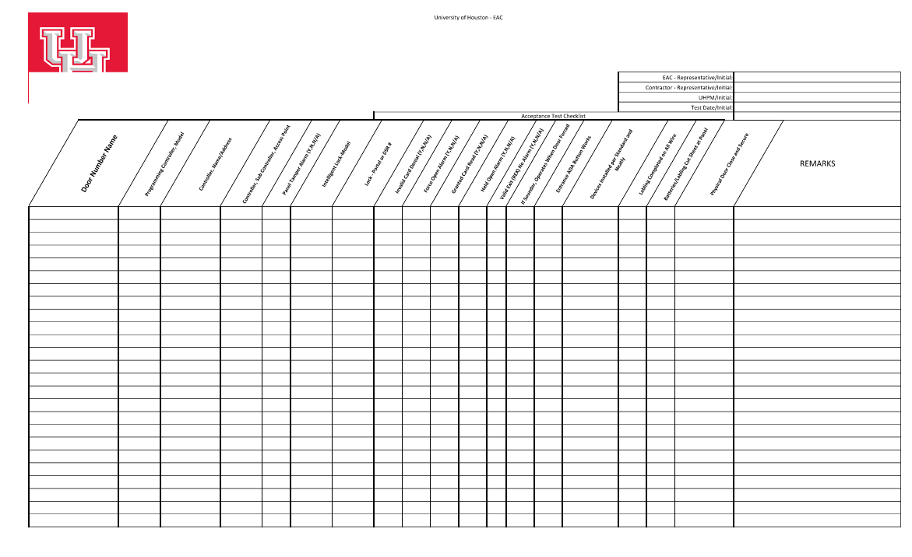
END OF SECTION 28 0600

