DESCRIPTION | Creating a 998 Journal Entry
NAVIGATION PATH | General Ledger, Journals, Journal Entry, Create Journal Entries
STEP 1 | After completing the navigation listed above you will be at the Journal Entry Screen.  The Business Unit defaults based on the Period Business Unit (ex. 00730), the Journal ID defaults to NEXT which assigns the next available journal number, the Journal Date for all 998 entries should be 08/31/YYYY, (last day of the fiscal year).  Note: When correcting or reversing an existing journal, delete NEXT in the Journal ID field and enter the existing journal number in the Journal ID field.  Select the Add button.  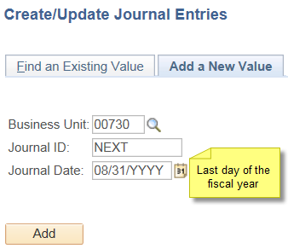
STEP 2 | On the Header screen, enter the purpose of the journal in the Long Description field, check the box for Adjusting Entry, and make sure the Period changed to 998 in the Period field.  DO NOT change the ADB Date on this screen. The ADB Date will automatically default; changing the ADB date will not change the accounting period to period 998.  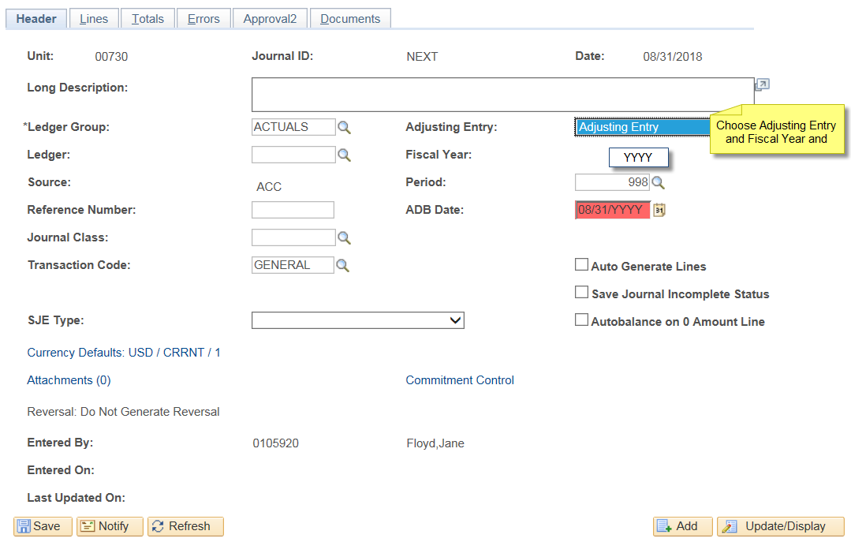
Step 3 | On the Lines screen, record your transactions using the appropriate account and cost center. Journals prepared during period 998 can transfer non-payroll expenses between the following types of cost centers:  - State to State  - Local to Local  - State to Local  - Local to State  Finance will prepare the voucher for state to local and local to state 998 expenditure transfers. Verify the transferred expenditure is allowable for the cost center receiving the expenditure.  You can also transfer fund equity between allowable fund codes. See the State and Local Fund Equity Non-Mandatory Transfer instructions on the web: http://www.uh.edu/finance/pages/Ref_Fund_Equity.htm

