Purpose: The following procedure explains the cost center verification process at the University of Houston. Cost center verifications are an important internal control for ensuring that authorized transactions post to the correct cost centers.
1. Each month, the Department Business Administrator (DBA) or designee runs the 1074 Verification Worksheet for all active cost centers in the department. (Cost centers may be verified at the Cost Center Manager level or the College/Division level, if desired.)
2. DBA or designee reviews transaction spreadsheets to verify that all transactions belong to that department. (It is not necessary to type an “X” in the Verified column of verified transactions.)
a. Review transactions that were generated at the department level, such as vouchers (expense only), SC vouchers, GL journals, budget journals, and requisitions. Verify that the document creator belongs to your department.
b. Review P-Card and Travel Card transactions, which have the last four digits of the card number in the transaction description. Verify that all cards belong to your department.
c. Review other vouchers created by Accounts Payable (in addition to P-Card and Travel Card), such as vouchers to Adroit (temporary personnel), and vouchers for copier rental or lease. Verify the vouchers are for goods or services requested by the department through a requisition (copiers) or online ordering process (Adroit).
- Review postage, telecom, and Physical Plant charges that are billed by Postal Services, Telecommunications, and Physical Plant to ensure they are reasonable and appropriate on the cost centers charged. DBAs or designees can review detailed charges, if needed, on the Postal Services and Physical Plant websites.

- It is not necessary to review system generated transactions, such as accounts payable liability, payroll liability, indirect cost expense (grants), revenue recognition (grants), letter of credit (grants), etc.

- It is not necessary to review payroll-related expense transactions on the Verification Worksheet, which summarize transactions from the HR System. The detailed transactions (by employee) will be reviewed in a separate step below.
3. DBA or designee determines if department has payroll suspense or a liability balance that needs to be cleared and, if so, creates correcting entries in PeopleSoft.
- Run the Fiscal Year Suspense report in the HR System to see if the department has any payroll suspense.
See Appendix A for instructions to run the Fiscal Year Suspense Report.
- Run the UHS_AP_LIABILITY_BALANCE query in the Finance System to see if there are any liability balances for your department’s P-Card, Travel Card, Adroit, Concur, or FG5 (Fund 5) Late Payment Interest transactions (accounts 20109 to 20115).
4. DBA or designee verifies that employees are paid from the correct cost center.
- Run the Labor Distribution Report or BOB Report in the HR System. Verify that all employees on the report are paid from the correct cost center.
See Appendix B for instructions to run the Labor Distribution Report.
See Appendix C for instructions to run the BOB Report.
- It is not necessary to verify the amount of salary or wage received by each employee is correct, because this was done when the department ran the Trial and Final Payroll Verification Reports during the month when notified by the Payroll Department.
5. DBA or designee verifies that budget balances are not exceeded, and equity balances are not in deficit.
a. Review the Verification Worksheet to verify that budget balances are not exceeded and to identify deficit equity balances.
b. If negative budget balances or equity deficits exist, DBA or designee should review revenue and expense budgets to determine whether the negative budget or deficit will be corrected by fiscal year end and reduce budgets or transfer fund equity as needed for anticipated shortfalls.
c. To assist in identification of equity deficits, the Controller’s Office will send interim deficit equity reports, which identify equity deficits by department and fund group, as of the close of periods 6, 9, 11, and 12. The Controller’s Office will send final deficit equity reports, which require action plan reporting, as of the close of period 998.
6. Once a month, the DBA or designee (i.e., verifier) completes the Cost Center Verification Log (Appendix D) and notes any corrections or adjustments needed.
Alternatively, the verifier can send an email to the Cost Center Manager or designee with the same information contained in the Cost Center Verification Log (i.e., cost centers verified, accounting period, and a list of any needed corrections or adjustments, if any).
7. No later than 60 days after the accounting period is closed, the Cost Center Manager or designee, who must be someone in higher authority than the person who performed the verifications and must be at the DBA level or higher, reviews the transactions in the 1074 Verification Worksheets that were previously verified and initials and dates the Cost Center Verification Log. Alternatively, the Cost Center Manager or designee can reply to the verifier’s email acknowledging review of the cost center verifications, instead of completing the Cost Center Verification Log.
All delegations of authority by the Cost Center Manager for someone else to review his/her cost center verifications must be in writing by memo or email.
8. Retain the following documentation in paper or electronic form for all the months of the current and previous fiscal years:
- Monthly 1074 Verification Worksheets.
- Cost Center Verification Logs initialed by verifier and the Cost Center Manager or designee or the Cost Center Manager or designee’s reply email that the verifications have been reviewed.
- Memo or email from Cost Center Manager to Department Business Administrator or higher position delegating authority to review the Manager’s cost centers, if the Cost Center Manager does not want to perform the review him or herself.

Appendix A

FISCAL YEAR REPORT INSTRUCTIONS

Navigation for running report in HR: Main Menu > UHS HRMS Payroll > Reports > FY Suspense Report
- Create a Run Control ID. (Suggestion: use the Department ID).
- Enter “as of date”
- Enter Business Unit
- Choose a sort option (by Division, college or department)
- Click Run button
- Selected the process name
- Click the Ok button on the next page
- Click report manager or process monitor to access the report (PDF file)

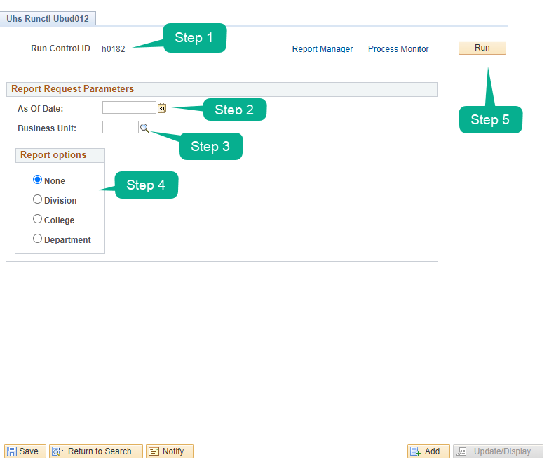
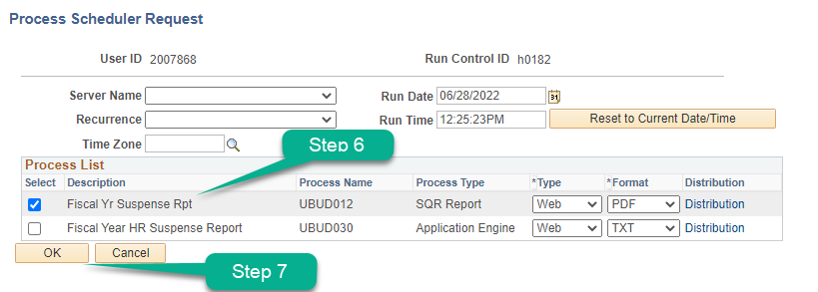
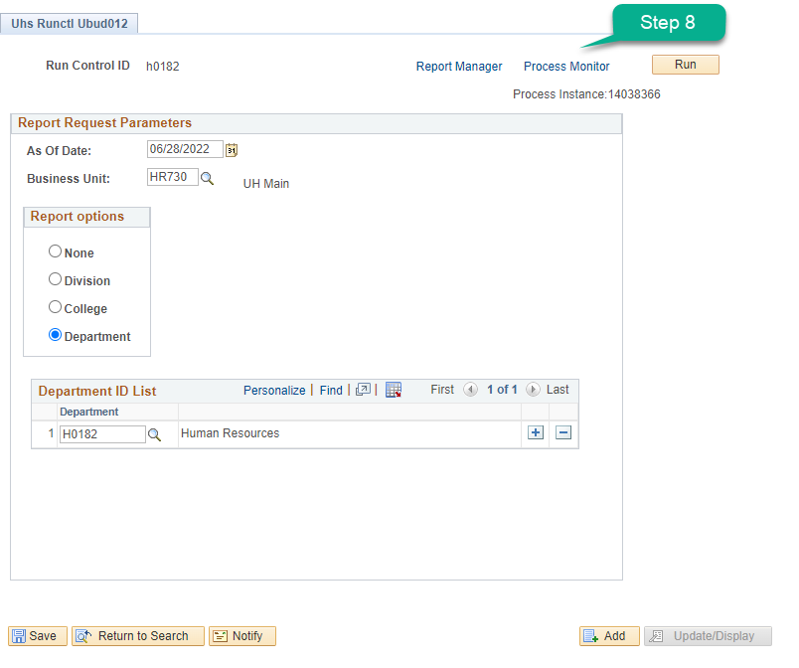
Appendix B
Labor Distribution Report Instructions
Navigation in HR System: UHS HRMS Payroll / Reports / Labor Distrib Rpt - CC Dept
- Create a Run Control ID. Suggestion: Use the Dept ID where the payroll expense is charged.
- Enter the last date of the month that corresponds to the accounting period you are verifying.
- Enter the business unit.
- Enter the Dept ID where payroll is charged; not the Job DeptID.
- Select the Sort Order for the report.
- Click the Run button.
- Click the OK button on the next page (not shown).
- Click Report Manager or Process Monitor to access the report (PDF file).

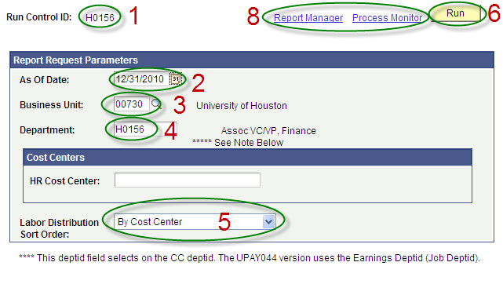

Appendix C

BOB REPORT INSTRUCTIONS
Navigation for running report in HR: Main Menu > UHS HRMS Budget > Reports > Bob Report
- Create a Run Control ID. (Suggestion: use the Department ID).
- Enter “as of date”
- Enter Business Unit
- Choose a sort option (by department or fund code)
- Enter information regarding Cost Center (i.e. fund code, department, program code, or project ID)
- Click Run button
- Click the Ok button on the next page
- Click report manager or process monitor to access the report (PDF file)
*Note: You have the option to include a page break after cost center.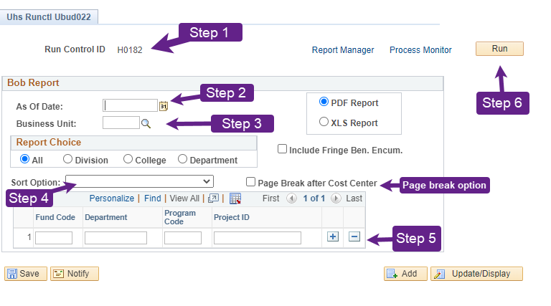
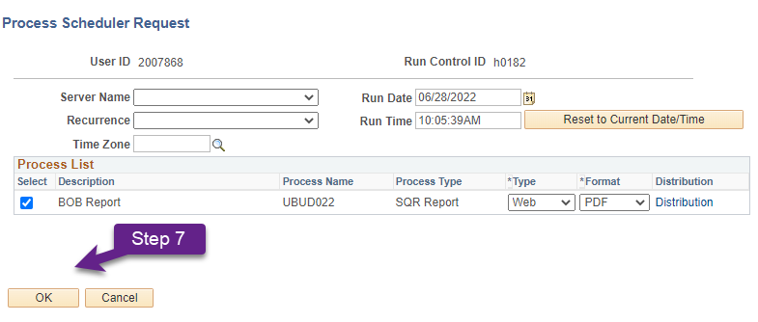

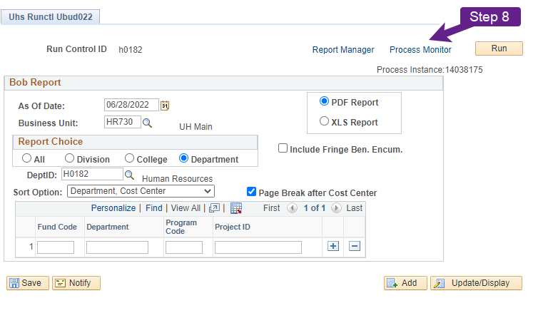

Appendix D
Cost Center Verification Log
I verified transactions for the following cost centers.
Description of Cost Centers Verified (Complete One):
All active cost centers for Dept ID ________
All active cost centers for Cost Center Manager __________________
Other: ___________________________________________________
Accounting Period Verified: Fiscal Year: ________ Month: _____________
Name of Verifier: ______________________________ Title: _____________________
Date Verification was Completed: _____________ Initials of Verifier: ___________
Are any corrections/adjustments needed to the cost centers verified? (Y/N) _________
For each correction or adjustment needed, note the following below: (1) cost center, (2) account, (3) amount, (4) date of original transaction, and (5) description of correction/adjustment needed.

I reviewed the above cost center verifications.
Name of Reviewer: ______________________________ Title: _____________________
Date Review was Completed: _____________ Initials of Reviewer: ___________
Note: Reviews of cost center verifications must be completed no later than 60 days after the close of the accounting period being verified.
Reviewer Comments (Optional):

