Please note the following when completing your monthly account reconciliations/entries

1. When entering in information under your account summary, you will need to save after each entry in the actual accounting codes information entry page, please see below:

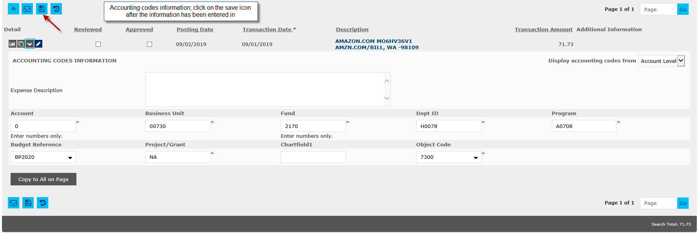

1. The Budget Reference field can be edited now. For those cost centers that have Fund 5 codes and do not require a Budget Reference, place your mouse curser in the Budget Reference field, highlight the BP2020 and use the Delete or Backspace key on the keyboard to remove the BP. Before clicking on save, use the Tab Key to move to the next field, then click on Save. This will ensure the Budget Reference BP2020 is removed and the field is empty. (***Again this is just for Fund 5 transactions that do not require a Budget Reference***). All other NA cost centers will need the Budget Reference of BP2020.

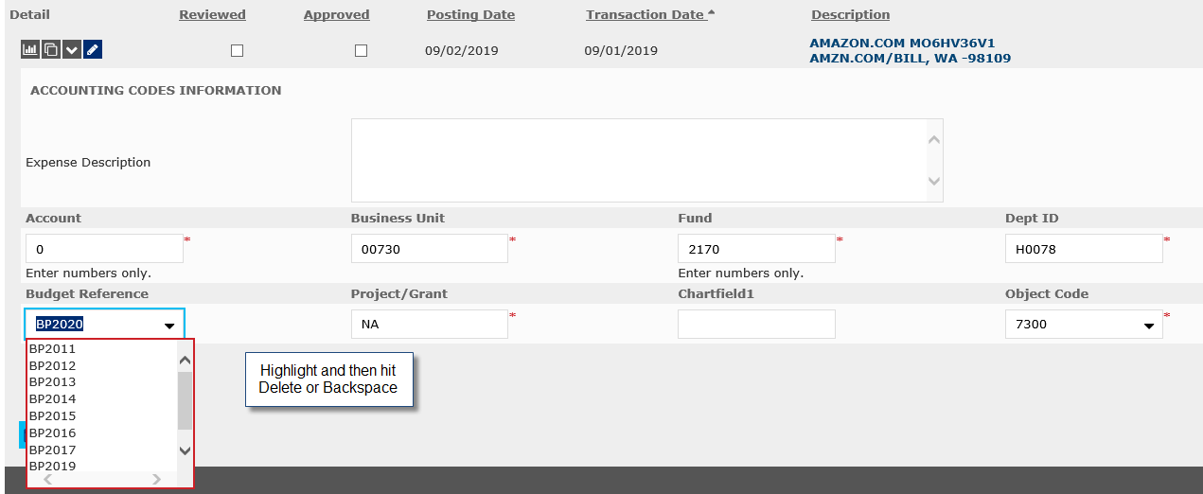

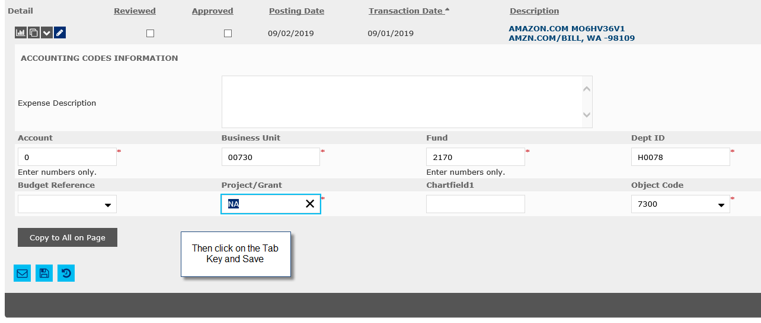

1. For those transactions that have a Budget Reference of BP2011 or BP2019, please highlight the field and use the down arrow to select BP2020, click on the Tab key, then click on Save.

