Virtual Field Trip: Exploring Earth’s Mantle

Physical Geology GEOL1330 Spring 2024

Name:

myUH ID number:

Professor’s Name:

Class Time:

Academic Honesty (Signature Required)
The Virtual Field Trip to Earth’s Mantle is to be completed by yourself; you should not work with a partner or group.

The Mantle trip is to be completed by yourself; you should not work with a partner or group. Do not search for answers on the internet because 1) it is cheating, 2) answers that are posted are incorrect, and 3) many of the questions change every semester. It is a violation of UH Academic Honesty Policy to upload any of this material to sites such as Chegg and CourseHero. ChatGPT may help with this but should not be used for answers. If you are unfamiliar with a word or geologic concept, it is okay to look it up online to find the correct spelling and definition. If you find yourself needing help, physical geology teaching assistants staff the Geoscience Learning Center.

By submitting this work, I, Type Your Name Here attest that I have not violated the UH Academic Honesty code. I completed this assignment by myself and did not copy any portion of my answers from another student, a website, or any other source.

Instructions
All answers should be written in complete sentences and typed in this document. Any answers not written in complete sentences will be marked as incorrect and will not receive credit.

Educators and students are now turning to open educational resources (OER) for ease of access as well as low cost. The O stands for open that gives users permission to redistribute this content in any format including print. We made this field trip available under the Creative Commons 4.0 BY-NC-SA license which gives anyone the right to use the material, but you must acknowledge (attribute or BY) and only use it non-commercially (NC). In addition, you may share and modify our material (SA). Even though this is not a traditional copyright, we expect students to respect our material and not share the questions and your answers with others. If you submit this material to an online learning platform such as Chegg, Course Hero or any other education technology website, you are violating our CC license and it will be removed from that site.

Assignment Submission
Save your completed PDF assignment as “yourlastname_firstname_VFTMantle”. Email your completed documents to file to easglc@cougarnet.uh.edu with the subject “Mantle VFT.” Teaching Assistants will begin grading submissions after the deadline. After your work is graded, you will receive a confirmation email from the TA. If your assignment requires resubmission, you will have 48 hours to do so.

Virtual Field Trip: Exploring Earth’s Mantle

Preface
Geological field trips are one of the primary ways that geologists can learn about the natural history of the Earth. Typical tools involved with classic geological field trips include the use of rock hammers, hand lenses and map boards. However, these classic geologic field trips are only possible if the rocks of interest are exposed at Earth’s surface. The vast majority of Earth’s geology is deep beneath our feet, in the Earth’s interior. In this assignment, we will explore Earth’s mantle. The mantle was once thought to be a relatively featureless realm between the crust and core. However, current ideas (see Fig. 1 below) suggest the mantle contains hot, buoyant ‘plumes’ of abnormally hot rock that rise under ‘hotspot chains’ such as Hawaii. Under subduction zones, ancient oceanic crust is inserted and recycled into the mantle, sinking and buckling under its own weight to the core-mantle boundary.

Geophysical techniques such as seismic tomography provide geologists with a window to peer into the 3D structure of the mantle to study present tectonic processes and the geologic past. This exercise will introduce students to mantle tomography, which is providing increasingly clearer images of Earth’s interior that are very similar to CT scans utilized by medical doctors.

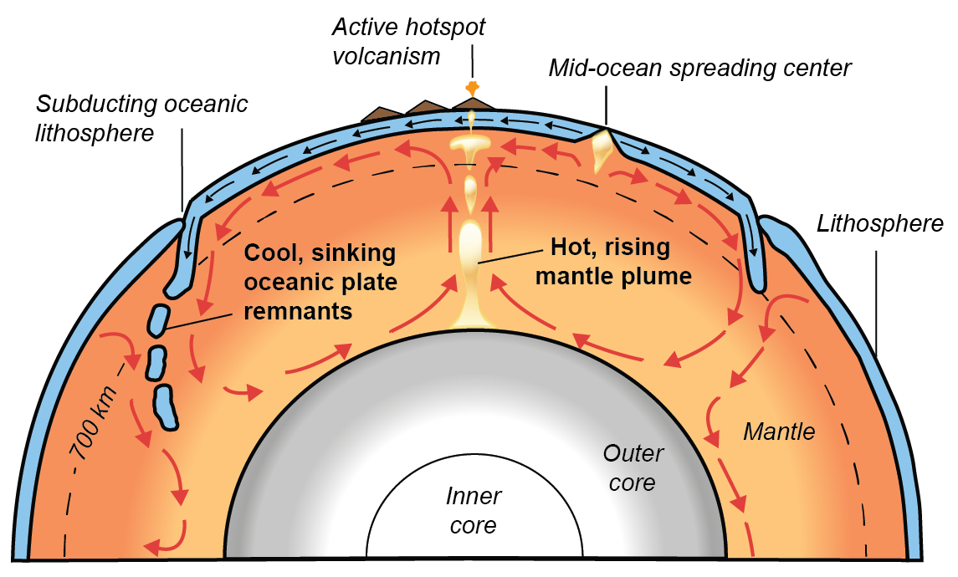

Figure 1: Earth’s mantle showing possible mantle flows (red arrows). Whole-mantle convection is driven by the sinking of cooler, subducted oceanic lithosphere, and the rising of hot, mantle plumes from the core-mantle boundary (re-drawn from USGS).

Aims
The purpose of this assignment is to make observations of the Earth’s mantle from seismic tomography. Our window into the mantle will be provided by the Hades Underworld Explorer (http://www.atlas-of-the-underworld.org/hades-underworld-explorer/), which was generously built by researcher Dr.Douwe van Hinsbergen of Utrecht University, Netherlands. If the link doesn’t work, try removing the “s” from “https” in the web address after clicking on the link.

Getting Started
Before we begin, let us first review two important terms: cross-sections, and seismic tomography. In this assignment, we look at cross-sections. A cross-section is a view exposed from making a straight cut through an object. For example, the Figure 2 photo below shows a cross-section through an apple. In this exercise, we will look at cross-sections of the Earth. Have another look at Figure 1 (on Page 2). Can you visualize how Figure 1 shows a straight cut through a spherical Earth?

Figure 2: Cross-section through an apple shown on the right.
(Source: Wikipedia https://en.wikipedia.org/wiki/Australian_cuisine)

Obviously, we cannot slice across the entire Earth like an apple. However, seismologists have developed a technique called seismic tomography to image the Earth’s interior. Seismic tomography uses seismic waves from earthquakes to create computer-generated Earth cross-sections. The cross-sections are colored by the variations in earthquake wave speeds, which can vary by several percent within Earth. Although research continues on specific reasons for these wave speed variations, most scientists agree that thermal differences (i.e. hotter or cooler regions) within Earth play the most important role. Hence, in a way, seismic tomography can be understood as a thermal camera image of the Earth. Figure 3 below shows a thermal camera image of two feet that reveal higher temperatures in one foot (left side of image).

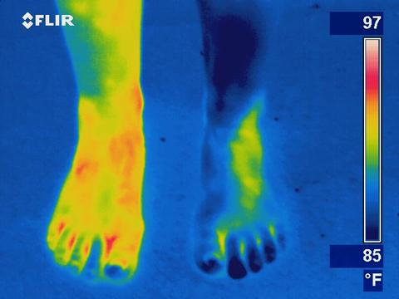

Figure 3: Thermal camera imaging of two feet.
(Source: https://reductionrevolution.com.au/blogs/news-reviews/thermal-camera-infrared-scanner-uses)

Part 1: A deep dive into the mantle under South America
We will now look at seismic tomography of the Earth’s mantle using Hades Underworld Explorer. This tool provides a web interface in which you can specify the start and end points of a geologic cross-section through the Earth (from the Earth surface to the core-mantle boundary at 2890 km depths). Mantle tomography data is then displayed on the specified cross-section slice. To get started:

- In a web browser, load the Hades Underworld Explorer (http://www.atlas-of-the-underworld.org/hades-underworld-explorer/). Note: Do not use a Firefox browser.
- Navigate to the top right corner of the map window and click on the button entitled “Settings (expand)”.
- Check these two boxes: “Show high contrast image” and “Show plate boundaries”. This will make mantle features clearer. The plate boundaries will help you to better locate your cross-sections.

On the map interface, navigate Google Maps to drag and move the “L or left” marker off the west coast of Chili and the “R or right” marker off the east coast of Argentina. An example is shown below:

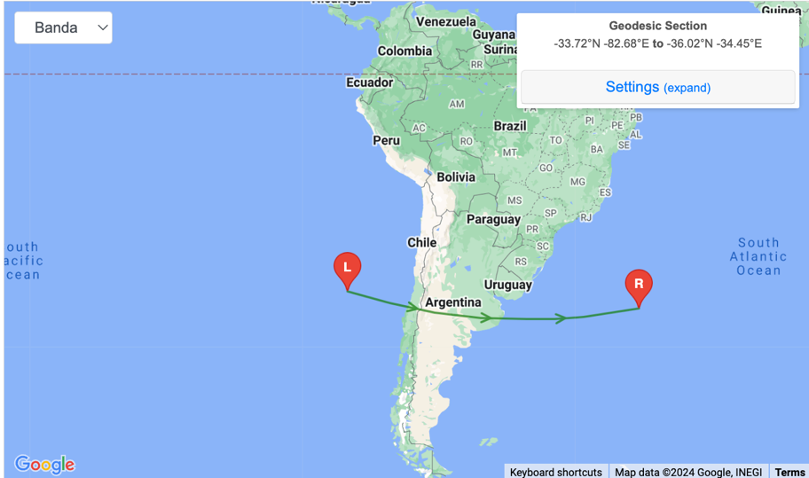

Examine the generated cross-section, then answer the following questions:
- Why is the top of the cross-section curved?

- What does the upper surface (the top of the cross-section) of the cross-section represent (i.e., what part of Earth)?

- What Earth boundary layer is represented at the lower surface of the cross-section?

Part Two: Convergent plate boundaries
As previously mentioned, seismic tomography shows regions of the Earth interior where seismic waves travel more slowly or more rapidly than expected. The tomographic color scale shows:

- warmer colors (red, orange) in areas where seismic waves have traveled slower than expected. Often these are interpreted as ‘hotter’ temperature areas.
- cooler colors in areas where seismic waves have traveled more faster than expected. Often these areas are interpreted as ‘cooler’ temperature areas.

Click on ‘Cartesian View’ tab above your selected cross-section. Your cross-section will be shown larger (but in a flattened, box-like Earth). Polar view shows your cross-section in a spherical Earth. Having both views is helpful for geoscientists. Also, note the two white lines for depth reference. The upper line denotes 410 kilometers depth and the lower line denotes 660 kilometers depth. For this assignment, you can switch back and forth from ‘Cartesian View’ or ‘Polar View’ at any time.

- Your cross-section cuts across a subduction plate boundary along the western coast of South America (i.e. Andean-type margin). Here, the Pacific Ocean plate is subducting below South America. Describe in your own words what you observe from tomography of the Earth’s mantle under South America. Which features (i.e., hot/ cold material, geometries of the anomalies, etc.) from Figure 1 (on page 2) can you identify in your tomographic cross-section? Explain.

Part Three: Divergent Plate Boundaries
Now move both of your markers to cross the East Pacific Rise
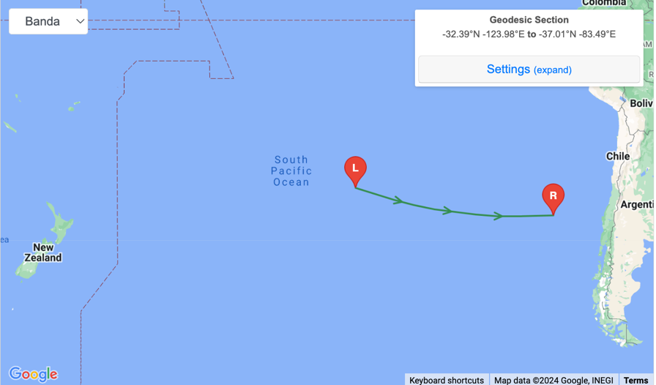

- What major ocean is at the top surface of our cross-section?

- Your cross-section cuts across a mid-ocean spreading ridge and a major divergent plate boundary. Describe in your own words what you observe from tomography of the Earth’s mantle under this major ocean. Which features from Figure 1 (on page 2) can you identify in your tomographic cross-section? Explain.

Part Four: Mantle Plumes and Hot Spots
Move the “L” marker to the Pacific Ocean off the western coast of the Big Island in Hawaii. Then move the “R” marker a similar distance off the eastern coast of Hawaii, making sure the middle of the cross-section intersects the Big Island. An example is shown below.
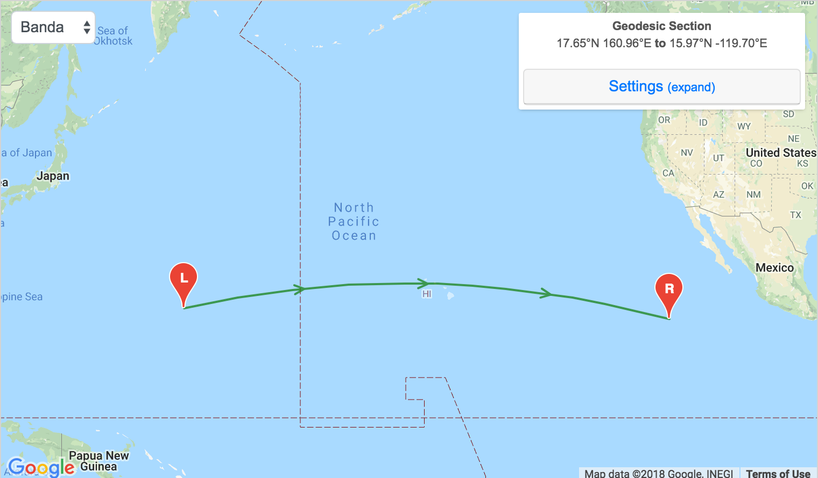

- Observe the tomographic section under Hawaii. What can we conclude about the seismic velocity of the mantle under Hawaii? Is it faster, or slower than expected? What else can you observe?

- Which of the plate boundaries (i.e., convergent or divergent) that we have looked at thus far most resembles the mantle under Hawaii? Explain.
Next, move the “L” and “R” markers to rotate your cross-section around Hawaii, always maintaining Hawaii at the cross-section center. Some examples are shown below. Look at 3 to 4 different cross-sections around Hawaii.
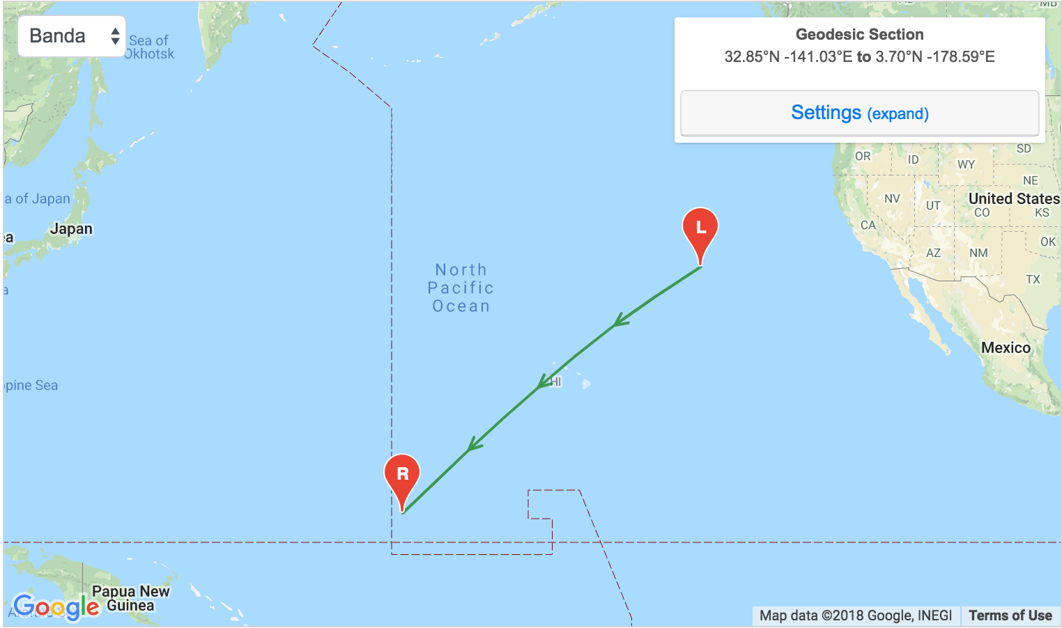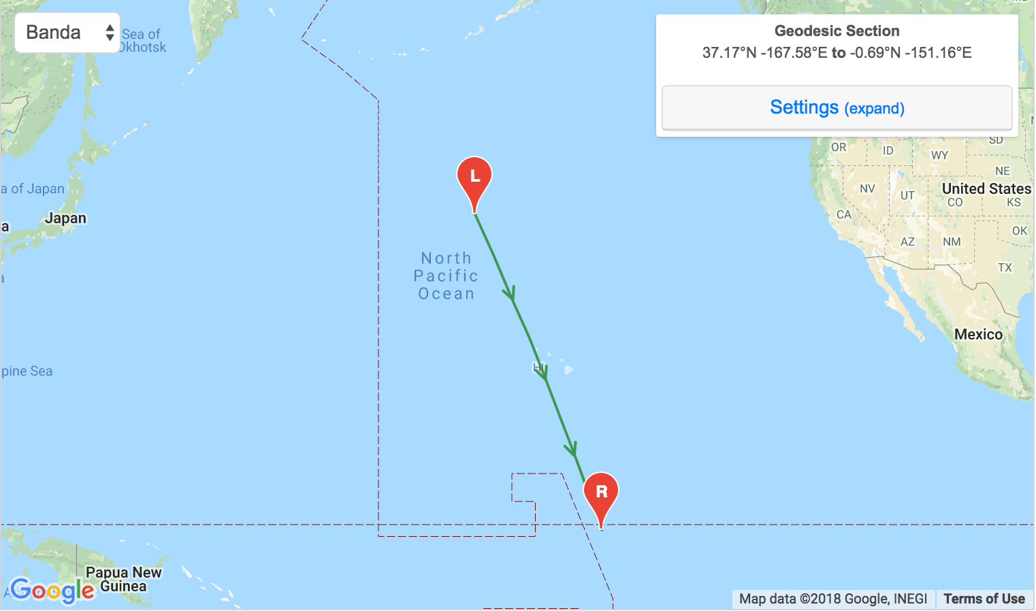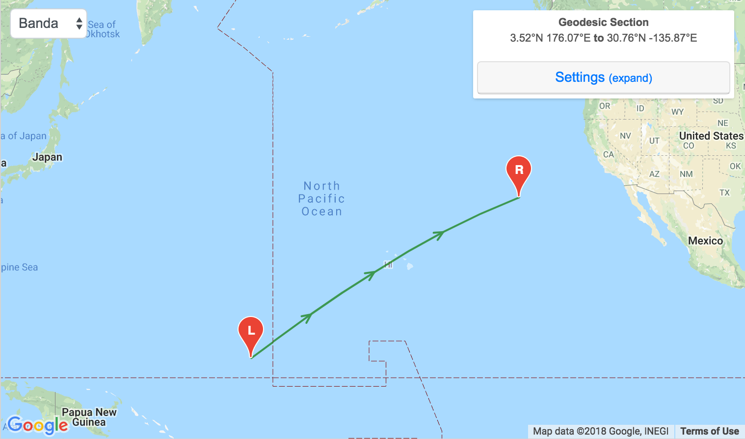

- Examine the mantle feature below Hawaii. Describe in your own words which 3D shape (i.e., cube, sphere, circular column, etc.) might best describe the observed mantle feature under Hawaii. Which features from Figure 1 (on page 2) can you identify in your tomographic cross-section? Explain.

You are now finished the extra credit assignment.

Assignment Submission (repeated from above)
Save your completed PDF assignment as “yourlastname_firstname_VFTMantle”. Email your completed documents to file to easglc@cougarnet.uh.edu with the subject “Mantle VFT.” Teaching Assistants will begin grading submissions after the deadline. After your work is graded, you will receive a confirmation email from the TA. If your assignment requires resubmission, you will have 48 hours to do so.

The National Science Foundation is thanked for providing
funding and support to develop this educational curriculum (Grant EAR-1848327). The exercise was developed by Jonny Wu and Spencer Fuston at the University of Houston.

