Payroll Deductions & Schedule:

Payroll deductions are amounts withheld from an employee’s payroll check for involuntary taxes and deductions which include:

- Medicare taxes
- Social Security taxes
- Federal income taxes
- Garnishments (mandatory – court ordered)
- Retirement contributions

And voluntary deductions such as:

- Insurance (Health, Dental, Vison, ADD, etc…)
- Optional Benefits
- Parking
- State Employees Charitable Contributions (SECC)
- Union
- Wellness Center
- Meal Plans
- UH & Non-UH Contributions

Monthly Deduction Schedule:

As a monthly employee all involuntary & voluntary deductions are taken on every payroll.

Biweekly Deduction Schedule:

As a biweekly employee some of your deductions are split between the first two pay periods in the month. These deductions include the following:

- Insurance (Health, Dental, Vison, ADD, Optional Life)
- Garnishments – taken on every paycheck (based on court document)
- Retirement – deduction is 7.7% of the calculated base

While the voluntary deductions are taken with the first biweekly check of the month. These deductions include the following:

- Parking
- Meal Plans
- Wellness Center
- Union Dues
- Athletic Tickets
- State Employees Charitable Contributions (SECC)
- UH & Non-UH Contributions

To identify which pay periods are the “first” check of the month for biweekly, you can find the information on the “Pay Date Schedule” and the pay period will be indicated with a red asteric “*” and the Pay Period Information will also be found in red (see below highlighted areas – first biweekly pay period of the month):

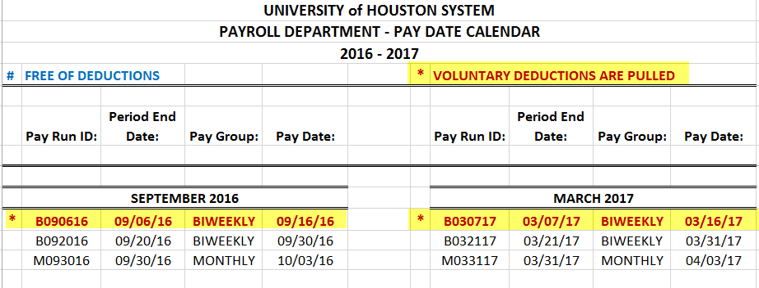

This schedule can be found on our HR Website at the following link:
http://www.uh.edu/human-resources/TRAM/

Biweekly Deduction Free Schedule:

Biweekly employees are paid for 26 pay periods each calendar year, as a result 2 of those pay period will be deduction free. This is primarily due to the involuntary deductions spliting over the first two pay period of the month.

To identify which pay periods are deduction free you can find the information on the “Pay Date Schedule” and the pay periods that are deduction free will be indicated with a blue pound sign “#” and the Pay Period Information will also be found in highlighted in blue (see below highlighted areas – deduction free pay periods):

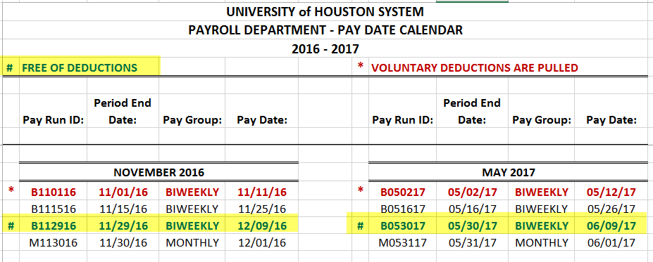

This schedule can be found on our HR Website at the following link:
http://www.uh.edu/human-resources/TRAM/
If you have any questions please feel free to contact one of your Payroll Coordinator’s for assistance:

Kim Thompson 713-743-8682
Carmen Canales 713-743-7775
Jodie Gomez 713-743-8947

