TABLE OF CONTENTS

Introduction - USAS Basic Concepts
PS Basic Concepts

Chapter 1 - Transactions Processed in State Accounting

Originator
Budget Authority to Spend in USAS – PS Cash and Revenue Entries

Budget Load - B2 DB/RW
Appropriation Matrices
Journal Entries
Budget Revision - B3 DB/RW
Budget to Cash Adjustment – USAS Entry - B4 RW
General Revenue Reduction – G0 DB/RW
Roll-forward and Roll-back for Appropriations with UB Authority - R6 RW

Encumbrances - E0 RS

Fund Equity and Cash Transfers - F1 DB/RW

Expenditure Transfers

Expenditure Transfer b/w State Appropriations – E5 (BU 00730), E6 (BU 00783) DB/RW
Expenditure Transfer (ABEST Reconciliation) – E7 DB/RW
HEAF Allocation - H2 DB/RW
Payroll Allocations of Salaries & Benefits - P1 DB

Holding Appropriation Activity

Clear Default - C6 RW
House Bill 3211 (Student Delinquency) - H1 DB

Interagency Contract between State Agencies

Amigos Inter-Library Courier Services - A7 DB
CSA Campus Net Service Charges - C0 DB

CSA Campus Net Service Charges (Distance Learning and Continuing Ed) - C0 DB
CSA Central Services Account - C1 DB

CSA Cinco Ranch Service Charge - C2 DB
CSA Miscellaneous Internal Services - C3 DB
CSA Sugarland Service Charge - C4 DB
CSA Victoria Sugarland Service Charge - C5 DB

Computing Charges (UHV) - C7 DB
Miscellaneous Internal Services - M0 DB

Monthly and Semester Payments

ERS Benefits UH – E3 & E4 DB
FICA (OASI) Benefits – F0 DB
ORP Benefits UH – O0 & O1 DB
TRS Benefits UH – T3 & T4 DB
Bonds Payment – Debt Service - B1 RW
UCI Benefits (Unemployment Compensation Insurance) – U0 RW
WCI Benefits (Worker Compensation Insurance – SORM) – W0 DB

Refund to State

Refund for Payroll Credits - R0 DB
Refund to State Clearing Cost Center (JE – from General Accounting) - R1 RW
Refund to State Duplicated Payments from Vendors (JE – from A/P) - R2 RW
Refund to State Payback for Payroll Overpayments - R3 RW
Refund to State Payback for Terminated Employee - R4 RW
Refund to State (Vouchers – from Departments) - R5 RW
Refund to State Correction – R9 RW

RTI Transactions

RTI Transactions Income for Consultation and Evaluation Services – R7 RW

Sales Taxes

Sales Tax UH - S0 & S1 DB

Shared Appropriation Between UH System Components - S2 DB

Tuition & Fees and Other E&G Dedicated Revenue

Organized Activity
Continuing Education Revenue – I0 RW
Hotel and Restaurant Revenue – I0 RW
Optometry Clinic Revenue – I0 RW

Other Education and General Revenue
Interest on Fund 0225 - I1 RW

Tuition Revenue and Set Asides
Tuition and Fees - T5 RW
Law Set Aside – T5 RW
Doctoral Degree Programs Set Aside – T5 RW
B-On-Time (Designated Tuition & Fees Set Aside) - B5 RW

Chapter 2 - Texas Higher Education Coordinating Board Programs and Higher Education Assistance Funds (HEAF)

Originator
ATP (Advance Technology Program) and ARP (Advance Research Program) – A1 RS
Development Education Program – D0 RS
Fifth Year Accounting Scholarship – F2 RS
HEAF Appropriation 13047 – H0 RS
License Plate Scholarship – L1 RW
Tech Workforce Development (Engineer & Technical Consortium) – E2 RS
Texas College Work Study - T0 DB/RW
Texas Excellence Fund – T1 RS
Texas Grant Program – T2 RW

Chapter 3 - Reconciliations and Analysis
Originator
Cash Reconciliation

Cash Reconciliation Process and Analysis RW
Adjustment Entries Appropriation Number - A2 RW
Adjustment Entries Appropriation Year - A3 RW
Adjustment Entries Rounding Errors - A4 RW
Adjustment Entries – Miscellaneous - A8 DB/RW

Benefits Reconciliation

Overview FICA and ORP Reconciliation
Data Analysis FICA (OASI) and ORP Benefits DB

Payroll Reimbursement File Review RS/DB

Control of Account Receivable from State

Reimbursement from the State Cycle
Reimbursement from the State Reconciliation
Chapter 4 – Year-End Process

Year End Process

Accruals and Accrual Reversals (APS 018) – A0 DB/RW
Benefits to be Proportional by Fund – APS 011 – B0 DB/RW
General Revenue Reconciliation and Year End Entries– G3 RS
Lapsed Appropriation – Reduce Budget and Cash TC 036 – L0 DB/RW
Appropriation Item Transfers – Schedule D-7 RS
Schedule of Indirect Cost – Schedule 6 RS

USAS Report Request Profile RS

Chapter 5 – Legislative Appropriations Request (LAR)

Legislative Appropriation Request (LAR)
Introduction

Overview This section of the reference manual provides some basic concepts used throughout the manual.

USAS Basic Concepts

Fund Type Colleges and universities are reported as a Proprietary Fund Type 05, Enterprise Funds per GASB 33/34. All college and university activity will be reported as Business-Type Activity (BTA) under a single-column enterprise activity. The NACUBO classifications (expenditure functions) and sub-funds are obsolete for our reporting in USAS. However, we continue to use the expenditure functions in PS for internal reporting purposes and some ad-hoc reporting requirement for other agencies.

Proprietary
Fund Accting Proprietary fund reporting focuses on the determination of operating income, changes in net assets (or cost recovery), financial positions and cash flows. The basis of accounting is full accrual and the measurement focus is the flow of economic resources. Proprietary funds focus on whether the enterprise is economically better off as a result of the events and transactions that occurred during the fiscal period reported. Transactions and events that improved an enterprise’s financial position are reported as revenues or gains. Transactions and events that diminished the economic position of the enterprise are reported as expenses or losses. Both current and long-term assets and liabilities are shown on the statement of net assets for proprietary funds.

Financial
Statements Agencies and universities with proprietary funds must prepare the following financial statements:
- Statement of net assets (or balance sheet)
- Statement of revenues, expenses, and changes in fund net assets (or income statement)
- Statement of cash flows

State vs.
Local Funds State funds are monies held and deposited in the State Treasury in Austin for the benefit of the university. Local funds are university monies held and deposited in bank accounts outside of the State Treasury

Fund 0001
Fund 0225 Both Fund 0001 and Fund 0225 (also known as fund 1 and fund 2) are considered state funds. The numerical identifier has been assigned by the State Comptroller to distinguish different categories of funds. Fund 0001 identifies appropriations made to the university from the State’s General Revenue Fund. Fund 0225 represents monies collected locally by the University of Houston (agency 730), such as tuition, and deposited into the State Treasury.

General Revenue
vs. Dedicated General Revenue is considered Appropriated Fund 0001 and is to be used as the Texas Constitution prescribes and the State Legislature directs. Receipts formerly deposited to the Omnibus Tax Clearance Fund (0120) are deposited and allocated from the State’s General Revenue Fund to our Appropriated Fund 0001. Depository interest is retained in the General Revenue Fund.

General Revenue Dedicated is considered Appropriated Fund 0225. It is income from the educational and general activities of the University of Houston and is used for the operation and maintenance of the University. The administering agency is the University of Houston. Depository interest is retained in the State Treasury in our Un-appropriated Activity account.

Both General and Dedicated revenue are included in Group 01 for General State Operating and Disbursing Funds and the appropriation technique is through the General Appropriations Act (GAA).

Appn Funds vs.
Consolidated
Accounts Appropriated Fund 0001 and specified consolidated accounts (e.g., Appropriated Fund 5079) should be the only funds included in the General Fund category on an agency’s report. All other funds, even though they receive their funding from Appropriated Fund 0001, should be classified as another fund type that fits its usage. The cash balance of these other funds and the liability Due to Other Agencies are reported in the controlling agency; the non-controlling agency will show a receivable Due from Other Agencies. (See Shared Funds) Funds that are dedicated to a particular agency are referred to as Consolidated General Revenue accounts. The funds that lose their dedication are consolidated in the General Revenue fund (Appropriated Fund 0001) and lose their identity as a separate fund.

Appropriated Fund 5079 is consolidated in the General Revenue as Appropriated Fund 0001 and the cash is reported in agency 781 (Texas Higher Educations Coordinating Board).

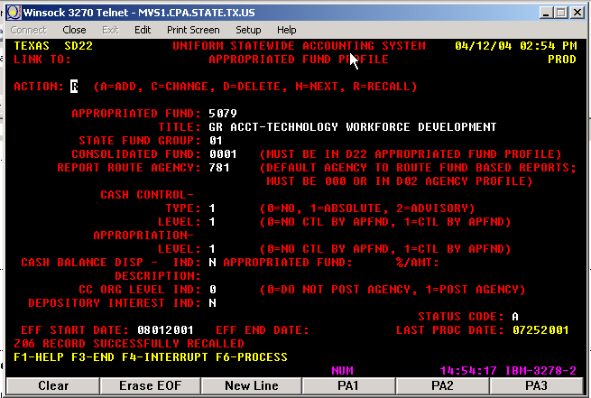

Appropriated Fund 0001 is dedicated to the University of Houston and reported in our agency (730).

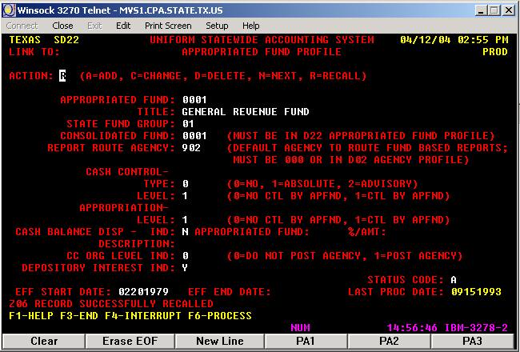

Appropriated
Funds Funds created by the state constitution or statute. The Comptroller assigns a fund number and enters the appropriated fund in USAS on the USAS D22 profile screen. Agencies with appropriations in the General Appropriations Act fund their appropriations with one or more funds.

Shared Funds Some state funds are appropriated for use by more than one agency and are called “shared funds.”
Controlling Agency is the agency required to reconcile the entire cash activity for the fund and report the cash balance in State Treasury on the Annual Financial Report (AFR). To determine the controlling agency, see the “report route agency” on the USAS Appropriated Fund Profile (D22) screen.
Non-Controlling Agency is any other state agency authorized to spend money from a shared fund. The agency should not report the shared cash balance in the State Treasury on the Annual Financial Report.
Agency coordination is required to record the transfers and Due-To/From between the controlling and non-controlling agencies. (back to appn funds vs. consolidated funds)

Appropriation
Years Appropriation years (AY) within a fiscal year: within a given fiscal year (September 1 through August 31), payments may be made from multiple appropriation years. The Benefits Proportional by Fund Report, which is due on November 20, applies only to payments of payroll benefits for the prior appropriation year (e.g., the report due November 20, 2003, which is in FY04, applies to payments of payroll benefits for appropriation year 2003).

Depository
Interest Default
Funds Appropriated funds in the State Treasury which are interest bearing have an agency level fund (D23) numbered in the 8000 series associated with them. For UH, Appropriated fund 0225 has fund 8225 in which the interest deposits are recorded.

Appn Record
Inquiry
(62) Screen The Appropriation Record Inquiry (62) Screen is the primary screen used to determine funding edits in USAS. The Appropriation Cash Available reflects the balance remaining on a cash basis in an appropriation for the committed budget plus any collected budget. (UH System components only have committed budget, not collected budget.) This screen is used to derive the internet balances to complete the general revenue reconciliation (GR Rec).

Object Codes
in Relation to
Transaction
Codes It is important to know the relationship between the COBJs and the T-codes. As shown below in USAS screen D10 for comp object 7299, the Object Group is number 10. Next, go to screen 28B to determine if a particular transaction code allows comp object 7299.

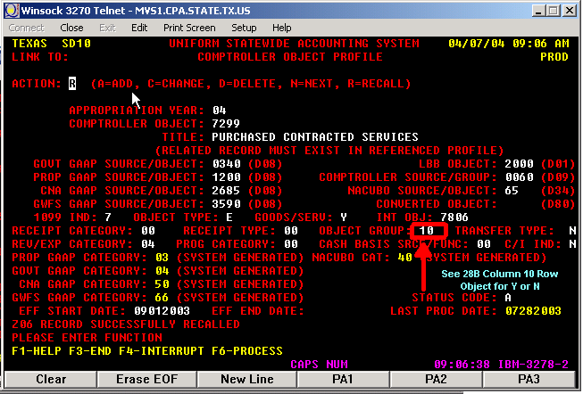

In screen 28B, enter transaction code 225 to determine if Object Code 10 (column 10) has a “Y” or “N.” Since Object Code 10 has a “Y,” comp object 7299 is allowed with TC 225.

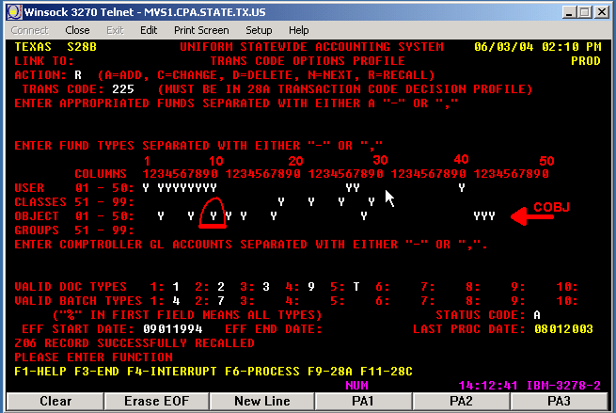

Payment
Between
Agencies The Comptroller’s Office recommendation is that payments between state agencies involving state funds should be done using an RTI (Recurring Transaction Index). The RTIs are set up with a six digit number, which indicates the COBJ, PCA, Appropriation number, Appropriated fund, Appropriation year, and transactions code. This six digit number is used in the payer transaction to tell where the transaction needs to be recorded.

Legal Cites for
AY08 AY09
Effective Date
09/01/2007
- Bookkeeping Errors HB1, 80th Leg,RS,ART IX, Section 6.16
  - Budget to Cash Adjustments
  - Reallocation of expenses because of an error (ABEST)
  - Reallocation of expenses because of an error
- Expenditure Transfers & Appn TRFs HB1,80th APS 001 Leg,RS,ART IX Sec 6.08
a. Proportional expenditure between fund 0001 and 0225
- Cost Allocations HB1,80th Leg,RS,ART IX, Section 6.21
- Lapses HB1,80th Leg,RS,ART IX, Section 7.02
- Gifts & Grants (and/or Specific Agy authorization) HB1,80th Leg,RS,ART IX, Sec 8.01
- Social Security (OASI) Appn #91142 HB1,80th Leg,RS,ART III, p. 212
- Group Insurance (GIP) Appn #95001 HB1,80th Leg,RS,ART III, p. 36-40
- Teacher Retirement (TRS) HB1,80th Leg,RS,ART III, p. 33, Rider 7
  - Budget Load
  - TRS monthly payments
- Optional Retirement Program (ORP) HB1,80th Leg,RS,ART III, p. 34, Rider 4
- SORM Payments HB1,80th Leg,RS,ART IX, Sec 15.02
- Unemployment Reimbursement HB1,80th Leg,RS,ART IX, Sec 15.01
- HEAF (Appn #13047) HB1,80th Leg,RS,ART III p. 55
- Line Item Transfers (Share Appn w/Board approval) HB1,80th Leg,RS,ART III, p. 214 Sec 4
- Refund of Deposits (fund 0225) TX Govt Code Ann, Ch 403.077
- UB Fund 0225 (Transfer Forward-Back) HB1, 80th Leg., R.S., ART. III-213, sec 2
  - Un-appropriated Activity Roll-Forward and Roll-Back

- Roll-forward funds with UB authority FD 0001, 5015 and 5079
  - Grant Funds (Approved) (FD 0001) HB1,80th Leg,RS,ART IX, Sec 17.04
Transfer roll-forward/roll-back ATP, ARP
b. HEAF roll forward/roll-back (FD 0001) HB1,80th Leg,RS,ARTIII, p. 56
c. License Plate Scholarship/roll-back (FD 5015) HB1,80th Leg,RS,ART III p. 228 Sec 41
- System Office Funding HB1,80th Leg,RS,ART III p. 221 Sec 19
- Deposit of Sales and Hotel Occupancy Taxes APS 008 (Collected by State Agencies)
a. Deposits of Sales and Hotel Taxes
- Central Services Account HB1,80th Leg Article III Sec 6 p. 217
a. Payments to CSA
22. Other E&G deposits Vernon's TX Codes,Educ Code Ch 51.008(b)
a. Hotel & Restaurant Revenue
b. Tuition & Fees Revenue
c. Indirect Cost
d. Rebate
e. Administrative Charges, Coin Commission, Optometry Clinic Revenue
23. Tuition Set-Aside deposits FPP A.040 Legal Cite
a. Transfer-out of Set Asides
24. Accrual and Accrual Reversals APS 018
25. Reimbursement and Payments (RTI transactions) HB1,80th Leg,RS,Art.IX Sec. 8.03
26. Budget Revisions SB1, 80th Leg,RS,Art. III-103
a. Budget Revision

For more legal citations the link to the Legislative Budget Board conference 2008-2009 is:

http://www.lbb.state.tx.us/Bill_80/7_Conference/80-7_Conference_0507.pdf
Return Unused
Appropriation Funds to
Coordinating
Board The Appropriations for which return of unused funds is processed are the following: Texas College Work Study, Texas Grant, Advanced Technology Program (ATP), Advanced Research Program (ARP), Fifth Year Accounting Scholarship, Technology Workforce Development, and Development Education. Some of the above appropriations are given to be used only during the year the award was made and after the award year is over the funds need to be returned. Those appropriations are: Texas College Work Study, Texas Grant, Fifth Year Accounting Scholarship, and Development Education.

Project Awards | Yearly Award Programs
Advanced Technology Program | Texas College Work Study
Advanced Research Program | Texas Grant
 | Fifth Year Accounting Scholarship
 | Development Education

PS Basic Concepts

Identify State
Cost Centers The cost centers that have fund codes starting with 1 are state cost centers except for fund codes 1040, 1050, and 1053. Some cost centers have fund codes starting with 7 and these can be state or local. To identify the state cost centers using fund codes starting with a 7 go to PeopleSoft and navigate to: Set Up Financials/Supply Chain_Common Definition_Design Chartfields_Define Values_Chartfield Values and click on fund code. Enter a fund code number and click on attributes to see the ST_APPROP value. The local fund codes will have the ST_APPROP equal to 99999. The state fund code will have another value not equal to 99999.

State vs.
Local Vouchers State vouchers use state cost centers and the state bank. Local vouchers use local cost centers and the local bank.

Deposit Refunds
of State Funds Departments that need to deposit a refund check into a state cost center prepare a journal entry crediting the state cost center and expense account charged and debiting the local bank. These journals are analyzed in the automatic expense reconciliaiton. The State Accounting Department creates a local voucher payable to the Comptroller using the Refund to State Clearing Cost Center (fund code 1050) and deposits the check from the local bank into the state bank.

Recovered Cost
Accounts Recovered cost accounts (50050, 50051, 50052, 50053, 50054) cannot be used with state cost centers. Only specific expense accounts should be used.

The charts below named Non-Payroll expense reallocations, transferring non- payroll expenses between state and local funds, and state fund equity non-mandatory transfers are located in the web and the address is:

http://www.uh.edu/finance/pages/References.htm
Non-Payroll Expenditure Reallocations: Process Overview
University of Houston

Accounting Events and Forms for Originating Department to Complete

 | TO: LOCAL FUND | TO: STATE FUND
FROM: LOCAL FUND | Journal Entry | State Voucher
FROM: STATE FUND | Local Voucher | Journal Entry

Department Tasks for Non-Payroll Expenditure Reallocations

 | Originating Department | General Accounting | Accounts Payable | State Accounting
From Local to (Same or Different) Local Fund | Complete Journal Entry | Approve Journal Entry and Post to PS
From Local to State Fund | Complete State Voucher |  | Approve State Voucher
From State to Local Fund | Complete Local Voucher |  | Approve Local Voucher | Create Journal Entry in PS and USAS
From State to Different State Fund | Complete Journal Entry | Approve Journal Entry and Post to PS |  | Create Journal Entry in USAS
From State to Same State Fund | Complete Journal Entry | Approve Journal Entry and Post to PS

Transferring Non-Payroll Expenses between State and Local Funds

1. Create a voucher to reimburse the cost center that originally paid the expense. Choose the correct vendor and address as follows:

Transfer Expense From (Credit) | Transfer Expense To (Debit) | Voucher Payable To | Vendor ID | Address
State Cost Center | Local UH Cost Center | Texas Comptroller | 0000026730 | 006
State Cost Center | Local UHSA Cost Center | Texas Comptroller | 0000026730 | 001
State Cost Center | Local UHCL Cost Center | Texas Comptroller | 0000026730 | 001
State Cost Center | Local UHD Cost Center | Texas Comptroller | 0000026730 | 007
State Cost Center | Local UHV Cost Center | Texas Comptroller | 0000026730 | 008
Local UH Cost Center | State Cost Center | University of Houston | 0000026780 | 002
Local UHSA Cost Center | State Cost Center | UH System Administration | 0000026798 | 009
Local UHCL Cost Center | State Cost Center | UH Clear Lake | 0000026794 | 001
Local UHD Cost Center | State Cost Center | UH Downtown | 0000026799 | 011
Local UHV Cost Center | State Cost Center | UH Victoria | 0000026796 | 001

- Enter the cost center that will receive the expense (debit) on the Invoice Information page.

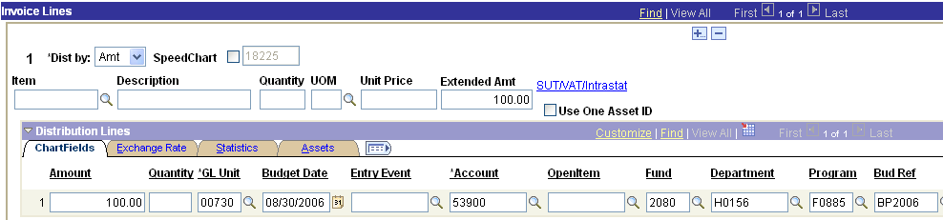

3. Select PCC 8 on the UHS Data Line page and complete the 3rd Party Vendor Information, which is the vendor paid for the original expenditure. If transferring a service center expense, choose the appropriate UH campus as the 3rd party vendor. In the example below, the original vendor was Today’s Business Solutions.

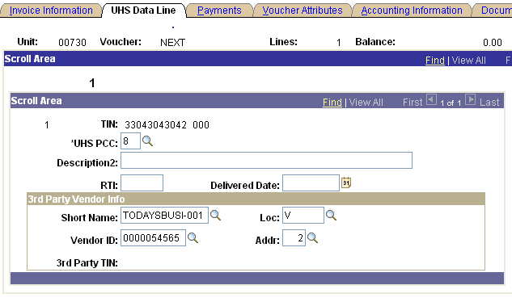

- Select SH (Special Handling) as the Handling code on the Payments page.

- Enter the cost center and account to be reimbursed in Payment Comments.

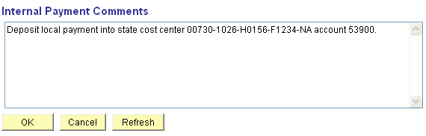
State Fund Equity Non-Mandatory Transfers Business Unit 00730 and 00783

Fund equity transfers may only be completed between fund codes on the same row in the matrix below, which are part of the same state appropriation. If you have any questions, please call Raquel Scarone at x38724.

D = Department may process transfer
I = Institutional transfer processed by central administration

General Revenue

Appropriation | D/I | Fund Codes

E & G | D | 1003 | 1026 | 1097 | 7043 | 7048 | 1101
TX Exc Fd Int | I | 1004
Tui Rev Bond | D | 1005
System Central Serv Acct | D | 1006 | 7050 | 7054
HEAF | D | 1008 | 1043 | 1044 | 1045 | 1046 | 7021 | 7035 | 7042 | 7045 | 7046 | 7047 | 7052
Tx Excl Fund | D | 1009 | 7049
ATP | D | 1010 | 1014 | 1025 | 1028 | 1034 | 1087 | 1098
ARP | D | 1011 | 1013 | 1024 | 1027 | 1033 | 1086
5th Year Accting | D | 1012
TCWS | D | 1015
System Office Operating | I | 1016
TASP | D | 1018
ERS | I | 1019
Lic Plate Schol | D | 1020
ORP | I | 1021
FICA | I | 1022
UCI | I | 1029
WCI | I | 1030
Tx Grant | D | 1032
Dev Ed Pilot | D | 1035
TRS | I | 1036
Sal Inc Faculty | I | 1039
Sal Inc Non-Fac | I | 1047
Longevity | I | 1081
Dram Enroll | D | 1088
Engr Tech Co | D | 1091
Research Develop Fund | D | 1099

General Revenue Dedicated

Appropriation | D/I | Fund Codes

E & G Dedicated | D | 1054 | 7044 | 1065
Sal Inc Fac | I | 1055 | 1065
Sal Inc Non-Fac | I | 1069 | 1065
FICA | I | 1072 | 1065
TRS | I | 1075 | 1065
ORP | I | 1078 | 1065
Longevity | I | 1082 | 1065
SWCAP | I | 1083 | 1065

Fund equity transfers between state funds use the following accounts:
From: 33500 (Credit, increases fund equity) Transfers from fund codes starting with number 1
To: 37400 (Debit, decreases fund equity) Transfers to fund codes starting with the number 1
From: 33523 (Credit, increases fund equity) Transfers from the Unexpended fund codes
To: 37423 (Debit, decreases fund equity) Transfers to the Unexpended fund codes
From: 33524 (Credit, increases fund equity) Transfers from the R&R fund codes
To: 37424 (Debit, decreases fund equity) Transfers to the R&R fund codes

Interagency Contract vs. Transfer Funds between Components

We perform both Interagency Contracts and Transfer of Funds between UH System components. The Central Service Account uses Interagency Contracts.
a) Transfer of Funds between components
When is a transfer between components done? A transfer between components can be done when an appropriation bill authorizes it. Otherwise, transactions between components are processed under an interagency contract or another kind of informal agreement.
    - Interagency Contract
According to the State of Texas Purchase Policies and Procedures Guide (chapter 5, section 5.022, published July 2004 (https://fmx.cpa.state.tx.us/fm/pubs/purchase/index.php), a state agency may contract with another state agency for necessary and authorized special or technical services, including the services of employees, materials, or equipment. A state agency may not, however, enter into a contract that requires or permits the agency to exceed its duties and responsibilities or the limitations of its duties and responsibilities or the limitations of its appropriated funds.
The contract must specify:
      - Kind and amount of services; and
      - Basis for computing reimbursable costs; and
      - The maximum cost during the period of the contract.
An interagency contract must be in writing unless:
- The contract concerns an emergency for the defense or safety of the civil population or in planning and preparing for that type of emergency; or
- The contract concerns a cooperative effort, proposed by the governor, for the economic development of the state; or
- The amount of the contract is less than $50,000.
If an interagency contract is not required to be in writing, then the parties to the contract must document the contract through informal letters of agreement or memoranda.
Examples of Interagency Contracts are:
Central Service Charges, Campus Net Service Charge, Cinco Ranch Service Charge, Sugarland Service Charge, Computing Charges – UHV, Victoria Sugarland Service Charge, Miscellaneous Internal Services.
Any kind of service performed by one of the components on behalf of another requires issuing a payment using one the following methods:
Method of payment: 1. Issue a warrant using TC 225 or
- Process the payment with an RTI (method preferred by Comptroller)

Return to Interagency Contract between State Agencies Chapter 1

USAS Reports

The USAS reports for agencies 730 and 783 are sent to the State Accounting, Treasury, and Accounts Payable departments.

Report Distribution is as follows:
DAFR3701 | Glinna Hilton – Treasury Department | Email PDF file
TRAVOST7 | Mike Glisson – Finance | Email PDF file
DAFR018A | State Accounting | Daily Reports
DAFR018B | State Accounting | Daily Reports
DAFR018F | State Accounting | Daily Reports
DAFR2161 | State Accounting | Daily Reports
DAFR8910 | State Accounting | End of Year Reports (AFR)
DAFR8580, DAFR8600 | State Accounting | End of Year Reports (AFR)

Return to Table of Contents

Chapter 1

Standard Transactions Processed in State Accounting

Budget Authority to spend in USAS – PS Cash and Revenue Entries

Budget Load - B2 Budget Load Matrices
State Accounting loads the budget in USAS and records the cash and revenue in PS for all state funds provided to our agencies (730 & 783). The matrices below show all the appropriations and funds for agencies 730 and 783.

1) Appropriation Bill - Education and General State Support & General Revenue Fund – Dedicated - Agency 730
Strategy# | Strategy Name |  | USAS Appn # | USAS Fund 0001 | USAS Fund 0225 | USAS Fund 7999 | PCA #
3701 | Operations Support |  | 10730 | X | X |  | 03701
3702 | Teaching Experience Supplement |  | 10730 | X |  |  | 03702
3705 | Staff Group Insurance Premiums |  | 10730 |  | X |  | 03705
3706 | Workers' Compensation |  | 10730 | X | X |  | 03706
3708 | Texas Public Education Grants |  | 10730 |  |  | X | 03708
3709 | Indirect Cost Recovery (for research related activities) |  | 10730 |  | X | X | 03709
3710 | Organized Activities |  | 10730 |  | X |  | 03710
3069 | Excellence Funding |  | 10730 | X |  |  | 03069
3025 | Space Explporation |  | 10730 | X |  |  | 03025
3712 | E&G Space Support (Education and General Space Support) |  | 10730 | X |  |  | 03712
3713 | Tuition Revenue Bond Retirement |  | 10730 | X |  |  | 03713
3714 | Skiles Act Revenue Bond Retirement |  | 10730 |  |  | X | 03714
3023 | Learning and Computation Center |  | 10730 | X |  |  | 03023
3025 | Space Exploration (Houston Partnership for Space Exploration) |  | 10730 | X |  |  | 03025
3027 | Commercial Development of Space |  | 10730 | X |  |  | 03027
 |  | Center for Commercial Development of Space
 |  | Space Vacuum Epitaxy Center
3091 | Superconductivity Center |  | 10730 | X |  |  | 03091
3035 | Small Business Development |  | 10730 | X |  |  | 03035
 |  | University of Houston Small Business
 |  | Development Center
3036 | Health Law & Policy Institute (Health Law and Policy Institute) |  | 10730 | X |  |  | 03036
3092 | Center for Public Policy |  | 10730 | X |  |  | 03092
3071 | Partnerships-Support Public School |  | 10730 | X |  |  | 03071
3072 | Institutional Enhancement |  | 10730 | X |  |  | 03072
3073 | Faculty Excellence |  | 10730 | X |  |  | 03073
3074 | Research Development Fund |  | 13061 | X |  |  | 03074
3075 | Competitive Knowledge Fund |  | 10730 | X |  |  | 03075
3076 | Special Item Appropriation |  | 20354 | X |  |  | 03076
3992 | Tuition & Fees appropriation |  | 00000 |  | X |  | 03992
2) Texas Higher Education Coordinating Board Appropriations and Higher Education Assistance Funds (HEAF) - Agency 730
Strategy# | Strategy Name | USAS Appn # | USAS Fund 0001 | USAS Fund 0106 | USAS Fund 0225 | USAS Fund 0347 | USAS Fund 5015 | USAS Fund 5079 | PCA #
3980 | Texas College Work Study | 13019 | X |  |  |  |  |  | 03980
3980 | Remedial Education (Development Education Program) | 13024 | X |  |  |  |  |  | 03980
3090 | 5th Year Accounting Scholarship | 13043 | X |  |  |  |  |  | 03090
3980 | HEAF | 13047 | X |  |  |  |  |  | 03980
3980 | Texas Grants Program | 13107 | X |  |  |  |  |  | 03980
3980 | Dramatic Enrollment Growth | 13112 | X |  |  |  |  |  | 03980
3980 | Advanced Research Program | 13020 | X |  |  |  |  |  | 03980
3980 | Advanced Technology Program | 13021 | X |  |  |  |  |  | 03980
3980 | Engineer & Technical Consortium (Tech Workforce Devel) | 13123 |  |  |  |  |  | X | 03980

3) Benefit Appropriations - Agency 730
Strategy# | Strategy Name | USAS Appn # | USAS Fund 0001 | USAS Fund 0106 | USAS Fund 0225 | USAS Fund 0347 | USAS Fund 5015 | USAS Fund 5079 | PCA #
3991 | FICA Fund 0001 and 0225 (OASI) | 91142 | X |  | X |  |  |  | 03991
3991 | ORP 6% fund 0001 and 0225 | 97646 | X |  | X |  |  |  | 03991
3991 | TRS Fund 0225 | 99323 |  |  | X |  |  |  | 03991
3705 | ERS Fund 0225 | 10730 |  |  | X |  |  |  | 03705
3992 | ERS Fund 0001 | 99999 | X |  |  |  |  |  | 03992
3992 | TRS Fund 0001 | 99999 | X |  |  |  |  |  | 03992

4) Miscellaneous Appropriations - Agency 730
Strategy# | Strategy Name | USAS Appn # | USAS Fund 0001 | USAS Fund 0106 | USAS Fund 0225 | USAS Fund 0347 | USAS Fund 5015 | USAS Fund 5079 | PCA #
3993 | SWCAP Reimbursement | 28976 |  |  | X |  |  |  | 03993
3706 | Contingent Appropriation for HB 2976 (SORM) | 27087 | X |  | X |  |  |  | 03706
3713 | Tuition Revenue Bond HB658 | 27988 | X |  |  |  |  |  | 03713
3701 | SB 311-GR Reduction-Reverse Auctions | 97191 | X |  |  |  |  |  | 03701
3980 | Texas Excellence Fund | 27986 |  |  |  | X |  |  | 03980
3980 | BEO – Texas Excellence Funds | 38028 |  |  |  | X |  |  | 03980
3980 | License Plate Scholarship | 29346 |  |  |  |  | X |  | 03980
1) Appropriation Bill - Education and General State Support - Agency 783
Strategy# | Strategy Name |  | Appn # | Fund 0001 | Fund 7999 | PCA
3007 | Instruction Operations |  | 10783 | X |  | 03007
 |  | Provide Infrastructure Support
3309 | Tuition Revenue Bond Retirement |  | 10783 | X |  | 03309
3008 | Special Item Support |  | 10783 | X |  | 03008
 |  | Provide Special Item Support
 |  | NASA Programs
 |  | High School Cooperative Education Program with
 |  | NASA and Technology Outreach Program

2) Texas Higher Education Coordinating Board Appropriations and Higher Education Assistance Funds (HEAF) – Agency 783

Agency 783 does not have THECB appropriations and receives HEAF allocations from the other UH System components that are deposited into the Central Services Account appropriation.

3) Benefit Appropriations - Agency 783
Strategy# |  | Strategy Name | Appn # | Fund 0001 | Fund 7999 | PCA
Benefit Appropriations
3991 | FICA Fund 0001 |  | 91142 |  | X | 03991
3991 | ORP 6% fund 0001 |  | 97646 |  | X | 03991
3992 | ERS Fund 0001 |  | 99999 | X |  | 03992
3992 | TRS Fund 0001 |  | 99999 | X |  | 03992

4) Miscellaneous Appropriations - Agency 783
Strategy# |  | Strategy Name | Appn # | Fund 0001 | Fund 7999 | PCA
Miscellaneous Appropriations
3993 | SWCAP Reimbursement |  |  | X |  | 03993
3706 | Contingent Appropriation for HB 2976 (SORM) |  | 27087 | X |  | 03706
Budget Load Journal Entries

1. Educational and General State Support (fund 0001) and General Revenue Fund - Dedicated (fund 0225)

State Accounting follows House Bill No. 1 (General Appropriations Act), Article III (Institutions of Higher Education), to record state operating revenue in PS and USAS. The ABEST/USAS Strategic Plan Cross Reference by ABEST Goal/Obj/Strat includes the General Revenue and General Revenue Dedicated portion of the budget load.

USAS entries for Budget Load of General Revenue and General Revenue Dedicated for AY08 - Agency 730
METHOD OF FINANCE ALLOCATION SCHEDULE
FOR APPROPRIATION YEAR 2008
 | Agency Name: | University of Houston |  |  |  | Prepared By: | Elbia Raquel Scarone
 | Agency Number: | 730 |  |  |  | Phone Number: | (713) 743-8724
Strategic Structure / Program Codes |  |  | Strategy |  | Method of Finance
Goal | Objective | Strategy | Appn Number | Strategy Amount | General Revenue Amount | GR Dedicated Amount | Federal Fund Amount | Other Fund Amount | Appd FD # | Rev Type
1701 | 2701 | 3701 | 10730 | 129,351,823 | 82,779,769 |  |  |  | 0001 | GR
1701 | 2701 | 3701 | 10730 |  |  | 46,572,054 |  |  | 0225 | GD
1701 | 2701 | 3702 | 10730 | 2,913,226 | 2,913,226 |  |  |  | 0001 | GR
1701 | 2701 | 3705 | 10730 | 4,915,532 |  | 4,915,532 |  |  | 0225 | GD
1701 | 2701 | 3706 | 10730 | 491,131 | 491,131 |  |  |  | 0001 | GR
1701 | 2701 | 3708 | 10730 | 5,896,015 |  |  |  | 5,896,015 | 7999 | GR
1701 | 2701 | 3710 | 10730 | 1,354,803 |  | 1,354,803 |  |  | 0225 | GD
1701 | 2701 | 3069 | 10730 | 3,999,193 | 3,999,193 |  |  |  | 0001 | GR
1702 | 2702 | 3712 | 10730 | 26,398,470 | 26,398,470 |  |  |  | 0001 | GR
1702 | 2702 | 3713 | 10730 | 11,879,624 | 11,879,624 |  |  |  | 0001 | GR
1702 | 2702 | 3714 | 10730 | 394,215 |  |  |  | 394,215 | 7999 | GR
1010 | 2022 | 3023 | 10730 | 1,935,804 | 1,935,804 |  |  |  | 0001 | GR
1010 | 2022 | 3025 | 10730 | 349,986 | 349,986 |  |  |  | 0001 | GR
1010 | 2022 | 3027 | 10730 | 400,900 | 400,900 |  |  |  | 0001 | GR
1010 | 2022 | 3091 | 10730 | 3,607,624 | 3,607,624 |  |  |  | 0001 | GR
1010 | 2023 | 3035 | 10730 | 2,811,134 | 2,811,134 |  |  |  | 0001 | GR
1010 | 2023 | 3036 | 10730 | 290,937 | 290,937 |  |  |  | 0001 | GR
1010 | 2023 | 3092 | 10730 | 249,374 | 249,374 |  |  |  | 0001 | GR
1010 | 2023 | 3071 | 10730 | 1,369,247 | 1,369,247 |  |  |  | 0001 | GR
1010 | 2024 | 3072 | 10730 | 3,204,306 | 3,204,306 |  |  |  | 0001 | GR
1010 | 2024 | 3074 | 13061 | 7,494,929 | 7,494,929 |  |  |  | 0001 | GR
1011 | 2025 | 3075 | 10730 | 4,099,811 | 4,099,811 |  |  |  | 0001 | GR
1010 | 2022 | 3076 | 20354 | 5,000,000 | 5,000,000 |  |  |  | 0001 | GR
PS entries for Budget Load of General Revenue and General Revenue Dedicated for FY07 - Business Unit 00730

 |  |  | University of Houston System  JOURNAL ENTRY DETAIL
  Header BU: | 00730
  Fiscal Year: | 2008
  Acctg Period: | 1
  Run Date: | 11/07/2007
  Run Time: | 12:10:35

Journal ID: | STB0730001 | Reversal: | None | Ledger Group: | ACTUALS
Date: | 09/01/2007 | Reversal Date: |  | Created By: | DBANKS
Source: | ACS | Budget Adjust Type: | Actuals | Post Date: | 09/01/2007
Header Ref: | B0730001 | Edit / Hdr Status: | Posted | BCM Status: | Valid
Description: | B2 - Budget load revenue appropriation for AY 08 for E&G fund 0001, 0225, Research Development Fund, fund 0001, and Special Item Appn. Usas was done on 7/13/07 effective 9/1/07. |  |  | BCM Bypass: | N

Line # | Account | Line BU | Fund | DeptId | Prog | Bdgt Ref. | Project | Line Ref | Chart.1 | Line Description | Amount
1 | 41100 | 00730 | 1026 | H0264 | A0202 | BP2008 | NA |  |  | B2 -Budget load rev appro. 08 | -146,780,536.00
2 | 10500 | 00730 | 1026 |  |  | BP2008 |  |  |  | B2 -Budget load rev appro. 08 | 146,780,536.00
3 | 41100 | 00730 | 1099 | H0264 | B1710 | BP2008 | NA |  |  | B2 -Budget load rev appro. 08 | -7,494,929.00
4 | 10500 | 00730 | 1099 |  |  | BP2008 |  |  |  | B2 -Budget load rev appro. 08 | 7,494,929.00
5 | 37400 | 00730 | 1065 | H0600 | F1651 | BP2008 | NA |  |  | B2 -Budget load rev appro. 08 | 52,842,389.00
6 | 10500 | 00730 | 1065 |  |  | BP2008 |  |  |  | B2 -Budget load rev appro. 08 | -52,842,389.00
7 | 33500 | 00730 | 1054 | H0600 | F1651 | BP2008 | NA |  |  | B2 -Budget load rev appro. 08 | -52,842,389.00
8 | 10500 | 00730 | 1054 |  |  | BP2008 |  |  |  | B2 -Budget load rev appro. 08 | 52,842,389.00
9 | 4% |  | 1104 | H0264 |  | BP2008 | NA |  |  | B2 -Budget load rev appro. 08 | -5,000,000.00
10 | 10500 | 00730 | 1104 |  |  | BP2008 |  |  |  | B2 -Budget load rev appro. 08 | 5,000,000.00

Totals for Journal: STB0730001 | Total Lines: 10 | Total Base Debits: 264,960,243.00 | Total Base Credits: 264,960,243.00

Signatures | ___________________________________ | Date | __________________________________
PS Approval: | ___________________________________ |  | __________________________________

Created By: DBANKS | Date Printed: 11/07/2007 | Jrnl. Dt.: 09/01/2007

USAS entries for Budget Load of General Revenue for AY07 - Agency 783

METHOD OF FINANCE ALLOCATION SCHEDULE
FOR APPROPRIATION YEAR 2007
 | Agency Name: | University of Houston-System |  |  |  | Prepared By: | Elbia Raquel Scarone
 | Agency Number: | 783 |  |  |  | Phone Number: | (713) 743-8724
Strategic Structure / Program Codes |  |  | Strategy |  | Method of Finance
Goal | Objective | Strategy | Appn Number | Strategy Amount | General Revenue Amount | GR Dedicated Amount | Federal Fund Amount | Other Fund Amount | Appd FD # | Rev Type
1006 | 2006 | 3007 | 10783 | 1,761,563 | 1,761,563 |  |  |  | 0001 | GR
1007 | 2070 | 3008 | 10783 | 840,617 | 840,617 |  |  |  | 0001 | GR

PS entries for Budget Load of Educational and General State Support (fund 0001) for FY07 – Business Unit 783

 |  |  | University of Houston System  JOURNAL ENTRY DETAIL
  Header BU: | 00783
  Fiscal Year: | 2008
  Acctg Period: | 1
  Run Date: | 11/07/2007
  Run Time: | 03:00:31

Journal ID: | STB0783001 | Reversal: | None | Ledger Group: | ACTUALS
Date: | 09/01/2007 | Reversal Date: |  | Created By: | DBANKS
Source: | ACS | Budget Adjust Type: | Actuals | Post Date: | 09/01/2007
Header Ref: | B0783001 | Edit / Hdr Status: | Posted | BCM Status: | Valid
Description: | B2 - Budget load for AY 07. Usas entry was done on 7/13/07 effective date inside: 9/1/07. |  |  | BCM Bypass: | N

Line # | Account | Line BU | Fund | DeptId | Prog | Bdgt Ref. | Project | Line Ref | Chart.1 | Line Description | Amount
1 | 41100 | 00783 | 1016 | S0027 | F0949 | BP2008 | NA |  |  | B2- Budget load fd 1 for AY 08 | -2,602,180.00
2 | 10500 | 00783 | 1016 |  |  | BP2008 |  |  |  | B2- Budget load fd 1 for AY 08 | 2,602,180.00

Totals for Journal: STB0783001 | Total Lines: 2 | Total Base Debits: 2,602,180.00 | Total Base Credits: 2,602,180.00

Signatures | ___________________________________ | Date | __________________________________
PS Approval: | ___________________________________ |  | __________________________________

Created By: DBANKS | Date Printed: 11/07/2007 | Jrnl. Dt.: 09/01/2007

2. Texas Higher Education Coordinating Board appropriations and Higher Education Assistance Funds (HEAF)

The Texas Higher Education Coordinating Board (THECB) sends a memorandum with the list of Recurring Transaction Index (RTI) for each appropriation number. THECB enters the budget load in USAS after the RTIs are set up by each agency in screen 55. Check the 62 screen for each appropriation and fund number listed in the THECB memorandum for the amount to be entered in PS only. It is not necessary to enter the budget load in USAS, the RTI process post the funds.

The HEAF appropriation budget load is entered by the Comptroller. Check the 62 screen for the amount to be entered in PS only. Agency 783 does not have a HEAF appropriation, but a HEAF allocation is made from the other UH System components to UH System Administration to assist with System operations. See HEAF Allocation section (H2).

PS entries for HEAF Budget Load - Business Unit 00730

 |  |  | University of Houston System  JOURNAL ENTRY DETAIL
  Header BU: | 00730
  Fiscal Year: | 2007
  Acctg Period: | 1
  Run Date: | 11/07/2006
  Run Time: | 02:44:20

Journal ID: | STA2207902 | Reversal: | None | Ledger Group: | ACTUALS
Date: | 09/07/2006 | Reversal Date: |  | Created By: | BANKSDA
Source: | ACS | Budget Adjust Type: | Actuals | Post Date: | 09/08/2006
Header Ref: | A2207902 | Edit / Hdr Status: | Posted | BCM Status: | Valid
Description: | B2 & H0- Budget Load for HEAF AY07, FY07. |  |  | BCM Bypass: | N

Line # | Account | Line BU | Fund | DeptId | Prog | Bdgt Ref. | Project | Line Ref | Chart.1 | Line Description | Amount
1 | 41105 | 00730 | 1008 | H0264 | F0003 | BP2007 | NA | A2207902 |  | BUDGET LOAD- HEAF | -23,517,427.00
2 | 10500 | 00730 | 1008 |  |  | BP2007 |  | A2207902 |  | STATE BANK | 23,517,427.00

Totals for Journal: STA2207902 | Total Lines: 2 | Total Base Debits: 23,517,427.00 | Total Base Credits: 23,517,427.00

Signatures | ___________________________________ | Date | __________________________________
PS Approval: | ___________________________________ |  | __________________________________

Created By: BANKSDA | Date Printed: 11/07/2006 | Jrnl. Dt.: 09/07/2006

PS entries for THECB appropriations Budget Load - Business Unit 00730

THECB appropriation: Development Education Program

 |  |  | University of Houston System  JOURNAL ENTRY DETAIL
  Header BU: | 00730
  Fiscal Year: | 2007
  Acctg Period: | 3
  Run Date: | 01/13/2007
  Run Time: | 02:04:47

Journal ID: | STH300278M | Reversal: | None | Ledger Group: | ACTUALS
Date: | 11/20/2006 | Reversal Date: |  | Created By: | SCARONRE
Source: | ACS | Budget Adjust Type: | Actuals | Post Date: | 12/02/2006
Header Ref: | H300278M | Edit / Hdr Status: | Posted | BCM Status: | Valid
Description: | B2 & D0 - Budget Load Development Education AY07. |  |  | BCM Bypass: | N

Line # | Account | Line BU | Fund | DeptId | Prog | Bdgt Ref. | Project | Line Ref | Chart.1 | Line Description | Amount
1 | 42405 | 00730 | 1018 | H0005 | A0313 | BP2007 | NA |  |  | Budget Load Dev Edu Progr | -37,237.00
2 | 10500 | 00730 | 1018 |  |  | BP2007 |  |  |  | STATE BANK | 37,237.00

Totals for Journal: STH300278M | Total Lines: 2 | Total Base Debits: 37,237.00 | Total Base Credits: 37,237.00

Signatures | ___________________________________ | Date | __________________________________
PS Approval: | ___________________________________ |  | __________________________________

Created By: SCARONRE | Date Printed: 01/13/2007 | Jrnl. Dt.: 11/20/2006

THECB appropriation: Texas College Work Study Program

 |  |  | University of Houston System  JOURNAL ENTRY DETAIL
  Header BU: | 00730
  Fiscal Year: | 2007
  Acctg Period: | 4
  Run Date: | 01/13/2007
  Run Time: | 02:06:56

Journal ID: | ST0400178M | Reversal: | None | Ledger Group: | ACTUALS
Date: | 12/08/2006 | Reversal Date: |  | Created By: | NGUYENTB
Source: | ACS | Budget Adjust Type: | Actuals | Post Date: | 12/09/2006
Header Ref: | G4260019 | Edit / Hdr Status: | Posted | BCM Status: | Valid
Description: | B2 & T0 - Budget load for Texas-College Work Study Appropriation AY07. |  |  | BCM Bypass: | N

Line # | Account | Line BU | Fund | DeptId | Prog | Bdgt Ref. | Project | Line Ref | Chart.1 | Line Description | Amount
1 | 42404 | 00730 | 1015 | H0213 | H0222 | BP2007 | NA |  |  | Budget Load TCWS Prog | -151,949.00
2 | 10500 | 00730 | 1015 |  |  | BP2007 |  |  |  | STATE BANK | 151,949.00

Totals for Journal: ST0400178M | Total Lines: 2 | Total Base Debits: 151,949.00 | Total Base Credits: 151,949.00

Signatures | ___________________________________ | Date | __________________________________
PS Approval: | ___________________________________ |  | __________________________________

Created By: NGUYENTB | Date Printed: 01/13/2007 | Jrnl. Dt.: 12/08/2006

THECB appropriation: Texas Grant Program

 |  |  | University of Houston System  JOURNAL ENTRY DETAIL
  Header BU: | 00730
  Fiscal Year: | 2007
  Acctg Period: | 5
  Run Date: | 01/13/2007
  Run Time: | 02:10:00

Journal ID: | STT401242M | Reversal: | None | Ledger Group: | ACTUALS
Date: | 01/13/2007 | Reversal Date: |  | Created By: | NGUYENTB
Source: | ACS | Budget Adjust Type: | Actuals | Post Date: | 01/14/2007
Header Ref: | T401242M | Edit / Hdr Status: | Posted | BCM Status: | Valid
Description: | B0 & T2 - Budget load for Texas Grants AY07 |  |  | BCM Bypass: | N

Line # | Account | Line BU | Fund | DeptId | Prog | Bdgt Ref. | Project | Line Ref | Chart.1 | Line Description | Amount
1 | 42400 | 00730 | 1032 | H0213 | H0228 | BP2007 | NA |  |  | Budget Load TX Grant Prog | -3,746,449.00
2 | 10500 | 00730 | 1032 |  |  | BP2007 |  |  |  | STATE BANK | 3,746,449.00

Totals for Journal: STT401242M | Total Lines: 2 | Total Base Debits: 3,746,449.00 | Total Base Credits: 3,746,449.00

Signatures | ___________________________________ | Date | __________________________________
PS Approval: | ___________________________________ |  | __________________________________

Created By: NGUYENTB | Date Printed: 01/13/2007 | Jrnl. Dt.: 01/13/2007

THECB appropriation: Advanced Technology Program

 |  |  | University of Houston System  JOURNAL ENTRY DETAIL
  Header BU: | 00730
  Fiscal Year: | 2007
  Acctg Period: | 6
  Run Date: | 01/13/2007
  Run Time: | 02:13:51

Journal ID: | STJ401527M | Reversal: | None | Ledger Group: | ACTUALS
Date: | 02/19/2007 | Reversal Date: |  | Created By: | NGUYENTB
Source: | ACS | Budget Adjust Type: | Actuals | Post Date: | 02/23/2007
Header Ref: | G4014019 | Edit / Hdr Status: | Posted | BCM Status: | Valid
Description: | B2 & A1 - ATP - AY 07 for Jan.'s rec.'s, 13021, 0001, 07. * Ref. # G4014019. |  |  | BCM Bypass: | N

Line # | Account | Line BU | Fund | DeptId | Prog | Bdgt Ref. | Project | Line Ref | Chart.1 | Line Description | Amount
1 | 42402 | 00730 | 1098 | H0107 | B0020 | BP2007 | G088128 |  |  | Budget Load ADV TECH Prog. | -70,000.00
2 | 42402 | 00730 | 1098 | H0067 | B0020 | BP2007 | G088045 |  |  | Budget Load ADV TECH Prog. | -160,000.00
3 | 42402 | 00730 | 1098 | H0073 | B0020 | BP2007 | G088086 |  |  | Budget Load ADV TECH Prog. | -160,000.00
4 | 42402 | 00730 | 1098 | H0070 | B0020 | BP2007 | G088330 |  |  | Budget Load ADV TECH Prog. | -170,000.00
5 | 42402 | 00730 | 1098 | H0070 | B0020 | BP2007 | G088332 |  |  | Budget Load ADV TECH Prog. | -170,000.00
6 | 42402 | 00730 | 1098 | H0112 | B0020 | BP2007 | G086642 |  |  | Budget Load ADV TECH Prog. | -63,900.00
7 | 42402 | 00730 | 1098 | H0243 | B0020 | BP2007 | G088283 |  |  | Budget Load ADV TECH Prog. | -125,000.00
8 | 42402 | 00730 | 1098 | H0109 | B0020 | BP2007 | G088160 |  |  | Budget Load ADV TECH Prog. | -45,050.00
9 | 42402 | 00730 | 1098 | H0247 | B0020 | BP2007 | G088106 |  |  | A Budget Load ADV TECH Prog. | -110,000.00
10 | 42402 | 00730 | 1098 | H0067 | B0020 | BP2007 | G088319 |  |  | Budget Load ADV TECH Prog. | -150,000.00
11 | 42402 | 00730 | 1098 | H0067 | B0020 | BP2007 | G088614 |  |  | Budget Load ADV TECH Prog. | -50,000.00
12 | 10500 | 00730 | 1098 |  |  | BP2007 |  |  |  | STATE BANK | 1,273,950.00

Totals for Journal: STJ401527M | Total Lines: 12 | Total Base Debits: 1,273,950.00 | Total Base Credits: 1,273,950.00

Signatures | ___________________________________ | Date | __________________________________
PS Approval: | ___________________________________ |  | __________________________________

Created By: NGUYENTB | Date Printed: 01/13/2007 | Jrnl. Dt.: 02/19/2007

State Accounting enters the budget load to the most recent fund code (i.e., 1098 for 04-05 awards) and to each project that received an award. Call Office of Contracts and Grants (Judy Morris 3-9920) for the cost centers. Return to ATP/ARP.

THECB appropriation: 5th Year Accounting Scholarship Program

 |  |  | University of Houston System  JOURNAL ENTRY DETAIL
  Header BU: | 00730
  Fiscal Year: | 2007
  Acctg Period: | 1
  Run Date: | 01/13/2007
  Run Time: | 02:20:12

Journal ID: | STT400029M | Reversal: | None | Ledger Group: | ACTUALS
Date: | 09/16/2006 | Reversal Date: |  | Created By: | NGUYENTB
Source: | ACS | Budget Adjust Type: | Actuals | Post Date: | 09/18/2006
Header Ref: | G4245014 | Edit / Hdr Status: | Posted | BCM Status: | Valid
Description: | B2 & F2 - Budget load for 5th year Accounting Scholarship Program for AY 07, FY 07. (13043, 0106) |  |  | BCM Bypass: | N

Line # | Account | Line BU | Fund | DeptId | Prog | Bdgt Ref. | Project | Line Ref | Chart.1 | Line Description | Amount
1 | 42407 | 00730 | 1012 | H0213 | H2536 | BP2007 | NA |  |  | Budget Load FIFTH YR ACCTNG SCHOL | -19,504.20
2 | 10500 | 00730 | 1012 |  |  | BP2007 |  |  |  | STATE BANK | 19,504.20

Totals for Journal: STT400029M | Total Lines: 2 | Total Base Debits: 19,504.20 | Total Base Credits: 19,504.20

Signatures | ___________________________________ | Date | __________________________________
PS Approval: | ___________________________________ |  | __________________________________

Created By: NGUYENTB | Date Printed: 01/13/2006 | Jrnl. Dt.: 09/16/2006

THECB appropriation: Development Technology Workforce Program Return to Tech Workforce Program

 |  |  | University of Houston System  JOURNAL ENTRY DETAIL
  Header BU: | 00730
  Fiscal Year: | 2007
  Acctg Period: | 998
  Run Date: | 10/09/2007
  Run Time: | 02:43:27

Journal ID: | STT202714M | Reversal: | None | Ledger Group: | ACTUALS
Date: | 08/31/2007 | Reversal Date: |  | Created By: | TRANK
Source: | ACS | Budget Adjust Type: | Actuals | Post Date: | 10/07/2007
Header Ref: | G2115010 | Edit / Hdr Status: | Posted | BCM Status: | Valid
Description: | B2 & D0 - Technical Workforce Development (Eng & Tech Consortium) Budget Load |  |  | BCM Bypass: | N

Line # | Account | Line BU | Fund | DeptId | Prog | Bdgt Ref. | Project | Line Ref | Chart.1 | Line Description | Amount
1 | 41113 | 00730 | 1091 | H0070 | D0005 | BP2007 | G086940 |  |  | Budget Load Tech Workforce Develop | -54,418.50
2 | 10500 | 00730 | 1091 |  |  | BP2007 |  |  |  | STATE BANK | 54,418.50

Totals for Journal: STT202714M | Total Lines: 2 | Total Base Debits: 54,418.50 | Total Base Credits: 54,418.50

Signatures | ___________________________________ | Date | __________________________________
PS Approval: | ___________________________________ |  | __________________________________

Created By: TRANK | Date Printed: 10/09/2007 | Jrnl. Dt.: 08/31/2007

State Accounting enters the budget load to the cost centers specified by the Office of Contrancts and Grants (Judy Morris 3-9920).
Other THECB Appropriations

Below are other THECB appropriations with the revenue account and cost centers. For the Budget Load, credit the revenue account and cost center and debit the state bank account 10500, corresponding fund code, and budget period according to the appropriation year.
Cr. Revenue accounts
00730 | 42413 | 1088 | H0264 | H2587 | NA | Dramatic Enrollment Growth
00730 | 42409 | 1009 | H0264 | B1590 | NA | Texas Excellence Funds
00730 | 42409 | 1099 | H0264 | B1710 | NA | BEO – Texas Excellence Funds
00730 | 42200 | 1020 | H0213 | H0214 | NA | License Plate Scholarship
00783 | 42200 | 1020 | S0027 | F0982 | NA | License Plate Scholarship

Dr. State Bank account
00730 | 10500 | 1088 | BP200X
00730 | 10500 | 1009 | BP200X
00730 | 10500 | 1099 | BP200X
00730 | 10500 | 1020 | BP200X
00730 | 10500 | 1020 | BP200X

Note: The entries in PS use the entry number posted in USAS adding the ST at the beginning. For example, PS journal entry STT202714M corresponds to USAS journal entry T202714M.

- Budget load for the Benefits appropriations needs to be entered in USAS and PS.

According to APS 019, state agencies and institutions of higher education must submit for data entry, budget documents with completed batch headers to their appropriation control officer (ACO) at the Texas Comptroller of Public Accounts by September 15 of each year to receive budget to pay for employees' benefit payments for the new appropriation year. In order to accomplish that, calculate the estimated amount for the benefits for the current year based on the three previous years. Calculate the increase for each appropriation by adding the percentage increase of the previous three years and divide it by three. Apply the new percentage to the previous year appropriation to obtain the current year appropriation amount.

USAS Entries for Benefits Program Budget Load - Agency 730
B U D G E T R E V I S I O N |  |  |  |  |  |  |  |  |  |  |  |  |  |  |  | STATE OF TEXAS |  |  |  |  |  |  |  |  |  |  |  |  |  |  |  |  |  |  |  |  |  |  |  | Page |  |  |  |  | 1 |  |  |  | of |  | 2
1. Archive reference number |  |  |  | 2. Agency number |  |  |  | 3. Agency name |  |  |  |  |  |  |  |  |  |  |  |  |  |  |  |  |  |  |  |  |  |  |  |  |  |  |  |  |  |  |  |  |  | 4. Current document number
 |  |  |  | 730 |  |  |  | University of Houston
 |  |  |  | 5. Effective date |  |  |  | 6. Doc date |  |  |  |  |  |  |  |  | 7. Doc Agency |  |  |  |  |  |  |  |  |  | 8. Document amount
 |  |  |  | 9/01/12006 |  |  |  | 9/11/2006 |  |  |  |  |  |  |  |  | 730 |  |  |  |  |  |  |  |  |  |  |  | $ |  | 40,688,511.00 |  |  |  |  |  |  |  |  |  |  |  |  |  | A0730002
9. AGENCY | SFX | REF DOC |  |  | SFX |  | TC |  | INDEX |  |  |  | PCA |  |  |  |  |  | AY |  |  |  | COBJ |  |  |  | AOBJ |  | AMOUNT |  |  |  | R |  |  |  | APPN |  |  |  |  |  |  |  | FUND
902 | 1 |  |  |  | 1 |  | 12 |  |  |  |  |  | 13048 |  |  |  |  |  | 7 |  |  |  | 7000 |  |  |  |  |  |  |  | 8,066,973.86 |  |  |  |  |  | 13048 |  |  |  |  |  |  |  | 0001
 | AFUND |  | NACUBO SUB-FUND |  |  | GRANT NUMBER |  |  |  |  | GRANT YR/PHASE |  |  |  | PROJECT NUMBER |  |  |  |  |  | PROJECT PHASE |  |  |  |  |  | CONTRACT NUMBER |  |  |  |  |  |  |  | GL AC/AGL
 |  |  | 1100 |  |  |  |  |  |  |  |  |  |  |  |  |  |  |  |  |  |  |  |  |  |  |  |  |  |  |  |  |  |  |  |  | 73000010
9. AGENCY | SFX | REF DOC |  |  | SFX |  | TC |  | INDEX |  |  |  | PCA |  |  |  |  |  | AY |  |  |  | COBJ |  |  |  | AOBJ |  | AMOUNT |  |  |  | R |  |  |  | APPN |  |  |  |  |  |  |  | FUND
730 | 2 |  |  |  | 2 |  | 18 |  |  |  |  |  | 3991 |  |  |  |  |  | 7 |  |  |  | 7000 |  |  |  |  |  |  |  | 8,066,973.86 |  |  |  |  |  | 91142 |  |  |  |  |  |  |  | 0001
 | AFUND |  | NACUBO SUB-FUND |  |  | GRANT NUMBER |  |  |  |  | GRANT YR/PHASE |  |  |  | PROJECT NUMBER |  |  |  |  |  | PROJECT PHASE |  |  |  |  |  | CONTRACT NUMBER |  |  |  | MULTIPURPOSE CODE |  |  |  | GL AC/AGY
 |  |  | 1100 |  |  |  |  |  |  |  |  |  |  |  |  |  |  |  |  |  |  |  |  |  |  |  |  |  |  |  |  |  |  |  |  | 90200010
9. AGENCY | SFX | REF DOC |  |  | SFX |  | TC |  | INDEX |  |  |  | PCA |  |  |  |  |  | AY |  |  |  | COBJ |  |  |  | AOBJ |  | AMOUNT |  |  |  | R |  |  |  | APPN |  |  |  |  |  |  |  | FUND
902 | 3 |  |  |  | 3 |  | 12 |  |  |  |  |  | 13048 |  |  |  |  |  | 7 |  |  |  | 7000 |  |  |  |  |  |  |  | 3,973,285.63 |  |  |  |  |  | 13048 |  |  |  |  |  |  |  | 0999
 | AFUND |  | NACUBO SUB-FUND |  |  | GRANT NUMBER |  |  |  |  | GRANT YR/PHASE |  |  |  | PROJECT NUMBER |  |  |  |  |  | PROJECT PHASE |  |  |  |  |  | CONTRACT NUMBER |  |  |  |  |  |  |  | GL AC/AGL
 |  |  | 1100 |  |  |  |  |  |  |  |  |  |  |  |  |  |  |  |  |  |  |  |  |  |  |  |  |  |  |  |  |  |  |  |  | 73002250
9. AGENCY | SFX | REF DOC |  |  | SFX |  | TC |  | INDEX |  |  |  | PCA |  |  |  |  |  | AY |  |  |  | COBJ |  |  |  | AOBJ |  | AMOUNT |  |  |  | R |  |  |  | APPN |  |  |  |  |  |  |  | FUND
730 | 4 |  |  |  | 4 |  | 18 |  |  |  |  |  | 3991 |  |  |  |  |  | 7 |  |  |  | 7000 |  |  |  |  |  |  |  | 3,973,285.63 |  |  |  |  |  | 91142 |  |  |  |  |  |  |  | 0225
 | AFUND |  | NACUBO SUB-FUND |  |  | GRANT NUMBER |  |  |  |  | GRANT YR/PHASE |  |  |  | PROJECT NUMBER |  |  |  |  |  | PROJECT PHASE |  |  |  |  |  | CONTRACT NUMBER |  |  |  | MULTIPURPOSE CODE |  |  |  | GL AC/AGY
 |  |  | 1100 |  |  |  |  |  |  |  |  |  |  |  |  |  |  |  |  |  |  |  |  |  |  |  |  |  |  |  |  |  |  |  |  | 90209990
9. AGENCY | SFX | REF DOC |  |  | SFX |  | TC |  | INDEX |  |  |  | PCA |  |  |  |  |  | AY |  |  |  | COBJ |  |  |  | AOBJ |  | AMOUNT |  |  |  | R |  |  |  | APPN |  |  |  |  |  |  |  | FUND
902 | 5 |  |  |  | 5 |  | 12 |  |  |  |  |  |  | 13010 |  |  |  |  |  | 7 |  |  |  |  |  |  |  |  |  |  |  | 3,804,764.28 |  |  |  |  |  |  | 13010 |  |  |  |  |  |  |  | 0001
 | AFUND |  | NACUBO SUB-FUND |  |  | GRANT NUMBER |  |  |  |  | GRANT YR/PHASE |  |  |  | PROJECT NUMBER |  |  |  |  |  | PROJECT PHASE |  |  |  |  |  | CONTRACT NUMBER |  |  |  | MULTIPURPOSE CODE |  |  |  | GL AC/AGY
 |  |  | 1100 |  |  |  |  |  |  |  |  |  |  |  |  |  |  |  |  |  |  |  |  |  |  |  |  |  |  |  |  |  |  |  |  |  |  |  |  | 7300001 0
9. AGENCY | SFX | REF DOC |  |  | SFX |  | TC |  | INDEX |  |  |  | PCA |  |  |  |  |  | AY |  |  |  | COBJ |  |  |  | AOBJ |  | AMOUNT |  |  |  | R |  |  |  | APPN |  |  |  |  |  |  |  | FUND
730 | 006 |  |  |  | 6 |  | 18 |  |  |  |  |  | 3991 |  |  |  |  |  | 7 |  |  |  |  |  |  |  |  |  |  |  | 3,804,764.28 |  |  |  |  |  | 97646 |  |  |  |  |  |  |  | 0001
 | AFUND |  | NACUBO SUB-FUND |  |  | GRANT NUMBER |  |  |  |  | GRANT YR/PHASE |  |  |  | PROJECT NUMBER |  |  |  |  |  | PROJECT PHASE |  |  |  |  |  | CONTRACT NUMBER |  |  |  | MULTIPURPOSE CODE |  |  |  | GL AC/AGY
 |  |  | 1100 |  |  |  |  |  |  |  |  |  |  |  |  |  |  |  |  |  |  |  |  |  |  |  |  |  |  |  |  |  |  |  |  |  |  |  |  | 90200010
10. Legal cite | APS 019: Salary Benefits Appropriation Allocations; General Appropriations Act (GAA), Art. III, 80th Leg., R.S.
11. Description |  | Benefit appropriations budget load for FY04
12. Contact name |  |  |  |  |  |  |  |  |  |  |  |  |  | Phone (Area code & no.) |  |  |  |  |  |  |  |  |  | Approved |  |  |  |  |  |  |  |  |  |  |  |  |  |  |  | 14. Entered by |  |  |  |  |  |  |  | 15. Comp
Raquel Scarone |  |  |  |  |  |  |  |  |  |  |  |  |  | (713) 743-8724 Date: 08/05/2003 |  |  |  |  |  |  |  |  |  | Approved: Kevin Draper

STATE OF TEXAS
B U D G E T R E V I S I O N |  |  |  |  |  |  |  |  |  |  |  |  |  |  |  |  |  |  |  |  |  |  | Page |  | 2 | of | 2
1. Archive reference number |  |  |  | 2. Agency number |  |  |  | 3. Agency name |  |  |  |  |  |  |  |  |  |  |  |  |  |  |  | 4. Current document number
 |  |  |  | 730 |  |  |  | University of Houston
 |  |  |  | 5. Effective date |  |  |  | 6. Doc date |  |  |  |  | 7. Doc Agency |  |  |  |  | 8. Document amount
 |  |  |  | 9/01/12006 |  |  |  | 9/11/2006 |  |  |  |  | 730 |  |  |  |  |  | $ | 40,688,511.00 |  |  |  |  | A0730002
9. AGENCY | SFX | REF DOC |  |  | SFX |  | TC |  | INDEX |  | PCA |  |  | AY |  | COBJ |  | AOBJ | AMOUNT |  | R |  | APPN |  |  | FUND
902 | 7 |  |  |  | 7 |  | 12 |  |  |  | 13010 |  |  | 7 |  | 7000 |  |  |  | 1,873,988.38 |  |  | 13010 |  |  | 0999
 | AFUND |  | NACUBO SUB-FUND |  |  | GRANT NUMBER |  |  |  | GRANT YR/PHASE |  | PROJECT NUMBER |  |  | PROJECT PHASE |  |  | CONTRACT NUMBER |  |  |  | GL AC/AGL
 |  |  | 1100 |  |  |  |  |  |  |  |  |  |  |  |  |  |  |  |  |  |  | 73002250
9. AGENCY | SFX | REF DOC |  |  | SFX |  | TC |  | INDEX |  | PCA |  |  | AY |  | COBJ |  | AOBJ | AMOUNT |  | R |  | APPN |  |  | FUND
730 | 8 |  |  |  | 8 |  | 18 |  |  |  | 3991 |  |  | 7 |  | 7000 |  |  |  | 1,873,988.38 |  |  | 97646 |  |  | 0225
 | AFUND |  | NACUBO SUB-FUND |  |  | GRANT NUMBER |  |  |  | GRANT YR/PHASE |  | PROJECT NUMBER |  |  | PROJECT PHASE |  |  | CONTRACT NUMBER |  | MULTIPURPOSE CODE |  | GL AC/AGY
 |  |  | 1100 |  |  |  |  |  |  |  |  |  |  |  |  |  |  |  |  |  |  | 90209990
9. AGENCY | SFX | REF DOC |  |  | SFX |  | TC |  | INDEX |  | PCA |  |  | AY |  | COBJ |  | AOBJ | AMOUNT |  | R |  | APPN |  |  | FUND
323 | 9 |  |  |  | 9 |  | 12 |  |  |  | 13100 |  |  | 7 |  | 7000 |  |  |  | 1,452,458.80 |  |  | 13009 |  |  | 09990
 | AFUND |  | NACUBO SUB-FUND |  |  | GRANT NUMBER |  |  |  | GRANT YR/PHASE |  | PROJECT NUMBER |  |  | PROJECT PHASE |  |  | CONTRACT NUMBER |  |  |  | GL AC/AGL
 |  |  | 1100 |  |  |  |  |  |  |  |  |  |  |  |  |  |  |  |  |  |  | 73002250
9. AGENCY | SFX | REF DOC |  |  | SFX |  | TC |  | INDEX |  | PCA |  |  | AY |  | COBJ |  | AOBJ | AMOUNT |  | R |  | APPN |  |  | FUND
730 | 10 |  |  |  | 10 |  | 18 |  |  |  | 3991 |  |  | 7 |  | 7000 |  |  |  | 1,452,458.80 |  |  | 99323 |  |  | 0225
 | AFUND |  | NACUBO SUB-FUND |  |  | GRANT NUMBER |  |  |  | GRANT YR/PHASE |  | PROJECT NUMBER |  |  | PROJECT PHASE |  |  | CONTRACT NUMBER |  | MULTIPURPOSE CODE |  | GL AC/AGY
 |  |  | 1100 |  |  |  |  |  |  |  |  |  |  |  |  |  |  |  |  |  |  | 32309990
9. AGENCY | SFX | REF DOC |  |  | SFX |  | TC |  | INDEX |  | PCA |  |  | AY |  | COBJ |  | AOBJ | AMOUNT |  | R |  | APPN |  |  | FUND
 | AFUND |  | NACUBO SUB-FUND |  |  | GRANT NUMBER |  |  |  | GRANT YR/PHASE |  | PROJECT NUMBER |  |  | PROJECT PHASE |  |  | CONTRACT NUMBER |  | MULTIPURPOSE CODE |  | GL AC/AGY
9. AGENCY | SFX | REF DOC |  |  | SFX |  | TC |  | INDEX |  | PCA |  |  | AY |  | COBJ |  | AOBJ | AMOUNT |  | R |  | APPN |  |  | FUND
 | AFUND |  | NACUBO SUB-FUND |  |  | GRANT NUMBER |  |  |  | GRANT YR/PHASE |  | PROJECT NUMBER |  |  | PROJECT PHASE |  |  | CONTRACT NUMBER |  | MULTIPURPOSE CODE |  | GL AC/AGY
10. Legal cite | APS 019: Salary Benefits Appropriation Allocations; General Appropriations Act (GAA), Art. III, 80th Leg., R.S.
11. Description | Benefit appropriations budget load for FY07
12. Contact name |  |  |  |  |  |  |  |  |  |  | Phone (Area code & no.) |  |  |  |  | Approved |  |  |  |  |  |  | 14. Entered by |  |  | 15. Comp
Raquel Scarone |  |  |  |  |  |  |  |  |  |  | (713) 743-8724 |  |  |  |  | Kevin Draper
13. Approved |  |  |  |  |  |  |  |  |  |  | Date | 09/06/2005 |  |  |  | Approved

PS entries for Benefits Program Budget Load – Business Unit 00730
 |  |  | University of Houston System  JOURNAL ENTRY DETAIL
  Header BU: | 00730
  Fiscal Year: | 2007
  Acctg Period: | 1
  Run Date: | 01/13/2007
  Run Time: | 04:44:49

Journal ID: | STA0730002 | Reversal: | None | Ledger Group: | ACTUALS
Date: | 09/06/2006 | Reversal Date: |  | Created By: | BANKSDA
Source: | ACS | Budget Adjust Type: | Actuals | Post Date: | 09/06/2006
Header Ref: | A0730002 | Edit / Hdr Status: | Posted | BCM Status: | Valid
Description: | B2, F0, O0, & T3- Benefits Budget Load for AY07, FY07. FICA and ORP FD'S 1 and 2, and TRS FD2. |  |  | BCM Bypass: | N

Line # | Account | Line BU | Fund | DeptId | Prog | Bdgt Ref. | Project | Line Ref | Chart.1 | Line Description | Amount
1 | 41300 | 00730 | 1022 | H0437 | F0293 | BP2007 | NA | A0730002 |  | FICA FD1 BUDGET LOAD | -8,066,973.86
2 | 10500 | 00730 | 1022 |  |  | BP2007 |  | A0730002 |  | STATE BANK | 8,066,973.86
3 | 41306 | 00730 | 1021 | H0437 | F0292 | BP2007 | NA | A0730002 |  | ORP 6.00%- FD1 BUDGET LOAD | -3,804,764.28
4 | 10500 | 00730 | 1021 |  |  | BP2007 |  | A0730002 |  | STATE BANK | 3,804,764.28
5 | 10500 | 00730 | 1072 |  |  | BP2007 |  | A0730002 |  | STATE BANK | 3,973,285.63
6 | 10500 | 00730 | 1075 |  |  | BP2007 |  | A0730002 |  | STATE BANK | 1,873,988.38
7 | 10500 | 00730 | 1078 |  |  | BP2007 |  | A0730002 |  | STATE BANK | 1,452,458.80
8 | 10500 | 00730 | 1065 |  |  | BP2007 |  | A0730002 |  | STATE BANK | -7,299,732.81

Totals for Journal: STA0730002 | Total Lines: 12 | Total Base Debits: 33,770,936.57 | Total Base Credits: 33,770,936.57

Signatures | ___________________________________ | Date | __________________________________
PS Approval: | ___________________________________ |  | __________________________________

Created By: BANKSDA | Date Printed: 01/13/2007 | Jrnl. Dt.: 09/06/2006

Note: The above entry to 1065 is the budget authority in USAS transferred to the other fund 0225 appropriations. In PS, we only transfer the cash between 1065 and the other fund 2 fund codes.
USAS Entries for Benefits Program Budget Load - Agency 783
STATE OF TEXAS
B U D G E T R E V I S I O N |  |  |  |  |  |  |  |  |  |  |  |  |  |  |  |  |  |  |  |  |  |  | Page |  | 1 | of | 1
1. Archive reference number |  |  |  | 2. Agency number |  |  |  | 3. Agency name |  |  |  |  |  |  |  |  |  |  |  |  |  |  |  | 4. Current document number
 |  |  |  | 783 |  |  |  | University of Houston
 |  |  |  | 5. Effective date |  |  |  | 6. Doc date |  |  |  |  | 7. Doc Agency |  |  |  |  | 8. Document amount
 |  |  |  | 9/01/12006 |  |  |  | 9/11/2006 |  |  |  |  | 783 |  |  |  |  |  | $ | 1,614462.00 |  |  |  |  | A0783002
9. AGENCY | SFX | REF DOC |  |  | SFX |  | TC |  | INDEX |  | PCA |  |  | AY |  | COBJ |  | AOBJ | AMOUNT |  | R |  | APPN |  |  | FUND
902 | 001 |  |  |  | 001 |  | 012 |  |  |  | 13048 |  |  | 07 |  | 7000 |  |  |  | 522,687.00 |  |  | 13048 |  |  | 0001
 | AFUND |  | NACUBO SUB-FUND |  |  | GRANT NUMBER |  |  |  | GRANT YR/PHASE |  | PROJECT NUMBER |  |  | PROJECT PHASE |  |  | CONTRACT NUMBER |  |  |  | GL AC/AGL
 |  |  | 1100 |  |  |  |  |  |  |  |  |  |  |  |  |  |  |  |  |  |  | 78300010
9. AGENCY | SFX | REF DOC |  |  | SFX |  | TC |  | INDEX |  | PCA |  |  | AY |  | COBJ |  | AOBJ | AMOUNT |  | R |  | APPN |  |  | FUND
783 | 002 |  |  |  | 002 |  | 018 |  |  |  | 03991 |  |  | 07 |  | 7000 |  |  |  | 522,687.00 |  |  | 91142 |  |  | 0001
 | AFUND |  | NACUBO SUB-FUND |  |  | GRANT NUMBER |  |  |  | GRANT YR/PHASE |  | PROJECT NUMBER |  |  | PROJECT PHASE |  |  | CONTRACT NUMBER |  | MULTIPURPOSE CODE |  | GL AC/AGY
 |  |  | 1100 |  |  |  |  |  |  |  |  |  |  |  |  |  |  |  |  |  |  | 902000010
9. AGENCY | SFX | REF DOC |  |  | SFX |  | TC |  | INDEX |  | PCA |  |  | AY |  | COBJ |  | AOBJ | AMOUNT |  | R |  | APPN |  |  | FUND
902 | 003 |  |  |  | 003 |  | 012 |  |  |  | 13010 |  |  | 07 |  | 7000 |  |  |  | 284,544.00 |  |  | 13010 |  |  | 0001
 | AFUND |  | NACUBO SUB-FUND |  |  | GRANT NUMBER |  |  |  | GRANT YR/PHASE |  | PROJECT NUMBER |  |  | PROJECT PHASE |  |  | CONTRACT NUMBER |  |  |  | GL AC/AGL
 |  |  | 1100 |  |  |  |  |  |  |  |  |  |  |  |  |  |  |  |  |  |  | 78300010
9. AGENCY | SFX | REF DOC |  |  | SFX |  | TC |  | INDEX |  | PCA |  |  | AY |  | COBJ |  | AOBJ | AMOUNT |  | R |  | APPN |  |  | FUND
783 | 004 |  |  |  | 004 |  | 018 |  |  |  | 03991 |  |  | 07 |  | 7000 |  |  |  | 284,544.00 |  |  | 97646 |  |  | 0001
 | AFUND |  | NACUBO SUB-FUND |  |  | GRANT NUMBER |  |  |  | GRANT YR/PHASE |  | PROJECT NUMBER |  |  | PROJECT PHASE |  |  | CONTRACT NUMBER |  | MULTIPURPOSE CODE |  | GL AC/AGY
 |  |  | 1100 |  |  |  |  |  |  |  |  |  |  |  |  |  |  |  |  |  |  | 902000010
10.Legal Cit | APS 019: Salary Benefits Appropriation Allocations; General Appropriations Act (GAA), Art. III, 80th Leg., R.S.
11. Description | Benefit appropriations budget load for FY04
12. Contact name |  |  |  |  |  |  |  |  |  |  | Phone (Area code & no.) |  |  |  |  | Approved |  |  |  |  |  |  | 14. Entered by |  |  | 15. Comp
Raquel Scarone |  |  |  |  |  |  |  |  |  |  | (713) 743-8724 |  |  |  |  | Kevin Draper
13. Approved |  |  |  |  |  |  |  |  |  |  | Date |  |  |  |  | Approved
 |  |  |  |  |  |  |  |  |  |  | 5/18/2004

PS entries for Benefits Program Budget Load - Business Unit 00783 (Fund 0001 only)
 |  | University of Houston System  JOURNAL ENTRY DETAIL
  Header BU: | 00783
  Fiscal Year: | 2007
  Acctg Period: | 1
  Run Date: | 01/13/2007
  Run Time: | 04:25:56

Journal ID: |  | STA0783002 |  |  |  |  |  |  |  |  |  |  | Reversal: |  | None |  |  | Ledger Group: | ACTUALS
Date: |  | 09/01/2006 |  |  |  |  |  |  |  |  |  |  | Reversal Date: |  |  |  |  | Created By: | SCARONRE
Source: |  | ACS |  |  |  |  |  |  |  |  |  |  | Budget Adjust Type: |  | Actuals |  |  | Post Date: | 09/04/2006
Header Ref: |  | A0783002 |  |  |  |  |  |  |  |  |  |  | Edit / Hdr Status: |  | Posted |  |  | BCM Status: | Valid
Description: |  | B2 - Benefits Budget Load for AY07. FICA and ORP fund 0001 |  |  |  |  |  |  |  |  |  |  |  |  |  |  |  | BCM Bypass: | N
Line # | Account |  | Line BU | Fund |  | DeptId | Prog | Bdgt Ref. | Project |  | Line Ref |  |  | Chart.1 | Line Description |  |  |  |  | Amount
1 | 41300 |  | 00783 | 1022 |  | S0027 | F0214 | BP2007 | NA |  |  |  |  |  | Budget Load FICA FD 1 |  |  |  |  | -522,687.00
2 | 10500 |  | 00783 | 1022 |  |  |  | BP2007 |  |  |  |  |  |  | STATE BANK |  |  |  |  | 522,687.00
3 | 41306 |  | 00783 | 1021 |  | S0027 | F0208 | BP2007 | NA |  |  |  |  |  | Budget Load ORP 6.00% FD 1 |  |  |  |  | -284,544.00
4 | 10500 |  | 00783 | 1021 |  |  |  | BP2007 |  |  |  |  |  |  | STATE BANK |  |  |  |  | 284,544.00
Totals for Journal: STA0042001 |  |  |  |  |  | Total Lines: 4 |  |  |  | Total Base Debits: 807,231.00 |  |  |  |  |  |  | Total Base Credits: 807,231.00
Signatures |  |  |  |  | ___________________________________ |  |  |  |  |  |  | Date |  |  |  | __________________________________
PS Approval: |  |  |  |  | ___________________________________ |  |  |  |  |  |  |  |  |  |  | __________________________________

Created By: SCARONRE | Date Printed: 01/13/2007 | Jrnl. Dt.: 09/01/2006

Note: The entry numbers in PS start with the ST for State Accounting, followed by the A for the document type, 0730 or 0783 for the business unit, and a sequential number starting with 002. The sequential number 001 is for the E&G budget load.

The budget load for TRS and ERS fund 0001 for BU 00730 and 00783 uses an automatic allocation process to post to the following cost centers and accounts:

00783 | 41301 | 1019 | S0027 | B0209 | NA | ERS FD 1
00783 | 41301 | 1019 | S0027 | D0287 | NA | ERS FD 1
00783 | 41301 | 1019 | S0027 | E0207 | NA | ERS FD 1
00783 | 41301 | 1019 | S0027 | F0217 | NA | ERS FD 1
00783 | 41301 | 1019 | S0027 | G0250 | NA | ERS FD 1
00730 | 41301 | 1019 | H0437 | A0300 | NA | ERS FD 1
00783 | 41307 | 1036 | S0027 | D0287 | NA | TRS FD 1
00783 | 41307 | 1036 | S0027 | F0211 | NA | TRS FD 1
00783 | 41307 | 1036 | S0027 | G0252 | NA | TRS FD 1
00730 | 41307 | 1036 | H0437 | A0298 | NA | TRS FD 1

Return to T3 – TRS Benefits
- Miscellaneous appropriations

The other miscellaneous appropriations are listed below with the cost centers and accounts to use. For the Salary Increase, Longevity, and State-Wide Cost Allocation Program a new cost center with department code H0600 will need to be created in the case a new appropriation is awarded in the future.

00730 | 41112 | 1047 | H0264 | F1652 | NA | Salary Increase – Non Faculty Fund 1 | Create journal number from Log
00783 | 41112 | 1047 | S0027 | F0981 | NA | Salary Increase – Non-Faculty Fund 1 | Create journal number from Log
00730 | 41112 | 1039 | H0264 | A1970 | NA | Salary Increase – Faculty Fund 1 (BU 00783 do not have this appropriation) | Create journal number from Log
00730 | 42410 | 1081 | H0264 | F1667 | NA | State Longevity Higher Education Agencies Fund 1 | Create journal number from Log
00783 | 42410 | 1081 | S0027 | F0990 | NA | State Longevity Higher Education Agencies Fund 1 | Create journal number from Log
00730 | 41114 | 1005 | H0264 | F1700 | NA | Tuition Revenue Bond | Use USAS journal number
00730 | 41304 | 1026 | H0264 | F0283 | NA | Contingent Appropriation SORM (when an appropriation is provided) | Use USAS journal number

For the fund two appropriations, the credit to the equity accounts and cost centers is not longer entered in PS. Only the cash is transfer between the unappropriated activity (00000/0225) fund code 1065 and the corresponding fund 2 appropriations.

00730 | 10500 | 1083 | H0264 | F1666 | NA | State-Wide Cost Allocation Program (SWCAP) Reimbursement | Use USAS journal number
00730 | 10500 | 1069 | H0264 | F1682 | NA | Salary Increase – Non-Faculty Fund 2 | Create journal number from Log
00730 | 10500 | 1055 | H0264 | A1971 | NA | Salary Increase – Faculty Fund 2 | Create journal number from Log
00730 | 10500 | 1082 | H0264 | F1668 | NA | State Longevity Higher Education Agencies Fund 2 | Create journal number from Log

USAS entry for Tuition Revenue Bond Rider Budget Load – Agency 730
Unit | Curr Doc Num | Batch date | Comptroller Obj | Approp Num | Fund | Appropriat Yr | Fiscal Year | Transaction Cd | Sum Trans Amt | Ref Doc Num | HX Per | Reverse | PCA
00730 | B3730520 | 2002-08-05 | 7000 | 27988 | 0001 | 03 | 03 | 001 | 3,796,028.00 |  | 12 |  | 11065

PS entry for Tuition Revenue Bond Rider Budget Load – Business Unit 00730
 |  |  | University of Houston System  JOURNAL ENTRY DETAIL
  Header BU: | 00730
  Fiscal Year: | 2003
  Acctg Period: | 4
  Run Date: | 01/14/2005
  Run Time: | 09:47:57

Journal ID: | STB3730520 | Reversal: | None | Ledger Group: | ACTUALS
Date: | 12/12/2002 | Reversal Date: |  | Created By: | SCARONRE
Source: | ACS | Budget Adjust Type: | Actuals | Post Date: | 01/09/2003
Header Ref: | B3730520 | Edit / Hdr Status: | Posted | BCM Status: | Valid
Description: | B2 - Budget load for riders increasing budget - tuition revenue bond HB658. |  |  | BCM Bypass: | N

Line # | Account | Line BU | Fund | DeptId | Prog | Bdgt Ref. | Project | Line Ref | Chart.1 | Line Description | Amount
1 | 41114 | 00730 | 1005 | H0264 | F1700 | BP2003 | NA |  |  | STA APPROP-TUIT REV BD RETIRED | -3,796,028.00
2 | 10500 | 00730 | 1005 |  |  | BP2003 |  |  |  | STATE BANK | 3,796,028.00

Totals for Journal: STB3730520 | Total Lines: 2 | Total Base Debits: 3,796,028.00 | Total Base Credits: 3,796,028.00

Signatures | ___________________________________ | Date | __________________________________
PS Approval: | ___________________________________ |  | __________________________________

Created By: SCARONRE | Date Printed: 01/14/2005 | Jrnl. Dt.: 12/12/2002

Return to Table of Contents
Budget Revision – B3

State Accounting enters a budget revision for the benefit appropriations to adjust the budget load amount to the actual expenses at year-end for fund 1 and fund 2. The budget revision entered in the fund 2 benefit appropriations (fund codes 1072 for FICA, and 1078 for ORP) takes its budget authority to spend from/to the un-appropriated activity appropriation (fund code 1065, appropriation number 00000/0225). However, the budget revision entered in the general revenue fund 1 is requested or returned from/to the general revenue state support (agency 902, Comptroller).

USAS Entries for adjustment of FICA and ORP fund 0001 to request funds to cover the expenses at year-end – Agency 730
STATE OF TEXAS
B U D G E T R E V I S I O N |  |  |  |  |  |  |  |  |  |  |  |  |  |  |  |  |  |  |  |  |  |  | Page |  | 1 | of | 1
1. Archive reference number |  |  |  | 2. Agency number |  |  |  | 3. Agency name |  |  |  |  |  |  |  |  |  |  |  |  |  |  |  | 4. Current document number
 |  |  |  | 730 |  |  |  | University of Houston
 |  |  |  | 5. Effective date |  |  |  | 6. Doc date |  |  |  |  | 7. Doc Agency |  |  |  |  | 8. Document amount
 |  |  |  | 8/31/2003 |  |  |  | 9/11/2003 |  |  |  |  | 730 |  |  |  |  |  | $ | 400,000.00 |  |  |  |  | A0161698
9. AGENCY | SFX | REF DOC |  |  | SFX |  | TC |  | INDEX |  | PCA |  |  | AY |  | COBJ |  | AOBJ | AMOUNT |  | R |  | APPN |  |  | FUND
902 | 001 |  |  |  | 001 |  | 012 |  |  |  | 13010 |  |  | 03 |  | 7000 |  |  |  | 100,000.00 |  |  | 13010 |  |  | 0001
 | AFUND |  | NACUBO SUB-FUND |  |  | GRANT NUMBER |  |  |  | GRANT YR/PHASE |  | PROJECT NUMBER |  |  | PROJECT PHASE |  |  | CONTRACT NUMBER |  |  |  | GL AC/AGL
 |  |  | 1100 |  |  |  |  |  |  |  |  |  |  |  |  |  |  |  |  |  |  | 73000010
9. AGENCY | SFX | REF DOC |  |  | SFX |  | TC |  | INDEX |  | PCA |  |  | AY |  | COBJ |  | AOBJ | AMOUNT |  | R |  | APPN |  |  | FUND
730 | 002 |  |  |  | 002 |  | 018 |  |  |  | 03991 |  |  | 03 |  | 7000 |  |  |  | 100,000.00 |  |  | 97646 |  |  | 0001
 | AFUND |  | NACUBO SUB-FUND |  |  | GRANT NUMBER |  |  |  | GRANT YR/PHASE |  | PROJECT NUMBER |  |  | PROJECT PHASE |  |  | CONTRACT NUMBER |  | MULTIPURPOSE CODE |  | GL AC/AGY
 |  |  | 1100 |  |  |  |  |  |  |  |  |  |  |  |  |  |  |  |  |  |  | 902000010
9. AGENCY | SFX | REF DOC |  |  | SFX |  | TC |  | INDEX |  | PCA |  |  | AY |  | COBJ |  | AOBJ | AMOUNT |  | R |  | APPN |  |  | FUND
902 | 003 |  |  |  | 003 |  | 012 |  |  |  | 13048 |  |  | 03 |  | 7000 |  |  |  | 100,000.00 |  |  | 13048 |  |  | 0001
 | AFUND |  | NACUBO SUB-FUND |  |  | GRANT NUMBER |  |  |  | GRANT YR/PHASE |  | PROJECT NUMBER |  |  | PROJECT PHASE |  |  | CONTRACT NUMBER |  |  |  | GL AC/AGL
 |  |  | 1100 |  |  |  |  |  |  |  |  |  |  |  |  |  |  |  |  |  |  | 73000010
9. AGENCY | SFX | REF DOC |  |  | SFX |  | TC |  | INDEX |  | PCA |  |  | AY |  | COBJ |  | AOBJ | AMOUNT |  | R |  | APPN |  |  | FUND
730 | 004 |  |  |  | 004 |  | 018 |  |  |  | 03991 |  |  | 03 |  | 7000 |  |  |  | 100,000.00 |  |  | 91142 |  |  | 0001
 | AFUND |  | NACUBO SUB-FUND |  |  | GRANT NUMBER |  |  |  | GRANT YR/PHASE |  | PROJECT NUMBER |  |  | PROJECT PHASE |  |  | CONTRACT NUMBER |  | MULTIPURPOSE CODE |  | GL AC/AGY
 |  |  | 1100 |  |  |  |  |  |  |  |  |  |  |  |  |  |  |  |  |  |  | 902000010
10. Legal Cit | APS 019: Salary Benefits Appropriation Allocations
11. Description | Request funds to cover expenses on FICA and ORP fund 0001
12. Contact name |  |  |  |  |  |  |  |  |  |  | Phone (Area code & no.) |  |  |  |  | Approved |  |  |  |  |  |  | 14. Entered by |  |  | 15. Comp
Raquel Scarone |  |  |  |  |  |  |  |  |  |  | (713) 743-8724 |  |  |  |  | David Ellis
13. Approved |  |  |  |  |  |  |  |  |  |  | Date |  |  |  |  | Approved

Note: If funds need to be returned, issue a budget revision using the same T-Codes with an R for reverse.

PS Entries for adjustment of FICA and ORP fund 0001 to request funds to cover expenses at year-end – Business Unit 00730

 |  |  | University of Houston System  JOURNAL ENTRY DETAIL
  Header BU: | 00730
  Fiscal Year: | 2003
  Acctg Period: | 998
  Run Date: | 07/10/2005
  Run Time: | 12:42:07

Journal ID: | STA0161698 | Reversal: | None | Ledger Group: | ACTUALS
Date: | 08/31/2003 | Reversal Date: |  | Created By: | SCARONRE
Source: | ACS | Budget Adjust Type: | Actuals | Post Date: | 09/11/2003
Header Ref: | A0161698 | Edit / Hdr Status: | Posted | BCM Status: | Valid
Description: | Budget Revision for FICA and ORP fund 0001 AND 0225. |  |  | BCM Bypass: | N

Line # | Account | Line BU | Fund | DeptId | Prog | Bdgt Ref. | Project | Line Ref | Chart.1 | Line Description | Amount
1 | 41300 | 00730 | 1022 | H0437 | A0296 | BP2003 | NA |  |  | ST APP, STAFF BENEFIT | -100,000.00
2 | 10500 | 00730 | 1022 |  |  | BP2003 |  |  |  | STATE BANK | 100,000.00
3 | 41306 | 00730 | 1021 | H0437 | A0294 | BP2003 | NA |  |  | ST PD RET MATCH ORP 6.00%-FD 1 | -100,000.00
4 | 10500 | 00730 | 1021 |  |  | BP2003 |  |  |  | STATE BANK | 100,000.00
5 | 10500 | 00730 | 1072 |  |  | BP2003 |  |  |  | STATE BANK | 50,000.00
6 | 10500 | 00730 | 1078 |  |  | BP2003 |  |  |  | STATE BANK | 50,000.00
7 | 10500 | 00730 | 1065 |  |  | BP2003 |  |  |  | STATE BANK | -100,000.00

Totals for Journal: STA0161698 | Total Lines: 10 | Total Base Debits: 400,000.00 | Total Base Credits: 400,000.00

Signatures | ___________________________________ | Date | __________________________________
PS Approval: | ___________________________________ |  | __________________________________

Created By: SCARONRE | Date Printed: 07/10/2005 | Jrnl. Dt.: 08/31/2003

The entry for the fund 2 appropriations receives the cash in PS and budget authority to spend from the un-appropriated activity in USAS.

State Accounting Dept. also adjusts budget authority to spend in our general revenue dedicated appropriation (10730/0225) to use the cash available in our un-appropriated activity appropriation (00000/0225). The calculations for the USAS Budget Revision for the general revenue dedicated appropriation 10730/0225 to increase the budget authority to use the cash available in appropriation 00000/0225 are as follows:

UNIVERSITY OF HOUSTON - FY04
APPROPRIATION 00000 AY03
As of July 22, 2003
Appropriation Number/Appropriated Fund | PS fund codes | USAS Allocation of budget authority to the other fund 2 appropriations | USAS cash available in fund 2
00000/0225 | 1065 |  | 12,073,195.25
10730/0225 | 1054 | 8,375,885.94
92071/0225 | 1083 | 62,704.50
27980/0225 | 1082 | 0.00
27978/0225 | 1069 | 0.00
91142/0225 | 1072 | 135,601.63
97646/0225 | 1078 | 113,584.91
99323/0225 | 1075 | 275,282.29
Total amount allocated to the other fund 2 appropriations |  | 8,963,059.27 | (8,963,059.27)
Increase budget authority in 10730/0225 by the remaining USAS cash available |  |  | 3,110,135.98

USAS entry to adjust budget authority to the cash available - Agency 730

USAS Form Batch Type Edit Mode Doc Type

Budget Revision 1 1 A

Unit | Curr Doc Num | Batch date | Comptroller Obj | Approp Num | Fund | Appropriat Yr | Fiscal Year | Transaction Cd | Sum Trans Amt | Ref Doc Num | HX Per | Reverse | PCA
00730 | A0161581 | 2003-07-22 | 7000 | 10730 | 0225 | 03 | 03 | 006 | 3,110,135.98 | A0161581 | 11 |  | 03701

PS entry to adjust budget authority to the cash available – Business Unit 730
 |  |  | University of Houston System  JOURNAL ENTRY DETAIL
  Header BU: | 00730
  Fiscal Year: | 2003
  Acctg Period: | 11
  Run Date: | 07/09/2005
  Run Time: | 07:44:54

Journal ID: | STA0161581 | Reversal: | None | Ledger Group: | ACTUALS
Date: | 07/31/2003 | Reversal Date: |  | Created By: | SCARONRE
Source: | ACS | Budget Adjust Type: | Actuals | Post Date: | 07/31/2003
Header Ref: | A0161581 | Edit / Hdr Status: | Posted | BCM Status: | Valid
Description: | Budget Revision to increase the budget authority in 10730/0225 from 00000/0225. |  |  | BCM Bypass: | N

Line # | Account | Line BU | Fund | DeptId | Prog | Bdgt Ref. | Project | Line Ref | Chart.1 | Line Description | Amount
1 | 33500 | 00730 | 1054 | H0600 | F1651 | BP2003 | NA |  |  | Incr Bud Auth | -3,110,135.98
2 | 37400 | 00730 | 1065 | H0600 | F1651 | BP2003 | NA |  |  | Incr Bud Auth | 3,110,135.98
3 | 10500 | 00730 | 1065 |  |  | BP2003 |  |  |  | STATE BANK | -3,110,135.98
4 | 10500 | 00730 | 1054 |  |  | BP2003 |  |  |  | STATE BANK | 3,110,135.98

Totals for Journal: STA0161581 | Total Lines: 4 | Total Base Debits: 6,220,271.96 | Total Base Credits: 6,220,271.96

Signatures | ___________________________________ | Date | __________________________________
PS Approval: | ___________________________________ |  | __________________________________

Created By: SCARONRE | Date Printed: 07/09/2005 | Jrnl. Dt.: 07/31/2003

http://www.lbb.state.tx.us/Bill_80/7_Conference/80-7_Conference_0507.pdf

LDT: HB1, 80TH LEG., R.S., ART. III p. 103

Return to Table of Contents

Budget to Cash Adjustments are only USAS entries - B4

We record budget to cash adjustments entries in USAS, when screen 62 appn cash avail does not equal rem cash basis budget. This situation occurs when a transaction uses a T-Code that moves only cash and revenue and does not affect the budget (i.e., T-Code 195). This entry is done for all appropriations in USAS. At year-end this adjustment needs to be monitored to make sure all appropriations have cash equal to the budget authority to spend.

USAS entries for budget to cash adjustments - Agency 730

Form Batch Type Edit Mode TC PCA COBJ APPN FUND Doc Type A
Budget Revision Type 1 1 006 xxxxx xxxxx 7000 xxxx A
Budget Revision Type 1 1 009 xxxxx xxxxx 3000 xxxx A

006 +Budget + Cash
009 - Cash

006R -Budget - Cash
009R + Cash

Enter two lines for T_Codes 006 and 009 using the generic COBJ 7000 and 3000 respectively.
Screen 19 LDT: HB1, 80th Leg,RS,ART III, p. 213 Section 2

Example of screen 62 in USAS below:
TEXAS S062 UNIFORM STATEWIDE ACCOUNTING SYSTEM 04/04/02 01:54 PM
LINK TO: APPROPRIATION RECORD INQUIRY PROD

AGY: 730 APPN YEAR: 02 APPN #: 10730 EDUCATIONAL AND GENERAL STATE SUPPORT
APPR FUND: 0225 FUND: COMP SRCE/GRP: LBB/COMP OBJ:
PRG CD: LVL: ORG CD: LVL:
INQ TYPE: CB INQ YEAR: 02 INQ MONTH: 04 NET CASH ACT: 7,405,151.78-
REM CASH BASIS BUDG: 41,222,885.22 APPN CASH AVAIL: 41,223,045.22
REM ACCR BASIS BUDG: 41,220,642.49 APPN ACCR CSH AVAIL: 41,220,802.49
REM ENC BASIS BUDG: 41,220,642.49 APPN ENC CASH AVAIL: 41,220,802.49
BT TITLE AMOUNT BT TITLE AMOUNT
01 APPN ORIG BDGT 48,628,197.00
12 CASH REVENUES 160.00
15 CASH EXPEND 7,369,932.73 41,223,045.22
16 CASH RSRVD - PR 35,379.05 41,222,885.22
17 ACCRUED EXPEND 2,242.73 160.00
18 ENC OUTSTAND .00

F1-HELP F3-END F4-INTERRUPT F8-FRWD
The entry needed in USAS is for $160.00.
USAS entries for different appropriations

Unit | HX Fiscal Yr | HX Per | Transaction Cd | Approp Num | Fund | PCA | EOC | Comptroller Obj | Doc Date | Curr Doc Num | Ref Doc Num | Trans Amt | Fiscal Year | Appropriat Yr | Reverse | Fiscal Month | Batch Number
00730 | 2004 | 1 | 006 | 13121 | 0001 | 03980 | 980 | 7000 |  | A0161022 |  | 500,000.00 | 04 | 04 |  | 01 | 022
00730 | 2004 | 1 | 009 | 13121 | 0001 | 03980 | 980 | 3000 |  | A0161022 |  | 500,000.00 | 04 | 04 |  | 01 | 022
00730 | 2004 | 1 | 006 | 13019 | 0001 | 03980 | 980 | 7000 |  | A0161033 |  | 151,949.00 | 04 | 04 |  | 01 | 033
00730 | 2004 | 1 | 009 | 13019 | 0001 | 03980 | 980 | 3000 |  | A0161033 |  | 151,949.00 | 04 | 04 |  | 01 | 033
00730 | 2004 | 4 | 006 | 13107 | 0001 | 03980 | 980 | 7000 |  | A0161115 |  | 3,746,449.00 | 04 | 04 |  | 04 | 115
00730 | 2004 | 4 | 009 | 13107 | 0001 | 03980 | 980 | 3000 |  | A0161115 |  | 3,746,449.00 | 04 | 04 |  | 04 | 115
00730 | 2004 | 5 | 006 | 13043 | 0106 | 03980 | 980 | 7000 |  | A0161146 |  | 32,507.00 | 04 | 04 |  | 05 | 146
00730 | 2004 | 5 | 009 | 13043 | 0106 | 03980 | 980 | 3000 |  | A0161146 |  | 32,507.00 | 04 | 04 |  | 05 | 146
00730 | 2004 | 6 | 006 | 13123 | 5079 | 03980 | 980 | 7000 |  | A0161190 |  | 114,052.19 | 04 | 04 |  | 06 | 190
00730 | 2004 | 6 | 009 | 13123 | 5079 | 03980 | 980 | 3000 |  | A0161190 |  | 114,052.19 | 04 | 04 |  | 06 | 190
00730 | 2004 | 6 | 006 | 13120 | 0001 | 03980 | 980 | 7000 |  | A0161192 |  | 533,735.23 | 04 | 04 |  | 06 | 192
00730 | 2004 | 6 | 009 | 13120 | 0001 | 03980 | 980 | 3000 |  | A0161192 |  | 533,735.23 | 04 | 04 |  | 06 | 192
00730 | 2004 | 6 | 006 | 29346 | 5015 | 03980 | 980 | 7000 |  | A0161206 |  | 2,684.00 | 04 | 04 |  | 06 | 206
00730 | 2004 | 6 | 009 | 29346 | 5015 | 03980 | 980 | 3000 |  | A0161206 |  | 2,684.00 | 04 | 04 |  | 06 | 206
00730 | 2004 | 6 | 006 | 10730 | 0001 | 03701 | 701 | 7000 |  | A0161206 |  | 37,000.00 | 04 | 04 |  | 06 | 206
00730 | 2004 | 6 | 009 | 10730 | 0001 | 03701 | 701 | 3000 |  | A0161206 |  | 37,000.00 | 04 | 04 |  | 06 | 206

Note: See the Appropriation Number Profile in USAS screen 20 to confirm the COBJs to use. T-Code 006 is the expenditure budget and T-Code 009 is the revenue budget. If the generic codes 7000 and 3000 are not set up in the appropriation number profile (screen 20), the Comptroller’s Office needs to be notified.

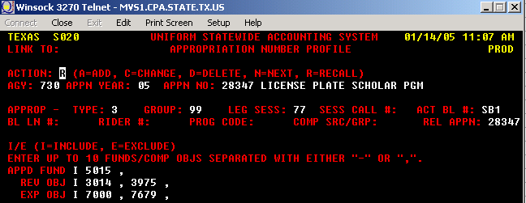

Return to Table of Contents
General Revenue Reduction – G0

For FY04, the implementation of GAA, 78th Leg, RS, Art III, Sec 56.1 GR Reduction reduced our general revenue as a transfer-out from our E&G main appropriation (BT 03) and a transfer-in into appropriation 28056 FD 1 (BT 04). The reduction of the budget in appropriation 28056 is done with T-code 001R (BT 01) transferring the funds to the General Revenue. There is no general revenue reduction in FY08. The biennial AY08-09 (80th Legislature) does not have any provisions for a General Revenue Reductions.

USAS entries to enter the General Revenue Reduction - Agency 730

Form Batch Type Edit Mode Doc Type
Cash Receipt Type 1 1 A

Unit | Curr Doc Num | Batch date | Comptroller Obj | Approp Num | Fund | Appropriat Yr | Fiscal Year | Transaction Cd | Sum Trans Amt | Ref Doc Num | HX Per | Reverse | PCA
730 | A4C90203 | 2003-10-22 | 7000 | 10730 | 0001 | 04 | 04 | 012 | 335,618.00 |  | 2 |  | 99999
902 | A4C90203 | 2003-10-22 | 7000 | 28056 | 0001 | 04 | 04 | 018 | 335,618.00 |  | 2 |  | 99999

Note: Entry done by the Comptrollers’ Office.

PS Entries to enter the General Revenue Reduction - Business Unit 00730
 |  |  | University of Houston System  JOURNAL ENTRY DETAIL
  Header BU: | 00730
  Fiscal Year: | 2004
  Acctg Period: | 2
  Run Date: | 01/18/2005
  Run Time: | 11:58:12

Journal ID: | STA4C90203 | Reversal: | None | Ledger Group: | ACTUALS
Date: | 10/28/2003 | Reversal Date: |  | Created By: | TRANK
Source: | ACS | Budget Adjust Type: | Actuals | Post Date: | 10/29/2003
Header Ref: | A4C90203 | Edit / Hdr Status: | Posted | BCM Status: | Valid
Description: | G0 - Record General Rev Reduction mandated. (Impl of GAA, 78th Leg, RS, Art III, Sec 56.1_GR Reduction) |  |  | BCM Bypass: | N

Line # | Account | Line BU | Fund | DeptId | Prog | Bdgt Ref. | Project | Line Ref | Chart.1 | Line Description | Amount
1 | 41102 | 00730 | 1026 | H0264 | A0202 | BP2004 | NA |  |  | GEN REV REDUCTION, MANDATED | 335,618.00
2 | 10500 | 00730 | 1026 |  |  | BP2004 |  |  |  | STATE BANK | -335,618.00

Totals for Journal: STA4C90203 | Total Lines: 2 | Total Base Debits: 335,618.00 | Total Base Credits: 335,618.00

Return to Table of Contents
Roll forward and Roll back for appropriations with UB authority - R6

The roll-forward and roll-back of funds is for those appropriations with UB (unexpended balance) authority. The appropriations with UB authority are:

- Advance Technology Program (0001) and Advance Research Program (13021/0001 and 13020/0001 respectively)
- Technical Workforce Development (formerly Engineering and Technical Consortium) (13123/5079)
- Higher Education Assistance Fund (HEAF) (13047/0001)
- Un-appropriated Activity (00000/0225)

- ATP/ARP

To process the roll-forward of funds for ATP/ARP (e.g., un-expended and un-encumbered funds in AY03 to roll-forward to AY04), use the journal voucher document, batch type 8 and edit mode 2. We are able to roll-forward the funds because ATP and ARP are considered grants and the legal site is HB1, 80th Leg., R.S., Article IX, Sec. 17.04.

USAS entries to Roll-Forward funds for ARP – Agency 730
Unit | Curr Doc Num | Batch date | Comptroller Obj | Approp Num | Fund | Appropriat Yr | Fiscal Year | Transaction Cd | Sum Trans Amt | Ref Doc Num | HX Per | Reverse | PCA
00730 | J0161013 | 2006-09-10 | 3975 | 13020 | 0001 | 06 | 07 | 406 | 995,026.81 |  | 1 |  | 03980
00730 | J0161013 | 2006-09-10 | 3975 | 13020 | 0001 | 07 | 07 | 405 | 995,026.81 |  | 1 |  | 03980

LDT: HB1, 80th Leg., R.S., Article IX, Sec. 17.04
PS entries to Roll-Forward funds for ARP – Business Unit 730
 |  |  | University of Houston System  JOURNAL ENTRY DETAIL
  Header BU: | 00730
  Fiscal Year: | 2007
  Acctg Period: | 1
  Run Date: | 01/18/2007
  Run Time: | 03:41:00

Journal ID: | STJ0161013 | Reversal: | None | Ledger Group: | ACTUALS
Date: | 09/10/2006 | Reversal Date: |  | Created By: | NGUYENTB
Source: | ACS | Budget Adjust Type: | Actuals | Post Date: | 09/11/2006
Header Ref: | J0161013 | Edit / Hdr Status: | Posted | BCM Status: | Valid
Description: | R6 - Rollforward from AY06 to AY07 for ARP, 13020, 0001. |  |  | BCM Bypass: | N

Line # | Account | Line BU | Fund | DeptId | Prog | Bdgt Ref. | Project | Line Ref | Chart.1 | Line Description | Amount
1 | 10500 | 00730 | 1100 |  |  | BP2006 |  |  |  | STATE BANK | -995,026.81
2 | 10500 | 00730 | 1100 |  |  | BP2007 |  |  |  | STATE BANK | 995,026.81

Totals for Journal: STJ0161013 | Total Lines: 2 | Total Base Debits: 995,026.81 | Total Base Credits: 995,026.81

Signatures | ___________________________________ | Date | __________________________________
PS Approval: | ___________________________________ |  | __________________________________

Created By: NGUYENTB | Date Printed: 01/18/2007 | Jrnl. Dt.: 09/10/2006

Note: Use the most recent PS fund code for ATP or ARP. The fund code for ATP program 06-07 is 1100.
- Technical Workforce Development

To process the roll-forward of funds for Engineer and Technical Consortium, use the journal voucher document, batch type 8 and edit mode 2. We are able to roll-forward the funds because Tech Workforce Development is considered a grant and the legal cite is HB1, 80th Leg., R.S., Article IX, Sec. 17.04.

USAS entry to Roll-Forward funds for Technical Workforce Development – Agency 730
Unit | Curr Doc Num | Batch date | Comptroller Obj | Approp Num | Fund | Appropriat Yr | Fiscal Year | Transaction Cd | Sum Trans Amt | Ref Doc Num | HX Per | Reverse | PCA
00730 | J0161189 | 2006-09-10 | 3975 | 13123 | 5079 | 07 | 07 | 405 | 114,052.19 | J0161189 | 1 |  | 03980
00730 | J0161189 | 2006-09-10 | 3975 | 13123 | 5079 | 06 | 07 | 406 | 114,052.19 | J0161189 | 1 |  | 03980

PS entry to Roll-Forward funds for Technical Workforce Development – Business Unit 00730
 |  |  | University of Houston System  JOURNAL ENTRY DETAIL
  Header BU: | 00730
  Fiscal Year: | 2007
  Acctg Period: | 1
  Run Date: | 01/18/2007
  Run Time: | 03:43:12

Journal ID: | STJ0161189 | Reversal: | None | Ledger Group: | ACTUALS
Date: | 09/10/2006 | Reversal Date: |  | Created By: | NGUYENTB
Source: | ACS | Budget Adjust Type: | Actuals | Post Date: | 09/10/2006
Header Ref: | J0161189 | Edit / Hdr Status: | Posted | BCM Status: | Valid
Description: | R6 - Rollforward from 27919, 5079, 06 to 13123, 5079, 07. (Engineering & Tech. Consortium) |  |  | BCM Bypass: | N

Line # | Account | Line BU | Fund | DeptId | Prog | Bdgt Ref. | Project | Line Ref | Chart.1 | Line Description | Amount
1 | 10500 | 00730 | 1091 |  |  | BP2006 |  |  |  | STATE BANK | -114,052.19
2 | 10500 | 00730 | 1091 |  |  | BP2007 |  |  |  | STATE BANK | 114,052.19

Totals for Journal: STJ0161189 | Total Lines: 2 | Total Base Debits: 114,052.19 | Total Base Credits: 114,052.19

- Higher Education Assistance Fund

To process the roll-forward of funds for HEAF, use document type B, batch type 1 and edit mode 1.

USAS entries to roll-forward funds for HEAF – Agency 730
Unit | HX Fiscal Yr | HX Per | Transaction Cd | Approp Num | Fund | PCA | EOC | Comptroller Obj | Doc Date | Curr Doc Num | Ref Doc Num | Trans Amt | Fiscal Year | Appropriat Yr | Reverse | Fiscal Month | Batch Number
00730 | 2004 | 2 | 040 | 13047 | 0001 | 03980 | 980 | 7000 |  | B0161066 | B0161066 | 15,446,910.49 | 07 | 06 |  | 02 | 066
00730 | 2004 | 2 | 042 | 13047 | 0001 | 03980 | 980 | 7000 |  | B0161066 | B0161066 | 15,446,910.49 | 07 | 07 |  | 02 | 066

LDT: HB1,80th Leg,RS,ART III p. 56 Rider 1

PS entries to roll-forward funds for HEAF – Business Unit 00730
 |  |  | University of Houston System  JOURNAL ENTRY DETAIL
  Header BU: | 00730
  Fiscal Year: | 2007
  Acctg Period: | 2
  Run Date: | 01/18/2007
  Run Time: | 03:48:06

Journal ID: | STB0161066 | Reversal: | None | Ledger Group: | ACTUALS
Date: | 10/15/2006 | Reversal Date: |  | Created By: | TRANK
Source: | ACS | Budget Adjust Type: | Actuals | Post Date: | 10/15/2006
Header Ref: | B0161066 | Edit / Hdr Status: | Posted | BCM Status: | Valid
Description: | R6 - HEAF Roll forward from AY06 to AY07. Amount to roll-forward takes in consideration the encumbrances that will liquidate for AY06. |  |  | BCM Bypass: | N

Line # | Account | Line BU | Fund | DeptId | Prog | Bdgt Ref. | Project | Line Ref | Chart.1 | Line Description | Amount
1 | 10500 | 00730 | 1008 |  |  | BP2007 |  |  |  | STATE BANK | 15,446,910.49
2 | 10500 | 00730 | 1008 |  |  | BP2006 |  |  |  | STATE BANK | -15,446,910.49

Totals for Journal: STB0161066 | Total Lines: 2 | Total Base Debits: 15,446,910.49 | Total Base Credits: 15,446,910.49

4. Un-appropriated Activity

Un-appropriated activity is set apart from the other appropriations. The roll-forward has to be followed by a budget revision when the budget load amount has been exceeded.

- At the beginning of the year roll-forward the amount of the deferred revenue tuition. This is only a cash entry in PS and USAS with no budget revision.

Roll-forward the deferred tuition revenue for appropriation 00000/0225 from AY06 to AY07:

USAS entry to roll-forward funds for the un-appropriated activity for the amount of deferred tuition revenue- Agency 730

Form Batch Type Edit Mode Doc Type
Deposit Type 8 2 J
Unit | Curr Doc Num | Batch date | Comptroller Obj | Approp Num | Fund | Appropriat Yr | Fiscal Year | Transaction Cd | Sum Trans Amt | Ref Doc Num | HX Per | Reverse | PCA
00730 | J0161004 | 2006-09-06 | 3975 | 00000 | 0225 | 07 | 07 | 405 | 17,215,765.02 | J0161004 | 1 |  | 03992
00730 | J0161004 | 2006-09-06 | 3975 | 00000 | 0225 | 06 | 07 | 406 | 17,215,765.02 | J0161004 | 1 |  | 03992

PS Entries to roll-forward funds for the un-appropriated activity - Business Unit 00730
 |  |  | University of Houston System  JOURNAL ENTRY DETAIL
  Header BU: | 00730
  Fiscal Year: | 2007
  Acctg Period: | 1
  Run Date: | 09/10/2006
  Run Time: | 05:00:22

Journal ID: | STJ0161004 | Reversal: | None | Ledger Group: | ACTUALS
Date: | 09/06/2006 | Reversal Date: |  | Created By: | NGUYENTB
Source: | ACS | Budget Adjust Type: | Actuals | Post Date: | 09/06/2006
Header Ref: | J0161004 | Edit / Hdr Status: | Posted | BCM Status: | Valid
Description: | R6 - E & G, Roll-forward from AY06 to AY07 for the amount of the deferred revenue. |  |  | BCM Bypass: | N

Line # | Account | Line BU | Fund | DeptId | Prog | Bdgt Ref. | Project | Line Ref | Chart.1 | Line Description | Amount
1 | 10500 | 00730 | 1065 |  |  | BP2007 |  |  |  | STATE BANK | 17,215,765.02
2 | 10500 | 00730 | 1065 |  |  | BP2006 |  |  |  | STATE BANK | -17,215,765.02

Totals for Journal: STJ0161004 | Total Lines: 2 | Total Base Debits: 17,215,765.02 | Total Base Credits: 17,215,765.02

Signatures | ___________________________________ | Date | __________________________________
PS Approval: | ___________________________________ |  | __________________________________

Created By: NGUYENTB | Date Printed: 09/10/2006 | Jrnl. Dt.: 09/06/2006
- Roll-forward for 00000/0225 has to be followed by an adjustment to 10730/0225 appropriation when the amount of the budget load is exceeded. The budget and cash is increased in 10730 0225 in the year the funds were transferred to (AY07) and decreased in the year the funds were transferred from (AY06).

USAS entry to roll-forward funds for the un-appropriated activity for the amount in excess of the budget load - Agency 730

Form Batch Type Edit Mode Doc Type
Deposit Type 8 2 J

Unit | Curr Doc Num | Batch date | Comptroller Obj | Approp Num | Fund | Appropriat Yr | Fiscal Year | Transaction Cd | Sum Trans Amt | Ref Doc Num | HX Per | Reverse | PCA
00730 | J0161187 | 2007-02-05 | 3975 | 00000 | 0225 | 07 | 07 | 405 | 124,142.15 | J0161187 | 1 |  | 03992
00730 | J0161187 | 2007-02-05 | 3975 | 00000 | 0225 | 06 | 07 | 406 | 124,142.15 | J0161187 | 1 |  | 03992

PS Entries to roll-forward funds for the un-appropriated activity - Business Unit 00730
 |  |  | University of Houston System  JOURNAL ENTRY DETAIL
  Header BU: | 00730
  Fiscal Year: | 2007
  Acctg Period: | 1
  Run Date: | 02/05/2007
  Run Time: | 05:00:22

Journal ID: | STJ0161187 | Reversal: | None | Ledger Group: | ACTUALS
Date: | 02/05/2007 | Reversal Date: |  | Created By: | NGUYENTB
Source: | ACS | Budget Adjust Type: | Actuals | Post Date: | 02/05/2007
Header Ref: | J0161187 | Edit / Hdr Status: | Posted | BCM Status: | Valid
Description: | R6 - E & G, Roll-forward from AY06 to AY07 for the amount of the deferred revenue. |  |  | BCM Bypass: | N

Line # | Account | Line BU | Fund | DeptId | Prog | Bdgt Ref. | Project | Line Ref | Chart.1 | Line Description | Amount
1 | 10500 | 00730 | 1065 |  |  | BP2007 |  |  |  | STATE BANK | 124,142.15
2 | 10500 | 00730 | 1065 |  |  | BP2006 |  |  |  | STATE BANK | -124,142.15

Totals for Journal: STJ0161187 | Total Lines: 2 | Total Base Debits: 124,142.15 | Total Base Credits: 124,142.15

Signatures | ___________________________________ | Date | __________________________________
PS Approval: | ___________________________________ |  | __________________________________

Created By: NGUYENTB | Date Printed: 02/05/2007 | Jrnl. Dt.: 02/05/2007

USAS entry to increase the budget authority and adjust the cash in the E&G dedicated appropriation - Agency 730

Form Batch Type Edit Mode Doc Type
Budget Revision Type 1 1 A
Unit | Curr Doc Num | Batch date | Comptroller Obj | Approp Num | Fund | Appropriat Yr | Fiscal Year | Transaction Cd | Sum Trans Amt | Ref Doc Num | HX Per | Reverse | PCA
00730 | A0161193 | 2007-02-05 | 7000 | 10730 | 0225 | 06 | 07 | 006 | 124,142.15 | A0161193 | 6 | R | 03701
00730 | A0161193 | 2007-02-05 | 7000 | 10730 | 0225 | 07 | 07 | 006 | 124,142.15 | A0161193 | 6 |  | 03701

PS entries to increase the budget authority and adjust the cash balance in fund code 1054 - Business Unit 00730
 |  |  | University of Houston System  JOURNAL ENTRY DETAIL
  Header BU: | 00730
  Fiscal Year: | 2004
  Acctg Period: | 6
  Run Date: | 02/06/2007
  Run Time: | 05:03:17

Journal ID: | STA0161193 | Reversal: | None | Ledger Group: | ACTUALS
Date: | 02/05/2007 | Reversal Date: |  | Created By: | NGUYENTB
Source: | ACS | Budget Adjust Type: | Actuals | Post Date: | 02/06/2007
Header Ref: | A0161193 | Edit / Hdr Status: | Posted | BCM Status: | Valid
Description: | Decrease the budget authority in 10730/0225/03 to match the cash in 00000/0225/03 appn; and increase the budget authority in 10730/0225/04 to match the cash in 00000/0225/04 appn. |  |  | BCM Bypass: | N

Line # | Account | Line BU | Fund | DeptId | Prog | Bdgt Ref. | Project | Line Ref | Chart.1 | Line Description | Amount
1 | 33500 | 00730 | 1054 | H0600 | F1655 | BP2006 | NA |  |  | Decr Budget Auth | 124,142.15
2 | 10500 | 00730 | 1054 |  |  | BP2006 |  |  |  | STATE BANK | -124,142.15
3 | 37400 | 00730 | 1065 | H0600 | F1651 | BP2006 | NA |  |  | Decr Budget Auth | -124,142.15
4 | 10500 | 00730 | 1065 |  |  | BP2006 |  |  |  | STATE BANK | 124,142.15
5 | 33500 | 00730 | 1054 | H0600 | F1651 | BP2007 | NA |  |  | Increase Budget Auth | -124,142.15
6 | 10500 | 00730 | 1054 |  |  | BP2007 |  |  |  | STATE BANK | 124,142.15
7 | 37400 | 00730 | 1065 | H0600 | F1651 | BP2007 | NA |  |  | Increase Budget Auth | 124,142.15
8 | 10500 | 00730 | 1065 |  |  | BP2007 |  |  |  | STATE BANK | -124,142.15

Totals for Journal: STA0161193 | Total Lines: 8 | Total Base Debits: 496,568.60 | Total Base Credits: 496,568.60

Signatures | ___________________________________ | Date | __________________________________
PS Approval: | ___________________________________ |  | __________________________________

Created By: NGUYENTB | Date Printed: 02/06/2007 | Jrnl. Dt.: 02/05/2006

Note: When the rollforward entry uses TCodes 405/406, the budget to cash adjustment entry needs to follow to increase/decrease the budget authority to spend. TCodes 405/406 move only cash.
c. Roll-back for fund 0225 main appropriation (10730)

Step 1: Roll-back from appropriation 00000/0225 from AY07 to AY06 is processed by issuing a journal entry just like in the example for roll-forward, but using first T-Codes 406R for FY06 and second 405R for FY07. The PS entry is crediting account 10500 for BP2007 and debiting 10500 for BP2006 for fund code 1065.

Step 2: The prior step is also followed by a Budget Revision in appn 10730/0225. The budget and cash is increased in 10730/0225 in the year the funds were transferred to with TC 006 (AY06 in this case) and decreased in the year the funds were transferred from with TC 006R (AY07 in this case). The PS entry adjusts the cash available in 1054 and 1065 to match the cash available in USAS and transfers the corresponding equities just like in the roll-forward entry, but with the opposite sign.

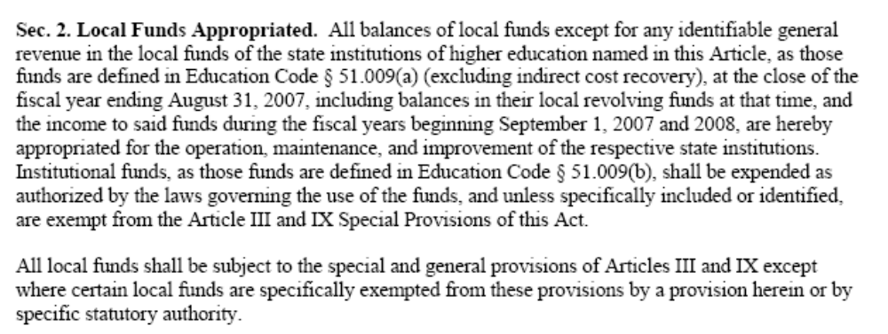

LDT: HB1,80th Leg,RS,ART III, Sec 2, page 213

Return to Table of Contents
Encumbrances – E0

Policy
Annually, payables and binding encumbrances must be reported to the Texas Comptroller of Public Accounts, the State Auditor's office and the Legislative Budget Board by October 30. Certifications are required with each report.
Binding encumbrances and payables must be entered in USAS for appropriations made for the current appropriation year within 30 days after the close of the first three fiscal year quarters, that is, 30 days after November 30, February 28/29 and May 31, respectively. For those appropriations that do not have Unexpended Balance (UB) authority On November 1 of each fiscal year, the Comptroller lapses all unencumbered appropriation balances on the payables and binding encumbrances reported by processing a budget revision.
The table below shows the due dates for entering binding encumbrances and payables in USAS.
Period | End Date/Effective Date | Due Date
1st Quarter | November 30 | December 30
2nd Quarter | February 28/29 | March 30
3rd Quarter | May 31 | June 30
Annual | August 31 | October 30

The quarterly and annual encumbrances report is a computer-generated file that is sent to USAS to accomplish reserves required by APS 018.

Legal cite - Tex. Const. Art. III, § 49(g) and art. VIII, § 6; Tex. Gov't Code Ann. §§ 403.021, 403.071, 403.074

Payables: Amounts obligated for goods or services actually rendered or provided to the agency at the end of the reporting period, for which the agency has not made payments, should be recorded as accounts payable. Enter vouchers payable with an effective date of August 31. Agencies should not process accrual transactions which generate liquidating transactions that post to cash (GL 0045) if they exceed the amount of remaining cash-basis budget and appropriation cash available in a prior year's appropriation.

Expenditure Transfers: If cash expenditures are posted incorrectly in the prior fiscal year, or there is need to reallocate expenditures, accrue expenditure transfers (T-Codes 467/468) with an effective date equal to the last day of the period. Accruals done using T-Codes 467 and 468 will generate an automatic reversal and post the cash in the following year. The accrual and reversal of accrual entries should be done in PS as well to keep both systems in balance.

Operating Transfers: Accrued operating transfers (due tos and due froms) should be posted with the appropriate effective date using T-Code 450 (record accrual of operating transfer-out) and T-Code 451 (record accrual of operating transfer-in). These T-Codes will reverse themselves in the new quarter/year.

Encumbrances are amounts obligated for goods or services through contractual obligations, agreement or other action which legally obligates state funds, but where the good or service has not been received by the end of the reporting period. Therefore, balances on this report will include only obligated amounts to be paid from an appropriation. In the report, do not include balances that will be transferred forward (unexpended balance [UB] authority) to the following year. Anticipated contracts or contracts under negotiation are not legal commitments and should not be reported as encumbrances. As an example, funds dedicated for construction, but not yet specifically awarded as a contract, would not be reported as an encumbrance. In this case, a reservation of fund balance should be entered on the annual financial report.

Agencies may obligate or encumber an appropriation during the specified term for which it was made. However, payments for such obligations must be made within two years following the last day of the appropriation year. Agencies must obligate or encumber an appropriation during the specified term for which it was appropriated.

If the appropriation year (AY) is... | Then funds must be encumbered by... | And vouchers must be paid by...
2002 (September 1, 2001 - August 31, 2002) | August 31, 2002 | August 31, 2004
2003 (September 1, 2002 - August 31, 2003) | August 31, 2003 | August 31, 2005
Refer to the State of Texas Purchase Policies and Procedures Guide, https://fmx.cpa.state.tx.us/fm/pubs/purchase/index.php Section 8.006 for "Appropriation year determination."
Encumbrances differ from payables. The former are commitments for goods or services made before the reporting period's end, but the actual receipt of the good or performance of the service does not occur until after the end of the reporting period.

Accruals and encumbrances appropriation balances are identified on the USAS Appropriation Record Inquiry (62) profile as remaining accrual and encumbrance-basis budget and appropriation accrual and encumbrance cash available. The annual encumbrance and payables information entered in USAS should agree with the encumbrances and payables reported on the AFR (Annual Financial Report).

Appropriations statutorily expire when:
- They are not obligated before the end of the appropriation term or
- They are not expended during the authorized payment period or
- They are not reappropriated in subsequent legislation.

The T-Code used for recording encumbrances is determined by whether agencies use encumbrance accounting in USAS. As a Higher Ed agency, UH System components do not use encumbrance accounting in USAS and, therefore, we use T-Code 207 to record encumbrances on a quarterly basis.

Return to Table of Contents

Fund Equity and Cash Transfers – F1

The only fund equity transfers entered in PS by State Accounting are the funding of the payroll allocations between the central services and system operation appropriations in Business Unit 00783 and between the E&G fund 1 and 2 appropriations in Business Unit 00730.

We transfer payroll expenses in PS and USAS from E&G fund 1 to E&G fund 2 for proportionality purposes. This entry leaves a deficit in the fund 2 cost center and a surplus in the fund 1 cost center. The fund transfers for the payroll allocations between the E&G fund 1 and 2 (10730/0001 fund code 1026 in PS and 10730/0225 fund code 1054 in PS, respectively), corrects the deficit equity in the fund 2 cost center by transferring the equity from the fund 1 cost center. See entry below.

PS entry to balance the equity between fund 1026 and 1054 – Business Unit 00730
 |  | University of Houston System  JOURNAL ENTRY DETAIL
  Header BU: | 00730
  Fiscal Year: | 2007
  Acctg Period: | 6
  Run Date: | 03/09/2007
  Run Time: | 02:01:17

Journal ID: |  | STJ0161180 |  |  |  |  |  |  |  |  |  |  |  |  | Reversal: |  |  | None | Ledger Group: |  | ACTUALS
Date: |  | 02/27/2007 |  |  |  |  |  |  |  |  |  |  |  |  | Reversal Date: |  |  |  | Created By: |  | BANKSDA
Source: |  | ACS |  |  |  |  |  |  |  |  |  |  |  |  | Budget Adjust Type: |  |  | Actuals | Post Date: |  | 02/28/2007
Header Ref: |  | J0161180 |  |  |  |  |  |  |  |  |  |  |  |  | Edit / Hdr Status: |  |  | Posted | BCM Status: |  | Valid
Description: |  | P1 & F1- Funding for salary allocation between E&G fund 1026 and E&G- Dedicated fund 1054 for the 1st-2nd Quarter (1st). |  |  |  |  |  |  |  |  |  |  |  |  |  |  |  |  | BCM Bypass: |  | N
Line # | Account |  | Line BU | Fund |  | DeptId |  | Prog | Bdgt Ref. | Project | Line Ref |  |  | Chart.1 | Line Description |  |  |  |  | Amount
1 | 37400 |  | 00730 | 1026 |  | H0600 |  | A1994 | BP2007 | NA | J0161180 |  |  |  | FUNDING SAL. ALLOC. 1ST-2NDQTR |  |  |  |  | 26,051,047.77
2 | 33500 |  | 00730 | 1054 |  | H0600 |  | A1994 | BP2007 | NA | J0161180 |  |  |  | FUNDING SAL. ALLOC. 1ST-2NDQTR |  |  |  |  | -26,051,047.77
3 | 10100 |  | 00730 | 1026 |  |  |  |  | BP2007 |  |  |  |  |  | CLAIM ON CASH |  |  |  |  | -26,051,047.77
4 | 10100 |  | 00730 | 1054 |  |  |  |  | BP2007 |  |  |  |  |  | CLAIM ON CASH |  |  |  |  | 26,051,047.77
Totals for Journal: STJ0161180 |  |  |  |  |  |  | Total Lines: 4 |  |  |  |  | Total Base Debits: 52,102,095.54 |  |  |  |  | Total Base Credits: 52,102,095.54
Signatures |  |  |  |  | ___________________________________ |  |  |  |  |  |  |  | Date |  |  | __________________________________
PS Approval: |  |  |  |  | ___________________________________ |  |  |  |  |  |  |  |  |  |  | __________________________________

Created By: BANKSDA | Date Printed: 03/09/2007 | Jrnl. Dt.: 02/27/2007

The cash transfers are processed in between fund codes related to the same state appropriation to cover the negative balance on the state cash account 10500 for BU 00783 and 00730.

PS entry to cover negative balances – BU 00783
 |  |  | University of Houston System  JOURNAL ENTRY DETAIL
  Header BU: | 00783
  Fiscal Year: | 2006
  Acctg Period: | 4
  Run Date: | 01/10/2006
  Run Time: | 12:06:02

Journal ID: | STJ0042037 | Reversal: | None | Ledger Group: | ACTUALS
Date: | 12/13/2005 | Reversal Date: |  | Created By: | NGUYENTB
Source: | ACS | Budget Adjust Type: | Actuals | Post Date: | 12/20/2005
Header Ref: | J0042037 | Edit / Hdr Status: | Posted | BCM Status: | Valid
Description: | F1 - Funding negative balances on the state cash balances as of 11/30/05 for CSA, AY 06 and Heaf , AY 05 for November Cash Reconciliation. |  |  | BCM Bypass: | N

Line # | Account | Line BU | Fund | DeptId | Prog | Bdgt Ref. | Project | Line Ref | Chart.1 | Line Description | Amount
1 | 10500 | 00783 | 7050 |  |  | BP2006 |  |  |  | Funding Neg. balances as 11/30 | 411,698.05
2 | 10500 | 00783 | 1006 |  |  | BP2006 |  |  |  | Funding Neg. balances as 11/30 | -411,698.05
3 | 10500 | 00783 | 7054 |  |  | BP2006 |  |  |  | Funding Neg. balances as 11/30 | 2,964.35
4 | 10500 | 00783 | 1006 |  |  | BP2006 |  |  |  | Funding Neg. balances as 11/30 | -2,964.35
5 | 10500 | 00783 | 1008 |  |  | BP2005 |  |  |  | Funding Neg. balances as 11/30 | 165,905.83
6 | 10500 | 00783 | 7042 |  |  | BP2005 |  |  |  | Funding Neg. balances as 11/30 | -165,905.83
7 | 10100 | 00783 | 7050 |  |  | BP2006 |  |  |  | CLAIM ON CASH | -414,662.40
8 | 10100 | 00783 | 1006 |  |  | BP2006 |  |  |  | CLAIM ON CASH | 414,662.40
9 | 10100 | 00783 | 7050 |  |  | BP2006 |  |  |  | CLAIM ON CASH | 2,964.35
10 | 10100 | 00783 | 7054 |  |  | BP2006 |  |  |  | CLAIM ON CASH | -2,964.35
11 | 10100 | 00783 | 7050 |  |  | BP2006 |  |  |  | CLAIM ON CASH | 165,905.83
12 | 10100 | 00783 | 1008 |  |  | BP2005 |  |  |  | CLAIM ON CASH | -165,905.83
13 | 10100 | 00783 | 7050 |  |  | BP2006 |  |  |  | CLAIM ON CASH | -165,905.83
14 | 10100 | 00783 | 7042 |  |  | BP2005 |  |  |  | CLAIM ON CASH | 165,905.83

Totals for Journal: STJ0042037 | Total Lines: 14 | Total Base Debits: 1,330,006.64 | Total Base Credits: 1,330,006.64

Signatures | ___________________________________ | Date | __________________________________
PS Approval: | ___________________________________ |  | __________________________________

Created By: NGUYENTB | Date Printed: 01/10/2006 | Jrnl. Dt.: 12/13/2005

Return to Table of Contents
Expenditure Transfers

Expenditure transfers are processed for the following reasons:

- Transfers between FD 1 and 2 for proportionality purposes (APS 001 HB1,79th Leg,RS,ART IX p. 30 Sec 6.08); or
- To correct posted ineligible expenses (HB1, 80th Leg,RS,ART IX, Section 6.16); or
- To correct over expended cost centers (HB1, 80th Leg, RS, ART IX, Section 6.16).

All the expenditure transfers are processed in PS and USAS using the same procedures. The examples below illustrate the different types of situations.

Expenditure Transfers – F0 (FICA), O0 (Optional Retirement Program), and P1 (Payroll Allocations)

    - When the expenditure transfer is recorded to adjust proportionally expenses between fund 0001 and 0225, a PS and USAS entry is completed as follows:

USAS entries to transfer expenditures between different appropriations to adjust proportionality - Agency 730

Journal Voucher Batch Type Edit Mode Doc Type
Type 8 2 J

Example below is a FICA expenditure transfer between fund 0001 and 0225. Payroll expenses post to fund 0001 and we need to transfer a portion of those expenses to fund 0225 to pay proportional according to APS 011.

Unit | Curr Doc Num | Batch date | Comptroller Obj | Approp Num | Fund | Appropriat Yr | Fiscal Year | Transaction Cd | Sum Trans Amt | Ref Doc Num | HX Per | Reverse | PCA
00730 | J0161384 | 2005-05-04 | 7086 | 97646 | 0001 | 05 | 05 | 407 | 339,605.70 | J0161384 | 9 |  | 03991
00730 | J0161384 | 2005-05-04 | 7086 | 97646 | 0225 | 05 | 05 | 408 | 339,605.70 | J0161384 | 9 |  | 03991

Note: Use document type “J” to transfer expenses between fund one and two or between different appropriation numbers when the expenditure transfer is not the result of a bookkeeping error.

LDT: HB1,80th APS 001 Leg,RS,ART IX p. 30 Sec 6.08

PS entries to transfer expenditures between different appropriations to adjust proportionality - Business Unit 00730
 |  | University of Houston System  JOURNAL ENTRY DETAIL
  Header BU: | 00730
  Fiscal Year: | 2007
  Acctg Period: | 5
  Run Date: | 03/09/2007
  Run Time: | 02:19:56

Journal ID: |  |  | STJ0161103 |  |  |  |  |  |  |  |  |  |  | Reversal: |  | None | Ledger Group: |  | ACTUALS
Date: |  |  | 01/22/2007 |  |  |  |  |  |  |  |  |  |  | Reversal Date: |  |  | Created By: |  | BANKSDA
Source: |  |  | ACS |  |  |  |  |  |  |  |  |  |  | Budget Adjust Type: |  | Actuals | Post Date: |  | 01/23/2007
Header Ref: |  |  | J0161103 |  |  |  |  |  |  |  |  |  |  | Edit / Hdr Status: |  | Posted | BCM Status: |  | Valid
Description: |  |  | F0- Proportionality adjustment according to APS 011 between funds 1 & 2 for FICA for September-December 2006 (Payment). |  |  |  |  |  |  |  |  |  |  |  |  |  | BCM Bypass: |  | N
Line # |  | Account | Line BU |  | Fund | DeptId |  | Prog | Bdgt Ref. |  | Project | Line Ref | Chart.1 | Line Description |  |  |  | Amount
1 |  | 51115 | 00730 |  | 1072 | H0437 |  | A0279 | BP2007 |  | NA | J0161103 |  | PROP ADJ- FICA FD2 SEPT-DEC 06 |  |  |  | 1,044,204.73
2 |  | 10500 | 00730 |  | 1072 |  |  |  | BP2007 |  |  | J0161103 |  | STATE BANK |  |  |  | -1,044,204.73
3 |  | 10500 | 00730 |  | 1022 |  |  |  | BP2007 |  |  | J0161103 |  | STATE BANK |  |  |  | 1,044,204.73
4 |  | 51109 | 00730 |  | 1022 | H0437 |  | A0295 | BP2007 |  | NA | J0161103 |  | PROP ADJ- FICA FD1 SEPT-DEC 06 |  |  |  | -1,044,204.73
Totals for Journal: STJ0161103 |  |  |  |  |  |  | Total Lines: 4 |  |  | Total Base Debits: 2,088,409.46 |  |  |  |  | Total Base Credits: 2,088,409.46
Signatures |  |  |  | ___________________________________ |  |  |  |  |  |  |  | Date | __________________________________
PS Approval: |  |  |  | ___________________________________ |  |  |  |  |  |  |  |  | __________________________________

Created By: BANKSDA | Date Printed: 03/09/2007 | Jrnl. Dt.: 01/22/2007

Expenditure Transfers – E5

b and c. When the expenditure transfer is as a result of a bookkeeping error the following cases are describe below:

1. The expenditure transfer can be between different budget periods. When the entry is between different budget periods, the USAS entry is required between the different appropriation years.
2. When the expenditure transfer is between different program codes and/or project codes, a USAS entry is not required, unless the program codes and/or project codes are in reference to different strategies (different PCA).
3. When a reallocation of expenses is between different PS account numbers within the same appropriation, an entry in USAS is required if the different account numbers involve different COBJs.
4. When departments reallocate expenses between different state fund codes, they send the journal entry to General Accounting. State Accounting determines if the reallocation is between different appropriations; if the entry involves different appropriations a journal entry in USAS and PS needs to be created. See entries below:

USAS entries reallocating expenses between different appropriations as a result of an error - Agency 730

Form Batch Type Edit Mode Doc Type
Journal Entry Type 8 2 K
Unit | Curr Doc Num | Batch date | Comptroller Obj | Approp Num | Fund | Appropriat Yr | Fiscal Year | Transaction Cd | Sum Trans Amt | Ref Doc Num | HX Per | Reverse | PCA
00730 | K0161163 | 2004-01-20 | 7291 | 10730 | 0001 | 04 | 04 | 408 | 4.44 | K0161163 | 5 |  | 03701
00730 | K0161163 | 2004-01-20 | 7291 | 10730 | 0225 | 04 | 04 | 407 | 4.44 | K0161163 | 5 |  | 03701
00730 | K0161163 | 2004-01-20 | 7806 | 10730 | 0001 | 04 | 04 | 408 | 60.21 | K0161163 | 5 |  | 03701
00730 | K0161163 | 2004-01-20 | 7806 | 13047 | 0001 | 04 | 04 | 407 | 60.21 | K0161163 | 5 |  | 03980

Note: Use document type “K” to transfer expenses between different COBJs, appropriation years, PCA corrections, or any other bookkeeping error.

LDT: HB1, 80th Leg,RS,ART IX, Section 6.16

PS Entries reallocating expenses between different appropriations as a result of an error – Business Unit 730
 |  |  | University of Houston System  JOURNAL ENTRY DETAIL
  Header BU: | 00730
  Fiscal Year: | 2004
  Acctg Period: | 5
  Run Date: | 01/18/2005
  Run Time: | 10:16:41

Journal ID: | STK0161163 | Reversal: | None | Ledger Group: | ACTUALS
Date: | 01/20/2004 | Reversal Date: |  | Created By: | NGUYENTB
Source: | ACS | Budget Adjust Type: | Actuals | Post Date: | 01/21/2004
Header Ref: | J0161163 | Edit / Hdr Status: | Posted | BCM Status: | Valid
Description: | Expenditure transfer. Ref. # 0000861398, 0000861777. |  |  | BCM Bypass: | N

Line # | Account | Line BU | Fund | DeptId | Prog | Bdgt Ref. | Project | Line Ref | Chart.1 | Line Description | Amount
1 | 10500 | 00730 | 1026 |  |  | BP2004 |  | 0000861398 |  | STATE BANK | -60.21
2 | 10500 | 00730 | 1043 |  |  | BP2004 |  | 0000861398 |  | STATE BANK | 60.21
5 | 10500 | 00730 | 1026 |  |  | BP2004 |  | 0000861777 |  | STATE BANK | -4.44
6 | 10500 | 00730 | 1054 |  |  | BP2004 |  | 0000861777 |  | STATE BANK | 4.44
7 | 10100 | 00730 | 1026 |  |  |  |  |  |  | CLAIM ON CASH | 64.65
8 | 10100 | 00730 | 1043 |  |  |  |  |  |  | CLAIM ON CASH | -60.21
9 | 10100 | 00730 | 1054 |  |  |  |  |  |  | CLAIM ON CASH | -4.44

Totals for Journal: STJ0161163 | Total Lines: 7 | Total Base Debits: 129.30 | Total Base Credits: 129.30

Signatures | ___________________________________ | Date | __________________________________
PS Approval: | ___________________________________ |  | __________________________________

Created By: NGUYENTB | Date Printed: 01/18/2005 | Jrnl. Dt.: 01/20/2004

Note: The expense portion has been entered by the departments in another PS entry indicated in the Line reference of this entry.

Return to Table of Contents Return to Refund to State
Expenditure Transfer for the Automated Budget and Evaluation System of Texas (ABEST) – E7

The expenditure transfers for the ABEST Reconciliation correct the Program Cost Account (PCA). No entry in PS is required. To correct the PCA do the following:

Go to the SGA Ad Hoc Reports, Main Menu (http://mvs1.cpa.state.tx.us/fiscal/sga_reports.html) and click on Uniform Statewide Accounting System Financial Reports.

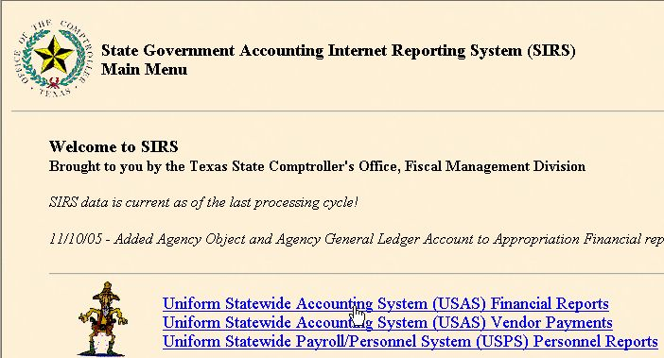

In the next page, click on Institutions of Higher Education.

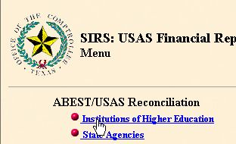

Then, click on detail by strategy for all USAS expenditures. The ABEST format has only the E&G transactions. By correcting all USAS transactions the ABEST expenditures are also corrected.

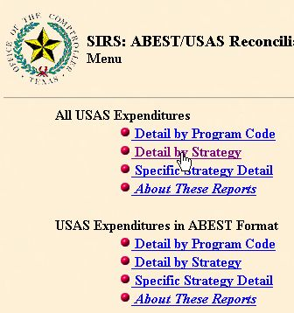

Choose the parameters indicated below and click submit to have the transactions for agency 765, FY06, appropriation year 2006, and second quarter reconciliation. Choose the Comma-Separated Values so the transactions can be downloaded to excel.

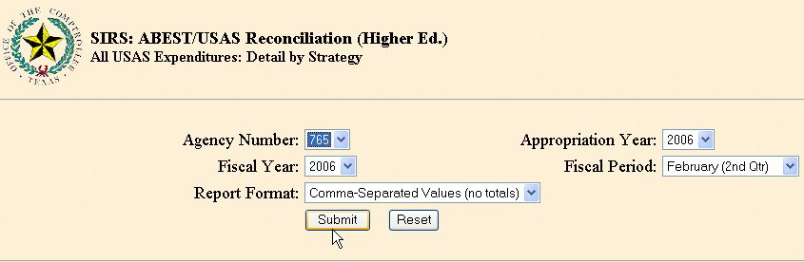

The result is below. Click on edit and select all to highlight all the transactions.

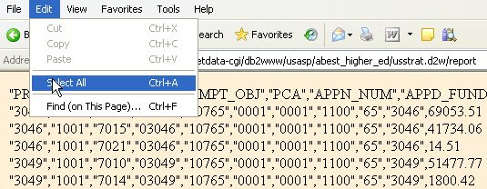

Then, click on copy to download the transactions to excel.

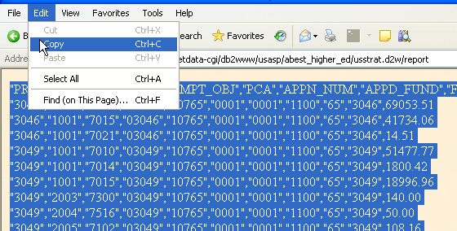

Open excel and paste the transactions. In excel, after highlighting column A, go to Data and choose Text to Columns.

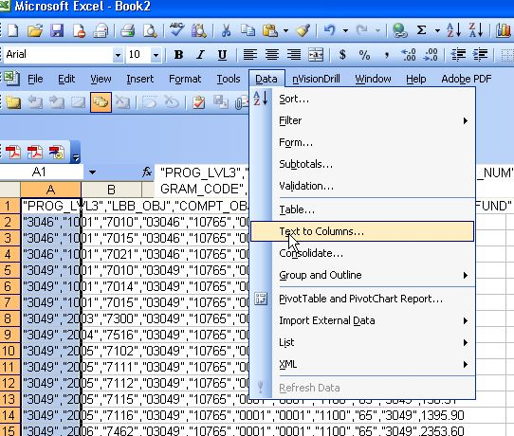

A menu will appear and click next.

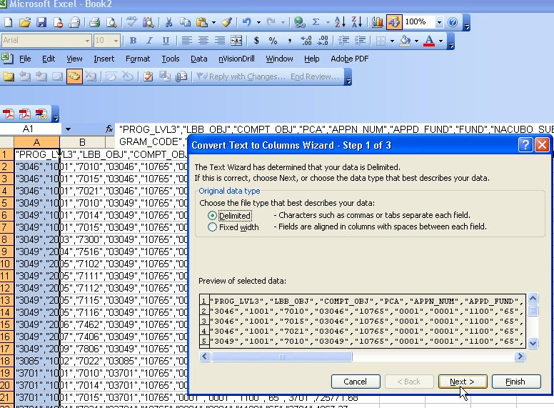
Select comma, unselect tab, and click next.

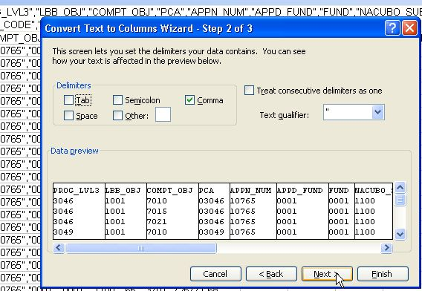

The headers for all the columns should be "Text", so click on Text for each column except for the column with the amounts.

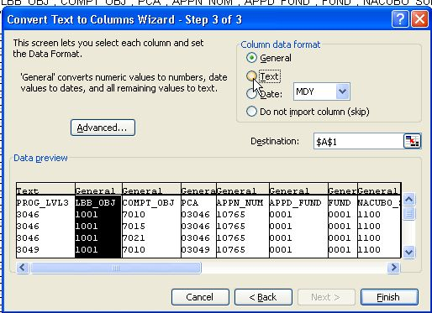

Then, click finish.

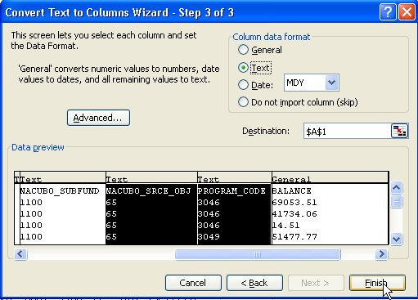

The spreadsheet should look like the one below. Sort the worksheet by appropriation number and PCA.

PROG_LVL3 | LBB_OBJ | COMPT_OBJ | PCA | APPN_NUM | APPD_FUND | FUND | NACUBO_SUBFUND | NACUBO_SRCE_OBJ | PROGRAM_CODE | BALANCE
3046 | 1001 | 7010 | 03046 | 10765 | 0001 | 0001 | 1100 | 65 | 3046 | 69,053.51
3046 | 1001 | 7015 | 03046 | 10765 | 0001 | 0001 | 1100 | 65 | 3046 | 41,734.06
3046 | 1001 | 7021 | 03046 | 10765 | 0001 | 0001 | 1100 | 65 | 3046 | 14.51
3049 | 1001 | 7010 | 03049 | 10765 | 0001 | 0001 | 1100 | 65 | 3049 | 51,477.77
3049 | 1001 | 7014 | 03049 | 10765 | 0001 | 0001 | 1100 | 65 | 3049 | 1,800.42
3049 | 1001 | 7015 | 03049 | 10765 | 0001 | 0001 | 1100 | 65 | 3049 | 18,996.96
3049 | 2003 | 7300 | 03049 | 10765 | 0001 | 0001 | 1100 | 65 | 3049 | 140.00
3049 | 2004 | 7516 | 03049 | 10765 | 0001 | 0001 | 1100 | 65 | 3049 | 50.00

Separate the E&G appropriations fund one and two from the other appropriations, sort by PCA and subtotal. The result should look like the chart below that shows an example for BU 00730. PCA 03980 is only for the Coordinating Board activity and should not be used for the E&G transactions.

PROG_LVL3 | LBB_OBJ | COMPT_OBJ | PCA | APPN_NUM | APPD_FUND | FUND | NACUBO_SUBFUND | NACUBO_SRCE_OBJ | PROGRAM_CODE | BALANCE
 |  |  | 03046 Total |  |  |  |  |  |  | 110,802.08
 |  |  | 03049 Total |  |  |  |  |  |  | 78,664.14
 |  |  | 03085 Total |  |  |  |  |  |  | 2,833.52
 |  |  | 03701 Total |  |  |  |  |  |  | 5,715,853.68
 |  |  | 03706 Total |  |  |  |  |  |  | 24,883.72
 |  |  | 03712 Total |  |  |  |  |  |  | 222,175.64
 |  |  | 03713 Total |  |  |  |  |  |  | 1,308,229.75
3980 | 1001 | 7010 | 03980 | 10730 | 0001 | 0001 | 1100 | 65 | 3980 | 9,949.53
3980 | 1001 | 7014 | 03980 | 10730 | 0001 | 0001 | 1100 | 65 | 3980 | 60.47
3980 | 1001 | 7015 | 03980 | 10730 | 0001 | 0001 | 1100 | 65 | 3980 | 1,666.41
 |  |  | 03980 Total |  |  |  |  |  |  | 11,676.41
 |  |  | Grand Total |  |  |  |  |  |  | 7,475,118.94

For the PCA errors, a query needs to be run to locate those cost centers that are feeding the state with the wrong PCA chartfield.

The query to run is with the UHS_COST_CENTER table. The example below is for the E&G appropriation posted in USAS with PCAs 03980 and 03990.

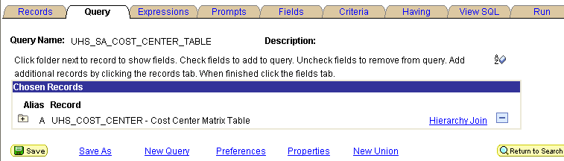

The fields and criteria are shown below. The E&G fund one fund codes are for BU 00730.

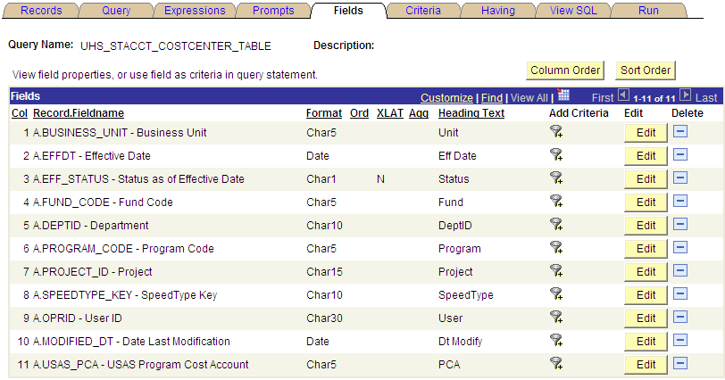

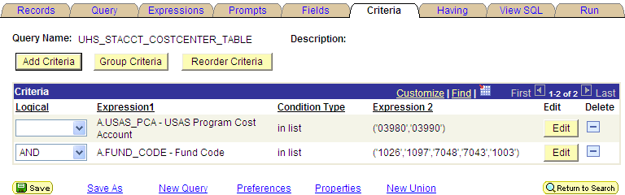

The result of the query shows the cost centers that have the E&G fund one appropriation with 03980 and 03990 PCAs which are for the THECB and CSA appropriations respectively.

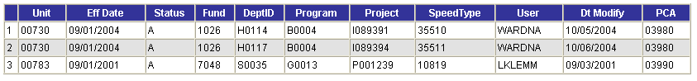
The third line on the query results is a bad chartfield combination. Fund code 7048 can not be used in BU 00783. The cost center needs to be inactivated. See the attributes of fund code 7048 below.

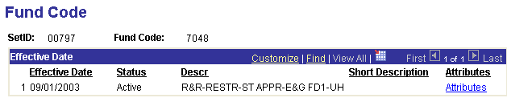

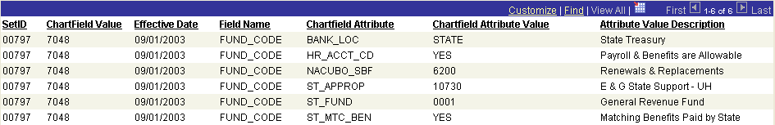

USAS entries to correct the PCA - Agency 730

Form Batch Type Edit Mode Doc Type LDT
Journal Entry Type 8 2 K HB1, 80th Leg, RS, ART IX, Section 6.16

Unit | Batch date | Comptroller Obj | Approp Num | Appropriat Yr | Transaction Cd | Sum Trans Amt | Ref Doc Num | HX Per | Reverse | Fund | Curr Doc Num | PCA
00730 | 2/28/2005 | 7010 | 10730 | 05 | 407 | 9,949.53 | K0161274 | 6 |  | 0001 | K0161274 | 03980
00730 | 2/28/2005 | 7010 | 10730 | 05 | 408 | 9,949.53 | K0161274 | 6 |  | 0001 | K0161274 | 03701
00730 | 2/28/2005 | 7014 | 10730 | 05 | 407 | 60.47 | K0161274 | 6 |  | 0001 | K0161274 | 03980
00730 | 2/28/2005 | 7014 | 10730 | 05 | 408 | 60.47 | K0161274 | 6 |  | 0001 | K0161274 | 03701
00730 | 2/28/2005 | 7015 | 10730 | 05 | 407 | 1,666.41 | K0161274 | 6 |  | 0001 | K0161274 | 03980
00730 | 2/28/2005 | 7015 | 10730 | 05 | 408 | 1,666.41 | K0161274 | 6 |  | 0001 | K0161274 | 03701

Return to Table of Contents Return to Correction Refund to State
HEAF Allocation - H2

The budgeted amount for the HEAF appropriation for the University of Houston System is allocated between the different campuses excluding University of Houston System Administration. The University of Houston System Administration does not receive an actual HEAF appropriation, but has two programs called System Admin/Fort Bend and Computer System Upgrade that can be paid with the HEAF funds. In order to pay for those programs, the other campuses pay a Service Charge. The RTI process is followed when the other UH components pay with state funds. If the payments are done using a local cost center a voucher needs to be issued. This allocation of expenses from the other campuses is decided at the University of Houston System level.

The request for the transfers and worksheets are emailed from the Budget Office to all the campuses and processed by the State Accounting Departments. Below are the worksheets that detailed how to process the transfers.

University of Houston System
PeopleSoft Project Service Charge
Transfers to System
 |  | Cost Center (Speed Type) - Account | FY2006 Budget
From:
University of Houston – Ledger 1 |  | 00730-1008-H0264-G0018-P001540 (36181)-53856 | 2,284,634
UH-Downtown – Ledger 1 |  | 00784-1008-D004-D0611-NA (14105)-53856 | 326,553
UH-Clear Lake – Ledger 1 |  | 00759-1008-C0069-F0255-NA (11282)-53856 | 313,459
UH-Victoria – Ledger 1 |  | 00765-1008-V0010-G0225-NA (10300)-53856 | 75,354
To:
UH System Administration – Ledger 1 |  | 00783-2080-S0027-F0973 (12346)-45100
 | Total Current Budget |  | 3,000,000

University of Houston System
Sugarland HEAF Project Service Charge
Transfers to System
 |  | Cost Center (Speed Type) - Account | FY2006 Budget
From:
University of Houston – Ledger 1 |  | 00730-1008-H0264-G0018-P001540 (36181)-53856 | 11,579
UH-Downtown – Ledger 1 |  | 00784-1008-D004-D0611-NA (14105)-53856 | 144,135
UH-Clear Lake – Ledger 1 |  | 00759-1008-C0069-F0255-NA (11282)-53856 | 31,663
UH-Victoria – Ledger 1 |  | 00765-1008-V0010-G0225-NA (10300)-53856 | 19,859
To:
UH System Administration – Ledger 1 |  | 00783-1006-S0027-F0973-NA (12265)-45100 | 207,236
 | Total Current Budget |  | 207,236

Below are the entries in PS and USAS for UHSA and UH to process the allocations for the worksheets sent by the Budget Office.

PS entries for Sugarland HEAF Service Charge - Business Unit 00783
 |  | University of Houston System  JOURNAL ENTRY DETAIL
  Header BU: | 00783
  Fiscal Year: | 2006
  Acctg Period: | 1
  Run Date: | 03/15/2006
  Run Time: | 09:18:58

Journal ID: | STT0161027 | Reversal: | None | Ledger Group: | ACTUALS
Date: | 09/29/2005 | Reversal Date: |  | Created By: | BANKSDA
Source: | ACS | Budget Adjust Type: | Actuals | Post Date: | 09/29/2005
Header Ref: | T0161027 | Edit / Hdr Status: | Posted | BCM Status: | Valid
Description: | H2- FY06 HEAF Budget Allocation. Interagency agreement between UH, UHCL, UHD, UHV, and UHSA for Sugarland HEAF (Service Charge). Using the same entry number used for the payment done in UH-Central. |  |  | BCM Bypass: | N

Line # | Account | Line BU | Fund | DeptId | Prog | Bdgt Ref. | Project | Line Ref | Chart.1 | Line Description | Amount
1 | 45100 | 00783 | 1006 | S0027 | F0973 | BP2006 | NA | T0161027 |  | FY06 S-LAND HEAF SC F/UH | -11,579.00
2 | 45100 | 00783 | 1006 | S0027 | F0973 | BP2006 | NA | T0161027 |  | FY06 S-LAND HEAF SC F/UHD | -144,135.00
3 | 45100 | 00783 | 1006 | S0027 | F0973 | BP2006 | NA | T0161027 |  | FY06 S-LAND HEAF SC F/UHCL | -31,663.00
4 | 45100 | 00783 | 1006 | S0027 | F0973 | BP2006 | NA | T0161027 |  | FY06 S-LAND HEAF SC F/UHV | -19,859.00
5 | 10500 | 00783 | 1006 |  |  | BP2006 |  | T0161027 |  | STATE BANK | 207,236.00

Totals for Journal: STT0161027 | Total Lines: 5 | Total Base Debits: 207,236.00 | Total Base Credits: 207,236.00

Signatures | ___________________________________ | Date | __________________________________
PS Approval: | ___________________________________ |  | __________________________________

Created By: BANKSDA | Date Printed: 03/15/2006 | Jrnl. Dt.: 09/29/2005

PS entries for Sugarland HEAF Service Charge - Business Unit 00730
 |  | University of Houston System  JOURNAL ENTRY DETAIL
  Header BU: | 00730
  Fiscal Year: | 2006
  Acctg Period: | 1
  Run Date: | 03/15/2006
  Run Time: | 09:11:07

Journal ID: |  | STT0161027 |  |  |  |  |  | Reversal: |  |  |  |  |  | None | Ledger Group: | ACTUALS
Date: |  | 09/29/2005 |  |  |  |  |  | Reversal Date: |  |  |  |  |  |  | Created By: | BANKSDA
Source: |  | ACS |  |  |  |  |  | Budget Adjust Type: |  |  |  |  |  | Actuals | Post Date: | 09/29/2005
Header Ref: |  | T0161027 |  |  |  |  |  | Edit / Hdr Status: |  |  |  |  |  | Posted | BCM Status: | Valid
Description: |  | H2- FY06 HEAF Budget Allocation. Interagency agreement between UH, UHCL, UHD, UHV, and UHSA for Sugarland HEAF (Service Charge). |  |  |  |  |  |  |  |  |  |  |  |  | BCM Bypass: | N
Line # | Account |  | Line BU |  | Fund | DeptId | Prog | Bdgt Ref. | Project | Line Ref | Chart.1 |  | Line Description |  | Amount
1 | 53856 |  | 00730 |  | 1008 | H0264 | G0018 | BP2006 | P001540 | T0161027 |  |  | FY06 HEAF BDGT ALLOC UH S-LAND |  | 11,579.00
2 | 10500 |  | 00730 |  | 1008 |  |  | BP2006 |  | T0161027 |  |  | STATE BANK |  | -11,579.00
Totals for Journal: STT0161027 |  |  |  |  |  |  | Total Lines: 2 |  | Total Base Debits: 11,579.00 |  |  |  |  |  | Total Base Credits: 11,579.00
Signatures |  |  |  | ___________________________________ |  |  |  |  |  | Date |  | __________________________________
PS Approval: |  |  |  | ___________________________________ |  |  |  |  |  |  |  | __________________________________

Created By: BANKSDA | Date Printed: 03/15/2006 | Jrnl. Dt.: 09/29/2005

USAS entry for Sugarland HEAF Service Charge – AGY 730

Form Batch Type Edit Mode Doc Type
Journal Entry Type 4 1 T
Unit | Curr Doc Num | Batch date | Comptroller Obj | Approp Num | Fund | Appropriat Yr | Fiscal Year | Transaction Cd | Sum Trans Amt | Ref Doc Num | HX Per | Reverse | PCA
00730 | T01661027 | 2005-09-29 | 7643 | 13047 | 0001 | 06 | 06 | 225 | 11,579.00 | T0161027 | 7 |  | 03980

The PeopleSoft Service Charge is payable to UHSA into a local cost center. For this case, the UH components need to issue a local voucher.

Voucher Coversheet
Business Unit: | 00730 | PO ID:
Voucher ID: | 00566540 | TINS: | 37837837832 002
Vendor ID: | 0000026798
Name: | UNIV OF HOUSTON-SYS ENDOWMENT
Address: | 2
Treasures Office
E Cullen Bldg
Suite 10F
 | Houston TX 77204-2009
 | USA
Invoice ID: | H2-FY06 HEAF BDGT ALLOC P-SOFT
Contract ID:
PCC: | 9
Bank: | STATE
Scheduled Due Date: | 09/29/2005
Gross Amount: | $2,284,634.00
Old Voucher Comments:
New Voucher Comments: | Purpose/Benefits: FY06 HEAF Budget Allocation. Interagency agreement between UH and UHSA for the PeopleSoft Project (Service Charge).
Payment Comments: | Please deposit into: 00783-2080-S0027-F0973-NA (12359)- 45100.
Handling: | BP
Budget Check: | Valid Budget Check

Acct./Desc. | Fund | Dept. | Prog. | Bud. Ref. | Proj. | Chartfield 1 | Amount | Description
53856 | 1008 | H0264 | G0018 | BP2006 | P001540 |  | 2,284,634.00 | H2-FY06 HEAF BDGT ALLOC P-SOFT
central service expenditures

Signatures | ___________________________________ | Date | __________________________________
PS Approval: | ___________________________________ |  | __________________________________

Created By: Dante A Banks | Date Printed: 03/15/2006 | Acctg. Dt.: 09/29/2005

Return to Table of Contents Return to Budget Load
Payroll Allocations of Salaries and Benefits - P1

The payroll allocations of salaries and benefits are prepared to comply with the Accounting Policy Statement 011 (APS 011) of proportional adjustment between fund one and two. The benefit and salary allocations are recorded on a monthly basis and on a quarterly basis respectively in PS and USAS. The allocations are done using department code H0600 and only in the instruction expenditure functions for both fund one and two. The allocations from fund one to fund two is only transferring the expenses for proportionality purposes, but the original distribution of the expenses to all expenditure functions are not affected.

The cost centers used to do the salary and benefit allocations are listed below:

Unit | Eff Date | Status | Fund | DeptID | Program | Project | SpeedType | PCA | Appropriation Name | Budget Accounts | Transaction Type
00730 | 6/1/2003 | A | 1019 | H0600 | A0300 | NA | 31381 | 03992 | ERS Fund 1 | B5007 | Benefits
00730 | 6/1/2003 | A | 1021 | H0600 | A0294 | NA | 31385 | 03991 | ORP Fund 1 | B5007 | Benefits
00730 | 6/1/2003 | A | 1022 | H0600 | A0295 | NA | 31389 | 03991 | FICA Fund 1 | B5007 | Benefits
00730 | 6/1/2003 | A | 1036 | H0600 | A0298 | NA | 31377 | 03992 | TRS Fund 1 | B5007 | Benefits
00730 | 6/1/2003 | A | 1072 | H0600 | A0279 | NA | 31387 | 03991 | FICA Fund 2 | B5007 | Benefits
00730 | 6/1/2003 | A | 1075 | H0600 | A0290 | NA | 31375 | 03991 | TRS Fund 2 | B5007 | Benefits
00730 | 6/1/2003 | A | 1078 | H0600 | A0288 | NA | 31383 | 03991 | ORP Fund 2 | B5007 | Benefits
00730 | 6/1/2003 | A | 1026 | H0600 | A1994 | NA | 31393 | 03701 | E&G Fund 1 | B5006 | Payroll
00730 | 6/1/2003 | A | 1054 | H0600 | A1994 | NA | 31391 | 03701 | E&G Fund 2 | B5006 & B5007 | Payroll & Benefits

The allocations for benefits are calculated according to the proportionality percentages of the APS 011 for the prior year and enter in PS and USAS on a monthly basis. That percentage can be adjusted during the year by analyzing the payroll expenses and revenues remitted to the state treasury of the current year. If the payroll expenses have decreased or increased, the remissions of revenue to the state will changed and affect the proportions between fund one and two. Those analysis need to be coordinated with the Budget Office.

The allocation of salaries between fund 0001 and 0225 are made on a quarterly basis. Transfer enough expenses to absorb the funds on fund 0225 and making sure to use the entire fund 0001 appropriation. Any funds available on fund 0001 at year end are lapsed.

PS entry is allocating payroll expenses from fund 0001 to fund 0225 according to the APS 011 proportionality percentage.
 |  | University of Houston System  JOURNAL ENTRY DETAIL
  Header BU: | 00730
  Fiscal Year: | 2007
  Acctg Period: | 6
  Run Date: | 03/09/2007
  Run Time: | 02:32:36

Journal ID: |  | STJ0161178 |  |  |  |  |  |  |  | Reversal: |  |  |  |  |  | None |  |  | Ledger Group: |  | ACTUALS
Date: |  | 02/26/2007 |  |  |  |  |  |  |  | Reversal Date: |  |  |  |  |  |  |  |  | Created By: |  | BANKSDA
Source: |  | ACS |  |  |  |  |  |  |  | Budget Adjust Type: |  |  |  |  |  | Actuals |  |  | Post Date: |  | 02/26/2007
Header Ref: |  | J0161178 |  |  |  |  |  |  |  | Edit / Hdr Status: |  |  |  |  |  | Posted |  |  | BCM Status: |  | Valid
Description: |  | P1- Expenditure transfer from E&G fund 1026 to E&G- Dedicated fund 1054 for the 1st-2nd Quarter (1st). Payroll from September and October 2006 (Ref. Journal ID's: HR01352640, dated 9/30/06 and HR01368669, dated 10/31/06). $26,051,047.77. |  |  |  |  |  |  |  |  |  |  |  |  |  |  |  |  | BCM Bypass: |  | N
Line # | Account |  | Line BU | Fund |  |  | DeptId | Prog | Bdgt Ref. |  | Project |  |  | Line Ref | Chart.1 | Line Description |  |  |  | Amount
1 | 50182 |  | 00730 | 1026 |  |  | H0600 | A1994 | BP2007 |  | NA |  |  | J0161178 |  | EXP TRF F/E&G FD 1 TO FD 2 |  |  |  | -339,032.72
2 | 10500 |  | 00730 | 1026 |  |  |  |  | BP2007 |  |  |  |  | J0161178 |  | STATE BANK |  |  |  | 339,032.72
3 | 50182 |  | 00730 | 1054 |  |  | H0600 | A1994 | BP2007 |  | NA |  |  | J0161178 |  | EXP TRF F/E&G FD 1 TO FD 2 |  |  |  | 339,032.72
4 | 10500 |  | 00730 | 1054 |  |  |  |  | BP2007 |  |  |  |  | J0161178 |  | STATE BANK |  |  |  | -339,032.72
5 | 50180 |  | 00730 | 1026 |  |  | H0600 | A1994 | BP2007 |  | NA |  |  | J0161178 |  | EXP TRF F/E&G FD 1 TO FD 2 |  |  |  | -7,493,199.49
6 | 10500 |  | 00730 | 1026 |  |  |  |  | BP2007 |  |  |  |  | J0161178 |  | STATE BANK |  |  |  | 7,493,199.49
7 | 50180 |  | 00730 | 1054 |  |  | H0600 | A1994 | BP2007 |  | NA |  |  | J0161178 |  | EXP TRF F/E&G FD 1 TO FD 2 |  |  |  | 7,493,199.49
8 | 10500 |  | 00730 | 1054 |  |  |  |  | BP2007 |  |  |  |  | J0161178 |  | STATE BANK |  |  |  | -7,493,199.49
9 | 50173 |  | 00730 | 1026 |  |  | H0600 | A1994 | BP2007 |  | NA |  |  | J0161178 |  | EXP TRF F/E&G FD 1 TO FD 2 |  |  |  | -160,628.22
10 | 10500 |  | 00730 | 1026 |  |  |  |  | BP2007 |  |  |  |  | J0161178 |  | STATE BANK |  |  |  | 160,628.22
11 | 50173 |  | 00730 | 1054 |  |  | H0600 | A1994 | BP2007 |  | NA |  |  | J0161178 |  | EXP TRF F/E&G FD 1 TO FD 2 |  |  |  | 160,628.22
12 | 10500 |  | 00730 | 1054 |  |  |  |  | BP2007 |  |  |  |  | J0161178 |  | STATE BANK |  |  |  | -160,628.22
13 | 50172 |  | 00730 | 1026 |  |  | H0600 | A1994 | BP2007 |  | NA |  |  | J0161178 |  | EXP TRF F/E&G FD 1 TO FD 2 |  |  |  | -320,778.54
14 | 10500 |  | 00730 | 1026 |  |  |  |  | BP2007 |  |  |  |  | J0161178 |  | STATE BANK |  |  |  | 320,778.54
15 | 50172 |  | 00730 | 1054 |  |  | H0600 | A1994 | BP2007 |  | NA |  |  | J0161178 |  | EXP TRF F/E&G FD 1 TO FD 2 |  |  |  | 320,778.54
16 | 10500 |  | 00730 | 1054 |  |  |  |  | BP2007 |  |  |  |  | J0161178 |  | STATE BANK |  |  |  | -320,778.54
17 | 50171 |  | 00730 | 1026 |  |  | H0600 | A1994 | BP2007 |  | NA |  |  | J0161178 |  | EXP TRF F/E&G FD 1 TO FD 2 |  |  |  | -788,831.52
18 | 10500 |  | 00730 | 1026 |  |  |  |  | BP2007 |  |  |  |  | J0161178 |  | STATE BANK |  |  |  | 788,831.52
19 | 50171 |  | 00730 | 1054 |  |  | H0600 | A1994 | BP2007 |  | NA |  |  | J0161178 |  | EXP TRF F/E&G FD 1 TO FD 2 |  |  |  | 788,831.52
20 | 10500 |  | 00730 | 1054 |  |  |  |  | BP2007 |  |  |  |  | J0161178 |  | STATE BANK |  |  |  | -788,831.52
21 | 50160 |  | 00730 | 1026 |  |  | H0600 | A1994 | BP2007 |  | NA |  |  | J0161178 |  | EXP TRF F/E&G FD 1 TO FD 2 |  |  |  | -1,255,745.80
22 | 10500 |  | 00730 | 1026 |  |  |  |  | BP2007 |  |  |  |  | J0161178 |  | STATE BANK |  |  |  | 1,255,745.80
23 | 50160 |  | 00730 | 1054 |  |  | H0600 | A1994 | BP2007 |  | NA |  |  | J0161178 |  | EXP TRF F/E&G FD 1 TO FD 2 |  |  |  | 1,255,745.80
24 | 10500 |  | 00730 | 1054 |  |  |  |  | BP2007 |  |  |  |  | J0161178 |  | STATE BANK |  |  |  | -1,255,745.80
25 | 50153 |  | 00730 | 1026 |  |  | H0600 | A1994 | BP2007 |  | NA |  |  | J0161178 |  | EXP TRF F/E&G FD 1 TO FD 2 |  |  |  | -256,096.17
26 | 10500 |  | 00730 | 1026 |  |  |  |  | BP2007 |  |  |  |  | J0161178 |  | STATE BANK |  |  |  | 256,096.17
27 | 50153 |  | 00730 | 1054 |  |  | H0600 | A1994 | BP2007 |  | NA |  |  | J0161178 |  | EXP TRF F/E&G FD 1 TO FD 2 |  |  |  | 256,096.17
28 | 10500 |  | 00730 | 1054 |  |  |  |  | BP2007 |  |  |  |  | J0161178 |  | STATE BANK |  |  |  | -256,096.17
29 | 50152 |  | 00730 | 1026 |  |  | H0600 | A1994 | BP2007 |  | NA |  |  | J0161178 |  | EXP TRF F/E&G FD 1 TO FD 2 |  |  |  | -156,576.02
30 | 10500 |  | 00730 | 1026 |  |  |  |  | BP2007 |  |  |  |  | J0161178 |  | STATE BANK |  |  |  | 156,576.02
31 | 50152 |  | 00730 | 1054 |  |  | H0600 | A1994 | BP2007 |  | NA |  |  | J0161178 |  | EXP TRF F/E&G FD 1 TO FD 2 |  |  |  | 156,576.02
32 | 10500 |  | 00730 | 1054 |  |  |  |  | BP2007 |  |  |  |  | J0161178 |  | STATE BANK |  |  |  | -156,576.02
33 | 50151 |  | 00730 | 1026 |  |  | H0600 | A1994 | BP2007 |  | NA |  |  | J0161178 |  | EXP TRF F/E&G FD 1 TO FD 2 |  |  |  | -769,134.37
34 | 10500 |  | 00730 | 1026 |  |  |  |  | BP2007 |  |  |  |  | J0161178 |  | STATE BANK |  |  |  | 769,134.37
35 | 50151 |  | 00730 | 1054 |  |  | H0600 | A1994 | BP2007 |  | NA |  |  | J0161178 |  | EXP TRF F/E&G FD 1 TO FD 2 |  |  |  | 769,134.37
36 | 10500 |  | 00730 | 1054 |  |  |  |  | BP2007 |  |  |  |  | J0161178 |  | STATE BANK |  |  |  | -769,134.37
37 | 50150 |  | 00730 | 1026 |  |  | H0600 | A1994 | BP2007 |  | NA |  |  | J0161178 |  | EXP TRF F/E&G FD 1 TO FD 2 |  |  |  | -488,632.77
38 | 10500 |  | 00730 | 1026 |  |  |  |  | BP2007 |  |  |  |  | J0161178 |  | STATE BANK |  |  |  | 488,632.77
39 | 50150 |  | 00730 | 1054 |  |  | H0600 | A1994 | BP2007 |  | NA |  |  | J0161178 |  | EXP TRF F/E&G FD 1 TO FD 2 |  |  |  | 488,632.77
40 | 10500 |  | 00730 | 1054 |  |  |  |  | BP2007 |  |  |  |  | J0161178 |  | STATE BANK |  |  |  | -488,632.77
41 | 50140 |  | 00730 | 1026 |  |  | H0600 | A1994 | BP2007 |  | NA |  |  | J0161178 |  | EXP TRF F/E&G FD 1 TO FD 2 |  |  |  | -13,846,148.37
42 | 10500 |  | 00730 | 1026 |  |  |  |  | BP2007 |  |  |  |  | J0161178 |  | STATE BANK |  |  |  | 13,846,148.37
43 | 50140 |  | 00730 | 1054 |  |  | H0600 | A1994 | BP2007 |  | NA |  |  | J0161178 |  | EXP TRF F/E&G FD 1 TO FD 2 |  |  |  | 13,846,148.37
44 | 10500 |  | 00730 | 1054 |  |  |  |  | BP2007 |  |  |  |  | J0161178 |  | STATE BANK |  |  |  | -13,846,148.37
45 | 50112 |  | 00730 | 1026 |  |  | H0600 | A1994 | BP2007 |  | NA |  |  | J0161178 |  | EXP TRF F/E&G FD 1 TO FD 2 |  |  |  | -176,243.78
46 | 10500 |  | 00730 | 1026 |  |  |  |  | BP2007 |  |  |  |  | J0161178 |  | STATE BANK |  |  |  | 176,243.78
47 | 50112 |  | 00730 | 1054 |  |  | H0600 | A1994 | BP2007 |  | NA |  |  | J0161178 |  | EXP TRF F/E&G FD 1 TO FD 2 |  |  |  | 176,243.78
48 | 10500 |  | 00730 | 1054 |  |  |  |  | BP2007 |  |  |  |  | J0161178 |  | STATE BANK |  |  |  | -176,243.78
Totals for Journal: STJ0161178 |  |  |  |  |  | Total Lines: 48 |  |  |  |  |  | Total Base Debits: 52,102,095.54 |  |  |  |  |  | Total Base Credits: 52,102,095.54
Signatures |  |  |  |  | ___________________________________ |  |  |  |  |  |  |  | Date |  |  |  | __________________________________
PS Approval: |  |  |  |  | ___________________________________ |  |  |  |  |  |  |  |  |  |  |  | __________________________________

Created By: BANKSDA | Date Printed: 03/09/2007 | Jrnl. Dt.: 02/26/2007

USAS entry also transfers the expenses from fund 0001 to fund 0225.

Form Batch Type Edit Mode Doc Type
Journal Entry Type 8 2 J
Unit | Curr Doc Num | Batch date | Comptroller Obj | Approp Num | Fund | Appropriat Yr | Fiscal Year | Transaction Cd | Sum Trans Amt | Ref Doc Num | HX Per | Reverse | PCA
00730 | J0161178 | 2007-02-26 | 7022 | 10730 | 0001 | 07 | 07 | 407 | 176,243.78 | J0161178 | 6 |  | 03701
00730 | J0161178 | 2007-02-26 | 7022 | 10730 | 0225 | 07 | 07 | 408 | 176,243.78 | J0161178 | 6 |  | 03701
00730 | J0161178 | 2007-02-26 | 7008 | 10730 | 0001 | 07 | 07 | 407 | 16,772,333.50 | J0161178 | 6 |  | 03701
00730 | J0161178 | 2007-02-26 | 7008 | 10730 | 0225 | 07 | 07 | 408 | 16,772,333.50 | J0161178 | 6 |  | 03701
00730 | J0161178 | 2007-02-26 | 7014 | 10730 | 0001 | 07 | 07 | 407 | 1,270,238.28 | J0161178 | 6 |  | 03701
00730 | J0161178 | 2007-02-26 | 7014 | 10730 | 0225 | 07 | 07 | 408 | 1,270,238.28 | J0161178 | 6 |  | 03701
00730 | J0161178 | 2007-02-26 | 7010 | 10730 | 0001 | 07 | 07 | 407 | 7,832,232.21 | J0161178 | 6 |  | 03701
00730 | J0161178 | 2007-02-26 | 7010 | 10730 | 0225 | 07 | 07 | 408 | 7,832,232.21 | J0161178 | 6 |  | 03701

LDT: APS 001; HB1,80th Leg,RS,ART IX p. 30 Sec 6.08

Return to Table of Contents

Holding Appropriation Activity

Clear Default - C6

Screen 69 in USAS gives us the total amount of the transactions that went into default. A transaction goes into default when an amount in a deposit slip does not match the amount in the transactions entered in USAS or when there is an error edit in the transactions that has not been corrected when the deposit slip gets to the State Treasury in Austin.

Screen 69 should be checked daily by entering the following:

- Enter agency number
- Enter the current Appropriation Year in the AP Year field
- Enter 9000 in the fund field
- Click enter

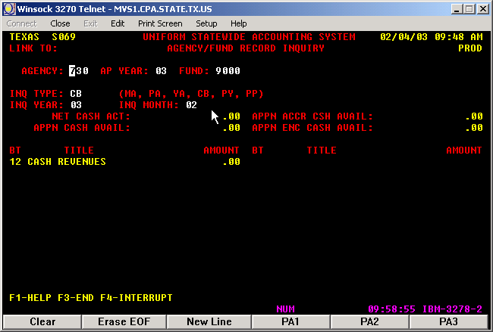

When a transaction is in default, check screen 88 below by entering the following:

- Enter AP in the Type field
- Type the agency number in the AGY field
- Enter the current Fiscal Year (e.g., FY 03)
- Enter current Appropriation Year (AY) or previous appropriation years whichever is needed
- In the EFF DT field enter the previous day when the screen is checked every day; otherwise enter the effective day from the last day the screen have been checked
- In the AFund field enter 0001
- Hit the “enter” key
- Look for the transaction(s) that makes up the amount in screen 69

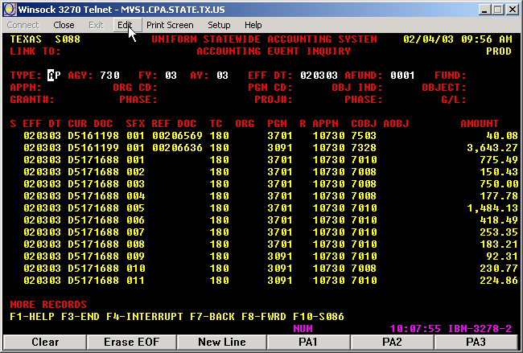

- Do an entry in USAS only for the transaction(s) in default
Note: If the appropriation number 00000 is entered in the APPN field in screen 88 you will only see the default transaction.

USAS entries to transfer the transactions for the holding appropriation to our appropriation(s) – Agency 730

Form Batch Type Edit Mode
Journal Entry Type 2 1

After the first line is entered to clear the default from the holding appropriation, enter the original transaction(s) using the same PCAs, Comp Objects, Appropriations, and Funds. In USAS, use the new journal number for the document number and for reference number use the original document number (see example below).

Unit | Curr Doc Num | Batch date | Comptroller Obj | Approp Num | Fund | Appropriat Yr | Fiscal Year | Transaction Cd | Sum Trans Amt | Ref Doc Num | HX Per | Reverse | PCA
00730 | J0161084 | 2003-10-31 | 3788 | 00000 | 9000 | 04 | 04 | 195 | 7,281.22 | D0161078 | 3 | R | 99900
00730 | J0161084 | 2003-10-31 | 3765 | 10730 | 0001 | 04 | 04 | 179 | 7,281.22 | D0161078 | 3 |  | 03701

The entry is for the amount in Clear Default (screen 69).

Screen 19 LTD – HB1, 80th Leg, R.S., Art. IX, Sec. 6.16

Return to Table of Contents

House Bill 3211 Warrant Hold Offset Account - H1

Reporting and Verification of State Debts and Hold Offset Procedures (028) - FPP E.037

SUBJECT: | State agencies and institutions of higher education must report to the Texas Comptroller of Public Accounts the names of entities with a debt to the state. This includes indebtedness to the state, a tax delinquency, a child support delinquency, or a student loan default. Agencies must use the Comptroller's warrant hold procedures to ensure payments are not issued to an entity with a debt to the state.
LEGAL CITE: | Tex. Gov't Code Ann. §§ 403.055, 403.0551, and 403.0552 (Vernon 2005); §§ 2107.008 and 2252.903 (Vernon Supp. 2005); Tex. Educ Code Ann. §§ 57.48 and 57.482 (Vernon Supp. 2005); Tex. Fam. Code Ann. § 231.007(a), (i)-(k) (Vernon Supp. 2005).
APPLICABLE TO: | All state agencies and institutions of higher education (other than public junior colleges and community colleges)
UPDATED | Through the acts of the 79th Legislature, 2nd Called Session.
FM00-82: | HB 3211 - Warrant Hold Program

DATE: | June 19, 2000
TO: | Chief Fiscal Officers, Purchase Voucher Contacts, Data Processing Contacts
SUBJECT: | HB 3211 - Warrant Hold Program  This Notice to State Agencies only applies to the 53 agencies that actually have Vendor Holds. These agencies received a hard copy of this notice with an attached form. These agencies must complete the form by either sending the completed form to our FAX number or by submitting our online form. Do not respond to this notice if your agency does not have Vendor Holds.

Gathering the Information from USAS and Providing the Information to General Accounting

To gather the information about the deposits in USAS see screens below:

- Go to screen 62 and type the information for the holding appropriation 93211 as shown below to know the balance.

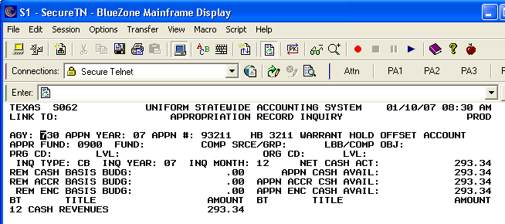

- Go to screen 88 and type the information to get the deposits information as shown below.

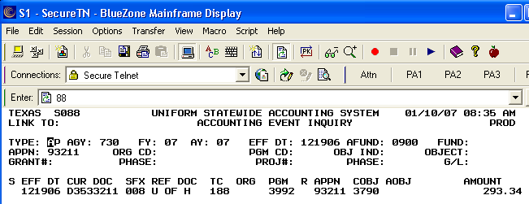

- Print screen 88 with the deposit information and screen 62 with the balance on appropriation 93211.
- Do the entries in USAS and PS to transfer the funds to the Unappropriated Appropriation.

Transfer the funds from the holding appropriation to University of Houston

The transfer of funds from the holding appropriation 93211/0900 to the University of Houston is performed in two steps:

1) From the holding appropriation to our appropriation Unappropriation Appropriation (00000), and

2) From our appropriation to the University of Houston

Send email to General Accounting and Student Financial Services to make them aware of the warrant UH is going to receive from the Comptroller.

1) To make this transfer, the holding agency withdraws the funds from the holding appropriation using the coding block below except for a reverse indicator (R) and Object Code 3992 on the journal voucher. The "Transfer IN" portion of the journal voucher will be completely agency-defined, determining the appropriation, fund, COBJ and T-Code. The holding agency must transfer the funds from the offset account within 30 days of receipt of the itemized report from the Comptroller.
The Comptroller uses the following coding block when preparing the offset deposit vouchers:
Batch Agency | 902
Document Agency | 902
Financial Agency | XXX (Hold Source Agency)
Appropriated Fund No. | 0900
Agency Fund | 9016
Appropriation No. | 93211
PCA | 93211
Object Code | 3790
T-Code | 188

USAS entries to transfer the funds from the holding appropriation to our appropriation – Agency 730

Form Batch Type Edit Mode Doc Type
Cash Receipt Type 2 1 J

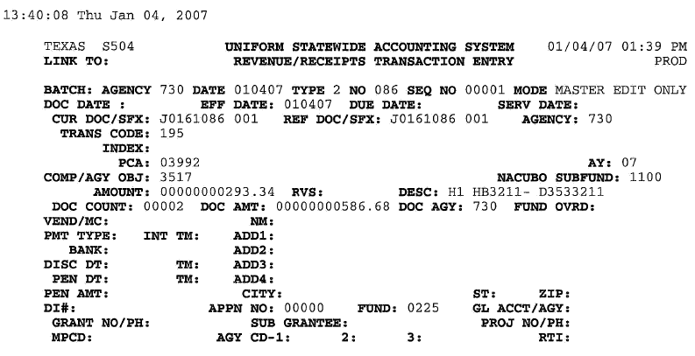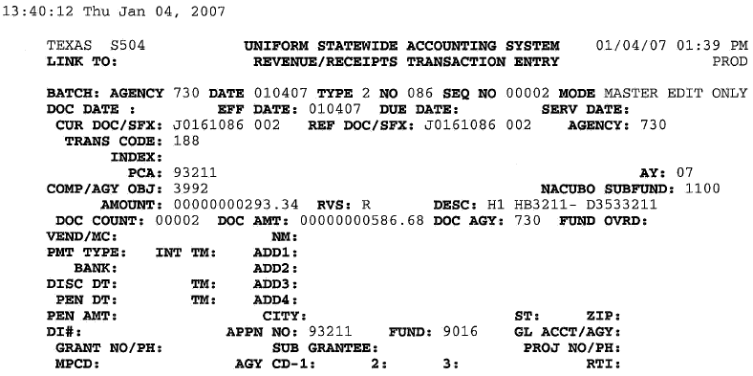

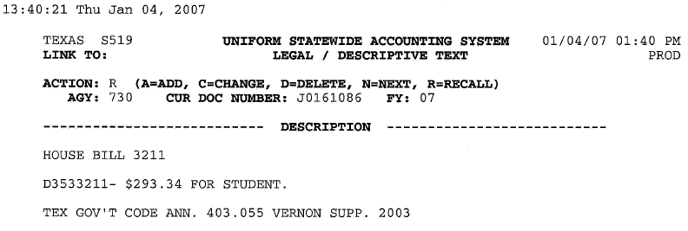

PS entries to transfer the funds from the holding appropriation to our appropriation – Business Unit 00730

 |  |  | University of Houston System  JOURNAL ENTRY DETAIL
  Header BU: | 00730
  Fiscal Year: | 2007
  Acctg Period: | 5
  Run Date: | 01/10/2007
  Run Time: | 08:33:09

Journal ID: |  | STJ0161086 |  |  |  |  |  |  |  | Reversal: |  | None | Ledger Group: |  | ACTUALS
Date: |  | 01/04/2007 |  |  |  |  |  |  |  | Reversal Date: |  |  | Created By: |  | BANKSDA
Source: |  | ACS |  |  |  |  |  |  |  | Budget Adjust Type: |  | Actuals | Post Date: |  | 01/04/2007
Header Ref: |  | J0161086 |  |  |  |  |  |  |  | Edit / Hdr Status: |  | Posted | BCM Status: |  | Valid
Description: |  | H1- House Bill 3211 (D3533211) for student. Funds are withdrawn from the holding appropriation. |  |  |  |  |  |  |  |  |  |  | BCM Bypass: |  | N
Line # | Account |  | Line BU | Fund | DeptId | Prog | Bdgt Ref. | Project | Line Ref |  | Chart.1 | Line Description |  | Amount
1 | 40702 |  | 00730 | 1065 | H0264 | F1606 | BP2007 | NA | D3533211 |  |  | HB3211- D3533211 |  | -293.34
2 | 10500 |  | 00730 | 1065 |  |  | BP2007 |  | D3533211 |  |  | STATE BANK |  | 293.34

Totals for Journal: STJ0161086 | Total Lines: 2 | Total Base Debits: 293.34 | Total Base Credits: 293.34

Signatures | ___________________________________ | Date | __________________________________
PS Approval: | ___________________________________ |  | __________________________________

Created By: BANKSDA |  | Date Printed: 01/10/2007 |  | Jrnl. Dt.: 01/04/2007
Approval History
Step | Status |  | Date Timestamp |  | User ID

2) To transfer the funds from our appropriation 00000/0225 to the University of Houston, a journal voucher is entered in USAS.

USAS entries to transfer the funds from our appropriation to UH - Agency 730

Form Batch Type Edit Mode Doc Type
Journal Voucher Type 4 1 9

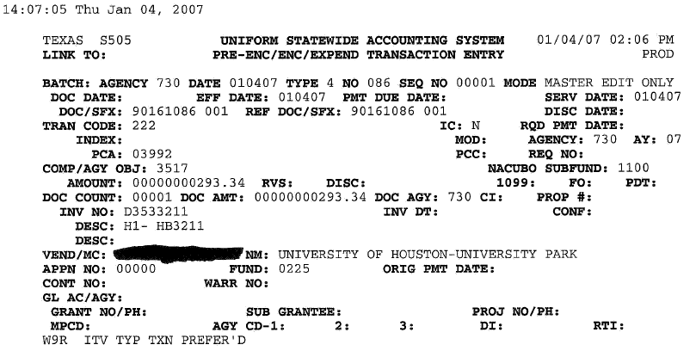

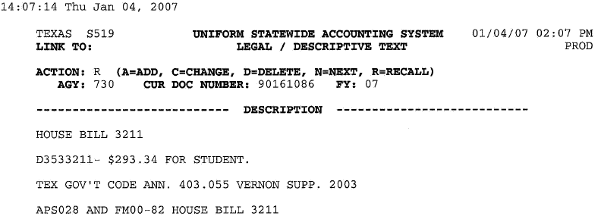

PS entries to transfer the funds from our appropriation to UH - Business Unit 00730

 |  |  | University of Houston System  JOURNAL ENTRY DETAIL
  Header BU: | 00730
  Fiscal Year: | 2007
  Acctg Period: | 5
  Run Date: | 01/10/2007
  Run Time: | 08:43:54

Journal ID: |  | ST90161086 |  |  |  |  |  |  |  | Reversal: |  | None | Ledger Group: |  | ACTUALS
Date: |  | 01/04/2007 |  |  |  |  |  |  |  | Reversal Date: |  |  | Created By: |  | BANKSDA
Source: |  | ACS |  |  |  |  |  |  |  | Budget Adjust Type: |  | Actuals | Post Date: |  | 01/04/2007
Header Ref: |  | 90161086 |  |  |  |  |  |  |  | Edit / Hdr Status: |  | Posted | BCM Status: |  | Valid
Description: |  | H1- House Bill 3211 (D3533211) for student. Transferring the funds to UH to apply to the student's account. |  |  |  |  |  |  |  |  |  |  | BCM Bypass: |  | N
Line # | Account |  | Line BU | Fund | DeptId | Prog | Bdgt Ref. | Project | Line Ref |  | Chart.1 | Line Description |  | Amount
1 | 40702 |  | 00730 | 1065 | H0264 | F1606 | BP2007 | NA | D3533211 |  |  | HB3211- D3533211 |  | 293.34
2 | 10500 |  | 00730 | 1065 |  |  | BP2007 |  | D3533211 |  |  | STATE BANK |  | -293.34

Totals for Journal: ST90161086 | Total Lines: 2 | Total Base Debits: 293.34 | Total Base Credits: 293.34

Signatures | ___________________________________ | Date | __________________________________
PS Approval: | ___________________________________ |  | __________________________________

Created By: BANKSDA | Date Printed: 01/10/2007 | Jrnl. Dt.: 01/04/2007

Approval History
Step | Status | Date Timestamp | User ID

Send email to General Accounting and Student Financial Services specifying the deposit number and amount.

Return to Table of Contents

Interagency Contract between State Agencies

See Interagency Contract between State Agencies in the Introduction for background information.

Amigos Inter-Library Courier Services - A7

The Amigos Inter-Library Courier Services is a reimbursement of expenses from UHSA (00783) to UHCL (00759), UHD (00784), and UHV (00765). Follow the instructions coming from the Budget Office to post the correct cost centers in PS and appropriations in USAS. Below is an example of the entries in USAS and PS.

PS entries to enter the reimbursement of expenses for the Courier Services - Business Unit 00783 (cost center may change)
 |  |  | University of Houston System  JOURNAL ENTRY DETAIL
  Header BU: | 00783
  Fiscal Year: | 2004
  Acctg Period: | 6
  Run Date: | 07/09/2005
  Run Time: | 08:01:42

Journal ID: | STT0042056 | Reversal: | None | Ledger Group: | ACTUALS
Date: | 02/23/2004 | Reversal Date: |  | Created By: | SCARONRE
Source: | ACS | Budget Adjust Type: | Actuals | Post Date: | 02/23/2004
Header Ref: | T0042056 | Edit / Hdr Status: | Posted | BCM Status: | Valid
Description: | Amigos Inter-Library Currier Service expense reimbursement for AY03. |  |  | BCM Bypass: | N

Line # | Account | Line BU | Fund | DeptId | Prog | Bdgt Ref. | Project | Line Ref | Chart.1 | Line Description | Amount
1 | 52812 | 00783 | 1006 | S0005 | F0300 | BP2003 | NA |  |  | Amigos Inter_Lib Exp Reim UHCL | 10,000.00
2 | 52812 | 00783 | 1006 | S0005 | F0300 | BP2003 | NA |  |  | Amigos Inter-Lib Exp Reim UHD | 10,000.00
3 | 52812 | 00783 | 1006 | S0005 | F0300 | BP2003 | NA |  |  | Amigos Inter-Lib Exp Reim UHV | 5,000.00
4 | 10500 | 00783 | 1006 |  |  | BP2003 |  |  |  | STATE BANK | -25,000.00

Totals for Journal: STT0042056 | Total Lines: 4 | Total Base Debits: 25,000.00 | Total Base Credits: 25,000.00

Signatures | ___________________________________ | Date | __________________________________
 | ___________________________________ |  | __________________________________
PS Approval: | ___________________________________ |  | __________________________________

Created By: SCARONRE | Date Printed: 07/09/2005 | Jrnl. Dt.: 02/23/2004

USAS entries to enter the reimbursement of expenses using TC 485 for the Courier Services - Agency 783
Unit | HX Fiscal Yr | HX Per | Transaction Cd | Approp Num | Fund | PCA | Comptroller Obj | Doc Date | Curr Doc Num | Ref Doc Num | Trans Amt | Fiscal Year | Appropriat Yr | Reverse | Fiscal Month | Batch Number
EXPENSE ACCRUAL TC ENTERED
00783 | 2004 | 6 | 485 | 96243 | 0001 | 03990 | 7276 | 2004-02-23 | T0042056 | T0042056 | 10,000.00 | 04 | 03 |  | 06 | 056
00783 | 2004 | 6 | 485 | 96243 | 0001 | 03990 | 7276 | 2004-02-23 | T0042056 | T0042056 | 10,000.00 | 04 | 03 |  | 06 | 056
00783 | 2004 | 6 | 485 | 96243 | 0001 | 03990 | 7276 | 2004-02-23 | T0042056 | T0042056 | 5,000.00 | 04 | 03 |  | 06 | 056
 |  |  |  |  |  |  |  |  |  |  | 25,000.00
TC 765 is generated from TC 485 to liquidate the transaction.
00783 | 2004 | 6 | 765 | 96243 | 0001 | 03990 | 7276 | 2004-02-23 | G4054023 | T0042056 | 10,000.00 | 04 | 03 |  | 06 | 396
00783 | 2004 | 6 | 765 | 96243 | 0001 | 03990 | 7276 | 2004-02-23 | G4054024 | T0042056 | 5,000.00 | 04 | 03 |  | 06 | 396
00783 | 2004 | 6 | 765 | 96243 | 0001 | 03990 | 7276 | 2004-02-23 | G4054025 | T0042056 | 10,000.00 | 04 | 03 |  | 06 | 397
 |  |  |  |  |  |  |  |  |  |  | 25,000.00

Form Batch Type Edit Mode TC PCA COBJ APPN FUND CAMPUS RTI Doc Type
Journal Type 4 2 485 03990 7276 96243 0001 UHCL * T
Type 4 2 485 03990 7276 96243 0001 UHD * T
Type 4 2 485 03990 7276 96243 0001 UHV * T

Note: * Ask the other campuses for the RTI numbers to use and confirm the USAS Vendor ID numbers. Enter Appropriation Year and Budget Period according to the instructions in the memo from the Budget Office.

Return to Table of Contents

CSA Campus Net Service Charges - C0
The Campus Net Service provided by UH System Administration to the other campuses is paid with state and local funds on a quarterly basis. The transaction is performed using an Interagency Contract. Follow instructions in email from Budget Office.

PS entries for Campus Net Service Charge revenue at UH System level - Business Unit 00783 (cost center may change)

Enter one line for each campus that is paying the Service Charge and change the description field to specify the type of service charge and campus (e.g., Campus Net Service UHCL). See example below for the state fund payments.

 |  |  | University of Houston System  JOURNAL ENTRY DETAIL
  Header BU: | 00783
  Fiscal Year: | 2004
  Acctg Period: | 1
  Run Date: | 07/09/2005
  Run Time: | 08:07:03

Journal ID: | STT0161052 | Reversal: | None | Ledger Group: | ACTUALS
Date: | 09/30/2003 | Reversal Date: |  | Created By: | PURYEACL
Source: | ACS | Budget Adjust Type: | Actuals | Post Date: | 10/02/2003
Header Ref: | T0161152 | Edit / Hdr Status: | Posted | BCM Status: | Valid
Description: | 1ST QTR FY04 - Campus Net Service Charge payment from UH Components |  |  | BCM Bypass: | N

Line # | Account | Line BU | Fund | DeptId | Prog | Bdgt Ref. | Project | Line Ref | Chart.1 | Line Description | Amount
1 | 45100 | 00783 | 1006 | S0027 | F0973 | BP2004 | NA |  |  | 1ST QTR 04 CAMP NET SC - UH | -28,116.00
2 | 45100 | 00783 | 1006 | S0027 | F0973 | BP2004 | NA |  |  | 1ST QTR 04 CAMP NET SC - UHCL | -6,858.00
3 | 45100 | 00783 | 1006 | S0027 | F0973 | BP2004 | NA |  |  | 1ST QTR 04 CAMP NET SC - UHV | -19,887.00
4 | 10500 | 00783 | 1006 |  |  | BP2004 |  |  |  | STATE BANK | 54,861.00

Totals for Journal: STS0042009 | Total Lines: 4 | Total Base Debits: 54,861.00 | Total Base Credits: 54,861.00

Signatures | ___________________________________ | Date | __________________________________
 | ___________________________________ |  | __________________________________
PS Approval: | ___________________________________ |  | __________________________________

Created By: PURYEACL | Date Printed: 07/09/2005 | Jrnl. Dt.: 09/30/2003

PS entries for Campus Net Service Charge payment at UH - Business Unit 00730 (cost center may change)
 |  | University of Houston System  JOURNAL ENTRY DETAIL
  Header BU: | 00730
  Fiscal Year: | 2004
  Acctg Period: | 1
  Run Date: | 07/09/2005
  Run Time: | 08:09:57

Journal ID: | STT0161052 | Reversal: | None | Ledger Group: | ACTUALS
Date: | 09/30/2003 | Reversal Date: |  | Created By: | PURYEACL
Source: | ACS | Budget Adjust Type: | Actuals | Post Date: | 10/02/2003
Header Ref: | T0161052 | Edit / Hdr Status: | Posted | BCM Status: | Valid
Description: | 1st Qtr. FY04 - Campus Net Service Charge |  |  | BCM Bypass: | N

Line # | Account | Line BU | Fund | DeptId | Prog | Bdgt Ref. | Project | Line Ref | Chart.1 | Line Description | Amount
1 | 53826 | 00730 | 1026 | H0265 | F0486 | BP2004 | NA |  |  | 1ST QTR 04 CAMPUS NET SERV CHG | 28,116.00
2 | 10500 | 00730 | 1026 |  |  | BP2004 |  |  |  | STATE BANK | -28,116.00

Totals for Journal: STT0161052 | Total Lines: 2 | Total Base Debits: 28,116.00 | Total Base Credits: 28,116.00

Signatures | ___________________________________ | Date | __________________________________
 | ___________________________________ |  | __________________________________
PS Approval: | ___________________________________ |  | __________________________________

Created By: PURYEACL | Date Printed: 07/09/2005 | Jrnl. Dt.: 09/30/2003

USAS entries for the Campus Net Service Charge payment - Agency 730

Form Batch Type Edit Mode TC PCA COBJ APPN FUND DOC Type
Cash Disbursement Type 4 2 225 60002 7643 10730 0001 T

NACUBO SUBFUND
1100

Set the Recurring Transaction Profile (RTI) – Agency 783

The RTI# is set up in screen 55. The appropriation year needs to be changed at the beginning of each year to reflect the current year. See example below.

Unit | HX Fiscal Yr | HX Per | Transaction Cd | Approp Num | Fund | PCA | Comptroller Obj | Doc Date | Curr Doc Num | Ref Doc Num | Trans Amt | Fiscal Year | Appropriat Yr | Reverse | Fiscal Month | Batch Number
00730 | 2004 | 2 | 225 | 10730 | 0001 | 03701 | 7643 | 2003-09-30 | T0161052 | T0161052 | 28,116.00 | 04 | 04 |  | 01 | 052

In addition to the USAS and PS entries, the following steps must be completed to process service center charges:

- Budget Office notifies the other UH System components via email of the cost center, account, and amount that needs to be paid. State Accounting notifies the components the RTI number.

- State Accounting notifies the other UH System components the legal description.

- Check appropriation 96243 for agency 783 for the payments from the other UH components (agency numbers 759, 784, and 765) on screens 62, 88, and 86 and verify in the state cash reconciliation the document number and amount.

Return to Table of Contents

CSA Campus Net Service Charges (Distance Learning and Continuing Ed) - C0
The Campus Net Service provided by UH System Administration to the other campuses is paid with state funds on a quarterly basis. The transaction is performed using an Interagency Contract.

PS entries for the Campus Net Service Charge revenue at UH System level - Business Unit 00783 (cost center may change)

Form Fund Dept Progr Proj BP Spd Type Account dr/cr
Journal Entry 1006 S0027 F0973 NA BP200X 10635 52404 Credit
1006 BP200X 10500 Debit

PS entries for the Campus Net Service Charge payment - Business Unit 00730

Form Fund Dept Progr Proj BP Account dr/cr
Journal Entry 1026 xxxxx xxxxx NA BP200X 52404 Debit (1)
1026 BP200X 10500 Credit

(1) The department and program code will vary depending on the type of activity and department performing the activity.

USAS entries Campus Net Service Charge payment - Agency 730

Form Batch Type Edit Mode TC PCA COBJ APPN FUND
Cash Disbursement Type 4 2 225 03701 7252 10730 0001

SUBFUND
1100

Set up RTI – Agency 783

The RTI# is set up in screen 55. The appropriation year needs to be changed at the beginning of each year to reflect the current year.

In addition to the USAS and PS entries, the following steps must be completed to process service center charges:

1. Budget Office notifies the other UH System components via email of the cost center, account, and amount that needs to be paid. State Accounting notifies the components of the RTI number.

  - State Accounting notifies the other UH System components of the legal description.

  - Check appropriation 96243 for agency 783 for the payments from the other UH components (agency numbers 759, 784, and 765) on screen 62, 88, and 86 and verify in the state cash reconciliation the document number and amount.

Return to Table of Contents

CSA Central Services Account - C1

The System Service Charge is paid on a quarterly basis.

LDT: 80th Leg Article III Section 6.6 Page 217

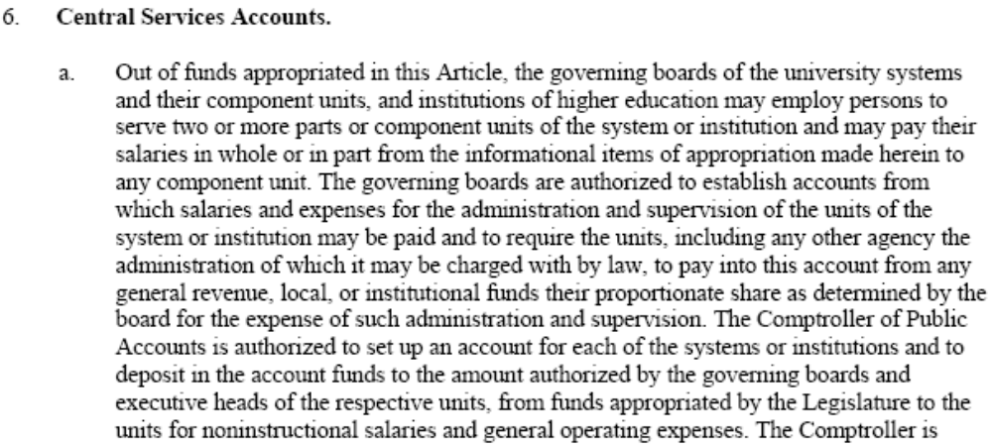
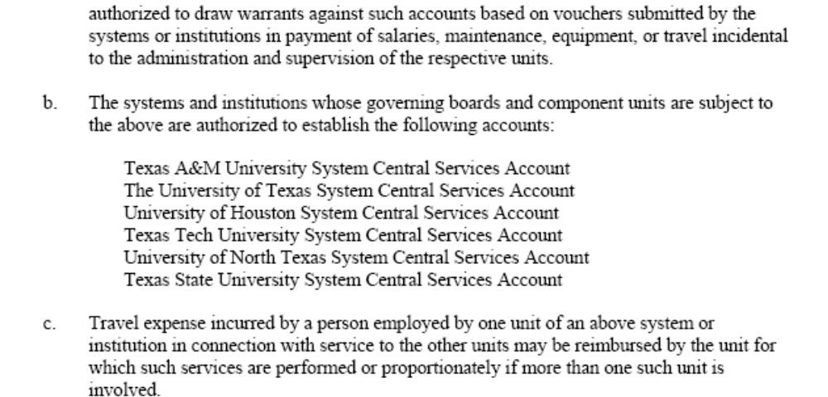

PS Entries for the Central Service Account revenue at UH System level - Business Unit 00783 (cost center may change)
 |  |  | University of Houston System  JOURNAL ENTRY DETAIL
  Header BU: | 00783
  Fiscal Year: | 2004
  Acctg Period: | 4
  Run Date: | 07/09/2005
  Run Time: | 08:16:32

Journal ID: | STT0161132 | Reversal: | None | Ledger Group: | ACTUALS
Date: | 12/19/2003 | Reversal Date: |  | Created By: | SCARONRE
Source: | ACS | Budget Adjust Type: | Actuals | Post Date: | 12/22/2003
Header Ref: | T0161132 | Edit / Hdr Status: | Posted | BCM Status: | Valid
Description: | System Service Charge 2nd quarter for FY04. Using the same entry number that was used in UH for the payment. |  |  | BCM Bypass: | N

Line # | Account | Line BU | Fund | DeptId | Prog | Bdgt Ref. | Project | Line Ref | Chart.1 | Line Description | Amount
1 | 45100 | 00783 | 1006 | S0026 | F0973 | BP2004 | NA |  |  | 2ND QTR FY04 CSA FROM UH | -416,452.00
2 | 45100 | 00783 | 1006 | S0026 | F0973 | BP2004 | NA |  |  | 2ND QTR FY04 CSA FROM UHCL | -74,300.00
3 | 45100 | 00783 | 1006 | S0026 | F0973 | BP2004 | NA |  |  | 2ND QTR FY04 CSA FROM UHV | -108,329.00
4 | 10500 | 00783 | 1006 |  |  | BP2004 |  |  |  | STATE BANK | 599,081.00

Totals for Journal: STT0161132 | Total Lines: 4 | Total Base Debits: 599,081.00 | Total Base Credits: 599,081.00

Signatures | ___________________________________ | Date | __________________________________
 | ___________________________________ |  | __________________________________
PS Approval: | ___________________________________ |  | __________________________________

Created By: SCARONRE | Date Printed: 07/09/2005 | Jrnl. Dt.: 12/19/2003

Note: Enter one line for the amount that each component pays for Service Charges. The bank’s line is for the total amount of the deposit.
PS entries for the Central Service Account payment - Business Unit 00730
Journal ID: | STT0161132 | Reversal: | None | Ledger Group: | ACTUALS
Date: | 12/19/2003 | Reversal Date: |  | Created By: | SCARONRE
Source: | ACS | Budget Adjust Type: | Actuals | Post Date: | 12/22/2003
Header Ref: | T0161132 | Edit / Hdr Status: | Posted | BCM Status: | Valid
Description: | System Service Charge 2nd quarter for FY04. |  |  | BCM Bypass: | N

Line # | Account | Line BU | Fund | DeptId | Prog | Bdgt Ref. | Project | Line Ref | Chart.1 | Line Description | Amount
1 | 53826 | 00730 | 1026 | H0264 | F0428 | BP2004 | NA |  |  | CENTRAL SERVICE EXPENDITURES | 416,452.00
2 | 10500 | 00730 | 1026 |  |  | BP2004 |  |  |  | STATE BANK | -416,452.00

Totals for Journal: STT0161132 | Total Lines: 2 | Total Base Debits: 416,452.00 | Total Base Credits: 416,452.00

Signatures | ___________________________________ | Date | __________________________________
 | ___________________________________ |  | __________________________________
PS Approval: | ___________________________________ |  | __________________________________

Created By: SCARONRE | Date Printed: 07/09/2005 | Jrnl. Dt.: 12/19/2003

USAS entries for the Central Service Account payment - Agency 730

Form Batch Type Edit Mode TC PCA COBJ APPN FUND
Cash Disbursement Type 4 1 225 03701 7643 10730 0001

NACUBO SUBFUND
1100

Unit | HX Fiscal Yr | HX Per | Transaction Cd | Approp Num | Fund | PCA | EOC | Comptroller Obj | Doc Date | Curr Doc Num | Ref Doc Num | Trans Amt | Fiscal Year | Appropriat Yr | Reverse | Fiscal Month | Batch Number
00730 | 2004 | 4 | 225 | 10730 | 0001 | 03701 | 701 | 7643 | 2003-12-19 | T0161132 | T0161132 | 416,452.00 | 04 | 04 |  | 04 | 132

Set up RTI - Agency 783

The RTI# is set up in screen 55. The appropriation year needs to be changed at the beginning of each year to reflect the current year.

In addition to the USAS and PS entries, the following steps must be completed to process service center charges:

- Budget Office notifies the other UH System components via email of the cost center, account, and amount that needs to be paid. State Accounting notifies the components of the RTI number.

- State Accounting notifies the other UH System components of the legal description.

- Check appropriation 96243 for agency 783 for the payments from the other UH components (agency numbers 759, 784, and 765) on screen 62, 88, and 86 and verify in the state cash reconciliation the document number and amount.

Return to Table of Contents

CSA Cinco Ranch Service Charge - C2

This System Service Charge is paid on a quarterly basis.

PS Entries for Cinco Ranch Service Charge revenue - Business Unit 00783 (cost center may change)
 | GLC7501 |  |  | PeopleSoft Financials |  | Page No. | 1
  Report ID:
 |  |  |  | JOURNAL ENTRY DETAIL |  | Run Date | 28.Apr.2004
Unit: | 00783 |  | Ledger Group: | ACTUALS | Foreign Currency: | USD
Journal ID: | STT0161133 |  | Source: | ACS | Rate Type:
Date: | 19.Dec.2003 |  | Reversal: | N | Effective Date: | 19.Dec.2003
Description: | Cinco Ranch Service Charge 2nd quarter for FY04. Using the same entry number used for the payment done at UH. |  | Reversal Date: |  | Exchange Rate: | 1.00
Line # | Account | Fund | DeptId | Prog | Bdgt Perio | Prjt/Grant | Foreign Amount
1 | 45100 | 1006 | S0026 | F0973 | BP2004 | NA | (55,678.00)
 | Description | 2nd Qtr FY04 C-Ranch SC F/UH |  | Open Item Key:
2 | 45100 | 1006 | S0026 | F0973 | BP2004 | NA | (7,500.00)
 | Description | 2nd Qtr FY04 Dist LRN SC F/UH |  | Open Item Key:
3 | 45100 | 1006 | S0026 | F0973 | BP2004 | NA | (12,045.00)
 | Description | 2nd Qtr FY04 C-Ranch SC F/UHCL |  | Open Item Key:
4 | 45100 | 1006 | S0026 | F0973 | BP2004 | NA | (58,503.00)
 | Description | 2nd Qtr FY04 C-Ranch SC F/UHV |  | Open Item Key:
5 | 10500 | 1006 |  |  | BP2004 |  | 133,726.00
 | Description | STATE BANK |  | Open Item Key:
Totals for Journal: | STT0161133 | Total Lines: | 5 | Total Base Debits: 133,726.00 | Total Base Credits: | 133,726.00

Note: Enter one line for the amount that each component pays for Service Charges. The bank’s line is for the total amount of the deposit.
PS entries for Cinco Ranch Service Charge payment - Business Unit 00730 (cost center may change)
 | GLC7501 |  |  | PeopleSoft Financials |  | Page No. | 1
  Report ID:
 |  |  |  | JOURNAL ENTRY DETAIL |  | Run Date | 27.Apr.2004
Unit: | 00730 |  | Ledger Group: | ACTUALS | Foreign Currency: | USD
Journal ID: | STT0161133 |  | Source: | ACS | Rate Type:
Date: | 19.Dec.2003 |  | Reversal: | N | Effective Date: | 19.Dec.2003
Description: | Cinco Ranch Service Charge 2nd quarter for FY04. |  | Reversal Date: |  | Exchange Rate: | 1.00
Line # | Account | Fund | DeptId | Prog | Bdgt Perio | Prjt/Grant | Affilia | Foreign Amount
1 | 53826 | 1026 | H0015 | A0301 | BP2004 | NA |  | 55,678.00
 | Description | CENTRAL SERVICE EXPENDITURES |  | Open Item Key:
2 | 53826 | 1026 | H0015 | D0456 | BP2004 | NA |  | 7,500.00
 | Description | CENTRAL SERVICE EXPENDITURES |  | Open Item Key:
3 | 10500 | 1026 |  |  | BP2004 |  |  | (63,178.00)
 | Description | STATE BANK |  | Open Item Key:
Totals for Journal: | STT0161133 | Total Lines: | 3 | Total Base Debits: 63,178.00 | Total Base Credits: | 63,178.00

USAS entries for Cinco Ranch Service Charge payment - Agency 730

NACUBO SUBFUND
1100

Unit | Curr Doc Num | Batch date | Comptroller Obj | Approp Num | Fund | Appropriat Yr | Fiscal Year | Transaction Cd | Sum Trans Amt | Ref Doc Num | HX Per | Reverse | PCA
00730 | T0161133 | 2003-12-19 | 7643 | 10730 | 0001 | 04 | 04 | 225 | 63,178.00 | T0161133 | 4 |  | 03701

Set up RTI - Agency 783

The RTI# is set up in screen 55. The appropriation year needs to be changed at the beginning of each year to reflect current year.

In addition to the USAS and PS entries, the following steps must be completed to process service center charges:

- Budget Office notifies the other UH System components via email of the cost center, account, and amount that needs to be paid. State Accounting notifies the components of the RTI number.

- State Accounting notifies the other UH System components of the legal description.

3. Check appropriation 96243 for agency 783 for the payments from the other UH components (agency numbers 759, 784, and 765) on screen 62, 88, and 86 and verify in the state cash reconciliation the document number and amount.

Return to Table of Contents

CSA Miscellaneous Internal Services - C3

This transaction is related to services provided by the University of Houston to support the coordination, administration and other related services to the other campuses. The transaction is done with an Interagency Contract, or another kind of informal agreement depending on the amount and the nature of the expense. The funds are paid from the Central Services Account in UH System. The payment is processed by issuing a state voucher as follows (cost center may change):

Voucher Coversheet
Business Unit: 00783
Voucher ID: 00016360
Vendor ID: 0000026798 TINS:
Name: UNIV OF HOUSTON-SYS
Address: 6
PO Box 230205
Houston TX 77223-0205
USA
Invoice ID: Miscellaneous internal services
Contract ID:
PCC: 9
Bank: STATE
Scheduled Due Date: 10/03/2003
Gross Amount: $ 1,515,024.55
Voucher Comments: Payment of miscellaneous internal services to provide support for coordination, administration, and other related services.
Payment Comments: Please deposit check to: 45100 / 2063 / S0026 / F0403 / NA.
Handling: SH
Budget Check: Valid
Account Fund Department Program Budget Period Project Amount
53821 1006 S0027 F0973 BP2003 NA 1,515,024.55
Signatures Date
PS Approval
Created By: NGUYEN, TUYET B -UH Date Printed: 05/03/2004
Page 1

The warrant from the state is deposited to a local cost center and revenue account (45100 2063 S0026 F0403 NA).

Return to Table of Contents

CSA Sugarland Service Charge - C4

This System Service Charge is paid on a quarterly basis from UH to UHSA.

PS Entries for the Sugarland Service Charge revenue at UH System level - Business Unit 00783 (cost center may change)
 | UGL01062 |  |  |  |  |  | Page No. | 1
  Report ID:
Unit: | 00783 |  |  | University of Houston System |  |  | Run Date | 03.May.2004
Fiscal Year: | 2004 |  |  | JOURNAL ENTRY DETAIL |  |  | Run Time | 2:01:38 PM
Acctg Period: | 4
Journal ID: | STT0161134 |  | Reversal: | None |  | Ledger Group: | ACTUALS
Date: | 12/19/2003 |  |  |  |  | Created By: | SCARONRE
Source: | ACS |  |  |  |  | Post Date: | 12/22/2003
Header Ref: | T0161134 |  | Edit / Hdr Status: | Posted |  | BCM Status: |  | Valid
Hdr Descr: | Sugarland Service Charge 2nd quarter for FY04. Using the same entry number that was use for the payment in UH. |  |  |  |  | BCM Bypass: |  | No
Line # | Account | Fund | DeptId | Prog | Bdgt Period | Prjt/Grant | Line Ref | Line Description | Amount
1 | 45100 | 1006 | S0026 | F0973 | BP2004 | NA |  | 2nd Qtr FY04 S-Land SC F/UH | (18,123.00)
2 | 45100 | 1006 | S0026 | F0973 | BP2004 | NA |  | 2nd Qtr FY04 S-Land SC F/UHCL | (18,538.00)
3 | 45100 | 1006 | S0026 | F0973 | BP2004 | NA |  | 2nd Qtr FY04 S-Land SC F/UHV | (108,737.00)
4 | 10500 | 1006 |  |  | BP2004 |  |  | STATE BANK | 145,398.00
Totals for Journal: | STT0161134 | Total Lines: | 4 |  |  |  | Total Base Debits: | 145,398.00 | 145,398.00

Note: Enter one line for the amount that each component pays for Service Charges. The bank’s line is for the total amount of the deposit.
PS entry for the Sugarland Service Charge payment - Business Unit 00730 (cost center may change)
 | UGL01062 |  |  |  |  |  | Page No. | 1
  Report ID:
Unit: | 00730 |  |  | University of Houston System |  |  | Run Date | 03.May.2004
Fiscal Year: | 2004 |  |  |  |  |  | Run Time | 1:46:38 PM
Acctg Period: | 4 |  |  | JOURNAL ENTRY DETAIL
Journal ID: | STT0161134 |  | Reversal: | None |  | Ledger Group: | ACTUALS
Date: | 12/19/2003 |  | Reversal Date: |  |  | Created By: | SCARONRE
Source: | ACS |  | Bud Adjust Type: |  |  | Post Date: | 12/22/2003
Header Ref: | T0161134 |  | Edit / Hdr Status: | Posted |  | BCM Status: |  | Valid
Hdr Descr: | Sugarland Service Charge 2nd quarter for FY04. |  |  |  |  | BCM Bypass: |  | No
Line # | Account | Fund | DeptId | Prog | Bdgt Period | Prjt/Grant | Line Ref | Line Description | Amount
1 | 53826 | 1026 | H0603 | F0430 | BP2004 | NA |  | CENTRAL SERVICE EXPENDITURES | 18,123.00
2 | 10500 | 1026 |  |  | BP2004 |  |  | STATE BANK | (18,123.00)
Totals for Journal: | STT0161134 | Total Lines: | 2 |  |  |  | Total Base Debits: | 18,123.00 | 18,123.00

USAS entries for the Sugarland Service Charge payment - Agency 730
Unit | Curr Doc Num | Batch date | Comptroller Obj | Approp Num | Fund | Appropriat Yr | Fiscal Year | Transaction Cd | Sum Trans Amt | Ref Doc Num | HX Per | Reverse | PCA
00730 | T0161134 | 2003-12-19 | 7643 | 10730 | 0001 | 04 | 04 | 225 | 18,123.00 | T0161134 | 4 |  | 03701

NACUBO SUBFUND
1100

Set up RTI - Agency 783

RTI# is set up in screen 55. The appropriation year needs to be changed at the beginning of each year to reflect the current year.

In addition to the USAS and PS entries, the following steps must be completed to process service center charges:

- Budget Office notifies the other UH System components via email of the cost center, account, and amount that needs to be paid. State Accounting notifies the components of the RTI number.

- State Accounting notifies the other UH System components of the legal description.

3. Check appropriation 96243 for agency 783 for the payments from the other UH components (agency numbers 759, 784, and 765) on screen 62, 88, and 86 and verify in the state cash reconciliation the document number and amount.

Return to Table of Contents

CSA Victoria Sugarland Service Charge - C5

This System Service Charge is paid on a quarterly basis. These payments are done from the UH System to UH Victoria.

PS Victoria Sugarland Service Charge payment - Business Unit 00783 (cost center may change)
 | UGL01062 |  |  |  |  |  | Page No. | 1
  Report ID:
Unit: | 00783 |  |  | University of Houston System |  |  | Run Date | 03.May.2004
Fiscal Year: | 2004 |  |  |  |  |  | Run Time | 2:17:09 PM
 |  |  |  | JOURNAL ENTRY DETAIL
Acctg Period: | 4
Journal ID: | STT0042036 |  | Reversal: | None |  | Ledger Group: | ACTUALS
Date: | 12/19/2003 |  | Reversal Date: |  |  | Created By: | SCARONRE
Source: | ACS |  | Bud Adjust Type: |  |  | Post Date: | 12/22/2003
Header Ref: | T0042036 |  | Edit / Hdr Status: | Posted |  | BCM Status: |  | Valid
Hdr Descr: | Victoria Sugarland Service Charge 2nd quarter for FY04. |  |  |  |  | BCM Bypass: |  | No
Line # | Account | Fund | DeptId | Prog | Bdgt Period | Prjt/Grant | Line Ref | Line Description | Amount
1 | 53826 | 1006 | S0027 | D0994 | BP2004 | NA |  | 2nd Qtr Vic S-Labd SC FY04 | 117,303.00
2 | 10500 | 1006 |  |  | BP2004 |  |  | STATE BANK | (117,303.00)
Totals for Journal: | STT0042036 | Total Lines: |  |  |  | 2 | Total Base Debits: | 117,303.00 | 117,303.00

USAS entries for Victoria Sugarland Service Charge payment - Agency 783

Form Batch Type Edit Mode
Cash Disbursement Type 2 1

Unit | Curr Doc Num | Batch date | Comptroller Obj | Approp Num | Fund | Appropriat Yr | Fiscal Year | Transaction Cd | Sum Trans Amt | Ref Doc Num | HX Per | Reverse | PCA
00783 | T0042036 | 2003-12-19 | 7643 | 96243 | 0001 | 04 | 04 | 225 | 117,303.00 | T0042036 | 4 |  | 03990

NACUBO SUBFUND
1100

Set up RTI – Agency 765

The RTI# is set up in screen 55.

In addition to the USAS and PS entries, the following steps must be completed to process this service center charge:

- Confirm with UHV the RTI#.

- Check appropriation 96243 agency 783 for the payments processed to agency 765 on screen 62.

Return to Table of Contents

Computing Charges (UHV) - C7
UH Victoria pays UH for computer charges, which involves programming support for the student information system for use in recording and tracking student activity. The transaction is performed using an Interagency Contract.

PS entries for Computing Charges revenue - Business Unit 00730 (cost center may change)
 | GLC7501 |  |  | PeopleSoft Financials |  | Page No. | 1
  Report ID:
 |  |  |  | JOURNAL ENTRY DETAIL |  | Run Date | 28.Apr.2004
 |  |  |  |  |  | Run Time | 11:56:26 AM
Unit: | 00730 |  | Ledger Group: | ACTUALS | Foreign Currency: | USD
Journal ID: | STT0019447 |  | Source: | ACS | Rate Type:
Date: | 28.Jan.2004 |  | Reversal: | N | Effective Date: | 28.Jan.2004
Description: | Computing Charges - Victoria. |  | Reversal Date: |  | Exchange Rate: | 1.00
Line # | Account | Fund | DeptId | Prog | Bdgt Perio | Prjt/Grant | Foreign Amount
1 | 43639 | 1026 | H0199 | F0468 | BP2004 | NA | (37,000.00)
 | Description | Computing Charges - UHV |  | Open Item Key:
2 | 10500 | 1026 |  |  | BP2004 |  | 37,000.00
 | Description | STATE BANK |  | Open Item Key:
Totals for Journal: | STT0019447 | Total Lines: | 2 | Total Base Debits: 37,000.00 | Total Base Credits: | 37,000.00

PS entries for Computing Charges payment - Business Unit 00765 (cost center may change)

Form Fund Dept Progr Proj BP Spd Type Account dr/cr
Journal Entry 1061 V0012 E0215 NA BP200X 10706 53821 Debit
1061 BP200X 10500 Credit

USAS entries for Computing Charges payment - Agency 765

Form Batch Type Edit Mode TC PCA COBJ APPN FUND
Cash Disbursement 4 1 225 50045 7210 10765 0001

Doc Type T

NACUBO SUBFUND
1100

Set up RTI – Agency 730

The RTI# is set up in screen 55. The appropriation year needs to be changed at the beginning of each year to reflect the current year.

In addition to the USAS and PS entries, the following steps must be completed to process this service center charge:

  - Notify UHV of the RTI number.

  - Call UHV for the document number used to make the payment, and check USAS screens 88 and 86. The payment should post in our agency to Appropriation 10730, Fund 0001, COBJ 3765, PCA 03701, and T-Code 970.

Return to Table of Contents

Miscellaneous Internal Services - M0

Payroll and other types of expense reimbursements, between UH System components are performed under an interagency contract or other kind of informal agreement depending on the amount and the nature of the expense. Each component does its own entry. Another type of transaction is the transfer for the year end remaining balance from the State Central Services Account Appropriation to the Designated Central Services in UHSA.

PS entries to record a payment from UHSA to UHV - Business Unit 00783 (cost center may change)
 | UGL01062 |  |  |  |  |  | Page No. | 1
  Report ID:
Unit: | 00783 |  |  | University of Houston System |  |  | Run Date | 03.May.2004
Fiscal Year: | 2005 |  |  |  |  |  | Run Time | 2:17:09 PM
Acctg Period: | 4 |  |  | JOURNAL ENTRY DETAIL
Journal ID: | STT0042036 |  | Reversal: | None |  | Ledger Group: | ACTUALS
Date: | 10/26/2004 |  | Reversal Date: |  |  | Created By: | SCARONRE
Source: | ACS |  | Bud Adjust Type: |  |  | Post Date: | 10/26/2004
Header Ref: | T0042036 |  | Edit / Hdr Status: | Posted |  | BCM Status: |  | Valid
Hdr Descr: | Interagency Contract-UH-UHV Reimbursing for Payroll Expenses for Elizabeth Branch |  |  |  |  | BCM Bypass: |  | No
Line # | Account | Fund | DeptId | Prog | Bdgt Period | Prjt/Grant | Line Ref | Line Description | Amount
1 | 53826 | 7050 | S0068 | F0006 | BP2005 | P001250 |  | Contract Serv with UHV-Elizabeth Branch | 43,333.00
2 | 10500 | 7050 |  |  | BP2005 |  |  | STATE BANK | (43,333.00)
Totals for Journal: | STT0042036 | Total Lines: |  |  |  | 2 | Total Base Debits: | 43,333.00 | 43,333.00

Note: PS entry on UH or UHSA cost center to record payment from another component credits UH/UHSA cost center and expense and debits state bank. USAS entry is not needed, because the other component pays by RTI. UH/UHSA needs to provide the RTI# to the other UH component to receive the reimbursement of expenses.

USAS entry to record the payment from UHSA to UHV - Agency 783

Form Batch Type Edit Mode
Cash Disbursement Type 2 1
Unit | Curr Doc Num | Batch date | Comptroller Obj | Approp Num | Fund | Appropriat Yr | Fiscal Year | Transaction Cd | Sum Trans Amt | Ref Doc Num | HX Per | Reverse | PCA
00783 | T0042036 | 2004-10-26 | 7643 | 96243 | 0001 | 05 | 05 | 225 | 43,333.00 | T0042036 | 4 |  | 03990

NACUBO SUBFUND
1100

Note: For the payroll expenses, the RTI needs to be set up with COBJ 7252 when paying for a faculty, because we are using T_Code 485 and 486 for payment to and payment from other agencies, respectively. T_Codes 485 and 486 do not allow the use of payroll COBJ.

LECTURERS – HIGHER EDUCATION Expenditure Code 7252
Purpose To record the payment for guest lecturers providing lecture services to institutions of higher education.
This code includes:
• Visiting professors
• Distinguished individuals
• Artists presenting lectures
• Colloquiums
• Speeches
• Seminars
• Workshops
• Recitals
• Performances
Travel expenses incurred by vendor should be included as part of the total cost of services.
Note RESTRICTED. This code may be only used by institutions of higher education.
This code does NOT include professionally conducted training for agency employees (7243).
Object Group 10 (Comptroller Manual of Accounts – Volume I Expenditure Codes – Detail Descriptions – Cash)

In addition to the USAS and PS entries, the following steps must be completed to process this interagency payment:

1. Confirm the RTI# with the UH component when making the payment or notify the UH component the RTI# when receiving the payment.
2. In USAS screens 62 and 86, verify that the payment was processed by reviewing the appropriation of the payer/payee agency.

Return to Table of Contents

Monthly and Semester Payments

ERS Benefits - E3 & E4

The appropriation for Higher Education Employees Group Insurance contributions state match paid with fund 1 is awarded to the Employees Retirement System of Texas (ERS), which pays the employer’s contribution on our behalf. State Accounting transfers the budget authority to spend for fund 2 to appropriation 10730. A PCA must be established in USAS for Program Cost Account Profile (26) screen, which is derived from Program Code 3705. The retirement payment, like all the payroll benefits, is subject to the proportionality rules (APS 011).

The ERS provide us with a monthly report shown below.

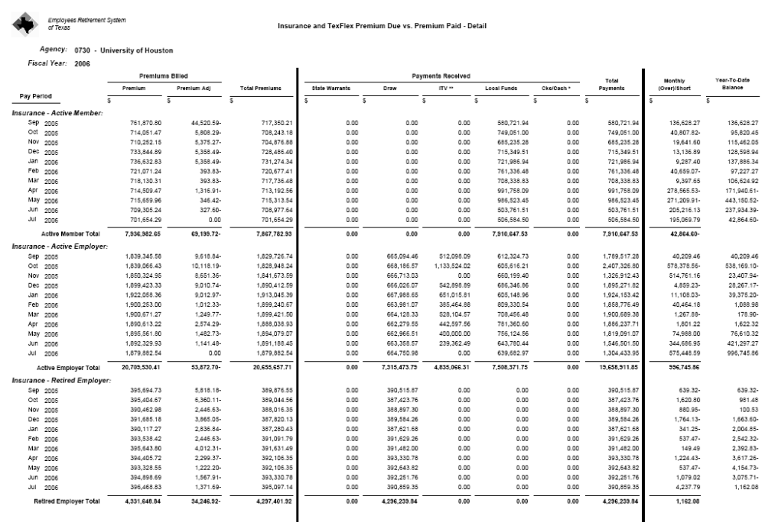
The entries done in PS for fund 0001 and 0225 are entered as follows:

- The retired employer contribution activity for fund 0001 is recorded in PS on a monthly basis in BU 00730 and 00783 according to the monthly ERS report by looking at the “Draw” column. For July 2006, the amount to record in PS is $392,251.76 and 13,836.74 for BU 00730 and 00783 respectively.

PS entry for retired employer contribution - BU 00730

 |  |  | University of Houston System  JOURNAL ENTRY DETAIL
  Header BU: | 00730
  Fiscal Year: | 2006
  Acctg Period: | 12
  Run Date: | 09/12/2006
  Run Time: | 01:46:05

Journal ID: | STJ0161518 | Reversal: | None | Ledger Group: | ACTUALS
Date: | 08/31/2006 | Reversal Date: |  | Created By: | BANKSDA
Source: | ACS | Budget Adjust Type: | Actuals | Post Date: | 09/06/2006
Header Ref: | J0161518 | Edit / Hdr Status: | Posted | BCM Status: | Valid
Description: | E3- ERS Retired Employer contribution entry for July 2006 for FY06. |  |  | BCM Bypass: | N

Line # | Account | Line BU | Fund | DeptId | Prog | Bdgt Ref. | Project | Line Ref | Chart.1 | Line Description | Amount
1 | 51104 | 00730 | 1019 | H0600 | A3504 | BP2006 | NA | J0161518 |  | ERS RET EMP CONTR- JULY 06 | 129,425.97
2 | 51104 | 00730 | 1019 | H0600 | B4394 | BP2006 | NA | J0161518 |  | ERS RET EMP CONTR- JULY 06 | 25,445.47
3 | 51104 | 00730 | 1019 | H0600 | C3484 | BP2006 | NA | J0161518 |  | ERS RET EMP CONTR- JULY 06 | 12,968.44
4 | 51104 | 00730 | 1019 | H0600 | D3586 | BP2006 | NA | J0161518 |  | ERS RET EMP CONTR- JULY 06 | 62,609.56
5 | 51104 | 00730 | 1019 | H0600 | E5053 | BP2006 | NA | J0161518 |  | ERS RET EMP CONTR- JULY 06 | 26,709.90
6 | 51104 | 00730 | 1019 | H0600 | F3488 | BP2006 | NA | J0161518 |  | ERS RET EMP CONTR- JULY 06 | 79,879.61
7 | 51104 | 00730 | 1019 | H0600 | G3482 | BP2006 | NA | J0161518 |  | ERS RET EMP CONTR- JULY 06 | 55,212.81
8 | 41301 | 00730 | 1019 | H0600 | A3504 | BP2006 | NA | J0161518 |  | ERS RET EMP CONTR- JULY 06 | -129,425.97
9 | 41301 | 00730 | 1019 | H0600 | B4394 | BP2006 | NA | J0161518 |  | ERS RET EMP CONTR- JULY 06 | -25,445.47
10 | 41301 | 00730 | 1019 | H0600 | C3484 | BP2006 | NA | J0161518 |  | ERS RET EMP CONTR- JULY 06 | -12,968.44
11 | 41301 | 00730 | 1019 | H0600 | D3586 | BP2006 | NA | J0161518 |  | ERS RET EMP CONTR- JULY 06 | -62,609.56
12 | 41301 | 00730 | 1019 | H0600 | E5053 | BP2006 | NA | J0161518 |  | ERS RET EMP CONTR- JULY 06 | -26,709.90
13 | 41301 | 00730 | 1019 | H0600 | F3488 | BP2006 | NA | J0161518 |  | ERS RET EMP CONTR- JULY 06 | -79,879.61
14 | 41301 | 00730 | 1019 | H0600 | G3482 | BP2006 | NA | J0161518 |  | ERS RET EMP CONTR- JULY 06 | -55,212.81

PS entry for retired employer contribution - BU 00783

Signatures | ___________________________________ | Date | __________________________________
PS Approval: | ___________________________________ |  | __________________________________

Created By: BANKSDA | Date Printed: 09/12/2006 | Jrnl. Dt.: 08/31/2006

 |  |  | University of Houston System  JOURNAL ENTRY DETAIL
  Header BU: | 00783
  Fiscal Year: | 2006
  Acctg Period: | 12
  Run Date: | 09/12/2006
  Run Time: | 02:02:59

Journal ID: |  | STJ0042103 |  |  |  | Reversal: |  |  |  |  | None | Ledger Group: | ACTUALS
Date: |  | 08/31/2006 |  |  |  | Reversal Date: |  |  |  |  |  | Created By: | BANKSDA
Source: |  | ACS |  |  |  | Budget Adjust Type: |  |  |  |  | Actuals | Post Date: | 09/06/2006
Header Ref: |  | J0042103 |  |  |  | Edit / Hdr Status: |  |  |  |  | Posted | BCM Status: | Valid
Description: |  | E4- ERS Retired Employer contribution entry for July 2006 for FY06. |  |  |  |  |  |  |  |  |  | BCM Bypass: | N
Line # | Account | Line BU | Fund | DeptId | Prog |  | Bdgt Ref. | Project | Line Ref | Chart.1 | Line Description |  |  | Amount
1 | 51104 | 00783 | 1019 | S0027 | B2011 |  | BP2006 | NA | J0042103 |  | ERS RET EMP CONTR- JULY 06 |  |  | 219.01
2 | 51104 | 00783 | 1019 | S0027 | D0289 |  | BP2006 | NA | J0042103 |  | ERS RET EMP CONTR- JULY 06 |  |  | 1,878.51
3 | 51104 | 00783 | 1019 | S0027 | E0212 |  | BP2006 | NA | J0042103 |  | ERS RET EMP CONTR- JULY 06 |  |  | 170.25
4 | 51104 | 00783 | 1019 | S0027 | F1015 |  | BP2006 | NA | J0042103 |  | ERS RET EMP CONTR- JULY 06 |  |  | 7,240.75
5 | 51104 | 00783 | 1019 | S0027 | G0254 |  | BP2006 | NA | J0042103 |  | ERS RET EMP CONTR- JULY 06 |  |  | 4,328.22
6 | 41301 | 00783 | 1019 | S0027 | B2011 |  | BP2006 | NA | J0042103 |  | ERS RET EMP CONTR- JULY 06 |  |  | -219.01
7 | 41301 | 00783 | 1019 | S0027 | D0289 |  | BP2006 | NA | J0042103 |  | ERS RET EMP CONTR- JULY 06 |  |  | -1,878.51
8 | 41301 | 00783 | 1019 | S0027 | E0212 |  | BP2006 | NA | J0042103 |  | ERS RET EMP CONTR- JULY 06 |  |  | -170.25
9 | 41301 | 00783 | 1019 | S0027 | F1015 |  | BP2006 | NA | J0042103 |  | ERS RET EMP CONTR- JULY 06 |  |  | -7,240.75
10 | 41301 | 00783 | 1019 | S0027 | G0254 |  | BP2006 | NA | J0042103 |  | ERS RET EMP CONTR- JULY 06 |  |  | -4,328.22

- Record the payment for fund 0225 in PS and USAS for BU 00730 for the amount owed to ERS for the employer contribution for active employees according to the payroll report.

  - The payroll department makes the payment with a state voucher using the RTI number provided by ERS and PS account and cost center 51104-1054-H0437-A0284-NA.

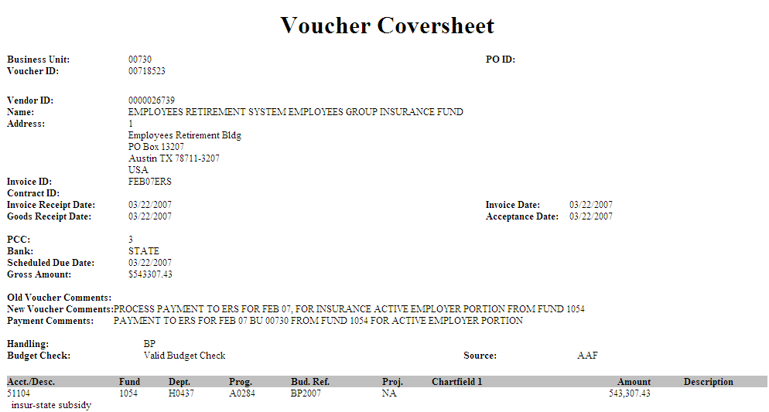

  - The payroll department reduces the expenses and revenues on fund 0001 for the amount of the payments on fund 0225 (1054) by entering a journal entry as indicated below:

 |  | University of Houston System  JOURNAL ENTRY DETAIL
  Header BU: | 00730
  Fiscal Year: | 2007
  Acctg Period: | 7
  Run Date: | 05/31/2007
  Run Time: | 11:53:03

Journal ID: |  | PR0028306 |  |  |  |  |  |  |  | Reversal: | None | Ledger Group: |  | ACTUALS
Date: |  | 03/30/2007 |  |  |  |  |  |  |  | Reversal Date: |  | Created By: |  | SUECL
Source: |  | AAF |  |  |  |  |  |  |  | Budget Adjust Type: | Actuals | Post Date: |  | 04/03/2007
Header Ref: |  | PR028306 |  |  |  |  |  |  |  | Edit / Hdr Status: | Posted | BCM Status: |  | Valid
Description: |  | E3 - TO REDUCE ERS ER BENEFITS EXPENSES AND RECORD REVENUES ON FUND 1019 FOR THE AMOUNT OF PAYMENTS IN FUND 1054 FOR JAN07 AND FEB 07 |  |  |  |  |  |  |  |  |  | BCM Bypass: |  | N
Line # | Account | Line BU | Fund | DeptId | Prog | Bdgt Ref. | Project | Line Ref | Chart.1 | Line Description |  |  | Amount
1 | 51104 | 00730 | 1019 | H0437 | A0300 | BP2007 | NA | 00718523 |  | INSUR-STATE SUBSIDY – FEB 07 |  |  | -543,307.43
2 | 41301 | 00730 | 1019 | H0437 | A0300 | BP2007 | NA | 00718523 |  | INSUR-STATE SUBSIDY – FEB 07 |  |  | 543,307.43

- The payroll department sends the payment for SKIP according to the payroll report for BU 00783 and 00730 to the following cost centers:

BU 00730 – 51104-2064-H0264-F2663-NA
BU 00783 – 51104-2080-S0027-F1011-NA

- For BU 00783, any additional payments for Active Employer Contribution are made from the Central Services Appropriation, which is also fund 0001.

  - The payroll department makes the payment with a state voucher using the RTI number provided by ERS and PS account and cost center 51104-1006-S0027-F0973-NA.
  - The payroll department reduces the expenses and revenues on fund 0001 for the amount of the payments on Central Services (1006) by entering a journal entry as indicated below:

 | Journal ID: |  | STT0042086 |  |  |  |  | Reversal: |  |  |  | None | Ledger Group: | ACTUALS
 | Date: |  | 07/10/2006 |  |  |  |  | Reversal Date: |  |  |  |  | Created By: | BANKSDA
 | Source: |  | ACS |  |  |  |  | Budget Adjust Type: |  |  |  | Actuals | Post Date: | 07/10/2006
 | Header Ref: |  | T0042086 |  |  |  |  | Edit / Hdr Status: |  |  |  | Posted | BCM Status: | Valid
 | Description: |  | E3 - Reducing the expenses and revenues ERS fund 0001 (1019) for the amount paid with CSA funds (1006). |  |  |  |  |  |  |  |  |  | BCM Bypass: | N
Line # |  | Account | Line BU | Fund | DeptId | Prog | Bdgt Ref. |  | Project | Line Ref | Chart.1 | Line Description |  |  | Amount
1 |  | 51104 | 00783 | 1019 | S0027 | F0217 | BP2006 |  | NA | 00039975 |  | Reducing FUND 1- for amt of payment on CSA funds |  |  | -17,386.93
2 |  | 41301 | 00783 | 1019 | S0027 | F0217 | BP2006 |  | NA | 00039975 |  | Reducing FUND 1- for amt of payment on CSA funds |  |  | 17,386.93

5. The amount of payments posted to account 51104 and fund code 1054 should be equal to the amount of payments posted in USAS appropriation 10730/0225 COBJ 7041. The payroll entries posted to PS expense account 51104 and fund code 1054 do not feed USAS system and should be reversed. Run the query below specifying the period to be adjusted, fiscal year, and business unit:

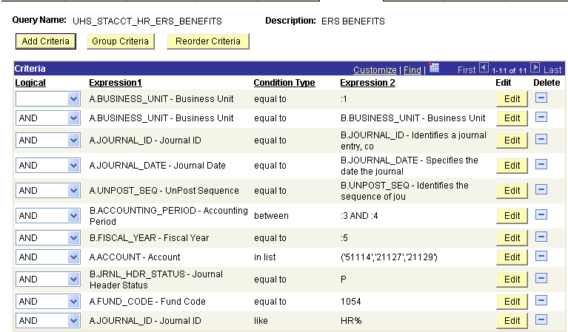

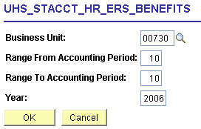

Download to Excel, sort and subtotal by account

Unit | Journal ID | Account | Fund | DeptID | Program | Descr | Project | Period | Year | Sum Amount
00730 | HR01296758 | 21127 | 1054 | H0437 | A0284 | ERS INS PREM-FD2-INSTRUCT | NA | 10 | 2006 | 0.00
00730 | HR01302667 | 21127 | 1054 | H0437 | A0284 | ERS INS PREM-FD2-INSTRUCT | NA | 10 | 2006 | (6,340.71)
00730 | HR01302667 | 21127 | 1054 | H0437 | C0212 | ERS INS PREM-FD2-PUBL SVC | NA | 10 | 2006 | (800.68)
00730 | HR01302667 | 21127 | 1054 | H0437 | E0214 | ERS INS PREM-FD2-STUD SVC | NA | 10 | 2006 | (341.26)
00730 | HR01302737 | 21127 | 1054 | H0437 | C0212 | ERS INS PREM-FD2-PUBL SVC | NA | 10 | 2006 | (170.63)
00730 | HR01303322 | 21127 | 1054 | H0437 | A0284 | ERS INS PREM-FD2-INSTRUCT | NA | 10 | 2006 | (5,991.68)
00730 | HR01303322 | 21127 | 1054 | H0437 | C0212 | ERS INS PREM-FD2-PUBL SVC | NA | 10 | 2006 | (3,106.88)
00730 | HR01303322 | 21127 | 1054 | H0437 | D0441 | ERS INS PREM-FD2-ACAD SUPP | NA | 10 | 2006 | (682.50)
00730 | HR01303752 | 21127 | 1054 | H0437 | A0284 | ERS INS PREM-FD2-INSTRUCT | NA | 10 | 2006 | 0.00
00730 | HR01304616 | 21127 | 1054 | H0437 | A0284 | ERS INS PREM-FD2-INSTRUCT | NA | 10 | 2006 | (127.97)
00730 | HR01305473 | 21127 | 1054 | H0437 | A0284 | ERS INS PREM-FD2-INSTRUCT | NA | 10 | 2006 | (6,340.70)
00730 | HR01305473 | 21127 | 1054 | H0437 | C0212 | ERS INS PREM-FD2-PUBL SVC | NA | 10 | 2006 | (800.68)
00730 | HR01305473 | 21127 | 1054 | H0437 | E0214 | ERS INS PREM-FD2-STUD SVC | NA | 10 | 2006 | (341.26)
 |  | 21127 Total |  |  |  |  |  |  |  | (25,044.95)
00730 | HR01296758 | 21129 | 1054 | H0437 | A0284 | ERS INS PREM-FD2-INSTRUCT | NA | 10 | 2006 | 0.00
00730 | HR01302667 | 21129 | 1054 | H0437 | A0284 | ERS INS PREM-FD2-INSTRUCT | NA | 10 | 2006 | (32.76)
00730 | HR01302667 | 21129 | 1054 | H0437 | C0212 | ERS INS PREM-FD2-PUBL SVC | NA | 10 | 2006 | (5.04)
00730 | HR01302667 | 21129 | 1054 | H0437 | E0214 | ERS INS PREM-FD2-STUD SVC | NA | 10 | 2006 | (2.24)
00730 | HR01302737 | 21129 | 1054 | H0437 | C0212 | ERS INS PREM-FD2-PUBL SVC | NA | 10 | 2006 | (1.12)
00730 | HR01303322 | 21129 | 1054 | H0437 | A0284 | ERS INS PREM-FD2-INSTRUCT | NA | 10 | 2006 | (31.79)
00730 | HR01303322 | 21129 | 1054 | H0437 | C0212 | ERS INS PREM-FD2-PUBL SVC | NA | 10 | 2006 | (16.17)
00730 | HR01303322 | 21129 | 1054 | H0437 | D0441 | ERS INS PREM-FD2-ACAD SUPP | NA | 10 | 2006 | (4.46)
00730 | HR01303752 | 21129 | 1054 | H0437 | A0284 | ERS INS PREM-FD2-INSTRUCT | NA | 10 | 2006 | 0.00
00730 | HR01304616 | 21129 | 1054 | H0437 | A0284 | ERS INS PREM-FD2-INSTRUCT | NA | 10 | 2006 | (0.84)
00730 | HR01305473 | 21129 | 1054 | H0437 | A0284 | ERS INS PREM-FD2-INSTRUCT | NA | 10 | 2006 | (32.76)
00730 | HR01305473 | 21129 | 1054 | H0437 | C0212 | ERS INS PREM-FD2-PUBL SVC | NA | 10 | 2006 | (5.04)
00730 | HR01305473 | 21129 | 1054 | H0437 | E0214 | ERS INS PREM-FD2-STUD SVC | NA | 10 | 2006 | (2.24)
 |  | 21129 Total |  |  |  |  |  |  |  | (134.46)
00730 | HR01296758 | 51104 | 1054 | H0437 | A0284 | ERS INS PREM-FD2-INSTRUCT | NA | 10 | 2006 | 0.00
00730 | HR01302667 | 51104 | 1054 | H0437 | A0284 | ERS INS PREM-FD2-INSTRUCT | NA | 10 | 2006 | 6,373.47
00730 | HR01302667 | 51104 | 1054 | H0437 | C0212 | ERS INS PREM-FD2-PUBL SVC | NA | 10 | 2006 | 805.72
00730 | HR01302667 | 51104 | 1054 | H0437 | E0214 | ERS INS PREM-FD2-STUD SVC | NA | 10 | 2006 | 343.50
00730 | HR01302737 | 51104 | 1054 | H0437 | C0212 | ERS INS PREM-FD2-PUBL SVC | NA | 10 | 2006 | 171.75
00730 | HR01303322 | 51104 | 1054 | H0437 | A0284 | ERS INS PREM-FD2-INSTRUCT | NA | 10 | 2006 | 6,023.47
00730 | HR01303322 | 51104 | 1054 | H0437 | C0212 | ERS INS PREM-FD2-PUBL SVC | NA | 10 | 2006 | 3,123.05
00730 | HR01303322 | 51104 | 1054 | H0437 | D0441 | ERS INS PREM-FD2-ACAD SUPP | NA | 10 | 2006 | 686.96
00730 | HR01303752 | 51104 | 1054 | H0437 | A0284 | ERS INS PREM-FD2-INSTRUCT | NA | 10 | 2006 | 0.00
00730 | HR01304616 | 51104 | 1054 | H0437 | A0284 | ERS INS PREM-FD2-INSTRUCT | NA | 10 | 2006 | 128.81
00730 | HR01305473 | 51104 | 1054 | H0437 | A0284 | ERS INS PREM-FD2-INSTRUCT | NA | 10 | 2006 | 6,373.46
00730 | HR01305473 | 51104 | 1054 | H0437 | C0212 | ERS INS PREM-FD2-PUBL SVC | NA | 10 | 2006 | 805.72
00730 | HR01305473 | 51104 | 1054 | H0437 | E0214 | ERS INS PREM-FD2-STUD SVC | NA | 10 | 2006 | 343.50
 |  | 51114 Total |  |  |  |  |  |  |  | 25,179.41
 |  | Grand Total |  |  |  |  |  |  |  | 0.00

Prepare a PS entry to transfer the expenses and liabilities posted with the HR journals from fund 2 to fund 1.

Journal ID: |  | STT0161416 |  |  |  | Reversal: |  |  |  |  | None | Ledger Group: | ACTUALS
Date: |  | 07/13/2006 |  |  |  | Reversal Date: |  |  |  |  |  | Created By: | BANKSDA
Source: |  | ACS |  |  |  | Budget Adjust Type: |  |  |  |  | Actuals | Post Date: | 07/14/2006
Header Ref: |  | T0161416 |  |  |  | Edit / Hdr Status: |  |  |  |  | Posted | BCM Status: | Valid
Description: |  | E3- Transfering ERS fund 2 (1054) benefit charges (June 2006 HR journals) to fund 1 (1019).  Charges to fund 2 will only be for the amount of the actual payments. June 2006 Benefits Reconciliation |  |  |  |  |  |  |  |  |  | BCM Bypass: | N
Line # | Account | Line BU | Fund | DeptId | Prog |  | Bdgt Ref. | Project | Line Ref | Chart.1 | Line Description | Amount
1 | 51104 | 00730 | 1054 | H0600 | A0284 |  | BP2006 | NA | J0161416 |  | Transfering ERS FD2 charges to FD1 | -25,179.41
2 | 21127 | 00730 | 1054 | H0600 | A0284 |  | BP2006 | NA | J0161416 |  | Transfering ERS FD2 charges to FD1 | 25,044.95
3 | 21129 | 00730 | 1054 | H0600 | A0284 |  | BP2006 | NA | J0161416 |  | Transfering ERS FD2 charges to FD1 | 134.46
4 | 51104 | 00730 | 1019 | H0600 | A0300 |  | BP2006 | NA | J0161416 |  | Transfering ERS FD2 charges to FD1 | 25,179.41
5 | 21127 | 00730 | 1019 | H0600 | A0300 |  | BP2006 | NA | J0161416 |  | Transfering ERS FD2 charges to FD1 | -25,044.95
6 | 21129 | 00730 | 1019 | H0600 | A0300 |  | BP2006 | NA | J0161416 |  | Transfering ERS FD2 charges to FD1 | -134.46

Return to Table of Contents

FICA (OASI) Benefits - F0

For Business Unit 00783, the state FICA benefits represent the employer contribution paid with only general revenue fund 0001. For Business Unit 00730, the FICA benefits represent the employer contribution paid with general revenue fund 0001 and general revenue dedicated fund 0225. The sharing of fund 0001 and 0225 is based on the Method of Finance calculations per APS 011. Our payroll system posts almost all payroll expenses to fund 0001. A manual entry is entered on a monthly basis to allocate the expenses from fund 0001 to fund 0225 according to the previous year proportions of APS 011. The proportions are adjusted during the year according to the Method of Finance calculations for the current year.

The allocation of expense benefits between fund 0001 and 0225 is as follows:

1. Go to the appropriation record inquiry screen 62 in USAS and see the expenses for fund 0001 and 0225.

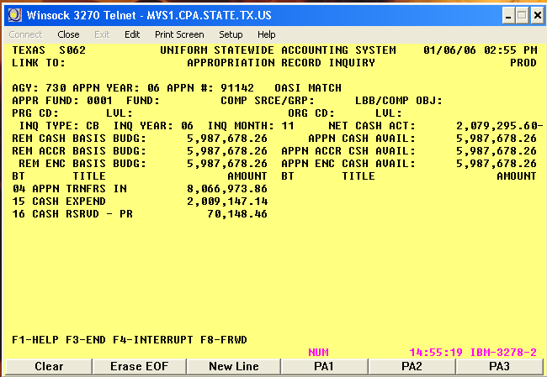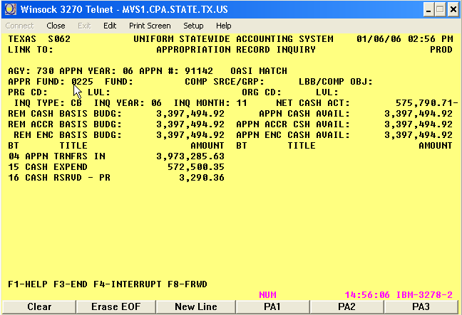

2. Prepare a chart displaying the expenses for both state funds and calculate the proportions

Appn # | Expenses | Reserved | Total fund 0001 | Expenses | Reserved | Total fund 0225 | Total Amt Benefits | Date
91142 | 2,009,147.14 | 70,148.46 | 2,079,295.60 | 572,500.35 | 3,290.36 | 575,790.71 | 2,655,086.31 | 11/30/2005
 |  | Actual % | 78.31% |  |  | 21.69%
 |  |  | Fund 0001 | Fund 0225 |  | Total Amount
APS011 FY05 % |  |  | 68.00% | 32.00%
 |  |  | 1,805,458.69 | 849,627.62 |  | 2,655,086.31
FICA Adjustment (Exp. Transfer) |  |  | (273,836.91) | 273,836.91
USAS entry: |  |  | T-Code FD 1 | T-Code FD 2 | COBJ | APPN | PCA
 |  |  | 407 | 408 | 7043 | 91142 | 03991
Batch Type 8 | Batch Mode 2 | Doc Type J

PS Entry |  |  |  |  |  |  |  | 273,836.91
Dr | 51109 | 1072 | A0279 | H0437 | NA | BP200X | 273,836.91
Cr | 10500 | 1072 |  |  |  | BP200X |  | 273,836.91
Dr | 10500 | 1022 |  |  |  | BP200X | 273,836.91
Cr | 51109 | 1022 | A0295 | H0437 | NA | BP200X |  | 273,836.91

Return to Table of Contents Return to ORP Benefits
ORP Benefits UH and UHSA - O0 & O1

For Business Unit 00783, the state Optional Retirement Plan (ORP) benefits represent the employer contribution paid with only general revenue fund 0001. For Business Unit 00730, the ORP benefits represent the employer contribution paid with general revenue fund 0001 and general revenue dedicated fund 0225. The share of fund 0001 and 0225 is based on the Method of Finance calculations found in APS 011. Our payroll system posts almost all payroll expenses to fund 0001. A manual entry is completed at the beginning of each month to transfer the expenses from fund 0001 to fund 0225 according to the previous year proportions of APS 011. The proportions are adjusted during the year according to the Method of Finance calculations for the current year.

The allocation of expense benefits between fund 0001 and 0225 is as follows:

1. Go to the appropriation record inquiry screen 62 in USAS and see the expenses for fund 0001 and 0225.

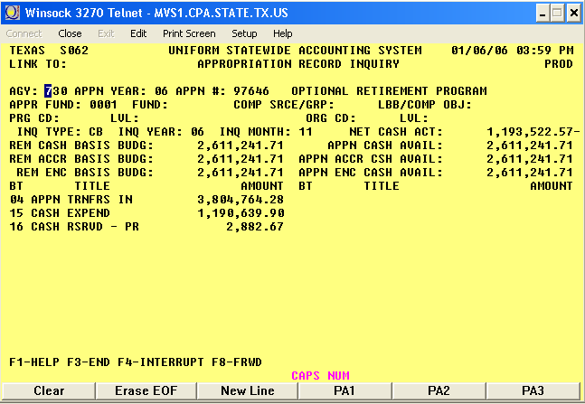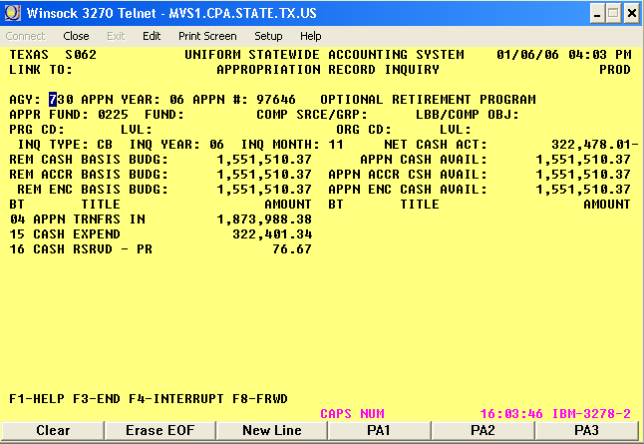

2. Prepare a chart displaying the expenses for both state funds and calculate the proportions

Appn # | Expenses | Reserved | Total fund 0001 | Expenses | Reserved | Total fund 0225 | Total Amt Benefits | Date
91142 | 1,190,639.90 | 2,882.67 | 1,193,522.57 | 322,401.34 | 76.67 | 322,478.01 | 1,516,000.58 | 11/30/2005
 |  | Actual % | 78.31% |  |  | 21.69%
 |  |  | Fund 0001 | Fund 0225 |  | Total Amount
APS011 FY05 % |  |  | 68.00% | 32.00%
 |  |  | 1,030,880.39 | 485,120.19 |  | 1,516,000.58
ORP Adjustment (Exp. Transfer) |  |  | (162,642.18) | 162,642.18
USAS entry: |  |  | T-Code FD 1 | T-Code FD 2 | COBJ | APPN | PCA
 |  |  | 407 | 408 | 7043 | 91142 | 03991
Batch Type 8 | Batch Mode 2 | Doc Type J

PS Entry |  |  |  |  |  |  |  | 162,642.18
Dr | 51110 | 1078 | H0437 | A0288 | NA | BP200X | 162,642.18
Cr | 10500 | 1078 |  |  |  | BP200X |  | 162,642.18
Dr | 10500 | 1021 |  |  |  | BP200X | 162,642.18
Cr | 51110 | 1021 | H0437 | A0294 | NA | BP200X |  | 162,642.18

Return to Table of Contents

TRS Benefits UH - T3 & T4

The appropriation for institutional teacher retirement state match paid with fund 1 is awarded to the Teacher Retirement System (TRS), which pays the employer’s contribution on our behalf. State Accounting transfers the budget authority to spend for fund 2 to appropriation 99323. According to APS 019, the budget authority must be entered into USAS no later than September 15 of each fiscal year to transfer sufficient appropriation authority for the upcoming fiscal year. This transaction must include transfers for all funds except GR from which payments will be made if the transaction is for an employee under TRS. A PCA must be established in USAS for Program Cost Account Profile (26) screen, which is derived from Program Code 3991. At year-end, return the excess appropriation authority prior to October 30 of each fiscal year. The retirement payment, like all the payroll benefits, is subject to the proportionality rules (APS 011).

UH needs to reimburse TRS for the amount TRS pays from GR for non-GR funded employees, according to APS 005. LDT TRS budget load: HB1,80th Leg,RS,ART III, p. 33, Rider 7

Agency receiving the budget authority
Receiving Agency | Appn# | Title
730/783 | 99323 | Higher Education TRS Retirement

Agency allocating the budget authority
 | Allocation Agency |  | Appn# |  | Title |  |  | PCA
 | 323 |  | 13009 |  | Higher Education TRS Retirement |  |  | 13100
Agency |  | T-Code |  | Appn |  | COBJ | Appn Fund/PCA |  | GL AC/AGY
730 |  | 416 |  | 99323 |  | 7909 | 0225/03991 |  | 32309600
323 |  | 417 |  | 96541 |  | 3790 | 0960/13100 |  | 73002250

USAS entries for a budget revision to request the funds in the state - Agency 730

PS entries recorded to match the entry in USAS - Business Unit 00730

See USAS and PS entries for Benefit Programs section to see the USAS and PS entries

To match the retirement contribution payments from funds held in the treasury to TRS as reimbursement from other E&G the entry should be as follows:

TRS monthly payments are processed by issuing a state voucher using the RTI provided by TRS - Agency 730

Agency | T-Code/Description | Appropriation | COBJ | Approp. Fund/ Agy Fund/PCA
730 | 485/RTI – Estab Interagency Accr’d Expend Reimb | 99323/TRS – Other E&G | 7909 | 0225/0225/03991

PS entries to reduce expenses and revenues on fund 1 for the amount of the payment on fund 2 – BU Unit 00730

 |  | University of Houston System  JOURNAL ENTRY DETAIL
  Header BU: | 00730
  Fiscal Year: | 2006
  Acctg Period: | 9
  Run Date: | 10/30/2006
  Run Time: | 02:37:38

Journal ID: | STJ0161320 | Reversal: | None | Ledger Group: | ACTUALS
Date: | 05/08/2006 | Reversal Date: |  | Created By: | BANKSDA
Source: | ACS | Budget Adjust Type: | Actuals | Post Date: | 05/08/2006
Header Ref: | J0161320 | Edit / Hdr Status: | Posted | BCM Status: | Valid
Description: | T3- TRS fund 0225 payment for April 2006 for FY06. Entry to TRS fund 0001 (1036) reduces the expenses for the amount paid with fund 0225 (1075). |  |  | BCM Bypass: | N

Line # | Account | Line BU | Fund | DeptId | Prog | Bdgt Ref. | Project | Line Ref | Chart.1 | Line Description | Amount
1 | 51111 | 00730 | 1036 | H0437 | A0298 | BP2006 | NA | J0161320 |  | RVS FUND 1- PAYING W/FUND 2 | -119,672.51
2 | 41307 | 00730 | 1036 | H0437 | A0298 | BP2006 | NA | J0161320 |  | RVS FUND 1- PAYING W/FUND 2 | 119,672.51

Return to Table of Contents

Bond Payment – Debt Service - B1

Most of our interest payments on Debt Services are processed twice a year and the principal once a year. The information for all the payments comes from the UH System Treasury Office and the State Accounting department processes the payments with the state funds. For these types of Debt Service programs, the steps are as follows:

1 | Budget Office tells the Treasury Office which type of funds (local or state) to use for Bond payments.
2 | When Treasury Office receives the invoices from the paying agency, the invoices are emailed to Plant Accounting and State Accounting.
3 | State Accounting issues a state voucher to pay the paying agency for interest and/or principal.
4 | The state voucher issues a warrant that is sent to UH Treasury.
5 | The Treasury Office sends the warrant to the paying agency to be deposited into the trustee custodian account.
6 | The paying agency makes the payment to the bond holders on the payment due date.
7 | A confirmation that the payment to the paying agency has been made comes to the Treasury Office and is emailed to Plant Accounting.
8 | Plant Accounting reclassifies the expense account to a mandatory transfer account between the ledger 1 and the ledger 7.
9 | Since the check is sent prior to the due date, the funds deposited during that time are invested and earn interest.
10 | State Accounting deducts the interest earned from the following invoice when issuing the state voucher.

 | ACCOUNT | FUND CODE | DEPT | PROG | PROJ | Dr. | Cr. | 1026/54707-54709 | 10500/1026 | 1026/F0274/37314 | 7058/34102 | 7058/33100
3 | State Accting issues state voucher
Dr. | 54707 | 1026 | HXXXX | XXXX | NA | 100.00 |  | 100.00
Dr. | 54709 | 1026 | HXXXX | XXXX | NA | 100.00 |  | 100.00
Cr. | 10500 | 1026 |  |  |  |  | 200.00 |  | (200.00)
8 | Plant Accting Reclassification
Dr. | 37314 | 1026 | H0264 | F0274 | NA | 200.00 |  |  |  | 200.00
Cr. | 54707 | 1026 | H0264 | F0274 | NA |  | 100.00 | (100.00)
Cr. | 54709 | 1026 | H0264 | F0274 | NA |  | 100.00 | (100.00)
Dr. | 34102 | 7058 | H0256 | XXXX | NA | 200.00 |  |  |  |  | 200.00
Cr. | 33100 | 7058 | H0256 | XXXX | NA |  | 200.00 |  |  |  |  | (200.00)
Balances on the account-cost center |  |  |  |  |  |  |  | 0.00 | (200.00) | 200.00 | 200.00 | (200.00)

PS Entries in February FYXX - Business Unit 00730

BANK OF NEW YORK (state warrant)

Voucher Coversheet
Business Unit: | 00730 | PO ID:
Voucher ID: | 00600055
Vendor ID: | 0000001425
Name: | BANK OF NEW YORK
Address: | 1
10161 CENTURION PKWY 3RD FLR
TOWERMARC PLAZA
 | JACKSONVILLE FL 322560530
 | USA
Invoice ID: | CRB 1999 - 02/15/06
Contract ID:
Invoice Receipt Date: | 01/19/2006 | Invoice Date: | 01/19/2006
Goods Receipt Date: | 01/19/2006 | Acceptance Date: | 01/19/2006
PCC: | 9
Bank: | STATE
Scheduled Due Date: | 01/19/2006
Gross Amount: | $719,411.31

Old Voucher Comments:
New Voucher Comments: | B1 - Semi-Annual Debt Service payment required by the board of regents of the University of Houston System. Consolidated revenue bonds series 1999. Debt service - February 15, 2006.
Payment Comments: | Due to Bank of New York by February 15, 2006.

Handling: | SH
Budget Check: | Valid Budget Check | Source:

Acct./Desc. | Fund |  | Dept. | Prog. | Bud. Ref. | Proj. | Chartfield 1 | Amount | Description
54709 | 1026 |  | H0602 | F0274 | BP2006 | NA |  | 493,063.00 | CRB 1999 - 02/15/06
principal payment - capital bo
54707 | 1026 |  | H0602 | F0274 | BP2006 | NA |  | 226,348.31 | CRB 1999 - 02/15/06
interest expense-capital borro
Signatures |  | ___________________________________ |  |  |  |  | Date | __________________________________
PS Approval: |  | ___________________________________ |  |  |  |  |  | __________________________________

Created By: Perez,Irma - UH | Date Printed: 05/22/2006 | Acctg. Dt.: 01/19/2006

Change the due date to the same date the voucher is being issued to obtain the state warrant as soon as possible so it can be sent to the paying agency. Click the “Separate Payment” box so a check is issued separately.

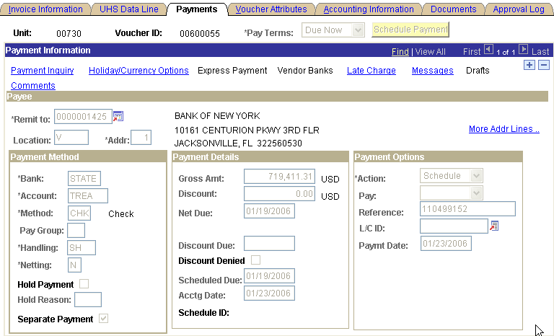

WELLS FARGOBANK (TEXAS) NA (state warrant)

Voucher Coversheet
Business Unit: | 00730 | PO ID:
Voucher ID: | 00599596
Vendor ID: | 0000042407
Name: | WELLS FARGO BANK (TEXAS) N A
Address: | 1
T5001-061 Mac
1000 Louisiana St 6th Fl
 | Houston TX 77002-5005
 | USA
Invoice ID: | CRB 2002A - 02/15/06
Contract ID:
Invoice Receipt Date: | 01/18/2006 | Invoice Date: | 01/18/2006
Goods Receipt Date: | 01/18/2006 | Acceptance Date: | 01/18/2006
PCC: | 9
Bank: | STATE
Scheduled Due Date: | 01/19/2006
Gross Amount: | $2,874,780.36

Old Voucher Comments:
New Voucher Comments: | B1 - Semi-Annual Debt service payment required by the board of regents of the University of Houston System. Consolidate revenue bonds, series 2002A. Debt service due February 15,2006.
Payment Comments: | Due to Wells Fargo Bank (Texas) NA by February 15,2006.

Handling: | SH
Budget Check: | Valid Budget Check | Source:

Acct./Desc. | Fund |  | Dept. | Prog. | Bud. Ref. | Proj. | Chartfield 1 |  | Amount |  | Description
54709 | 1026 |  | H0602 | F1700 | BP2006 | NA |  |  | 1,930,000.00 |  | CRB 2002A - 02/15/06
principal payment - capital bo
54707 | 1026 |  | H0602 | F1700 | BP2006 | NA |  |  | 944,780.36 |  | CRB 2002A - 02/15/06
interest expense-capital borro
Signatures |  | ___________________________________ |  |  |  |  |  | Date |  | __________________________________
PS Approval: |  | ___________________________________ |  |  |  |  |  |  |  | __________________________________

Created By: Perez,Irma - UH | Date Printed: 05/22/2006 | Acctg. Dt.: 01/18/2006

Change the due date to the same date the voucher is being issued to obtain the state warrant as soon as possible so it can be sent to the paying agency. Click the “Separate Payment” box so a check is issued separately.

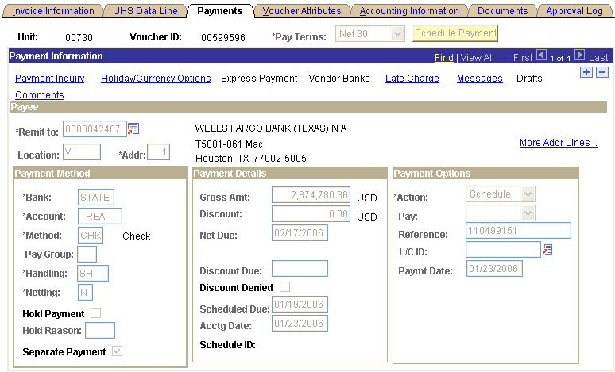

PS Entries in August FYXX - Business Unit 00730

BANK OF NEW YORK (state warrant)

Form Fund Dept Progr Proj BP Account dr/cr
Voucher 1026 H0602 F0274 NA BP200x 54707 Debit

VENDOR # ADDRESS PCC HANDLING
0000001425 1 9 SH

Invoice ID: CRB 1999 (Type Bond series number)

Voucher Comments: Semi-Annual debt service payment required by the Board of Regents of the University of Houston System. Consolidated Revenue Bonds, series xxxxx, Debt Service – August 15, 200X.

Payment Comments: Due to Bank of New York by August 08, 200X

WELLS FARGOBANK (TEXAS) NA (state warrant)

Form Fund Dept Progr Proj BP Account dr/cr
Voucher 1026 H0602 F1700 NA BP200x 54707 Debit

VENDOR # ADDRESS PCC HANDLING
0000042407 1 9 SH

Invoice ID: CRB 2002A (Type Bond series number)

Voucher Comments: Semi-Annual debt service payment required by the Board of Regents of the University of Houston System. Consolidated Revenue Bonds, series xxxxx, Debt Service – August 15, 200X.

Payment Comments: Due to Wells Fargo by August 15, 200X

One of our interest payments on Debt Services is processed on a monthly basis (CRB 2004). The information for all the payments comes from the UH System Treasury Office and the State Accounting department processes the payments with local funds. For this type of Debt Service program, the steps are as follows:

1 | Budget Office tells the Treasury Office which type of funds (local or state) to use for Bond payments. CRB 2004 is paid with local funds.
2 | When Treasury Office receives the invoices from the paying agency, the invoices are emailed to Plant Accounting and State Accounting.
3 | Plant Accounting issues a local voucher to pay the paying agency.
4 | State Accounting issues a state voucher to obtain the reimbursement from the State for interest and/or principal.
5 | The state voucher issues a warrant that is sent to UH Treasury.
6 | The warrant from the state comes to the Treasury Office and is deposited into the local bank.
7 | General Accounting enters a journal entry to records the deposit of the warrant from the state into the local bank and cost center.
8 | A confirmation that the payment to the vendor has been made comes to the Treasury Office and is emailed to Plant Accounting.
9 | Plant Accounting reclassifies the expense account to a mandatory transfer account between the ledger 1 and the ledger 7.
10 | The check issued to pay the paying agency is deposited into a trustee custodian account and from there the bond holders are paid on the due date.
11 | Since the check is sent prior to the due date, the funds deposited during that time are invested and earn interest.
12 | State Accounting deducts the interest earned from the following invoice when issuing the state voucher.

 | ACCOUNT | FUND CODE | DEPT | PROG | PROJ | Dr. | Cr. | 2080/F0275 | 10510/BANK | 1026/F0274/54707 | 10500/1026 | 1026/F0274/37314 | 7058/34102 | 7058/33100
3 | Plant Accting issues a local voucher
Dr. | 54707 | 2080 | H0264 | F0275 | NA | 100.00 |  | 100.00
Cr. | 10510 | BANK |  |  |  |  | 100.00 |  | (100.00)
4 | State Accting iIssues state voucher
Dr. | 54707 | 1026 | H0264 | F0274 | NA | 100.00 |  |  |  | 100.00
Cr. | 10500 | 1026 |  |  |  |  | 100.00 |  |  |  | (100.00)
7 | Record the deposit into the local bank
Dr. | 10510 | BANK |  |  |  | 100.00 |  |  | 100.00
Cr. | 54707 | 2080 | H0264 | F0275 | NA |  | 100.00 | (100.00)
9 | Plant Accting Reclassification
Dr. | 37314 | 1026 | H0264 | F0274 | NA | 100.00 |  |  |  |  |  | 100.00
Cr. | 54707 | 1026 | H0264 | F0274 | NA |  | 100.00 |  |  | (100.00)
Dr. | 34102 | 7058 | H0256 | XXXX | NA | 100.00 |  |  |  |  |  |  | 100.00
Cr. | 33100 | 7058 | H0256 | XXXX | NA |  | 100.00 |  |  |  |  |  |  | (100.00)
Balances on the account-cost center |  |  |  |  |  |  |  | 0.00 | 0.00 | 0.00 | (100.00) | 100.00 | 100.00 | (100.00)

PS state voucher to reimburse the monthly interest payments for CRB 2004 - Business Unit 00730

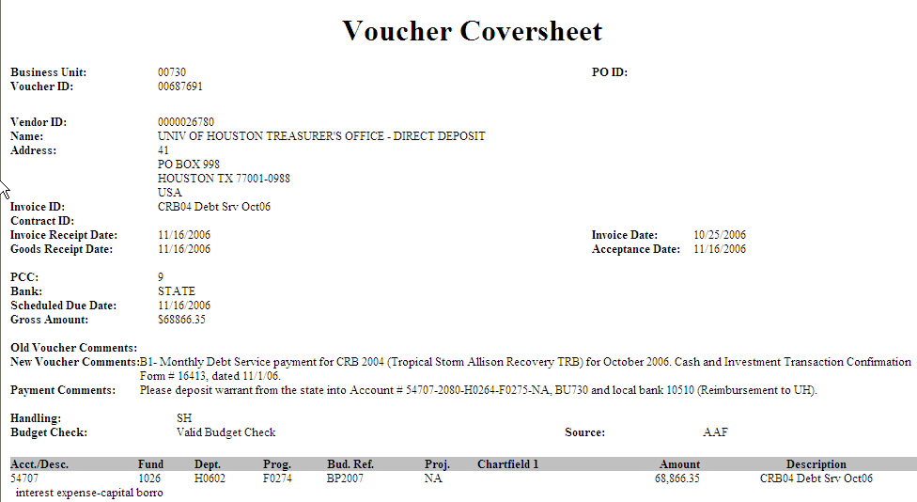

Payment panel showing the the method of payment.

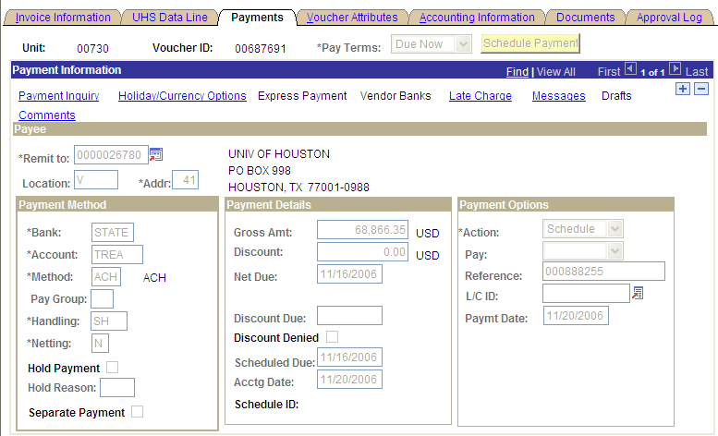

To check for the payment status in PS run the query named UHS_AP_ACCTG_LINE

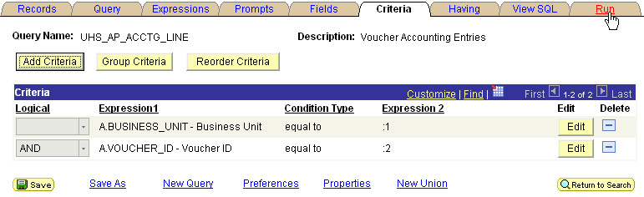

- Click run to run the query

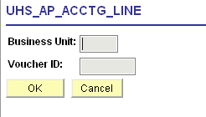

- Enter the Business Unit and Voucher ID and click OK
- Download the results to Excel
- Sort the results by accounts
- Print out the results and attach to the voucher
- Go to USAS screens 86 and enter the voucher ID by substituting the first zero for a 9 follow by the next 7 digits of the voucher number to get the warrant information
- Go to USAS screen 88 entering the voucher payment due date and print out the information that contains the liquidating TC
- Print out both USAS screens (86 and 88) and attach them to the voucher

Return to Table of Contents

Unemployment Compensation Insurance Reimbursement - U0

Texas Workforce Commission sends a report on a quarterly basis for all reimbursable unemployment benefits to the Payroll Department. The Payroll Department sends State Accounting a spreadsheet detailing the reimbursement needed for all campuses and the local vouchers prepared by Payroll reimbursing the state for UH and UHSA.

1. Unemployment compensation is paid by the Texas Workforce Commission. A portion of that payment is reimbursed 100% from local funds and another portion is reimbursed 50% from state funds. For the 100% reimbursement to the TWC, a local voucher is issued by the Payroll Department payable to the Comptrollers using the direct deposit address number 6. The payment is deposited into the direct deposit refunds to state holding appropriation. Then, State Accounting records the following entries in USAS in 783 and 730 using user class number 61.

USAS entries depositing 100% payment to Agency 320 (Texas Workforce Commission) - Agency 730

Form Batch Type Edit Mode AGY
Deposit Type 2 1 320

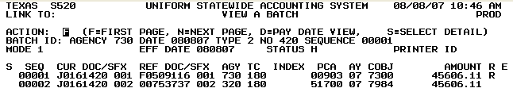

Unit | Curr Doc Num | Batch date | Comptroller Obj | Approp Num | Fund | Appropriat Yr | Fiscal Year | Transaction Cd | Sum Trans Amt | Ref Doc Num | HX Per | Reverse | PCA
00783 | J0161420 | 2007-08-08 | 7984 | 00903 | 0001 | 04 | 04 | 180 | 45,606.11 | F0509116 | 8 | R | 00903
00783 | J0161420 | 2007-08-08 | 7984 | 13004 | 0165 | 04 | 04 | 180 | 45,606.11 | 00753737* | 8 |  | 51700

Local Voucher number

USAS entries depositing 100% payment to Agency 320 (Texas Workforce Commission) - Agency 783

Form Batch Type Edit Mode AGY
Deposit Type 2 1 320

Unit | Curr Doc Num | Batch date | Comptroller Obj | Approp Num | Fund | Appropriat Yr | Fiscal Year | Transaction Cd | Sum Trans Amt | Ref Doc Num | HX Per | Reverse | PCA
00783 | J0042052 | 2006-02-18 | 7984 | 00903 | 0001 | 04 | 04 | 180 | 5,866.00 | F0209115 | 6 | R | 00903
00783 | J0042052 | 2006-02-18 | 7984 | 13004 | 0165 | 04 | 04 | 180 | 5,866.00 | 00018724* | 6 |  | 51700

2. Do the following entries for the 50% payment to TWC with state funds in USAS in 783 and 730:

USAS entries for the payment of the 50% to TWC - Agency 730

Form Batch Type Edit Mode
Deposit Type 2 1
Unit | Curr Doc Num | Batch date | Comptroller Obj | Approp Num | Fund | Appropriat Yr | Fiscal Year | Transaction Cd | Sum Trans Amt | Ref Doc Num | HX Per | Reverse | PCA
00730 | T0161210 | 2006-02-18 | 7984 | 10730 | 0001 | 04 | 04 | 485 | 21,443.75 | T0161210 | 6 |  | 03701

PS entries for the 50% payment to TWC - Business Unit 00730
 |  |  | University of Houston System  JOURNAL ENTRY DETAIL
  Header BU: | 00730
  Fiscal Year: | 2006
  Acctg Period: | 6
  Run Date: | 07/09/2005
  Run Time: | 09:09:08

Journal ID: | STT0161200 | Reversal: | None | Ledger Group: | ACTUALS
Date: | 02/18/2006 | Reversal Date: |  | Created By: | NGUYENTB
Source: | ACS | Budget Adjust Type: | Actuals | Post Date: | 02/19/2006
Header Ref: | T0161200 | Edit / Hdr Status: | Posted | BCM Status: | Valid
Description: | Unemployment Compensation Insurance Reimb. for 4th quarter ended 12/31/03, 50% reimb. from General Revenue Funds for UH shares and State paid. |  |  | BCM Bypass: | N

Line # | Account | Line BU | Fund | DeptId | Prog | Bdgt Ref. | Project | Line Ref | Chart.1 | Line Description | Amount
1 | 41303 | 00730 | 1029 | H0264 | F0281 | BP2004 | NA |  |  | UNEMPLOY COMP - FD1 ST PD | -21,443.75
2 | 10500 | 00730 | 1029 |  |  | BP2004 |  |  |  | STATE BANK | 21,443.75
3 | 54566 | 00730 | 1029 | H0264 | F0281 | BP2004 | NA |  |  | UNEMP COMP INS CLAIMS - ST PD | 21,443.75
4 | 10500 | 00730 | 1029 |  |  | BP2004 |  |  |  | STATE BANK | -21,443.75
5 | 54564 | 00730 | 1026 | H0264 | F0284 | BP2004 | NA |  |  | UNEMPLOYMENT COMP CLAIMS | 21,443.75
6 | 10500 | 00730 | 1026 |  |  | BP2004 |  |  |  | STATE BANK | -21,443.75

Totals for Journal: STT0161200 | Total Lines: 6 | Total Base Debits: 64,331.25 | Total Base Credits: 64,331.25

Note: The entry to fund code 1026 relates to the UH payment in USAS using appn 10730/0001. The entries to fund code 1029 relate to the 50% paid by the Texas Workforce Commission (AGY 320) on our behalf, per APS 003.

USAS entries for the 50% payment to TWC - Agency 783

Form Batch Type Edit Mode
Deposit Type 2 1
Unit | Curr Doc Num | Batch date | Comptroller Obj | Approp Num | Fund | Appropriat Yr | Fiscal Year | Transaction Cd | Sum Trans Amt | Ref Doc Num | HX Per | Reverse | PCA
00783 | T0042053 | 2006-02-18 | 7984 | 10783 | 0001 | 04 | 04 | 485 | 608.50 | T0042053 | 6 |  | 03007

PS entries for the 50% payment to TWC - Business Unit 00783
 |  |  | University of Houston System  JOURNAL ENTRY DETAIL
  Header BU: | 00783
  Fiscal Year: | 2006
  Acctg Period: | 6
  Run Date: | 07/09/2006
  Run Time: | 09:12:58

Journal ID: | STT0042053 | Reversal: | None | Ledger Group: | ACTUALS
Date: | 02/18/2006 | Reversal Date: |  | Created By: | NGUYENTB
Source: | ACS | Budget Adjust Type: | Actuals | Post Date: | 02/19/2006
Header Ref: | T0042053 | Edit / Hdr Status: | Posted | BCM Status: | Valid
Description: | Unemployment Compensation Insurance Reimb. 4th quarter ended 12/31/03, 50% reimb. from General Revenue Funds for UH shares and state paid. |  |  | BCM Bypass: | N

Line # | Account | Line BU | Fund | DeptId | Prog | Bdgt Ref. | Project | Line Ref | Chart.1 | Line Description | Amount
1 | 41303 | 00783 | 1029 | S0027 | F0225 | BP2004 | NA |  |  | UNEMPLOY COMP - FD1 ST PD | -608.50
2 | 10500 | 00783 | 1029 |  |  | BP2004 |  |  |  | STATE BANK | 608.50
3 | 54566 | 00783 | 1029 | S0027 | F0225 | BP2004 | NA |  |  | UNEMP COMP INS CLAIMS - ST PD | 608.50
4 | 10500 | 00783 | 1029 |  |  | BP2004 |  |  |  | STATE BANK | -608.50
5 | 54564 | 00783 | 1016 | S0027 | F1009 | BP2004 | NA |  |  | UNEMPLOYMENT COMP CLAIMS | 608.50
6 | 10500 | 00783 | 1016 |  |  | BP2004 |  |  |  | STATE BANK | -608.50

Totals for Journal: STT0042053 |  | Total Lines: 6 | Total Base Debits: 1,825.50 |  |  | Total Base Credits: 1,825.50
Signatures | ___________________________________ |  |  | Date | __________________________________
PS Approval: | ___________________________________ |  |  |  | __________________________________

Created By: NGUYENTB | Date Printed: 07/09/2006 | Jrnl. Dt.: 02/18/2006

Note: The entry to fund code 1016 relates to the payment in USAS with appn 10783/0001. The entries to fund code 1029 relate to the 50% paid by the Texas Workforce Commission (AGY 320) on our behalf, per APS 003.

Return to Table of Contents

WCI Benefits (Worker Compensation Insurance – State Office of Risk Management - SORM) - W0

Workers’ compensation is paid under an Interagency Contract between the State Office of Risk Management and the University of Houston System.

The purpose of this Interagency Contract is to state the terms and conditions under which the University of Houston System will receive risk management services and workers’ compensation coverage for its employees in compliance with the Texas Labor Code Chapter 412 and Chapter 501.

Each campus will pay SORM an amount assessed for the services provided in accordance with 28 T.A.C. 251.507. University of Houston System will have no liability to SORM for risk management services or workers’ compensation losses in excess of the assessment during the covered fiscal year.

Payment of the sums due under this interagency contract will be made in accordance with APS 014. The payments are made from funds held or controlled by us in the same proportion as the composition of the salaries paid in accordance with GAA, 80th Legislature, article IX, section 15.02, subsection (c), p. 66.

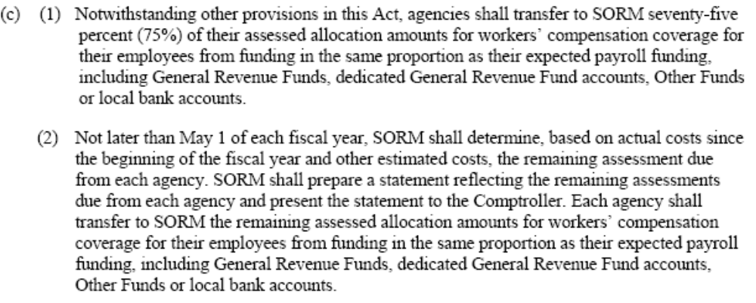

SORM requires us to inform the funding sources from which we have made the payments according to subsection (k), pg 44 of the same citation above.

To make the payments for the current year, the State Accounting Department receives a copy of the memo from the Environmental Health & Risk Management Department sent to the State Office of Risk Management (SORM) specifying the amount to be paid for agencies 730 (UH) and 783 (UHSA). The memo is attached to the contract between SORM and the University of Houston. To process the payment do the following:

- Run the query shown below to get the payroll data for the prior year (e.g., FY07 payments use payroll data from FY06).

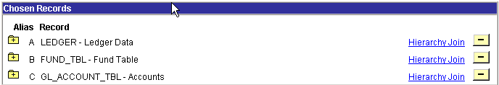

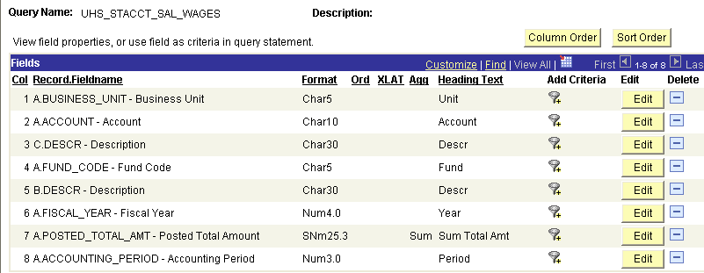
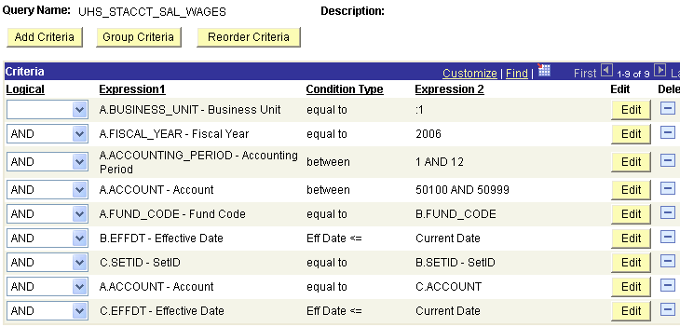

Note: The query results will show state and local funds. For the ledger 7 state fund codes, copy and paste the data and include them with the rest of the state ledger 1 fund codes. Also, according to the definitions in the Cost Allocation Assessment Form, do not include longevity (50112 and 50116), overtime (50111), and hazardous duty (50110) accounts.

- Sort the file by account number
- Separate fund 1 from fund 2
- Subtotal state funds 1 and 2 and local funds (agency 783 does not have fund 2)
- Calculate the percentage between those funds
- Apply the percentage for each fund group to the amount to be paid
- Make the payments from the state fund 1 and 2 and local funds

University of Houston - Agency 730 | Payroll Funding | Percentage | FY07 Assessment Invoice
General Revenue (Fund 0001) | 130,103,707.09 | 43.41% | 378,701.67
Dedicated General Revenue (Fund 0225) | 48,410,134.41 | 16.15% | 140,910.66
Local Funds | 121,161,982.27 | 40.43% | 352,674.39
Total amount payroll funding | 299,675,823.77 | 100.00% | 872,286.72
University of Houston System Administration - Agency 783 | Payroll Funding | Percentage | FY07 Assessment Invoice
General Revenue (Fund 0001) | 7,272,915.34 | 92.19% | 13,741.18
Local Funds | 615,775.69 | 7.81% | 1,163.42
Total amount payroll funding | 7,888,691.03 | 100.00% | 14,904.60
Do not include Overtime, Longevity, or Hazardous Duty in the calculation.

USAS entries to make payment to the SORM (agency 479) – Agency 730

Form Batch Type Edit Mode Doc Type
Journal Voucher Type 4 1 T

Note: Use the RTI number provided by SORM.

Unit | Curr Doc Num | Batch date | Comptroller Obj | Approp Num | Fund | Appropriat Yr | Fiscal Year | Transaction Cd | Sum Trans Amt | Ref Doc Num | HX Per | Reverse | PCA
00730 | T0161001 | 09/05/06 | 7947 | 10730 | 0001 | 06 | 06 | 225 | 378,701.67 | T0161001 | 1 |  | 03706
00730 | T0161001 | 09/05/06 | 7947 | 10730 | 0225 | 06 | 06 | 225 | 140,910.66 | T0161001 | 1 |  | 03706

PS entries to reflect the payment to SORM in USAS - Business Unit 00730
 |  |  | University of Houston System  JOURNAL ENTRY DETAIL
  Header BU: | 00730
  Fiscal Year: | 2007
  Acctg Period: | 1
  Run Date: | 09/12/2006
  Run Time: | 03:58:59

Journal ID: | STT0161001 | Reversal: | None | Ledger Group: | ACTUALS
Date: | 09/01/2006 | Reversal Date: |  | Created By: | BANKSDA
Source: | ACS | Budget Adjust Type: | Actuals | Post Date: | 09/05/2006
Header Ref: | T0161001 | Edit / Hdr Status: | Posted | BCM Status: | Valid
Description: | W0- State payment for SORM for FY07 based on payroll expenses from FY06. |  |  | BCM Bypass: | N

Line # | Account | Line BU | Fund | DeptId | Prog | Bdgt Ref. | Project | Line Ref | Chart.1 | Line Description | Amount
1 | 54565 | 00730 | 1026 | H0264 | F2663 | BP2007 | NA | T0161001 |  | SORM PAYMENT FOR FY07 FD1 | 378,701.67
2 | 10500 | 00730 | 1026 |  |  | BP2007 |  | T0161001 |  | STATE BANK | -378,701.67
3 | 54565 | 00730 | 1054 | H0264 | F2663 | BP2007 | NA | T0161001 |  | SORM PAYMENT FOR FY07 FD2 | 140,910.66
4 | 10500 | 00730 | 1054 |  |  | BP2007 |  | T0161001 |  | STATE BANK | -140,910.66

Note: The cost center to use to record the payment from the state funds for BU 00783 is: 1016-S0027-F1011-NA. The appropriation number and fund in USAS is: 10783/0001. UHSA (AGY 783) is a single funded agency. The cost center to use for the payment with the local funds in BU 00783 is: 2061-S0027-F0747-NA.
The local portion is paid with a local voucher – BU 00730

Voucher Coversheet
Business Unit: | 00730 | PO ID:
Voucher ID: | 00664570
Vendor ID: | 0000007873
Name: | TEXAS COMPTROLLER OF PUBLIC ACCOUNTS TREASURY OPERATIONS
Address: | 3
State Office Of Risk Management
Attn: Belinda Hood
PO Box 13777
 | Austin TX 78711-3777
 | USA
Invoice ID: | SORM- 9/1/06
Invoice Receipt Date: | 09/01/2006 | Invoice Date: | 09/01/2006
Goods Receipt Date: | 09/01/2006 | Acceptance Date: | 09/01/2006
PCC: | 9
Bank: | CHASH
Scheduled Due Date: | 09/01/2006
Gross Amount: | $352,674.39

Old Voucher Comments:
New Voucher Comments: | Purpose/Benefits: W0- SORM payment for FY07 (Interagency contract- UH).
Payment Comments:

Handling: | EN
Budget Check: | Valid Budget Check | Source: | AAF

Acct./Desc. | Fund | Dept. | Prog. | Bud. Ref. | Proj. | Chartfield 1 | Amount | Description
54563 | 2061 | H0264 | F1040 | BP2007 | NA |  | 352,674.39 | SORM PAYMENT- FY07
worker's comp claims

Note: Notify State Office of Risk Management (SORM) about the specific funding according to GAA, 80th Legislature, article IX, section 15.02, subsection (c), p. 66 mentioned above.

Return to table of Contents
Refund to State

Refund for Payroll Credit - R0

The refund for Payroll Credit is a reimbursement to the state appropriations for payroll reallocation of expenses. This refund is done for all the campuses from the System Administration Business Unit 00783. The summary and appropriation fund worksheets from the reimbursement file received from the Financial System Department (payroll file) is printed for all business units 00730, 00759, 00765, 00783, and 00784 that have refunds to state.

The tasks are as follows:

- Check the total amount of FICA and ORP on the appropriation fund worksheet and verify that the amount on the detail file and summary worksheet are the same
- From the total amount of the reimbursement file, the FICA and ORP portion is subtracted to be recorded in a specific cost center (see list below)
- Issue Deposit Slip(s) for each campus and document number and email to Treasury Department (UH). Use the document number(s) listed in the payroll file as the number for the deposit slip. The checks issued to the Texas Comptroller of Public Accounts for the total amount of the reimbursement file is deposited into the appropriation number(s) in USAS for each one of the campuses
- Scan back up documentation (summary, appropriation fund, and detail worksheet from the payroll file, deposit ticket(s)) and upload image into PS
- Submit voucher to workflow for approval
- Copy image file from the Z drive to email the information as an attachment to each of the other campus

The example below is for a refund to state from BU 00783

Summary Worksheet
Sum of Trans Amt
Appropriat Yr | Batch Agency | Batch date | Batch Number | Voucher | Cycle Type | Total
06 | 783 | 2006-08-15 | 543 | 09608226 | Off | 13,070.40
 |  |  |  | 09608228 | Off | 910.75
 |  |  | 543 Total |  |  | 13,981.15
 | 783 Total |  |  |  |  | 13,981.15
06 Total |  |  |  |  |  | 13,981.15
Grand Total |  |  |  |  |  | 13,981.15

Appropriation-Fund Worksheet
Sum of Trans Amt
Approp - Fund | Account | Total
91142-0001 | 51109 | 910.75
91142-0001 Total |  | 910.75 | FICA
96243-0001 | 50104 | 13,030.40
 | 50112 | 40.00
96243-0001 Total |  | 13,070.40
Grand Total |  | 13,981.15

Total Amt | 13,981.15
FICA | (910.75)
Total Amt Payroll | 13,070.40

PS local voucher to reimburse the expenses to state treasury - Business Unit 00783

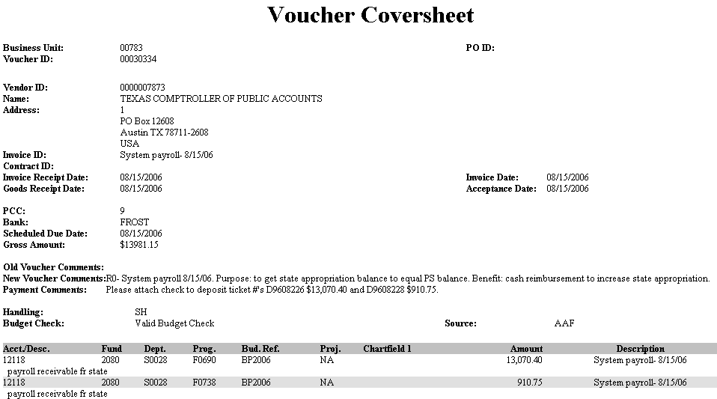

The list of cost centers to use for each campus is as follows.

Campus | Type | Fund Code | Dept Code | Program Code | Project Code
UH | Pyrll | 2080 | S0028 | F0687 | NA
UH | FICA & ORP | 2080 | S0028 | F0735 | NA
UHCL | Pyrll | 2080 | S0028 | F0688 | NA
UHCL | FICA & ORP | 2080 | S0028 | F0736 | NA
UHD | Pyrll | 2080 | S0028 | F0689 | NA
UHD | FICA & ORP | 2080 | S0028 | F0737 | NA
SYS | Pyrll | 2080 | S0028 | F0690 | NA
SYS | FICA & ORP | 2080 | S0028 | F0738 | NA
UHV | Pyrll | 2080 | S0028 | F0691 | NA
UHV | FICA & ORP | 2080 | S0028 | F0739 | NA

Return to Table of Contents

Refund to State - R1 – R5

We refund the state in the following cases:
1. Refunds from vendors for duplicate payments made with state funds and the check is sent to the Colleges (R1)
2. Refunds from vendors for duplicate payments made with state funds and the check is sent to the Accounts Payable Department. The refunds for overpayment from vendors coming to the Accounts Payable Department have two cases:
- Refund check is for the state funds only (R2)
- Accounts Payable requests a deposit slip from State Accounting and sends the back up documentation
- State Accounting issues and emails the deposit slip to A/P (the deposit slip number is the last seven digits of the PS entry number preceded by the letter “D”)
- Accounts Payable enters the PS entry to the department cost centers and the state bank for the amount to be deposited into the state funds
- Accounts Payable sends the check from the vendor and the deposit slip directly to the State Treasury Office
- State Accounting enters the deposit into USAS using the deposit slip number as the document number
- Refund check is for state and local combined (R1)
- Accounts Payable does the PS entry into the department cost center for state and local cost centers and the local bank
- Accounts Payable sends the check from the vendor directly to UH Treasury Office
- Accounts Payable sends the back up documentation and the PS entry to State Accounting
- State Accounting issues a local voucher using the clearing cost center
- State Accounting makes an entry in PS to the clearing cost center and the state bank
- State Accounting enters the deposit into USAS
3. Reallocation of expenses between state and local funds as a consequence of an error (R5)

All vouchers route through the Accounts Payable Department via workflow. The local vouchers reallocating expenses from state to local are made payable to the Comptrollers processed as Direct Deposits, which is a wire transfer of funds from UH local bank to the state bank. The vendor ID and address to use for the direct deposit is 0000026730 and 6 respectively. The direct deposit is recorded into a holding appropriation (00903 - TREAS DD Refund/Suspense Account) in USAS. From the holding appropriation a document type “J” and batch type “2” is prepared to transfer the funds to the correct appropriation.

The State Accounting Department receives an email from the State Treasury Office for all the direct deposits that have the information about the voucher numbers. State Accounting prints out the voucher coversheet and back up documentation for each local voucher from the PS System to make the necessary entries.
To know the direct payment number and the vouchers that have been paid with the same direct deposit number go to the PS path as follows:

1. Enter the voucher ID number
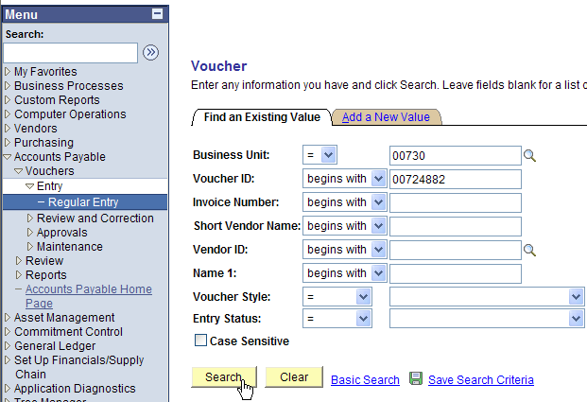

2. Click on Search and go to the Payments tab (notice that we do not have checked the separate payment box and the method of payment is “ACH”

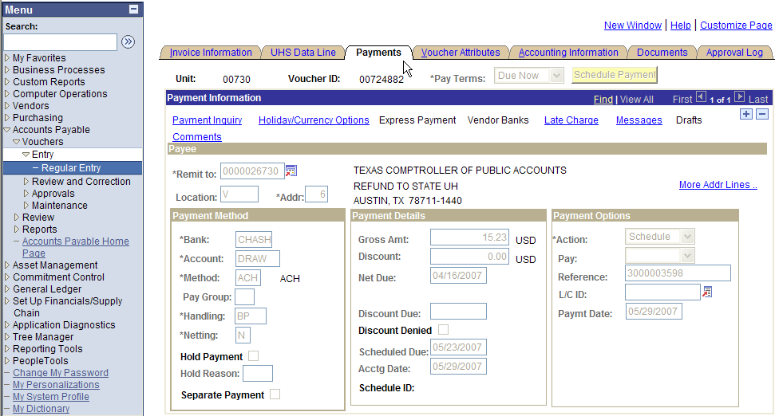
- Take a note of the direct payment number, which is the “Reference” number 3000003598
- Go to Payment Inquiry
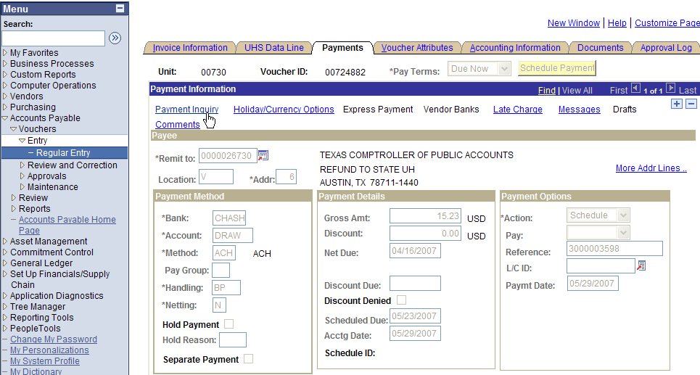

- Click on the “Payment Reference ID” to see all the vouchers paid with the same check number

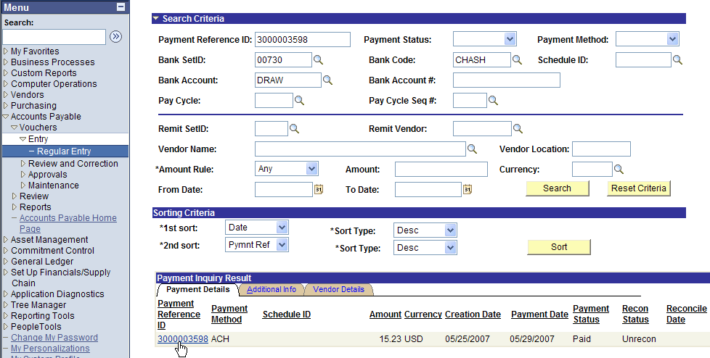

6. Direct Deposit number 3000003598 paid only voucher number 00724882 (see below).

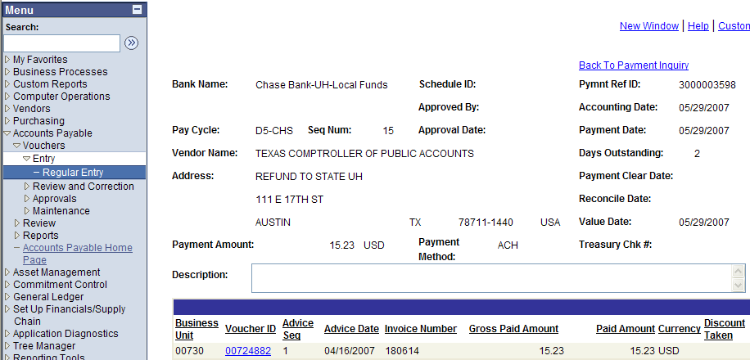

7. Group the vouchers paid by the same direct deposit and record an entry in PS and USAS as indicated in the instructions below.

R1 – 1 Refunds from vendors for duplicate payments made with state funds and the check is sent to the Colleges

For duplicate payments, the department receives a check from a vendor, prepares a cash receipt journal entry that debits the local bank and credits the state cost center(s), then forwards the entry to General Accounting via workflow. Treasury deposits the check into a local bank account. The process is as follows:

- The deposits recorded to the state cost center(s) and the local bank creates a balance in the claim on cash account (10100) in the state fund code(s) and the local bank that needs to be cleared. Below is an example of one of the entries.

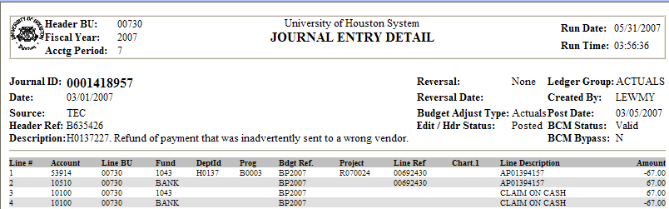

- To clear the balance on the claim on cash account State Accounting completes does the following:

Local voucher is prepared for the amount recorded into the state cost center and the local bank.

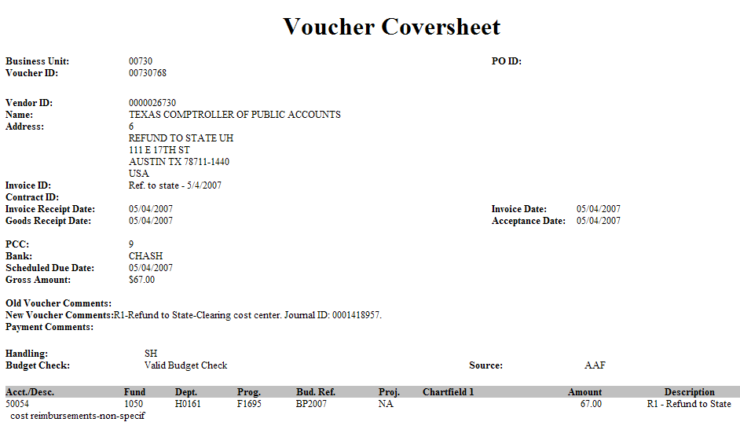

Note: Use PS account 50054 and the clearing cost center for all the R1 refunds to state. The PS account and clearing cost center is going to be offset with the PS journal entry to record the deposit in the state bank (see entry number ST01418957 below).

PS entries to record the refund to state for overpayment - Business Unit 00730

Journal Entry credits the State Accounting PS account 50054 and the clearing cost center to offset the debit done in the local voucher. For the cash entry, use the fund code that appears in the original journal entry issued by the Department and in this case the state fund code was 1043. The entries to the 10100 are generated by the system offsetting the original entries to the 10100 generated in the entry done by the department and AP journal entry from the local voucher.

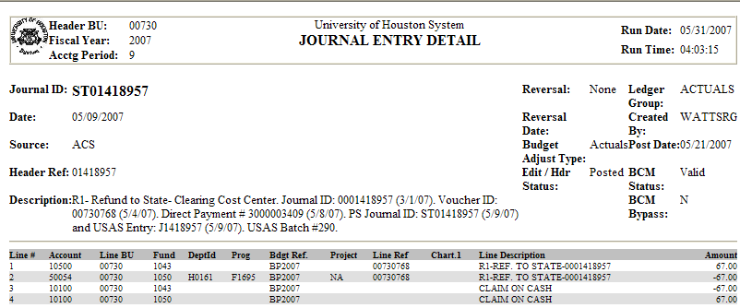

USAS entries to record the refund to state for overpayment - Agency 730

Form Batch Type Edit Mode Doc Type Vendor ID
Deposit Type 2 1 J Use vendor ID of the original payment in the 2nd line and UH vendor ID in the 1st line

Unit | Curr Doc Num | Batch date | Comptroller Obj | Approp Num | Fund | Appropriat Yr | Fiscal Year | Transaction Cd | Sum Trans Amt | Ref Doc Num | HX Per | Reverse | PCA
00730 | J1418957 | 2007-05-09 | 7300 | 00903 | 0001 | 07 | 07 | 180 | 67.00 | F0501268 | 9 | R | 00903
00730 | J1418957 | 2007-05-09 | 7380 | 13047 | 0001 | 07 | 07 | 180 | 67.00 | J1418957 | 9 |  | 03980

Note: See the back up documentation attached to the journal entry from the department to know the PCA, COBJ, fund, Vendor ID, and appropriation number and year. The first line of the entry in USAS reverses the refund from the holding appropriation (00903) having as a reference document number the direct deposit number F0501268. The second entry deposits the refunds into the appropriation requested by the Department.

To know the PCA to use follow the PS path below and click search

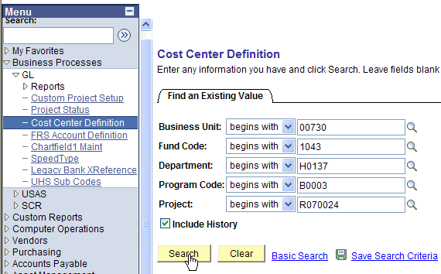

Check the PCA number and print out the screen to attach to the journal entry in PS

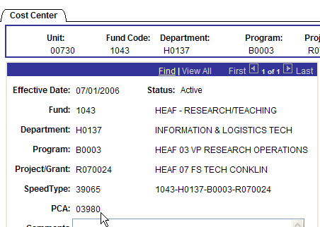

To know the COBJ to use follow the PS path below and click on the account.

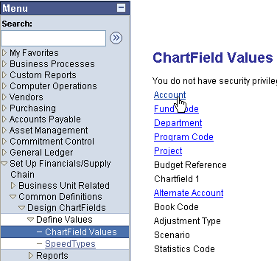

Enter the PS account number and click search.

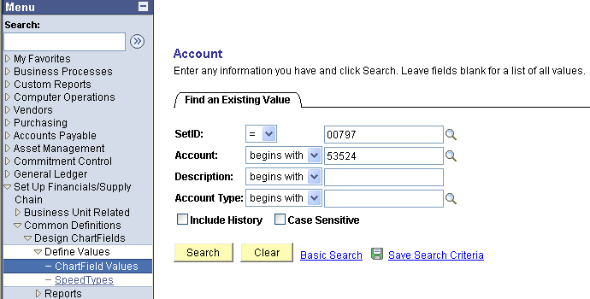

Choose the Map to Alternate Account tab and in this case the COBJ (Alt Account in PS) is 7470. Print out the the screen to attach to the journal entry in PS

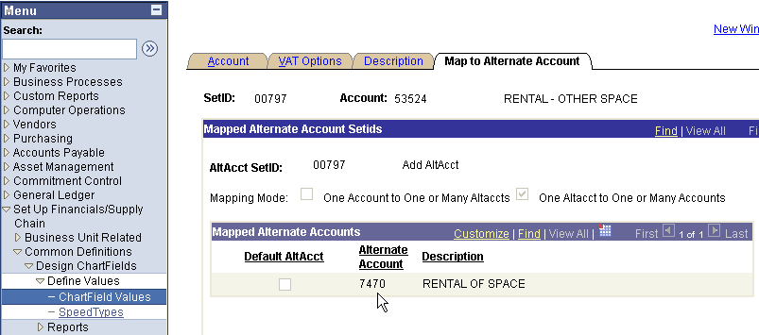

R2 – 2 There are refunds from vendors for duplicate payments made with state funds and the check is sent to the Accounts Payable Department. The refunds for overpayment from vendors coming to the Accounts Payable Department have two cases:

  - For duplicate payments, for which Accounts Payable receives the refund checks from vendors and are from state funds only, State Accounting needs to email the deposit slip to Accounts Payable. Accounts Payable enters the PS entry directly into the department cost center(s) and State Accounting enters the USAS entry using the information provided by Accounts Payable. The USAS entry is recorded to the appropriate appropriation according to the fund code used in the PS entry. The Accounts Payable Department endorses the check from the vendor (“For deposit only”) and mails it directly to the Comptrollers with the deposit slip as follows:

The steps to follow include:

- Clip the deposit slip in front of the check
- Mail check(s) to: Comptroller of Public Accounts
Banking and Electronic Processing
Cashier 1st Floor
208 East 10th
Austin, TX 78701
- Use the Express Mail Sticker Form and fill out the following:
Method of Payment: L10060
To: Phone (512) 463-5987
- Fill out the Department Mailing Card
Print Name and sign
Write number of Pieces and date
- Write on Cardboard Envelope
On Name – Write “Cashier” and
Telephone (512) 463-5987

Deposit Slip is issued for the amount of the check using the journal entry document number.

Comptroller of Public Accts |  |  |  | Raquel Scarone / (713) 743-8724 |  |  |  |  |  |  |  | Teller Stamp
Deposit Slip |  |  |  | Agency Contact/ Phone Number
Cash Amount |  |  |  | Bank Name/ Deposit Type
 |  |  |  |  |  |  |  |  |  |  |  | Accepted subject to verification & collection
Document |  |  |  |  |  |  |  |  |  |  | Fiscal
Agency No. | Document No. |  |  |  |  |  |  |  |  |  | Year | Total Deposit Amount
730 |  | D | 1 | 4 | 5 | 7 | 2 | 1 | 9 |  | 07 | $1,494.00
***** DO NOT WRITE IN THIS AREA - RESERVED FOR TEXAS STATE TREASURY USE *****

The process to deposit the check is as follows:

    - The deposit is recorded to the state cost center(s) and the state bank. Below is an example of one of the entries.

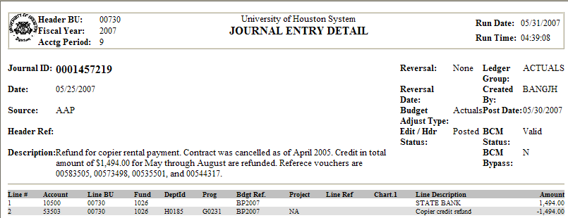

2. USAS entries to record the refund to state for overpayment - Agency 730

Form Batch Type Edit Mode Doc Type Vendor ID
Deposit Type 2 1 D Use vendor ID of the original payment

Unit | Curr Doc Num | Batch date | Comptroller Obj | Approp Num | Fund | Appropriat Yr | Fiscal Year | Transaction Cd | Sum Trans Amt | Ref Doc Num | HX Per | Reverse | PCA
00730 | D1457219 | 2007-05-29 | 7406 | 10730 | 0001 | 07 | 07 | 180 | 1,494.00 | 01457219 | 9 |  | 03712

Note: See the back up documentation attached to the journal entry from the department to know the PCA, COBJ, fund, Vendor ID, and appropriation number and year.

  - For duplicate payments, in which Accounts Payable Department receives the refund check from vendors that have state and local funds combined, the check is sent to the UH Treasury Office and deposited into the local bank. For the state portion, Accounts Payable sends a copy of the cash receipt done for the deposit into the local bank to State Accounting. Then, State Accounting follows the process described in R1-1 for the PS and USAS entries.
R5 - 3 For reallocations of expenses from state to local, the refund to state is entered when a payment was done by mistake using state funds instead of local funds. The State Accounting Department prints out the back up documentation from the PeopleSoft system to do the entries in PS and USAS.

The accounting events, department task, and work flow is indicated below:

Accounting Event | Original Cost center | Desired Cost center
Reallocation of Expenses | State Fund | Local fund
Department Task | Vendor ID | Address
Prepare Local Voucher | 0000026730 | 006
Work Flow originates | Approval | Transfer funds
Department | Accounts Payable | State Accounting  - Prepares Journal entry to credit cost center and account as indicated in the local voucher  - Enter a journal entry in USAS transferring the funds from the holding appropriation to the correct appropriation

PS local voucher to refund the state issued by the department – Business Unit 00730

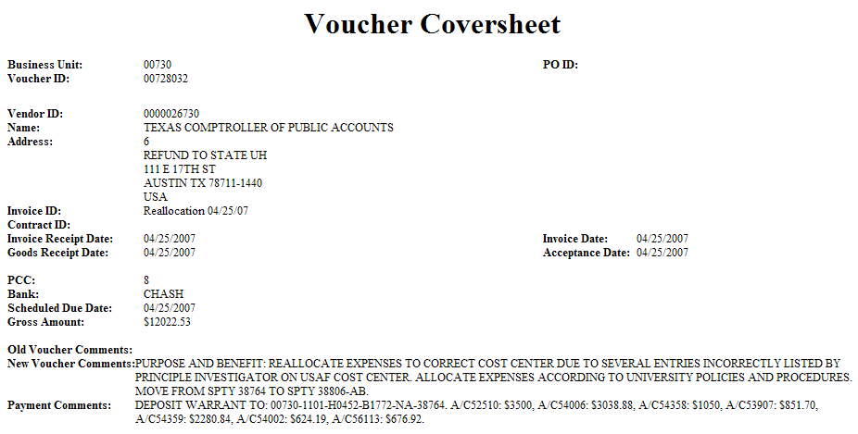
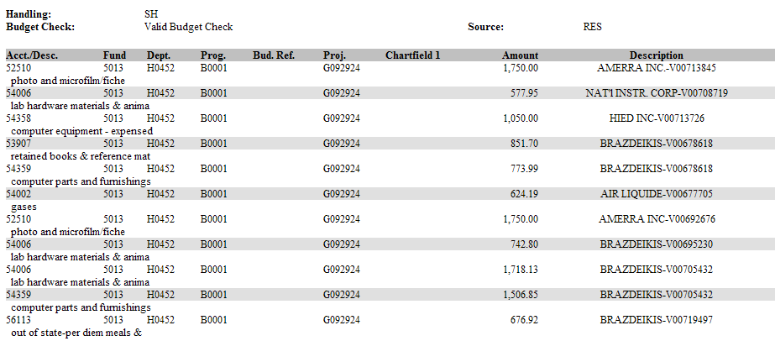

PS entries prepared by State Accounting to reallocate from state to local cost centers

The journal entry credits the account and cost center(s) used in the original voucher and specified in the payment comments of the local voucher reimbursing the state.

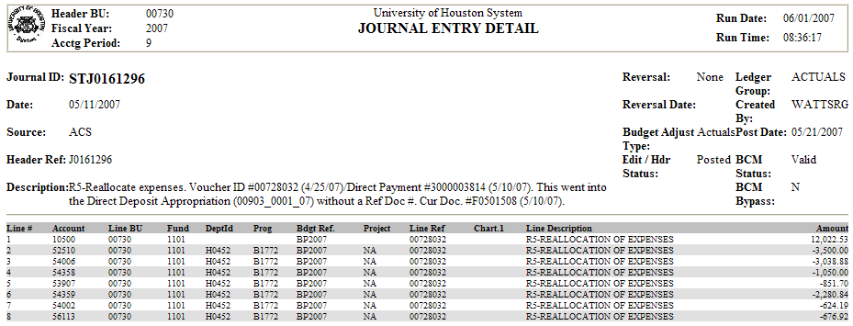

USAS entries prepared by State Accounting to refund the state - Agency 730

Form Batch Type Edit Mode Doc Type Vendor ID
Deposit Type 2 1 J UH Vendor ID

Unit | Curr Doc Num | Batch date | Comptroller Obj | Approp Num | Fund | Appropriat Yr | Fiscal Year | Transaction Cd | Sum Trans Amt | Ref Doc Num | HX Per | Reverse | PCA
00730 | J0161296 | 2007-05-11 | 7300 | 00903 | 0001 | 07 | 07 | 180 | 12,022.53 | F0501508 | 9 | R | 00903
00730 | J0161296 | 2007-05-11 | 7273 | 10730 | 0001 | 07 | 07 | 180 | 3,500.00 | J0161296 | 9 |  | 03091
00730 | J0161296 | 2007-05-11 | 7328 | 10730 | 0001 | 07 | 07 | 180 | 3,038.88 | J0161296 | 9 |  | 03091
00730 | J0161296 | 2007-05-11 | 7377 | 10730 | 0001 | 07 | 07 | 180 | 1,050.00 | J0161296 | 9 |  | 03091
00730 | J0161296 | 2007-05-11 | 7382 | 10730 | 0001 | 07 | 07 | 180 | 851.70 | J0161296 | 9 |  | 03091
00730 | J0161296 | 2007-05-11 | 7335 | 10730 | 0001 | 07 | 07 | 180 | 2.280.84 | J0161296 | 9 |  | 03091
00730 | J0161296 | 2007-05-11 | 7310 | 10730 | 0001 | 07 | 07 | 180 | 624.19 | J0161296 | 9 |  | 03091
00730 | J0161296 | 2007-05-11 | 7116 | 10730 | 0001 | 07 | 07 | 180 | 676.92 | J0161296 | 9 |  | 03091

Note: See journal entry in PS to know the COBJ, PCA, fund, and appropriation number and year. If the reallocation is entered in BU 00783, the vendor ID# should be the UHSA vendor ID.

LDT: HB1, 80th Leg,RS,ART IX, Section 6.16
Refund to State others, refund to local, reallocations within state and local funds

4. The refund to state done for Contract Revenue is in the section of Interagency Contract vs. Transfer Funds between Components.
5. For reallocations of expenses from local to state, the departments issue a state voucher and deposit the check into the local cost center. The voucher goes directly to the Accounts Payable Department and is processed. The accounting event, department task, and work flow is indicated below.

Accounting Event | Original Cost center | Desired Cost center
Reallocation of Expenses | Local Fund | State Fund
Department Task | Vendor ID | Address
Prepare State Voucher | 0000026780 | 002
Work Flow originates | Approval
Department | Accounts Payable

- For reallocation of expenses within the same state or local fund codes, Departments do a Journal Entry and send it to General Accounting. If the reallocation within the same state fund codes or fund codes that relate to the same state appropriation involves different alt accounts, State Accounting enters the reallocation in USAS to match the PS entry with a “K” document (See Expenditure Transfers). For reallocation of expenses within different local fund codes, Departments do a Journal Entry and send it to General Accounting.

Between state funds that pertains to the same state appropriation

Accounting Event | Original Cost center | Desired Cost center
Reallocation of Expenses | State Fund | Fund Code that relates to the same state appropriation
Department Task
Prepare Journal Entry in PS
Work Flow originates | Approval | Transfer Expenses in USAS
Department | General Accounting | State Accounting

Between same or different local fund codes

Accounting Event | Original Cost center | Desired Cost center
Reallocation of Expenses | Local Fund | Same or Different Local Fund
Department Task
Prepare Journal Entry in PS
Work Flow originates | Approval
Department | General Accounting

7. For reallocation of expenses (expenditure transfers) within different state fund codes, which are related to different state appropriations, Departments do a Journal Entry and send it to General Accounting. State Accounting enters the reallocation in USAS to match the PS entry with a “K” document. See Expenditure Transfers.

Accounting Event | Original Cost center | Desired Cost center
Reallocation of Expenses | State Fund | Different state fund
Department Task
Prepare Journal Entry in PS
Work Flow originates | Approval | Transfer Expenses in USAS
Department | General Accounting | State Accounting  - Transfer the expenses in USAS  - Prepares a journal entry in PS to move the cash between the different appropriations
R3 – Refund to State Payback for Payroll Overpayments

The payroll Department makes corrections for payroll overpayments in the payroll system and those transactions are fed directly to the state system. State Accounting does not need to do any entries for these cases.

R4 - ORP refund to state for non-vested terminated employee

Payroll Department receives ORP refunds from terminated employee that are deposited into the state treasury. To accomplish this task the steps to follow are:
- Payroll Department remits the check received from the vendor directly to the State Comptrollers within seven days of receipt. LDT: Vernon's Texas Codes, Education Code, Chapter 51.008(b)
- Endorse the check from the carrier with the stamp “For Deposit Only”.
- Scan the check(s) front and back and pertinent back up documentation
- Email the scan documents to the State Accounting Department asking for a deposit slip to be attached to the original check(s).
- State Accounting Department emails the deposit slip to the Payroll Department. The deposit slip has the agency number, the document number to be entered in the state system, and the total amount of the deposit.
- Clip the deposit slip in front of the original check(s)
7. Mail check(s) to: Comptroller of Public Accounts
Banking and Electronic Processing
Cashier 1st Floor
208 East 10th
Austin, TX 78701
8. Use the Express Mail Sticker Form and fill out the following:
Method of Payment: L10060
To: Phone (512) 463-5987
9. Fill out the Department Mailing Card
Print Name and sign
Write number of Pieces and date
10. Write on Cardboard Envelope
On Name – Write “Cashier” and
Telephone (512) 463-5987
- State Accounting Department records the transaction in PS at campus level by entering a journal entry to the ORP state cost centers indicated in the back up documentation.
- Enters the refund to state in the state system (USAS).

PS entry at campus level to the ORP cost center – BU 00730

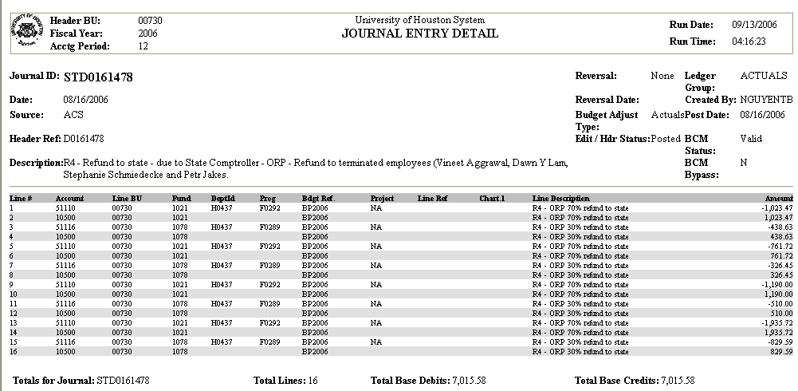

USAS entry at agency level to the ORP appropriations fund 1 and 2 – Agency 00730

Unit | Batch date | Comptroller Obj | Approp Num | Appropriat Yr | Transaction Cd | Sum Trans Amt | Ref Doc Num | Curr Doc Num | HX Per | Reverse | Fund
00730 | 8/16/2006 | 7086 | 97646 | 06 | 180 | 4,910.91 | D0161478 | D0161478 | 12 |  | 0001
00730 | 8/16/2006 | 7086 | 97646 | 06 | 180 | 2,104.67 | D0161478 | D0161478 | 12 |  | 0225

R9 - Refund to State Correction

An example of refund to state correction is for duplicates of refunds to state. To correct the duplicate follow the three steps below:

- Issue a state voucher using a state cost center with department code H0600 and the PS expense account used in the duplicated refund to state entry. Use the state cost center that corresponds to the state appropriation that received the duplicated refund. For example, for state appropriation 10730 fund 1 use the cost center 1026 H0600 A1994 NA.

The state voucher will feed the state system to seek the reimbursement and the PS GL to record the same transaction as a debit to the expense and a credit to the state bank.

In the voucher comments write the following:
“Correcting a duplication of a refund to state that happened for the PS journal entry number 0012345678 with the State Accounting journal entry number STD0161178 and STD0161162”.

In the payment comments of the state voucher write the following:
“Please deposit the state warrant to: PS account 5% (corresponding expense account) and local clearing cost center 1050 H0161 F1695 NA.

Use PCC 8 and the third party needs to be the vendor ID according to the type of refund (reallocation or overpayment)

State voucher to seek reimbursement from the state

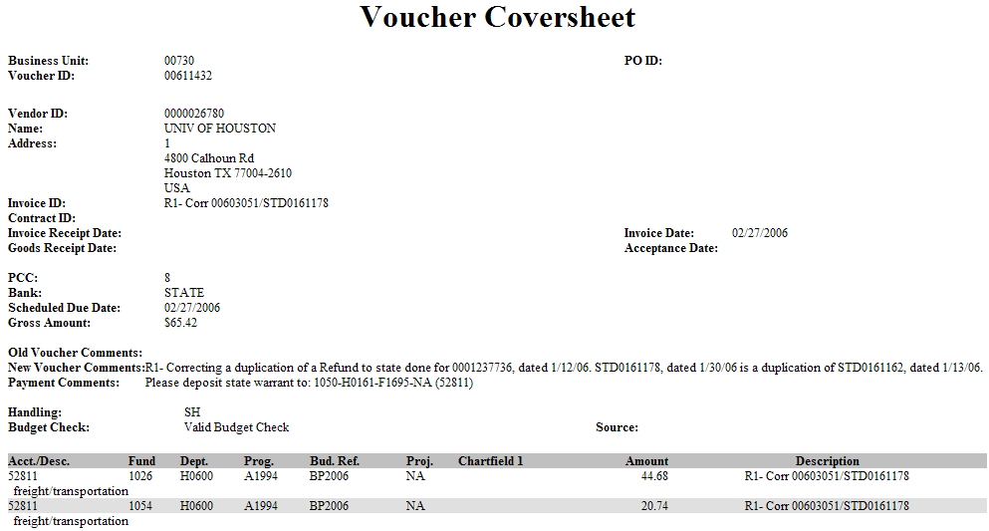

- Enter a journal entry in PS to clear the state cost center used in the state voucher. In our example above the state cost center used was 1026 H0600 A1994 NA, so the entry will be as follows:

PS entry to offset the state cost center use in the state voucher and recording the clearing cost center

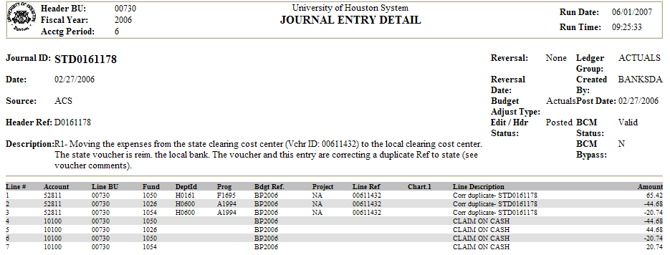

Note: The reimbursement from the state needed to be recorded using a state cost center and the refund to the local bank needs to be done with a local cost center. An email is sent to General Accounting communicating the amount of the reimbursement from the state and the account and cost center to use.

PS entry to offset the clearing cost center cost center use in the entry recorded by State Accounting

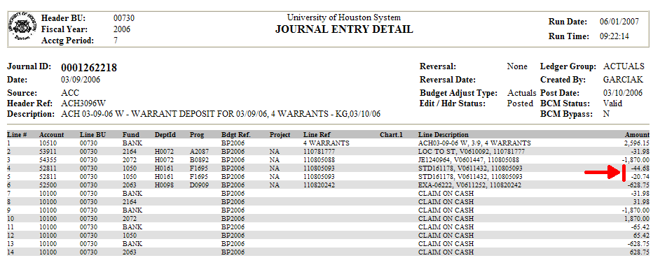

- General Accounting will record the reimbursement from the state into the local bank as follows:

Dr. 10510-Bank
Cr. 5% 1050-H0161-F1695-NA

This entry will clear the local clearing cost center in step number two and transfer the reimbursement from the state into the local bank.

Note: The state voucher correcting the duplicate uses clearing cost centers that have PCA 03701. If the original refund to state was processed with another PCA number, a correcting entry in USAS only needs to be entered correcting the PCA. The correction is made as an expenditure transfer using document type “k”, edit mode 2, and batch type 8. To reference how to do the entry see the section called “Expenditure Transfer (ABEST Reconciliation)”.

Return to Table of Contents

RTI Transactions

Recurring Transactions Index (RTI) for Transaction Income for Consultation and Evaluation Services – R7

This section is in reference to the Accounting policy 014 (Interagency Payments and Receipts for Goods and Services).

State agencies must submit interagency payments for goods and services using the Recurring Transaction Index (RTI) process in USAS when funding sources for both agencies are held in the State Treasury. Interagency payments from funding sources in the State Treasury for deposit into local bank accounts are submitted using the USAS purchase voucher process. Interagency payments from funding sources outside the State Treasury for deposit into the State Treasury are submitted as deposits in USAS.

Legal Cite - Chapter 771, Tex. Gov't Code Ann.; Sec. 8.03, Art. IX, General Appropriations Act (GAA), 80th Leg., R.S.

The University of Texas – MD Anderson Cancer Center pays for services rendered by the University Career Services. These services are paid by using the RTI process. Only a PS entry needs to be entered to record the receiving income. The payment received is captured in the Cash Reconciliation as an outstanding item in USAS with no PS entry.

PS entry to record the income received from another state agency – BU 00730
 |  | University of Houston System  JOURNAL ENTRY DETAIL
  Header BU: | 00730
  Fiscal Year: | 2006
  Acctg Period: | 6
  Run Date: | 03/14/2006
  Run Time: | 10:05:13

Journal ID: | STT2006026 | Reversal: | None | Ledger Group: | ACTUALS
Date: | 02/23/2006 | Reversal Date: |  | Created By: | NGUYENTB
Source: | ACS | Budget Adjust Type: | Actuals | Post Date: | 02/23/2006
Header Ref: | GT030031 | Edit / Hdr Status: | Posted | BCM Status: | Valid
Description: | (R7) - RTI Transaction. Income for consultation & evaluation services. |  |  | BCM Bypass: | N

Line # | Account | Line BU | Fund | DeptId | Prog | Bdgt Ref. | Project | Line Ref | Chart.1 | Line Description | Amount
1 | 40729 | 00730 | 1026 | H0215 | E0239 | BP2006 | NA | GT030031 |  | R7-Income consultat.serv | -150.00
2 | 10500 | 00730 | 1026 |  |  | BP2006 |  | GT030031 |  | R7-Income consultat.serv | 150.00

Totals for Journal: STT2006026 | Total Lines: 2 | Total Base Debits: 150.00 | Total Base Credits: 150.00

Signatures | ___________________________________ | Date | __________________________________
PS Approval: | ___________________________________ |  | __________________________________

Created By: NGUYENTB | Date Printed: 03/14/2006 | Jrnl. Dt.: 02/23/2006

The other state agency should enter the payment in USAS using the RTI given by the state agency receiving the payment. The two screens below show the payment transaction from the University of Texas (AGY 506) and the receiving income transaction in UH (AGY 730).

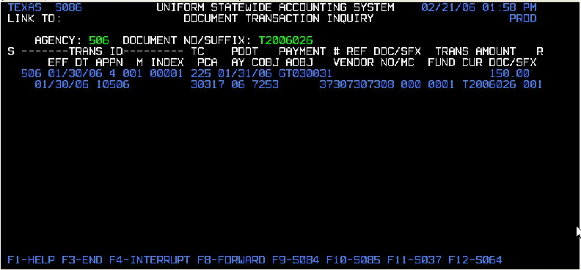

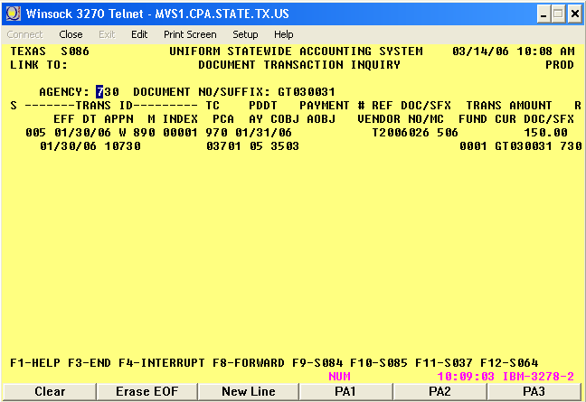

Return to Table of Contents
Sales Taxes

Sales Taxes - S0 & S1

Policy statement 008 establishes procedures for those agencies depositing sales taxes and hotel occupancy taxes into the State Treasury.

State agencies must collect all applicable sales taxes (state, city, county, transit authority and special purpose district) and hotel occupancy taxes when making sales to the public. Specified revenues, including taxes, must be deposited into the State Treasury within three business days of receipt as provided by § 404.094, Government Code, or as otherwise provided by § 51.008, Education Code. Deposits must be made as follows:
Deposits must be made as follows:
- State sales and hotel occupancy taxes are deposited into the General Revenue fund, Appropriated Fund 0001.
- City, county, transit authority and special purpose district sales taxes are deposited into the City, County, Metropolitan Transit Authority and Special Purpose District Sales Tax Trust, Appropriated Fund 0882, for allocation to the local taxing authorities.
Agencies must enter their deposit transactions into USAS in a state holding appropriation. The USAS transaction records will serve as the agencies' tax information. The Comptroller's office will accumulate the sales tax data, as entered into USAS and will prepare a monthly sales tax return for all state agencies. A separate sales tax return form will not be filed by the individual agency. The state accounting department receives a local voucher from General Accounting from which a deposit slip and an entry into USAS for the amount of the voucher are issued. State accounting enters the date, the document number and the amount of the total voucher in the Voucher Total field and the amount on account 20605 in the Base Occupancy field (if account 20605 is not in the voucher enter zero in the Base Occupancy field). The spreadsheet calculates the amount to be sent for each COBJ and appropriation number.

 |  |  |  |  | Occup. | Net | Occup.
 |  | Voucher | Tax | Base | Tax | Occup. Tax | Tax | check
Date | Doc/Batch # | Total | Discount | Occup | Disc. | Disc. | Discount | figure
 |  |  |  |  | 0.00 | 0.00 | 0.00 | 0.00
 |  | H4 | S0 | H4 | 0.00 | 0.00 | S0 | S0
 |  |  |  |  | 0.00 | 0.00 | 0.00 | 0.00
 |  |  |  |  | 0.00 | 0.00 | 0.00 | 0.00
10/06/04 | D0161058 | 6,950.43 |  | 6,950.43 | 69.50 | 6,880.93 | 0.00 | 0.00
10/15/04 | D0161076 | 3,181.56 |  | 3,181.56 | 31.82 | 3,149.74 | 0.00 | 0.00
10/20/04 | D0161084 | 50.71 | 50.71 | 0.00 | 0.00 | 0.00 | 50.71 | 50.71

USAS entries to refund the Hotel and Sales collected taxes - Agency 730

Form Batch Type Edit Mode Doc Type
Cash Receipt Type 2 1 D

Hotel Taxes
Unit | Curr Doc Num | Batch date | Comptroller Obj | Approp Num | Fund | Appropriat Yr | Fiscal Year | Transaction Cd | Sum Trans Amt | Ref Doc Num | HX Per | Reverse | PCA
00730 | D0161058 | 10/06/2004 | 3138 | 99906 | 0001 | 05 | 05 | 188 | 69.50 | D0161058 | 2 |  | 03992
00730 | D0161058 | 10/06/2004 | 3139 | 99906 | 0001 | 05 | 05 | 188 | 6880.93 | D0161058 | 2 |  | 03992

Sales Taxes
Unit | Curr Doc Num | Batch date | Comptroller Obj | Approp Num | Fund | Appropriat Yr | Fiscal Year | Transaction Cd | Sum Trans Amt | Ref Doc Num | HX Per | Reverse | PCA
00730 | D0161084 | 10/20/2004 | 3105 | 99906 | 0001 | 05 | 05 | 188 | 50.71 | D0161084 | 2 |  | 03992

LDT: APS 008

Deposit Slip is for the amount of the local voucher using the USAS document number. The check issued from the local voucher to the Texas Comptroller of Public Accounts is deposited into state holding appropriation 99906.

For agency 783, the same appropriation number, fund, T-Code, PCA, and Comp Object is used in the USAS entry. The agency number in the deposit slip needs to be 783 instead of 730.

NOTE: The T-Code, PCA, Comp Object, Appropriation, and Fund to use are included in the worksheet above.

Return to Table of Contents

Shared Appropriation Between UH System Components - S2

Each year the Board of Regents approves joint special items among UH System components. For fiscal years FY06-07, the following were approved.

- Houston Partnership for Space Exploration (transfer from UH to UHCL) (1)
- Environmental Studies (transfer from UHCL to UH) (2)

USAS entries to transfer the funds between UH components – interagency transfer

Form AGY TC PCA COBJ APPN FUND Campus
Budget Revision 730 012 03025 7000 10730 0001 (1) UH
759 018 11110 7000 10759 0001 (1) UHCL
759 012 11075 7000 10759 0001 (2) UHCL
730 018 03701 7000 10730 0001 (2) UH

Fax entry to Comptroller

PS Entries to transfer the funds between UH components – Business Unit 00730 (cost center may change)

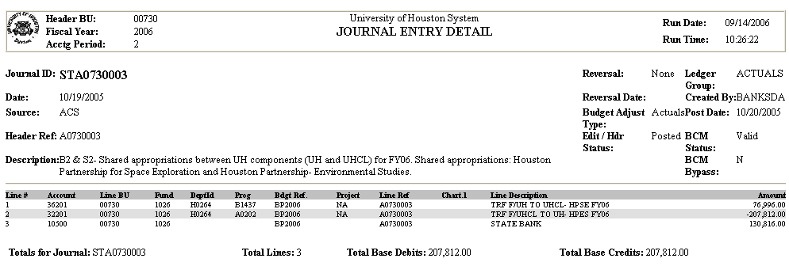

Note: Number (4) depends on the amounts transferred between components.

HB1, 80th Leg., R.S.,Article III, p. 214, section 4

Return to Table of Contents

Tuition & Fees and Other Educational and General State Support Revenues

Tuition & Fees and Other Educational and General State Support revenues are remitted to the state as a direct deposit. The Comptrollers Treasury Office has assigned specific codes for each type of direct deposits.

The charts below show all the codes used to remit the funds to State Treasury for agenry 730 and 783.
Agency Number : __ |  |  |  | 50037/730 |  |  | Agency Contact |  |  |  | Raquel Scarone
 |  |  |  |  |  |  | Phone # |  | (713) 743-8724
Code Number |  | To Agency |  |  | Trans. Code |  | PCA |  | Comp Obj. |  | Description |  | Vendor No/MC (Jurisdiction) |  | Appropriation Number |  | Fund
0001 |  | 730 |  |  | 195 |  | 03992 |  | 3505 |  | Tuition & Fees |  | UH |  | 00000 |  | 0225
0002 |  | 730 |  |  | 195 |  | 03992 |  | 3686 |  | Law Tuition Set Aside |  | UH |  | 00000 |  | 0225
0003 |  | 730 |  |  | 195 |  | 03992 |  | 3691 |  | B-on-Time |  | UH |  | 00000 |  | 5103
0004 |  | 730 |  |  | 195 |  | 03992 |  | 3765 |  | Other E&G |  | UH |  | 00000 |  | 0225
0005 |  | 730 |  |  | 195 |  | 03992 |  | 3508 |  | ID |  | UH |  | 00000 |  | 0225
0006 |  | 730 |  |  | 195 |  | 03992 |  | 3514 |  | ID |  | UH |  | 00000 |  | 0225
0007 |  | 730 |  |  | 195 |  | 03992 |  | 3526 |  | ID |  | UH |  | 00000 |  | 0225
0008 |  | 730 |  |  | 195 |  | 03992 |  | 3726 |  | ID |  | UH |  | 00000 |  | 0225
0009 |  | 730 |  |  | 173 |  | 03992 |  | 3505 |  | Defferred Tuition |  | UH |  | 00000 |  | 0225
0010 |  | 730 |  |  | 173 |  | 03992 |  | 3686 |  | Defferred Law Tuition |  | UH |  | 00000 |  | 0225
0011 |  | 730 |  |  | 173 |  | 03992 |  | 3691 |  | Defferrred B-on-Time |  | UH |  | 00000 |  | 5103

Agency Number : __ |  |  |  | 50031/783 |  |  | Agency Contact |  |  |  | Raquel Scarone
 |  |  |  |  |  |  | Phone # |  | (713) 743-8724
Code Number |  | To Agency |  |  | Trans. Code |  | PCA |  | Comp Obj. |  | Description |  | Vendor No/MC (Jurisdiction) |  | Appropriation Number |  | Fund
0001 |  | 783 |  |  | 195 |  | 03990 |  | 3765 |  | CSA |  | UHSA |  | 96243 |  | 0001

The recording of the deposits in the state system (USAS) and PS are performed as follows:

    - The State Accounting Department communicates to the University of Houston Treasury Department the amounts to be remitted using the form provided by the Comptrollers Treasury Office.

Agency Number: | 50037/730
Agency Contact: | Raquel Scarone
Phone #: | (713) 743-8724
Code Number | Amount
0001
0002
0003
0004
0005
0006
0007
0008
0009
0010
0011

    - The remission of funds performed by the Treasury Office is uploded into the state system (USAS).
    - The State Accounting Department confirms that the funds have been correctly recorded into USAS and creates a PS entry using the same document number used in USAS.

This section is classified by the type of revenue into the following: Organized Activities, Other Educational and General Revenue, and Tuition and Fees and Set Asides.

Organized Activities is in strategy A.1.7. in the General Appropriation Act (GAA), which is part of our appropriated funds. These funds are from sales and services provided by some departments that originate other Educational and General State Support revenue. The departments that are now generating that revenue are Continuing Education, Hotel and Restaurant Management, and Optometry Clinic.

Other Educational and General Revenue is strategy A.1.1. (Operations Support) in the General Appropriation Act (GAA), which is part of our appropriated funds. These funds are from: auxiliary administratibe charges, interest on fund 0225, indirect cost, and SBC coin commission (this is collected by the Information Technology Department). For FY07, the only revenue to be considered is the interest on fund 0225, the other revenues are not going to be remitted to the State Treasury.

Tuition and Fees and Set Asides is collected and sent to the state.
Organized Activities

Continuing Education Revenue - I0

The Continuing Education Revenue is remitted to the state treasury to pay for the salaries charged to a state cost center. The Continuing Education department sends a monthly detail of the revenue to be posted to the state cost center 1054-H0013-A0273-NA to cover the state salary expenses. The ledger 2 cost centers need to be charged to reimburse the state for the salary expenses.

FY06 Period Closed | Expense Amount in 1054-A0273 |  |  |  | Move this | from this | email to
 |  |  |  |  | Amount | Cost Center | Raquel
7 and 8 | 26,324.00 |  |  |  | 26,324.00 | 2078-00730-H0013-A2124 | 04/28/06

The steps to follow to remit the funds to the state are as follows:

1. Complete the direct deposit form and email it to the University of Houston Treasury - Business Unit 00730

Agency Number: | 50037/730
Agency Contact: | Raquel Scarone
Phone #: | (713) 743-8724
Code Number | Amount
0001
0002
0003
0004 | $37,747.96
0005
0006
0007
0008
0009
0010
0011

The University of Houston Treasury will remit the funds from the local bank to the state bank.

2. The direct deposit is up-loaded into USAS and can be retrieved from screen 88 - Agency 730

TEXAS S088 UNIFORM STATEWIDE ACCOUNTING SYSTEM 01/04/06 04:43 PM
LINK TO: ACCOUNTING EVENT INQUIRY PROD

TYPE: AP AGY: 730 FY: 06 AY: 06 EFF DT: 120705 AFUND: 0225 FUND: APPN: 00000
ORG CD: PGM CD: OBJ IND: OBJECT:
GRANT#: PHASE: PROJ#: PHASE: G/L:

S EFF DT CUR DOC SFX REF DOC TC ORG PGM R APPN COBJ AOBJ AMOUNT
120705 F0458435 002 195 3992 00000 3765 37,747.96

3. PS entry is recorded using the same document number used in USAS and adding the ST prefix.

PS entry to record the deposit remitted to the State Treasury using the USAS document number – Bus Unit 00730
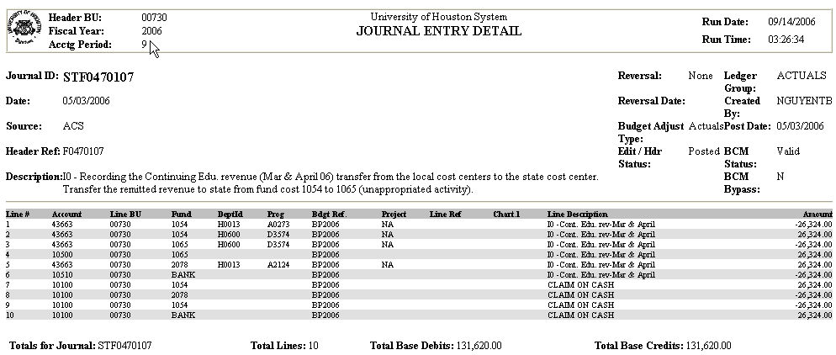

The Continuing Education Department needs the revenue in their cost centers. However, the funds are deposited in the unappropriated appropriation in USAS, fund code 1065 in PS. To accomplish that, additional entries in PS are entered to record a debit for the same revenue to the State Accounting institutional cost center with fund code 1054 and department code H0600. The institutional cost center using fund code 1054 and department code H0600 offset the revenue in fund code 1065 and department code H0600. At fund level the revenue is in fund code 1065.

Return to Table of Contents
Hotel & Restaurant Revenue (Other E&G Revenue) - I0

The College of Hotel and Restaurant Management collects part of the Organized activities revenue funds that needs to be remitted to the state. To accomplish that the Hotel and Restaurant Business Department sends an email with an attachment of a journal entry made at the end of each month for the revenue collected in PS accounts 44000 and 44010 in a Ledger 3 cost center. See entry below:

University of Houston System |  |  |  |  |  |  |  | Campus | 00730 - University of Houston
Journal Entry Request Form
 | Date Prepared |  |  |  | 6/7/2006 |  |  |  |  |  |  | Department | H0080
 | Prepared by |  |  |  | Cassie Millings |  |  |  |  |  |  | Extension | Ext 3-2434
 | Filename |  |  |  | H0680517.xls |  |  |  |  |  |  | Jnl Ref # | H0680517
 | Effective Date: |  |  |  | 3/31/2004 |  |  |  |  |  |  | Justification
 |  |  |  |  |  |  |  |  |  |  |  | University Hilton Revenue Ending May 31, 2006.
 | Description /
 | Explanation: |  |  |  | Hotel Revenue – May 2006
 | Approvals: |  |  |  | Thomas Chandapilla
 | Certifying Signatures: |  |  |  |  |  |  |  |  |  |  | Debit Total | Credit Total
 |  |  |  |  |  |  |  |  |  |  |  | 430,428.78 | 430,428.78
 |  | Accounting Use Only:
 |  |  |  | Fiscal Year: | 2006
 |  |  |  | Source: | ACC |  |  | Ledger: | ACTUALS
 | Line |  |  | Bus Un |  | Account | Fund | Dept ID | Program | BP | Proj/Grant | Debit Amount | Credit Amount | Description
 | 1 |  |  | 00730 - University of Houston |  | 12100 | 3056 | H0081 | I0342 | BP2004 | N/A | 293,866.09 |  | HOTEL ACCOUNTS RECEIVALBE
 | 2 |  |  | 00730 - University of Houston |  | 20101 | 3056 | H0081 | I0342 | BP2004 | N/A |  | 243,766.59 | Aramark Food Services
 | 3 |  |  | 00730 - University of Houston |  | 44010 | 3056 | H0081 | I0344 | BP2004 | N/A |  | 9,682.79 | C & I INSTITUTE TAXABLE
 | 4 |  |  | 00730 - University of Houston |  | 44000 | 3056 | H0081 | I0344 | BP2004 | N/A |  | 32,922.88 | C & I INSTITUTE NON-TAXABLE
 | 6 |  |  | 00730 - University of Houston |  | 44027 | 3056 | H0081 | I0347 | BP2004 | N/A |  | 6,695.00 | HOTEL GARAGE NON-TAXABLE
 | 7 |  |  | 00730 - University of Houston |  | 20604 | 3056 | H0081 | I0342 | BP2004 | N/A |  | 156.83 | HOTEL SALES TAX
 | 8 |  |  | 00730 - University of Houston |  | 20605 | 3056 | H0081 | I0342 | BP2004 | N/A |  | 642.00 | HOTEL STATE OCC. TAX
 | 13 |  |  | 00730 - University of Houston |  | 12100 | 3056 | H0081 | I0342 | BP2004 | N/A |  | 136,562.69 | HOTEL ACCOUNTS RECEIVABLE
 | 14 |  |  | 00730 - University of Houston |  | 23119 | 3056 | H0081 | I0342 | BP2004 | N/A | 136,562.69 |  | HOTEL ADVANCE DEPOSITS

The steps to follow to remit the funds to the state are as follows:

1. Complete the direct deposit form and email it to the University of Houston Treasury - Business Unit 00730

Agency Number: | 50037/730
Agency Contact: | Raquel Scarone
Phone #: | (713) 743-8724
Code Number | Amount
0001
0002
0003
0004 | $42,605.67
0005
0006
0007
0008
0009
0010
0011

The University of Houston Treasury will remit the funds from the local bank to the state bank.

2. The direct deposit is up-loaded into USAS and can be retrieved from screen 88 - Agency 730

TEXAS S088 UNIFORM STATEWIDE ACCOUNTING SYSTEM 01/04/06 04:43 PM
LINK TO: ACCOUNTING EVENT INQUIRY PROD

TYPE: AP AGY: 730 FY: 06 AY: 06 EFF DT: 062206 AFUND: 0225 FUND: APPN: 00000
ORG CD: PGM CD: OBJ IND: OBJECT:
GRANT#: PHASE: PROJ#: PHASE: G/L:

S EFF DT CUR DOC SFX REF DOC TC ORG PGM R APPN COBJ AOBJ AMOUNT
062206 F0474580 000 195 3992 00000 3765 42,605.67

LDT: Vernon's Texas Codes, Education Code, Chapter 51.008(b)

3. PS entry is recorded using the same document number used in USAS and adding the ST prefix.

PS entries to enter the deposit of revenue remitted to the state - Business Unit 00730
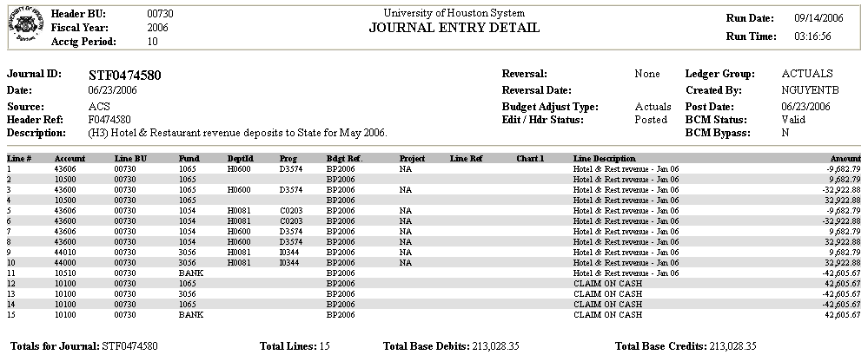

The Hotel and Restaurant Department needs the revenue in their cost centers. However, the funds are deposited in the unappropriated appropriation in USAS, fund code 1065 in PS. To accomplish that, additional entries in PS are entered to record a debit for the same revenue to the State Accounting institutional cost center with fund code 1054 and department code H0600. The institutional cost center using fund code 1054 and department code H0600 offset the revenue in fund code 1065 and department code H0600. At fund level the revenue is in fund code 1065.

Return to Table of Contents

Optometry Clinic Revenue - I0

The College of Optometry collects part of the organized activities revenue funds that needs to be remitted to the state. The revenue is pulled from the PS system with a query using the Ledger Table or from the ledger criteria panel for the 43% revenue accounts and department code H0115, program code A0276, and fund code 1054.

Query using the Ledger Table

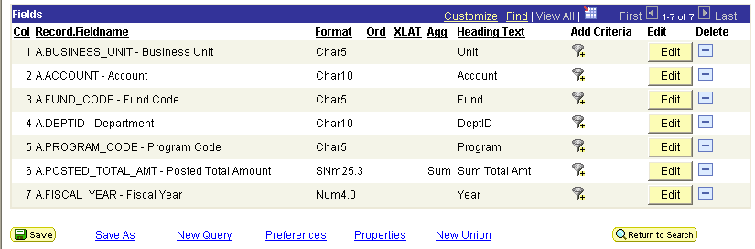

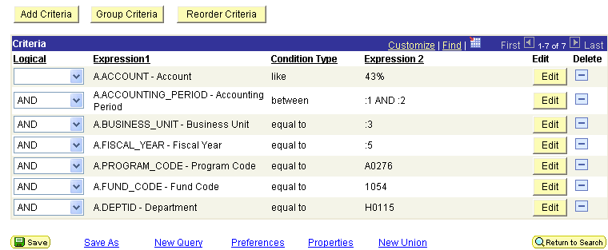

Ledger Criteria

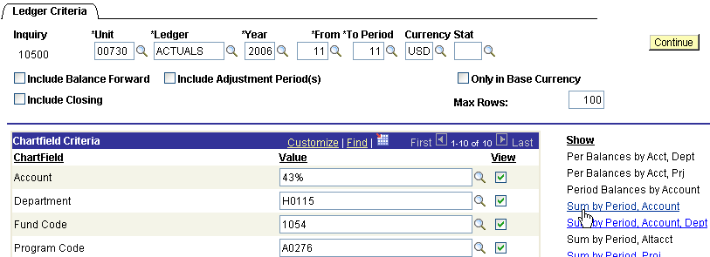

For the ledger criteria you click on Sum by Period Account and you can copy/paste the results to a worksheet.

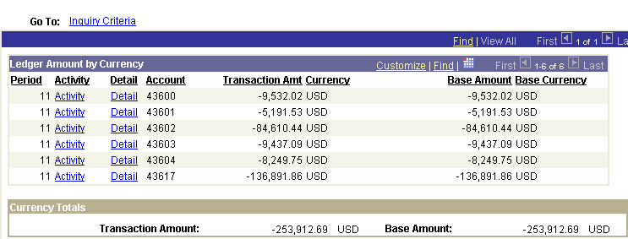

The steps to follow to remit the funds to the state are as follows:

1. Complete the direct deposit form and email it to the University of Houston Treasury - Business Unit 00730

Agency Number: | 50037/730
Agency Contact: | Raquel Scarone
Phone #: | (713) 743-8724
Code Number | Amount
0001
0002
0003
0004 | $253,912.69
0005
0006
0007
0008
0009
0010
0011

The University of Houston Treasury will remit the funds from the local bank to the state bank.

2. The direct deposit is up-loaded into USAS and can be retrieved from screen 88 - Agency 730

TEXAS S088 UNIFORM STATEWIDE ACCOUNTING SYSTEM 08/11/06 08:26 AM
LINK TO: ACCOUNTING EVENT INQUIRY PROD

TYPE: AP AGY: 730 FY: 06 AY: 06 EFF DT: 081006 AFUND: 0225 FUND: APPN: 00000
ORG CD: PGM CD: OBJ IND: OBJECT:
GRANT#: PHASE: PROJ#: PHASE: G/L:

S EFF DT CUR DOC SFX REF DOC TC ORG PGM R APPN COBJ AOBJ AMOUNT
081006 F0478828 000 195 3992 00000 3765 253,912.69

LDT: Vernon's Texas Codes, Education Code, Chapter 51.008(b)

- PS entry is recorded using the same document number used in USAS and adding the ST prefix.

PS entries to record the remission to state Optometry Clinic - Business Unit 00730
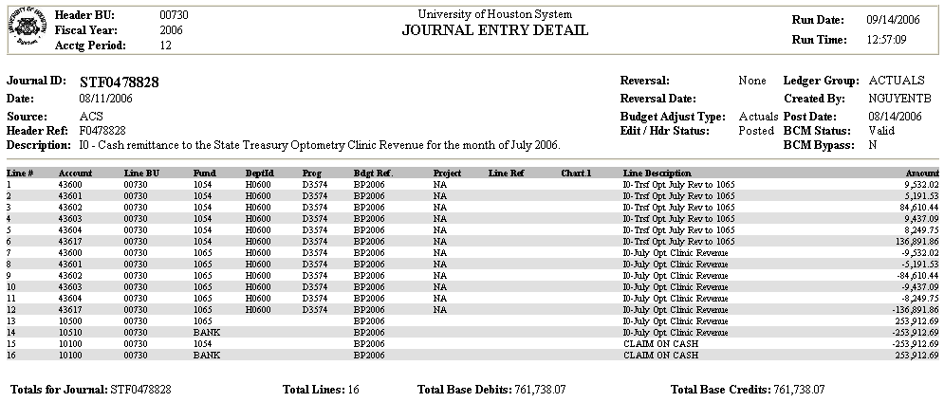

Note: The complete list for the Optometry Clinic revenue accounts is: 43600-05, 43617, 43639, and 43902

Return to Table of Contents

Other Educational and General Revenue

Interest on Fund 0225 - I1

Interest in our unappropriated activity fund 0225 appropriation (Appropriation number 00000, fund 0225) is earned on a monthly basis and posted to USAS according to Education Code Title 3 subtitle A Section 51.008 Subsection (f).

Subsection (f) of the code says: “interest earned on the receipts deposited under this section to an institution's separate fund account in the state treasury shall be credited to that separate fund account”; subsection (g) adds: “revenues collected at institutions of higher education and deposited in the state treasury pursuant to this section and Section 34.017, Natural Resources Code, and the interest earned thereon, are dedicated to the institution which collected and deposited the funds irrespective of the year the funds were collected, deposited, or earned. These funds may be only used for the support, maintenance, and operation of the institution as provided for by law. Section 403.094(h), Government Code, does not apply to funds described in this section.”

An entry in PS needs to be made to match the entry posted in USAS. To do the PS entry, use the eight digit document number in USAS and add ST at the beginning.

PS entries to post the interest earned on fund 0225 - Business Unit 00730
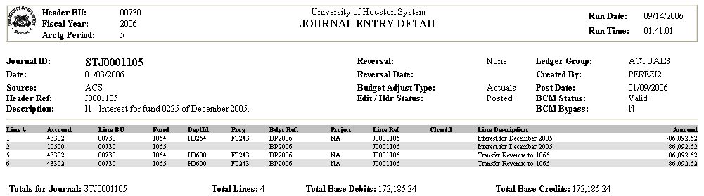
Check screen 47 to see the amount posted each month. Also check screen 88 to see the entry number to do the entry in PS; the entry will be posted in USAS between the 15 and 28 of each month. Attached both screen to the entry made in PS.

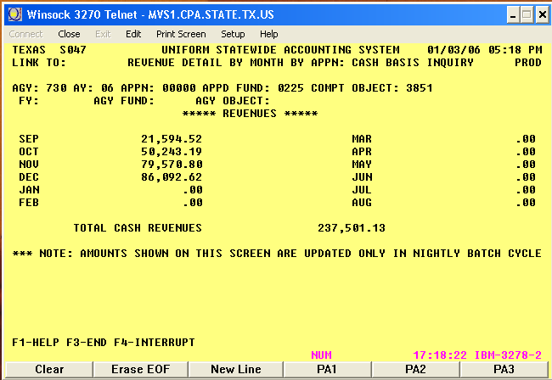

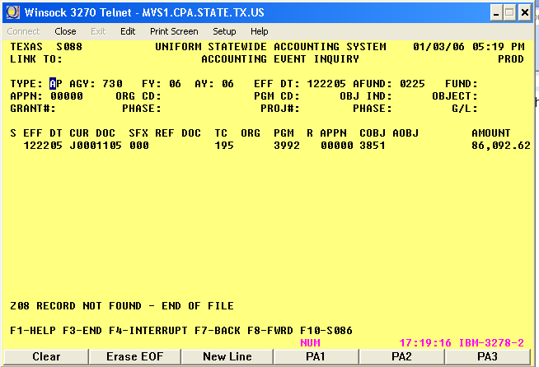

Return to Table of Contents

TUITION & FEES - T5

The cash remittance of tuition and fees to the state treasury is processed according to the Education Code Title 3 subtitle A Section 51.008 Subsection (b). Subsection (b) says: “the governing board of every state institution of higher education shall deposit in the state treasury all cash receipts accruing to any college or university under its control that may be derived from all sources except auxiliary enterprises, non-instructional services, agency, designated, and restricted funds, endowment and other gift funds, student loan funds, funds retained under Chapter 145 of this code, and Constitutional College Building Amendment funds. The comptroller is directed to credit such receipts deposited by each such institution to a separate fund account for the institution depositing the receipts, but he shall not be required to keep separate accounts of types of funds deposited by each institution. For the purpose of facilitating the transferring of such institutional receipts to the state treasury, each institution shall open in a local depository bank a clearing account to which it shall deposit daily all such receipts, and shall, not less often than every seven days, make remittances there-from to the comptroller of all except $500 of the total balance in said clearing account, such remittances to be in the form of checks drawn on the clearing account by the duly authorized officers of the institution, and no disbursements other than remittances to the state treasury shall be made from such clearing account. All money so deposited in the state treasury shall be paid out on warrants drawn by the comptroller as provided by law.”

We are required to remit the Set Aside Tuition funds for the Law School, B-On-Time, and Doctoral Degree Incentive to the Un-appropriated Appropriation (00000/0225). The deposits for the Set Aside funds are remitted to the THECB by the 10th working day of the month following deposit. (As a result, universities report "transfers out" and THECB reports "transfers in" for the funds transferred from the universities to THECB.)

Law School Tuition Set-Aside Funds
According to Sec. 61.9731, Education Code (formerly Sec. 61.961, Education Code), the governing board of each public school of law is required to set aside one percent of tuition charges for resident students enrolled in the school of law. These funds must be deposited into the State Treasury for the sole purpose of repayment of education loans of attorneys under this program.

Doctoral Degree Tuition Set-Aside Funds
According to Sec. 56.095, Education Code, the governing board of each institution of higher education is required to set aside $2 per semester credit hour of the tuition collected from each student enrolled in a doctoral degree program, other than a law or health professional program. These funds must be deposited into the State Treasury for the sole purpose of repayment of student loans of individuals employed as faculty and administrators at institutions of higher education in this state under this program.

Texas B-On-Time Tuition Set-Aside Funds
According to Sec. 56.465, Education Code, the governing board of each institution of higher education is required to set aside five percent of an amount of tuition charged to resident undergraduate students under Sec. 54.0513, Education Code that is in excess of $46 per semester credit hour. The amount of a student’s tuition set aside under Sec. 56.465(a) is considered a part of the amount required to be set aside under Sec. 56.011, Education Code. These funds must be deposited in the State Treasury into the Texas B-On-Time account (Appropriated Fund 5103) in the General Revenue Fund for the sole purpose of awarding loans under the Texas B-On-Time Loan Program.

The charts below show all the codes used to remit the funds to State Treasury for agenry 730 and 783.
Agency Number : __ |  |  |  | 50037/730 |  |  | Agency Contact |  |  |  | Raquel Scarone
 |  |  |  |  |  |  | Phone # |  | (713) 743-8724
Code Number |  | To Agency |  |  | Trans. Code |  | PCA |  | Comp Obj. |  | Description |  | Vendor No/MC (Jurisdiction) |  | Appropriation Number |  | Fund
0001 |  | 730 |  |  | 195 |  | 03992 |  | 3505 |  | Tuition & Fees |  | UH |  | 00000 |  | 0225
0002 |  | 730 |  |  | 195 |  | 03992 |  | 3686 |  | Law Tuition Set Aside |  | UH |  | 00000 |  | 0225
0003 |  | 730 |  |  | 195 |  | 03992 |  | 3691 |  | B-on-Time |  | UH |  | 00000 |  | 5103
0004 |  | 730 |  |  | 195 |  | 03992 |  | 3765 |  | Other E&G |  | UH |  | 00000 |  | 0225
0005 |  | 730 |  |  | 195 |  | 03992 |  | 3508 |  | ID |  | UH |  | 00000 |  | 0225
0006 |  | 730 |  |  | 195 |  | 03992 |  | 3514 |  | ID |  | UH |  | 00000 |  | 0225
0007 |  | 730 |  |  | 195 |  | 03992 |  | 3526 |  | ID |  | UH |  | 00000 |  | 0225
0008 |  | 730 |  |  | 195 |  | 03992 |  | 3726 |  | ID |  | UH |  | 00000 |  | 0225
0009 |  | 730 |  |  | 173 |  | 03992 |  | 3505 |  | Defferred Tuition |  | UH |  | 00000 |  | 0225
0010 |  | 730 |  |  | 173 |  | 03992 |  | 3686 |  | Defferred Law Tuition |  | UH |  | 00000 |  | 0225
0011 |  | 730 |  |  | 173 |  | 03992 |  | 3691 |  | Defferrred B-on-Time |  | UH |  | 00000 |  | 5103
0012 |  | 730 |  |  | 195 |  | 03992 |  | 3693 |  | Recover Overpayments |  | UH |  | 29803 |  | 0001
0013 |  | 730 |  |  | 195 |  | 03992 |  | 3693 |  | Doctoral Degree Set Aside |  | UH |  | 00000 |  | 0225
0014 |  | 730 |  |  | 195 |  | 03992 |  | 3693 |  | Deferred Doctoral Degree |  | UH |  | 00000 |  | 0225

Agency Number : __ |  |  |  | 50031/783 |  |  | Agency Contact |  |  |  | Raquel Scarone
 |  |  |  |  |  |  | Phone # |  | (713) 743-8724
Code Number |  | To Agency |  |  | Trans. Code |  | PCA |  | Comp Obj. |  | Description |  | Vendor No/MC (Jurisdiction) |  | Appropriation Number |  | Fund
0001 |  | 783 |  |  | 195 |  | 03990 |  | 3765 |  | CSA |  | UHSA |  | 96243 |  | 0001

A) To remit the cash to the state treasury without Set Aside Funds do the following entries in PS and USAS:

In PS, the local voucher records the issuing of the check from the local bank and the journal entry records the deposits of the cash into the state bank. No entry is done to the tuition and fees revenue accounts which already have been credited by the student accounting system. In USAS, the cash and revenue are posted to match the entries in PS.

The steps to follow to remit the funds to the state are as follows:

1. Complete the direct deposit form and email it to the University of Houston Treasury - Business Unit 00730

Agency Number: | 50037/730
Agency Contact: | Raquel Scarone
Phone #: | (713) 743-8724
Code Number | Amount
0001 | $4,603,915.18
0002
0003
0004
0005
0006
0007
0008
0009
0010
0011

The University of Houston Treasury will remit the funds from the local bank to the state bank.

2. The direct deposit is up-loaded into USAS and can be retrieved from screen 88 - Agency 730

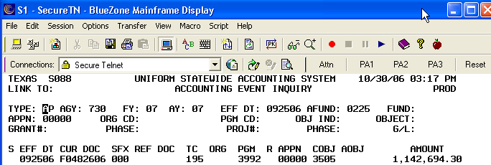

LDT: Vernon's Texas Codes, Education Code, Chapter 51.008(b)

3. PS entry is recorded using the same document number used in USAS and adding the ST prefix. The entry is recorded by General Accounting transferring the revenue from fund code 1054 to fund code 1065 and and the cash from the local bank to the state bank.

Follow the paty below to see the PS entries to transfer the cash from the local bank to the state bank - Business Unit 00730

https://my.uh.edu:9980/psc/fsprd/EMPLOYEE/ERP/s/WEBLIB_UHS_GL.UHS_GL_ENTRY_DTL.FieldFormula.IScript_JrnlEntryDetail?BUSINESS_UNIT=00730&JOURNAL_DATE=2006-10-11&JOURNAL_ID=STF0482606&UNPOST_SEQ=0

B) For the set-aside tuition revenues, the Comptroller’s requires depositing the Law Tuition set-aside and the B-ON-TIME at the time we remit the tuition and fees revenues when those funds are available. The entries in PS and USAS are as follows:

The steps to remit the funds to the state are as follows:

1. Complete the direct deposit form and email it to the University of Houston Treasury - Business Unit 00730

Agency Number: | 50037/730
Agency Contact: | Raquel Scarone
Phone #: | (713) 743-8724
Code Number | Amount
0001 | $203,419.59
0002 | $113.87
0003 | $113,989.56
0004
0005
0006
0007
0008
0009
0010
0011

The University of Houston Treasury will remit the funds from the local bank to the state bank.

2. The direct deposit is up-loaded into USAS and can be retrieved from screen 88 - Agency 730

For appropriation 00000 and fund 0225 (Tuition & Fees and Law tuition set aside)

TEXAS S088 UNIFORM STATEWIDE ACCOUNTING SYSTEM 01/04/06 04:43 PM
LINK TO: ACCOUNTING EVENT INQUIRY PROD

TYPE: AP AGY: 730 FY: 06 AY: 06 EFF DT: 03/02/06 AFUND: 0225 FUND: APPN: 00000
ORG CD: PGM CD: OBJ IND: OBJECT:
GRANT#: PHASE: PROJ#: PHASE: G/L:

S EFF DT CUR DOC SFX REF DOC TC ORG PGM R APPN COBJ AOBJ AMOUNT
030206 F0464939 001 195 3992 00000 3765 203,419.59
030206 F0464939 002 195 3992 00000 3686 113.87

For appropriation 00000 and fund 5103 (B_On_Time)

TEXAS S088 UNIFORM STATEWIDE ACCOUNTING SYSTEM 01/04/06 04:43 PM
LINK TO: ACCOUNTING EVENT INQUIRY PROD

TYPE: AP AGY: 730 FY: 06 AY: 06 EFF DT: 06/16/06 AFUND: 5103 FUND: APPN: 00000
ORG CD: PGM CD: OBJ IND: OBJECT:
GRANT#: PHASE: PROJ#: PHASE: G/L:

S EFF DT CUR DOC SFX REF DOC TC ORG PGM R APPN COBJ AOBJ AMOUNT
061606 F0474083 000 195 3992 00000 3691 113,989.56

LDT: Vernon's Texas Codes, Education Code, Chapter 51.008(b)

3. PS entry is recorded using the same document number used in USAS and adding the ST prefix.

PS entries for the deposit of tuition and fees revenue and Law set aside - Business Unit 00730
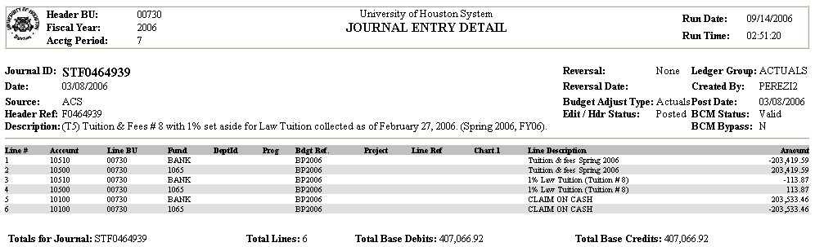

Note: Starting FY07, General Accounting will be adding the transactions for the tuition revenue and remissions and exemptions.

PS entries for the deposit B-On-Time set aside - Business Unit 00730
 |  | University of Houston System  JOURNAL ENTRY DETAIL
  Header BU: | 00730
  Fiscal Year: | 2006
  Acctg Period: | 10
  Run Date: | 09/14/2006
  Run Time: | 02:03:30

Journal ID: |  |  | STF0474083 |  |  |  |  |  |  |  |  |  | Reversal: |  | None | Ledger Group: | ACTUALS
Date: |  |  | 06/20/2006 |  |  |  |  |  |  |  |  |  | Reversal Date: |  |  | Created By: | NGUYENTB
Source: |  |  | ACS |  |  |  |  |  |  |  |  |  | Budget Adjust Type: |  | Actuals | Post Date: | 06/20/2006
Header Ref: |  |  | F0474083 |  |  |  |  |  |  |  |  |  | Edit / Hdr Status: |  | Posted | BCM Status: | Valid
Description: |  |  | B5 - B-on-time activity from 5/1/06 thru 5/31/06, Summer 2006. Ref. # STT0161384. |  |  |  |  |  |  |  |  |  |  |  |  | BCM Bypass: | N
Line # |  | Account | Line BU | Fund | DeptId |  | Prog | Bdgt Ref. |  | Project | Line Ref | Chart.1 | Line Description |  |  |  |  | Amount
1 |  | 40112 | 00730 | 2064 | H0264 |  | H2620 | BP2006 |  | NA |  |  | B5 - B-on-time May 2006 |  |  |  |  | 113,989.56
2 |  | 53864 | 00730 | 1065 | H0600 |  | F1651 | BP2006 |  | NA |  |  | B5 - B-on-time May 2006 |  |  |  |  | -113,989.56
3 |  | 10500 | 00730 | 1065 |  |  |  | BP2006 |  |  |  |  | B5 - B-on-time May 2006 |  |  |  |  | 113,989.56
4 |  | 10510 | 00730 | BANK |  |  |  | BP2006 |  |  |  |  | B5 - B-on-time May 2006 |  |  |  |  | -113,989.56
5 |  | 10100 | 00730 | 2064 |  |  |  | BP2006 |  |  |  |  | CLAIM ON CASH |  |  |  |  | -113,989.56
6 |  | 10100 | 00730 | BANK |  |  |  | BP2006 |  |  |  |  | CLAIM ON CASH |  |  |  |  | 113,989.56
Totals for Journal: STF0474083 |  |  |  |  |  | Total Lines: 6 |  |  | Total Base Debits: 341,968.68 |  |  |  |  | Total Base Credits: 341,968.68

Note: Starting FY07, General Accounting will be adding the transactions for the tuition revenue that are related to the B-On-Time.

4. Write a Journal Entry in PS to transfer-out to THECB the set-asides tuition revenue funds

In USAS, check screen 49A to confirm that the deposits have been recorded into appropriation 00000, appropriated fund 0225, and COBJ 3686 for the Law Tuition set aside; and appropriation 00000, appropriated fund 5103, and COBJ 3691 for the B_On_Time set aside.

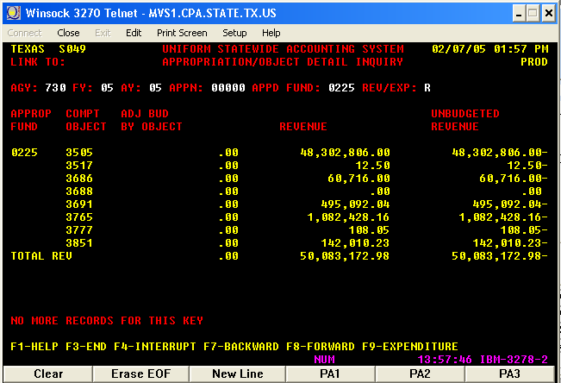

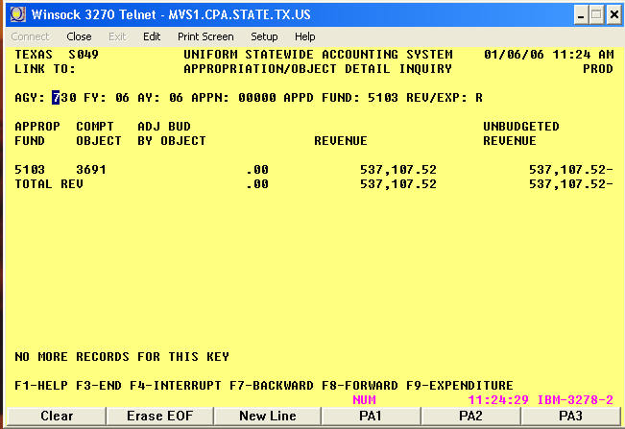

PS entries to transfer-out the set-asides to THECB - Business Unit 00730

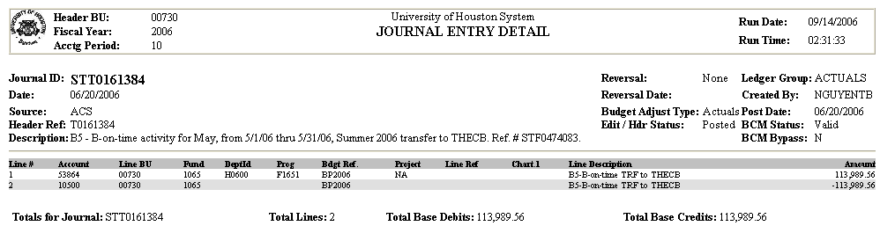

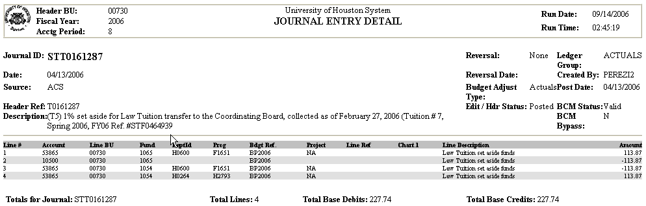

5. Enter transfer-out in USAS for the set-aside funds using the RTIs provided by the Comptroller

USAS entries to transfer-out the set-aside funds to THECB - Agency 730

Form Batch Type Edit Mode Ref Doc# Short Description Doc Type
Transfer Type 4 2 F0474083 Tuition Set Asides T

Unit | Curr Doc Num | Batch date | Comptroller Obj | Approp Num | Fund | Appropriat Yr | Fiscal Year | Transaction Cd | Sum Trans Amt | Ref Doc Num | HX Per | Reverse | PCA
00730 | T0161172 | 2004-01-27 | 7972 | 00000 | 0225 | 04 | 04 | 475 | 228.00 | F0458515 | 6 |  | 03992
00730 | T0161384 | 2006-20-06 | 7972 | 00000 | 5103 | 04 | 04 | 475 | 113,989.56 | F0474083 | 10 |  | 03992

LDT: FPP A.040 Processing Requirements for Various Tuition Set-Aside Funds

Return to Table of Contents

Chapter 2

Texas Higher Education Coordinating Board programs,

and

Higher Education Assistance Funds (HEAF)

ATP (Advance Technology Program) and ARP (Advance Research Program) - A1

The ATP and ARP programs are classified as a State Grant Pass-Through (sub-recipient) because they have the following characteristics:

a. The paying/grantor agency (Texas Higher Education Coordinating Board - THECB) has received an appropriation with the authority to grant that money to another agency.

b. The receiving agency was granted the dollars based on meeting specific qualifications.

c. The paying/grantor do not directly receive any consideration or benefit in exchange for the funds.

These programs have UB (un-expended balance) authority for any un-expended balance at year-end. This means that the unexpended balance that has not been accrued or encumbered can be rolled-forward into the following appropriation year.

The legal citation describing how funds are appropriated and distributed is below:

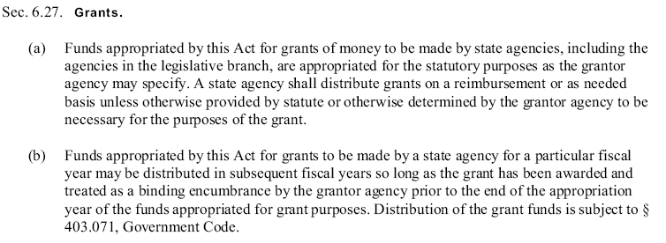

The ATP and ARP programs are also classified as State Grant Pass-Through Revenue Operating which uses COBJ 3842, because the grant finances a program that the university would not normally undertake. For all other State Pass-Through programs the university decides between Revenue Operating (COBJ 3842) or Revenue Non-Operating (COBJ 3725).

Once the University determines the classification of each program, contact your Appropriation Control Office (ACO) to make sure all of the appropriate USAS screens are updated with the correct COBJs.

The transactions that we have for the ATP and ARP programs are payroll and state voucher payments and they are processed by using the payroll and AP system.

The manual entries that are completed in the State Accounting Department are:

1. Return unused funds,
2. Roll-forward,
3. Budget load.

1. To process a refund (return un-used funds), a payment transaction needs to be entered in USAS using TC 272, COBJ 3842, the Coordinating Board Vendor ID, document type “T” and RTI number provided by the Coordinating Board. The cost center to use in PS will vary depending on the project for which the funds are being returned.

USAS entry to return unused funds during FY 04 – AGY 730
Unit | Curr Doc Num | Batch date | Comptroller Obj | Approp Num | Fund | Appropriat Yr | Fiscal Year | Transaction Cd | Sum Trans Amt | Ref Doc Num | HX Per | Reverse | PCA
00730 | T0161798 | 2003-10-01 | 3842 | 13120 | 0001 | 03 | 04 | 272 | 1,282.60 | T0161798 | 2 |  | 03980
00730 | T0161798 | 2003-10-01 | 3842 | 13121 | 0001 | 03 | 04 | 272 | 2.00 | T0161798 | 2 |  | 03980

RTI#
See Coordinating Board List

PS entry to return un-used funds – BU 00730

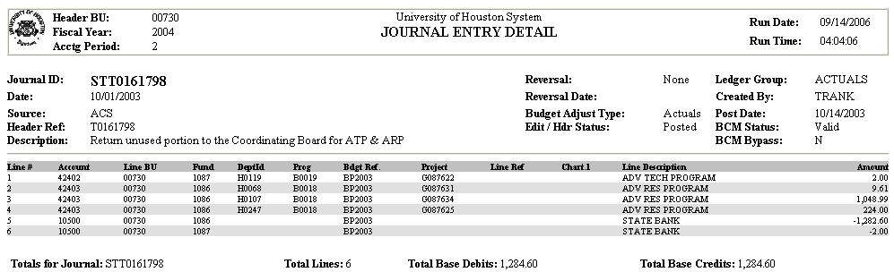

Note: Fund codes 1086 and 1087 are for the 2002-2003 ARP and ATP programs respectively. For 2004-2005, the fund code for ATP is 1098. For 2006-2007, the fund code for ARP is 1100. We have not been awarded funds for ATP for FY06-07.

2. To process the roll-forward of funds (i.e. unused funds in AY03 to roll-forward to AY04), use the journal voucher document, batch type 8 and edit more 2. We are able to roll-forward the funds because ATP and ARP are considered grants and the legal site is HB1,80th Leg,RS,ART IX, Sec 17.04, page 72. Roll-forward only the portion that has not been encumbered.

USAS entry to Roll-Forward funds – AGY 730
Unit | Curr Doc Num | Batch date | Comptroller Obj | Approp Num | Fund | Appropriat Yr | Fiscal Year | Transaction Cd | Sum Trans Amt | Ref Doc Num | HX Per | Reverse | PCA
00730 | J0161013 | 2003-09-10 | 3975 | 13120 | 0001 | 03 | 04 | 406 | 995,026.81 |  | 1 |  | 03980
00730 | J0161013 | 2003-09-10 | 3975 | 13120 | 0001 | 04 | 04 | 405 | 995,026.81 |  | 1 |  | 03980

PS entry to Roll-Forward funds – BU 00730

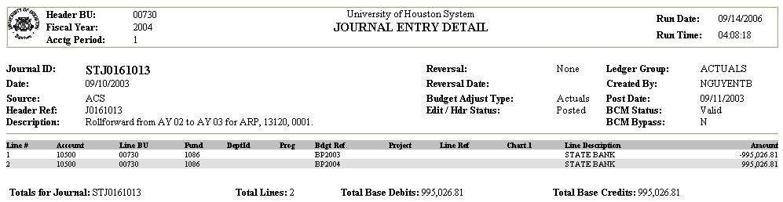

3. To post the revenue given by the Coordinating Board follow the directions on the Budget Load Section.

Return to Table of Contents

Development Education Program - D0

Development Education at Public Higher Education institutions are academic courses that can be placed into two broad categories: college-level credit courses and developmental education courses. In some cases developmental courses simply provide an orientation to campus facilities and programs (i.e. overview of campus library holdings, explains check-out procedures, and describe inter-library loan and other special services). Some institutions address personal development problems common to many low-achieving students with courses as “Study Skills” and “Time Management”. However, most developmental education courses address deficiencies in students’ academic preparation for college.

Most developmental education offered by universities and community and technical colleges are semester-length courses included in the institution’s regular course offerings. Credits earned for these courses may not be used for either a baccalaureate degree or an associate degree. The institutions charge tuition at the usual rates and receive funding for course-based developmental education trough the funding formulas.

In Texas, Developmental education is strongly linked to the Texas Academic Skills Program (TASP). In 1987, the 70th Texas Legislature passed legislation which created the program. The TASP identifies students who need to improve their skills and mandates developmental instruction for them. Many students who previously would have foregone developmental classes are now required to take them. The amount of developmental education offered increased, both at universities and two-year institutions, after the TASP was established. Those increased levels of developmental education have continued. The allocation that the Coordinating Board makes to each institution for each fiscal year will be based on the number of students who successfully complete developmental education during the previous fiscal year.

Development Education Program Funds appropriated for developmental programs need to be expended only for those costs associated with the operation of the developmental education program including instruction, tutorial, peer counseling, evaluation, retraining of faculty, and related costs for administration of the program. The funds can not be used for the recruitment of students.

The legal citation given more description of the program is below:

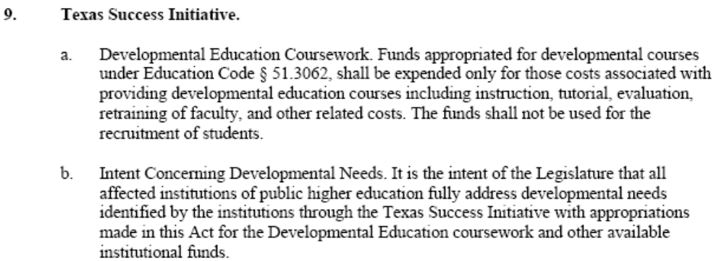

We have not received any funding for this program since FY08 or FY09. The entries for the Budget Load are in the Budget Load section. The payments are processed using the payroll system or by issuing a state voucher. Any unused funds need to be returned to the THECB. The entries to return the funds are as follows:

USAS entry to return the un-used portion of funds (refund of Pass Thru – AGY 730

Batch Type Edit Mode
Type 2 1
Unit | Curr Doc Num | Batch date | Comptroller Obj | Approp Num | Fund | Appropriat Yr | Fiscal Year | Transaction Cd | Sum Trans Amt | Ref Doc Num | HX Per | Reverse | PCA
00730 | T0161176 | 2004-01-29 | 3842 | 13024 | 0001 | 03 | 04 | 272 | 28,607.02 | T0161176 | 7 |  | 03980

RTI #
THECB list

LDT: HB1,80th Leg,RS,ART IX, Sec 17.04

PS entry to return the unused funds – BU 00730
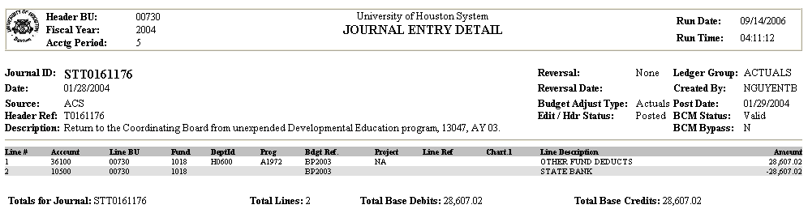

Return to Table of Contents

Fifth Year Accounting Scholarship - F2

Source/Allocation of Funds

Funds are generated through additional fees paid by Texas CPAs when they renew their licenses.
5% of the funds appropriated for the Fifth-Year Program are set aside for applicants from community/junior colleges.

Purpose

The purpose of the Fifth-Year Accounting Student Scholarship Program is to promote the professional and educational needs of the state; increase the number of highly trained and educated professional accountants available to serve the residents of this state; improve the state's business environment and encourage economic development and financial stability; and identify, recognize and support outstanding scholars who plan to pursue careers in accounting.

Eligible Institutions

An eligible institution of higher education may be any public institution as defined in Texas Education Code, Section 61.003(8) or any nonprofit, independent institution approved by the board under Texas Education Code, Section 61.222.

Eligible Students

(a) To receive funds, a student must

(1) meet the general eligibility requirements of this chapter;
(2) have completed at least 120 credit hours of college work, including at least 15 hours of accounting, and
    - sign a written statement confirming his/her intent to take the written examination conducted by the Texas State Board of Public Accountancy for the purpose of granting a certificate of "certified public accountant". Beginning with fall 1997 awards, the student must confirm he or she has not yet taken the CPA examination and does not intend to take the examination prior to May 1998. The student’s cumulative grade point average, as determined by the institution, must be equal to or greater than the grade point average required by the institution for graduation.

- In selecting recipients the program officer shall consider at a minimum the following factors relating to each applicant:

(1) financial need;
(2) scholastic ability and performance as measured by the student’s cumulative college grade point average as determined by the institution in which the student is enrolled; and
(3) Texas residency.
Award Amounts

No individual may receive an aggregate total of more than $3,000 through the program. The maximum annual award for a student through this program is the lesser of an amount equal to the student's financial need and the program maximum of $3,000 less any amount received in the past.

Funding

Funds awarded through the program may not exceed the amount appropriated for that purpose, plus any gifts, grants and donations of real or personal property from any entity, subject to limitations or conditions set by law, for the purposes of this subchapter.

Allocations and Reallocations

The board will survey eligible institutions on an annual basis regarding the number of persons receiving degrees in accounting and will use that information as a basis of allocating funds among institutions.

(1) Award Procedures -- Public Universities and Technical Colleges. Funds allocated to each institution will be transferred to a cost center at the State Comptroller’s Office, to be drawn down by the institution as needed to cover local awards. Funds not drawn down by deadlines established by the board will be available for reallocation to other institutions needing additional funds.

Award Procedures -- Independent Institutions and Public Community Colleges. Funds allocated to each institution will be accessed through the board. Program Officers will submit applications for eligible students to the board, which will issue state warrants to the students in accordance with disbursement schedules on the applications. Funds not encumbered by deadlines established by the board will be available for reallocation to other institutions needing additional funds.

Disbursements

A minimum of one disbursement per semester will be required for all awards.

PS state voucher issue according to the award procedure mentioned above to draw down the funds by our institution – BU 00730

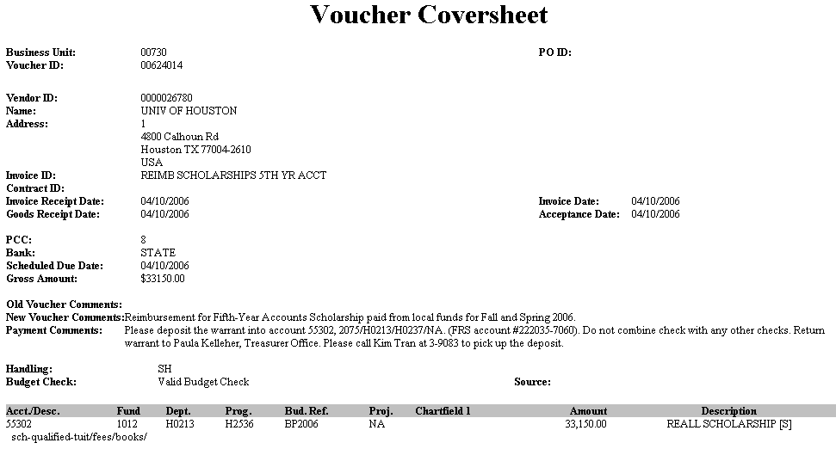

PS entry to return the un-used funds - BU 00730

 |  | University of Houston System  JOURNAL ENTRY DETAIL
  Header BU: | 00730
  Fiscal Year: | 2006
  Acctg Period: | 10
  Run Date: | 09/14/2006
  Run Time: | 04:31:32

Journal ID: | STT0161379 | Reversal: | None | Ledger Group: | ACTUALS
Date: | 06/20/2006 | Reversal Date: |  | Created By: | NGUYENTB
Source: | ACS | Budget Adjust Type: | Actuals | Post Date: | 06/20/2006
Header Ref: | T0161379 | Edit / Hdr Status: | Posted | BCM Status: | Valid
Description: | (F2) Return unused portion to the Coordinating Board for 5th yr Accounting Scholarship Program, 13043, 0106, AY 06. |  |  | BCM Bypass: | N

Line # | Account | Line BU | Fund | DeptId |  | Prog | Bdgt Ref. |  | Project | Line Ref | Chart.1 | Line Description |  | Amount
1 | 42407 | 00730 | 1012 | H0213 |  | H2536 | BP2006 |  | NA |  |  | F2 -Return unused to CBoard |  | 7,500.00
2 | 10500 | 00730 | 1012 |  |  |  | BP2006 |  |  |  |  | F2 -Return unused to CBoard |  | -7,500.00
Totals for Journal: STT0161379 |  |  |  |  | Total Lines: 2 |  |  | Total Base Debits: 7,500.00 |  |  |  |  | Total Base Credits: 7,500.00

USAS Entries to return the un-used portion – AGY 730

Form Batch Type Edit Mode
Cash Receipt Type 1 1

Unit | Curr Doc Num | Batch date | Comptroller Obj | Approp Num | Fund | Appropriat Yr | Fiscal Year | Transaction Cd | Sum Trans Amt | Ref Doc Num | HX Per | Reverse | PCA
730 | T0161379 | 2006-06-20 | 3872 | 13043 | 0106 | 06 | 06 | 272 | 7,500.00 |  | 10 |  | 03980

RTI#
THECB list

Note: The budget load for this appropriation in PS and USAS is in the Budget Load section.

Return to Table of Contents

HEAF Appropriation 13047 UH - H0

The HEAF appropriation is set up under the Comptroller (AGY 902) like some of the benefits (i.e. OASI). In the case of HEAF, the funding is distributed to each of the eligible higher education institutions at the beginning of the year. This appropriation has UB authority so any unused fund that has not been encumbered or accrued can be roll-forwarded to the following year. Reimbursement from the state and payments is through the payroll and AP systems.

      - To process the roll-forward of funds (i.e. unused funds in AY03 to roll-forward to AY04), use document type B, batch type 1 and edit more 1.

Roll-Forward funds in USAS
Unit | HX Fiscal Yr | HX Per | Transaction Cd | Approp Num | Fund | PCA | Comptroller Obj | Doc Date | Curr Doc Num | Ref Doc Num | Trans Amt | Fiscal Year | Appropriat Yr | Reverse | Fiscal Month | Batch Number
00730 | 2005 | 2 | 040 | 13047 | 0001 | 03980 | 7000 | 10/13/04 | B0161071 | B0161071 | 23,947,166.09 | 05 | 04 |  | 02 | 071
00730 | 2005 | 2 | 042 | 13047 | 0001 | 03980 | 7000 | 10/13/04 | B0161071 | B0161071 | 12,947,166.09 | 05 | 05 |  | 02 | 071

PS entry to Roll-Forward funds – BU 00730
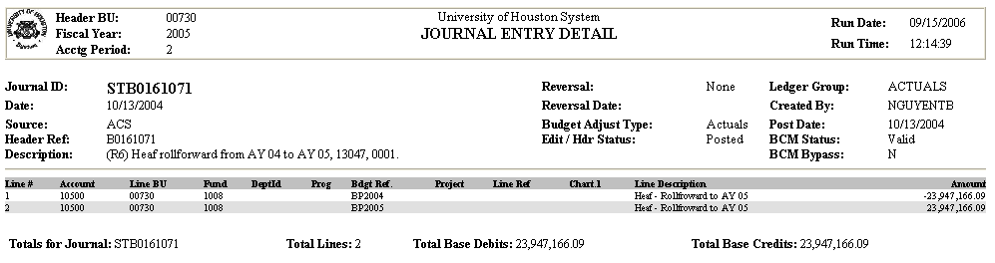

LDT: HB1, 80th Leg., R.S., Article III p. 55 Return to Table of Contents

License Plate Scholarship - L1

Funds are deposited by the Department of Transportation into the State Treasury AGY 783 for purchase of a license plate for the amount of $25. Each university provides TxDot with a coding block to deposit the funds. There used to be a minimum number of license plates already ordered before they are produced. With one plate and one account the Department of Transportation can not tell which campus has the sales, and the smaller campuses may not qualify for their own plate. The University of Houston System went with a single design for all campuses in order to attain the deposit of sales. The System Office needs to decide how to distribute the funds among the campuses. The funds are allocated to each campus according to the number of students. Those funds are used to dispense scholarships to eligible students through out the campuses. The License Plate appropriation number for FY07 is 29346 and the appropriated fund is 5015.

The contact person in the Department of Transportation is Brad Gatlin at (512) 936-2701 (Bgatlin@dot.state.tx.us).

The appropriation number for the License Plate scholarship program for AY02 and AY03 was 27320; for AY04 and FY05 the appropriation number was 28347; and for FY06 and FY07 the appropriation number is 29346.

The appropriation has UB authority so unused funds can be roll-forwarded into future years. To manage those funds the following procedures are followed:

1. Roll-forward the funds to the following year
2. Record the deposit of funds in PS
3. Allocate the funds to UH components
4. Adjustment budget to Cash in USAS
1. Roll forward balance to the next year. For example: from AY02 to AY03.

PS entries ro roll-forward the funds to the following year – BU 00783
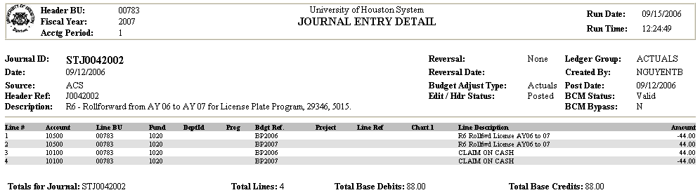

USAS entries to roll-forward the funds to the following year – AGY 783
Unit | Curr Doc Num | Batch date | Comptroller Obj | Approp Num | Fund | Appropriat Yr | Fiscal Year | Transaction Cd | Sum Trans Amt | Ref Doc Num | HX Per | Reverse | PCA
00783 | J0042002 | 2006-09-12 | 3975 | 29346 | 5015 | 06 | 07 | 406 | 44.00 | J0042002 | 1 |  | 03980
00783 | J0042002 | 2006-09-12 | 3975 | 29346 | 5015 | 07 | 07 | 405 | 44.00 | J0042002 | 1 |  | 03980

Batch Type: 8 Edit Mode: 2

LDT: HB1, 80TH LEG., R.S., ART. III p. 228, SECTION 41

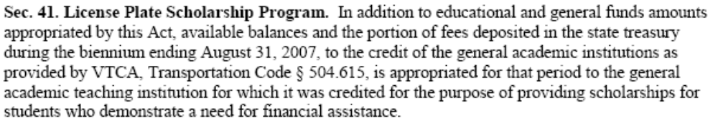
2. Deposits of funds made in USAS in AGY 783 on a monthly basis

PS entries to record the License Plate deposits - Business Unit 00783
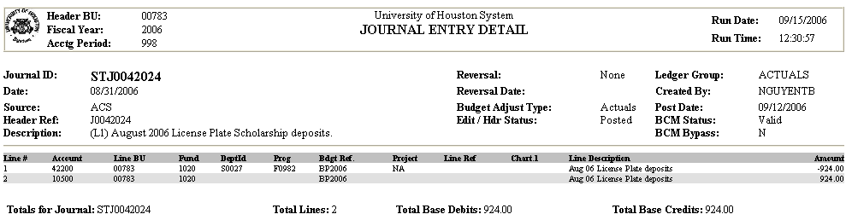

Note: The document number for all deposits recorded in PS will be always STJ0042024. We need to match the USAS entries to the PS entries and by using the same document number in PS it facilitates the system analyst to match the transactions automatically.

3. Allocate the funds to UH components

FY200X STUDENT HEAD COUNT FOR UH CAMPUSES

(Fall + Spring)/2
FALL 03 SPRING 04 FY04 AVERAGE

UH CENTRAL 35,066 33,499 34,283

UH CLEAR LAKE 7,776 7,539 7,658

UH DOWNTOWN 10,974 10,404 10,689

UH VICTORIA 2,411 3,349 2,380

55,009

Call each campus’ records or institutional reporting department for student head count.
UH Central Josh Currie (713) 743-0642 jacurrie@uh.edu
UH Clear Lake Simone Tiu (281) 283-3008 TiuSim@uhcl.edu
UH Downtown Gloria Stewart (713) 221-8269 gs@dt.uh.edu
UH Victoria Trydy Wortham (361) 570-4110 worthamt@uhv.edu

License Plate Scholarship Revenue Allocation Based On Head Count
Campus Enrollment % of Total Amount
FY 2002 Average Enrollment Allocated

System (783) |  |  | 9,724.00
Houston (730) | 34,283 | 62.32% | 6,060.00
Clear Lake (759) | 7,658 | 13.92% | 1,354.00
Downtown (784) | 10,689 | 19.43% | 1,890.00
Victoria (765) | 2,380 | 4.33% | 420.00
Totals | 55,009 | 100.00% | 9,724.00

PS entries for the License Plate Allocation of funds to UH components - Business Unit 00783
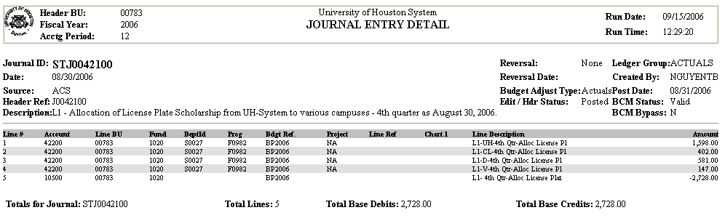

Note: For the first allocation done in the year, use the equity account 36100 for the amount of the beginning balance. After depleting the beginning balance, use the revenue account 42200. The journal entry number in BU 730 should be the same number used in BU 783. The allocation entry in USAS entered by the comptrollers is for all the units (783, 730, 784, 765, and 759) and it uses the same number for all components.

PS entries for the allocation to UH - Business Unit 00730

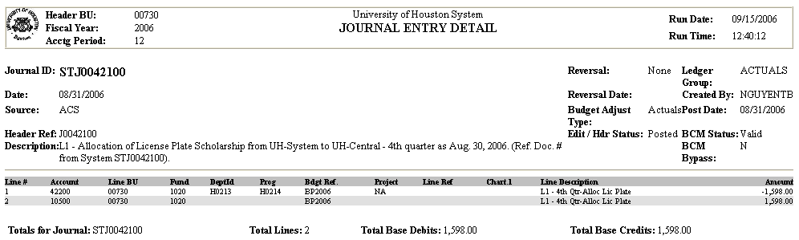

Note: The entry number in PS in BU 00730 should be the same as the number used in the allocation in BU 00783 to match the USAS entry. The USAS entry in USAS in AGY 783 is entered by the comptrollers to allocate the funds to the different UH components. The entry number in 783 is carried to the other UH components as a Reference Document Number.

USAS entries for the allocation to the UH components - AGY 783
Unit | Curr Doc Num | Batch date | Comptroller Obj | Approp Num | Fund | Appropriat Yr | Fiscal Year | Transaction Cd | Sum Trans Amt | Ref Doc Num | HX Per | Reverse | PCA
00783 | J0042100 | 2006-08-06 | 3014 | 29346 | 5015 | 06 | 06 | 406 | 1,598.00 |  | 12 |  | 03980
00730 | J0062100 | 2006-08-06 | 3014 | 29346 | 5015 | 06 | 06 | 405 | 1,598.00 |  | 12 |  | 03980
00783 | J0062100 | 2006-08-06 | 3014 | 29346 | 5015 | 06 | 06 | 406 | 402.00 |  | 12 |  | 03980
00759 | J0062100 | 2006-08-06 | 3014 | 29346 | 5015 | 06 | 06 | 405 | 402.00 |  | 12 |  | 03980
00783 | J0062100 | 2006-08-06 | 3014 | 29346 | 5015 | 06 | 06 | 406 | 581.00 |  | 12 |  | 03980
00784 | J0062100 | 2006-08-06 | 3014 | 29346 | 5015 | 06 | 06 | 405 | 581.00 |  | 12 |  | 03980
00783 | J0062100 | 2006-08-06 | 3014 | 29346 | 5015 | 06 | 06 | 406 | 147.00 |  | 12 |  | 03980
00765 | J0062100 | 2006-08-06 | 3014 | 29346 | 5015 | 06 | 06 | 405 | 147.00 |  | 12 |  | 03980

Fax this Journal Entry to the Comptroller’s Office after the proper signatures have been gathered.
4. Adjusting the budget to cash in USAS – AGY 730

The allocation entry in AGY 730 with Transaction Code 405 increases only the cash available see screen below.

TEXAS S062 UNIFORM STATEWIDE ACCOUNTING SYSTEM 01/13/06 10:40 AM
LINK TO: APPROPRIATION RECORD INQUIRY PROD

AGY: 730 APPN YEAR: 06 APPN #: 29346 LICENSE PLATE SCHOLAR PGM
APPR FUND: 5015 FUND: COMP SRCE/GRP: LBB/COMP OBJ:
PRG CD: LVL: ORG CD: LVL:
INQ TYPE: CB INQ YEAR: 06 INQ MONTH: 07 NET CASH ACT: 1,598.00
REM CASH BASIS BUDG: 0.00 APPN CASH AVAIL: 1,598.00
REM ACCR BASIS BUDG: 0.00 APPN ACCR CSH AVAIL: 1,598.00
REM ENC BASIS BUDG: 0.00 APPN ENC CASH AVAIL: 1,598.00
BT TITLE AMOUNT BT TITLE AMOUNT
02 APPN REVISIONS 9,995.00
11 EST COL REVENUE 9,995.00
12 CASH REVENUES 9,995.00
15 CASH EXPEND 8,397.00
17 ACCRUED EXPEND .00

F1-HELP F3-END F4-INTERRUPT F8-FRWD

USAS entries to increase the budget to equal cash - AGY 730
Unit | Curr Doc Num | Batch date | Comptroller Obj | Approp Num | Fund | Appropriat Yr | Fiscal Year | Transaction Cd | Sum Trans Amt | Ref Doc Num | HX Per | Reverse | PCA
00783 | J0062064 | 2006-03-05 | 3000 | 29346 | 5015 | 06 | 06 | 009 | 6,060.00 |  | 7 |  | 03980
00730 | J0062064 | 2006-03-05 | 7000 | 29346 | 5015 | 06 | 06 | 006 | 6,060.00 |  | 7 |  | 03980

Note: A PS entry is not needed.

Return to Table of Contents

Tech Workforce Development (Engineer & Technical Consortium) - T2

The Texas engineering and technical consortium is a partnership between private companies and higher education institutions that will:
- Direct grants to eligible universities and computer science graduates;
- Coordinate public and private resources, technical research and degree programs;
- Serve as a resource for technology businesses that want to better leverage human resource expenditures and corporate contributions; and
- Increase collaborative efforts between related academic programs and the private sector.

The goal is to increase the number of engineering and computer science graduates from Texas colleges and universities.

The transactions that we create for Tech Workforce Development are payroll and state voucher payments and they are processed through the payroll and AP system.

The manual entries that are recorded in the State Accounting Department are:

1. Return unused funds,
2. Roll-forward, and
3. Budget load.

1. To process a refund (return unused funds), a payment transaction needs to be entered in USAS using TC 272, COBJ 3842, the Coordinating Board Vendor ID, document type “T” and RTI provided by THECB.

Return unused funds entry in USAS and PS

We have not returned any unused funds.

2. To process the roll-forward of funds (i.e. unused funds in AY05 to roll-forward to AY06), use the journal voucher document, batch type 8 and edit more 2. We are able to roll-forward the funds because Tech Workforce Development is considered a grant and the legal site is H.B. 1, 78th Leg., R.S., Article IX, Sec. 6.31.

Roll-Forward funds in USAS – AGY 730
Unit | Curr Doc Num | Batch date | Comptroller Obj | Approp Num | Fund | Appropriat Yr | Fiscal Year | Transaction Cd | Sum Trans Amt | Ref Doc Num | HX Per | Reverse | PCA
00730 | J0161002 | 2005-06-09 | 3975 | 13123 | 5079 | 06 | 06 | 405 | 427,995.61 | J0161002 | 6 |  | 03980
00730 | J0161002 | 2005-06-09 | 3975 | 13123 | 5079 | 05 | 06 | 406 | 427,995.61 | J0161002 | 6 |  | 03980

Roll-Forward funds in PS – BU 00730
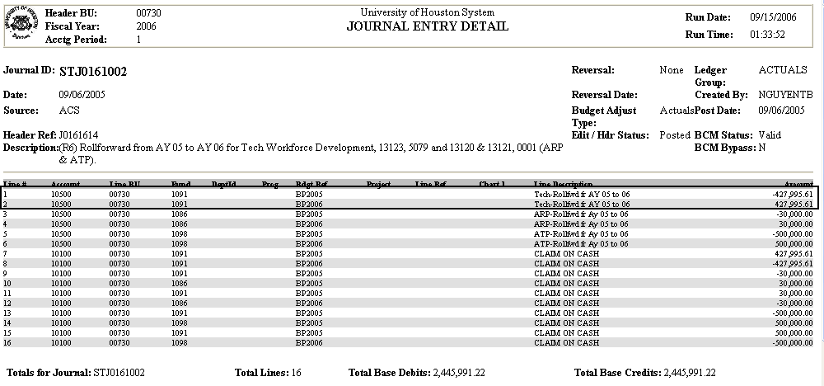

3. For the budget load refer to the Budget Load section.

Return to Table of Contents

Texas College Work Study Appropriation - T0

The Texas College Work Study Program is provided through the Texas Higher Education Coordinating Board via RTI (Recurring Transaction Indicator). The students’ awards are managed by the Financial Aid Department and the payments are made using the Payroll System. State Accounting process the return of funds to the THECB for unused funds. At year-end any payments over the amount of the awarded funds are transferred to the main appropriation (USAS 10730/0001 and PS cost center and account 50202 1026 H0213 E0245 NA).

USAS entries to return unused funds - AGY 730

Form Batch Type Edit Mode Doc Type
Deposit Type 4 2 T
Unit | Curr Doc Num | Batch date | Comptroller Obj | Approp Num | Fund | Appropriat Yr | Fiscal Year | Transaction Cd | Sum Trans Amt | Ref Doc Num | HX Per | Reverse | PCA
00730 | T0161483 | 2006-08-17 | 3842 | 13019 | 0001 | 06 | 06 | 272 | 13.42 |  | 12 |  | 03980

PS entries to post the return of un-used funds - Business Unit 00730

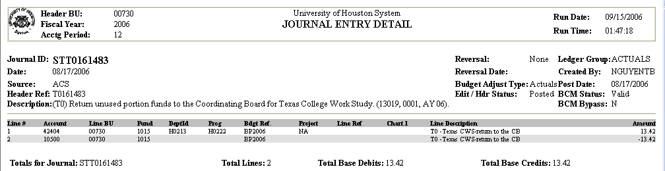

Note: The journal entry to post the return of funds during the same fiscal year the award was provided needs to use the revenue account; when the funds are returned in the following year the equity account 36100 needs to be used.

Return to Table of Contents

Texas Excellence Fund - T1

For FY07, we do not have Texas Excellence Funds

Return to Table of Contents
Texas Grants - T2

The Texas Grants Program is provided through the Texas Higher Education Coordinating Board via RTI. The students’ awards are managed by the Financial Aid Department. The reimbursement of expenses is prepared by the Financial Aid Department by issuing a state voucher using the same state cost center the awards are being posted throught the ABC system. The warrant from the state is also deposited to the same state cost center. State Accounting process the return of funds to the THECB for unused funds.

USAS entries to return unused funds - AGY 730

Form Batch Type Edit Mode Doc Type
Deposit Type 4 2 T
Unit | Curr Doc Num | Batch date | Comptroller Obj | Approp Num | Fund | Appropriat Yr | Fiscal Year | Transaction Cd | Sum Trans Amt | Ref Doc Num | HX Per | Reverse | PCA
00730 | T0161387 | 2006-06-22 | 3842 | 13107 | 0001 | 06 | 06 | 272 | 190,064.00 |  | 10 |  | 03980

PS entries to post the return of funds - Business Unit 00730
 |  | University of Houston System  JOURNAL ENTRY DETAIL
  Header BU: | 00730
  Fiscal Year: | 2006
  Acctg Period: | 10
  Run Date: | 09/15/2006
  Run Time: | 01:56:00

Journal ID: |  |  | STT0161387 |  |  |  |  |  |  |  |  |  | Reversal: |  | None | Ledger Group: | ACTUALS
Date: |  |  | 06/22/2006 |  |  |  |  |  |  |  |  |  | Reversal Date: |  |  | Created By: | NGUYENTB
Source: |  |  | ACS |  |  |  |  |  |  |  |  |  | Budget Adjust Type: |  | Actuals | Post Date: | 06/22/2006
Header Ref: |  |  | T0161387 |  |  |  |  |  |  |  |  |  | Edit / Hdr Status: |  | Posted | BCM Status: | Valid
Description: |  |  | T2 - Return unused portion to the Coordinating Board for Texas Grants, 13107, 0001, AY 06. |  |  |  |  |  |  |  |  |  |  |  |  | BCM Bypass: | N
Line # |  | Account | Line BU | Fund | DeptId |  | Prog | Bdgt Ref. |  | Project | Line Ref | Chart.1 | Line Description |  |  |  |  | Amount
1 |  | 42400 | 00730 | 1032 | H0213 |  | H0228 | BP2006 |  | NA |  |  | T2 Return unused to the CBoard |  |  |  |  | 190,064.00
2 |  | 10500 | 00730 | 1032 |  |  |  | BP2006 |  |  |  |  | T2 Return unused to the CBoard |  |  |  |  | -190,064.00
Totals for Journal: STT0161387 |  |  |  |  |  | Total Lines: 2 |  |  | Total Base Debits: 190,064.00 |  |  |  |  | Total Base Credits: 190,064.00

Note: The journal entry to post the return of funds during the same fiscal year the award was provided needs to use the revenue account; when the funds are returned in the following year the equity account 36100 needs to be used

Return to Table of Contents

Chapter 3

Reconciliations and Analysis
Cash Reconciliation

Cash Reconciliation Process and Analysis

The reconciliation of the state bank account 10500 is done automatically on a monthly basis. A program was developed to match the cash transactions by appropriation number, appropriation year, fund (USAS Fund), and reconciliation document number (Rec Doc Number). This chapter deals with several sections: a) Storing Data from USAS and Reconciliation Query, b) Run Query to Excel, c) Analysis of Outstanding Items, d) Summary of Outstanding Items, and e) Run USAS Reconciliation Process.

a. Storing Data from USAS and Reconciliation Query

- Transactions that goes to USAS are stored on a daily basis in a table called UHS_USAS_DETTRN
- Transactions from USAS are received on a daily basis and stored in a table called UHS_USAS_DETPMT
- Financial Operations Department loads the HX data (history transactions data in USAS) and runs a monthly process that picks up the T-Codes affecting the cash transactions in USAS and stores them in the UHS_USAS_RECON table.
- The last step of the process run by Financial Operations (Run USAS Reconciliation) matches the USAS and PS cash transactions and flags the transactions with an “N” for no match and “Y” for match.
5. Transactions flagged with an “N” (outstanding transactions) needs to be pulled on a monthly basis. Go to the UHS_RECON_READ query to get all the outstanding transactions having all lines for each document.

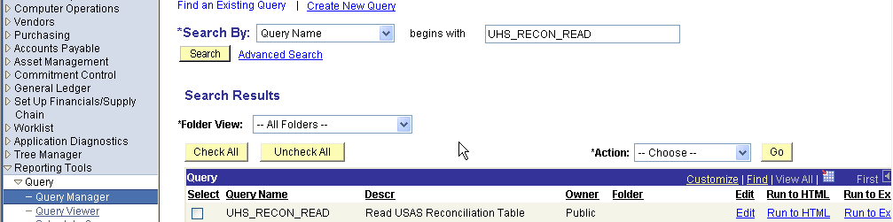

6. Go to UHS_USAS_RECON_DISTINCT query to get all the outstanding transactions without the line details. This query will be summarized by document number and it will be shorter and easier to manage.

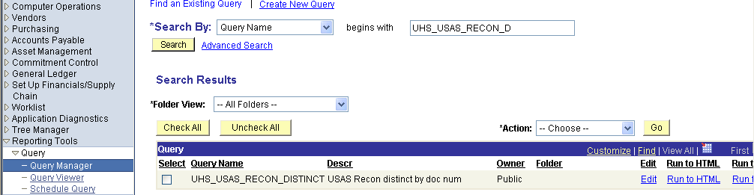

7. Click on Edit to check the criteria.

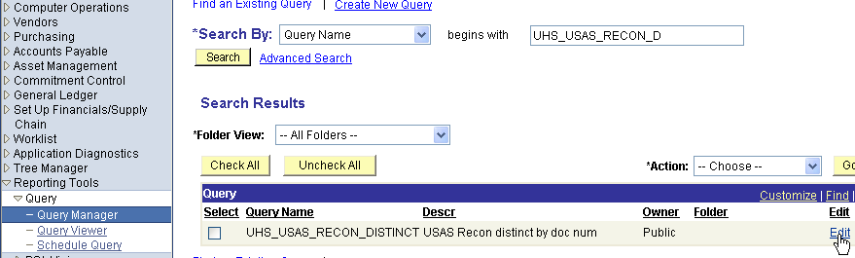

8. In Expression 2, we have the following:
- The USAS appropriation 99906, 99907, and 93211 do not need to be reconciled, because they are holding appropriations.
- The USAS fund 9000 is the default fund and it is also in relation to a holding appropriation.
- The outstanding transactions required to reconcile are those that have the “N” for non-matched transactions.

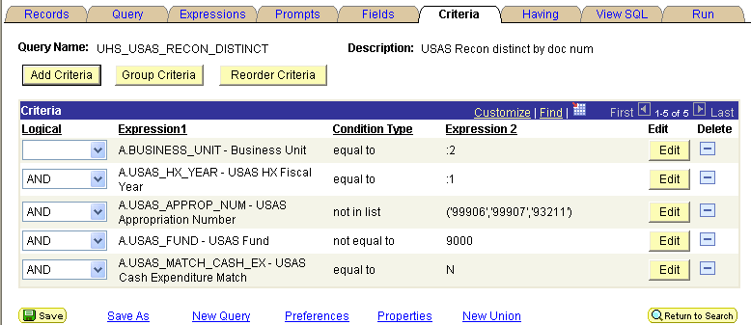

- The fields look as follows:
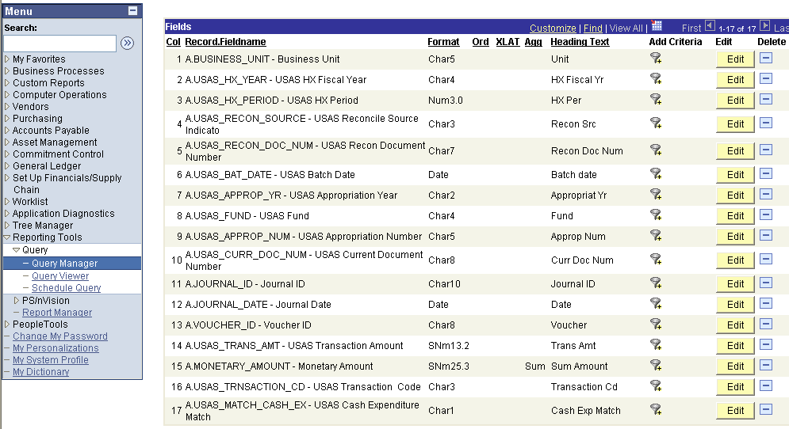
10. Save the query as a private query using the Save As feature.
b. Run Query to Excel

1. When doing the reconciliation each month, click on Run to Excel in the query manager to download to excel.

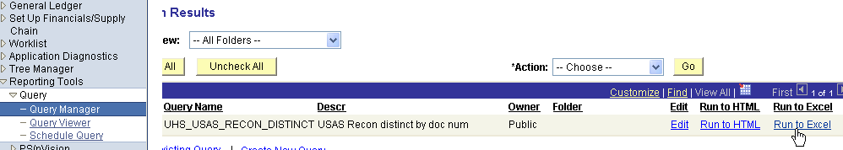

2. Enter fiscal year and business unit and press enter.



2. The file will download to excel. Insert a new sheet and copy original spreadsheet to the second sheet. This step is done to keep the original spreadsheet with all the data with no changes to use it for research purposes and make sure no data was lost.
3. In this second sheet, sort the excel file by first appropriation number, second appropriation year and third by appropriation fund.
4. Insert as many sheets as outstanding appropriation numbers, appropriation funds, and appropriation years.
- Copy and paste each appropriation number, fund, and appropriation year to the inserted worksheets. Name each worksheet with the appropriation number, fund, and appropriation year. Example: 10730/0001/03.

c. Analysis of Outstanding Items

      - Create another worksheet and copy all the data from the original worksheet. Name this worksheet “Sorted by Rec Doc Number”. This is the analytical worksheet that helps to research and analyze each reconciling item.
- Sort the worksheet by “Rec Doc Number”
- Insert row to separate the different “Rec Doc Numbers”
- Sort each “Rec Doc Number” by appropriation number, appropriation year, and fund.
- For each Rec Doc Number calculate the differences between USAS and PS by each appropriation number, appropriation year and fund.
- If the differences are in cents the correcting entry is for rounding errors.
- If the differences are between different appropriations having the same appropriation year, the correcting entry is for posting transactions in different appropriations in PS and USAS.
- If the differences are between different appropriation years, the correcting entry is for posting transactions is different appropriation years in PS and USAS.
2. Differences between PS and USAS transactions can also be for the following reasons:
i. For Accounts Payable Transactions
- Interest posted in USAS and not in PS
- Reimbursement from state was partially posted to the GL
- Payments posted in PS twice
- Reimbursement sent to USAS twice for which payment can be posted only once
ii. For Payroll Transactions
- Reimbursement from state was partially posted to the GL
- Payments posted in PS twice
- Reimbursement sent to USAS twice for which payment can be posted only once
iii. For State Accounting Transactions
- Transactions posted for different amount in PS and USAS
- Transactions posted in PS or USAS with an opposite sign
- Transactions were processed using a different document number in PS and USAS
- Transactions posted using the wrong bank account number (10510 instead of 10500)
3. Find those transactions for which there is only a USAS or PS transaction.
i. Transactions posted only in USAS needing a PS entry
- Interest in Fund 0225
- Revenue from the Coordinating Board
- Payments from another Agency
- Transactions posted in USAS until cost centers are set up in PS
- Payroll transactions going into default in USAS for which PS payment have not been posted
ii. Transactions posted only in USAS not needing a PS entry
- Transactions were processed with a different document number in PS
- A/P vouchers in transit will show in USAS first and the PS entry will post in the following month. This should be only for transactions in the current month and at month-end. Transactions for prior months should be researched.
iii. Transactions posted only in PS not needing or not having a matching USAS entry
- The cash activity between the un-appropriated activity appropriation and other fund 2 appropriations is recorded in PS as a transfer of equity and cash. In USAS, the transaction is recorded as an equity transfer (budget authority) and the cash remains in the un-appropriated activity appropriation. The cash recorded in the un-appropriated activity in PS do not have a matching entry in USAS.
- Transactions were processed with a different document number in PS
- Payroll vouchers in transit will show in PS and not in USAS. This should be only for transactions in the current month and at month-end. Transactions for prior months should be researched.

d. Summary Outstanding Items

1. Enter the USAS and PS balances in each worksheet right below the outstanding items.
2. Calculate the difference between USAS and PS balances. The difference should equal the total amount of the outstanding entries in PS and USAS. Otherwise, your items outstanding are not in balance and you need to check the following:
- T-Codes used that is not in the reconciliation program.
- Budget period missing in a PS transaction
- Rerun the reconciliation process
3. Type the classified outstanding entries as shown below.
4. Difference between USAS and PS should be zero after all outstanding entries are summarized.
5. Do necessary entries in PS or USAS and write the entry number date for control purposes in the summary below.

APPROPRIATION NUMBER 10730 FUND 0225
ACTIVITY IN BP2005
RECONCILIATION JULY 31, 2005
 | USAS Screen 62 | USAS BALANCE | PS BALANCE | Fund Code | Adj Entry # | Entry Date
 | APPN CASH AVAIL: | 14,710,065.75 | 207,266.98 | 1003
 | 16 CASH RSRVD - PR | 11,345,217.99 | 16,372,256.47 | 1026
 |  |  | (8,442.86) | 1097
 |  |  | (61,970.60) | 7068
Timing Items to clear in the following month
R1 - REFUND TO STATE - JOURNAL - IN TRANSIT |  | 1,949.41
R5 - REFUND TO STATE - VOUCHERS - IN TRANSIT |  | 200.00
A/P VOUCHERS & INTEREST IN TRANSIT |  |  | (15,148.00)
RTI - IN TRANSIT |  |  | 350.00
CLEAR DEFAULT - PAYROLL IN TRANSIT |  |  | 4,155.08
A/P VOUCHERS IN TRANSIT |  |  | (285.39)
PAYROLL VOUCHERS IN TRANSIT |  | (9,559,280.91)
Adjusting Entries
PAYROLL VOUCHER (REIM. F/STATE) POSTED WITH ROUNDING ERRORS |  |  | (0.01) |  | ST0B56S972 | 8/18/2005
PAYROLL VOUCHER (REIM. F/STATE) POSTED WITH ROUNDING ERRORS |  |  | (0.17) |  | ST0B57C982 | 8/17/2005
PAYROLL VOUCHER (REIM. F/STATE) POSTED WITH ROUNDING ERRORS |  |  | (0.02) |  | ST00507962 | 8/17/2005
PAYROLL VOUCHER (REIM. F/STATE) POSTED WITH ROUNDING ERRORS |  |  | 0.01 |  | ST0M56U949 | 8/17/2005
SCR VOUCHER NOT POSTED IN PS |  |  | (31.25) |  | ST0D059837 | 8/31/2005
R1 - REFUND TO STATE - JOURNAL - CORR IN 8/3 |  |  | 2.00 |  | STD0161470 | 8/2/2005
 |  | 16,498,152.24 | 16,498,152.24
 |  |  | 0.00
Prepared by: | Tuyet Nguyen |  |  | Date:
Approved by: | Raquel Scarone |  |  | Date:
e. Run USAS Reconciliation Process

1. During the month, to update the Y and N flags, after matching some transactions manually, run the USAS Reconciliation process following the PS path Business Processes, USAS, and Run USAS Reconciliation and,
      - Type the Run Control ID (in our case “REC”)

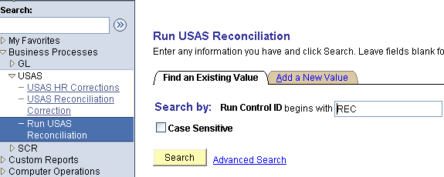

      - To match the new manually matched transactions up to period 5 for FY05 (January 2005) in Business Unit 00783, type the Request ID, Business Unit, Fiscal Year, Accounting Period, and click on Run.

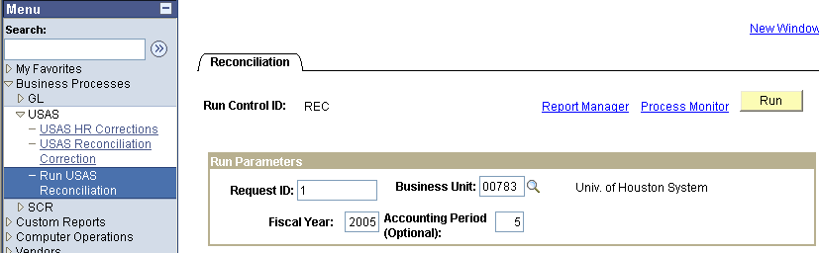

      - On the Process Scheduler Request verify the parameters below and click OK.
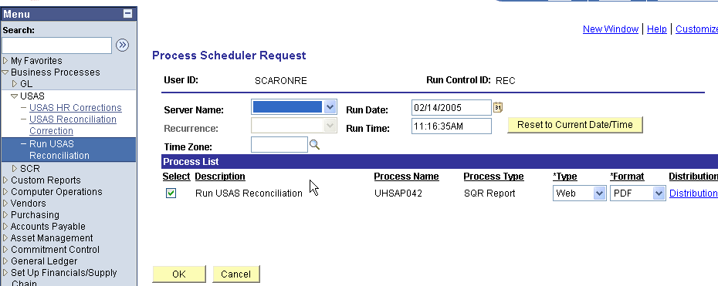

      - SQR report will run to update the UHS_USAS_RECON table. Click on Report Manager to check on the status of the update.

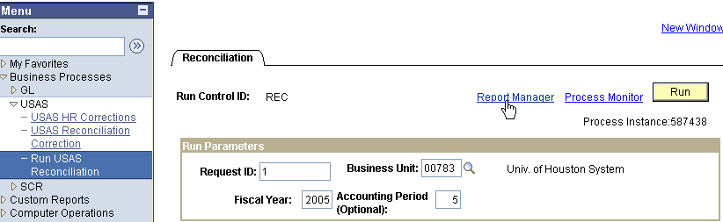

6. To check on the status of the USAS reconciliation process go to the Administration tab. When the word “Details” is shown the new transactions have been matched.

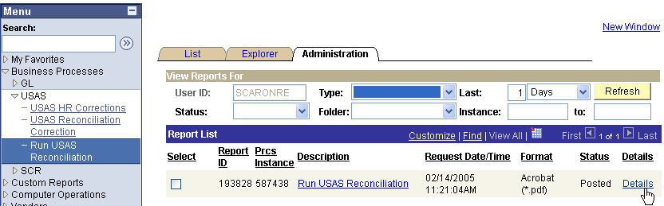

7. If you click on Details, the data from the reconciliation will not show. You need to run the reconciliation query again to obtain the remaining outstanding transactions.

Return to Table of Contents

Adjustment Entries Appropriation Number - A2

These adjustment entries are processed when transactions have been posted in different appropriation numbers in USAS and PS. The most frequent cases are the following:

- Interest payments from vouchers paid from multiple appropriations are sometimes posted in one appropriation in USAS and in another appropriation in PS. PS entry needs to correct the cost center and the state bank.
- AP voucher using a capital asset account (i.e. 58229) with an E&G cost center will be rejected in USAS. If the account was correct and the payment was changed to the HEAF appropriation, the PS entry needs to correct the cost center and state bank. (1) However, if the AP voucher using a capital asset account (i.e. 58229) with an E&G cost center is rejected in USAS, but the PS account was incorrect. The transaction in USAS is corrected online changing the COBJ. A correcting entry is recorded in PS to the correct account.
- Payroll reimbursements were posted in PS to an appropriation that does not have enough funding in USAS. The most frequent case is the Texas College Work-Study appropriation. The cost center is changed before the transactions are fed to USAS or the appropriation is changed online from the TCWS appropriation to the E&G appropriation. An entry is needed in PS to reflect the change on the appropriation in USAS.
- FICA or ORP accounts posted to the ERS, TRS, HEAF, CSA, ATP, ARP, or any other appropriation that does not allow payroll benefits expenses.
    - ERS and TRS cost centers posted with the FICA or ORP accounts are rejected in USAS. These transactions are changed before they are fed to USAS or online. The correcting entry in PS changes the ERS or TRS cost center to the one that matches the Payroll benefit account.
    - For those appropriations that allow payroll benefit expenses like HEAF, CSA, ATP, and ARP, PS and USAS correcting entry is needed to change the appropriation number in USAS and the cost center and the state bank in PS. These correcting entries are initiated by the departments and monitored by our department.

(1) For this case, the Accounts Payable Department has decided not to change the appropriation number in USAS when the PS account can not be changed to agree with the funding. The original voucher is then deleted from USAS and the voucher is closed in PS. Then, a new voucher with the different appropriation number is issued.

The research steps are as follows:

a. Analyze the transaction to make sure that the voucher paid in USAS is in the correct appropriation before recording the correcting entry in PS or USAS.
- In PS and for the AP vouchers, go to Query Manager and pull the query UHS_AP_ACCTG_LINE

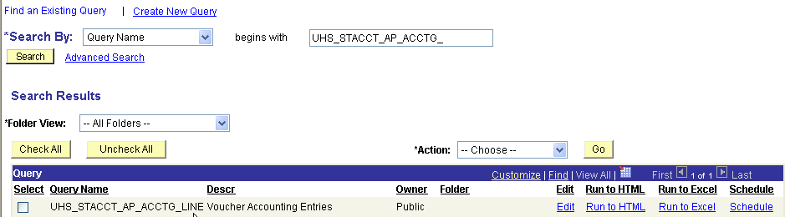

- Click on Run to Excel

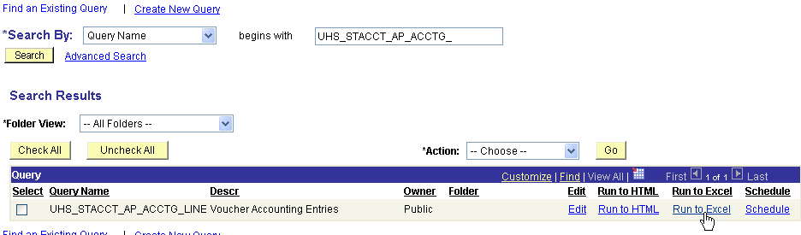

- Type Business Unit and Voucher ID and click “OK”. Click View Results.


- Voucher detail lines will be downloaded to excel.

Voucher Accounting Entries | 10
Descr | Ledger | Template | GL Unit | Type | Account | Fund | DeptID | Program | Project | Bud Ref | Amount | Year | Acct Period | Journal ID | Jrnl Line # | Jrnl Date
Cash Distribution | ACTUALS | AP_PAYM | 00730 | Cash Distribution | 10500 | 1063 | H0108 | B0003 | P001858 | BP2003 | (5,998.65) | 2006 | 6 | AP00886813 | 3 | 2/3/2006
Cash Distribution | ACTUALS | AP_PAYM | 00730 | Cash Distribution | 10500 | 1026 | H0233 | B1458 | NA | BP2003 | (13,498.65) | 2006 | 6 | AP00886813 | 1 | 2/3/2006
Accounts Payable | ACTUALS | APACCR | 00730 | Accounts Payable | 20100 | 1063 | H0108 | B0003 | P001858 | BP2003 | (5,998.65) | 2006 | 5 | AP00883975 | 23 | 1/30/2006
Accounts Payable | ACTUALS | APACCR | 00730 | Accounts Payable | 20100 | 1026 | H0233 | B1458 | NA | BP2003 | (13,498.65) | 2006 | 5 | AP00883975 | 19 | 1/30/2006
Accounts Payable | ACTUALS | AP_PAYM | 00730 | Accounts Payable | 20100 | 1063 | H0108 | B0003 | P001858 | BP2003 | 5,998.65 | 2006 | 6 | AP00886813 | 6 | 2/3/2006
Accounts Payable | ACTUALS | AP_PAYM | 00730 | Accounts Payable | 20100 | 1026 | H0233 | B1458 | NA | BP2003 | 13,498.65 | 2006 | 6 | AP00886813 | 7 | 2/3/2006
InfiniBand Switch based on Mel | ACTUALS | APACCR | 00730 | Expense Distribution | 58602 | 1063 | H0108 | B0003 | P001858 | BP2003 | 13,498.65 | 2006 | 5 | AP00883975 | 760 | 1/30/2006
InfiniBand Switch based on Mel | ACTUALS | APACCR | 00730 | Expense Distribution | 58602 | 1026 | H0233 | B1458 | NA | BP2003 | 13,498.65 | 2006 | 5 | AP00883975 | 759 | 1/30/2006
Shipping | ACTUALS | APACCR | 00730 | Expense Distribution | 58602 | 1063 | H0108 | B0003 | P001858 | BP2003 | 500.00 | 2006 | 5 | AP00883975 | 760 | 1/30/2006
University discount | ACTUALS | APACCR | 00730 | Expense Distribution | 58602 | 1063 | H0108 | B0003 | P001858 | BP2003 | (8,000.00) | 2006 | 5 | AP00883975 | 760 | 1/30/2006

- Sort and subtotal by accounts and fund code in excel.
- Do the PS or USAS entry depending on the correct funding.
- In PS and for the payroll reimbursement, go to query manager and pull the query UHS_STACCT_JRNL_STATE_REIMB

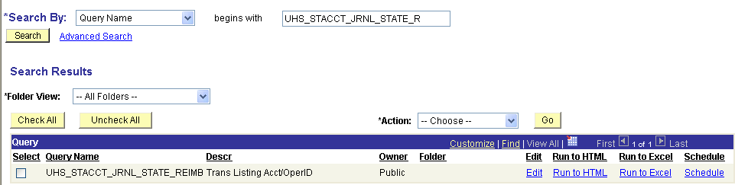

- Click Run to Excel, enter business unit, fiscal year, and accounting period from and to, and click view results

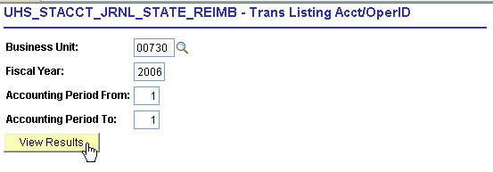

- The reimbursement entries will be downloaded to excel. Find the rec doc number and copy paste all the lines of the reimbursement journal entry to another worksheet. The journal entry that has the rec doc number in the description field is the payment entry that debits the liability account 21100 and credits the state bank account. Sort the worksheet by fund code and account.
- Do the PS correcting entry to match the entry in USAS.

Examples of entries to correct the posting in different appropriation numbers are as follows:

Interest Payments - The example above shows the voucher accounting lines for voucher number 00339307. The voucher was paid from multiple appropriations and the interest paid posted in different appropriations in PS and USAS. The PS entry is recorded to the expense and state bank accounts.

Note: The document number in PS will be ST for State Accounting, the number zero and the reconciliation document number (rec doc number) from the reconciliation file 0339307.

 |  |  | University of Houston System  JOURNAL ENTRY DETAIL
  Header BU: | 00730
  Fiscal Year: | 2006
  Acctg Period: | 7
  Run Date: | 01/07/2005
  Run Time: | 03:24:08

Journal ID: | ST00339307 | Reversal: | None | Ledger Group: | ACTUALS
Date: | 03/25/2006 | Reversal Date: |  | Created By: | BANKSDA
Source: | ACS | Budget Adjust Type: | Actuals | Post Date: | 03/25/2006
Header Ref: | 00339307 | Edit / Hdr Status: | Posted | BCM Status: | Valid
Description: | A2-Adjusting entries changing appropriation number. Interest posted in PS in E&G instead of HEAF. |  |  | BCM Bypass: | N

Line # | Account | Line BU | Fund | DeptId | Prog | Bdgt Ref. | Project | Line Ref | Chart.1 | Line Description | Amount
1 | 10500 | 00730 | 1026 |  |  | BP2003 |  |  |  | STATE BANK | 47.00
2 | 54705 | 00730 | 1026 | H0233 | B1458 | BP2003 | NA |  |  | CORR INT FROM E&G TO HEAF | -47.00
3 | 54705 | 00730 | 1043 | H0108 | B0003 | BP2003 | P001858 |  |  | CORR INT FROM E&G TO HEAF | 47.00
4 | 10500 | 00730 | 1043 |  |  | BP2003 |  |  |  | STATE BANK | -47.00

Totals for Journal: ST00339307 | Total Lines: 4 | Total Base Debits: 94.00 | Total Base Credits: 94.00

Signatures | ___________________________________ | Date | __________________________________
PS Approval: | ___________________________________ |  | __________________________________

Created By: BANKSDA | Date Printed: 01/07/2005 | Jrnl. Dt.: 03/25/2006

Payroll Reimbursement. The USAS transactions can be corrected in the USAS payroll correction panel in PS before it goes to USAS. The correction is to the fund code in PS or appropriation in USAS. The entry for the cash reconciliation is recorded to state account receivable 12118 and state bank account 10500, because it involves the accrual and payment entries.

The document number in PS will be ST, the number zero and the rec doc number from the reconciliation file.
 |  |  | University of Houston System  JOURNAL ENTRY DETAIL
  Header BU: | 00730
  Fiscal Year: | 2006
  Acctg Period: | 4
  Run Date: | 01/07/2005
  Run Time: | 03:27:27

Journal ID: | ST09102103 | Reversal: | None | Ledger Group: | ACTUALS
Date: | 12/11/2003 | Reversal Date: |  | Created By: | NGUYENTB
Source: | ACS | Budget Adjust Type: | Actuals | Post Date: | 12/15/2003
Header Ref: | 09102103 | Edit / Hdr Status: | Posted | BCM Status: | Valid
Description: | Correcting payroll PS entries that posted in the wrong appropriation # for Nov.'s rec.'s. * It should be in 91142, 0001, 06 instead of 13019. |  |  | BCM Bypass: | N

Line # | Account | Line BU | Fund | DeptId | Prog | Bdgt Ref. | Project | Line Ref | Chart.1 | Line Description | Amount
1 | 12118 | 00730 | 1015 | H0213 | H0222 | BP2006 | NA |  |  | PAYROLL RECEIVABLE FR STATE | 9.27
2 | 10500 | 00730 | 1015 |  |  | BP2006 |  |  |  | STATE BANK | -9.27
3 | 12118 | 00730 | 1022 | H0264 | A0296 | BP2006 | NA |  |  | PAYROLL RECEIVABLE FR STATE | -9.27
4 | 10500 | 00730 | 1022 |  |  | BP2006 |  |  |  | STATE BANK | 9.27

Totals for Journal: ST09102103 | Total Lines: 4 | Total Base Debits: 18.54 | Total Base Credits: 18.54

Signatures | ___________________________________ | Date | __________________________________
PS Approval: | ___________________________________ |  | __________________________________

Created By: NGUYENTB | Date Printed: 01/07/2005 | Jrnl. Dt.: 12/11/2003

Note: If the corrections need to be done in USAS instead of PS, use T-Codes 407 and 408 to do an expenditure transfer between the different appropriation numbers.

Return to Table of Contents

Adjustment Entries Appropriation Year - A3

These adjustment entries are done when entries have been posted in different appropriation years in USAS and PS. The entries are done to the state bank account (10500) with the two budget periods affected.

The most frequent cases are the following:

  - Posting the payments in USAS in the current appropriation year and PS posted in the previous appropriation year.
  - Posting the project cost centers to BP0000 in PS and in the current appropriation year in USAS.

The research steps are as follows:

- Analyze the transaction to make sure that the voucher paid in USAS is in the correct appropriation year before making the correcting entry in PS
b. Follow the same research steps as of A2
c. The PS entry is recoded only to the state bank account 10500, because it involves one fund code in different budget periods
- If USAS entry is required, use T-Codes 407 and 408 to do an expenditure transfer between the different appropriation years

The document number in PS will be ST, the number zero and the rec doc number from the reconciliation file.
 |  |  | University of Houston System  JOURNAL ENTRY DETAIL
  Header BU: | 00730
  Fiscal Year: | 2006
  Acctg Period: | 4
  Run Date: | 01/07/2005
  Run Time: | 03:41:39

Journal ID: | ST00299337 | Reversal: | None | Ledger Group: | ACTUALS
Date: | 12/15/2003 | Reversal Date: |  | Created By: | NGUYENTB
Source: | ACS | Budget Adjust Type: | Actuals | Post Date: | 12/16/2003
Header Ref: | 00299337 | Edit / Hdr Status: | Posted | BCM Status: | Valid
Description: | Correcting PS entry that posted in the wrong appn. year. *For Nov.'s rec.'s, 10730, 0001. |  |  | BCM Bypass: | N

Line # | Account | Line BU | Fund | DeptId | Prog | Bdgt Ref. | Project | Line Ref | Chart.1 | Line Description | Amount
1 | 10500 | 00730 | 1026 |  |  | BP2003 |  |  |  | STATE BANK | 2,567.85
2 | 10500 | 00730 | 1026 |  |  | BP2006 |  |  |  | STATE BANK | -2,567.85

Totals for Journal: ST00299337 | Total Lines: 2 | Total Base Debits: 2,567.85 | Total Base Credits: 2,567.85

Signatures | ___________________________________ | Date | __________________________________
PS Approval: | ___________________________________ |  | __________________________________

Created By: NGUYENTB | Date Printed: 01/07/2005 | Jrnl. Dt.: 12/15/2003

Return to Table of Contents

Adjustment Entries Rounding Errors - A4

The rounding errors occur when PS applies the prorated rate coming from USAS payment posting to spread over the payments in a voucher. Most of the time the entries are done to the liability account 21100 and state cash account 10500, because it involves the payment entries. However, research also the posting to account 12118. To do the entries in PS do the following:

The research steps are as follows:

a. Follow the same research steps as of A2
b. Do the PS entry considering accounts 12118, 21100 and 10500

Benefits Appropriations
Unit | Eff Date | Status | Fund | DeptID | Program | Project | SpeedType | Dt Modify | PCA | Description
00730 | 6/1/2003 | A | 1019 | H0600 | A0300 | NA | 31381 | 6/12/2003 | 03992 | ERS fund 0001
00730 | 6/1/2003 | A | 1021 | H0600 | A0294 | NA | 31385 | 6/12/2003 | 03991 | ORP fund 0001
00730 | 6/1/2003 | A | 1022 | H0600 | A0295 | NA | 31389 | 6/12/2003 | 03991 | FICA fund 0001
00730 | 6/1/2003 | A | 1036 | H0600 | A0298 | NA | 31377 | 6/12/2003 | 03992 | TRS fund 0001
00730 | 6/1/2003 | A | 1072 | H0600 | A0279 | NA | 31387 | 6/12/2003 | 03991 | FICA fund 0225
00730 | 6/1/2003 | A | 1075 | H0600 | A0290 | NA | 31375 | 6/12/2003 | 03991 | TRS fund 0225
00730 | 6/1/2003 | A | 1078 | H0600 | A0288 | NA | 31383 | 6/12/2003 | 03991 | ORP fund 0225

Other non-benefits appropriations

Use table below for the State Accounting Department cost centers to do the entries in PS using accounts 12118, 21100 and 10500.
Unit | Eff Date | Status | Fund | DeptID | Program | Proj/Grt | Speed Type | DESCRIPTION
00730 | 2003-09-01 | A | 1012 | H0600 | H2536 | NA | 33081 | 5th year accounting scholarship
00730 | 2003-06-01 | A | 1009 | H0600 | A1994 | NA | 31371 | Texas Excellence Funds
00730 | 2003-09-01 | A | 1015 | H0600 | F1654 | NA | 32890 | TCWS
00730 | 2003-09-01 | A | 1018 | H0600 | A1972 | NA | 32952 | Develop Ed (TASP)
00730 | 2003-09-01 | A | 1020 | H0600 | H2601 | NA | 32954 | License Plate Scholarship
00730 | 2003-06-01 | A | 1026 | H0600 | A1994 | NA | 31393 | Salary Allocation Fund 0001
00730 | 2003-09-01 | A | 1032 | H0600 | H2535 | NA | 32950 | Texas Grant
00730 | 2003-06-01 | A | 1054 | H0600 | A1994 | NA | 31391 | Salary Allocation Fund 0225
00730 | 2003-09-01 | A | 1065 | H0600 | F0241 | NA | 32944 | Indirect Cost and Other E&G
00730 | 2003-09-01 | A | 1086 | H0600 | B0018 | NA | 32894 | ARP FY02
00730 | 2003-09-01 | A | 1087 | H0600 | B0019 | NA | 32892 | ATP FY02
00730 | 2003-09-01 | A | 1091 | H0600 | D0005 | NA | 32896 | Eng and Tech Consortium
00730 | 2003-09-01 | A | 1098 | H0600 | B0020 | NA | 32898 | ATP FY06

The document number in PS will be ST, the number zero and the rec doc number from the reconciliation file.
 |  |  | University of Houston System  JOURNAL ENTRY DETAIL
  Header BU: | 00730
  Fiscal Year: | 2006
  Acctg Period: | 7
  Run Date: | 01/10/2005
  Run Time: | 09:12:35

Journal ID: | ST0M292206 | Reversal: | None | Ledger Group: | ACTUALS
Date: | 03/25/2006 | Reversal Date: |  | Created By: | BANKSDA
Source: | ACS | Budget Adjust Type: | Actuals | Post Date: | 03/25/2006
Header Ref: | 0M292206 | Edit / Hdr Status: | Posted | BCM Status: | Valid
Description: | A4- Adjustment entries for rounding errors. |  |  | BCM Bypass: | N

Line # | Account | Line BU | Fund | DeptId | Prog | Bdgt Ref. | Project | Line Ref | Chart.1 | Line Description | Amount
1 | 10500 | 00730 | 1026 |  |  | BP2006 |  |  |  | STATE BANK | 0.24
2 | 21100 | 00730 | 1026 | H0600 | A1994 | BP2006 | NA |  |  | PNT POSTED W/ ROUNDING ERRORS | -0.24
3 | 21100 | 00730 | 1086 | H0600 | B0018 | BP2006 | NA |  |  | PNT POSTED W/ ROUNDING ERRORS | 0.19
4 | 10500 | 00730 | 1086 |  |  | BP2006 |  |  |  | STATE BANK | -0.19
5 | 21100 | 00730 | 1098 | H0600 | B0020 | BP2006 | NA |  |  | PNT POSTED W/ ROUNDING ERRORS | 0.16
6 | 10500 | 00730 | 1098 |  |  | BP2006 |  |  |  | STATE BANK | -0.16
7 | 10500 | 00730 | 1054 |  |  | BP2006 |  |  |  | STATE BANK | 0.11
8 | 21100 | 00730 | 1054 | H0600 | A1994 | BP2006 | NA |  |  | PNT POSTED W/ ROUNDING ERRORS | -0.11

Totals for Journal: ST0M292206 | Total Lines: 8 | Total Base Debits: 0.70 | Total Base Credits: 0.70

Signatures | ___________________________________ | Date | __________________________________
 | ___________________________________ |  | __________________________________
PS Approval: | ___________________________________ |  | __________________________________

Created By: BANKSDA | Date Printed: 01/10/2005 | Jrnl. Dt.: 03/25/2006

Note: These errors occurred for the Payroll vouchers, but we are not longer using the AP system for the state reimbursement. For the payroll reimbursement, we are now using journal entries and the payments are applied outside the PS system.

Return to Table of Contents

Adjustment Entries – Miscellaneous - A8

Return to Table of Contents

Benefits Reconciliation

Overview FICA and ORP Reconciliation

The benefit reconciliation is done for the current year and on a monthly basis. During the year for each benefit appropriation, the balance type (BT) 15 and 16 for the current appropriation year in the 62 screen (USAS) should equal the amount of expenses in PeopleSoft for the current budget period (i.e. in FY06 AY06=BP2006).

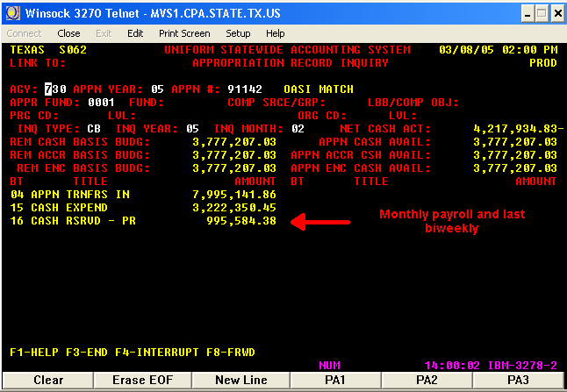

Balance type 17 at year-end should equal the amount of the accruals done in PeopleSoft by debiting the expense account and crediting the accrual account. The reversal of accruals in PeopleSoft is done by crediting the state bank (10500) and debiting the accrual account. At year-end the total amount of expenses is equal to BT 15, 16 and 17.

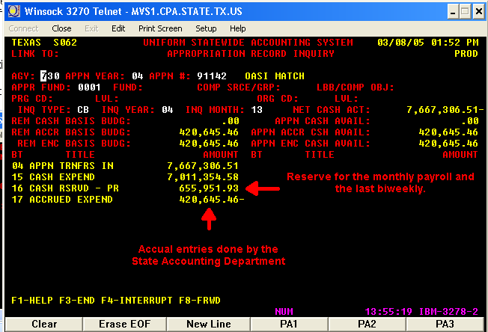

Return to Table of Contents
Data analysis and gathering of information section for FICA (OASI)

            - Copy the USAS screens for the month to be reconciled and the previous month into each appropriation worksheet.

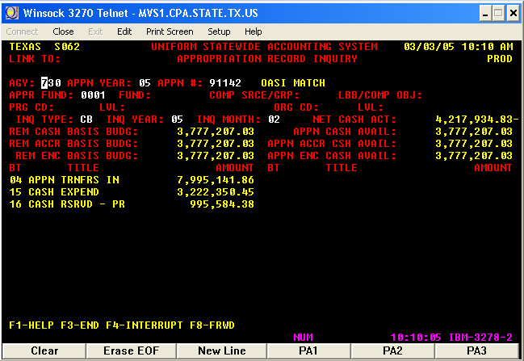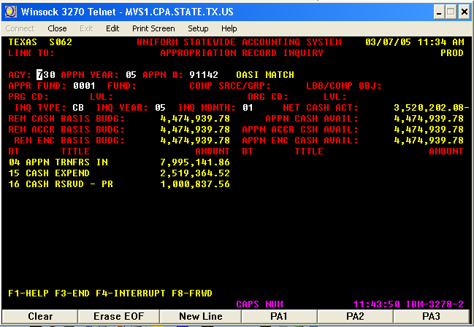

            - Add BT 15 and 16 for both months (current and previous month $4,217,934.83 and $3,520,202.08 respectively).
            - Calculate the difference between the two months to obtain the expenses for the current month (February expenses is $697,732.75)

 | 3,222,350.45
 | 995,584.38
Exp. as of February | 4,217,934.83
 | 2,519,364.52
 | 1,000,837.56
Exp. as of January | 3,520,202.08
February Expenses | 697,732.75

- This amount in USAS will be compared to the total amount of expenses posted in PS during the same month.
- Select Ledger Balances on the Ledger Criteria Page to see the monthly transactions for each benefit account to be reconciled:
- Account 51109
- Fund code 1%
- Budget Period 2005 (BP2005)

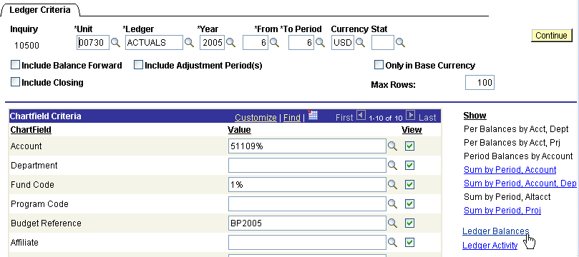

            - Sort the results by fund code to see all the funds codes used with each benefit account

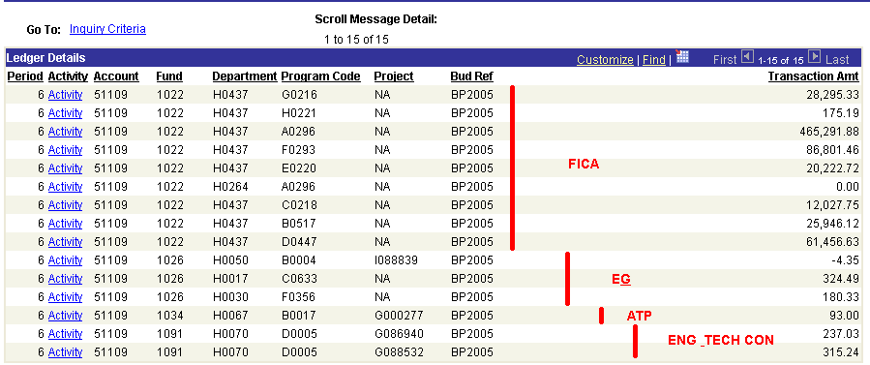

- Select also account 51108 for the Ledger Balances on the Ledger Criteria Page to see the monthly transactions.

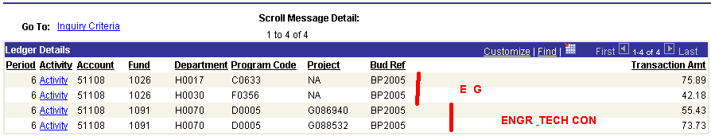

            - These pages show that the FICA accounts were used with different types of fund codes. The expenses recorded in E&G and Engineer and Technical Consortium need to be reconciled separately. For the expenses posted to ATP, check the balance for COBJ 7063 in USAS screen 49A for appropriation 13121. If the $93 is also in USAS, a payroll reallocation of expenses needs to be done to transfer the expenses to the FICA appropriation. If the $93 is not in USAS, the payroll department needs to reallocate the expenses only in PS.
            - The only appropriations that must pay for matching benefits are: E&G (Lamar University Contract fund code 1097), Engr. and Tech Consortium fund code 1091, and Texas Excellence fund code 1009, 7069, and 1099. This is according to our last Appropriation Bill.
            - Benefit accounts posted to any other fund code other than the appropriate benefit appropriation or the appropriation that pays benefits listed in the previous line needs to be reallocated to the appropriate benefit appropriation (i.e. account 51109 posted to the ORP appropriation should be reallocated the FICA fund 1 appropriation; account 51110 posted to the FICA appropriation should be reallocated to the ORP fund 1 appropriation; account 51109 posted to the Texas College Work Study appropriation should be reallocated to the FICA fund 1 appropriation).
            - Below is a list of the benefit accounts versus the fund codes:

BENEFITS FUND CODES VERSUS ACCOUNTS

FD 1 APPROPRIATIONS
DESCRIPTION | EXP ACCOUNT | GENERIC FUND CODE | FUND CODE UH | FUND CODE UHCL | FUND CODE UHD | FUND CODE UHV | ACCOUNT ACTIVITY
Insurance-State Subsidy ERS | 51106 | 1019
State Match Medicare Paid in System BU783 | 51108 | 1022
State Match FICA (OASI) FD-1 | 51109 | 1022
State PD Ret Match ORP 6.00% | 51110 | 1021
State PD Ret Match TRS | 51111 | 1036
Vacation Expense | 51107 |  | 1026 | 1051 | 1061 | 1061
FD 2 APPROPRIATIONS
DESCRIPTION | ACCOUNT | GENERIC FUND CODE | FUND CODE UH | FUND CODE UHCL | FUND CODE UHD | FUND CODE UHV
Ret Benefit ORP 1.19%-FD | 51112 |  | 1054 | 1052 | 1062 | 1062
Ret Benefit ORP 1.31%-FD | 51113 |  | 1054 | 1052 | 1062 | 1062 | Use for local activity in PS
Group Insur-State Subsidy-FD 2 | 51114 |  | 1054 | 1052 | 1062 | 1062
State Match FICA (OASI)-FD 2 | 51115 |  | 1072 | 1007 | 1073 | 1074
Ret Match ORP 6.00%-FD 2 | 51116 |  | 1078 | 1038 | 1079 | 1080
Ret Match TRS-FD 2 | 51117 |  | 1075 | 1037 | 1076 | 1077
Ret Benefit ORP 1.31%-FD 2 | 51118 |  | 1054 | 1052 | 1062 | 1062 | In use for 1054 and local activity
St PD Ret Match ORP 6%-FD 1 Reimbursement | 51119 | 1021 |  |  |  |  | No activity in PS (DUPLICATED)

STATE APPROPRIATIONS PAYING MATCHING BENEFITS
DESCRIPTION | ACCOUNT | GENERIC FUND CODE | FUND CODE UH | FUND CODE UHCL | FUND CODE UHD | FUND CODE UHV | FUND CODE DESCRIPTION
Insurance-State Subsidy ERS | 51106 | 1091 |  |  |  |  | Engineering and Technical Consortium
Vacation Expense | 51107 | 1091 |  |  |  |  | Engineering and Technical Consortium
State Match Medicare Paid in System BU783 | 51108 | 1091 |  |  |  |  | Engineering and Technical Consortium
State Match FICA (OASI) FD-1 | 51109 | 1091 |  |  |  |  | Engineering and Technical Consortium
State PD Ret Match ORP 6.00% | 51110 | 1091 |  |  |  |  | Engineering and Technical Consortium
State PD Ret Match TRS | 51111 | 1091 |  |  |  |  | Engineering and Technical Consortium
DESCRIPTION | ACCOUNT | GENERIC FUND CODE | FUND CODE UH | FUND CODE UHCL | FUND CODE UHD | FUND CODE UHV | FUND CODE DESCRIPTION
Insurance-State Subsidy ERS | 51106 | 1099 |  |  |  |  | Texas Excellence Fund
Vacation Expense | 51107 | 1099 |  |  |  |  | Texas Excellence Fund
State Match Medicare Paid in System BU783 | 51108 | 1099 |  |  |  |  | Texas Excellence Fund
State Match FICA (OASI) FD-1 | 51109 | 1099 |  |  |  |  | Texas Excellence Fund
State PD Ret Match ORP 6.00% | 51110 | 1099 |  |  |  |  | Texas Excellence Fund
State PD Ret Match TRS | 51111 | 1099 |  |  |  |  | Texas Excellence Fund
DESCRIPTION | ACCOUNT | FUND CODE | FUND CODE UH | FUND CODE UHCL | FUND CODE UHD | FUND CODE UHV | FUND CODE DESCRIPTION
Insurance-State Subsidy ERS | 51106 | 1097 |  |  |  |  | Lamar Contract Revenue
Vacation Expense | 51107 | 1097 |  |  |  |  | Lamar Contract Revenue
State Match Medicare Paid in System BU783 | 51108 | 1097 |  |  |  |  | Lamar Contract Revenue
State Match FICA (OASI) FD-1 | 51109 | 1097 |  |  |  |  | Lamar Contract Revenue
State PD Ret Match ORP 6.00% | 51110 | 1097 |  |  |  |  | Lamar Contract Revenue
State PD Ret Match TRS | 51111 | 1097 |  |  |  |  | Lamar Contract Revenue

Note: For the Texas Excellence Fund, only the new fund code (1099) is listed.
            - For our example, account 51109 posted into fund codes 1022 and 1034 during the month of February; to reconcile the FICA appropriation, select the Sum by Period Account in the Ledger Criteria Page with the parameters shown below to know the total amount of expenses in PS.

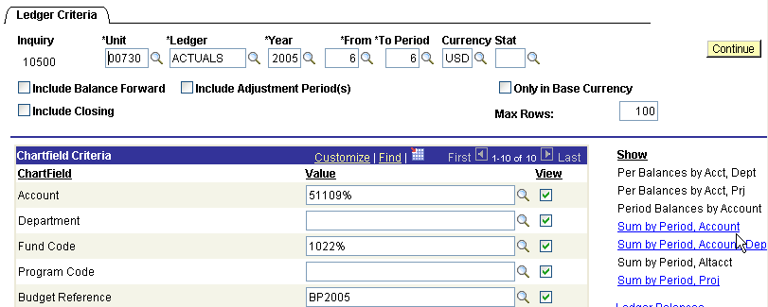

- The results show the total amount posted to account 51109 in the FICA appropriation.

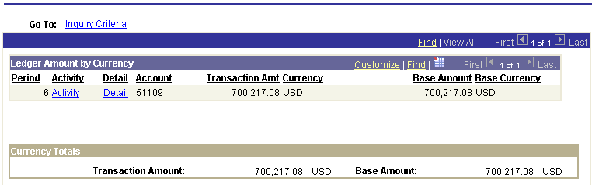

- ATP appropriation should not pay benefits. A payroll reallocation needs to be done transferring the expenses from the ATP cost center to the FICA cost center in PS. See the parameters in the ledger criteria page and the results.

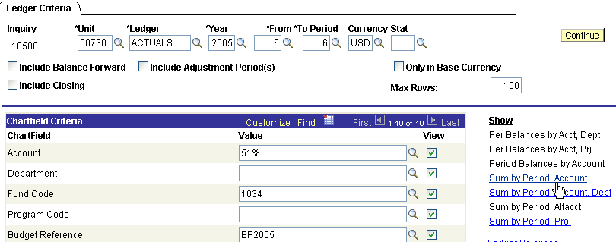
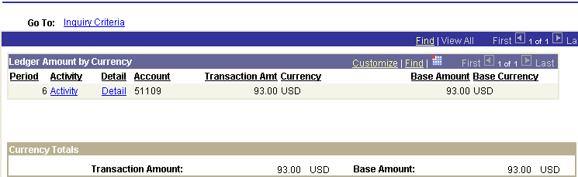

- COBJ 7063 in appropriation 13121 is zero. The FICA expenses need to be corrected only in PS.

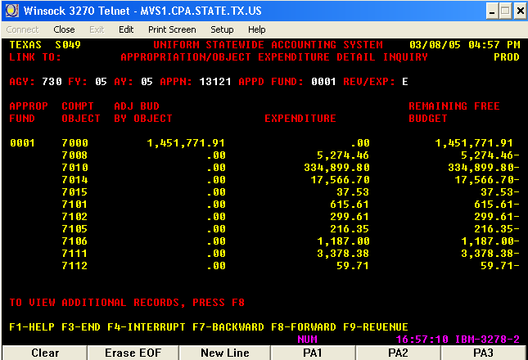

- Compare the total amount in PS ($93 + $700,217.08= $700,310.08) to the USAS expenses incurred during the month of February.
- The difference between USAS and PS is $2,577.33
- Check the ledger criteria page by clicking on Sum by Period Account for any other expense account posted by mistake into a particular benefit appropriation. For example, for the FICA appropriation during November 2006 the selection is as follows:
- Account like 5%
- Fund code (FICA appropriation) 1022
- All budget periods

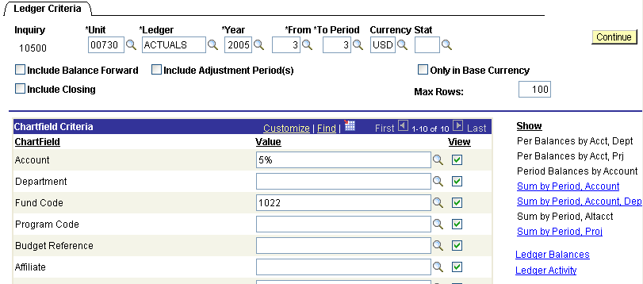

  - The results below show that we had other accounts posted incorrectly into the FICA appropriation. Accounts 51105 and 51107 should be moved from the FICA appropriation. Account 51110 should be reallocated to the ORP appropriation.

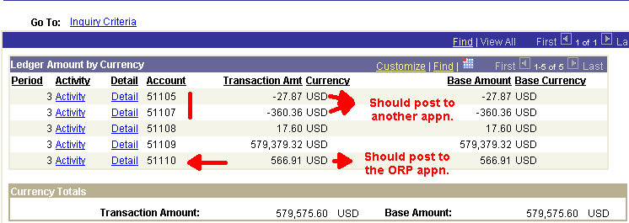

- For the month we are reconciling, check the ledger criteria page by clicking on Sum by Period Account for any other expense account posted by mistake into a particular benefit appropriation. For example, for the FICA appropriation during February 2005 the selection is as follows:
- Account like 5%
- Fund code (FICA appropriation) 1022
- All budget periods
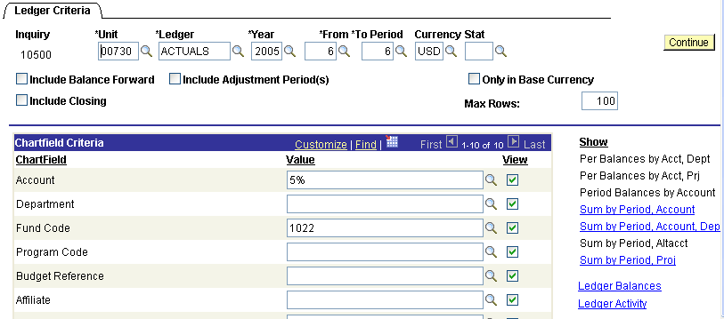

- The results below show that we had no other accounts posted incorrectly into the FICA appropriation for February 2005

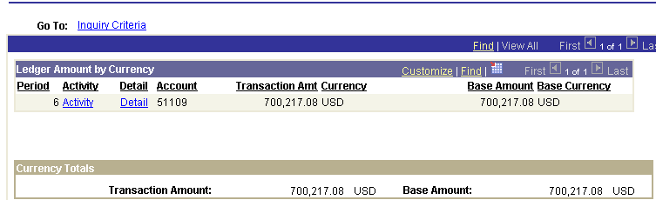

Reconciliation Worksheet

After calculating the total amount of expenses in PS and USAS, start the reconciliation of each appropriation by itemizing the previous month outstanding entries. The September reconciliation is the only month with no outstanding entries.

A. Previous Month Outstanding Items

PS Previous Month Outstanding Entries

Journal ID | Date | Acco  unt | Fund | Dept  ID | Prog  ram | Bud Ref | Sum Amount | Per  iod | Year | Sta  tus | Mat  ch | Description

HR01070679 | 1/25/2005 | 51109 | 1022 | H0637 | A0296 | BP2005 | 196.03 | 5 | 2005 | P | 1 | HR Payroll Biweekly Off Cycle
HR01070679 | 1/25/2005 | 51109 | 1022 | H0637 | B0517 | BP2005 | 151.27 | 5 | 2005 | P | 1 | HR Payroll Biweekly Off Cycle
HR01070679 | 1/25/2005 | 51109 | 1022 | H0637 | C0218 | BP2005 | 102.17 | 5 | 2005 | P | 1 | HR Payroll Biweekly Off Cycle
HR01070679 | 1/25/2005 | 51109 | 1022 | H0637 | D0647 | BP2005 | 162.34 | 5 | 2005 | P | 1 | HR Payroll Biweekly Off Cycle
HR01070679 | 1/25/2005 | 51109 | 1022 | H0637 | E0220 | BP2005 | 0.42 | 5 | 2005 | P | 1 | HR Payroll Biweekly Off Cycle
HR01070679 | 1/25/2005 | 51109 | 1022 | H0637 | F0293 | BP2005 | 31.46 | 5 | 2005 | P | 1 | HR Payroll Biweekly Off Cycle
HR01070679 | 1/25/2005 | 51109 | 1022 | H0637 | G0216 | BP2005 | 123.64 | 5 | 2005 | P | 1 | HR Payroll Biweekly Off Cycle
HR01070695 | 1/25/2005 | 51109 | 1022 | H0637 | A0296 | BP2005 | 10,432.38 | 5 | 2005 | P | 1 | HR B012505Payroll Biwk OnCycle
HR01070695 | 1/25/2005 | 51109 | 1022 | H0637 | B0517 | BP2005 | 1,498.97 | 5 | 2005 | P | 1 | HR B012505Payroll Biwk OnCycle
HR01070695 | 1/25/2005 | 51109 | 1022 | H0637 | C0218 | BP2005 | 1,523.26 | 5 | 2005 | P | 1 | HR B012505Payroll Biwk OnCycle
HR01070695 | 1/25/2005 | 51109 | 1022 | H0637 | D0647 | BP2005 | 6,875.18 | 5 | 2005 | P | 1 | HR B012505Payroll Biwk OnCycle
HR01070695 | 1/25/2005 | 51109 | 1022 | H0637 | E0220 | BP2005 | 5,569.07 | 5 | 2005 | P | 1 | HR B012505Payroll Biwk OnCycle
HR01070695 | 1/25/2005 | 51109 | 1022 | H0637 | F0293 | BP2005 | 13,545.70 | 5 | 2005 | P | 1 | HR B012505Payroll Biwk OnCycle
HR01070695 | 1/25/2005 | 51109 | 1022 | H0637 | G0216 | BP2005 | 20,594.74 | 5 | 2005 | P | 1 | HR B012505Payroll Biwk OnCycle
HR01070695 | 1/25/2005 | 51109 | 1022 | H0637 | H0221 | BP2005 | 26.42 | 5 | 2005 | P | 1 | HR B012505Payroll Biwk OnCycle
HR01070697 | 1/25/2005 | 51109 | 1022 | H0637 | G0216 | BP2005 | 15.65 | 5 | 2005 | P | 1 | HR B012505Payroll Biwk OnCycle
HR01069996 | 1/26/2005 | 51109 | 1022 | H0637 | A0296 | BP2005 | 5,348.48 | 5 | 2005 | P | 1 | HR Payroll Monthly OffCycle
HR01069996 | 1/26/2005 | 51109 | 1022 | H0637 | B0517 | BP2005 | 99.00 | 5 | 2005 | P | 1 | HR Payroll Monthly OffCycle
HR01069996 | 1/26/2005 | 51109 | 1022 | H0637 | C0218 | BP2005 | 457.63 | 5 | 2005 | P | 1 | HR Payroll Monthly OffCycle
HR01069996 | 1/26/2005 | 51109 | 1022 | H0637 | D0647 | BP2005 | 2,250.14 | 5 | 2005 | P | 1 | HR Payroll Monthly OffCycle
HR01069996 | 1/26/2005 | 51109 | 1022 | H0637 | F0293 | BP2005 | 1,377.06 | 5 | 2005 | P | 1 | HR Payroll Monthly OffCycle
HR01069996 | 1/26/2005 | 51109 | 1022 | H0637 | G0216 | BP2005 | 638.33 | 5 | 2005 | P | 1 | HR Payroll Monthly OffCycle
HR01069991 | 1/28/2005 | 51109 | 1022 | H0637 | A0296 | BP2005 | 1,146.37 | 5 | 2005 | P | 1 | HR Payroll Reallocation
HR01069991 | 1/28/2005 | 51109 | 1022 | H0637 | B0517 | BP2005 | 44.44 | 5 | 2005 | P | 1 | HR Payroll Reallocation
HR01069991 | 1/28/2005 | 51109 | 1022 | H0637 | D0647 | BP2005 | - | 5 | 2005 | P | 1 | HR Payroll Reallocation
HR01069991 | 1/28/2005 | 51109 | 1022 | H0637 | F0293 | BP2005 | (337.20) | 5 | 2005 | P | 1 | HR Payroll Reallocation
 |  |  |  |  |  |  | 71,872.95

Adjusting entries transferring expenses in USAS from TCWS to FICA appropriation was done in February. The PS entry was done only for the cash transfer. The amount of the adjusting entry is $72.70.

These are the correcting entries done in PS only
00730 | HR01052568 | 12/10/2006 | ACTUALS | 51108 | 1015 | H0213 | H0222 | BP2005 | (8.57) | 4 | 2005 | P
00730 | HR01052568 | 12/10/2006 | ACTUALS | 51109 | 1015 | H0213 | H0222 | BP2005 | (36.61) | 4 | 2005 | P
00730 | HR01034423 | 10/31/2006 | ACTUALS | 51108 | 1015 | H0213 | H0222 | BP2005 | (5.22) | 2 | 2005 | P
00730 | HR01034423 | 10/31/2006 | ACTUALS | 51109 | 1015 | H0213 | H0222 | BP2005 | (22.30) | 2 | 2005 | P
 |  |  |  |  |  |  |  |  | (72.70)
Correct to FICA in USAS only posted in TCWS (do 10500 only in PS)
00730 | HR00003387 | 9/13/2006 | ACTUALS | 51108 | 1015 | H0213 | H0222 | BP2005 | 0.96 | 1 | 2005 | P
00730 | HR00003387 | 9/13/2006 | ACTUALS | 51109 | 1015 | H0213 | H0222 | BP2005 | 4.10 | 1 | 2005 | P
00730 | HR00003442 | 9/28/2006 | ACTUALS | 51108 | 1015 | H0213 | H0222 | BP2005 | 4.26 | 1 | 2005 | P
00730 | HR00003442 | 9/28/2006 | ACTUALS | 51109 | 1015 | H0213 | H0222 | BP2005 | 18.20 | 1 | 2005 | P
00730 | HR00003473 | 10/7/2006 | ACTUALS | 51108 | 1015 | H0213 | H0222 | BP2005 | 8.57 | 2 | 2005 | P
00730 | HR00003473 | 10/7/2006 | ACTUALS | 51109 | 1015 | H0213 | H0222 | BP2005 | 36.61 | 2 | 2005 | P
 |  |  |  |  |  |  |  |  | 72.70

USAS Previous Month Outstanding Entries

The type 6 transactions were retrieved from the USAS 88 screen and the type 2 transactions are from the USAS Payroll file; these outstanding transactions from January 2005 are in the February 2005 HX table as accrual and liquidated transactions.

- USAS screen 88 shows the effective date.

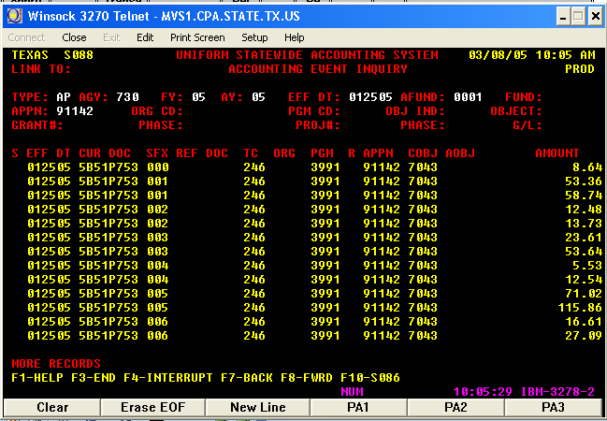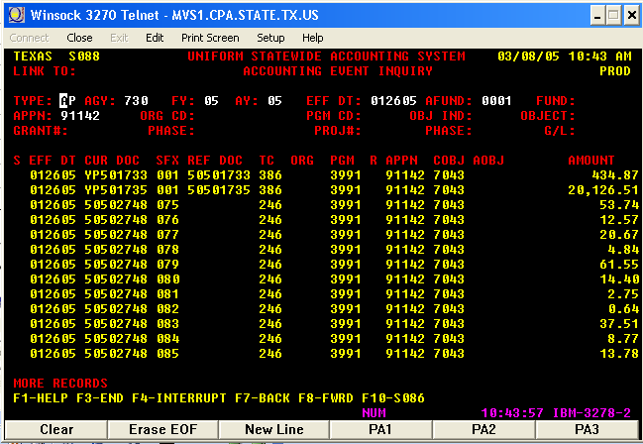

- USAS screen 86 shows the following dates:
- Effective date – Run Date for the Reimbursement (ending payroll date) and the accrual date.
- Pay date - payment due date in the USAS payroll file and date that is posted in USAS using T_Code 386. See screen 88 below.
- Batch date as part of the “Transaction ID” is the date the GL USAS Payroll file is prepared.
  - The Transaction ID includes the agency number, Batch Date, type of payroll (Type 6 or 2), batch number, and line number.

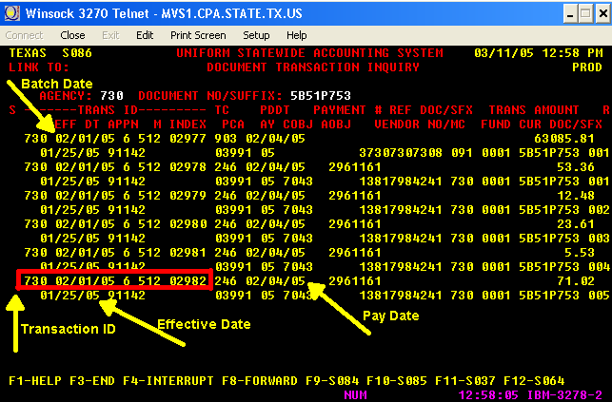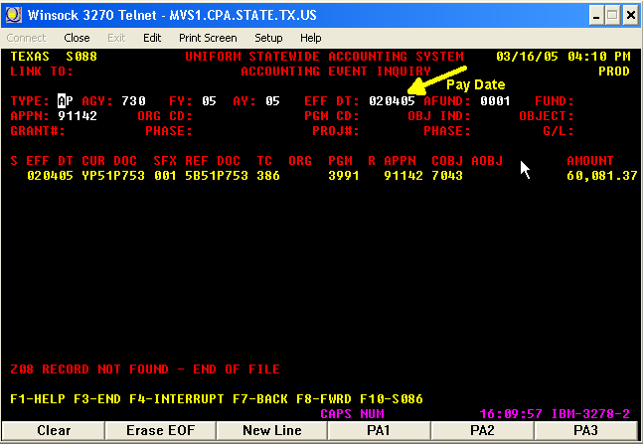

- For the Type 2 transactions, the effective date in USAS is when the check arrives to the State Comptrollers and is posted. The date that is in the Transaction ID is the Batch Date from the GL USAS payroll file.

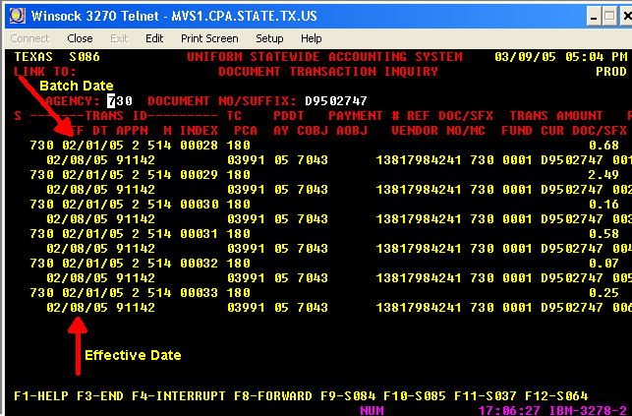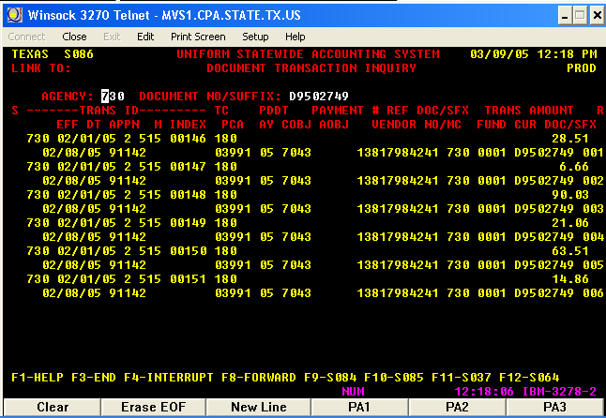

- The type 2 outstanding item transactions are from the GL USAS payroll file

Sum of Trans Amt |  |  |  |  | Sum of Trans Amt
Appropriat Yr | Approp - Fund | Account | Total |  | Appropriat Yr | Batch Agency | Batch date | Batch Number | Voucher | Total
05 | 10730-0001 | 50102 | 51,116.28 |  | 05 | 730 | 2005-02-01 | 514 | 09502740 | 3,291.09
 |  | 50103 | 6,937.86 |  |  |  |  |  | 09502747 | 10.76
 |  | 50106 | 2,136.64 |  |  |  |  | 514 Total |  | 3,301.85
 |  | 50106 | 26,723.52 |  |  |  |  | 515 | 09502742 | 87,730.36
 |  | 50107 | 1,603.63 |  |  |  |  |  | 09502745 | 2,474.54
 |  | 50110 | 91.00 |  |  |  |  |  | 09502749 | 4,430.31
 |  | 50111 | 2,158.10 |  |  |  |  | 515 Total |  | 94,635.21
 |  | 50112 | 113.72 |  |  |  | 2005-02-01 Total |  |  | 97,937.06
 |  | 51108 | 41.69 |  |  | 730 Total |  |  |  | 97,937.06
 |  | 51109 | 178.25 |  | 05 Total |  |  |  |  | 97,937.06
 | 10730-0001 Total |  | 91,100.69 |  | (blank) | (blank) | (blank) | (blank) | (blank)
 | 10730-0225 | 50108 | 70.70 |  |  |  |  | (blank) Total
 |  | 51112 | 315.44 |  |  |  | (blank) Total
 |  | 51118 | 346.99 |  |  | (blank) Total
 | 10730-0225 Total |  | 733.13 |  | (blank) Total
 | 91142-0001 | 51109 | 4,221.13 |  | Grand Total |  |  |  |  | 97,937.06
 | 91142-0001 Total |  | 4,221.13
 | 97646-0001 | 51110 | 1,812.11
 | 97646-0001 Total |  | 1,812.11
 | 99999-0001 | 50112 | 70.00
 | 99999-0001 Total |  | 70.00
05 Total |  |  | 97,937.06
Grand Total |  |  | 97,937.06
USAS Summary of Outstanding Entries

Curr Doc Num | Batch date | Compt  roller  Obj | Approp Num | Fund | Appro  priat  Yr | Fiscal Year | Transa  ction  Cd | Sum Trans Amt | Ref Doc Num | HX Per | Re  Ver  se | PCA | Mat  ch | Description
Type 6
50502748 | 01/26/2005 |  |  |  |  |  | 246 | 10,948.73 |  |  |  |  | 1
5B51P753 | 01/25/2005 |  |  |  |  |  | 246 | 60,081.37 |  |  |  |  | 1 | HR B012505  Payroll Biwk OnCycle
50502750 | 01/01/2005 |  |  |  |  |  | 246 | 5,063.98 |  |  |  |  | 1
 |  |  |  |  |  |  |  | 76,094.08
Type 2
D9502749 | 02/08/2005 |  |  |  |  |  | 180 | (4,210.37) |  |  |  |  | 1
D9502747 | 02/08/2005 |  |  |  |  |  | 180 | (10.76) |  |  |  |  | 1
 |  |  |  |  |  |  |  | (4,221.13)
 |  |  |  | Total | amount | Type 6 | & Type 2 | 71,872.95

B. Run the PS and USAS queries

            - Run a query with the JRNL_LN and JRNL_HEADER tables having the criteria shown below.

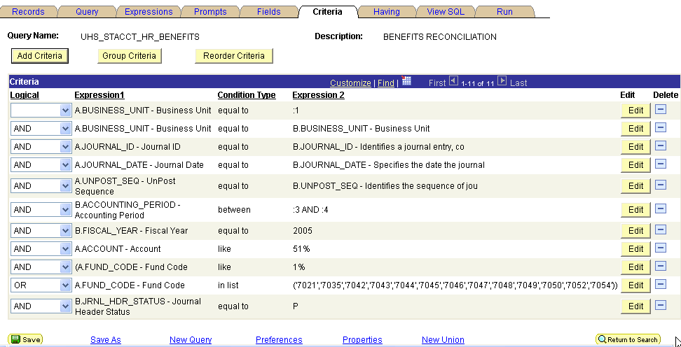

- The query provides all the journals posted to the benefit accounts (51%).
- Sort the results by benefit account.
- Copy and paste in different worksheets considering only the benefit account numbers that goes with the benefit appropriations (i.e. 51108 and 51109 for FICA, 51110 for ORP)
- Sort the PS transactions in each worksheet by fund code and date.
- Reconcile the E&G, Engr. & Tech Con, and Texas Excellence in a separately worksheet. These appropriations pay their own benefits.
- The total amount of benefit expenses that needs to be compared to the USAS total amount of benefit expenses are those expenses posted to the correct appropriation plus those posted to incorrect appropriations. For example, the total amount posted to the ORP fund 1 account 51110 for appropriations other than Engr & Tech Con, Tx Excellence, and E&G, is the total amount that needs to be compared to the USAS expenses.
- In our case, the total amount of PS expenses for FICA from the query should equal the total amount in the ledger criteria page ($700,310.08 see page 6)
- Run another query with the UHS_USAS_HX_TBL table having the criteria shown below for the Batch Dates to be reconciled (in this case from 02/01/2005 to 02/28/2005).

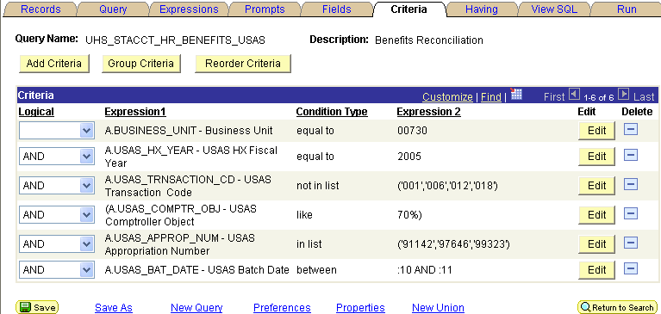

- Sort the results by appropriation number and date.
- Copy and paste each appropriation number transactions to the corresponding fund code worksheet with the PS transactions (i.e. copy appn 91142 transactions below the transactions posted to account 51109 and 51108 and fund codes 1022, 1015, 1021, 1036, 1019, 1072, 1078, 1075 and other fund codes that should not have benefit expenses).
- Sort and subtotal the USAS transactions by the Transaction Code.
C. Matching PS to USAS transactions

To keep better control of the matched items, assign the same number to the USAS and PS matched transactions.

- Start matching the outstanding items from the previous month and in the matched items column write number 1
- Match the monthly payroll in PS and USAS and in the matched items column write number 2. The USAS transactions will be the accrual transaction with transaction code (T_Code) 246 and document number ID starting with 5M (in this case 5M52S773). The PS HR journal line description field will have the payroll run ID (in this case HR M022805Payroll Mnth OnCycle).
- Match the first biweekly payroll on cycle by looking at the following:
- Payroll run ID in the HR Journal Line Description in PS and the payment due date in the USAS payroll file.
- USAS transaction ID starting with 5B as the Ref Doc Number and the payment date.
- In the matched items column write number 3.
- Match the second biweekly payroll on cycle by looking at the following:
  - Payroll run ID in the HR Journal Line Description in PS and the payment due date in the USAS payroll file.
  - USAS transaction ID starting with 5B as the Ref Doc Number and the payment date.
  - In the matched items column write number 4.
- Match the expenditure transfers done proportionality between fund 1 and 2 in PS and USAS and in the matched items column write number 5.
- Match the payroll reallocations and off cycle transactions in PS and USAS by running the query named UHS_STACCT_USAS_PAY_STEP1 considering the reimbursement cycle by looking at the Payroll Schedule below.
The address for the Payroll Schedule is: http://www.uh.edu/finance/pages/Calendar.htm
Select the first Day Reimbursement Cycle (February 1) and the last Day Reimbursement Cycle (February 15).

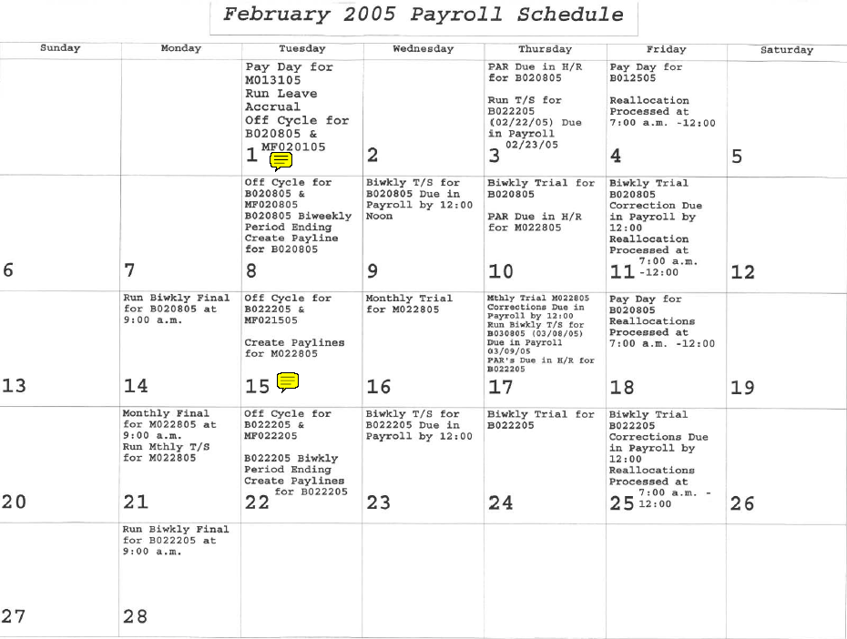

The query results shows all the HR journals numbers related to the type of payroll. The journal date is the accounting date and accrual date or ending payroll date for the on cycle transactions. The journal date for the off cycle and reallocation is the run date of the reallocation or off cycle.

Payroll Cycle Run Date | GL Unit | Type of Payroll Cycle | Journal ID | Journal Date
2/2/2005 | 00730 | HRMONOFF | HR01072781 | 2/1/2005
2/8/2005 | 00730 | HRREALLOC | HR01081133 | 2/8/2005
2/11/2005 | 00730 | HRMONOFF | HR01081145 | 2/9/2005
2/11/2005 | 00730 | HRREALLOC | HR01081136 | 2/11/2005
2/15/2005 | 00730 | HRBIWOFF | HR01081173 | 2/8/2005
2/15/2005 | 00730 | HRBIWON | HR01081161 | 2/8/2005
2/15/2005 | 00730 | HRBIWON | HR01081163 | 2/8/2005

- The computation column serves as a control feature and the total amount of PS and USAS transactions should equal zero. The signs of the total amount of matched transactions are as follows:
- T_Code 246 positive sign
- T_Code 180 negative sign
- T_Code 386 positive sign
- The PS total amount of matched transactions need to be multiplied by -1

USAS transactions for the month of February 2005 (Query Results from the USAS HX Table)

USAS Accrual Transactions
Unit | Curr Doc Num | Batch date | Comp  troller Obj | Appr  op Num | Fund | Appro  priat  Yr | Fiscal Year | Trans  action Cd | Sum Trans Amt | Ref  Doc Num | HX  Per | Re  Ver  se | PCA | Match  ed  Items | Computation
00730 | 50502748 | 2/1/2005 | 7063 | 91142 | 0001 | 05 | 05 | 246 | 10,948.73 |  | 6 |  | 03991
00730 | 50502750 | 2/1/2005 | 7063 | 91142 | 0001 | 05 | 05 | 246 | 5,063.98 |  | 6 |  | 03991
00730 | 5B51P753 | 2/1/2005 | 7063 | 91142 | 0001 | 05 | 05 | 246 | 60,081.37 |  | 6 |  | 03991
00730 | 50502763 | 2/15/2005 | 7063 | 91142 | 0001 | 05 | 05 | 246 | 4,080.96 |  | 6 |  | 03991
00730 | 50502765 | 2/15/2005 | 7063 | 91142 | 0001 | 05 | 05 | 246 | 41,224.67 |  | 6 |  | 03991
00730 | 5B528769 | 2/15/2005 | 7063 | 91142 | 0001 | 05 | 05 | 246 | 62,540.17 |  | 6 |  | 03991
00730 | 5M52S773 | 2/22/2005 | 7063 | 91142 | 0001 | 05 | 05 | 246 | 929,808.00 |  | 6 |  | 03991 | 2 | 929,808.00
 | Entries add manually from 88 screen
 | 50503779 | 3/1/2005 |  |  |  |  |  | 246 | 6,575.09 |  |  |  |  | 7 | 6,575.09
 | B52M782 | 3/1/2005 |  |  |  |  |  | 246 | 59,201.29 |  |  |  |  | 4 | 59,201.29
 |  |  |  |  |  |  |  |  | 995,584.38
 |  |  |  |  |  |  |  |  | (995,584.38) | USAS accrual
 |  |  |  |  |  |  |  |  | -

Liquidated Transactions in USAS
A) Deposit to State Treasury
Unit | Curr Doc Num | Batch date | Comp  troller  Obj | Appr  op Num | Fund | Appro  priat  Yr | Fiscal Year | Trans  action  Cd | Sum Trans Amt | Ref  Doc Num | HX  Per | Re  Ver  se | PCA | Match  ed  Items | Computation
00730 | D9502747 | 2/1/2005 | 7063 | 91142 | 0001 | 05 | 05 | 180 | 10.76 |  | 6 |  | 03991 | 1
00730 | D9502749 | 2/1/2005 | 7063 | 91142 | 0001 | 05 | 05 | 180 | 4,210.37 |  | 6 |  | 03991 | 1 | (4,221.13)
00730 | D9502762 | 2/15/2005 | 7063 | 91142 | 0001 | 05 | 05 | 180 | 2,893.45 |  | 6 |  | 03991 | 6
00730 | D9502764 | 2/15/2005 | 7063 | 91142 | 0001 | 05 | 05 | 180 | 33,683.71 |  | 6 |  | 03991 | 6 | (36,577.16)
 | Entry add manually from GL USAS Payroll file sent to USAS
 | D9503778 | 3/1/2005 |  |  |  |  |  | 180 | 1,664.10 |  |  |  |  | 7 | (1,664.10)
 |  |  |  |  |  |  |  |  | (42,462.39)
B) Proportionality Expenditure Transfers in USAS
00730 | J0161234 | 2/7/2005 | 7063 | 91142 | 0001 | 05 | 05 | 407 | (364,971.84) | J0161234 | 6 |  | 03991 | 5
00730 | J0161260 | 2/18/2005 | 7063 | 91142 | 0001 | 05 | 05 | 407 | (135.20) | J0161260 | 6 |  | 03991 | 5
00730 | J0161260 | 2/18/2005 | 7063 | 91142 | 0001 | 05 | 05 | 408 | 135.20 | J0161260 | 6 |  | 03991 | 5
 |  |  |  |  |  |  |  |  | (364,971.84) |  |  |  |  |  | (364,971.84)

C) Reimbursement from State Treasury
Unit | Curr Doc Num | Batch date (Payment Due Date) | Comp  troller  Obj | Appr  op Num | Fund | Appro  priat  Yr | Fiscal Year | Trans  action  Cd | Sum Trans Amt | Ref  Doc Num | HX  Per | Re  Ver  se | PCA | Match  ed  Items | Computation
00730 | YP502748 | 2/2/2005 | 7063 | 91142 | 0001 | 05 | 05 | 386 | 10,948.73 | 50502748 | 6 |  | 03991 | 1
00730 | YP502750 | 2/2/2005 | 7063 | 91142 | 0001 | 05 | 05 | 386 | 5,063.98 | 50502750 | 6 |  | 03991 | 1
00730 | YP51P753 | 2/2/2005 | 7063 | 91142 | 0001 | 05 | 05 | 386 | 60,081.37 | 5B51P753 | 6 |  | 03991 | 1 | 76,094.08
00730 | YP502763 | 2/18/2005 | 7063 | 91142 | 0001 | 05 | 05 | 386 | 4,080.96 | 50502763 | 6 |  | 03991 | 6
00730 | YP502765 | 2/18/2005 | 7063 | 91142 | 0001 | 05 | 05 | 386 | 41,224.67 | 50502765 | 6 |  | 03991 | 6 | 45,305.63
00730 | YP528769 | 2/18/2005 | 7063 | 91142 | 0001 | 05 | 05 | 386 | 62,540.17 | 5B528769 | 6 |  | 03991 | 3 | 62,540.17
 |  |  |  |  |  |  |  |  | 183,939.88
Correcting entry for TCWS done in PS on previous |  |  | months
00730 | J0161273 | 2/28/2005 | 7063 | 91142 | 0001 | 05 | 05 | 408 | 72.70 | J0161273 | 6 |  | 03991 | 0

Description | Subtotal Amt | Total Amount
Reserved for Payroll in USAS
5M52S773 | 929,808.00
50503779 | 6,575.09
B52M782 | 59,201.29
 | 995,584.38 | 995,584.38
Refund to State processed during February 2005
D9502747 | (10.76)
D9502749 | (4,210.37)
D9502762 | (2,893.45)
D9502764 | (33,683.71)
 | (40,798.29) | (40,798.29)
Expenditure Transfer | (364,971.84) | (364,971.84)
Correcting Entry b/w TCWS and FICA | 72.70 | 72.70
Expenses during February 2005
50502763 | 4,080.96
50502765 | 41,224.67
5B528769 | 62,540.17
 | 107,845.80 | 107,845.80
Total Amount Expenses in USAS |  | 697,732.75
PS transactions for the month of February 2005 (Query Results from the JRNL Line and JRNL Header Tables)

Expenses posted in PS
A) Reimbursement posted to GL
Unit | Journal  ID | Date  Effective Date | Ledger | Acco  unt | Fund | Dept  ID | Prog  ram | Bud Ref | Sum Amount | Per  iod | Year | Sta  tus | Line Descr | Mat  ched Items | Computation
00730 | HR01083377 | 2/15/2005 | ACTUALS | 51109 | 1022 | H0637 | A0296 | BP2005 | 2,212.56 | 6 | 2005 | P | HR Payroll Monthly OffCycle | 7
00730 | HR01083377 | 2/15/2005 | ACTUALS | 51109 | 1022 | H0637 | B0517 | BP2005 | (21.09) | 6 | 2005 | P | HR Payroll Monthly OffCycle | 7
00730 | HR01083377 | 2/15/2005 | ACTUALS | 51109 | 1022 | H0637 | C0218 | BP2005 | (312.68) | 6 | 2005 | P | HR Payroll Monthly OffCycle | 7
00730 | HR01083377 | 2/15/2005 | ACTUALS | 51109 | 1022 | H0637 | D0647 | BP2005 | (11.91) | 6 | 2005 | P | HR Payroll Monthly OffCycle | 7
00730 | HR01083377 | 2/15/2005 | ACTUALS | 51109 | 1022 | H0637 | F0293 | BP2005 | 45.53 | 6 | 2005 | P | HR Payroll Monthly OffCycle | 7
00730 | HR01083409 | 2/22/2005 | ACTUALS | 51109 | 1022 | H0637 | A0296 | BP2005 | 124.45 | 6 | 2005 | P | HR Labor Distribution | 7
00730 | HR01083409 | 2/22/2005 | ACTUALS | 51109 | 1022 | H0637 | B0517 | BP2005 | 31.60 | 6 | 2005 | P | HR Labor Distribution | 7
00730 | HR01083409 | 2/22/2005 | ACTUALS | 51109 | 1022 | H0637 | C0218 | BP2005 | (0.01) | 6 | 2005 | P | HR Labor Distribution | 7
00730 | HR01083409 | 2/22/2005 | ACTUALS | 51109 | 1022 | H0637 | D0647 | BP2005 | 141.25 | 6 | 2005 | P | HR Labor Distribution | 7
00730 | HR01083409 | 2/22/2005 | ACTUALS | 51109 | 1022 | H0637 | F0293 | BP2005 | 62.94 | 6 | 2005 | P | HR Labor Distribution | 7
00730 | HR01083409 | 2/22/2005 | ACTUALS | 51109 | 1022 | H0637 | G0216 | BP2005 | 284.31 | 6 | 2005 | P | HR Labor Distribution | 7
00730 | HR01083409 | 2/22/2005 | ACTUALS | 51109 | 1022 | H0637 | H0221 | BP2005 | 7.23 | 6 | 2005 | P | HR Labor Distribution | 7
00730 | HR01083378 | 2/23/2005 | ACTUALS | 51109 | 1022 | H0637 | A0296 | BP2005 | 787.00 | 6 | 2005 | P | HR Payroll Monthly OffCycle | 7
00730 | HR01083378 | 2/23/2005 | ACTUALS | 51109 | 1022 | H0637 | C0218 | BP2005 | 48.76 | 6 | 2005 | P | HR Payroll Monthly OffCycle | 7
00730 | HR01083378 | 2/23/2005 | ACTUALS | 51109 | 1022 | H0637 | D0647 | BP2005 | 175.35 | 6 | 2005 | P | HR Payroll Monthly OffCycle | 7
00730 | HR01083378 | 2/23/2005 | ACTUALS | 51109 | 1022 | H0637 | E0220 | BP2005 | 237.65 | 6 | 2005 | P | HR Payroll Monthly OffCycle | 7
00730 | HR01083378 | 2/23/2005 | ACTUALS | 51109 | 1022 | H0637 | F0293 | BP2005 | 1,098.05 | 6 | 2005 | P | HR Payroll Monthly OffCycle | 7 | (4,910.99)
00730 | HR01083398 | 2/22/2005 | ACTUALS | 51109 | 1022 | H0637 | A0296 | BP2005 | 10,517.55 | 6 | 2005 | P | HR B022205Payroll Biwk OnCycle | 4
00730 | HR01083398 | 2/22/2005 | ACTUALS | 51109 | 1022 | H0637 | B0517 | BP2005 | 1,595.34 | 6 | 2005 | P | HR B022205Payroll Biwk OnCycle | 4
00730 | HR01083398 | 2/22/2005 | ACTUALS | 51109 | 1022 | H0637 | C0218 | BP2005 | 1,342.91 | 6 | 2005 | P | HR B022205Payroll Biwk OnCycle | 4
00730 | HR01083398 | 2/22/2005 | ACTUALS | 51109 | 1022 | H0637 | D0647 | BP2005 | 6,607.75 | 6 | 2005 | P | HR B022205Payroll Biwk OnCycle | 4
00730 | HR01083398 | 2/22/2005 | ACTUALS | 51109 | 1022 | H0637 | E0220 | BP2005 | 5,485.50 | 6 | 2005 | P | HR B022205Payroll Biwk OnCycle | 4
00730 | HR01083398 | 2/22/2005 | ACTUALS | 51109 | 1022 | H0637 | F0293 | BP2005 | 13,055.74 | 6 | 2005 | P | HR B022205Payroll Biwk OnCycle | 4
00730 | HR01083398 | 2/22/2005 | ACTUALS | 51109 | 1022 | H0637 | G0216 | BP2005 | 20,538.02 | 6 | 2005 | P | HR B022205Payroll Biwk OnCycle | 4
00730 | HR01083398 | 2/22/2005 | ACTUALS | 51109 | 1022 | H0637 | H0221 | BP2005 | 42.79 | 6 | 2005 | P | HR B022205Payroll Biwk OnCycle | 4
00730 | HR01083399 | 2/22/2005 | ACTUALS | 51109 | 1022 | H0637 | G0216 | BP2005 | 15.69 | 6 | 2005 | P | HR B022205Payroll Biwk OnCycle | 4 | (59,201.29)
00730 | HR01081133 | 2/8/2005 | ACTUALS | 51109 | 1022 | H0264 | A0296 | BP2005 | (72.12) | 6 | 2005 | P | HR Payroll Reallocation | 6
00730 | HR01081133 | 2/8/2005 | ACTUALS | 51109 | 1022 | H0637 | A0296 | BP2005 | 2,916.87 | 6 | 2005 | P | HR Payroll Reallocation | 6
00730 | HR01081133 | 2/8/2005 | ACTUALS | 51109 | 1022 | H0637 | C0218 | BP2005 | - | 6 | 2005 | P | HR Payroll Reallocation | 6
00730 | HR01081133 | 2/8/2005 | ACTUALS | 51109 | 1022 | H0637 | D0647 | BP2005 | 474.82 | 6 | 2005 | P | HR Payroll Reallocation | 6
00730 | HR01081133 | 2/8/2005 | ACTUALS | 51109 | 1022 | H0637 | F0293 | BP2005 | 1,501.92 | 6 | 2005 | P | HR Payroll Reallocation | 6
00730 | HR01081133 | 2/8/2005 | ACTUALS | 51109 | 1022 | H0637 | G0216 | BP2005 | - | 6 | 2005 | P | HR Payroll Reallocation | 6
00730 | HR01081136 | 2/11/2005 | ACTUALS | 51109 | 1022 | H0637 | A0296 | BP2005 | 1,864.80 | 6 | 2005 | P | HR Payroll Reallocation | 6
00730 | HR01081136 | 2/11/2005 | ACTUALS | 51109 | 1022 | H0637 | B0517 | BP2005 | 1,291.41 | 6 | 2005 | P | HR Payroll Reallocation | 6
00730 | HR01081136 | 2/11/2005 | ACTUALS | 51109 | 1022 | H0637 | C0218 | BP2005 | (376.39) | 6 | 2005 | P | HR Payroll Reallocation | 6
00730 | HR01081136 | 2/11/2005 | ACTUALS | 51109 | 1022 | H0637 | D0647 | BP2005 | (1,214.43) | 6 | 2005 | P | HR Payroll Reallocation | 6
00730 | HR01081136 | 2/11/2005 | ACTUALS | 51109 | 1022 | H0637 | F0293 | BP2005 | 1,154.08 | 6 | 2005 | P | HR Payroll Reallocation | 6
00730 | HR01072781 | 2/1/2005 | ACTUALS | 51109 | 1022 | H0637 | A0296 | BP2005 | 591.40 | 6 | 2005 | P | HR Payroll Monthly OffCycle | 6
00730 | HR01072781 | 2/1/2005 | ACTUALS | 51109 | 1022 | H0637 | B0517 | BP2005 | (69.54) | 6 | 2005 | P | HR Payroll Monthly OffCycle | 6
00730 | HR01072781 | 2/1/2005 | ACTUALS | 51109 | 1022 | H0637 | C0218 | BP2005 | 2.99 | 6 | 2005 | P | HR Payroll Monthly OffCycle | 6
00730 | HR01072781 | 2/1/2005 | ACTUALS | 51109 | 1022 | H0637 | D0647 | BP2005 | 151.74 | 6 | 2005 | P | HR Payroll Monthly OffCycle | 6
00730 | HR01072781 | 2/1/2005 | ACTUALS | 51109 | 1022 | H0637 | E0220 | BP2005 | 9.25 | 6 | 2005 | P | HR Payroll Monthly OffCycle | 6
00730 | HR01081173 | 2/8/2005 | ACTUALS | 51109 | 1022 | H0637 | A0296 | BP2005 | 25.07 | 6 | 2005 | P | HR Payroll Biweekly OffCycle | 6
00730 | HR01081173 | 2/8/2005 | ACTUALS | 51109 | 1022 | H0637 | B0517 | BP2005 | 298.35 | 6 | 2005 | P | HR Payroll Biweekly OffCycle | 6
00730 | HR01081173 | 2/8/2005 | ACTUALS | 51109 | 1022 | H0637 | D0647 | BP2005 | (25.81) | 6 | 2005 | P | HR Payroll Biweekly OffCycle | 6
00730 | HR01081173 | 2/8/2005 | ACTUALS | 51109 | 1022 | H0637 | G0216 | BP2005 | 158.60 | 6 | 2005 | P | HR Payroll Biweekly OffCycle | 6
00730 | HR01081173 | 2/8/2005 | ACTUALS | 51109 | 1022 | H0637 | H0221 | BP2005 | 26.78 | 6 | 2005 | P | HR Payroll Biweekly OffCycle | 6
00730 | HR01081145 | 2/9/2005 | ACTUALS | 51109 | 1022 | H0637 | A0296 | BP2005 | 13.44 | 6 | 2005 | P | HR Payroll Monthly OffCycle | 6
00730 | HR01081145 | 2/9/2005 | ACTUALS | 51109 | 1022 | H0637 | B0517 | BP2005 | (126.54) | 6 | 2005 | P | HR Payroll Monthly OffCycle | 6
00730 | HR01081145 | 2/9/2005 | ACTUALS | 51109 | 1022 | H0637 | D0647 | BP2005 | 69.34 | 6 | 2005 | P | HR Payroll Monthly OffCycle | 6
00730 | HR01081145 | 2/9/2005 | ACTUALS | 51109 | 1022 | H0637 | E0220 | BP2005 | - | 6 | 2005 | P | HR Payroll Monthly OffCycle | 6
00730 | HR01081145 | 2/9/2005 | ACTUALS | 51109 | 1022 | H0637 | F0293 | BP2005 | 55.70 | 6 | 2005 | P | HR Payroll Monthly OffCycle | 6
00730 | HR01081145 | 2/9/2005 | ACTUALS | 51109 | 1022 | H0637 | G0216 | BP2005 | 6.74 | 6 | 2005 | P | HR Payroll Monthly OffCycle | 6 | (8,728.47)
00730 | HR01081161 | 2/8/2005 | ACTUALS | 51109 | 1022 | H0637 | A0296 | BP2005 | 10,903.63 | 6 | 2005 | P | HR B020805Payroll Biwk OnCycle | 3
00730 | HR01081161 | 2/8/2005 | ACTUALS | 51109 | 1022 | H0637 | B0517 | BP2005 | 1,629.77 | 6 | 2005 | P | HR B020805Payroll Biwk OnCycle | 3
00730 | HR01081161 | 2/8/2005 | ACTUALS | 51109 | 1022 | H0637 | C0218 | BP2005 | 1,433.00 | 6 | 2005 | P | HR B020805Payroll Biwk OnCycle | 3
00730 | HR01081161 | 2/8/2005 | ACTUALS | 51109 | 1022 | H0637 | D0647 | BP2005 | 7,166.38 | 6 | 2005 | P | HR B020805Payroll Biwk OnCycle | 3
00730 | HR01081161 | 2/8/2005 | ACTUALS | 51109 | 1022 | H0637 | E0220 | BP2005 | 5,750.15 | 6 | 2005 | P | HR B020805Payroll Biwk OnCycle | 3
00730 | HR01081161 | 2/8/2005 | ACTUALS | 51109 | 1022 | H0637 | F0293 | BP2005 | 13,759.26 | 6 | 2005 | P | HR B020805Payroll Biwk OnCycle | 3
00730 | HR01081161 | 2/8/2005 | ACTUALS | 51109 | 1022 | H0637 | G0216 | BP2005 | 21,749.02 | 6 | 2005 | P | HR B020805Payroll Biwk OnCycle | 3
00730 | HR01081161 | 2/8/2005 | ACTUALS | 51109 | 1022 | H0637 | H0221 | BP2005 | 132.86 | 6 | 2005 | P | HR B020805Payroll Biwk OnCycle | 3
00730 | HR01081163 | 2/8/2005 | ACTUALS | 51109 | 1022 | H0637 | G0216 | BP2005 | 16.10 | 6 | 2005 | P | HR B020805Payroll Biwk OnCycle | 3 | (62,540.17)
00730 | HR01080978 | 2/28/2005 | ACTUALS | 51109 | 1022 | H0637 | A0296 | BP2005 | 657,860.26 | 6 | 2005 | P | HR M022805Payroll Mnth OnCycle | 2
00730 | HR01080978 | 2/28/2005 | ACTUALS | 51109 | 1022 | H0637 | B0517 | BP2005 | 36,434.64 | 6 | 2005 | P | HR M022805Payroll Mnth OnCycle | 2
00730 | HR01080978 | 2/28/2005 | ACTUALS | 51109 | 1022 | H0637 | C0218 | BP2005 | 17,748.78 | 6 | 2005 | P | HR M022805Payroll Mnth OnCycle | 2
00730 | HR01080978 | 2/28/2005 | ACTUALS | 51109 | 1022 | H0637 | D0647 | BP2005 | 83,074.45 | 6 | 2005 | P | HR M022805Payroll Mnth OnCycle | 2
00730 | HR01080978 | 2/28/2005 | ACTUALS | 51109 | 1022 | H0637 | E0220 | BP2005 | 21,196.33 | 6 | 2005 | P | HR M022805Payroll Mnth OnCycle | 2
00730 | HR01080978 | 2/28/2005 | ACTUALS | 51109 | 1022 | H0637 | F0293 | BP2005 | 107,541.83 | 6 | 2005 | P | HR M022805Payroll Mnth OnCycle | 2
00730 | HR01080978 | 2/28/2005 | ACTUALS | 51109 | 1022 | H0637 | G0216 | BP2005 | 5,951.71 | 6 | 2005 | P | HR M022805Payroll Mnth OnCycle | 2 | (929,808.00)
 |  |  |  |  |  |  |  |  | 1,065,188.92

B) Proportionality Expenditure Transfer in PS
Unit | Journal  ID | Date | Ledger | Acco  unt | Fund | Dept  ID | Prog  ram | Bud Ref | Sum Amount | Per  iod | Year | Sta  tus | Line Descr | Mat  ched Items | Computation
00730 | STJ0161234 | 2/7/2005 | ACTUALS | 51109 | 1022 | H0637 | A0296 | BP2005 | (222,453.03) | 6 | 2005 | P | PROP ADJ- FICA FD1 JAN 05 | 5
00730 | STJ0161234 | 2/7/2005 | ACTUALS | 51109 | 1022 | H0637 | B0517 | BP2005 | (15,117.82) | 6 | 2005 | P | PROP ADJ- FICA FD1 JAN 05 | 5
00730 | STJ0161234 | 2/7/2005 | ACTUALS | 51109 | 1022 | H0637 | C0218 | BP2005 | (7,859.61) | 6 | 2005 | P | PROP ADJ- FICA FD1 JAN 05 | 5
00730 | STJ0161234 | 2/7/2005 | ACTUALS | 51109 | 1022 | H0637 | D0647 | BP2005 | (35,152.30) | 6 | 2005 | P | PROP ADJ- FICA FD1 JAN 05 | 5
00730 | STJ0161234 | 2/7/2005 | ACTUALS | 51109 | 1022 | H0637 | E0220 | BP2005 | (12,456.16) | 6 | 2005 | P | PROP ADJ- FICA FD1 JAN 05 | 5
00730 | STJ0161234 | 2/7/2005 | ACTUALS | 51109 | 1022 | H0637 | F0293 | BP2005 | (51,473.59) | 6 | 2005 | P | PROP ADJ- FICA FD1 JAN 05 | 5
00730 | STJ0161234 | 2/7/2005 | ACTUALS | 51109 | 1022 | H0637 | G0216 | BP2005 | (20,424.86) | 6 | 2005 | P | PROP ADJ- FICA FD1 JAN 05 | 5
00730 | STJ0161234 | 2/7/2005 | ACTUALS | 51109 | 1022 | H0637 | H0221 | BP2005 | (34.47) | 6 | 2005 | P | PROP ADJ- FICA FD1 JAN 05 | 5
 |  |  |  |  |  |  |  |  | (364,971.84) |  |  |  |  |  | 364,971.84
0.00
Total Computation
Amt
 |  |  |  |  |  |  |  | Total Exp PS | 700,217.08

  - Explanation of Expense Difference between PS and USAS

Description | Subtotal | Total
USAS Expenses |  | 697,732.75
Refund to State posted in PS in January processed in USAS in February
D9502747 | 10.76
D9502749 | 4,210.37
 | 4,221.13 | 4,221.13
Refund to State posted in PS in February processed in USAS in March
D9503778 | (1,664.10) | (1,664.10)
Correcting Entry between TCWS and FICA | (72.70) | (72.70)
PS Expenses |  | 700,217.08

The expenses posted to fund code 1034 are not in USAS on appropriations 13121 or 91142. A reallocation needs to be done in PS only.
E. Current Month Outstanding Items

PS Current Month Outstanding Entries

Unit | Journal  ID | Date  Effective Date | Ledger | Acco  unt | Fund | Dept  ID | Prog  ram | Bud Ref | Sum Amount | Per  iod | Year | Sta  tus | Line Descr | Mat  ched Items | Computation
00730 | HR01083377 | 2/15/2005 | ACTUALS | 51109 | 1022 | H0637 | A0296 | BP2005 | 2,212.56 | 6 | 2005 | P | HR Payroll Monthly OffCycle | 7
00730 | HR01083377 | 2/15/2005 | ACTUALS | 51109 | 1022 | H0637 | B0517 | BP2005 | (21.09) | 6 | 2005 | P | HR Payroll Monthly OffCycle | 7
00730 | HR01083377 | 2/15/2005 | ACTUALS | 51109 | 1022 | H0637 | C0218 | BP2005 | (312.68) | 6 | 2005 | P | HR Payroll Monthly OffCycle | 7
00730 | HR01083377 | 2/15/2005 | ACTUALS | 51109 | 1022 | H0637 | D0647 | BP2005 | (11.91) | 6 | 2005 | P | HR Payroll Monthly OffCycle | 7
00730 | HR01083377 | 2/15/2005 | ACTUALS | 51109 | 1022 | H0637 | F0293 | BP2005 | 45.53 | 6 | 2005 | P | HR Payroll Monthly OffCycle | 7
00730 | HR01083409 | 2/22/2005 | ACTUALS | 51109 | 1022 | H0637 | A0296 | BP2005 | 124.45 | 6 | 2005 | P | HR Labor Distribution | 7
00730 | HR01083409 | 2/22/2005 | ACTUALS | 51109 | 1022 | H0637 | B0517 | BP2005 | 31.60 | 6 | 2005 | P | HR Labor Distribution | 7
00730 | HR01083409 | 2/22/2005 | ACTUALS | 51109 | 1022 | H0637 | C0218 | BP2005 | (0.01) | 6 | 2005 | P | HR Labor Distribution | 7
00730 | HR01083409 | 2/22/2005 | ACTUALS | 51109 | 1022 | H0637 | D0647 | BP2005 | 141.25 | 6 | 2005 | P | HR Labor Distribution | 7
00730 | HR01083409 | 2/22/2005 | ACTUALS | 51109 | 1022 | H0637 | F0293 | BP2005 | 62.94 | 6 | 2005 | P | HR Labor Distribution | 7
00730 | HR01083409 | 2/22/2005 | ACTUALS | 51109 | 1022 | H0637 | G0216 | BP2005 | 284.31 | 6 | 2005 | P | HR Labor Distribution | 7
00730 | HR01083409 | 2/22/2005 | ACTUALS | 51109 | 1022 | H0637 | H0221 | BP2005 | 7.23 | 6 | 2005 | P | HR Labor Distribution | 7
00730 | HR01083378 | 2/23/2005 | ACTUALS | 51109 | 1022 | H0637 | A0296 | BP2005 | 787.00 | 6 | 2005 | P | HR Payroll Monthly OffCycle | 7
00730 | HR01083378 | 2/23/2005 | ACTUALS | 51109 | 1022 | H0637 | C0218 | BP2005 | 48.76 | 6 | 2005 | P | HR Payroll Monthly OffCycle | 7
00730 | HR01083378 | 2/23/2005 | ACTUALS | 51109 | 1022 | H0637 | D0647 | BP2005 | 175.35 | 6 | 2005 | P | HR Payroll Monthly OffCycle | 7
00730 | HR01083378 | 2/23/2005 | ACTUALS | 51109 | 1022 | H0637 | E0220 | BP2005 | 237.65 | 6 | 2005 | P | HR Payroll Monthly OffCycle | 7
00730 | HR01083378 | 2/23/2005 | ACTUALS | 51109 | 1022 | H0637 | F0293 | BP2005 | 1,098.05 | 6 | 2005 | P | HR Payroll Monthly OffCycle | 7 | (4,910.99)
00730 | HR01083398 | 2/22/2005 | ACTUALS | 51109 | 1022 | H0637 | A0296 | BP2005 | 10,517.55 | 6 | 2005 | P | HR B022205Payroll Biwk OnCycle | 4
00730 | HR01083398 | 2/22/2005 | ACTUALS | 51109 | 1022 | H0637 | B0517 | BP2005 | 1,595.34 | 6 | 2005 | P | HR B022205Payroll Biwk OnCycle | 4
00730 | HR01083398 | 2/22/2005 | ACTUALS | 51109 | 1022 | H0637 | C0218 | BP2005 | 1,342.91 | 6 | 2005 | P | HR B022205Payroll Biwk OnCycle | 4
00730 | HR01083398 | 2/22/2005 | ACTUALS | 51109 | 1022 | H0637 | D0647 | BP2005 | 6,607.75 | 6 | 2005 | P | HR B022205Payroll Biwk OnCycle | 4
00730 | HR01083398 | 2/22/2005 | ACTUALS | 51109 | 1022 | H0637 | E0220 | BP2005 | 5,485.50 | 6 | 2005 | P | HR B022205Payroll Biwk OnCycle | 4
00730 | HR01083398 | 2/22/2005 | ACTUALS | 51109 | 1022 | H0637 | F0293 | BP2005 | 13,055.74 | 6 | 2005 | P | HR B022205Payroll Biwk OnCycle | 4
00730 | HR01083398 | 2/22/2005 | ACTUALS | 51109 | 1022 | H0637 | G0216 | BP2005 | 20,538.02 | 6 | 2005 | P | HR B022205Payroll Biwk OnCycle | 4
00730 | HR01083398 | 2/22/2005 | ACTUALS | 51109 | 1022 | H0637 | H0221 | BP2005 | 42.79 | 6 | 2005 | P | HR B022205Payroll Biwk OnCycle | 4
00730 | HR01083399 | 2/22/2005 | ACTUALS | 51109 | 1022 | H0637 | G0216 | BP2005 | 15.69 | 6 | 2005 | P | HR B022205Payroll Biwk OnCycle | 4 | (59,201.29)
 |  |  |  |  |  |  | PS Total | Amount | 64,112.28

USAS Current Month Outstanding Entries

Unit | Curr Doc Num | Batch date | Comp  troller Obj | Appr  op Num | Fund | Appro  priat  Yr | Fiscal Year | Trans  action Cd |  | Sum Trans Amt | Ref  Doc Num | HX  Per | Re  Ver  se | PCA | Match  ed  Items | Computation
 | Entries add manually from 88 screen
 | 50503779 | 3/1/2005 |  |  |  |  |  | 246 |  | 6,575.09 |  |  |  |  | 7 | 6,575.09
 | 5B52M782 | 3/1/2005 |  |  |  |  |  | 246 |  | 59,201.29 |  |  |  |  | 4 | 59,201.29
 |  |  |  |  |  |  | Total | Type 6 |  | 65,776.38
 | Entry add manually from USAS Payroll file sent to USAS
 | D9503778 | 3/1/2005 |  |  |  |  |  | 180 |  | 1,664.10 |  |  |  |  | 7 | (1,664.10)
 |  |  |  |  |  |  | Total | Type 2 |  | 1,664.10
 |  |  |  |  |  |  | USAS Total | Amount |  | 64,112.28 |  |  |  |  |  | 0.00  Total  Computation Amt

Outstanding Entries | PS | USAS
HR01083377 | 1,912.41
HR01083409 | 651.77
HR01083378 | 2,346.81
HR01083398 | 59,185.60
HR01083399 | 15.69
50503779 |  | 6,575.09
5B52M782 |  | 59,201.29
D9503778 |  | (1,664.10)
 | 64,112.28 | 64,112.28

Return to Table of Contents

Payroll Reimbursement File Review

When we receive the payroll information before is sent to USAS, the following steps needs to be followed:

- Place the cursor in the second row below the row headers
- Go to data_filter_auto filter
- Go to the appropriation number and click on the arrow to choose the first appropriation that appears on the list.

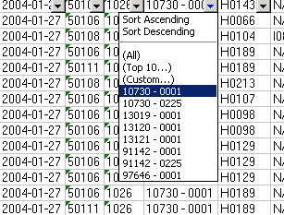

- Sort by account number for that particular appropriation
- Check for the accuracy of the accounts posted to that particular appropriation. For example, benefit accounts 51109 or 51110 should not be posted to our E&G appropriation.
- Check that there is not 99999 appropriation number
- Check for funding on the appropriations
- Repeat steps 3-5 for each appropriation (*)
- Print out the errors to be corrected in the USAS Payroll Correction Panel
- Go to the appropriation number and click on the arrow to choose “all” to see all appropriations
- Sort by “TINS” to see for incomplete or missing vendor Ids

(*) The summary page has already that information by appropriation and account, but I do this check again to confirm the summary.

Return to Table of Contents

Control of Account Receivable

Reimbursement from the State Cycle

The Financial System Operations Department performs several steps to capture our payroll reimbursement from the state initially paid with our local funds. The steps are: Accounts Receivable from State Cycle, Inter-Campus Transfer, Feed Payroll Information to the State System and Allocation of ERS and TRS liability to revenue.

Account Receivable from State Cycle
The Accounts Receivable from State Cycle refers to entries entered in our financial system and fed to the state only to the effect of capturing our state funds. Account receivable 12118 is cleared when the reimbursement is received. The accrual entry for the reimbursemt using account receivable 12118 is not set up for the payroll payments for the last payroll at year-end, since our cash is disbursed in the first day of the following fiscal year (09-01-2XXX). Otherwise, at year-end we will have two assets (cash account 10500 and receivable account 12118) and two liabilities (payroll clearing account 21100 and the payroll liability accounts from the HR journals). In the Account Receivable from State cycle, there are two steps at campus level.

      - The account receivable 12118 and payroll clearing account 21100 are used to set up our salary reimbursement from the state by issuing an accrual journal entry in PS at campus level. The salary reimbursement is for the amount of the net pay checks and benefits. The data to set up the receivable is taken from the HR load coming from the payroll system by looking at the cash lines (10711, 10714 net pay check) and the liability accounts for ORP and FICA.
      - Issue PS journal entries at campus level for the reimbursement coming from the state by debiting the payroll clearing (21100) and crediting the state cash account 10500.

Inter-Campus Transfer

The Inter-Campus Transfers moves the receivable from the state 12118 and benefit liability accounts (ORP and FICA) from the UH components to UHSA.

- Close the cash lines (10711, 10714) and benefit liability accounts (ORP and FICA) at campus level and credit the inter campus payroll account 20505 fund code 2080 with the PAY journal entry.
- At the same time, another PAY entry enters the receivable from the other campuses (account 1240X) and establishes the payroll liability accounts (ORP and FICA) at system level.
- Close the inter campus payroll account 20505 fund code 2080 and the account receivable from the state 12118 state fund codes at campus level with a USAS entry.
- Another USAS entry at system level reinstate the receivable from the state 12118 and closes the receivable from the components 1240X

Feed Payroll Information to the State System

Financial Operations feeds the state system the same information but using the expense accounts creating an accrual entry. Our financial system and the state system need to have the same expense data. The liability account from the accrual entry in the state system is reversed to the cash by issuing a state warrant that is remitted to our UHSA Treasury Office reimbursing the salary and benefit payments from the local bank. UHSA Treasury Office sends a confirmation to General Accounting to record the reimbursement.

Allocating ERS and TRS liability to revenue

    - The funds for group insurance (state contribution) and retirement contribution are controlled by the Employees Retirement System and Teacher Retirement System respectively. These organizations pay on our behalf. The expenses generated by the payroll system regarding these transactions need to be offset by a revenue account to show a zero effect. The allocation process debits the liability accounts to the revenue account and accomplishes the zero net amounts.

The flowcharts below show the following:

1. Payroll entries during the year
- The payroll expense and reimbursement cycles at campus level.
- The reimbursement cycle and the different departments affected at system level.

2. Payroll entries at year-end
- The payroll expense and reimbursement cycles at campus and system level.

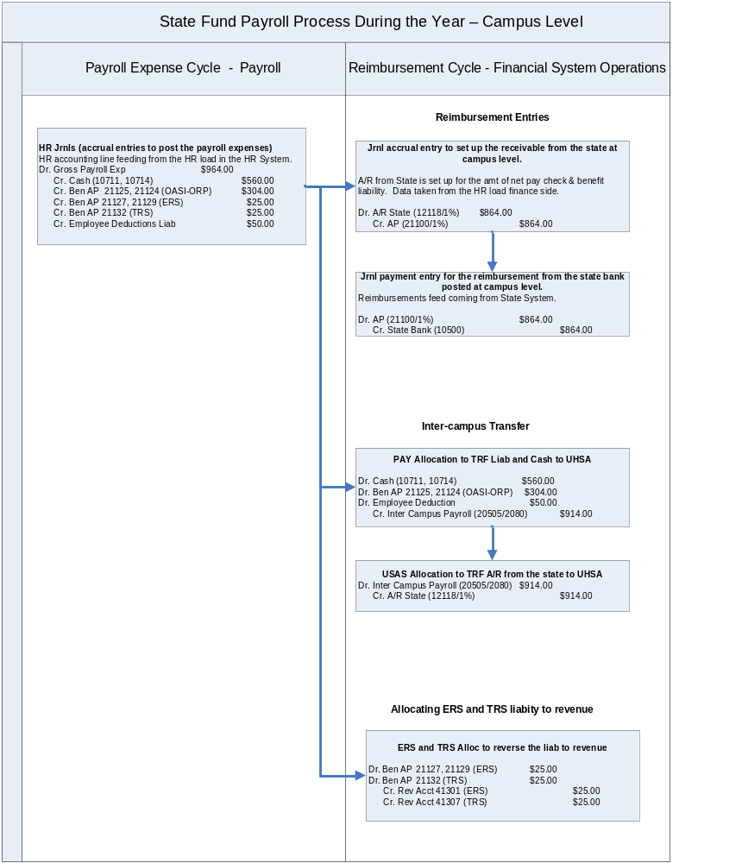
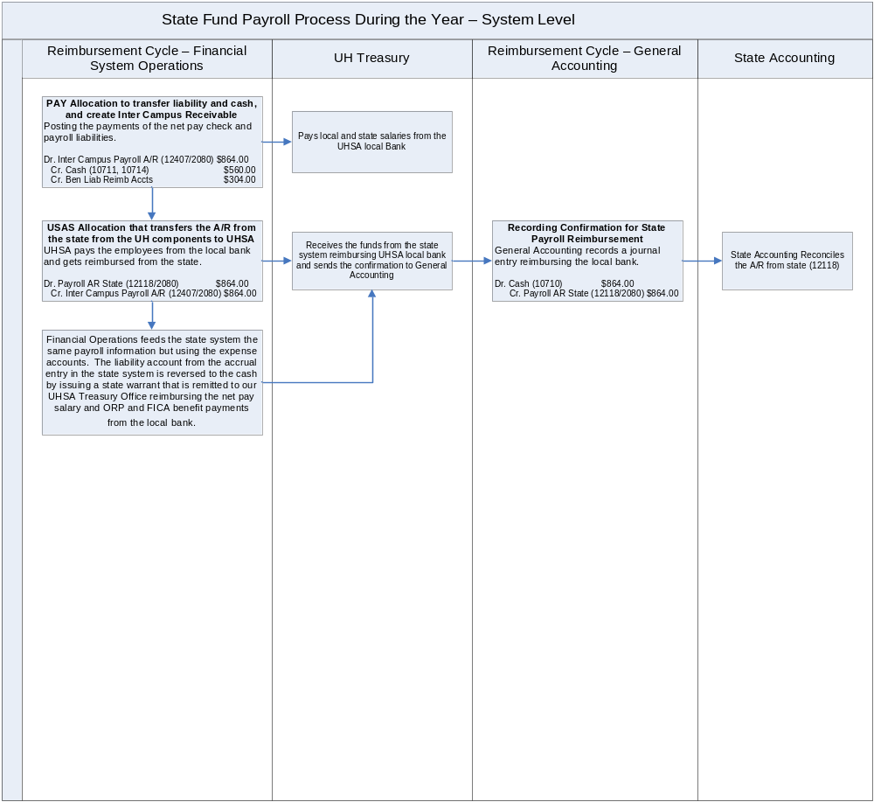
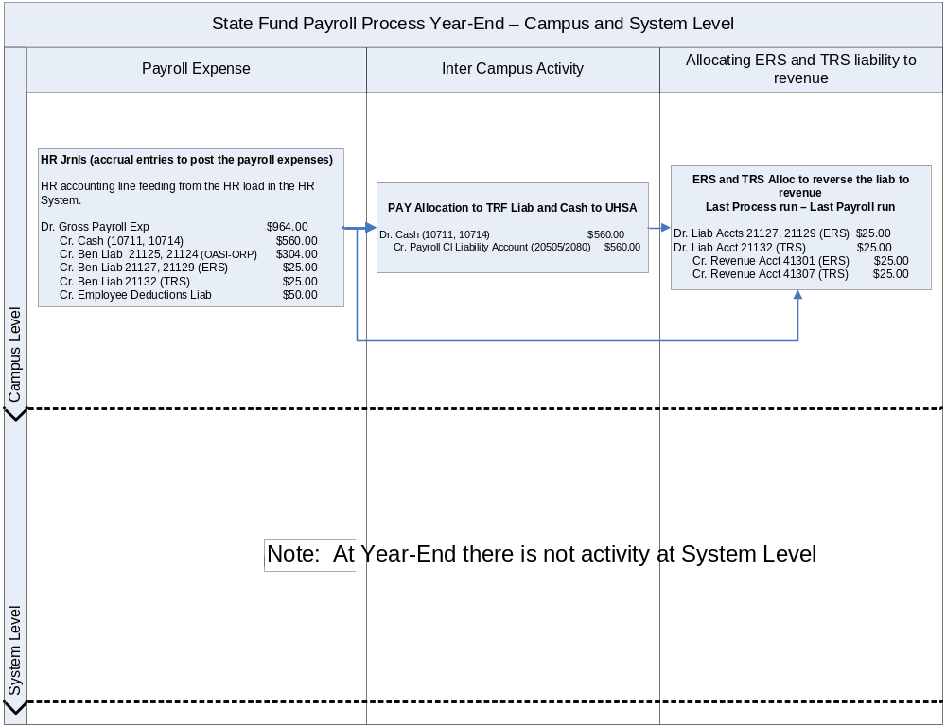
Reimbursement from the State Reconciliation - A5

The reconciliation of A/R from state is accomplished by comparing the balance in PS account 12118 and fund code 2080 at system level to the balance in the state system for all campuses. The receivable amount in USAS is equal to the balance type 16 (CASH RSRVD – PR).

Return to Table of Contents

Adjustment Entries State Payroll Liability Accounts - A6

These entries have been done to adjust previous year balances on PS accounts 20100, 20106, and 21100.

Return to Table of Contents

CHAPTER 4

YEAR-END PROCESS

Year End Process

Encumbrance, Lapsing, Accruals and Accrual Reversals (APS 018) – E0 L0 A0

Policy
State agencies and institutions of higher education must report encumbrances and payables for the current fiscal year within 30 days following each of the first three quarters of the fiscal year. On November 1 of each fiscal year, the Comptroller lapses all unencumbered appropriation balances on the payables and binding encumbrances reported.
Annually, payables and binding encumbrances must be reported to the Texas Comptroller of Public Accounts, the State Auditor's office and the Legislative Budget Board by October 30. Certifications are required with each report.

Legal cite - Tex. Const. Art. III, § 49(g) and art. VIII, § 6; Tex. Gov't Code Ann. §§ 403.021, 403.071, 403.074

APS 018 applies also to payables (accruals and accrual reversals) at year-end. For those appropriations that do not have Unexpended Balance (UB) authority, the end of year balance should be accrued or encumbered, otherwise, the unexpended balance is lapsed by processing a budget revision.

Payables: Amounts obligated for goods or services actually rendered or provided to the agency at the end of the reporting period, for which the agency has not made payments, should be recorded as accounts payable. Enter vouchers payable with an effective date of August 31. Agencies should not process accrual transactions which generate liquidating transactions that post to cash (GL 0065) if they exceed the amount of remaining cash-basis budget and appropriation cash available in a prior year's appropriation.

Expenditure Transfers: If cash expenditures are posted incorrectly in the prior fiscal year, or there is need to reallocate expenditures, accrue expenditure transfers (T-Codes 467/468) with an effective date equal to the last day of the period. Accruals done using T-Codes 467 and 468 will generate an automatic reversal and post the cash in the following year. The accrual and reversal of accrual entries should be done in PS as well to keep both systems in balance.

Operating Transfers: Accrued operating transfers (due tos and due froms) should be posted with the appropriate effective date using T-Code 450 (record accrual of operating transfer-out) and T-Code 451 (record accrual of operating transfer-in). These T-Codes will reverse themselves in the new quarter/year.

Accruals and encumbrances appropriation balances are identified on the USAS Appropriation Record Inquiry (62) profile as remaining accrual and encumbrance-basis budget and appropriation accrual and encumbrance cash available. The annual encumbrance and payables information entered in USAS should agree with the encumbrances and payables reported on the AFR (Annual Financial Report).
Accounting Policy Statements 011 - Benefits To Be Proportional by Fund - B0

Policy
The Texas Comptroller of Public Accounts, under the authority of the General Appropriations Act, requires agencies and institutions to ensure that payments of benefit costs are proportional to a state agency's or institution of higher education's funding from appropriated funds and federal receipts, unless another legal provision prohibits proportionality.

Legal cites - General Appropriations Act, Art. IX §§ 6.08, 8.02 (c), 80th Leg., R.S., §§ 51.009 (a) and (c), Education Code

Purpose: To ensure that employee benefit costs are distributed fairly and equitably between the agencies’s appropriated funds. General revenue (GR) is specifically prohibited from paying the benefits associated with salaries and wages paid from other funding sources. There may be restriction(s) on the level of salaries that can be paid from a particular source of funding. These restriction(s) must be reported when completing the Benefits Proportional by Fund Report.

Institutions of Higher Education Requirements

1. Single funded institutions – Institutions with only one appropriated fund that does not include federal funds confirms their status by letter to both the Comptroller and the State Auditor annually before November 19. UHSA has a single appropriated fund (0001).
2. Multiple funded institutions - Institutions funded from multiple appropriated funds or federal receipts must submit the Benefits proportional by fund report (Exhibit 2) annually before November 19. UH have multiple appropriated funds (0001, 0225).
3. Local funds adjustments - Addendum to Exhibit 2 – Adjustment to Other Educational & General (OE&G) income to compensate for matching benefits paid from OE&G. Include the documentation of the calculations when submitting the APS 011.
4. Adjustment notification/refund – Complete Exhibit 3 and send it to ERS and TRS with a copy to the Comptroller and the SAO.

Exhibit 2 Instructions

* SAMPLE *
BENEFITS PROPORTIONAL BY FUND REPORT (Institutions of Higher Education)
For Appropriation Year 2003 |  |  |  |  |  |  | as of Fiscal Year 2003
Institution Name |  |  |  |  |  |  |  |  |  | Agency Number
Sample University |  |  |  |  |  |  |  |  |  | 123
SECTION I - FUNDING PROPORTIONALITY CALCULATION
Financing Sources for Appropriated Funds and Federal Receipts
COLUMN 1 |  |  |  | COLUMN 2 |  | COLUMN 3 |  |  |  | COLUMN 4 |  |  |  | COLUMN 5
GENERAL REVENUE FINANCING SOURCES |  |  |  | FINANCING SOURCES AMOUNT** | - | EXCLUDE FUNDS WITH SALARY RESTRICTIONS*** |  |  | = | FUNDING SUBJECT TO PROPORTIONALITY REQUIREMENT |  |  |  | REQUIRED PROPORTION (reflects local funds adj)
General Revenue* |  |  |  | 91,950,000.00 |  | ₁ |  |  |  | 88,060,000.00
(Appd Fund # 0001) |  |  |  | 91,950,000.00 |  | 3,910,000.00
GR Riders |  |  |  | ₂ |  |  |  |  |  | 1,025,000.00
(Appd Fund # 0001) |  |  |  | 1,025,000.00
Appropriated Receipts
(Appd Fund # 0001)
Interagency Receipts
(Appd Fund # 0001)
Other Sources
(Appd Fund # 0001)
 |  |  |  |  |  |  |  |  |  | 89,065,000.00 |  |  |  | 71.0076% | B
GR Total and Percentage of Grand Total |  |  |  |  |  |  |  |  |  |  |  |  |  | 71.0076% | 74.9459%

COLUMN 1 |  |  |  | COLUMN 2 |  | COLUMN 3 |  |  |  | COLUMN 4 |  |  |  | COLUMN 5
GENERAL REVENUE-DEDICATED FINANCING SOURCES |  |  |  | FINANCING SOURCES AMOUNT** | - | EXCLUDE FUNDS WITH SALARY RESTRICTIONS*** |  |  | = | FUNDING SUBJECT TO PROPORTIONALITY REQUIREMENT |  |  |  | REQUIRED PROPORTION (reflects local funds adj)
GR-Dedicated |  |  |  | 38,290,200.00 |  | ₃ |  |  |  | 35,915,200.00
(Appd Fund # 02XX |  | ) |  | 38,290,200.00 |  | 2,375,000.00
Other E & G Indirect Cost Income |  |  |  | 450,000.00 |  |  |  |  |  | 450,000.00
(Appd Fund # |  | ) |  | 450,000.00
Other E & G Income
(Appd Fund # |  | )
Appropriated Receipts
(Appd Fund # |  | )
Interagency Receipts
(Appd Fund # |  | )
GR-D Riders
(Appd Fund #
GR-D Local Funds Adjustment |  |  |  |  |  | A |  |  |  | -6,591,123.66
(Appd Fund # |  | ) |  |  |  | 6,591,123.66
 |  |  |  |  |  |  |  |  |  | 36,365,200.00 |  |  |  | 28.9924% | C
GR - Dedicated Total and Percentage of Grand Total |  |  |  |  |  |  |  |  |  | 29,774,076.34 |  |  |  | 28.9924% | 25.0541%

COLUMN 1 |  |  |  | COLUMN 2 |  | COLUMN 3 |  |  |  | COLUMN 4 |  |  |  | COLUMN 5
FEDERAL FUNDS FINANCING SOURCES |  |  |  | FINANCING SOURCES AMOUNT** | - | EXCLUDE FUNDS WITH SALARY RESTRICTIONS*** |  |  | = | FUNDING SUBJECT TO PROPORTIONALITY REQUIREMENT |  |  |  | REQUIRED PROPORTION (reflects local funds adj)
Federal
(Appd Fund # |  | )
FF Riders
(Appd Fund # |  | )
 |  |  |  |  |  |  |  |  |  | 0.00 |  |  |  | 0.0000% | 0.0000%
Federal Fund Total and Percentage of Grand Total |  |  |  |  |  |  |  |  |  |  |  |  |  | 0.0000% | 0.0000%

COLUMN 1 |  |  |  | COLUMN 2 |  | COLUMN 3 |  |  |  | COLUMN 4 |  |  |  | COLUMN 5
OTHER FUNDS FINANCING SOURCES |  |  |  | FINANCING SOURCES AMOUNT** | - | EXCLUDE FUNDS WITH SALARY RESTRICTIONS*** |  |  | = | FUNDING SUBJECT TO PROPORTIONALITY REQUIREMENT |  |  |  | REQUIRED PROPORTION (reflects local funds adj)
Other Fund
(Appd Fund # |  | )
Appropriated Receipts
(Appd Fund # |  | )
Interagency Receipts
(Appd Fund # |  | )
Other E & G Patient Income
(Appd Fund # |  | )
Other Receipts
(Appd Fund # |  | )
OF Riders
(Appd Fund # |  | )
 |  |  |  |  |  |  |  |  |  | 0.00 |  |  |  | 0.0000% | 0.0000%
Other Funds Total and Percentage of Grand Total |  |  |  |  |  |  |  |  |  |  |  |  |  | 0.0000% | 0.0000%
 |  |  |  |  |  |  |  |  |  | 125,430,200.00 |  |  |  | 100.0000% | 100.0000%
 |  |  |  |  |  |  |  | Grand Total |  | 118,839,076.34 |  |  |  | 100.0000% | 100.0000%
 |  |  |  |  |  |  |  |  |  | D
Legal Cites and Documentation:
1-TRB ($3,910,000)
2-Salary Increase (Appn 27978), Longevity Incease (Appn 27980), Reverse Auction Reduction (Appn 97191),
Enrollment Audit (SB1,77th Leg,RS,Art III,p.201),
3- TPEG ($2,375,000).
* The amount listed as GR in the MOF of the GAA.
** If the sources of funding are estimated, enter the actual revenues.
***Provide statutory or other cite for excluded funds.

* SAMPLE *
SECTION II - BENEFITS WORKSHEETS
IIa - Social Security, State Employee Match (OASI)
COLUMN 1 |  |  |  | COLUMN 2 |  | COLUMN 3 |  | COLUMN 4 |  | COLUMN 5 |  | COLUMN 6
APPROPRIATED FUNDS |  |  |  | ACTUAL BENEFITS PAID | - | BENEFITS EXCLUDED | = | BENEFITS SUBJECT TO PROPORTIONALITY | - | CALCULATED PROPORTIONAL BENEFITS | = | REQUIRED ADJUSTMENT **
General Revenue |  |  |  | 1,805,032.53 |  | 0.00 |  | 1,805,032.53 |  | 1,883,090.3596 |  | -78,057.83
(Appd Fund # 0001 |  | ) |  | 1,805,032.53 |  | 0.00 |  | 1,805,032.53 |  | 1,883,090.3596 |  | -78,057.83
GR-Dedicated |  |  |  | 707,567.47 |  |  |  | 707,567.47 |  | 629,509.6406 |  | 78,057.83
(Appd Fund # 0279 |  | ) |  | 707,567.47 |  |  |  | 707,567.47 |  | 629,509.6406 |  | 78,057.83
Federal ** |  |  |  | 0.00 |  |  |  | 0.00 |  | 0.0000 |  | 0.00
(Appd Fund # |  | ) |  | 0.00 |  |  |  | 0.00 |  | 0.0000 |  | 0.00
Other |  |  |  | 0.00 |  |  |  | 0.00 |  | 0.0000 |  | 0.00
(Appd Fund # |  | ) |  | 0.00 |  |  |  | 0.00 |  | 0.0000 |  | 0.00
 |  |  |  |  |  | Totals |  | 2,512,600.00 |  | 2,512,600.0000 |  | 0.00
 |  |  |  |  |  |  |  |  |  | Adjustment made with Current Doc Number |  | J1234567

IIb - Group Insurance (GIP)
COLUMN 1 |  |  |  | COLUMN 2 |  | COLUMN 3 |  | COLUMN 4 |  | COLUMN 5 |  | COLUMN 6
APPROPRIATED FUNDS |  |  |  | ACTUAL BENEFITS PAID | - | BENEFITS EXCLUDED | = | BENEFITS SUBJECT TO PROPORTIONALITY | - | CALCULATED PROPORTIONAL BENEFITS | = | REQUIRED ADJUSTMENT **
General Revenue |  |  |  | 10,421,000.00 |  | 0.00 |  | 10,421,000.00 |  | 10,379,436.7505 |  | 41,563.25
(Appd Fund # 0001 |  | ) |  | 10,421,000.00 |  | 0.00 |  | 10,421,000.00 |  | 10,379,436.7505 |  | 41,563.25
GR-Dedicated |  |  |  | 3,428,241.30 |  |  |  | 3,428,241.30 |  | 3,469,806.5495 |  | -41,563.25
(Appd Fund # 0279 |  | ) |  | 3,428,241.30 |  |  |  | 3,428,241.30 |  | 3,469,806.5495 |  | -41,563.25
Federal ** |  |  |  | 0.00 |  |  |  | 0.00 |  | 0.0000 |  | 0.00
(Appd Fund # |  | ) |  | 0.00 |  |  |  | 0.00 |  | 0.0000 |  | 0.00
Other |  |  |  | 0.00 |  |  |  | 0.00 |  | 0.0000 |  | 0.00
(Appd Fund # |  | ) |  | 0.00 |  |  |  | 0.00 |  | 0.0000 |  | 0.00
 |  |  |  |  |  | Totals |  | 13,849,241.30 |  | 13,849,241.3000 |  | 0.00
 |  |  |  |  |  |  |  |  |  | Adjustment made with Current Doc Number |  | T1234559

IIc - Retirement Contributions TRS)
COLUMN 1 |  |  |  | COLUMN 2 |  | COLUMN 3 |  | COLUMN 4 |  | COLUMN 5 |  | COLUMN 6
APPROPRIATED FUNDS |  |  |  | ACTUAL BENEFITS PAID | - | BENEFITS EXCLUDED | = | BENEFITS SUBJECT TO PROPORTIONALITY | - | CALCULATED PROPORTIONAL BENEFITS | = | REQUIRED ADJUSTMENT **
General Revenue |  |  |  | 2,275,400.00 |  | 0.00 |  | 2,275,400.00 |  | 2,236,194.1594 |  | 39,205.84
(Appd Fund # 0001 |  | ) |  | 2,275,400.00 |  | 0.00 |  | 2,275,400.00 |  | 2,236,194.1594 |  | 39,205.84
GR-Dedicated |  |  |  | 708,345.00 |  |  |  | 708,345.00 |  | 747,550.8406 |  | -39,205.84
(Appd Fund # 0279 |  | ) |  | 708,345.00 |  |  |  | 708,345.00 |  | 747,550.8406 |  | -39,205.84
Federal ** |  |  |  | 0.00 |  |  |  | 0.00 |  | 0.0000 |  | 0.00
(Appd Fund # |  | ) |  | 0.00 |  |  |  | 0.00 |  | 0.0000 |  | 0.00
Other |  |  |  | 0.00 |  |  |  | 0.00 |  | 0.0000 |  | 0.00
(Appd Fund # |  | ) |  | 0.00 |  |  |  | 0.00 |  | 0.0000 |  | 0.00
 |  |  |  |  |  | Totals |  | 2,983,745.00 |  | 2,983,745.0000 |  | 0.00
 |  |  |  |  |  |  |  |  |  | Adjustment made with Current Doc Number |  | J1234568

IId - Optional Retirement Program (ORP)
COLUMN 1 |  |  |  | COLUMN 2 |  | COLUMN 3 |  | COLUMN 4 |  | COLUMN 5 |  | COLUMN 6
APPROPRIATED FUNDS |  |  |  | ACTUAL BENEFITS PAID | - | BENEFITS EXCLUDED | = | BENEFITS SUBJECT TO PROPORTIONALITY | - | CALCULATED PROPORTIONAL BENEFITS | = | REQUIRED ADJUSTMENT **
General Revenue |  |  |  | 2,560,200.00 |  | 0.00 |  | 2,560,200.00 |  | 2,539,466.4389 |  | 20,733.56
(Appd Fund # 0001 |  | ) |  | 2,560,200.00 |  | 0.00 |  | 2,560,200.00 |  | 2,539,466.4389 |  | 20,733.56
GR-Dedicated |  |  |  | 828,200.00 |  |  |  | 828,200.00 |  | 848,933.5611 |  | -20,733.56
(Appd Fund # 0279 |  | ) |  | 828,200.00 |  |  |  | 828,200.00 |  | 848,933.5611 |  | -20,733.56
Federal ** |  |  |  | 0.00 |  |  |  | 0.00 |  | 0.0000 |  | 0.00
(Appd Fund # |  | ) |  | 0.00 |  |  |  | 0.00 |  | 0.0000 |  | 0.00
Other |  |  |  | 0.00 |  |  |  | 0.00 |  | 0.0000 |  | 0.00
(Appd Fund # |  | ) |  | 0.00 |  |  |  | 0.00 |  | 0.0000 |  | 0.00
 |  |  |  |  |  | Totals |  | 3,388,400.00 |  | 3,388,400.0000 |  | 0.00
Benefits Excluded: |  | ATP, HEAF |  |  |  | Totals |  | 3,388,400.00 |  | 3,388,400.0000 |  | 0.00
* Amounts may differ due to rounding. |  |  |  |  |  |  |  |  |  | Adjustment made with Current Doc Number |  | K1111201
** Federal Funds must pay benefits on salaries paid from federal funds. See "Sources of Revenue Required to Pay Benefit Cost".
I certify that this report demonstrates compliance with HB1., 80th Legislature, R.S., Sec. 6.08 Art IX, p. 30 and has been completed in accordance
with the guidance provided in Fiscal Policies and Procedures for "Benefits Proportional by Fund".
Signature |  |  |  |  |  |  |  | Date
Chief Financial Officer or Designee

To determine the amount in column 2, go to screen 46 and enter your agency number, Appropriation Year, Appropriation Number, Fund, COBJ, and leave the Fiscal Year Blank. The total amount listed represents actual benefits paid. This form is completed after all the entries for proportionality have been entered and posted in USAS.

We do not have an amount in column 3, because we do not paid benefits with the funds that have been excluded in Section I or from pass through funding sources.

Section 1 Funding Proportionality Calculation

Column 1. Financing source. Rider appropriations should include the rider number.
Column 2. Financing source amounts.
Column 3. Exclude funds with salary restrictions. The following items are not subject to proportionality calculation:
        - Tuition Remissions and Exemptions
        - Emergency Appropriations
        - Transfer from the Texas Higher Education Coordinating Board (ATP/ARP, TCWS, Dev Ed., Texas Grant, Fifth Year Schol.)
        - GR appropriations for tuition revenue bond debt service
        - Texas Public Education Grant (TPEG)
        - Constitutional Funds such as HEAF
        - Statutory Restricted Funds such as Texas Excellence Funds
Column 4. Funding subject to proportionality requirements. To determine the funding subject to proportionality subtract Column3 from Column 2 and enter the amount in Column 4.
Column 5. Required proportion. To determine each fund’s proportionality divide each amount in Column 4 by the total amount in Column 4. These percentages are used to calculate the amount of benefits payments.

Local Fund
Adjustments Other E&G income classified as GR-D in the proportionality schedules may be adjusted to compensate for matching benefits paid from this source. The amount of the adjustment is calculated as follows:
- Complete the total General Revenue Funding Source (section 1) without any adjustments to GR-D funds
- Multiple the percentage calculated for GR-D Funds by the by the total benefits paid from all funds.
- Subtract this amount from GR-D Funds and recalculate the source of funding percentages
- Use these percentages to calculate how proportional benefits should be paid

Section 2 Benefits Worksheet

1. Social Security, State Employee Match – The state match appropriation is made to the Comptroller’s Office and the appropriation authority is transferred to our institution.
2 Group Insurance – The Employees Retirement System (ERS) is the state trustee agency. ERS pays all group insurance premiums in our behalf. See APS 005.
- Teacher Retirement System – The appropriation is made to the Teacher Retirement System (TRS). Appropriation authority for expenditures from OE&G sources is transferred to our institution appropriation number 99323. Our institution needs to pay TRS for the non-GR funded employees. See APS 005.
- Optional Retirement Program – The appropriation is made to the Comptroller’s Office and the appropriation authority is transferred to our institution for the 6% state match for both GR and OE&G.

Determine the required proportional payment amount for benefits payments for appropriated funds.

- Enter the benefit expenses reconciled in column 2. ERS fund 0001 expenses in PS should be adjusted to the amount stated in the ERS report.
- Enter the benefits subject to the adjustment for proportionality in column 4 (the same as in step a)
- Enter the calculated proportional benefits in column 5 (multiply column 4 by the percentage calculated for each appropriated fund in Column 5 in Section 1)
- Calculate the difference between b and c and enter it in column 6. If an adjustment is required enter the current document number
- Do adjustment in PS and in USAS for FICA, ORP, (fund 0001 and 0225) and ERS and TRS fund 0225. After 08/31 do entries using effective date 08/31and use T-Codes 467 and 468 for FICA and ORP between fund 0001 and 0225. For ERS and TRS fund 0225 do entries using effective date 08/31 and use T-code 420 (payment) or 420R (refund).
- T-Codes 467 and 468 are reversed automatically in the following year and T-Code 471 and 472 are generated making the actual payment in USAS. Reversal in PS is done to the liability and receivable account and cash.
- T-Code 420 or 420R is reversed automatically in the following year with T-Code 421 or 421R. A manual entry needs to be done in the following year for the actual payment to ERS and TRS fund 0225.
- Do adjustment in PS for TRS fund 0001 and submit Exhibit 2 to Comptroller’s office and SAO
- Do adjustment in PS for ERS fund 0001 and submit Exhibit 2 to Comptroller’s office and SAO
- Submit Exhibit 3 for adjustment or refunds for ERS or TRS
- Negative adjustments indicate the amount owed to GR and positive adjustments indicate amount to be refunded from GR
- Return unused portion for FICA and ORP fund 0001 and FICA, ORP and TRS fund 0225

Submission of certified report

The chief fiscal officer must sign the report certifying that the report is in compliance with GAA requirements and was completed according to this document’s guidelines. Send copies of the completed reports or correspondence to the Comptroller’s office, the
SAO, and the LBB at the following addresses:

Comptroller of Public Accounts: State Auditor’s Office:
Fund Accounting Division Central Files
Appropriation Control Section Attn: Laura Taylor-Woods
111 East 17th Street, Room 901 1501 North Congress Ave., Suite 4-224
Austin, Texas 78774-1440 Austin, Texas 78701-1429
FAX: 512-936-5972 FAX: 512-936-9400

Legislative Budget Board:
john.wielmaker@lbb.state.tx.us

Section III: Adjustment Notification/Refund Request Form,

Where to send the forms

Institutions that are not self-insured should send a completed Adjustment Notification/Refund Request Form to the Employees Retirement System (Attention: Finance and Administration Division, FAX number 512-867-7491), with copies sent to the Comptroller and SAO (see addresses listed in the “Submission of certified report” section above).

Institutions participating in the Teacher Retirement System of Texas should send a completed Adjustment Notification/Refund Request Form to the Teacher Retirement System (Attention: Benefit Accounting, FAX 512-542-6471), with copies sent to the Comptroller and SAO (see addresses listed in the Submission of Certified Report section above). Refund requests submitted to TRS must contain the institution’s TRS four-digit district number. If you do not know the district number, please call 1-800-433-5734 or 512-370-0592.

See the example from https://fmx.cpa.state.tx.us/fm/pubs/aps/11/aps011_forms.php HE, Section III worksheet.

Return to ERS Ben
Examples of accruals, accrual reversals and payments, and return of un-used funds are going to be displayed in the next pages. The particular examples are when expenses on fund 0225 are decreasing and expenses on fund 0001 are increasing (GR is returning money to the GRD).

APS 011 adjustment entries for FICA and ORP fund 0001 and 0225 in PS

 |  | University of Houston System  JOURNAL ENTRY DETAIL
  Header BU: | 00730
  Fiscal Year: | 2005
  Acctg Period: | 998
  Run Date: | 10/20/2005
  Run Time: | 09:06:42

Journal ID: | STU0161915 | Reversal: | None | Ledger Group: | ACTUALS
Date: | 08/31/2005 | Reversal Date: |  | Created By: | BANKSDA
Source: | ACS | Budget Adjust Type: | Actuals | Post Date: | 10/09/2005
Header Ref: | U0161915 | Edit / Hdr Status: | Posted | BCM Status: | Valid
Description: | A0 & F0- Accrual for Proportionality Adjustment for APS011 for FICA for FY05. |  |  | BCM Bypass: | N

Line # | Account | Line BU | Fund | DeptId | Prog | Bdgt Ref. | Project | Line Ref | Chart.1 | Line Description | Amount
1 | 51115 | 00730 | 1072 | H0637 | A0280 | BP2005 | NA | U0161915 |  | ACCR- PROP ADJ FICA FD2 FY05 | -7,866.90
2 | 51115 | 00730 | 1072 | H0637 | B0509 | BP2005 | NA | U0161915 |  | ACCR- PROP ADJ FICA FD2 FY05 | -639.75
3 | 51115 | 00730 | 1072 | H0637 | C0210 | BP2005 | NA | U0161915 |  | ACCR- PROP ADJ FICA FD2 FY05 | -289.40
4 | 51115 | 00730 | 1072 | H0637 | D0639 | BP2005 | NA | U0161915 |  | ACCR- PROP ADJ FICA FD2 FY05 | -1,383.66
5 | 51115 | 00730 | 1072 | H0637 | E0212 | BP2005 | NA | U0161915 |  | ACCR- PROP ADJ FICA FD2 FY05 | -490.52
6 | 51115 | 00730 | 1072 | H0637 | F0285 | BP2005 | NA | U0161915 |  | ACCR- PROP ADJ FICA FD2 FY05 | -1,870.17
7 | 51115 | 00730 | 1072 | H0637 | G0208 | BP2005 | NA | U0161915 |  | ACCR- PROP ADJ FICA FD2 FY05 | -769.35
8 | 51115 | 00730 | 1072 | H0637 | H0223 | BP2005 | NA | U0161915 |  | ACCR- PROP ADJ FICA FD2 FY05 | -0.61
9 | 12100 | 00730 | 1072 | H0637 | A0280 | BP2005 | NA | U0161915 |  | ACCR- PROP ADJ FICA FD2 FY05 | 7,866.90
10 | 12100 | 00730 | 1072 | H0637 | B0509 | BP2005 | NA | U0161915 |  | ACCR- PROP ADJ FICA FD2 FY05 | 639.75
11 | 12100 | 00730 | 1072 | H0637 | C0210 | BP2005 | NA | U0161915 |  | ACCR- PROP ADJ FICA FD2 FY05 | 289.40
12 | 12100 | 00730 | 1072 | H0637 | D0639 | BP2005 | NA | U0161915 |  | ACCR- PROP ADJ FICA FD2 FY05 | 1,383.66
13 | 12100 | 00730 | 1072 | H0637 | E0212 | BP2005 | NA | U0161915 |  | ACCR- PROP ADJ FICA FD2 FY05 | 490.52
14 | 12100 | 00730 | 1072 | H0637 | F0285 | BP2005 | NA | U0161915 |  | ACCR- PROP ADJ FICA FD2 FY05 | 1,870.17
15 | 12100 | 00730 | 1072 | H0637 | G0208 | BP2005 | NA | U0161915 |  | ACCR- PROP ADJ FICA FD2 FY05 | 769.35
16 | 12100 | 00730 | 1072 | H0637 | H0223 | BP2005 | NA | U0161915 |  | ACCR- PROP ADJ FICA FD2 FY05 | 0.61
17 | 20106 | 00730 | 1022 | H0637 | A0296 | BP2005 | NA | U0161915 |  | ACCR- PROP ADJ FICA FD1 FY05 | -7,866.90
18 | 20106 | 00730 | 1022 | H0637 | B0517 | BP2005 | NA | U0161915 |  | ACCR- PROP ADJ FICA FD1 FY05 | -639.75
19 | 20106 | 00730 | 1022 | H0637 | C0218 | BP2005 | NA | U0161915 |  | ACCR- PROP ADJ FICA FD1 FY05 | -289.40
20 | 20106 | 00730 | 1022 | H0637 | D0647 | BP2005 | NA | U0161915 |  | ACCR- PROP ADJ FICA FD1 FY05 | -1,383.66
21 | 20106 | 00730 | 1022 | H0637 | E0220 | BP2005 | NA | U0161915 |  | ACCR- PROP ADJ FICA FD1 FY05 | -490.52
22 | 20106 | 00730 | 1022 | H0637 | F0293 | BP2005 | NA | U0161915 |  | ACCR- PROP ADJ FICA FD1 FY05 | -1,870.17
23 | 20106 | 00730 | 1022 | H0637 | G0216 | BP2005 | NA | U0161915 |  | ACCR- PROP ADJ FICA FD1 FY05 | -769.35
24 | 20106 | 00730 | 1022 | H0637 | H0221 | BP2005 | NA | U0161915 |  | ACCR- PROP ADJ FICA FD1 FY05 | -0.61
25 | 51109 | 00730 | 1022 | H0637 | A0296 | BP2005 | NA | U0161915 |  | ACCR- PROP ADJ FICA FD1 FY05 | 7,866.90
26 | 51109 | 00730 | 1022 | H0637 | B0517 | BP2005 | NA | U0161915 |  | ACCR- PROP ADJ FICA FD1 FY05 | 639.75
27 | 51109 | 00730 | 1022 | H0637 | C0218 | BP2005 | NA | U0161915 |  | ACCR- PROP ADJ FICA FD1 FY05 | 289.40
28 | 51109 | 00730 | 1022 | H0637 | D0647 | BP2005 | NA | U0161915 |  | ACCR- PROP ADJ FICA FD1 FY05 | 1,383.66
29 | 51109 | 00730 | 1022 | H0637 | E0220 | BP2005 | NA | U0161915 |  | ACCR- PROP ADJ FICA FD1 FY05 | 490.52
30 | 51109 | 00730 | 1022 | H0637 | F0293 | BP2005 | NA | U0161915 |  | ACCR- PROP ADJ FICA FD1 FY05 | 1,870.17
31 | 51109 | 00730 | 1022 | H0637 | G0216 | BP2005 | NA | U0161915 |  | ACCR- PROP ADJ FICA FD1 FY05 | 769.35
32 | 51109 | 00730 | 1022 | H0637 | H0221 | BP2005 | NA | U0161915 |  | ACCR- PROP ADJ FICA FD1 FY05 | 0.61

Totals for Journal: STU0161915 |  | Total Lines: 32 | Total Base Debits: 26,620.72 |  |  | Total Base Credits: 26,620.72
Signatures | ___________________________________ |  |  | Date | __________________________________
PS Approval: | ___________________________________ |  |  |  | __________________________________

Created By: BANKSDA | Date Printed: 10/20/2005 | Jrnl. Dt.: 08/31/2005

 |  |  | University of Houston System  JOURNAL ENTRY DETAIL
  Header BU: | 00730
  Fiscal Year: | 2005
  Acctg Period: | 998
  Run Date: | 10/20/2005
  Run Time: | 06:35:03

Journal ID: | STU0161916 | Reversal: | None | Ledger Group: | ACTUALS
Date: | 08/31/2005 | Reversal Date: |  | Created By: | BANKSDA
Source: | ACS | Budget Adjust Type: | Actuals | Post Date: | 10/09/2005
Header Ref: | U0161916 | Edit / Hdr Status: | Posted | BCM Status: | Valid
Description: | A0 & O0- Accrual for Proportionality Adjustment for APS011 for ORP for FY05. |  |  | BCM Bypass: | N

Line # | Account | Line BU | Fund | DeptId | Prog | Bdgt Ref. | Project | Line Ref | Chart.1 | Line Description | Amount
1 | 51116 | 00730 | 1078 | H0637 | A0288 | BP2005 | NA | U0161916 |  | ACCR- PROP ADJ ORP FD2 FY05 | -5,458.98
2 | 51116 | 00730 | 1078 | H0637 | B0513 | BP2005 | NA | U0161916 |  | ACCR- PROP ADJ ORP FD2 FY05 | -267.78
3 | 51116 | 00730 | 1078 | H0637 | C0214 | BP2005 | NA | U0161916 |  | ACCR- PROP ADJ ORP FD2 FY05 | -25.13
4 | 51116 | 00730 | 1078 | H0637 | D0643 | BP2005 | NA | U0161916 |  | ACCR- PROP ADJ ORP FD2 FY05 | -496.13
5 | 51116 | 00730 | 1078 | H0637 | E0216 | BP2005 | NA | U0161916 |  | ACCR- PROP ADJ ORP FD2 FY05 | -93.01
6 | 51116 | 00730 | 1078 | H0637 | F0289 | BP2005 | NA | U0161916 |  | ACCR- PROP ADJ ORP FD2 FY05 | -313.80
7 | 51116 | 00730 | 1078 | H0637 | G0212 | BP2005 | NA | U0161916 |  | ACCR- PROP ADJ ORP FD2 FY05 | -34.36
8 | 12100 | 00730 | 1078 | H0637 | A0288 | BP2005 | NA | U0161916 |  | ACCR- PROP ADJ ORP FD2 FY05 | 5,458.98
9 | 12100 | 00730 | 1078 | H0637 | B0513 | BP2005 | NA | U0161916 |  | ACCR- PROP ADJ ORP FD2 FY05 | 267.78
10 | 12100 | 00730 | 1078 | H0637 | C0214 | BP2005 | NA | U0161916 |  | ACCR- PROP ADJ ORP FD2 FY05 | 25.13
11 | 12100 | 00730 | 1078 | H0637 | D0643 | BP2005 | NA | U0161916 |  | ACCR- PROP ADJ ORP FD2 FY05 | 496.13
12 | 12100 | 00730 | 1078 | H0637 | E0216 | BP2005 | NA | U0161916 |  | ACCR- PROP ADJ ORP FD2 FY05 | 93.01
13 | 12100 | 00730 | 1078 | H0637 | F0289 | BP2005 | NA | U0161916 |  | ACCR- PROP ADJ ORP FD2 FY05 | 313.80
14 | 12100 | 00730 | 1078 | H0637 | G0212 | BP2005 | NA | U0161916 |  | ACCR- PROP ADJ ORP FD2 FY05 | 34.36
15 | 20106 | 00730 | 1021 | H0637 | A0294 | BP2005 | NA | U0161916 |  | ACCR- PROP ADJ ORP FD1 FY05 | -5,458.98
16 | 20106 | 00730 | 1021 | H0637 | B0516 | BP2005 | NA | U0161916 |  | ACCR- PROP ADJ ORP FD1 FY05 | -267.78
17 | 20106 | 00730 | 1021 | H0637 | C0217 | BP2005 | NA | U0161916 |  | ACCR- PROP ADJ ORP FD1 FY05 | -25.13
18 | 20106 | 00730 | 1021 | H0637 | D0646 | BP2005 | NA | U0161916 |  | ACCR- PROP ADJ ORP FD1 FY05 | -496.13
19 | 20106 | 00730 | 1021 | H0637 | E0219 | BP2005 | NA | U0161916 |  | ACCR- PROP ADJ ORP FD1 FY05 | -93.01
20 | 20106 | 00730 | 1021 | H0637 | F0292 | BP2005 | NA | U0161916 |  | ACCR- PROP ADJ ORP FD1 FY05 | -313.80
21 | 20106 | 00730 | 1021 | H0637 | G0215 | BP2005 | NA | U0161916 |  | ACCR- PROP ADJ ORP FD1 FY05 | -34.36
22 | 51110 | 00730 | 1021 | H0637 | A0294 | BP2005 | NA | U0161916 |  | ACCR- PROP ADJ ORP FD1 FY05 | 5,458.98
23 | 51110 | 00730 | 1021 | H0637 | B0516 | BP2005 | NA | U0161916 |  | ACCR- PROP ADJ ORP FD1 FY05 | 267.78
24 | 51110 | 00730 | 1021 | H0637 | C0217 | BP2005 | NA | U0161916 |  | ACCR- PROP ADJ ORP FD1 FY05 | 25.13
25 | 51110 | 00730 | 1021 | H0637 | D0646 | BP2005 | NA | U0161916 |  | ACCR- PROP ADJ ORP FD1 FY05 | 496.13
26 | 51110 | 00730 | 1021 | H0637 | E0219 | BP2005 | NA | U0161916 |  | ACCR- PROP ADJ ORP FD1 FY05 | 93.01
27 | 51110 | 00730 | 1021 | H0637 | F0292 | BP2005 | NA | U0161916 |  | ACCR- PROP ADJ ORP FD1 FY05 | 313.80
28 | 51110 | 00730 | 1021 | H0637 | G0215 | BP2005 | NA | U0161916 |  | ACCR- PROP ADJ ORP FD1 FY05 | 34.36

Totals for Journal: STU0161916 | Total Lines: 28 | Total Base Debits: 13,378.38 | Total Base Credits: 13,378.38

Signatures | ___________________________________ | Date | __________________________________
 | ___________________________________ |  | __________________________________
PS Approval: | ___________________________________ |  | __________________________________

Created By: BANKSDA | Date Printed: 10/20/2005 | Jrnl. Dt.: 08/31/2005
APS 011 adjustment entries for FICA and ORP fund 0001 and 0225 in USAS

Unit | Curr Doc Num | Batch date | Comptroller Obj | Approp Num | Fund | Appropriat Yr | Fiscal Year | Transaction Cd | Sum Trans Amt | Ref Doc Num | HX Per | Reverse | PCA
00730 | J0161915 | 2005-08-31 | 7063 | 91142 | 0001 | 05 | 05 | 468 | 7,866.90 | J0161915 | 1 |  | 03991
00730 | J0161915 | 2005-08-31 | 7063 | 91142 | 0001 | 05 | 05 | 468 | 639.75 | J0161915 | 1 |  | 03991
00730 | J0161915 | 2005-08-31 | 7063 | 91142 | 0001 | 05 | 05 | 468 | 239.40 | J0161915 | 1 |  | 03991
00730 | J0161915 | 2005-08-31 | 7063 | 91142 | 0001 | 05 | 05 | 468 | 1,383.66 | J0161915 | 1 |  | 03991
00730 | J0161915 | 2005-08-31 | 7063 | 91142 | 0001 | 05 | 05 | 468 | 490.52 | J0161915 | 1 |  | 03991
00730 | J0161915 | 2005-08-31 | 7063 | 91142 | 0001 | 05 | 05 | 468 | 1,870.17 | J0161915 | 1 |  | 03991
00730 | J0161915 | 2005-08-31 | 7063 | 91142 | 0001 | 05 | 05 | 468 | 769.35 | J0161915 | 1 |  | 03991
00730 | J0161915 | 2005-08-31 | 7063 | 91142 | 0001 | 05 | 05 | 468 | .61 | J0161915 | 1 |  | 03991
00730 | J0161915 | 2005-08-31 | 7063 | 91142 | 0225 | 05 | 05 | 467 | 7,866.90 | J0161915 | 1 |  | 03991
00730 | J0161915 | 2005-08-31 | 7063 | 91142 | 0225 | 05 | 05 | 467 | 639.75 | J0161915 | 1 |  | 03991
00730 | J0161915 | 2005-08-31 | 7063 | 91142 | 0225 | 05 | 05 | 467 | 239.40 | J0161915 | 1 |  | 03991
00730 | J0161915 | 2005-08-31 | 7063 | 91142 | 0225 | 05 | 05 | 467 | 1,383.66 | J0161915 | 1 |  | 03991
00730 | J0161915 | 2005-08-31 | 7063 | 91142 | 0225 | 05 | 05 | 467 | 490.52 | J0161915 | 1 |  | 03991
00730 | J0161915 | 2005-08-31 | 7063 | 91142 | 0225 | 05 | 05 | 467 | 1,870.17 | J0161915 | 1 |  | 03991
00730 | J0161915 | 2005-08-31 | 7063 | 91142 | 0225 | 05 | 05 | 467 | 769.35 | J0161915 | 1 |  | 03991
00730 | J0161915 | 2005-08-31 | 7063 | 91142 | 0225 | 05 | 05 | 467 | .61 | J0161915 | 1 |  | 03991
00730 | J0161916 | 2005-08-31 | 7086 | 97646 | 0001 | 05 | 05 | 468 | 7,866.90 | J0161916 | 1 |  | 03991
00730 | J0161916 | 2005-08-31 | 7086 | 97646 | 0001 | 05 | 05 | 468 | 639.75 | J0161916 | 1 |  | 03991
00730 | J0161916 | 2005-08-31 | 7086 | 97646 | 0001 | 05 | 05 | 468 | 239.40 | J0161916 | 1 |  | 03991
00730 | J0161916 | 2005-08-31 | 7086 | 97646 | 0001 | 05 | 05 | 468 | 1,383.66 | J0161916 | 1 |  | 03991
00730 | J0161916 | 2005-08-31 | 7086 | 97646 | 0001 | 05 | 05 | 468 | 490.52 | J0161916 | 1 |  | 03991
00730 | J0161916 | 2005-08-31 | 7086 | 97646 | 0001 | 05 | 05 | 468 | 1,870.17 | J0161916 | 1 |  | 03991
00730 | J0161916 | 2005-08-31 | 7086 | 97646 | 0001 | 05 | 05 | 468 | 769.35 | J0161916 | 1 |  | 03991
00730 | J0161916 | 2005-08-31 | 7086 | 97646 | 0001 | 05 | 05 | 468 | .61 | J0161916 | 1 |  | 03991
00730 | J0161916 | 2005-08-31 | 7086 | 97646 | 0225 | 05 | 05 | 467 | 7,866.90 | J0161916 | 1 |  | 03991
00730 | J0161916 | 2005-08-31 | 7086 | 97646 | 0225 | 05 | 05 | 467 | 639.75 | J0161916 | 1 |  | 03991
00730 | J0161916 | 2005-08-31 | 7086 | 97646 | 0225 | 05 | 05 | 467 | 239.40 | J0161916 | 1 |  | 03991
00730 | J0161916 | 2005-08-31 | 7086 | 97646 | 0225 | 05 | 05 | 467 | 1,383.66 | J0161916 | 1 |  | 03991
00730 | J0161916 | 2005-08-31 | 7086 | 97646 | 0225 | 05 | 05 | 467 | 490.52 | J0161916 | 1 |  | 03991
00730 | J0161916 | 2005-08-31 | 7086 | 97646 | 0225 | 05 | 05 | 467 | 1,870.17 | J0161916 | 1 |  | 03991
00730 | J0161916 | 2005-08-31 | 7086 | 97646 | 0225 | 05 | 05 | 467 | 769.35 | J0161916 | 1 |  | 03991
00730 | J0161916 | 2005-08-31 | 7086 | 97646 | 0001 | 05 | 05 | 467 | .61 | J0161916 | 1 |  | 03991

Reversal of accrual and payments for FICA and ORP fund 0001 and 0225 entry in PS

 |  |  | University of Houston System  JOURNAL ENTRY DETAIL
  Header BU: | 00730
  Fiscal Year: | 2006
  Acctg Period: | 2
  Run Date: | 10/20/2005
  Run Time: | 01:12:08

Journal ID: | STJ0161035 | Reversal: | None | Ledger Group: | ACTUALS
Date: | 10/10/2005 | Reversal Date: |  | Created By: | BANKSDA
Source: | ACS | Budget Adjust Type: | Actuals | Post Date: | 10/10/2005
Header Ref: | J0161035 | Edit / Hdr Status: | Posted | BCM Status: | Valid
Description: | F0- Reversal of accrual for proportionality adjustment according to APS011 for FICA for FY05 (Payment). Ref. Journal ID STU0161915 FY05 (Accrual). |  |  | BCM Bypass: | N

Line # | Account | Line BU | Fund | DeptId | Prog | Bdgt Ref. | Project | Line Ref | Chart.1 | Line Description | Amount
1 | 12100 | 00730 | 1072 | H0637 | A0280 | BP2005 | NA | J0161035 |  | PROP ADJ- FICA FD2 FY05 | -7,866.90
2 | 12100 | 00730 | 1072 | H0637 | B0509 | BP2005 | NA | J0161035 |  | PROP ADJ- FICA FD2 FY05 | -639.75
3 | 12100 | 00730 | 1072 | H0637 | C0210 | BP2005 | NA | J0161035 |  | PROP ADJ- FICA FD2 FY05 | -289.40
4 | 12100 | 00730 | 1072 | H0637 | D0639 | BP2005 | NA | J0161035 |  | PROP ADJ- FICA FD2 FY05 | -1,383.66
5 | 12100 | 00730 | 1072 | H0637 | E0212 | BP2005 | NA | J0161035 |  | PROP ADJ- FICA FD2 FY05 | -490.52
6 | 12100 | 00730 | 1072 | H0637 | F0285 | BP2005 | NA | J0161035 |  | PROP ADJ- FICA FD2 FY05 | -1,870.17
7 | 12100 | 00730 | 1072 | H0637 | G0208 | BP2005 | NA | J0161035 |  | PROP ADJ- FICA FD2 FY05 | -769.35
8 | 12100 | 00730 | 1072 | H0637 | H0223 | BP2005 | NA | J0161035 |  | PROP ADJ- FICA FD2 FY05 | -0.61
9 | 10500 | 00730 | 1072 |  |  | BP2005 |  | J0161035 |  | STATE BANK | 13,310.36
10 | 10500 | 00730 | 1022 |  |  | BP2005 |  | J0161035 |  | STATE BANK | -13,310.36
11 | 20106 | 00730 | 1022 | H0637 | A0296 | BP2005 | NA | J0161035 |  | PROP ADJ- FICA FD1 FY05 | 7,866.90
12 | 20106 | 00730 | 1022 | H0637 | B0517 | BP2005 | NA | J0161035 |  | PROP ADJ- FICA FD1 FY05 | 639.75
13 | 20106 | 00730 | 1022 | H0637 | C0218 | BP2005 | NA | J0161035 |  | PROP ADJ- FICA FD1 FY05 | 289.40
14 | 20106 | 00730 | 1022 | H0637 | D0647 | BP2005 | NA | J0161035 |  | PROP ADJ- FICA FD1 FY05 | 1,383.66
15 | 20106 | 00730 | 1022 | H0637 | E0220 | BP2005 | NA | J0161035 |  | PROP ADJ- FICA FD1 FY05 | 490.52
16 | 20106 | 00730 | 1022 | H0637 | F0293 | BP2005 | NA | J0161035 |  | PROP ADJ- FICA FD1 FY05 | 1,870.17
17 | 20106 | 00730 | 1022 | H0637 | G0216 | BP2005 | NA | J0161035 |  | PROP ADJ- FICA FD1 FY05 | 769.35
18 | 20106 | 00730 | 1022 | H0637 | H0221 | BP2005 | NA | J0161035 |  | PROP ADJ- FICA FD1 FY05 | 0.61

Totals for Journal: STJ0161035 | Total Lines: 18 | Total Base Debits: 26,620.72 | Total Base Credits: 26,620.72

Signatures | ___________________________________ | Date | __________________________________
 | ___________________________________ |  | __________________________________
PS Approval: | ___________________________________ |  | __________________________________

Created By: BANKSDA | Date Printed: 10/20/2005 | Jrnl. Dt.: 10/10/2005

 |  |  | University of Houston System  JOURNAL ENTRY DETAIL
  Header BU: | 00730
  Fiscal Year: | 2006
  Acctg Period: | 2
  Run Date: | 10/20/2005
  Run Time: | 06:40:57

Journal ID: | STJ0161036 | Reversal: | None | Ledger Group: | ACTUALS
Date: | 10/10/2005 | Reversal Date: |  | Created By: | BANKSDA
Source: | ACS | Budget Adjust Type: | Actuals | Post Date: | 10/10/2005
Header Ref: | J0161036 | Edit / Hdr Status: | Posted | BCM Status: | Valid
Description: | O0- Proportionality adjustment according to APS011 for ORP for FY05 (Payment). Ref. Journal ID STU0161916 FY05 (Accrual). |  |  | BCM Bypass: | N

Line # | Account | Line BU | Fund | DeptId | Prog | Bdgt Ref. | Project | Line Ref | Chart.1 | Line Description | Amount
1 | 12100 | 00730 | 1078 | H0637 | A0288 | BP2005 | NA | J0161036 |  | PROP ADJ- ORP FD2 FY05 | -5,458.98
2 | 12100 | 00730 | 1078 | H0637 | B0513 | BP2005 | NA | J0161036 |  | PROP ADJ- ORP FD2 FY05 | -267.78
3 | 12100 | 00730 | 1078 | H0637 | C0214 | BP2005 | NA | J0161036 |  | PROP ADJ- ORP FD2 FY05 | -25.13
4 | 12100 | 00730 | 1078 | H0637 | D0643 | BP2005 | NA | J0161036 |  | PROP ADJ- ORP FD2 FY05 | -496.13
5 | 12100 | 00730 | 1078 | H0637 | E0216 | BP2005 | NA | J0161036 |  | PROP ADJ- ORP FD2 FY05 | -93.01
6 | 12100 | 00730 | 1078 | H0637 | F0289 | BP2005 | NA | J0161036 |  | PROP ADJ- ORP FD2 FY05 | -313.80
7 | 12100 | 00730 | 1078 | H0637 | G0212 | BP2005 | NA | J0161036 |  | PROP ADJ- ORP FD2 FY05 | -34.36
8 | 10500 | 00730 | 1078 |  |  | BP2005 |  | J0161036 |  | STATE BANK | 6,689.19
9 | 10500 | 00730 | 1021 |  |  | BP2005 |  | J0161036 |  | STATE BANK | -6,689.19
10 | 20106 | 00730 | 1021 | H0637 | A0294 | BP2005 | NA | J0161036 |  | PROP ADJ- ORP FD1 FY05 | 5,458.98
11 | 20106 | 00730 | 1021 | H0637 | B0516 | BP2005 | NA | J0161036 |  | PROP ADJ- ORP FD1 FY05 | 267.78
12 | 20106 | 00730 | 1021 | H0637 | C0217 | BP2005 | NA | J0161036 |  | PROP ADJ- ORP FD1 FY05 | 25.13
13 | 20106 | 00730 | 1021 | H0637 | D0646 | BP2005 | NA | J0161036 |  | PROP ADJ- ORP FD1 FY05 | 496.13
14 | 20106 | 00730 | 1021 | H0637 | E0219 | BP2005 | NA | J0161036 |  | PROP ADJ- ORP FD1 FY05 | 93.01
15 | 20106 | 00730 | 1021 | H0637 | F0292 | BP2005 | NA | J0161036 |  | PROP ADJ- ORP FD1 FY05 | 313.80
16 | 20106 | 00730 | 1021 | H0637 | G0215 | BP2005 | NA | J0161036 |  | PROP ADJ- ORP FD1 FY05 | 34.36

Totals for Journal: STJ0161036 | Total Lines: 16 | Total Base Debits: 13,378.38 | Total Base Credits: 13,378.38

Signatures | ___________________________________ | Date | __________________________________
 | ___________________________________ |  | __________________________________
PS Approval: | ___________________________________ |  | __________________________________

Created By: BANKSDA | Date Printed: 10/20/2005 | Jrnl. Dt.: 10/10/2005

Automatic reversal of accrual for FICA and ORP fund 0001 and 0225 in USAS

Unit | Curr Doc Num | Batch date | Comptroller Obj | Approp Num | Fund | Appropriat Yr | Fiscal Year | Transaction Cd | Sum Trans Amt | Ref Doc Num | HX Per | Reverse | PCA
00730 | G7302964 | 2003-09-29 | 7063 | 91142 | 0001 | 03 | 06 | 472 | 338,112.25 | J0161788 | 1 |  | 10057
00730 | G7302964 | 2003-09-29 | 7063 | 91142 | 0001 | 03 | 06 | 472 | 48,069.00 | J0161788 | 1 |  | 20057
00730 | G7302964 | 2003-09-29 | 7063 | 91142 | 0001 | 03 | 06 | 472 | 18,371.78 | J0161788 | 1 |  | 30057
00730 | G7302964 | 2003-09-29 | 7063 | 91142 | 0001 | 03 | 06 | 472 | 93,317.58 | J0161788 | 1 |  | 40057
00730 | G7302964 | 2003-09-29 | 7063 | 91142 | 0001 | 03 | 06 | 472 | 33,838.37 | J0161788 | 1 |  | 50057
00730 | G7302964 | 2003-09-29 | 7063 | 91142 | 0001 | 03 | 06 | 472 | 122,144.67 | J0161788 | 1 |  | 60057
00730 | G7302964 | 2003-09-29 | 7063 | 91142 | 0001 | 03 | 06 | 472 | 51,854.32 | J0161788 | 1 |  | 70057
00730 | G7302964 | 2003-09-29 | 7063 | 91142 | 0225 | 03 | 06 | 471 | 338,112.25 | J0161788 | 1 |  | 10013
00730 | G7302964 | 2003-09-29 | 7063 | 91142 | 0225 | 03 | 06 | 471 | 48,069.00 | J0161788 | 1 |  | 20013
00730 | G7302964 | 2003-09-29 | 7063 | 91142 | 0225 | 03 | 06 | 471 | 18,371.78 | J0161788 | 1 |  | 30013
00730 | G7302964 | 2003-09-29 | 7063 | 91142 | 0225 | 03 | 06 | 471 | 93,317.58 | J0161788 | 1 |  | 40013
00730 | G7302964 | 2003-09-29 | 7063 | 91142 | 0225 | 03 | 06 | 471 | 33,838.37 | J0161788 | 1 |  | 50013
00730 | G7302964 | 2003-09-29 | 7063 | 91142 | 0225 | 03 | 06 | 471 | 122,144.67 | J0161788 | 1 |  | 60013
00730 | G7302964 | 2003-09-29 | 7063 | 91142 | 0225 | 03 | 06 | 471 | 51,854.32 | J0161788 | 1 |  | 70013
00730 | G7302964 | 2003-09-29 | 7086 | 97646 | 0001 | 03 | 06 | 472 | 278,706.99 | J0161788 | 1 |  | 10055
00730 | G7302964 | 2003-09-29 | 7086 | 97646 | 0001 | 03 | 06 | 472 | 22,870.60 | J0161788 | 1 |  | 20055
00730 | G7302964 | 2003-09-29 | 7086 | 97646 | 0001 | 03 | 06 | 472 | 2,174.50 | J0161788 | 1 |  | 30055
00730 | G7302964 | 2003-09-29 | 7086 | 97646 | 0001 | 03 | 06 | 472 | 38,354.23 | J0161788 | 1 |  | 40055
00730 | G7302964 | 2003-09-29 | 7086 | 97646 | 0001 | 03 | 06 | 472 | 8,024.36 | J0161788 | 1 |  | 50055
00730 | G7302964 | 2003-09-29 | 7086 | 97646 | 0001 | 03 | 06 | 472 | 23,425.17 | J0161788 | 1 |  | 60055
00730 | G7302964 | 2003-09-29 | 7086 | 97646 | 0001 | 03 | 06 | 472 | 2,728.48 | J0161788 | 1 |  | 70055
00730 | G7302964 | 2003-09-29 | 7086 | 97646 | 0225 | 03 | 06 | 471 | 278,706.99 | J0161788 | 1 |  | 10155
00730 | G7302964 | 2003-09-29 | 7086 | 97646 | 0225 | 03 | 06 | 471 | 22,870.60 | J0161788 | 1 |  | 20155
00730 | G7302964 | 2003-09-29 | 7086 | 97646 | 0225 | 03 | 06 | 471 | 2,174.50 | J0161788 | 1 |  | 30155
00730 | G7302964 | 2003-09-29 | 7086 | 97646 | 0225 | 03 | 06 | 471 | 38,354.23 | J0161788 | 1 |  | 40155
00730 | G7302964 | 2003-09-29 | 7086 | 97646 | 0225 | 03 | 06 | 471 | 8,024.36 | J0161788 | 1 |  | 50155
00730 | G7302964 | 2003-09-29 | 7086 | 97646 | 0225 | 03 | 06 | 471 | 23,425.17 | J0161788 | 1 |  | 60155
00730 | G7302964 | 2003-09-29 | 7086 | 97646 | 0225 | 03 | 06 | 471 | 2,728.48 | J0161788 | 1 |  | 70155

Accrual entry for APS 011 for TRS FD 1 & 2 in PS

 |  |  | University of Houston System  JOURNAL ENTRY DETAIL
  Header BU: | 00730
  Fiscal Year: | 2005
  Acctg Period: | 998
  Run Date: | 10/20/2005
  Run Time: | 06:41:02

Journal ID: | STU0161918 | Reversal: | None | Ledger Group: | ACTUALS
Date: | 08/31/2005 | Reversal Date: |  | Created By: | BANKSDA
Source: | ACS | Budget Adjust Type: | Actuals | Post Date: | 10/09/2005
Header Ref: | U0161918 | Edit / Hdr Status: | Posted | BCM Status: | Valid
Description: | A0 & T3- Accrual for Proportionality Adjustment for APS011 for TRS for FY05. |  |  | BCM Bypass: | N

Line # | Account | Line BU | Fund | DeptId | Prog | Bdgt Ref. | Project | Line Ref | Chart.1 | Line Description | Amount
1 | 51117 | 00730 | 1075 | H0637 | A0290 | BP2005 | NA | U0161918 |  | ACCR- PROP ADJ TRS FD2 FY05 | -7,519.61
2 | 51117 | 00730 | 1075 | H0637 | B0514 | BP2005 | NA | U0161918 |  | ACCR- PROP ADJ TRS FD2 FY05 | -1,303.42
3 | 51117 | 00730 | 1075 | H0637 | C0215 | BP2005 | NA | U0161918 |  | ACCR- PROP ADJ TRS FD2 FY05 | -1,139.36
4 | 51117 | 00730 | 1075 | H0637 | D0644 | BP2005 | NA | U0161918 |  | ACCR- PROP ADJ TRS FD2 FY05 | -3,248.12
5 | 51117 | 00730 | 1075 | H0637 | E0217 | BP2005 | NA | U0161918 |  | ACCR- PROP ADJ TRS FD2 FY05 | -1,453.31
6 | 51117 | 00730 | 1075 | H0637 | F0290 | BP2005 | NA | U0161918 |  | ACCR- PROP ADJ TRS FD2 FY05 | -5,877.01
7 | 51117 | 00730 | 1075 | H0637 | G0213 | BP2005 | NA | U0161918 |  | ACCR- PROP ADJ TRS FD2 FY05 | -2,750.29
8 | 12100 | 00730 | 1075 | H0637 | A0290 | BP2005 | NA | U0161918 |  | ACCR- PROP ADJ TRS FD2 FY05 | 7,519.61
9 | 12100 | 00730 | 1075 | H0637 | B0514 | BP2005 | NA | U0161918 |  | ACCR- PROP ADJ TRS FD2 FY05 | 1,303.42
10 | 12100 | 00730 | 1075 | H0637 | C0215 | BP2005 | NA | U0161918 |  | ACCR- PROP ADJ TRS FD2 FY05 | 1,139.36
11 | 12100 | 00730 | 1075 | H0637 | D0644 | BP2005 | NA | U0161918 |  | ACCR- PROP ADJ TRS FD2 FY05 | 3,248.12
12 | 12100 | 00730 | 1075 | H0637 | E0217 | BP2005 | NA | U0161918 |  | ACCR- PROP ADJ TRS FD2 FY05 | 1,453.31
13 | 12100 | 00730 | 1075 | H0637 | F0290 | BP2005 | NA | U0161918 |  | ACCR- PROP ADJ TRS FD2 FY05 | 5,877.01
14 | 12100 | 00730 | 1075 | H0637 | G0213 | BP2005 | NA | U0161918 |  | ACCR- PROP ADJ TRS FD2 FY05 | 2,750.29
15 | 41307 | 00730 | 1036 | H0637 | A0298 | BP2005 | NA | U0161918 |  | ACCR- PROP ADJ TRS FD1 FY05 | -7,519.61
16 | 41307 | 00730 | 1036 | H0637 | B0518 | BP2005 | NA | U0161918 |  | ACCR- PROP ADJ TRS FD1 FY05 | -1,303.42
17 | 41307 | 00730 | 1036 | H0637 | C0219 | BP2005 | NA | U0161918 |  | ACCR- PROP ADJ TRS FD1 FY05 | -1,139.36
18 | 41307 | 00730 | 1036 | H0637 | D0648 | BP2005 | NA | U0161918 |  | ACCR- PROP ADJ TRS FD1 FY05 | -3,248.12
19 | 41307 | 00730 | 1036 | H0637 | E0221 | BP2005 | NA | U0161918 |  | ACCR- PROP ADJ TRS FD1 FY05 | -1,453.31
20 | 41307 | 00730 | 1036 | H0637 | F0294 | BP2005 | NA | U0161918 |  | ACCR- PROP ADJ TRS FD1 FY05 | -5,877.01
21 | 41307 | 00730 | 1036 | H0637 | G0217 | BP2005 | NA | U0161918 |  | ACCR- PROP ADJ TRS FD1 FY05 | -2,750.29
22 | 51111 | 00730 | 1036 | H0637 | A0298 | BP2005 | NA | U0161918 |  | ACCR- PROP ADJ TRS FD1 FY05 | 7,519.61
23 | 51111 | 00730 | 1036 | H0637 | B0518 | BP2005 | NA | U0161918 |  | ACCR- PROP ADJ TRS FD1 FY05 | 1,303.42
24 | 51111 | 00730 | 1036 | H0637 | C0219 | BP2005 | NA | U0161918 |  | ACCR- PROP ADJ TRS FD1 FY05 | 1,139.36
25 | 51111 | 00730 | 1036 | H0637 | D0648 | BP2005 | NA | U0161918 |  | ACCR- PROP ADJ TRS FD1 FY05 | 3,248.12
26 | 51111 | 00730 | 1036 | H0637 | E0221 | BP2005 | NA | U0161918 |  | ACCR- PROP ADJ TRS FD1 FY05 | 1,453.31
27 | 51111 | 00730 | 1036 | H0637 | F0294 | BP2005 | NA | U0161918 |  | ACCR- PROP ADJ TRS FD1 FY05 | 5,877.01
28 | 51111 | 00730 | 1036 | H0637 | G0217 | BP2005 | NA | U0161918 |  | ACCR- PROP ADJ TRS FD1 FY05 | 2,750.29

Totals for Journal: STU0161918 | Total Lines: 28 | Total Base Debits: 46,582.24 | Total Base Credits: 46,582.24

Signatures | ___________________________________ | Date | __________________________________
PS Approval: | ___________________________________ |  | __________________________________

Created By: BANKSDA | Date Printed: 10/20/2005 | Jrnl. Dt.: 08/31/2005

Accrual entry for APS 011 for TRS FD 0225 in USAS – This entry is for a refund that will be filled with Exhibit 3 and processed in PS and USAS as soon as the warrant from TRS is deposited in our state bank.

Unit | Curr Doc Num | Batch date | Comptroller Obj | Approp Num | Fund | Appropriat Yr | Fiscal Year | Transaction Cd | Sum Trans Amt | Ref Doc Num | HX Per | Reverse | PCA
00730 | U0161918 | 2005-32-05 | 7909 | 99323 | 0225 | 05 | 05 | 420 | 23,291.12 |  | 2 | R | 03991

Return Un-used portion to agency 902 for FICA and ORP fund 0001 and 0225 and TRS fund 0225 PS entry – for the amount of cash available at year end (refer to APS 018).

 |  |  | University of Houston System  JOURNAL ENTRY DETAIL
  Header BU: | 00730
  Fiscal Year: | 2005
  Acctg Period: | 998
  Run Date: | 10/20/2005
  Run Time: | 01:44:49

Journal ID: | STA0161642 | Reversal: | None | Ledger Group: | ACTUALS
Date: | 08/31/2005 | Reversal Date: |  | Created By: | BANKSDA
Source: | ACS | Budget Adjust Type: | Actuals | Post Date: | 10/10/2005
Header Ref: | A0161642 | Edit / Hdr Status: | Posted | BCM Status: | Valid
Description: | B3, F0, O0, & T3- Budget Revision decreasing budgetary authority (FICA FD1&2, ORP FD1&2, and TRS FD2). Returning cash available for FICA FD1 and ORP FD1 FY05. |  |  | BCM Bypass: | N

Line # | Account | Line BU | Fund | DeptId | Prog | Bdgt Ref. | Project | Line Ref | Chart.1 | Line Description | Amount
1 | 41306 | 00730 | 1021 | H0637 | A0294 | BP2005 | NA | A0161642 |  | RET. BDGT AUTH. & FUNDS ORP | 210,231.68
2 | 10500 | 00730 | 1021 |  |  | BP2005 |  | A0161642 |  | STATE BANK | -210,231.68
3 | 41300 | 00730 | 1022 | H0637 | A0295 | BP2005 | NA | A0161642 |  | RET. BDGT AUTH. & FUNDS FICA | 337,242.80
4 | 10500 | 00730 | 1022 |  |  | BP2005 |  | A0161642 |  | STATE BANK | -337,242.80
5 | 33500 | 00730 | 1072 | H0637 | A0279 | BP2005 | NA | A0161642 |  | RET. BDGT AUTH. FICA FD2 | 185,988.42
6 | 20106 | 00730 | 1072 | H0637 | A0279 | BP2005 | NA | A0161642 |  | RET. BDGT AUTH.FICA FD2 | -35,281.01
7 | 10500 | 00730 | 1072 |  |  | BP2005 |  | A0161642 |  | STATE BANK | -150,707.41
8 | 37400 | 00730 | 1026 | H0264 | A0202 | BP2005 | NA | A0161642 |  | RET. BDGT AUTH. FICA FD2 | -185,988.42
9 | 33500 | 00730 | 1078 | H0637 | A0288 | BP2005 | NA | A0161642 |  | RET. BDGT AUTH. ORP FD2 | 112,920.80
10 | 20106 | 00730 | 1078 | H0637 | A0288 | BP2005 | NA | A0161642 |  | RET.BDGT AUTH. ORP FD2 | -19,614.17
11 | 10500 | 00730 | 1078 |  |  | BP2005 |  | A0161642 |  | STATE BANK | -93,306.63
12 | 37400 | 00730 | 1026 | H0264 | A0202 | BP2005 | NA | A0161642 |  | STATE BANK | -112,920.80
13 | 33500 | 00730 | 1075 | H0637 | A0290 | BP2005 | NA | A0161642 |  | RET. BDGT AUTH. TRS FD2 | 324,847.96
14 | 10500 | 00730 | 1075 |  |  | BP2005 |  | A0161642 |  | STATE BANK | -324,847.96
15 | 37400 | 00730 | 1026 | H0264 | A0202 | BP2005 | NA | A0161642 |  | RET. BDGT AUTH. TRS FD2 | -324,847.96
16 | 33500 | 00730 | 1054 | H0600 | F1651 | BP2005 | NA | A0161642 |  | RET. BDGT AUTH. BENEFITS FD2'S | 623,757.18
17 | 37400 | 00730 | 1065 | H0600 | F1651 | BP2005 | NA | A0161642 |  | RET. BDGT AUTH. BENEFITS FD2'S | -623,757.18
18 | 10500 | 00730 | 1065 |  |  | BP2005 |  | A0161642 |  | STATE BANK | 568,862.00
19 | 12100 | 00730 | 1065 | H0264 | F1651 | BP2005 | NA | A0161642 |  | STATE BANK | 54,895.18
20 | 10100 | 00730 | 1021 |  |  | BP2005 |  |  |  | CLAIM ON CASH | -623,757.18
21 | 10100 | 00730 | 1026 |  |  | BP2005 |  |  |  | CLAIM ON CASH | 623,757.18
22 | 10100 | 00730 | 1021 |  |  | BP2005 |  |  |  | CLAIM ON CASH | 623,757.18
23 | 10100 | 00730 | 1054 |  |  | BP2005 |  |  |  | CLAIM ON CASH | -623,757.18

Totals for Journal: STA0161642 | Total Lines: 20 | Total Base Debits: 3,666,260.38 | Total Base Credits: 3,666,260.38

Signatures | ___________________________________ | Date | __________________________________
 | ___________________________________ |  | __________________________________
PS Approval: | ___________________________________ |  | __________________________________

Created By: BANKSDA | Date Printed: 10/20/2005 | Jrnl. Dt.: 08/31/2005

Return Un-used portion to agency 902 for FICA and ORP fund 0001 and 0225 and TRS fund 0225 USAS entry on August 31 – This is for the amount of cash available at year end (refer to APS 018)

Unit | Curr Doc Num | Batch date | Comptroller Obj | Approp Num | Fund | Appropriat Yr | Fiscal Year | Transaction Cd | Sum Trans Amt | Ref Doc Num | HX Per | Reverse | PCA
00730 | A0161642 | 2005-08-31 | 7000 | 91142 | 0001 | 05 | 05 | 018 | 337,242.80 |  | 12 | R | 03991
00730 | A0161642 | 2005-08-31 | 7000 | 97646 | 0001 | 05 | 05 | 018 | 210,231.68 |  | 12 | R | 03991
00730 | A0161642 | 2005-08-31 | 7000 | 13068 | 0001 | 05 | 05 | 012 | 337,242.80 |  | 12 | R | 13068
00730 | A0161642 | 2005-08-31 | 7000 | 13010 | 0001 | 05 | 05 | 012 | 210,231.68 |  | 12 | R | 13010
00730 | A0161642 | 2005-08-31 | 7000 | 91142 | 0225 | 05 | 05 | 018 | 150,707.41 |  | 12 | R | 03991
00730 | A0161642 | 2005-08-31 | 7000 | 97646 | 0225 | 05 | 05 | 018 | 93,306.63 |  | 12 | R | 03991
00730 | A0161642 | 2005-08-31 | 7000 | 13068 | 0999 | 05 | 05 | 012 | 150,707.41 |  | 12 | R | 13068
00730 | A0161642 | 2005-08-31 | 7000 | 13010 | 0999 | 05 | 05 | 012 | 93,306.63 |  | 12 | R | 13010
00730 | A0161642 | 2005-08-31 | 7000 | 99323 | 0225 | 05 | 05 | 018 | 324,847.96 |  | 12 | R | 03991
00730 | A0161642 | 2005-08-31 | 7000 | 13009 | 0999 | 05 | 05 | 012 | 324,847.96 |  | 12 | R | 13009

Return Un-used portion to agency 902 for FICA and ORP 0225 PS entry in the following year – This entry is for the cash amount that was insufficient at year end (August 31, 20XX).

 |  |  | University of Houston System  JOURNAL ENTRY DETAIL
  Header BU: | 00730
  Fiscal Year: | 2006
  Acctg Period: | 2
  Run Date: | 10/20/2005
  Run Time: | 05:15:25

Journal ID: | STA0161061 | Reversal: | None | Ledger Group: | ACTUALS
Date: | 10/13/2005 | Reversal Date: |  | Created By: | BANKSDA
Source: | ACS | Budget Adjust Type: | Actuals | Post Date: | 10/14/2005
Header Ref: | A0161061 | Edit / Hdr Status: | Posted | BCM Status: | Valid
Description: | A0, B3, F0, O0, & T3- Rev. of accrual STA0161642. Also, increasing bdgt auth. for the diff. b/w FY06 & FY05 Accr Cash Avail. in USAS (TRS FD2). Ref. STA0161642, dated 8/31/05. FICA FD2 & ORP FD2 was processed in USAS using Doc# A2273013. |  |  | BCM Bypass: | N

Line # | Account | Line BU | Fund | DeptId | Prog | Bdgt Ref. | Project | Line Ref | Chart.1 | Line Description | Amount
1 | 10500 | 00730 | 1072 |  |  | BP2005 |  | A0161642 |  | STATE BANK | -35,281.01
2 | 20106 | 00730 | 1072 | H0637 | A0279 | BP2005 | NA | A0161642 |  | REV ACCR- STA0161642 8/30/05 | 35,281.01
3 | 12100 | 00730 | 1065 | H0264 | F1651 | BP2005 | NA | A0161642 |  | REV ACCR- STA0161642 8/30/05 | -35,281.01
4 | 10500 | 00730 | 1065 |  |  | BP2005 |  | A0161642 |  | STATE BANK | 35,281.01
5 | 10500 | 00730 | 1078 |  |  | BP2005 |  | A0161642 |  | STATE BANK | -19,614.17
6 | 20106 | 00730 | 1078 | H0637 | A0288 | BP2005 | NA | A0161642 |  | REV ACCR- STA0161642 8/30/05 | 19,614.17
7 | 12100 | 00730 | 1065 | H0264 | F1651 | BP2005 | NA | A0161642 |  | REV ACCR- STA0161642 8/30/05 | -19,614.17
8 | 10500 | 00730 | 1065 |  |  | BP2005 |  | A0161642 |  | STATE BANK | 19,614.17
9 | 10500 | 00730 | 1075 |  |  | BP2005 |  | A0161642 |  | STATE BANK | 23,291.12
12 | 10500 | 00730 | 1065 |  |  | BP2005 |  | A0161642 |  | STATE BANK | -23,291.12
13 | 10100 | 00730 | 1072 |  |  | BP2005 |  |  |  | CLAIM ON CASH | -23,291.12
14 | 10100 | 00730 | 1065 |  |  | BP2005 |  |  |  | CLAIM ON CASH | 23,291.12
15 | 10100 | 00730 | 1072 |  |  | BP2005 |  |  |  | CLAIM ON CASH | 23,291.12
16 | 10100 | 00730 | 1075 |  |  | BP2005 |  |  |  | CLAIM ON CASH | -23,291.12

Totals for Journal: STA0161061 | Total Lines: 14 | Total Base Debits: 179,663.72 | Total Base Credits: 179,663.72

Signatures | ___________________________________ | Date | __________________________________
 | ___________________________________ |  | __________________________________
PS Approval: | ___________________________________ |  | __________________________________

Created By: BANKSDA | Date Printed: 10/20/2005 | Jrnl. Dt.: 10/13/2005

Return Un-used portion to agency 902 for FICA and ORP 0225 USAS entry – for the cash amount that was insufficient at year end.

Unit | Curr Doc Num | Batch date | Comptroller Obj | Approp Num | Fund | Appropriat Yr | Fiscal Year | Transaction Cd | Sum Trans Amt | Ref Doc Num | HX Per | Reverse | PCA
00730 | A2273013 | 2005-10-13 | 7000 | 91142 | 0225 | 05 | 05 | 018 | 35,281.01 | A0161061 | 2 | R | 03991
00730 | A2273013 | 2005-10-13 | 7000 | 97646 | 0225 | 05 | 05 | 018 | 19,614.17 | A0161061 | 2 | R | 03991
00730 | A2273013 | 2005-10-13 | 7000 | 13068 | 0999 | 05 | 05 | 012 | 35,281.01 | A0161061 | 2 | R | 13068
00730 | A2273013 | 2005-10-13 | 7000 | 13010 | 0999 | 05 | 05 | 012 | 19,614.17 | A0161061 | 2 | R | 13010

Accrual entry for APS 011 for ERS FD2 PS entry

 |  |  | University of Houston System  JOURNAL ENTRY DETAIL
  Header BU: | 00730
  Fiscal Year: | 2005
  Acctg Period: | 998
  Run Date: | 10/20/2005
  Run Time: | 06:28:11

Journal ID: | STU0161917 | Reversal: | None | Ledger Group: | ACTUALS
Date: | 08/31/2005 | Reversal Date: |  | Created By: | BANKSDA
Source: | ACS | Budget Adjust Type: | Actuals | Post Date: | 10/09/2005
Header Ref: | U0161917 | Edit / Hdr Status: | Posted | BCM Status: | Valid
Description: | A0 & E3- Accrual for Proportionality Adjustment for APS011 for ERS FD2 for FY05. |  |  | BCM Bypass: | N

Line # | Account | Line BU | Fund | DeptId | Prog | Bdgt Ref. | Project | Line Ref | Chart.1 | Line Description | Amount
1 | 51114 | 00730 | 1054 | H0637 | A0284 | BP2005 | NA | U0161917 |  | ACCR- PROP ADJ ERS FD2 FY05 | 528,507.53
2 | 51114 | 00730 | 1054 | H0637 | B0511 | BP2005 | NA | U0161917 |  | ACCR- PROP ADJ ERS FD2 FY05 | 50,277.69
3 | 51114 | 00730 | 1054 | H0637 | C0212 | BP2005 | NA | U0161917 |  | ACCR- PROP ADJ ERS FD2 FY05 | 26,379.51
4 | 51114 | 00730 | 1054 | H0637 | D0641 | BP2005 | NA | U0161917 |  | ACCR- PROP ADJ ERS FD2 FY05 | 112,387.65
5 | 51114 | 00730 | 1054 | H0637 | E0214 | BP2005 | NA | U0161917 |  | ACCR- PROP ADJ ERS FD2 FY05 | 52,857.19
6 | 51114 | 00730 | 1054 | H0637 | F0287 | BP2005 | NA | U0161917 |  | ACCR- PROP ADJ ERS FD2 FY05 | 160,435.67
7 | 51114 | 00730 | 1054 | H0637 | G0210 | BP2005 | NA | U0161917 |  | ACCR- PROP ADJ ERS FD2 FY05 | 102,118.48
8 | 20106 | 00730 | 1054 | H0637 | A0284 | BP2005 | NA | U0161917 |  | ACCR- PROP ADJ ERS FD2 FY05 | -528,507.53
9 | 20106 | 00730 | 1054 | H0637 | B0511 | BP2005 | NA | U0161917 |  | ACCR- PROP ADJ ERS FD2 FY05 | -50,277.69
10 | 20106 | 00730 | 1054 | H0637 | C0212 | BP2005 | NA | U0161917 |  | ACCR- PROP ADJ ERS FD2 FY05 | -26,379.51
11 | 20106 | 00730 | 1054 | H0637 | D0641 | BP2005 | NA | U0161917 |  | ACCR- PROP ADJ ERS FD2 FY05 | -112,387.65
12 | 20106 | 00730 | 1054 | H0637 | E0214 | BP2005 | NA | U0161917 |  | ACCR- PROP ADJ ERS FD2 FY05 | -52,857.19
13 | 20106 | 00730 | 1054 | H0637 | F0287 | BP2005 | NA | U0161917 |  | ACCR- PROP ADJ ERS FD2 FY05 | -160,435.67
14 | 20106 | 00730 | 1054 | H0637 | G0210 | BP2005 | NA | U0161917 |  | ACCR- PROP ADJ ERS FD2 FY05 | -102,118.48

Totals for Journal: STU0161917 | Total Lines: 28 | Total Base Debits: 2,065,927.44 | Total Base Credits: 2,065,927.44

Signatures | ___________________________________ | Date | __________________________________
 | ___________________________________ |  | __________________________________
PS Approval: | ___________________________________ |  | __________________________________

Created By: BANKSDA | Date Printed: 10/20/2005 | Jrnl. Dt.: 08/31/2005

Accrual entry for APS 011 for ERS FD2 USAS entry

Unit | Curr Doc Num | Batch date | Comptroller Obj | Approp Num | Fund | Appropriat Yr | Fiscal Year | Transaction Cd | Sum Trans Amt | Ref Doc Num | HX Per | Reverse | PCA
00730 | U0161917 | 2005-32-08 | 7061 | 10730 | 0225 | 05 | 05 | 420 | 1,032,963.72 |  | 2 |  | 03705

Reversal of accrual and payment for ERS FD 2 entry in PS

 |  |  | University of Houston System  JOURNAL ENTRY DETAIL
  Header BU: | 00730
  Fiscal Year: | 2006
  Acctg Period: | 2
  Run Date: | 10/20/2005
  Run Time: | 06:35:13

Journal ID: | STT0161037 | Reversal: | None | Ledger Group: | ACTUALS
Date: | 10/11/2005 | Reversal Date: |  | Created By: | BANKSDA
Source: | ACS | Budget Adjust Type: | Actuals | Post Date: | 10/11/2005
Header Ref: | T0161037 | Edit / Hdr Status: | Posted | BCM Status: | Valid
Description: | E3- Proportionality adjustment according to APS011 for ERS FD2 for FY05 (Payment). Ref. Journal ID STU0161917 FY05 (Accrual & Reversal). |  |  | BCM Bypass: | N

Line # | Account | Line BU | Fund | DeptId | Prog | Bdgt Ref. | Project | Line Ref | Chart.1 | Line Description | Amount
1 | 20106 | 00730 | 1054 | H0637 | A0284 | BP2005 | NA | T0161037 |  | PROP ADJ- ERS FD2 FY05 | 528,507.53
2 | 20106 | 00730 | 1054 | H0637 | B0511 | BP2005 | NA | T0161037 |  | PROP ADJ- ERS FD2 FY05 | 50,277.69
3 | 20106 | 00730 | 1054 | H0637 | C0212 | BP2005 | NA | T0161037 |  | PROP ADJ- ERS FD2 FY05 | 26,379.51
4 | 20106 | 00730 | 1054 | H0637 | D0641 | BP2005 | NA | T0161037 |  | PROP ADJ- ERS FD2 FY05 | 112,387.65
5 | 20106 | 00730 | 1054 | H0637 | E0214 | BP2005 | NA | T0161037 |  | PROP ADJ- ERS FD2 FY05 | 52,857.19
6 | 20106 | 00730 | 1054 | H0637 | F0287 | BP2005 | NA | T0161037 |  | PROP ADJ- ERS FD2 FY05 | 160,435.67
7 | 20106 | 00730 | 1054 | H0637 | G0210 | BP2005 | NA | T0161037 |  | PROP ADJ- ERS FD2 FY05 | 102,118.48
8 | 10500 | 00730 | 1054 |  |  | BP2005 |  | T0161037 |  | STATE BANK | -1,032,963.72

Totals for Journal: STT0161037 | Total Lines: 8 | Total Base Debits: 1,032,963.72 | Total Base Credits: 1,032,963.72

Signatures | ___________________________________ | Date | __________________________________
 | ___________________________________ |  | __________________________________
PS Approval: | ___________________________________ |  | __________________________________

Created By: BANKSDA | Date Printed: 10/20/2005 | Jrnl. Dt.: 10/11/2005

Payment for ERS FD 2 entry in USAS

Unit | Curr Doc Num | Batch date | Comptroller Obj | Approp Num | Fund | Appropriat Yr | Fiscal Year | Transaction Cd | Sum Trans Amt | Ref Doc Num | HX Per | Reverse | PCA
00730 | T0161917 | 2005-32-08 | 7061 | 10730 | 0225 | 05 | 05 | 485 | 1,032,963.72 |  | 2 |  | 03705

General Revenue Reconciliation – G3

A. The steps to complete the General Revenue Reconciliation (GR Rec) via Internet are as follows:

  - Establish GR security – Make sure you have the proper security access.
  - Gather Information
- Reconcile the expenses for FICA, ORP, fund 0001 and 0225 and TRS and ERS fund 0225 between PS and USAS.
- Verify expenses and revenues for ERS fund 0001 in PS and compare to the Payroll Related Cost report from ERS.
- Do manual entry in PS to match the amount of the expenses and revenues to the amount in the ERS report. Expenses and revenues should be equal and the cash balance should be zero since another agency pays on our behalf.
- Verify expenses and revenues for TRS fund 0001. Expenses and revenues should be equal and the cash balance should be zero since another agency pays on our behalf.
- Prepare APS 011 Proportional Spending to know the proportions between fund 0001 and 0225.
- Do the adjustment for proportionality according to APS 011 in PS and in USAS.
- Expenses should equal revenues. State benefits should not have equity balances. ORP and FICA will have a cash ending balance for the amount of the payroll reserved and accruals (BT 16 and 17 in USAS).
- Enter the Payroll related cost entries so the Legislative Revenue equals the amounts on the GR Rec revenue (Entry number 5730001 – use T-Code 462 to increase and 462R to decrease).

  - Log in the database by using the following address:
http://txcpa.cpa.state.tx.us/gr/login.html
- Input USER ID (same as Comptroller’s mainframe User ID)
- Input password (same as Comptroller’s mainframe password). Click Submit.

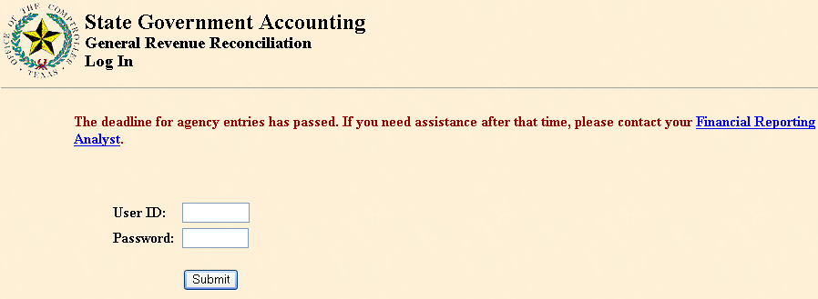

4. In the Agency Selection Menu do the following:
- Input your agency number.
- Input GAAP fund type 05 for Enterprise Funds.

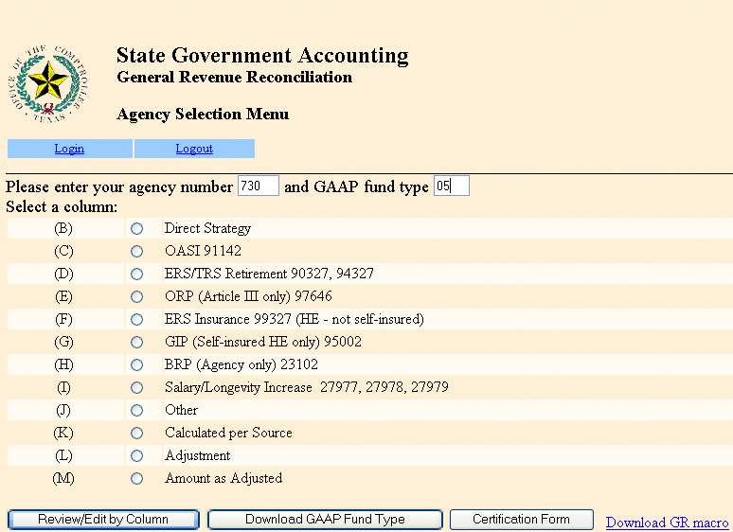

- To download Spreadsheet (working copy) into Excel. (See page 4.35 step 10 on the August 2006 AFR manual).

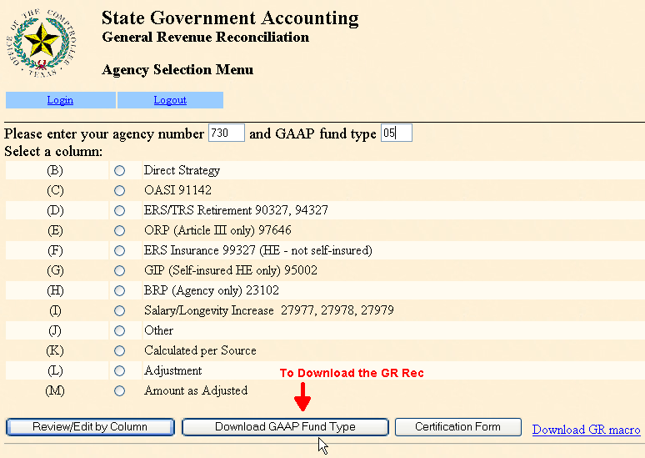

- Enter Agency Input Fields.
- To enter the amount for the retirement contribution, click on column D and enter the amount in line number 400100. Amount entered for the TRS fund 0001 is the amount paid on our behalf. Amount should be equal to the balance on account 51111 fund code 1036 in PS after the adjustment for APS 011.

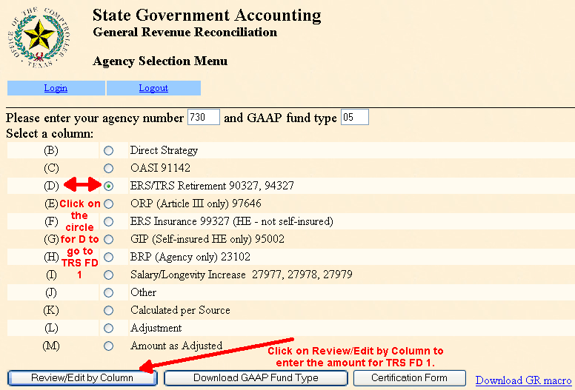

- To enter the amount for the Group insurance contribution (ERS), click on column F and enter the amount in line number 400200. This line only applies to the agencies that do not receive a transfer in from Agency 327. This amount is equal to the total Active and Retiree employee amounts in the Payroll Related Costs ERS report. The PS amount should be for the same amount.

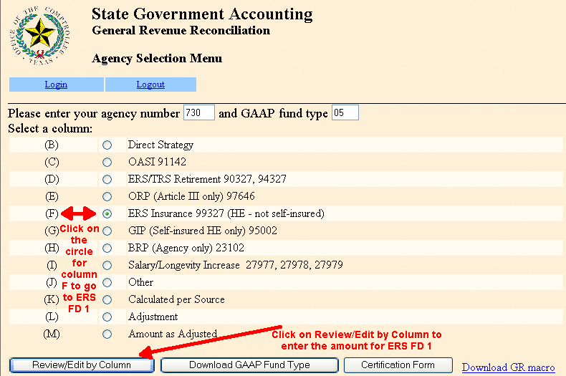

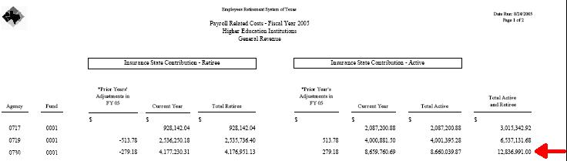

- To enter the amount for Unemployment contribution, click on column J and enter the amount in line number 400300. Enter a positive amount equal to the total local and state UCI expenses according to the TWC report. The report has the 5 campuses combined so a prorated amount needs to be entered.

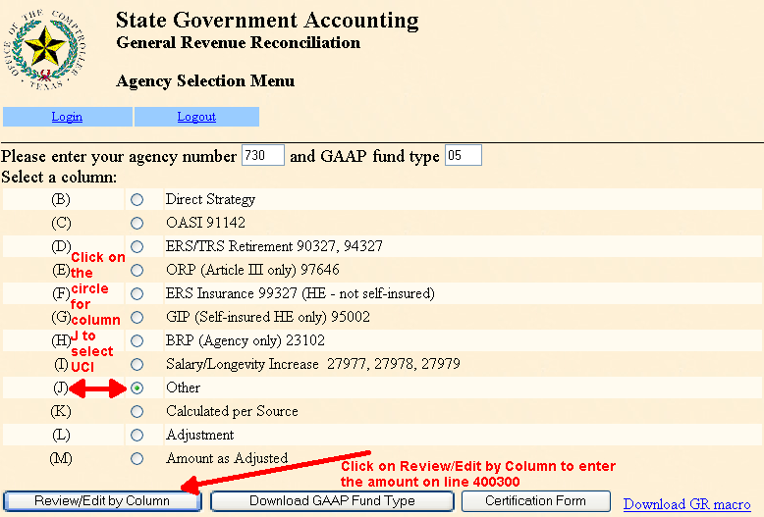

- To adjust the Committed Budget Transfers in click on column L and enter the amount in line 500300. The ending balance in column M should be equal to the share appropriation transfer in between components in PS. Use the generic T-Code 459 with USAS Comptroller Object Code 9410 (this elimination will not affect the budget that was originally transferred with T-Code 018 and 021): T-Code 459
    - Legislative Transfers-In
    - Legislative Appropriations
- To adjust the Committed Budget Transfers out click on column L and enter the amount in line 500600. The ending balance in column M should be equal to the share appropriation transfer out between components in PS. Use the generic T-Code 459 with USAS Comptroller Object Code 9515 (this elimination will not affect the budget that was originally transferred with T-Code 012 and 015): T-Code 459
    - Legislative Appropriations
      - Legislative Transfers-Out
Entry Instructions

To input the amount in those fields do the following:
- Click on the circle then on the Review/Edit by Column
- Click on the Add to enter your comments first

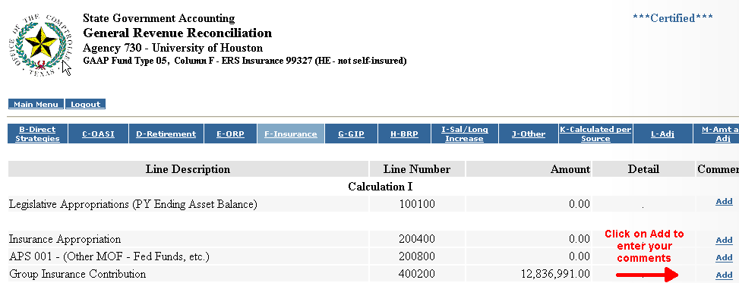

- Enter your comments and click submit comments to go back to enter the amount

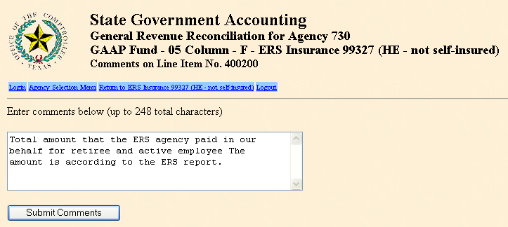
- Enter the amount second; click the Update Amount. If the input is successful, the user will see the screen Update Accepted. Click on the link Return to Previous Page to go back to the column. The amount entered should be equal to the amount in the ERS report, which is $12,836,991.00.

- Click on Main Menu to go back to the Main Menu. Amount should be $12,836,931.00 to match the ERS report.

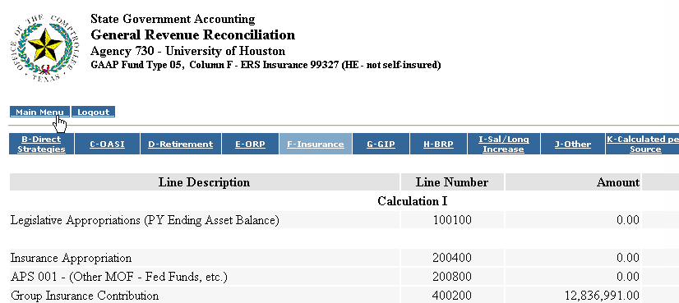
- Reconcile and Verify Data
- Line 100100 – Legislative Appropriation previous year Ending Balance
- Line 100300 – Appropriation Revenue for E&G fund 0001 (Appn# 107XX)
- Line 100600 – Riders increasing budget (FY05 Appn# 28056)
- Line 100500 – Riders decreasing budget (no appn in FY05)
- Line 200100 – Appropriation 91142 recognizes expenses for all appropriation years and should equal the amount in PS accounts 51108, 51109, and 41300 fund code 1022 after the APS 011 adjustment.
- Line 200300 – Appropriation 97646 recognized expenses for all appropriation years and should equal the amount in PS account 51110 and 41306 fund code 1021 after the APS 011 adjustment.
- Line 300200 – Unexpended Balance Forward. The amount in column B should be zero if the entries were done correctly to T_Codes 060/062 for appropriations with UB authority (For example: appns 13067, 13120, 13121)
    - Line 400100 – Retirement Contribution. This line is an input field.
- Line 400200 – Group Insurance Contribution (ERS). This line is an input field.
- Line 400300 – Unemployment Contribution (UCI). This line is an input field.
- Lines 400900 – Payroll Related Costs (sum of lines 28 to 30). This line is the payroll expenses equal to line 400100 with the opposite sign to net zero ending cash balance.
- Line 600200 – Appropriated Net Change in Cash for fund 0001 activity.
- Line 600300 – Unappropriated Net Change in Cash is the activity for appropriations 99906 and 99907 that should be zero.
- Line 700200 – Ending Asset Balance is a calculated field that represents the OASI portion of an agency’s remaining appropriation authority. This number in line 700200 should agree with the 62 screen BT 16 and 17 and PS cash ending balance in fund code 1022.
- Line 700700 – Ending Asset Balance is a calculated field that represents the ORP portion of an agency’s remaining appropriation authority. This number in line 700700 should agree the 62 screen BT 16 and 17 and PS cash ending balance in fund code 1021.
      - Computed Leg Appn (Asset Balance 08/31) – The amount in this field should be equal to our A3 query for all fund 0001 appropriations and our balance on the Statement of Net Assets (SNA) on the Legislative Appropriations.
      - Calculated per Source – Column K
- The line numbers are calculations from previous columns and line numbers.
- Total of Net Change in Cash Lines, sum of lines 600200 to 600500 should agree to Report 206, Net Change in Cash. The sum of lines 600200 to 600500 in Column K must be entered in USAS with the following T-Code: T-Code 463
0068 Legislative Cash
9000 Legislative Appropriation
  - Amount as Adjusted – Column M
The amounts in column M are the amounts that are required to be recorded on every agency’s AFR. All the line numbers are calculated fields from all of the other columns. Amount on the computed Legislative Appropriation in column M should be equal to the Legislative Appropriation line in the Balance Sheet and the A3 report in PS.
  - Certify
- Go to the Agency Selection Menu and select the Certification Form key. Review the certification statement on the Certification Page.
- Enter the name, title and telephone number for the individual responsible for the GR certification.
- Select the Certify key. The following message will appear “Certification Accepted”.
- Once the certification has been accepted, any attempts to add, change or delete to the web application will display the message, “This agency has been certified as complete. No additions, updates, or deletes are allowed.” Any changes after this point must be coordinated with FRS. After certification, viewing and downloading will still be allowed.

    - Year End entries in USAS

      - AFR USAS entries for the SRECNA

  - Payroll Related Costs – The Legislative Revenue must equal the amounts on the GR Rec Revenue.

Payroll Cost | Enter as Year End Adjustment for Legislative Appropriation Revenue
Retirement (TRS fund 0001) | Record the amount paid by TRS on your behalf recorded in PS (Ledger Criteria 51111-1036)
Group Insurance | Record the amount paid by ERS on your behalf according to the ERS report (Ledger Criteria 51106-1019 and ERS Paryoll Related Cost Report)
Unemployment Compensation | Record the amount paid on your behalf (Ledger Criteria 54566-1029) USAS screen 56 FD 1, GL account 5500, COBJ 7984)
Worker’s Compensation | Record the amount paid on your behalf
OASI | Record the adjustment to equal the amount in USAS screen 62 after the adjustment for APS 011 (All AY)
ORP | Record the adjustment to equal the amount in USAS screen 62 after the adjustment for APS 011 (All AY)

USAS Transaction Entries – Entry Number 5730001 (first digit is the fiscal year followed by the agency number and a sequential number)

Seq No | Batch Type | Doc Type | Eff Date | Fin Agy | TC | AY | PCA | COBJ | Amount | R | Fund | Desc
1 | 5 | U | 0831CY | XXX | 462 | XX | 99999 | 9420 | $XX.XX |  | 0001 | OASI
2 | 5 | U | 0831CY | XXX | 462 | XX | 99999 | 9465 | $XX.XX |  | 0001 | ORP
3 | 5 | U | 0831CY | XXX | 462 | XX | 99999 | 9435 | $XX.XX |  | 0001 | TRS
4 | 5 | U | 0831CY | XXX | 462 | XX | 99999 | 9425 | $XX.XX |  | 0001 | ERS
5 | 5 | U | 0831CY | XXX | 462 | XX | 99999 | 9486 | $XX.XX |  | 0001 | UCI

Use TC 462 to increase and 462 R to decrease.

  - Enter TPEG and SKILES

USAS Transaction Entries – Entry Number 5730002

Seq No | Batch Type | Doc Type | Eff Date | Fin Agy | TC | AY | PCA | COBJ | Amount | R | Fund | Desc
1 | 5 | U | 0831CY | XXX | 642 | XX | 80000 | 7593 | $XX.XX |  | 7999 | TPEG
2 | 5 | U | 0831CY | XXX | 642 | XX | 80000 | 7591 | $XX.XX |  | 7999 | SKILES

Use TC 642 to increase and 643 R to decrease.

  - SORM Adjustment ( We do not have an appropriation for FY05 so entry is not needed)

USAS Transaction Entries – Entry Number 5730003

Seq No | Batch Type | Doc Type | Eff Date | Fin Agy | TC | AY | PCA | COBJ | Amount | R | Fund | Desc
1 | 5 | U | 0831CY | XXX | 462 | XX | 99999 | 9410 | $XX.XX |  | 0001 | TRF – IN
2 | 5 | U | 0831CY | XXX | 456 | XX | 99999 | 9515 | $XX.XX |  | 0001 | TRF -OUT

  - State Pass-Thru Adjustment

USAS Transaction Entries – Entry Number 5730006

Seq No | Batch Type | Doc Type | Eff Date | Fin Agy | TC | AY | PCA | COBJ | Amount | R | Fund | Desc
1 | 5 | U | 0831CY | XXX | 643 | XX | 99999 | 3842 | $XX.XX |  | 7999 | Rev
2 | 5 | U | 0831CY | XXX | 643 | XX | 99999 | 3978 | $XX.XX |  | 7999 | Rev
3 | 5 | U | 0831CY | XXX | 642 | XX | 99999 | 7615 | $XX.XX |  | 7999 | Exp
4 | 5 | U | 0831CY | XXX | 642 | XX | 99999 | 7978 | $XX.XX |  | 7999 | Exp

Use AGL number composed by the Agency number and appropriated fund.

Example: for agency 781 and fund 7999, use AGL number 78179990, and for agency 734 and fund 0001, use AGL number 73400010.

Use TC 643/643R or 642/642R according to the adjustment needed.

- Eliminating the GR Reduction from Appropriation Transfer-in and out. Make sure to have all the transfers’ in-out in PS and USAS for B-On-Time and Law-Tuition set aside (COBJ 7972), and Tier one appropriation (TRF-in).

USAS Transaction Entries – Entry Number 5730005

Seq No | Batch Type | Doc Type | Eff Date | Fin Agy | TC | AY | PCA | COBJ | Amount | R | Fund
1 | 5 | U | 0831CY | XXX | 459 | XX | 99999 | 9410 | $XX.XX |  | 0001
1 | 5 | U | 0831CY | XXX | 457 | XX | 99999 | 9515 | $XX.XX |  | 0001

- Clearing Back-Out not Applicable Expenses. Use T-Codes 642 to decrease and 643 to increase the amounts to equal zero.

USAS Transaction Entries – Entry Number 5730006

Seq No | Batch Type | Doc Type | Eff Date | Fin Agy | TC | AY | PCA | COBJ | Amount | R | Fund
1 | 5 | U | 0831CY | XXX | 643 | XX | 99999 | XXXX | $XX.XX |  | XXXX
1 | 5 | U | 0831CY | XXX | 642 | XX | 99999 | XXXX | $XX.XX |  | XXXX
1 | 5 | U | 0831CY | XXX | 642 | XX | 99999 | XXXX | $XX.XX |  | XXXX
      - AFR USAS entries for the SNA

- Adjustment to Cash – The only cash balance in State Treasury is the cash in our appropriation 00000/02XX (Un-appropriated Activity). Check screen 57 (fund cash available) to match the balance in USAS and PS. The cash for all the other funds should be equal to zero except for fund 7999, for the local funds.

USAS Transaction Entries – Entry Number 5730007

Seq No | Batch Type | Doc Type | Eff Date | Fin Agy | TC | AY | PCA | COBJ | Amount | R | Fund | GL
1 | 5 | U | 0831CY | XXX | 646 | XX | 99999 | NA | $XX.XX |  | 0001 | *
2 | 5 | U | 0831CY | XXX | 646 | XX | 99999 | NA | $XX.XX |  | 0225 | *
3 | 5 | U | 0831CY | XXX | 646 | XX | 99999 | NA | $XX.XX |  | 7999 | *
4 | 5 | U | 0831CY | XXX | 646 | XX | 99999 | NA | $XX.XX |  | 0001 | 0067**

Use TC 646 to increase and 647 to decrease the cash balances.

* Use the GL account needed for each adjustment
** Adjust cash balance on GL 0067 for the adjustment amount on the Legislative Appropriation Balance entry number 5730002

- Adjustment to the Balance in Legislative Appropriation – The Legislative Appropriation Balance in USAS should be equal to the balance in our A3 for Fund 0001 and to the Legislative Appropriation line in our PS Statement of Net Assets.

USAS Transaction Entries – Entry Number 5730008

Seq No | Batch Type | Doc Type | Eff Date | Fin Agy | TC | AY | PCA | COBJ | Amount | R | Fund | Desc
1 | 5 | U | 0831CY | XXX | 463 | XX | 99999 | NA | $XX.XX |  | 0001 | LA

Use TC 463 or 463 R depending on the adjustment needed.

- Adjustment to Due from Other Agencies – Do entry in PS to reverse the cash on the share appropriations and record a receivable from other agencies. The share appropriations are: Engineer and Technical Consortium, License Plate Scholarship, and Texas Excellent Funds. Compare the balance on Due from Other Agencies in the following reports:
        - Statement of Net Assets in PS
        - Statement of Net Assets in USAS
        - DAFR 8910

USAS Transaction Entries – Entry Number 5730009

Seq No | Batch Type | Doc Type | Eff Date | Fin Agy | TC | AY | PCA | COBJ | Amount | R | Fund | Desc
1 | 5 | U | 0831CY | XXX | 666 | XX | 99999 | NA | $XX.XX |  | 7999 | Due/f

Use TC 666 or 666 R depending on the adjustment needed.
- Adjustment to Capital Assets

USAS Transaction Entries – Entry Number 5730010

Seq No | Batch Type | Doc Type | Eff Date | Fin Agy | TC | AY | PCA | COBJ | Amount | R | Fund | GL
1 | 5 | U | 0831CY | XXX | 646 | XX | 99999 | NA | $XX.XX |  | 7999 | *

Use TC 646 or 647 R depending on the adjustment needed.

* Use the GL account needed for the adjustment.

- Adjustment to the System Clearing GL account 9999

USAS Transaction Entries – Entry Number 5730011

Seq No | Batch Type | Doc Type | Eff Date | Fin Agy | TC | AY | PCA | COBJ | Amount | R | Fund | GL
1 | 5 | U | 0831CY | XXX | 646 | XX | 99999 | NA | $XX.XX |  | 0001 | 2950
1 | 5 | U | 0831CY | XXX | 646 | XX | 99999 | NA | $XX.XX |  | 0225 | 2950
1 | 5 | U | 0831CY | XXX | 646 | XX | 99999 | NA | $XX.XX |  | 7999 | 2950
1 | 5 | U | 0831CY | XXX | 646 | XX | 99999 | NA | $XX.XX |  | 0347 | 2950
1 | 5 | U | 0831CY | XXX | 646 | XX | 99999 | NA | $XX.XX |  | 0106 | 2950

Use TC 646 for positive amounts in the DAFR 8580 and 647 for negative amounts in the DAFR 8580. Do the necessary entries for all appropriated funds the list above may not include all the appropriated funds that you have.
    - Complete the CAUF_AFRRECON worksheet after the AFR entries for the SNA and SRECNA are done

1. Complete the Total per AFR column in the SRECNA tab using the Statement of Revenues (SRECNA), Expenses and Changes in Net Assets, Matrix of Operating Expenses Reported by Function, and ledger criteria.

- From the Operating Revenues in PS SRECNA
- Enter the PS amounts from Federal Pass Through Revenue (PR-OP Grants/Contribution) from PS SRECNA
- State Grant Pass Through Revenue (PR-OP Grants/Contributions) from PS SRECNA
- From the PS Matrix
- Federal Pass Through Expenses
- State Grant Pass Through Expenses
- From the ledger criteria
  - TPEG – Account 40109 in PS from ledger criteria for PS account 40109 and all state fund codes

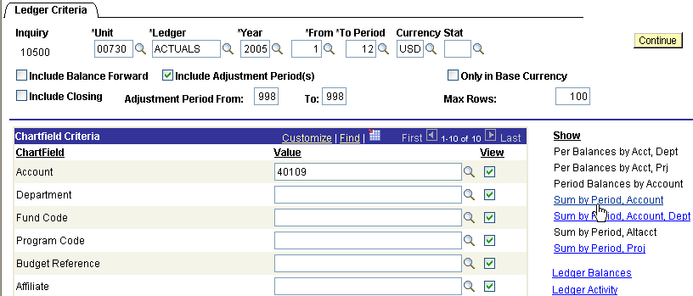

  - SKILES – Account 40105 in PS from ledger criteria for PS account 40105 and all state fund codes

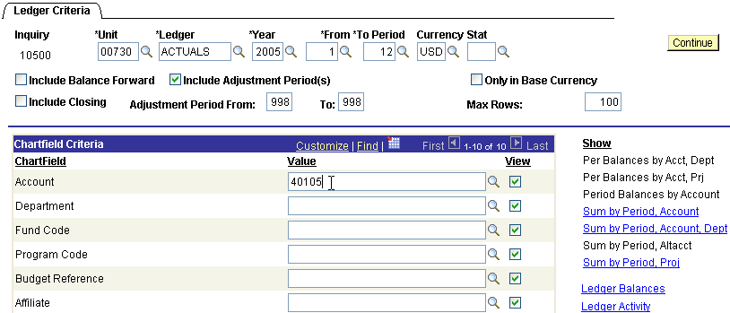
    - From the Non-Operating Revenues (Expenses) PS SRECNA

- Enter the Legislative Revenue (GR) from the PS SRECNA by using the nVisiondrill tool in excel in the Non-Operating Revenue – Payroll Related Cost (i.e. OASI, ORP, UCI, ERS, and TRS and Legislative Appropriation Revenue Appn# 107XX). The amounts for the payroll benefits can be also checked in the ledger criteria and/or PS report UGL016C after the adjustment for the APS 011 have been entered. The equity amount on the payroll benefits after the APS 011 adjustments should be zero (expenses equal revenues).

Note: The amounts of revenues and expenses on the report below should also be the amount of recognized expenses in the GR Rec line numbers 200100 and 200300 (see page 5 on item number 7 reconcile and verify data).

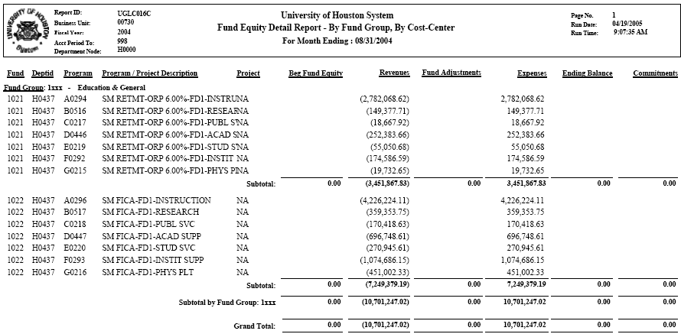

        - From the Other Revenues, Expenses, Gains, Losses And Transfers
i. Enter Capital Appropriation (HEAF) from PS SRECNA
- Transfers in-out – Texas Excellence Funds and Set Asides
- Legislature Transfers in-out - Share Appropriations between components and SORM (when applicable)

2. Complete the Total per USAS column in the SRECNA tab using the DAFR 8600

        - Federal Pass Through Revenue
        - State Grant Pass Through Revenue
        - Federal Pass Through Expenses
        - State Grant Pass Through Expenses
        - TPEG
        - SKILES
        - Non-Operating Revenue – Payroll Related Cost (i.e. OASI, ORP, UCI, ERS, TRS and Legislative Appropriation Revenue Appn# 107XX)
        - Capital Appropriation (HEAF)
        - Transfers in-out – Texas Excellence Funds and Set Asides
        - Legislature Transfers in-out - Share Appropriations between components and SORM

Note: Adjustment amount column should be zero, otherwise, and adjusting entry needs to be done in PS or USAS.

3. Complete the Amount per AFR column in the SNA tab using the Statement Net Assets, and ledger criteria. The amounts to be entered should be only the yellow rows in the worksheet.

- From Current Assets “Cash and Cash Equivalents
        - Cash on Hand
        - Cash in Bank
        - Cash in Transit/Reimb Due From Treasury
        - Cash in State Treasury
        - Cash Equivalents
          - From Current Assets “Restricted”
            - Cash on Hand
            - Cash in Bank
              - From the Current Assets “Legislative Appropriations”
- Enter the Legislative Appropriation amount that should be equal to the A-3 report for Fund 0001 and the Computed Leg Appn FYCY (Asset Bal 8/31) in the GR Rec (see page 5 Amount as Adjusted Column M).
  - From Current Assets “Due from Agencies”
- Enter the amount for Due from Agencies (share appropriations like: License Plate Scholarship, Engineering and Technical Consortium, Texas Excellence Funds, etc.)
- From Current Assets “Due from Other Components”
- Any amount due from the other UH components.

Note: We need to enter also Due from Other Components regarding the share appropriations for any amount that have not been paid (Small Business Development Center, Houston Partnership for Space Exploration).

- From the Non-Current Assets “Restricted Cash and Cash Equivalent”
- Cash in Bank
  - From the Non-Current Assets “Capital Assets, Non-Depreciable”
- Land and Land Improvements
- Construction in Progress
- Other Capital Assets
- From the Non-Current Assets “Capital Assets, Depreciable”
- Building and Building Improvements
Less Accumulated Depreciation
- Infrastructure
Less Accumulated Depreciation
- Facilities and Other Improvements
Less Accumulated Depreciation
- Furniture and Equipment
Less Accumulated Depreciation
- Vehicles, Boats and Aircraft
Less Accumulated Depreciation
- Other Capital Assets
Less Accumulated Depreciation
  - From Current Liabilities “Due to Other Agencies”
- Amount due to other state agencies
  - From Current Liabilities “Due to Other components”
i. Any amount due to the other UH components.

  - Complete the Fund per USAS columns in the SNA tab using DAFR 8580. The amounts to be entered should be only the yellow rows in the worksheet.

- Current Assets “Cash and Cash Equivalents”
- Current Assets “Restricted Cash and Cash Equivalents”
- Current Assets Legislative Appropriations”
- Current Assets “Due from Other Components (Share Appropriations)
- Current Assets “Due from Other Agencies
- Non-Current Assets “Restricted Cash and Cash Equivalents”
- Non-Current Assets “Capital Assets”
- Current Liabilities “Due to Other Agencies”
- Current Liabilities “Due to Other Components”
- System Clearing

Note: Total Adjustment for All Funds amount column should be zero, otherwise, and adjusting entry needs to be done in PS or USAS. Follow the directions in section B for any other entries to be done in USAS.
        - Lapsed Appropriations – L0

Lapse is the decrease in the ability to use existing appropriation budget. This occurs 60 days after the end of the fiscal year for all unencumbered balances.

USAS entry to reduce the original budget on the GR AY06 Appn for the assessment payment adjustment – AGY 730

Form Batch Type Edit Mode Doc Type
Cash Receipt Type 1 1 B
Unit | Curr Doc Num | Batch date | Comptroller Obj | Approp Num | Fund | Appropriat Yr | Fiscal Year | Transaction Cd | Sum Trans Amt | Ref Doc Num | HX Per | Reverse | PCA
00730 | B0161545 | 2005-29-08 | 7000 | 10730 | 0001 | 06 | 05 | 036 | 110,208.05 | B0161545 | 12 |  | 03706
00730 | B0161545 | 2005-29-08 | 7000 | 10730 | 0225 | 06 | 05 | 036 | 51,695.94 | B0161545 | 12 |  | 03706

PS Entry to reflect the entry done in USAS to reduce the original budget – BU 00730

 |  |  | University of Houston System  JOURNAL ENTRY DETAIL
  Header BU: | 00730
  Fiscal Year: | 2005
  Acctg Period: | 998
  Run Date: | 10/22/2005
  Run Time: | 06:30:51

Journal ID: | STB0161545 | Reversal: | None | Ledger Group: | ACTUALS
Date: | 08/29/2005 | Reversal Date: |  | Created By: | BANKSDA
Source: | ACS | Budget Adjust Type: | Actuals | Post Date: | 10/17/2005
Header Ref: | T400113V | Edit / Hdr Status: | Posted | BCM Status: | Valid
Description: | L0 & W0- Lapsing the SORM AY06 assessment payment adjustment. |  |  | BCM Bypass: | N

Line # | Account | Line BU | Fund | DeptId | Prog | Bdgt Ref. | Project | Line Ref | Chart.1 | Line Description | Amount
1 | 36106 | 00730 | 1026 | H0264 | F0283 | BP2006 | NA | T400113V |  | Lapsing SORM AY06 | 110,208.05
2 | 10500 | 00730 | 1026 |  |  | BP2006 |  | T400113V |  | Lapsing SORM AY06 | -110,208.05
3 | 36106 | 00730 | 1054 | H0600 | F1651 | BP2006 | NA | B0161545 |  | CORR ACCT F/36100 TO 36106 | 51,695.94
4 | 10500 | 00730 | 1054 |  |  | BP2006 |  | B0161545 |  |  | -51,695.94
5 | 36106 | 00730 | 1065 | H0600 | F1651 | BP2006 | NA | B0161545 |  |  | -51,695.94
6 | 10500 | 00730 | 1065 |  |  | BP2005 | NA | B0161545 |  |  | 51,695.94

Totals for Journal: STB0161545 | Total Lines: 6 | Total Base Debits: 213,599.93 | Total Base Credits: 213,599.93

Signatures | ___________________________________ | Date | __________________________________
 | ___________________________________ |  | __________________________________
PS Approval: | ___________________________________ |  | __________________________________

Created By: BANKSDA | Date Printed: 10/22/2005 | Jrnl. Dt.: 08/29/2005

Return to Table of Contents

E. Appropriation Item Transfers – D-7

According to the “Reporting Requirements for AFR of State Colleges and Universities June 1999 Page 4.102”, schedule D-7 must be completed as follows:

“This supporting schedule must be completed by agencies and institutions of higher education that are authorized to transfer funds between appropriation items; by the provisions of the General Appropriations Act, special legislation, or by Budget Execution Orders.

The purpose of this schedule is to identify the amount of money transferred from one item of appropriation, program, or activity, from the amounts appropriated in the General Appropriations Act to another item of appropriation, program or activity. To properly complete this schedule, list the agency bill pattern as included in the General Appropriations Act (GAA) and identify the transfers-in, transfers-out, and net transfer amount from any item of appropriation to another for the fiscal year ended August 31, 20XX. The appropriation transfer information will be displayed in Balance Types 03 and 06 in Appropriation Record Inquiry Screen (USAS screen 62). “

We complete Schedule D-7 by entering the information on the worksheet for preparation of the schedule:

      - List each strategy in the General Appropriation Act.
      - Go to the SIRS reports and click “USAS Expenditures in ABEST Format Detail by Strategy”
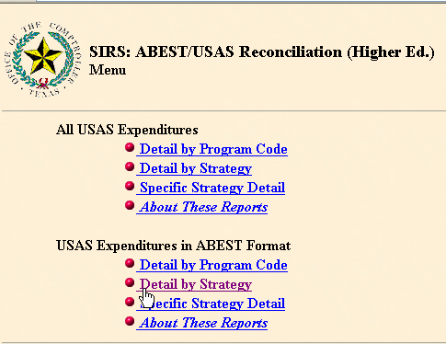

      - For FY05, choose Fiscal Year 2005 and Aprropriation Year 2005 for Fiscal Period Adjusted Month 13.

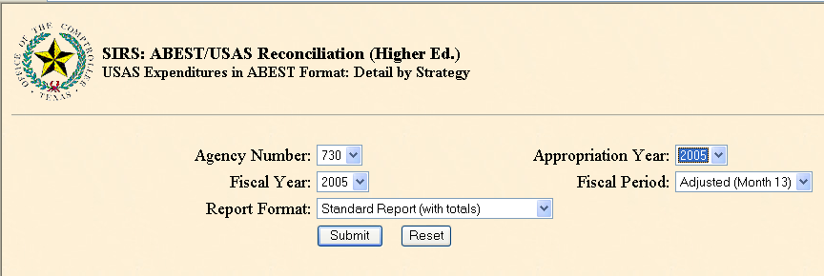

      - Print out report and complete the SIRS column according to the strategy number.
      - Add or Substract the Share Appropriation in the Budget column and the corresponding strategy.
      - Add a row for the GR Reduction to show the amount as a transfer in and out.
      - Substract any lapsed amount in the Budget column and the corresponding strategy.
      - Total per appropriation bill in/out column should be equal to zero. Any difference not equal to zero is related to prior year activity that should be substracted from the correspondent strategy in the SIRS column.
      - Each cell of the Schedule D-7 is linked to the worksheet for preparation. After Completing the budget and the SIRS columns of the worksheet for preparation the schedule should be finished.

 |  |  | University of Houston
 |  |  | Worksheet for Preparation of
 |  |  | Schedule of Appropriation Item Transfers
 |  |  | For the Year Ended August 31, 2005
 |  |  |  | Strat # | Budget (House Bill 78th GAA) | SIRS | Expended |  | IN/(OUT)
A. GOAL: INSTRUCTION/OPERATIONS
 | A.1.1. Operations Support |  |  | 3701 | 127,037,476.00 | 127,732,978.88 | (695,502.88) |  | 695,502.88
 | A.1.1. Operations Support (GR Reduction) |  |  | 3701 | 338,206.00 | 338,206.00 | - |  | -
 | A.1.2. Teaching Experience |  |  | 3702 | 3,001,629.00 |  | 3,001,629.00 |  | (3,001,629.00)
 | A.1.3. Staff Group Insurance |  |  | 3705 | 3,635,623.00 | 5,783,274.70 | (2,147,651.70) |  | 2,147,651.70
 | A.1.4. Workers Compensation Insurance |  |  | 3706 | 516,981.00 | 529,067.10 | (12,066.10) |  | 12,066.10
 | A.1.5. Texas Public Education Grants |  |  | 3708 | 5,411,710.00 | 0.00 | 5,411,710.00 |  | (5,411,710.00)
 | A.1.6. Indirect Cost Recovery |  |  | 3709 | 6,673,356.00 |  | 6,673,356.00 |  | (6,673,356.00)
 | A.1.7. Organized Activities |  |  | 3710 | 1,297,618.00 | 1,849,763.42 | (552,145.42) |  | 552,145.42
 | A.1.8. Capital Equity & Excellence Funding |  |  | 3069 | 4,209,677.00 |  | 4,209,677.00 |  | (4,209,677.00)
TOTAL GOAL A: INSTRUCTION/OPERATIONS |  |  |  |  | 152,122,274.00 | 136,233,268.10 | 15,889,005.90 |  | (15,889,005.90)
B. GOAL: INFRASTRUCTURE SUPPORT
 | B.1.1. E & G Space Support |  |  | 3712 | 22,608,866.00 | 40,396,980.53 | (17,788,114.53) |  | 17,788,114.53
 | B.1.2. Tuition Revenue Bond Retirement |  |  | 3713 | 3,246,798.00 | 4,735,811.39 | (1,489,013.39) |  | 1,489,013.39
 | B.1.3. Skiles Act Revenue Bond Retirement |  |  | 3714 | 407,190.00 | 0.00 | 407,190.00 |  | (407,190.00)
TOTAL GOAL B: INFRASTRUCTURE SUPPORT |  |  |  |  | 26,262,854.00 | 45,132,791.92 | (18,869,937.92) |  | 18,869,937.92
C. GOAL: SPECIAL ITEM SUPPORT
 | C.2.1. Learning and Computation Center |  |  | 3023 | 2,037,690.00 | 2,628,761.88 | (591,071.88) |  | 591,071.88
 | C.2.2. Space Exploration |  |  | 3025 | 287,358.00 | 311,599.44 | (24,241.44) |  | 24,241.44
 | C.2.3. Commercial Development of Space |  |  | 3027 | 422,002.00 | 408,607.14 | 13,394.86 |  | (13,394.86)
 | C.2.4. Superconductivity Center |  |  | 3091 | 3,797,500.00 | 3,608,693.35 | 188,806.65 |  | (188,806.65)
 | C.3.1. Small Business Development Ctr |  |  | 3035 | 2,511,535.00 | 2,248,615.29 | 262,919.71 |  | (262,919.71)
 | C.3.2. Health Law & Policy Instit |  |  | 3036 | 306,250.00 | 315,675.50 | (9,425.50) |  | 9,425.50
 | C. 3.3. Center for Public Policy |  |  | 3092 | 262,500.00 | 269,022.02 | (6,522.02) |  | 6,522.02
 | C.3.4. Partnerships - Support Public Schools |  |  | 3071 | 1,441,313.00 | 1,361,237.15 | 80,075.85 |  | (80,075.85)
 | C.4.1. Institutional Enhancement |  |  | 3072 | 3,807,536.00 | 740,540.21 | 3,066,995.79 |  | (3,066,995.79)
TOTAL GOAL C: SPECIAL ITEM SUPPORT |  |  |  |  | 14,873,684.00 | 11,892,751.98 | 2,980,932.02 |  | (2,980,932.02)
TOTAL PER APPROPRIATION BILL FY 05 |  |  |  |  | 193,258,812.00 | 193,258,812.00 | - |  | -

Schedule D-7
University of Houston
Schedule of Appropriation Item Transfers
For The Year Ended August 31, 2005
 |  |  |  |  |  | APPROPRIATION |  | TRANSFERS |  | TRANSFERS |  | NET
GOALS AND STRATEGIES |  |  |  | STRATEGY |  | NUMBER |  | IN |  | (OUT) |  | TRANSFERS
ITEM OF APPROPRIATION WITHIN BILL PATTERN
 | A. | GOAL: INSTRUCTION/OPERATIONS
 |  | OPERATIONS SUPPORT |  | A.1.1 |  | 5-10730 |  | $ 695,502.88 |  |  |  | $ 695,502.88
 |  | OPERATIONS SUPPORT (GR Reduction) |  | A.1.1 |  | 5-28057 |  | $ 338,206.00 |  | (338,206.00) |  | $ -
 |  | TEACHING EXPERIENCE |  | A.1.2 |  | 5-10730 |  |  |  | (3,001,629.00) |  | (3,001,629.00)
 |  | STAFF GROUP INSURANCE |  | A.1.3 |  | 5-10730 |  | 2,147,651.70 |  |  |  | 2,147,651.70
 |  | WORKERS COMP INSURANCE |  | A.1.4 |  | 5-10730 |  | 12,066.10 |  |  |  | 12,066.10
 |  | TEXAS PUBLIC EDUCATION GRANTS |  | A.1.5 |  | 5-10730 |  |  |  | (5,411,710.00) |  | (5,411,710.00)
 |  | INDIRECT COST RECOVERY |  | A.1.6 |  | 5-10730 |  |  |  | (6,673,356.00) |  | (6,673,356.00)
 |  | ORGANIZED ACTIVITIES |  | A.1.7 |  | 5-10730 |  | 552,145.42 |  |  |  | 552,145.42
 |  | CAPITAL EQUITY & EXCELL FUNDING |  | A.1.8 |  | 5-10730 |  |  |  | (4,209,677.00) |  | (4,209,677.00)
 | TOTAL GOAL A: INSTRUCTION/OPERATIONS |  |  |  |  |  |  | $ 3,745,570.10 |  | $ (19,634,576.00) |  | $ (15,889,005.90)
 | B. | GOAL: INFRASTRUCTURE SUPPORT
 |  | E & G SPACE SUPPORT |  | B.1.1 |  | 5-10730 |  | 17,788,114.53 |  |  |  | 17,788,114.53
 |  | TUITION REVENUE BOND RETIREMENT |  | B.1.2 |  | 5-10730 |  | 1,489,013.39 |  |  |  | 1,489,013.39
 |  | SKILES ACT REVENUE BOND RETIREM |  | B.1.3 |  | 5-10730 |  |  |  | (407,190.00) |  | (407,190.00)
 | TOTAL GOAL B: INFRASTRUCTURE SUPPORT |  |  |  |  |  |  | $ 19,277,127.92 |  | $ (407,190.00) |  | $ 18,869,937.92
 | C. | GOAL: SPECIAL ITEM SUPPORT
 |  | LEARNING AND COMPUTAION CENTER |  | C.2.1 |  | 5-10730 |  | 591,071.88 |  |  |  | 591,071.88
 |  | SPACE EXPLORATION |  | C.2.2 |  | 5-10730 |  | 24,241.44 |  |  |  | 24,241.44
 |  | COMMERCIAL DEVELOPMENT OF SPACE |  | C.2.3 |  | 5-10730 |  |  |  | (13,394.86) |  | (13,394.86)
 |  | SUPERCONDUCTIVITY CENTER |  | C.2.4 |  | 5-10730 |  |  |  | (188,806.65) |  | (188,806.65)
 |  | SMALL BUSINESS DEVELOPMENT |  | C.3.1 |  | 5-10730 |  |  |  | (262,919.71) |  | (262,919.71)
 |  | HEALTH LAW & POLICY INSTITUTE |  | C.3.2 |  | 5-10730 |  | 9,425.50 |  |  |  | 9,425.50
 |  | CENTER FOR PUBLIC POLICY |  | C.3.3 |  | 5-10730 |  | 6,522.02 |  |  |  | 6,522.02
 |  | PARTNERSHIPS-SUPPORT PUBLIC SCHOOLS |  | C.3.4 |  | 5-10730 |  |  |  | (80,075.85) |  | (80,075.85)
 |  | INSTITUTIONAL ENHANCEMENT |  | C.4.1 |  | 5-10730 |  |  |  | (3,066,995.79) |  | (3,066,995.79)
 | TOTAL GOAL C: SPECIAL ITEM SUPPORT |  |  |  |  |  |  | $ 631,260.84 |  | $ (3,612,192.86) |  | $ (2,980,932.02)
NET APPROPRIATION ITEM TRANSFERS W/I BILL PATTERN |  |  |  |  |  |  |  | $ 23,653,958.86 |  | $ (23,653,958.86) |  | $ -

Return to Table of Contents

Report Request Profile

      - Balance Sheet (BS) – Governmental & Proprietary Fund Types (FFS) (DAFR8580)

- The D23 Fund Profile is the lowest level of the fund hierarchy. This Structure defines the columns in the BS).
To request the BS at the D23 level and the GAAP GL account class, set up the report request as follows.

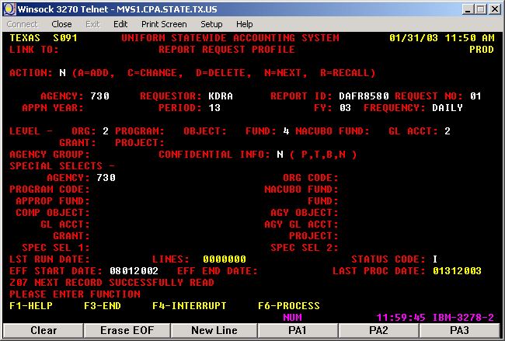

- To request the BS that should agree with the combining statements at the GAAP Fund level and the GAAP GL account class, set up the report request as follows.

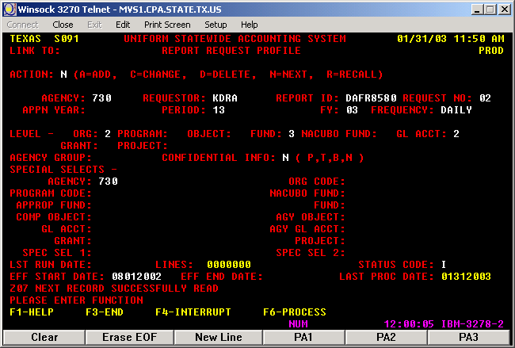

- To request the BS that should agree with Combined BS and the GAAP GL account class, your agency should set up the report request as follows:

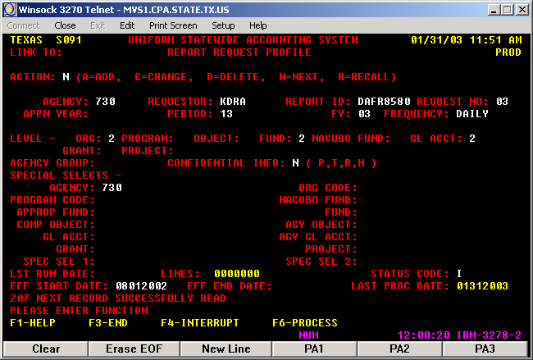

- To request the BS at the D23 Agency Fund level and the Comptroller GL account level, your agency should set up the report request as follows:

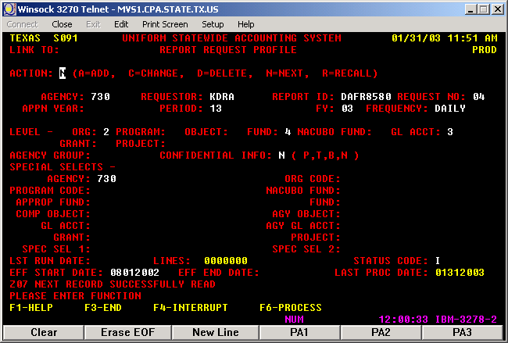

      - Operating Statement (OS) DAFR8600 (Propietary)

- The D23 Fund Profile is the lowest level of the fund hierarchy. This Structure defines the columns in the OS).
b. The D31 Comptroller General Ledger Account

For a summarized report, GL level 0 can be used on the report request and will look most like your hard copy AFR. The request will look as follows:

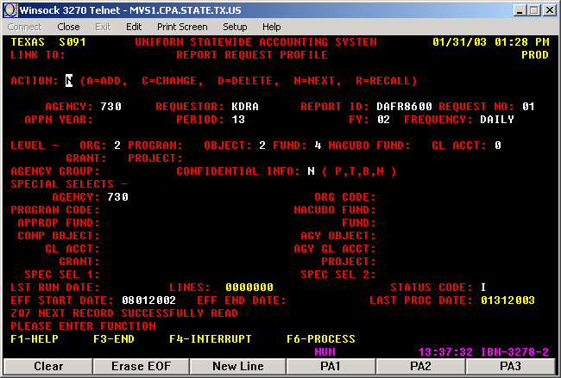

To group all Revenue GL Accounts (Cash, Accrued & Revenue Offset) together, set up the reports at GL level 2. The request will look as follows:

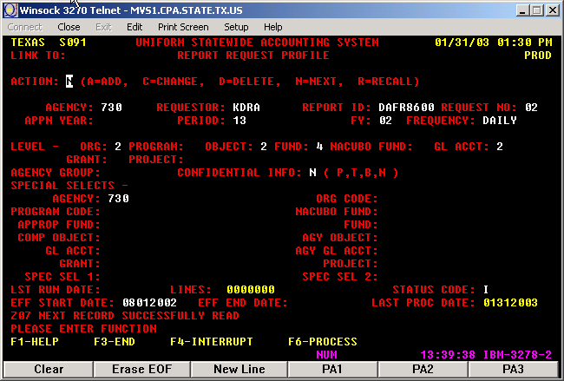

To analyze cash and accrual activity separately, set up the reports at GL level 3. The request will look as follows:

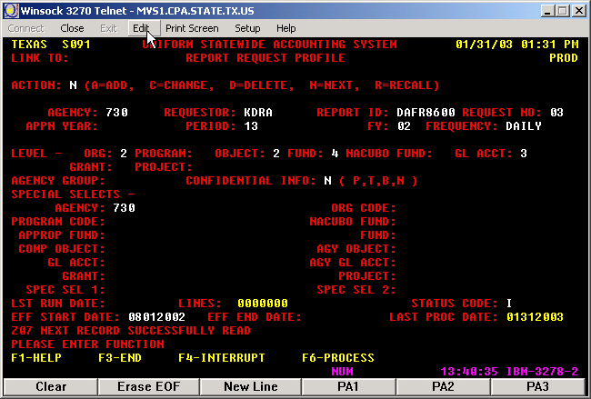

c. The D10 Comptroller Object
The D10 Comptroller Object serves as the building block for the operating statement. For a summarized report, an object level of 2 can be used on the report request and will look most like your hard copy AFR. If ordered at level 3, the COBJ’s will appear and will give additional detail and will look as follows:

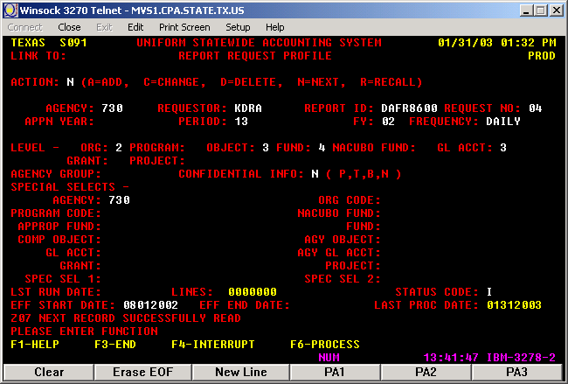

3. Interfund/Interagency Activity Report (DAFR8910)

This report provides the information to prepare the Annual Financial Report for Due To and Due From, Operating Transfers and State and Federal Grant Pass Through activity. All the information manually or automatically updated through the RTI process in the AGL (Agency General Ledger) field is in that report. The AGL field has the opposing agency in the first three positions, the D23 number in the next four positions and a zero in the last position. The amounts for which agency and fund information have not been posted appear with an NP in the interfund section of the report.

- Set up the request with COBJ 3725 and GL account range 5000 thru 5100.

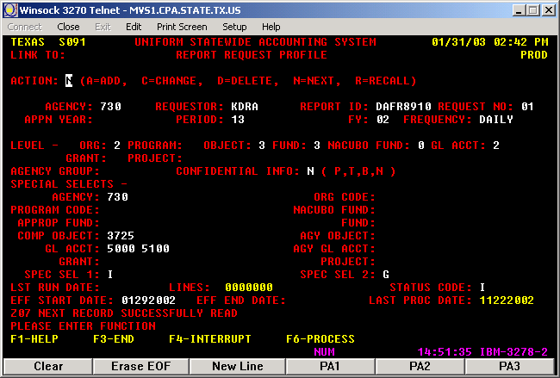

- Set up the request with COBJ 3842 and GL account range 5000 thru 5100.

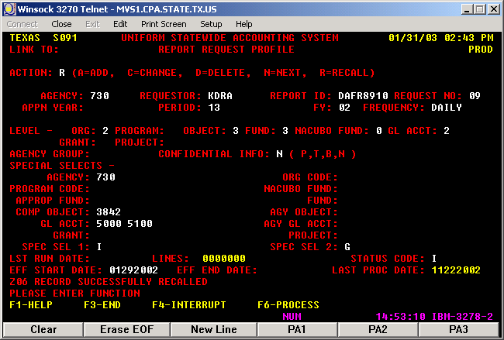

- Set up the request with the COBJ range 7614 thru 7615 and GL account range 5500 thru 5600.

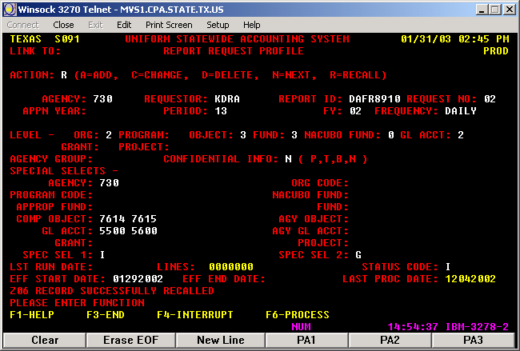

- Set up the request with the COBJ range 3971 thru 3978 and GL account range 5000 thru 5100.

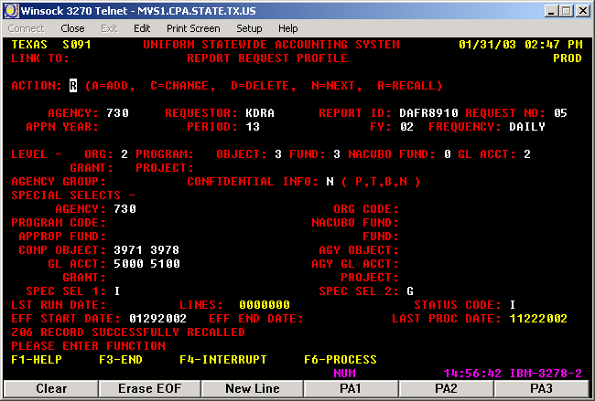

- Set up the request with the COBJ range 7971 thru 7978 and GL account range 5500 thru 5600.

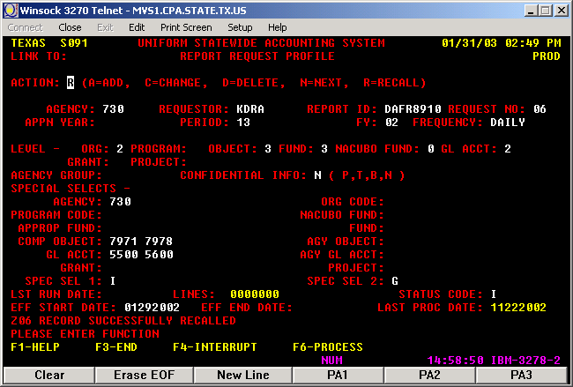

- Set up the request with the GL account range 0283 thru 0284.

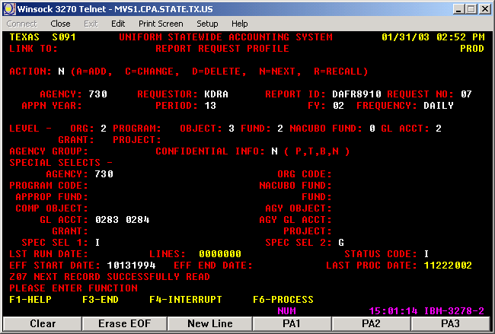

- Set up the request with the GL account range 1050 thru 1053.

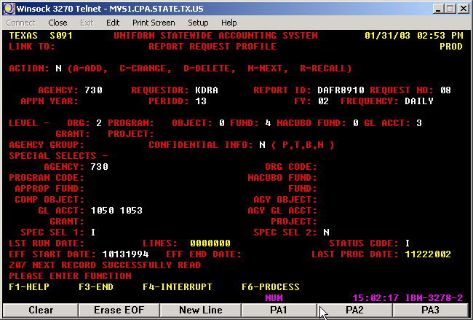

- Set up the request with the GL account range 6010 thru 6011.

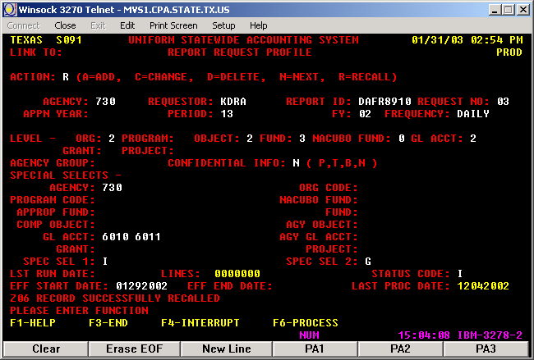

- Set up the request with the GL account range 6010 thru 6011.

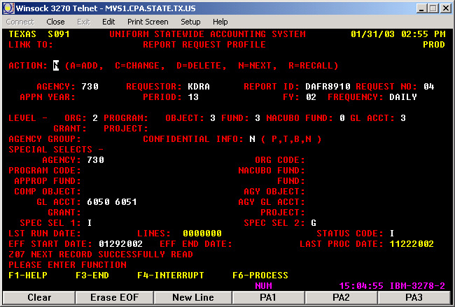

Note: Order 9 DAFR8910 reports for each 783 and 730 agencies, which are 8 ranges of GL accounts plus the range of GL 5500 – 5100 which is ordered with two Comp Objects 3725 and 3842.

Return to Table of Contents

CHAPTER 5

LEGISLATIVE APPROPRIATIONS REQUEST

LEGISLATIVE APPROPRIATIONS REQUEST – (LAR)

The Legislative Appropriation Request (LAR) is a biennial report striving to obtain the funding from the state. The report is submitted to the Automated Budget and Evaluation System of Texas (ABEST).

In FY06, the actual information from FY05 and estimated information for FY06 is gadhered to request the funding for Fiscal years 2008 and 2009. The biennial scope start with the even year and the bienninal request is also on the even year.

Seven schedules need to be completed and submitted to the Budget Office. The names and schedule numbers submitted are the following:

Schedule 1A: Other Educational and General Income
Schedule 2: Grant Total Educational, General and Other Funds
Schedule 4: Computation of OASI
Schedule 5: Calculation of Retirement Proportionality and ORP Differential
Schedule 6: Capital Funding
Schedule 7: Current and Local Fund (General) Balances
Schedule 8: Part C – Personnel

Schedule 1A - Other Educational and General Income

This schedule includes the Education and General income from tuition and fees, interest gain on the local funds in State Treasury, and the organized activity recognized in the bill. In other words, this is the General Revenue Dedicated (Fund 0225).

Schedule 1A can be analyzed by looking at the sections detailed below:

  - Gross Tuition
  - Net Tuition
  - Subtotal, Tuition and Fees
  - Subtotal, Other Educational and General Income
  - Total, Other Educational and General Income
  - Total, Other Educational and General Income Reported on Summary of Request

1. Gross Tuition section

SCHEDULE 1A
 |  |  |  |  |  | Actual |  | Estimated
 |  |  |  |  |  | 2005 |  | 2006
Tuition and Fees |  |  |  |  |  | 74,358,699.20 | Other fees not included
 | Gross Resident Tuition |  |  |  |  | 48,676,557.83 | Tuition Resident (PS Acct 40100)
 | Gross Non-Resident Tuition |  |  |  |  | 25,682,141.37 | Tuition Foreign and bad debt (PS Acct 40101, 40102, and 40107)
 |  | Gross Tuition |  |  |  | 74,358,699.20
 |  |  | Less: | a. | Remissions and Exemptions | (11,925,746.31) | Total rem & exemp (PS Acct like 555% posted in fund code 1054)
 |  |  |  | b. | Refunds
 |  |  |  | c. | Installment Payment Forfeits
 |  |  |  | d. | Board Authorized Tuition Income (Tx. Educ. Code Ann. Sec. 54.008)
 |  |  |  | e. | Statutory Tuition Increases (Tx. Educ. Code Ann. Sec. 54.0512) (2006)
 |  |  |  | f. | Tuition increases charged to doctoral students with hours in excess of 100 (Tx. Educ. Code Ann. Sec. 54.066)
 |  |  |  | g. | Tuition increases charged to undergraduate students with more than 45 hours above degree requirements (Tx. Educ. Code Ann. Sec. 61.0595)
 |  |  |  | h. | Tuition rebates for certain undergraduates (Tx. Educ. Code Ann. Sec. 54.0065)
 |  |  | Plus: | i. | Tuition waived for Students 55 Years or Older (Tx. Educ. Code Ann. Sec. 54.067
 |  |  |  | j. | Tuition waived for Texas Grant Recipients (Tx. Educ. Code Ann. Sec. 56.307)
 | Subtotal |  |  |  |  | 62,432,952.89

      - Net Tuition Section

We need to start from the subtotal for the gross tuition to continue into the next section.

 | Subtotal |  |  |  |  | 62,432,952.89
 |  |  | Less: | a. | Transfer of Tuition to Retirement of Indebtedness:
 |  |  |  |  | 1) Skiles Act | (403,810.00) | Skile Act (PS Acct 40105)
 |  |  |  | b. | Transfer of funds for Texas Public Education Grants Program (Tex. Educ. Code Ann. Sec. 56c) and for Emergency Loans (Tex. Educ. Code Ann. Sec. 56d) | (6,133,336.00) | TPEG (PS Acct 40109)
 |  |  |  | c. | Transfer of Funds (2%) for Emergency Loans (Medical School)
 |  |  |  | d. | Transfer of Funds for Cancellation of Student Loans of Physicians
 |  |  |  | e. | Other Authorized Deductions (Itemize and provide Vernonis citation)
Net Tuition |  |  |  |  |  | 55,895,806.89

      - Subtotal, Tuition and Fees

From the Net Tuition amount, continue into the next section with the laboratory fees revenues.

Net Tuition |  |  | 55,895,806.89
Student Teaching Fees
Special Course Fees
Laboratory Fees |  |  | 412,281.46 | Amount from 1028 report (Student Accounting)
 | Subtotal, Tuition and Fees (Formula Amounts for Health-Related Institutions) |  | 56,308,088.35

      - Subtotal, Other Educational and General Income

To the subtotal of tuitions and fees revenues, the other educational and general income revenue is added. In this case, only the interest earned on the local funds in State Treasury is added.

 | Subtotal, Tuition and Fees (Formula Amounts for Health-Related Institutions) |  | 56,308,088.35
Other Income
 | 50% of Indirect Cost Recovery |  | 0.00
 |  | (Indirect Cost on Federal, State, Local and Private Grants)
Interest on General Funds:
 | a. | Local Funds in State Treasury | 367,252.39 | Interest FD 2 (0225) Estimated Amount
 | b. | Funds in Local Depositories, e.g., local amounts | 0.00 | Acct 43303 (FRS 0630)
Other Income (Itemize)
 | Subtotal, Other Income |  | 367,252.39
Subtotal, Other Educational and General Income |  |  | 56,675,340.74

      - Total, Other Educational and General Income

From the total of other educational and general income, a deduction is made for the benefits paid based on proportionality with the local funds in State Treasury.

Subtotal, Other Educational and General Income |  |  |  |  |  | 56,675,340.74
 | Less: |  |  | O.A.S.I. Applicable to Educational and General Local Funds Payrolls
 |  |  |  |  |  |  | (3,751,917.27) |  | FICA FD 2
 | Less: |  |  | Teachers Retirement System and ORP Proportionality for Educational and General Funds
 |  |  |  |  |  |  | (3,085,242.06) |  | TRS and ORP FD2
 | Less: |  |  | Staff group insurance premiums |  | (3,635,623.00) |  | ERS FD2 revenue according to the House Bill
TOTAL, OTHER EDUCATIONAL AND GENERAL INCOME (Formula Amounts for General Academic Institutions) |  |  |  |  |  | 46,202,558.43

      - Total, Other Educational and General Income Reported on Summary of Request

To the previous total amount of educational and general income an addition is made for the skiles, TPEG, organized activity revenue, and the staff group insurance premiums given to us in the Bill.

TOTAL, OTHER EDUCATIONAL AND GENERAL INCOME (Formula Amounts for General Academic Institutions) |  |  |  |  |  | 46,202,558.43
Reconciliation to Summary of Request for FY 2008-2009:
 |  |  | Add: | a. | Transfer of Tuition for Retirement of Indebtedness - Skiles Act | 403,810.00 | SKILES Account 40105 for all fund codes
 |  |  |  | b. | Transfer of Funds for Texas Public Education Grants Program and Emergency Loans | 6,133,336.00 | TPEG Account 40109 for all fund codes
 |  |  |  | c. | Transfer of Funds for Cancellation of Student Loans of Physicians
 |  |  |  | d. | 50% of Indirect Cost Recovery | 0.00
 |  |  |  | e. | Organized Activities | 1,297,618.00 | According to the bill
 |  |  |  | f. | Staff Group Insurance Premiums | 3,635,623.00 | Should report revenue that is in the Bill not expenses. Amount paid was $5,768,317.84
 |  |  |  | g. | Board-authorized Tuition Income
 |  |  |  | h. | Statutory Tuition Increases
 |  |  |  | i. | Tuition Increases Charged to Doctoral Students with Hours in Excess of 100
 |  |  |  | j. | Tuition Increases Charged to Undergraduate Students with More than 45 hours Above Degree Requirements
 |  |  | Less: | k. | Tuition Waived for Students 55 Years or Older
 |  |  |  | l. | Tuition Waived for Texas Grant Recipients
Total, Other Educational and General Income Reported on Summary of Request |  |  |  |  |  | 57,672,945.43

Schedule 2 - Grant Total Educational, General and Other Funds

This schedule includes the General Revenue (Fund 0001), General Revenue Dedicated (Fund 0225), transfers from the Coordinating Board, Texas Excellence, local funds transferred to the state for operations, License Plate, and beginning and ending balance encumbered and obligated.

Schedule 2 can be analyzed by looking at the sections detailed below:

  - Beginning balance on Encumbered and Obligated
  - Subtotal, General Revenue
  - Other Educational and General Income
  - General Revenue Transfers
  - Other Additions and Total Amount of Funds
  - Ending balance on Encumbered and Obligated and Grand Total, Educational, General and Other Funds

1. Beginning balance on Encumbered and Obligated

The beginning balance for FY05 for encumbered and obligated is equal to the ending balance encumbered and obligated in FY06.

Item | Description |  |  | Actual |  | Estimated
No. |  |  |  | 2005 |  | 2006
1 | Balances as of Beginning of Fiscal Year
 |  | a. | Encumbered and Obligated | 4,669,054.76
 |  | b. | Unencumbered and Unobligated
 |  | c. | Capital Projects - Legislative Appropriations
 |  | d. | Capital Projects - Other Educational and General Funds

2. Subtotal, General Revenue

This is the area for our general revenue fund 0001. For FY05, the only transactions are the ones for the main appropriation and the general revenue reduction.

2 | General Revenue Appropriations
 |  | a. | Direct Appropriations | 129,877,770.00 | Appn# 10730 FD 1
 |  | b. | Vehicle Appropriation Reduction (2001) | 0.00
 |  | c. | Transfer Sec. 9-11.06, Subsections (a)-(h), $100 Per Month Salary Increase
 |  | d. | Transfer Sec. 9-11.06, Subsection (i) Faculty Salary Increase
 |  | e. | Transfer Sec. 9-10.12, Subsection ©, Non-Faculty Salary Increase (2002, 2003)
 |  | f. | Transfer Sec. 9-10.12, Subsection (l), Longevity Pay (2002, 2003)
 |  | g. | Transfer Sec. 9-10.19, Tuition Revenue Bond Debt Service (2002, 2003)
 |  | h. | Transfer Sec. 9-10.23, Workers' Compensation Transfer from State Office of Risk Management (SORM) (2002, 2003) |  | Paid with Appn. 10730 FD 1 T-Code 225 not a revenue
 |  | i. | Transfer 77th Leg., RS Sec. 9-10.36, Reverse Auction Reductions (2002, 2003 T-Codes 012-018)
 |  |  | Transfer GAA, 78th Leg,RS,Art III, Sec 56.1-GR Reduction | (338,206.00) | Appn. 28056 FD 1 T-Codes 012-018 for TRF and 001R reduce budget
 |  | j. | Transfer from Office of the Governor Deficiency and Emergency Grants
 |  | k. | Less: General Revenue Appropriations Lapsed
 |  | l. | Less: Transfer to System Administration (2001)
 |  |  | Subtotal, General Revenue Appropriation | 129,539,566.00

3. Other Educational and General Income

This section has the total amount of General Revenue Dedicated remitted to the State Treasury. This amount should agree to the total, Other Educational and General Income Reported on Summa of Request on Schedule 1A.

3 | Other Educational and General Income |  |  | 74,306,268.10
4 | Other Appropriated Funds Income
 |  | a. | Health-related Institutions Patient Income (medical, dental, other)
 |  | b. | Interagency Contracts
5 | TOTAL, EDUCATIONAL AND GENERAL APPROPRIATIONS

4. General Revenue Transfers

This section includes the revenue transfers from the Coordinating Board and the allocations coming from UHSA for the deposits made by Department of Transportation into the State Treasury in the License Plate appropriation.

6 | General Revenue Transfers
 |  | a. | Transfer from Coordinating Board for Developmental Education | 0.00
 |  | b. | Transfer from Coordinating Board for Advanced Research Program | 0.00 | Appn 13120
 |  | c. | Transfer from Coordinating Board for Advanced Technology Program | 0.00 | Appn 13121
 |  | d. | Transfer from Coordinating Board for Texas College Work Study Program | 113,183.86 | Appn 13019
 |  | e. | Transfer from Coordinating Board for Dramatic Enrollment Growth (Growth Supplement) |  | Appn 13112
 |  | f. | Transfer of GR Group Insurance Premium from ERS (UT and TAMU Components only)
 |  | g. | Other (Itemize)
 |  |  | Other (Itemize) Texas Grant | 8,026,054.50 | Appn 13107/0001
 |  |  | Other (Itemize) 5th Year Accounting Scholarship | 27,000.00 | Appn 13063/0106
 |  |  | Other (Itemize) Tech Workforce Development | 597,926.88 | Appn 13123/5079
 |  |  | License Plate | 7,154.00 | Appn 29346/5015
 |  | h. | Less: Transfer to Other Institutions
 |  | i. | Less: Transfer to Department of Health, Disproportionate Share - State-Owned Hospitals
 | Subtotal, General Revenue Transfers |  |  | 8,771,319.24
  - Other Additions and Total Amount of Funds

This section includes for HEAF, local fund transfers to the State Treasury for operations, and the Texas Excellence.

7 | General Revenue HEF for Operating Expenses |  |  | (7,354,951.05) | Schedule 6
 | Other Itemize
 |  | From UHSA for operations |  | 0.00 | 44799 1026-H0600-F1651
 |  | Auxiliary funds for operations |  | 2,366,250.94 | 43619 1054-H0264-F0248
8 | Transfer from Available University Funds
 |  | (UT, A&M and Prairie View only)
9 | Transfer from Texas Excellence Fund |  |  | 5,655,720.00 | Appn 38028/0347
10 | Other Additions (Itemize) (Include the following items if applicable)
 |  | a. | Increase Capital Projects - Educational and General Funds
 |  | b. | Transfer from Department of Health, Disproportionate Share - State-owned Hospitals
 |  | c. | Transfers from Other Funds, e.g., Designated funds transferred for operation (itemize)
11 | Other Deductions (Itemize) (Include the following if applicable)
 |  | a. | Decrease Capital Projects - Educational and General Funds
12 | Total Funds |  |  | 141,280,708.95

  - Ending balance on Encumbered and Obligated and Grand Total, Educational, General and Other Funds

This section is for the ending balance encumbered and obligated. The total amount encumbered and obligated is the total of open commiments in the UGLC016E report.

13 | Less: Balances as of End of Fiscal Year
 |  | a. | Encumbered and Obligated | 6,581,432.23 | UGLC016E commitment column L1 2,981,259.36 + L7 3,600,172.87
 |  | b. | Unencumbered and Unobligated
 |  | c. | Capital Projects - Legislative Appropriations
 |  | d. | Capital Projects - Educational and General Funds
14 | GRAND TOTAL, EDUCATIONAL, GENERAL AND OTHER FUNDS |  |  | 134,699,276.72

Schedule 4 - Computation of OASI

This schedule includes the amount of Gross Educational and General Payroll subject to OASI and the proportionality percentage based on Comptroller Accounting Policy Statement 011, Exhibit 2.

Schedule 4 can be analyzed by looking at the sections detailed below:

    - Gross Educational and General Payroll subject to OASI
    - Proportionality percentage based on Comptroller Accounting Policy Statement 011

    - Gross Educational and General Payroll subject to OASI

This amount is calculated by dividing the total amount of payments on OASI (fund 0001 and 0225) by the Employer OASI Rate 7.65%.

 |  | Actual |  | Estimated
 |  | Salaries &
 |  | Wages
 |  | 2005 |  | 2006
Gross Educational & General Payroll - Subject to OASI |  | $149,147,925.88

    - Proportionality percentage based on Comptroller Accounting Policy Statement 011

The percentages should be the ones from the APS 011 that have been filed at the end of the Fiscal Year to the Comptrollers and the State Auditors.

Proportionality Percentage Based on Comptroller Accounting Policy Statement #11, Exhibit 2 |  | Allocation of Total OASI | % to Total
General Revenue (Fund 0001) |  | 7,657,899.06 | 67.12%
Other Educational and General Funds (Fund 0225) |  | 3,751,917.27 | 32.88%
 | Grand Total, OASI | 11,409,816.33

Schedule 5 - Calculation of Retirement Proportionality and ORP Differential

This schedule includes the calculations of retirement proportionality and ORP differential.

Schedule 5 can be analyzed by looking at the sections detailed below:

    - Gross Educational and General Payroll subject to Retirement and Employer Contribution to Retirement Programs
    - Proportionality Percentages and Other Educational and General Proportional Contribution
    - Gross Payroll Subject to Differential – Optional Retirement Program

1. Gross Educational and General Payroll subject to Retirement and Employer Contribution to Retirement Programs

The Gross Educational and General Payroll subject to Retirement amount is calculated by dividing the total amount of payments on ORP and TRS (fund 0001 and 0225) by 6%.

 |  | Actual |  | Estimated
 | Description | 2005 |  | 2006
I. | Proportionality Amounts
 | Gross Educational and General Payroll - Subject to Retirement | 156,373,583.67 | Employer Contr. to retirement program divided by 6%
 | Employer Contribution to Retirement Programs | 9,382,415.02 | TRS and ORP FD1 & FD2

2. Proportionality Percentages and Other Educational and General Proportional Contribution

The other Educational and General proportional contribution is the amount paid in fund 0225.

 | Proportionality Percentage
 | Based on Comptroller Accounting policy Statement #11, Exhibit 2
 | General Revenue | 67.1168%
 | Other Educational and General Income | 32.8832%
 | Other Educational and General Proportional Contribution | 3,085,238.30 | TRS and ORP FD2
 | (Other E&G percent x Total Employer Contribution)

3. Gross Payroll Subject to Differential – Optional Retirement Program

The Gross Payroll Subject to Differential amount is calculated by dividing the total amount of payments on Differential (PS Accts 51112, 51113, and 51118) by 1.31%.

II. | Differential
 | Gross Payroll Subject to Differential - Optional Retirement Program | 109,911,420.61 | Acct 51118+51113+51112 divided by 1.31%
 | Total Differential | 1,439,839.61 | Accts 51112, 51113, 51118 on 1054-H0637

Schedule 6 - Capital Funding

This schedule includes the transactions related to Capital Funding.

Schedule 6 can be analyzed by looking at the sections detailed below:

    - Balances as of Beginning of Fiscal Year
    - Additions
    - Deductions
    - Balance as of End of Fiscal Year

- Balances as of Beginning of Fiscal Year

The amounts for this section are entered by the Budget Office.

 |  |  | Actual | Estimated
 |  |  | 2005 | 2006
I. | Balances as of Beginning of Fiscal Year
 | A. | PUF Bond Proceeds
 | B. | HEF Bond Proceeds
 | C. | HEF Annual Allocations
 | D. | TR Bond Proceeds

- Additions

Enter the amount of the award on the HEAF appropriation.

II. | Additions
 | A. | PUF Bond Proceeds Allocation
 | B. | HEF General Revenue Appropriation | 25,986,116.00
 | C. | HEF Bond Proceeds
 | D. | TR Bond Proceeds
 | E. | Investment Income on PUF Bond Proceeds
 | F. | Investment Income on HEF Bond Proceeds
 | G. | Investment Income on TR Bond Proceeds
 | H. | Other (Itemize)
 |  | GR Appn for TR Debt Service
III. | Total Funds Available - PUF, HEF, or TRB
3. Deductions

State Accounting enters the amounts for the A section. The total amount of Acquisition of Assets is from the 007 NVision report. The amount by project within categories is drill down from 007 NVision report. The other sections are completed by the Budget Office.

IV. |  | Less: Deductions
 | A. | Expenditures (Itemize by project within categories below)
 |  | 1. Library Books | (1,933,352.06)
 |  | 2. Repairs and Rehabilitation | 15,666.40
 |  | 3. Furnishings and Equipment | (3,987,024.44)
 |  | 4. Computing Equipment | (638,123.99)
 |  | 5. University Vehicles | (110,473.61)
 |  | 6. A. Other Buildings | (701,643.35)
 |  | 6. B. Other TRF to UHSA
 |  | Total | (7,354,951.05)
 | B. | Annual Debt Service on PUF Bonds
 | C. | Annual Debt Service on HEF Bonds
 |  | 1. RFS Commercial Paper
 |  | 2. RFS Bonds, Series 2001
 | D. | Annual Debt Service on TR Bonds
 | E. | Other (Itemize)
 |  | Total

- Balances as of End of Fiscal Year

This section is completed by the Budget Office.

V. | Balances as of End of Fiscal Year
 | A. | PUF Bond Proceeds
 | B. | HEF Bond Proceeds
 | C. | HEF Annual Allocations
 | D. | TR Bond Proceeds

Schedule 7 - Current and Local Fund (General) Balances

This schedule includes the balance of Current Fund in State Treasury at Year End and the Interest Earned in State Treasury during the year.

Agency Code: 730 | Agency Name: University of Houston
 |  | Actual | Estimated
 |  | 2005 | 2006
1. | Balance of Current Fund No. 0225 in State Treasury | $ 17,510,369.76
2. | Unobligated Balance | 0.00
3. | Interest Earned | 367,252.39
4. | Balance of Educational and General Funds in Local Depositories | 0.00
5. | Unobligated Balance
6. | Interest Earned

Schedule 8 - Part C – Personnel

This schedule includes the actual amount of salaries paid with Educational and General Funds (fund 0001 and 0225), Other Appropriated Funds, and All Other Funds. All Other Funds for the UH Components is the local funds. To obtain the total amount of salaries required by this schedule use the Ledger Table to do a query using the following criteria:

Business Unit: 00730 (or any other business unit)
Accounting period range: between 1 and 998
Account rante: between 50100 and 50999

From the query results first separate the salaries paid with the Other Appropriated Funds considering the Advance Technical Program (ATP), Advance Research Program (ARP), Texas College Work Study, Engineering and Technical Consortium, and HEAF programs.

Second, separate the payments made with the Educational and General Funds from the payments made with the Local Funds. Fund codes starting with number one are considered Educational and General Funds. There are some fund codes starting with number seven that are also Educational and General Funds. For BU 00730, those fund codes are 7063 and 7068. For BU 00783, those fund codes are 7050 and 7054.

Third, separate the faculty salaries from the non-faculty salaries. The faculty salaries payments are from PS accounts 50102 and 50103. The non-faculty salaries are from all the other PS accounts in the results of the query.

 |  |  |  |  |  |  | Other Appropriated Funds |  | Appropriated FTEs Subtotal |  | Contract Employees |  | All Other Funds |  | Non Appropriated Funds Subtotal |  | Grand Total
 | Educational and General Funds |  |  |  |  |  | Other Appropriated Funds |  | Appropriated FTEs Subtotal |  | Contract Employees |  | All Other Funds |  | Non Appropriated Funds Subtotal |  | Grand Total
 | a |  |  |  |  |  | b |  | c |  | d |  | e |  | f |  | g
 |  |  |  |  | Subtotal,
Part C. |  |  |  |  | E&G
Salaries | Faculty |  | Non-Faculty |  | Employees
Actual 2005 | 90,980,073.61 |  | 81,626,254.10 |  | 172,606,327.71 |  | 986,707.23 |  |  |  |  |  | 109,783,344.52
This report is for actual salaries

Return to Table of Contents

