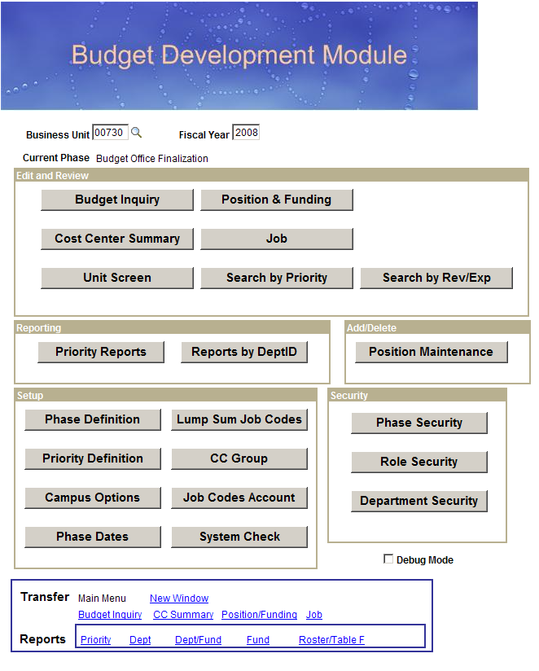
TABLE OF CONTENTS

INTRODUCTION 1
EDIT AND REVIEW 3
Budget Inquiry 3
Cost Center Summary 4
Unit Screen 7
Position and Funding 8
Job 10
Search by Priority 11
Search by Rev/Exp 12
REPORTING 13
Priority Reports 13
Reports by DeptID 14
ADD/DELETE 17
Position Maintenance 17

INTRODUCTION

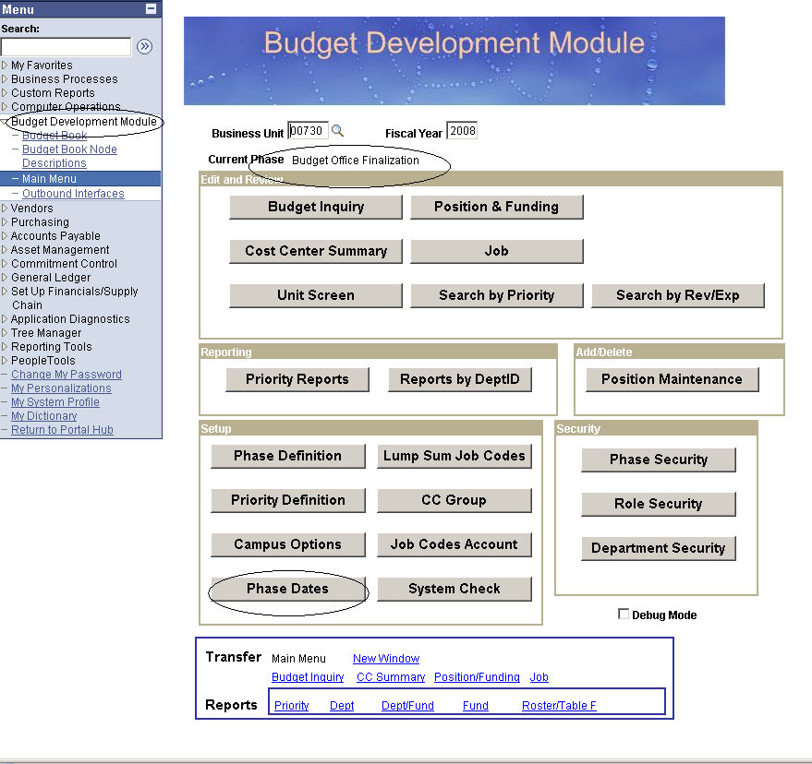

If you have been given access to view and prepare budget data for the budget development cycle, the Budget Preparation Module will appear on your PeopleSoft General Ledger menu. If you should have access, but do not see the Budget Preparation Module in your PeopleSoft General Ledger menu, have your College/Division administrator contact the Budget Office at ext: 3-0665.

Note: In order to be given access to the Budget Preparation Module, the user will need a PeopleSoft General Ledger EmplID.

Main menu will display the Current Budget Phase. Click on Phase Dates to view beginning and end dates of budget cycle.

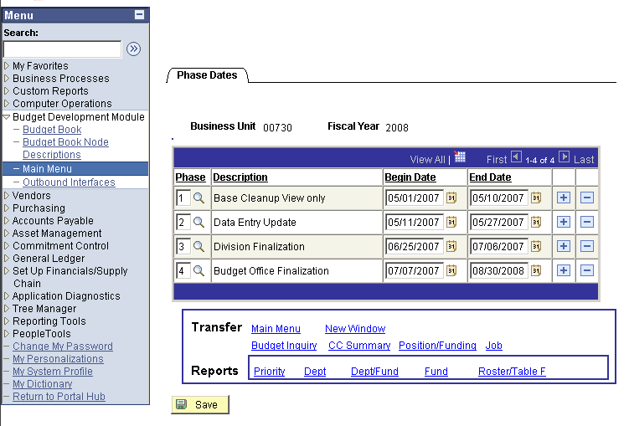

To navigate in BDM, use the links at the bottom of each page.

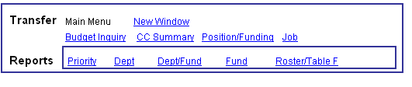

EDIT AND REVIEW

Budget Inquiry

Budget and FTE can be viewed by entering any combination of chartfield criteria or speed type. Click search.

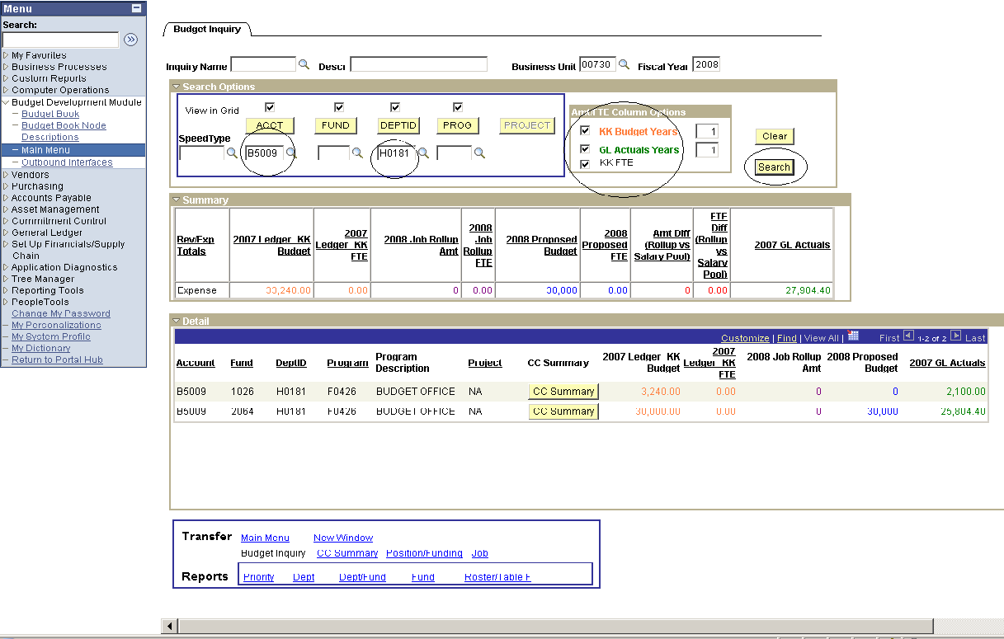

Columns that are underlined can be sorted by header.

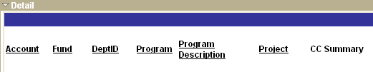

The option to download information to an Excel spreadsheet will be indicated by the download grid icon.

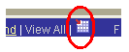

Cost Center Summary

Enter speed type and press enter or tab, to view or update cost center.

Click on the Budget Request Form or FTE Prorated links to access the reports.

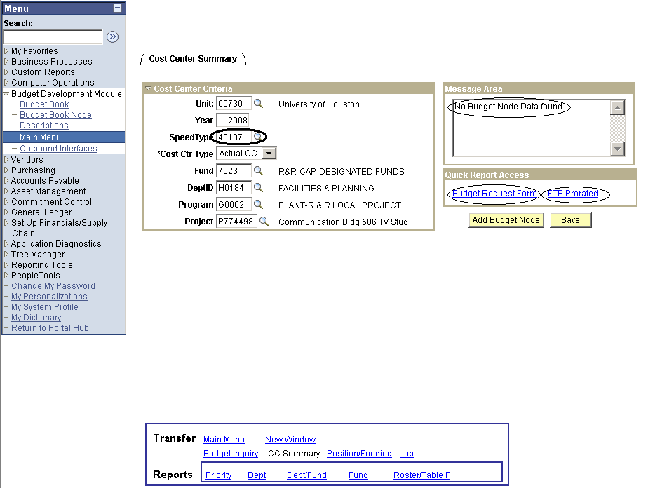

If the cost center exists but does not have budget, the Message Area will display a “No data found” message.

If budget has been assigned to the cost center, the appropriate node(s) and detailed budget information will be displayed in the Budget Node Summary grid.

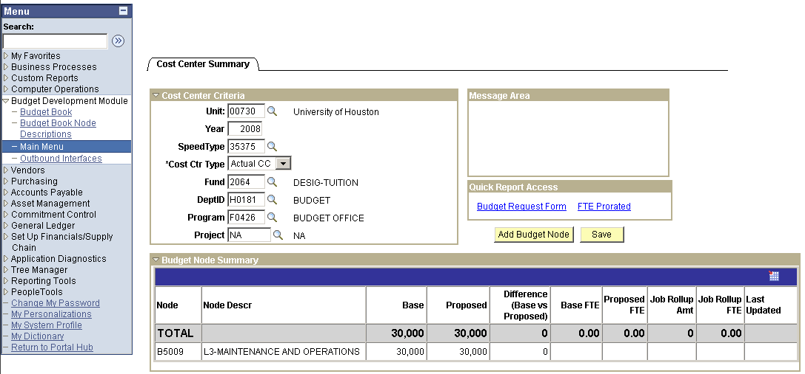

If a row for a budget node does not exist, click on the Add Budget Node button.

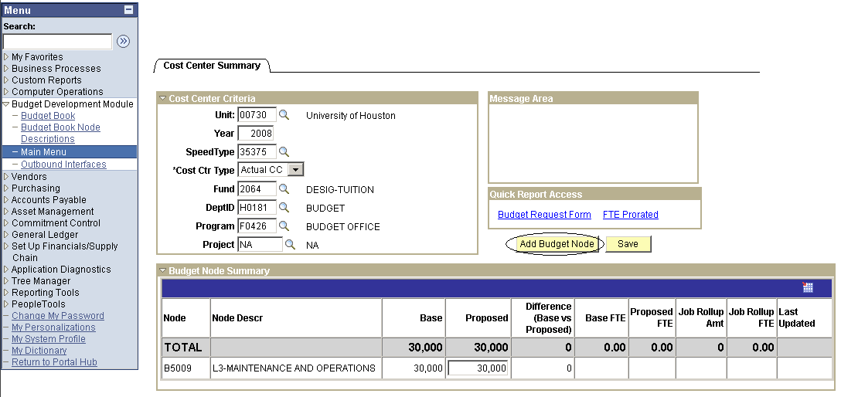

Enter the desired budget node and click OK.

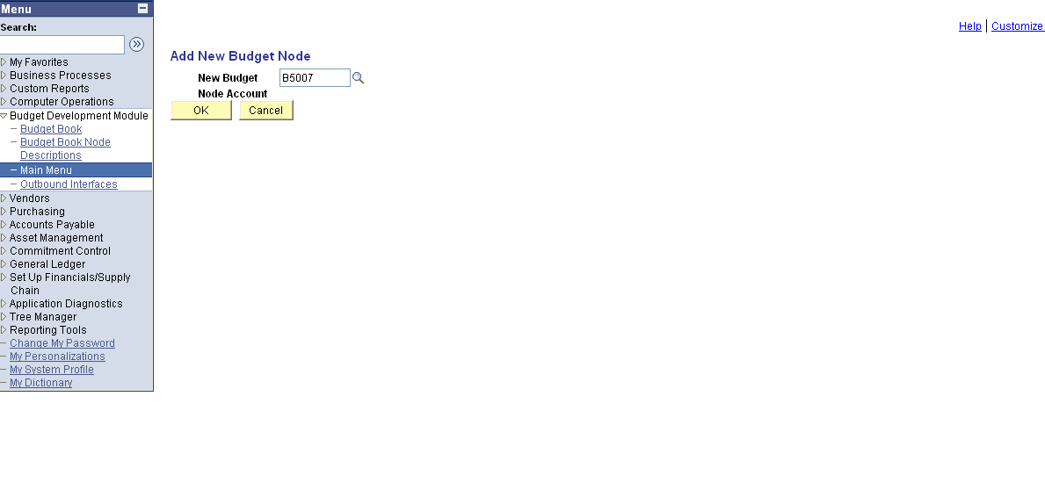

Enter the amount in the Proposed field and click Save.

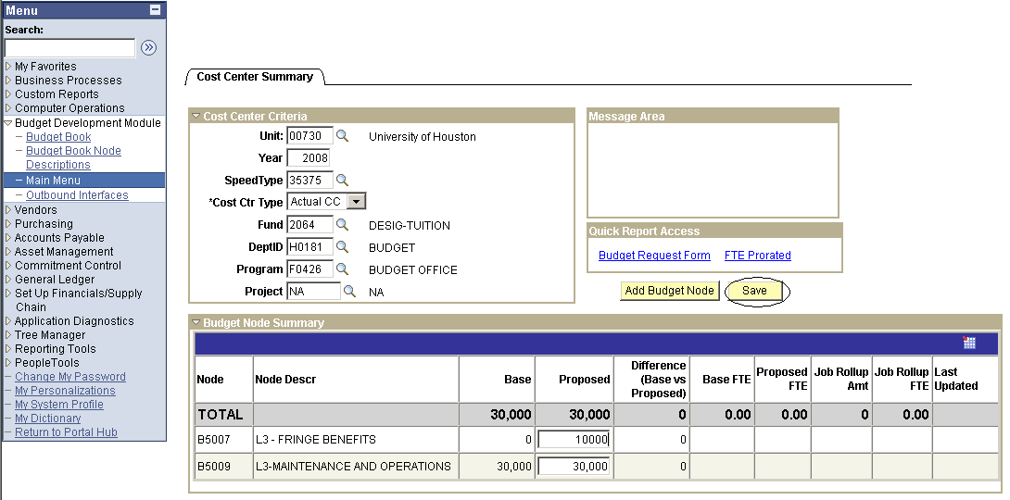

Note: Once a budget node has been added and saved, it cannot be deleted. To correct enter zero.

Unit Screen

The Unit Screen is available to view total expenditures or priorities by placeholder. Select desired combination of department and fund group.

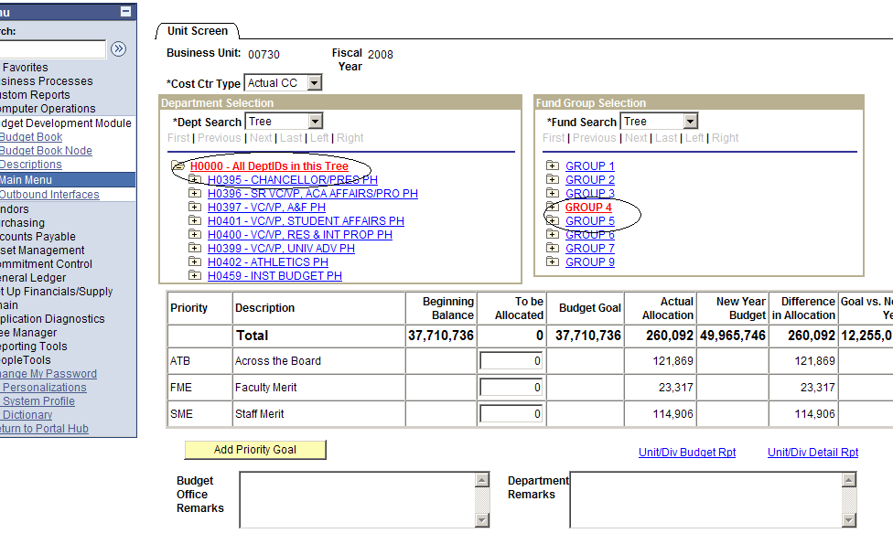

Position and Funding

Search by Position Number, Description, and/or Department.

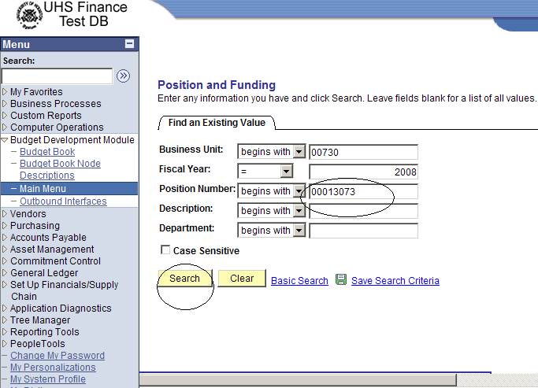

To assign funding source, enter speed type and tab to populate chartfield values. Enter percentage of distribution (Pct). Save.

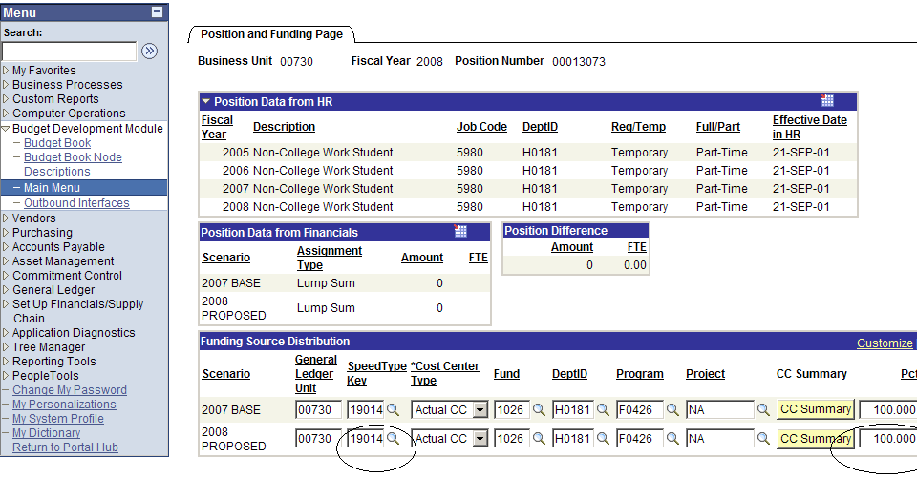

Note: Total percentage of distribution must equal 100 percent.

To add an employee to a position, select “Filled” for Assignment Type. Save. Click “Add Employee” to this position. Enter EmplID and click OK. Save.

Note: If position is to reflect “base,” notify budget office to update Assignment Type from vacant to filled.

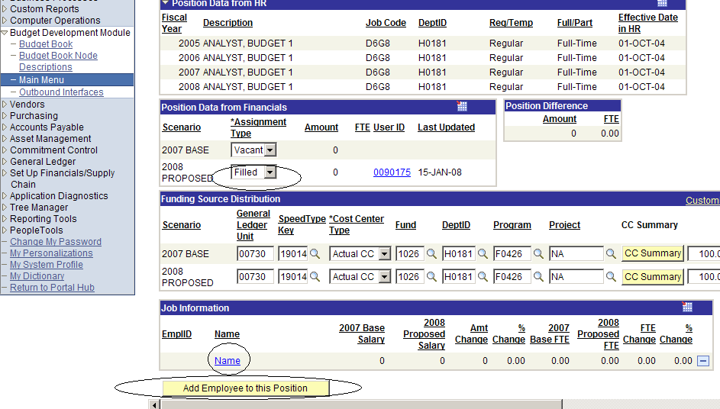

Note: Employee has been added successfully.
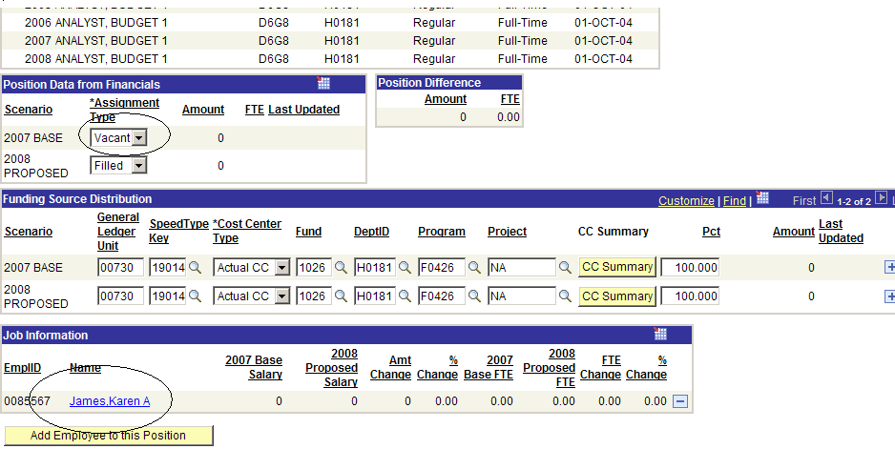

Job

Enter Standard Hours. Verify Comp Rate, Annual Rate, Officer Code, and Comp Freq.
If employee is new, enter amount under priority. Save.

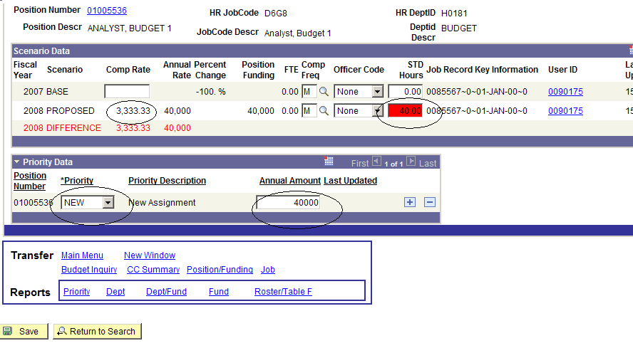

To add/delete an employee from a position, please contact your budget analyst.

Search by Priority

To retrieve Priority information, enter any combination of the following criteria and click search.
- Employee
- Position
- Priority
- Funding Source

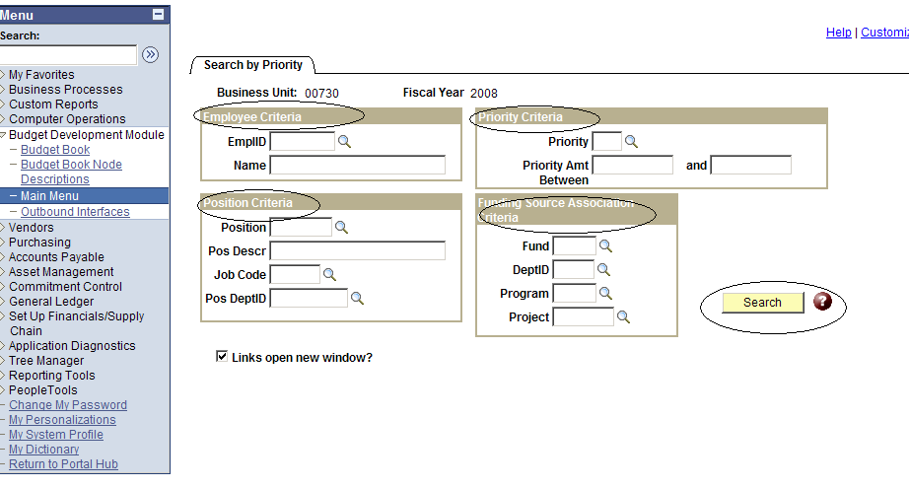

Search by Rev/Exp

Total expenditures and revenue can be viewed by placeholder or by Dept. Customize search by using DeptID and fund group or specific fund code.

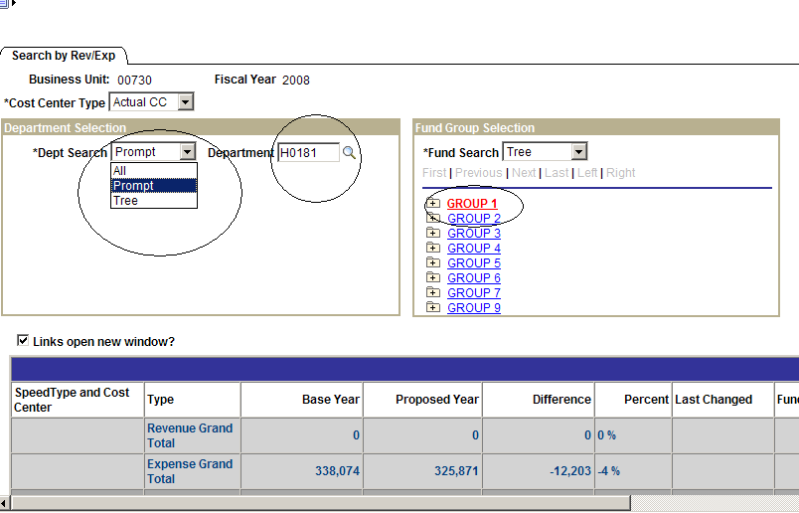

REPORTING

Priority Reports

Enter any search criteria and select one of the following sorting options to retrieve an Excel report.
- By Placeholder ( by selecting tree)
- By Department
- By Employee
- By Priority Pool
- By Fund Group

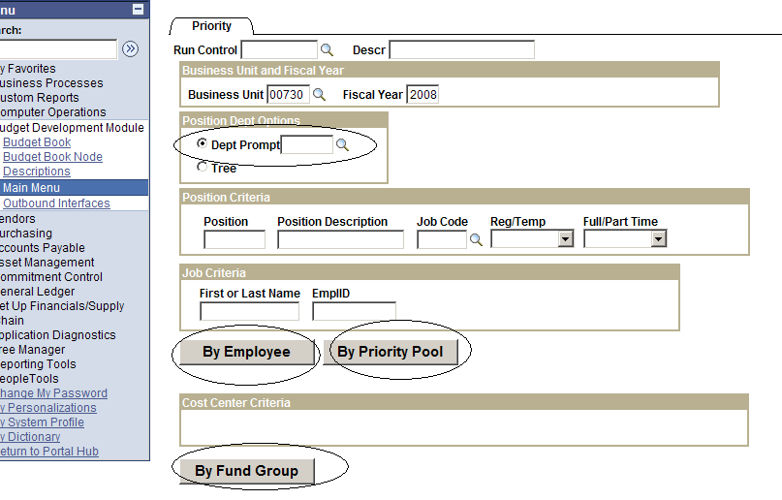

Reports by Dept

The following reports can be retrieved by specifying placeholder and or department. Additional departments will be displayed when clicking on the placeholder plus sign (+).

- Budget Rpt by Employee name or EmplID
- Position Budget Rpt ****
- Budget Summary by cost center, fund and program
- Megabud; compressed and not compressed
- FTE Prorated
- Table E
- Table E with Faculty Adjunct
- Audit

Report can be run via SQR or Window. If “SQR” is selected, click on process monitor to retrieve report. If “Window” option is selected, the report will appear in a new window.
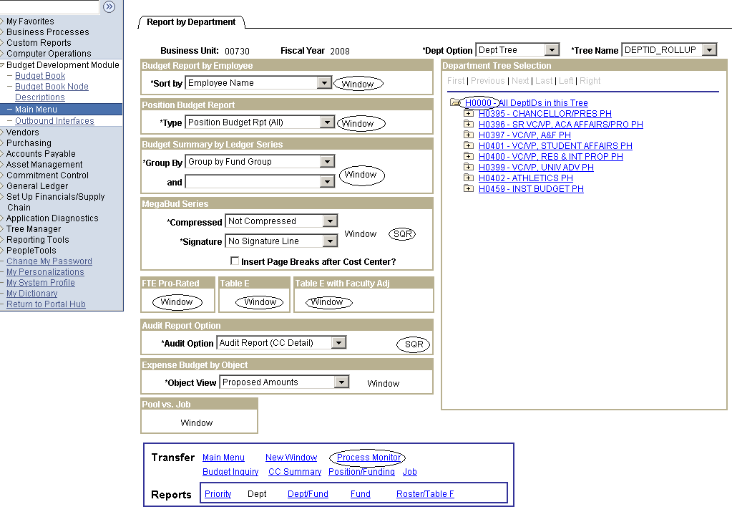

****Position Budget report: Three sort options

1. Non-Funded Positions. All vacant lump sum and benefits eligible positions.
2. Position Budget Rpt ALL. All positions filled and vacant.
3. Vacant Positions. ONLY benefits eligible positions.

MegaBud FTE Prorated Report

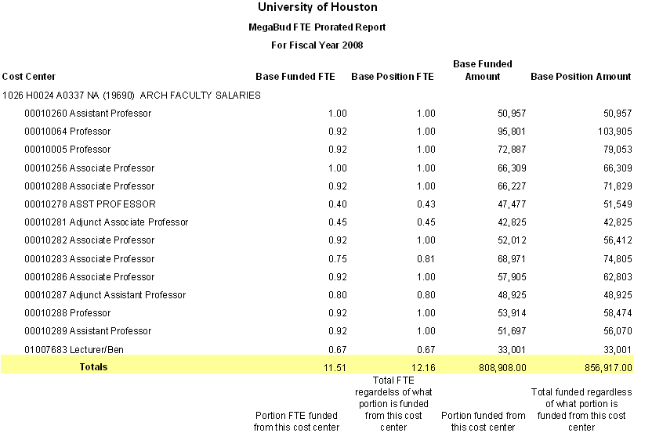

MegaBud FTE Prorated Report
Column Definitions

Base Funded FTE – The FTE figures in this column represent what portion of the position FTE is funded from the cost center. In most cases, the position FTE total will be 1.00 and will be multiplied by the percentage funded by the cost center 100%, 50% and so on. For example, a full time position, 1.00 FTE that is funded 50% by the cost center, would be reflected as .50 in the column. An FTE of .75 that is funded 50%, would be reflected as .38.

Base Position FTE – The FTE figures in this column represent the total position FTE regardless of what portion is funded from the cost center.

Base Funded Amount – The figures in this column represent what portion of the position base amount is funded from the cost center. For example, a $50,000 position that is funded 50% by the cost center, would be reflected as $25,000 in the column.

Base Position Amount – The figures in this column represent the total position amount regardless of what portion is funded from the cost center.

Proposed Funded FTE – The FTE figures in this column represent what portion of the position FTE is funded from the cost center. In most cases, the position FTE total will be 1.00 and will be multiplied by the percentage funded by the cost center 100%, 50% and so on. For example, a full time position, 1.00 FTE that is funded 50% by the cost center, would be reflected as .50 in the column. An FTE of .75 that is funded 50%, would be reflected as .38.

Proposed Position FTE – The FTE figures in this column represent the total position FTE regardless of what portion is funded from the cost center.

Proposed Funded Amount – The figures in this column represent what portion of the position proposed amount is funded from the cost center. For example, a $50,000 position that is funded 50% by the cost center, would be reflected as $25,000 in the column.

Proposed Position Amount – The figures in this column represent the total position amount regardless of what portion is funded from the cost center.

ADD/DELETE

Position Maintenance

To add or delete a position from BDM enter any combination of position criteria and click “Retrieve Positions”.

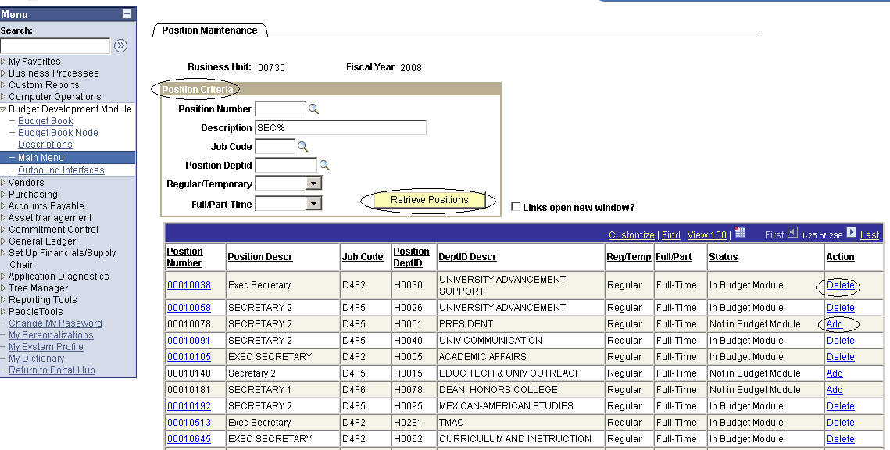

To add a position to BDM, click “Add” link in the Action column. Click OK when prompted. Note the status of the position “In Budget Module” to confirm it was successfully added to the budget module. Position number should be a hyperlink. Contact the Budget Office to add funding source.

To delete a position, click “Delete” link in the Action column. Click OK when prompted. Note the status of the position “Not in Budget Module”. Confirm the position has no assignment before deleting. Contact Budget Analyst for assistance.

