1. | Telecheck Check Scanners must be obtained through the University Treasurer’s Office.  These scanners are used to scan checks presented in person so that they will be settled electronically. These checks will be returned to the customer after acceptance and scanning and will not be presented for deposit with other checks and cash.
2. | Telecheck Check Scanners plug in to a credit card merchant processing (i.e. swipe) machine, but have their own separate Subscriber ID (similar to a Merchant ID for credit cards).
3. | Departments using Telecheck Check Scanners must display a sign that informs customers that providing a check authorizes the department to use the check to process a one time electronic payment. This sign must be visible to the customers.  Signs are obtained from the Treasurer’s Office. | 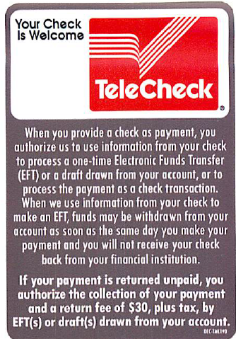
4. | Checks must be presented in person to use the Telecheck Check Scanner.  Only first party checks can be accepted.  Checks must be drawn on a U.S. bank.  All persons presenting a check must also present a Driver’s License or State issued ID card. The license or ID card must match the name of the person whose name is on the check. | Only first party checks  Checks must be on a U.S. Bank  State Driver’s License or ID required
5. | Accept the check from the customer, verify that it meets the criteria in #4 above, and scan the check through the machine.  If the customer says that they do not want the check scanned, the check must be processed as a manual check deposit.  Enter the 2-digit State code  Enter the Driver’s License number. | Customers can decline to have their check settled electronically.  Enter the State code.  Enter the Driver’s License or State ID number.
6. | The Telecheck Check Scanner will run the check and return a message of “Accept” or “Do Not Accept”.  “Accept” means that the check has been processed and will be settled electronically.  - The Telecheck Check Scanner will print out a receipt.  - Obtain the customer’s signature on the receipt.  - Return the check to the customer.  - Retain the receipt for 2 years.  - “Accept” message does not guarantee that the check will not be returned later for insufficient funds or account closing. | “Do Not Accept” Message:  - Return the check to the customer.  - Request another form of payment.  - Do not accept a check, even if it is drawn on another bank.  “Accept” Message:  - Obtain customer signature on receipt.  - Return check to customer.  - Retain copy of receipt for 2 years.  - Check can still be returned by the bank.
7. | At the end of the business day, the Telecheck Check Scanner must be “batched” so that transactions are submitted and processed. This must be done daily.  Please use the Telecheck Daily report run from the Telecheck website.  User IDs will be sent when Telecheck machines are sent. | Batch (settle) the Telecheck Check Scanner daily.  Run the Telecheck Daily Report at http://www.firstdata.com/telecheck/index.htm  Detailed instructions with images are available on the Bank Reconciliations website at http://www.uh.edu/finance/pages/GA_Bank_Recon.htm.
8. | Prepare your cash/check deposit using standard deposit procedures for checks and cash to be presented for deposit.  Record Telecheck deposits on a separate GL Journal Line from other cash, checks, and credit card transactions.  - Deposit to account 10510, Fund BANK  - Do not combine with other cash, check, ACH, or credit card BANK lines. Separate bank lines for other sections of the deposit are okay.  - Deposit line will read XXXXXX (last six digits of Telecheck Subscriber ID (this is the Merchant ID 2nd – 8th digit in the daily statement under “Merchant Reference”) MM.DD.YYYY (the month, day, and year of the processing).  - Line amount must equal total amount in daily report from Telecheck.  Journal Support  - Attach the Telecheck daily report as support. | 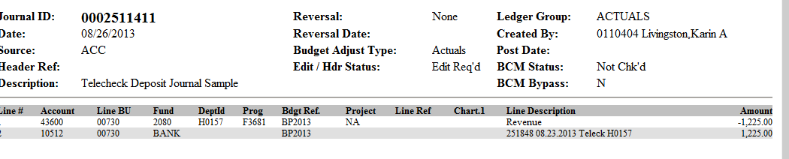  10510
9. | Submit your deposit using standard deposit procedures for cash and checks.  - Put nothing in the deposit bag or on the Deposit Ticket regarding the Telecheck Deposit.  Note: If the only items you are depositing are the Telecheck Check Scanner amounts and/or Credit Card transactions, there will be no physical deposit, so no pickup is required and journals can be routed through Path 1. | Put nothing in the Deposit Bag or on Deposit Ticket regarding the Telecheck Deposit.  If you are only depositing Telecheck receipts, or Telecheck receipts and Credit Card receipts, there will be no physical deposit. No UHPD pickup is required, and journals can be routed through Path 1.
10. | Maintain the Telecheck receipts with deposit documentation for 2 years.  Receipts can be maintained electronically, but must be indexed in a way that allows the retrieval of the receipts in the event of audit or customer complaint. | Telecheck receipts must be maintained for 2 years from the date of the transaction.
11. | If Telecheck items are returned by the bank, notification will be sent to the Cashier’s Office and funds will be withdrawn from the bank automatically.  Within 48 hours of the receipt of notification of a return, the Cashier’s Office will prepare a journal to reverse the deposit. Journals will be processed against the standard NSF check cost centers provided by all campus departments using Telecheck machines. The department will receive notification of the journal and information regarding the returned check.
12. | Telecheck charges fees, both a monthly usage fee and 25¢ per check.  Fees will be deducted from the University’s bank account at the end of each month, and a fee report will be received.  Fees will be posted to departmental cost centers in the month following their payment by Bank Reconciliations. Telecheck Fees will be posted to the same cost centers used to record Credit Card Discount Fees unless other information is provided. | Fees will be recorded in departmental cost centers by Bank Reconciliations each month once reports are received.
13. | Departments using Telecheck Check Scanners must have procedures for the use of the machines that include:  - Acceptance  - Employee training  - Records retention  - Deposit journals

