THE UNIVERSITY OF HOUSTON

[2016]

[BUILDING NAME]
EMERGENCY RESPONSE PLAN
TEMPLATE

Issued: [DATE]

[LIST OF DEPARTMENT NAMES]

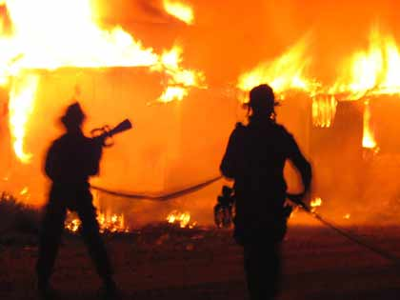
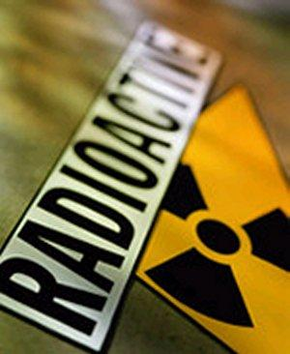
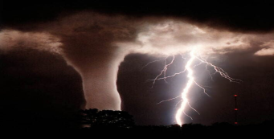

Contents
RECORD OF CHANGES 5
INTRODUCTION 6
EXPLANATION OF TERMS 6
NATIONAL INCIDENT MANAGEMENT SYSTEM (NIMS) OVERVIEW 6
EMERGENCY RESPONSE PROCEDURES 7
HAZARD/INCIDENT-SPECIFIC PROCEDURES 8
DEPARTMENT SPECIFIC OPERATIONS/PROCEDURES 8
POST INCIDENT PROCEDURES 8
PLAN DEVELOPMENT AND MAINTENANCE 9
ATTACHMENTS 10
Attachment 1 – UH Important Phone Numbers 11
Attachment 2 – [Building Name] Personnel Roster and/or Phone Tree 12
Attachment 3 – [Building Name] Specific Staff Assignments During Emergencies 13
Attachment 4 – [Building Name] Emergency Response Plan Annual Review Documentation Table 14
Attachment 5 – [Building Name] Emergency Response Plan Considerations for Special Needs Populations 15
Attachment 6 – Emergency Preparedness Kit Checklist 16
Attachment 7 – FEMA Emergency Supply List 17
Attachment 8 – UHDPS Emergency Quick Reference Guide 18
Attachment 9 – Emergency Planning Resources 19
Attachment 10 – UH Fire Marshal’s Office General Emergency Evacuation Procedures 20
Attachment 11 – Shelter In Place Guidelines 22
Attachment 12 – Shelter in Place vs. Lockdown 23
Attachment 13 – UH Police - Bomb Threat Checklist 24
Attachment 14 – UH Emergency Alert Notification System Information 25
Attachment 15 – UH Outdoor Warning Siren System Information 27
Attachment 16 – NIMS/ICS Training 30
Attachment 17 – ICS Features 32
Attachment 18 – UH CERT Training 34
Attachment 19 – Department/Building After-Action Report Template 35

Note regarding use of the Building Emergency Response Plan Template
*Do not include this section in your final building plan. This is simply a note about the use of this template.
The development of this template was a result of a coordinated effort between UH Police, UH Fire Marshal’s Office and the UH Office of Emergency Management. This template is for use by UH departments to develop an Emergency Response Plan for their buildings. Please note that if your building houses multiple departments, that representatives from each department should be included in the development of your Building Emergency Response Plan. Once the Emergency Response Plan has been drafted using this template, it should be submitted for review by the UH Department of Public Safety. If you need any assistance or are ready for your plan to be reviewed, please contact Chelsea McKeathen, Emergency Management Specialist, at 713-743-0341 or via e-mail at cmckeathen@uh.edu.

RECORD OF CHANGES
The University of Houston
[BUILDING NAME]
Emergency Response Plan
Date of Change | Page | Description of Change | Entered by

INTRODUCTION

The [Building Name] Emergency Response Plan is an all-hazard plan that details the emergency procedures specific to the [Building Name]. The purpose of the plan is to ensure the safety of the students, faculty, staff and visitors of the [Building Name] in the event of an emergency. This plan has been developed to improve the efficiency of the [Building Name] response to an incident in order to promote safety.

EXPLANATION OF TERMS

ACRONYMS

[List acronyms utilized in the plan here].

ICS Incident Command System
NIMS National Incident Management System
UH University of Houston
UHDPS University of Houston Department of Public Safety (includes UH Police, UH Fire Marshal’s Office, UH Environmental Health and Life Safety, and UH Office of Emergency Management)

NATIONAL INCIDENT MANAGEMENT SYSTEM (NIMS) OVERVIEW

The National Incident Management System (NIMS) is a comprehensive, nationwide systematic approach to incident management. NIMS is flexible due to its application to any incident regardless of cause, size, location or complexity. In addition, its principles are to be utilized in order to develop all-hazard plans and procedures. Lastly, NIMS provides an organized set of scalable and standardized operational structures. This standard is critical for allowing various organizations and agencies to work together in a predictable, coordinated manner. The UH Board of Regents formally adopted NIMS in November of 2008.

One major component of NIMS is the Incident Command System (ICS). ICS is a management tool that includes 14 key features that has become the standard for managing emergencies across the country. ICS may be used for planned events, natural disasters, and acts of terrorism. This response plan is in compliance with NIMS and the 14 features of ICS (see Attachments 15 and 16).

One key feature of ICS is “Management by Objectives.” Objectives and initial decisions for any emergency should be based on the following three (3) priorities:
- Life Safety
- Incident Stabilization
- Property Preservation

These priorities are utilized to establish objectives. General Emergency Planning Objectives include:
- Save lives and prevent injuries
- Promote an effective action in responding to emergencies
- Minimize loss of campus property
- Restore conditions to normal and with minimal disruption

EMERGENCY RESPONSE PROCEDURES

EVACUATION
[Insert building specific procedures here. Refer to the University of Houston General Emergency Evacuation Procedures and Area Specific Evacuation Procedure developed by the UH Fire Marshal’s Office in Attachment 10 of this template].

sHELTER IN PLACE
[Insert building specific procedures here. Refer to Attachments 11, 12 and 8 (for “severe weather” procedures) of this template].

LOCKDOWN
[Insert building specific procedures here. Refer to Attachments 9 and 12 for “Lockdown Procedures Resources” of this template].

HAZARD/INCIDENT-SPECIFIC PROCEDURES

[Insert hazard/incident-specific procedures as deemed necessary by your area. A sample list has been provided for your use below. Refer to Attachments 8-9 for additional guidance.]
- Fire
- Severe weather (Tornado, Flash Flood, Hurricane, etc.)
- Bomb Threat/Suspicious Activity/Package, etc.
- Active Shooter
- Protest/Riot
- Hazardous Material Release/Gas Leak
- Pandemic/Infectious Disease Threat
- Medical Emergency
- Power Outage/Loss of water
- Elevator Failure
- Mechanical and Plumbing

DEPARTMENT SPECIFIC OPERATIONS/PROCEDURES

[If the building houses multiple departments, include any department specific, key information or procedures here.]

POST INCIDENT PROCEDURES

[Insert post-incident procedures here as deemed necessary by your area.

For example, if your area needs to document an accident or injury, or other incident report, please include this procedure and documentation here. It is recommended that an After-Action Report (AAR) be completed after any major incidents within your area. AARs detail the strengths, areas of improvement, and recommendations in order to improve emergency operations after an exercise or incident. An AAR template is included as Attachment 19].

PLAN DEVELOPMENT AND MAINTENANCE

A. Plan development and maintenance

    - This plan was developed by [Insert the group or team responsible for developing the plan].
  - [Name of the area responsible for maintaining the plan] is responsible for maintaining this plan. Recommended changes to this plan should be forwarded as needs become apparent.
  - This plan will be reviewed and updated [annually/biannually/quarterly, etc.]
  - This plan will be updated based upon deficiencies identified during actual emergency situations, during exercises, and when changes in threats, hazards, resources or capabilities occur.
  - Areas/Managers with assigned responsibilities in this plan must develop and maintain procedures for their responsibilities.
  - Changes to this plan will be notated on the Record of Changes table on [page 5].
  - Training, exercises and/or drills will be conducted on a regular basis to prepare and test aspects of Emergency Response Plan. An After-Action Report (AAR) will be conducted after an exercise or incident to identify how to improve emergency operations (see Attachment 19).
  - This plan may be reviewed by the UH Department of Public Safety.

B. Distribution of Planning Documents

              - In general, copies of this response plan will be distributed to [Insert those areas/personnel who will receive copies of the plan.]
              - Hard copies will also be located in [Insert location(s)].
              - A copy of this plan will also be submitted to the UH Office of Emergency Management.

ATTACHMENTS

List of Attachments

*Note regarding the use of the Template Attachments:
The attachments to the template serve two primary purposes. Many of the attachments or resource links provide guidance or information to assist in the development of the Emergency Response Plan. You may find that other attachments would serve as useful references or additions to your
Building’s Emergency Response Plan. Please feel free to use or remove any attachments in order to include only the necessary attachments for your building plan.

- UH Important Phone Numbers
- [Building Name] Personnel Roster and/or Phone Tree
- [Building Name] Specific Staff Assignments During Emergencies
- [Building Name] Emergency Response Plan Annual Review Documentation Table
- [Building Name] Emergency Response Plan Considerations for Special Needs Populations
- Emergency Preparedness Kit Checklist
- FEMA Emergency Supply List
- UHDPS Emergency Quick Reference Guide
- Emergency Planning Resources
- UH Fire Marshal’s Office General Emergency Evacuation Procedures
- Shelter-In-Place Guidelines
- Shelter-In-Place vs. Lockdown
- UH Police - Bomb Threat Checklist
- UH Emergency Alert Notification System Information
- UH Outdoor Warning Siren System Information
- NIMS/ICS Training
- ICS Features
- UH CERT Training
- [Department/Building] After-Action Report Template

Attachment 1 – UH Important Phone Numbers

For EMERGENCIES:  UH Police | 713-743-3333  Or  911
UH Environmental Health and Life Safety | 713-743-5858
UH Fire Marshal’s Office | 713-743-5858
UH Health Center | 713-743-5151
UH Facilities Service Center (FIX-IT) | 713-743-4948

For UH emergency information, go to www.uh.edu/emergency.

*Departments should feel free to add to this list as needed.

Attachment 2 – [Building Name] Personnel Roster and/or Phone Tree

[Insert department roster and/or phone trees for all departments that occupy the building here.]

Attachment 3 – [Building Name] Specific Staff Assignments During Emergencies

[Insert any building specific staff assignments during emergencies here.]

Attachment 4 – [Building Name] Emergency Response Plan Annual Review Documentation Table
[BUILDING NAME]
Emergency Response Plan
Annual Review Documentation Table
Review Year | Date of Review | Reviewed By

Attachment 5 – [Building Name] Emergency Response Plan Considerations for Special Needs Populations

[Insert any building specific considerations for those with special needs, as needed.]

Attachment 6 – Emergency Preparedness Kit Checklist

An Emergency Preparedness Supplies Checklist is provided by the University of Houston Office of Emergency Management, and can be found on the UH Office of Emergency Management website.
(Link: http://www.uh.edu/emergency-management/planning-and-response/hurricane-preparedness/)

Attachment 7 – FEMA Emergency Supply List

An Emergency Supplies Checklist is provided by the Federal Emergency Management Agency (FEMA), and can be found on their ready.gov website.

(Link: http://www.ready.gov/sites/default/files/documents/files/checklist3.pdf)

Attachment 8 – UHDPS Emergency Quick Reference Guide

An Emergency Quick Reference Guide is provided by the University of Houston Department of Public Safety, and can be found on the UH Office of Emergency Management website.
(Link: http://www.uh.edu/police/UHDPSemergencyref.pdf)

Attachment 9 – Emergency Planning Resources

UH Emergency Information
www.uh.edu/emergency
UH Emergency Management Plan: http://www.uh.edu/emergency-management/planning-and-response/emergency-management-plan/
UH Police
http://www.uh.edu/police/home.html
Emergency Quick Reference Guide: http://www.uh.edu/police/UHDPSemergencyref.pdf
Shelter-in-Place vs. Lockdown: http://www.uh.edu/police/shelter-or-lockdown/
UH Environmental Health and Life Safety
http://www.uh.edu/ehls/
UH Fire Marshal’s Office
http://www.uh.edu/ehls/fire/
UH Office of Emergency Management
http://www.uh.edu/oem
City of Houston Office of Emergency Management
http://www.houstonoem.org/
Harris County Office of Homeland Security and Emergency Management
http://www.hcoem.org/
FEMA Ready.gov
http://www.ready.gov/

Lockdown Procedures Resources:
UH Police - http://www.uh.edu/police/active-shooter/lockdown-deny.html
Department of Homeland Security (DHS) - http://www.dhs.gov/active-shooter-preparedness
Federal Bureau of Investigation (FBI) - http://www.fbi.gov/about-us/cirg/active-shooter-and-mass-casualty-incidents

Attachment 10 – UH Fire Marshal’s Office General Emergency Evacuation Procedures

UNIVERSITY OF HOUSTON
GENERAL EMERGENCY EVACUATION PROCEDURES

For emergencies dial 911

It is essential that the campus community be prepared to respond appropriately in the face of emergencies such as fires, explosions and chemical releases. The following procedures are to be used by supervisors and managers to assist employees and students in thoroughly understanding the methods of an evacuation.

The key to a successful evacuation is planning. Each employee and student must familiarize himself/herself with the university’s emergency procedures and evacuation plan. Employees and the student must also become familiar with the buildings in which they work, including the location of exits, fires alarms, and fire extinguishers. All employees and students must know their responsibilities. Practice drills should be conducted to maintain preparedness.

- Pre-emergency responsibilities

  - Knowing at least two exits other than the elevators.
  - Knowing the location and operation of the fire alarm system.
  - Keeping the University Police emergency phone numbers conspicuously posted.
  - Participating in all fire drills and taking them seriously.
  - Knowing how to use fire extinguishers. Become familiar with the locations and types of fire extinguishers.
  - Knowing the location outside the building where members of your department must congregate upon exiting.
  - Advising personal that they are to begin evacuating at the first sign of smoke or fire alarm.
  - Assigning one person and a backup to assist with evacuating each disabled individual.

- Duties during an Emergency.

  - Activate the fire alarms and dial 911.
  - Confine the fire by closing all doors and windows.
  - Alert people on the floor so they can begin evacuation.
  - Take your personal belongings and exit the building.
  - Remain outside the building until allowed back in by the University Police.
  - Congregate at the pre-designated location outside the building so that a head count of the department may be taken.

- Emergency Procedures for Disabled Personnel

  - If the fire is not on the same floor as the disabled person, close all doors and wait for assistance.
  - One person should stay with the disabled individuals while another person reports to the University Police.
  - Hearing-impaired and visually impaired persons need only one person assigned to assist them during an evacuation. They must be notified of fire alarms and guided to safe escapes routes.
  - If needed, after the other employees and students have been evacuated, disabled employees and students may be assisted to the stairwell landings to wait for emergency personnel. All doors to the stairwell must be kept closed in order to reduce the buildup of smoke.

UNIVERSITY OF HOUSTON
AREA SPECIFIC EVACUATION PROCEDURE

- If an evacuation alarms sounds you should…..

  - Call 911. If no response, call UHPD at ext.3-3333.
  - Check immediate area for other employees who may not be aware of the alarm and warn them.
  - Accompany or assist handicapped personnel, visitors and any co-workers who appear to need calm direction or assistance
  - Leave the area and take personal items with you.
  - Shut all doors behind you as you leave. Closed doors can slow the spread of fire, smoke and water.
  - Before you open a closed door, feel it with the back of your hand. If it is hot, leave it closed and use your alternate escape route. If it feels normal, brace your body against the door and open it a crack. Be prepared to slam it shut if heat or smoke rushes in.
  - Never use an elevator during a fire emergency. An elevator might be called or sent to the fire floor thus exposing passengers to deadly heat and gases.
  - Proceed to the primary exit which is located ________________________________________. If unable to use the primary exit, proceed to the secondary exit which is located ____________________________________________________________________________.
  - If you must use an escape route where there is smoke, stay as low as possible. Crawling lets you breathe the cleaner air nearer the floor as you move toward the exit.
  - Proceed to the designated assembly area. The assembly area for your group is ____________________________________________________________________________.
  - Meet with other members of your group and remain in the assembly area and wait for further instructions from your Fire Warden. Your Fire Warden is ____________________________________________________________________________.

- If a fire occurs in your area you should…..

  - Remain calm. Uncontrolled panic can result in more serious problems than the actual emergency.
  - Close the door(s) and/or window(s) to isolate fire.
  - Go to the nearest fire alarm pull station and activate alarm. The closest pull station is _______________________________________. The next closest pull station is _______________________________________________________________________.
  - Call 911 and report the location of the fire. If no response, contact the University Police at ext. 3-3333.
  - If the fire is small and you are trained in the use of fire extinguishers you can attempt to put the fire out. Do not jeopardize your personal safety to do so. Do not allow the fire to come between you and the exit. Fire extinguishers are located_________________________________________________________________.
  - Disconnect electrical equipment that is on fire if it is safe to do so. Pull the plug or throw the circuit breaker.
  - All employees who are not involved in the firefighting or evacuation efforts should immediately begin the evacuation procedures listed in IA.

Attachment 11 – Shelter In Place Guidelines
While you are at work, there may be situations when it's simply best to stay where you are and avoid any uncertainty outside.
There may be circumstances when staying put and creating a barrier between yourself and potentially contaminated air outside, a process known as "sealing the room," is a matter of survival.
Use common sense and available information to assess the situation and determine if there is immediate danger. If you see large amounts of debris in the air, or if local authorities say the air is badly contaminated, you may want to take this kind of action.
The process used to seal the room is considered a temporary protective measure to create a barrier between you and potentially contaminated air outside. It is a type of sheltering in place that requires preplanning.
- Take shelter inside.
- Lock doors, close windows, and air vents.
- Turn off fans, air conditioning and forced air heating systems.
- Take your emergency supply kit unless you have reason to believe it has been contaminated.
- Go into an interior room with few windows, if possible.
- Seal all windows, doors and air vents with 2-4 milliliter thick plastic sheeting and duct tape. Consider measuring and cutting the sheeting in advance to save time.
- Cut the plastic sheeting several inches wider than the openings and label each sheet.
- Duct tape plastic at corners first and then tape down all edges.
- Be prepared to improvise and use what you have on hand to seal gaps so that you create a barrier between yourself and any contamination.
- Stay tuned to additional emergency information from the UH Emergency Alert Notification System or go to www.uh.edu/emergency. In addition, check local TV, radio or other internet resources often for official news and instructions as they become available.

Source: http://www.ready.gov/shelter

*For specific guidelines to shelter-in-place from severe weather, see “Severe Weather” on Attachment 8.

Attachment 12 – Shelter in Place vs. Lockdown
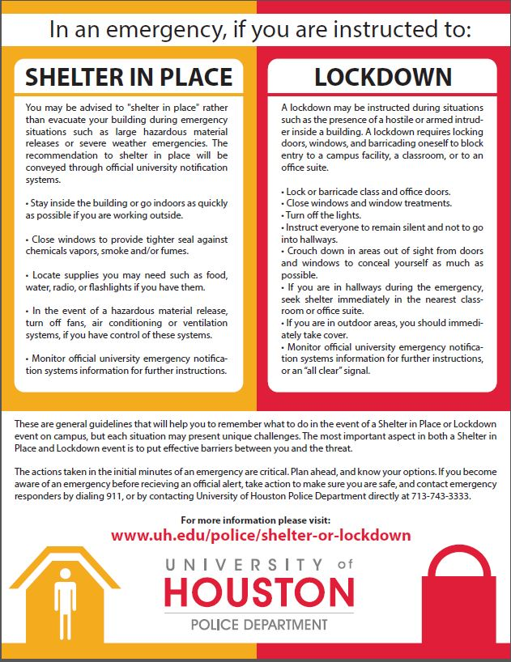 http://www.uh.edu/police/shelter-or-lockdown/

Attachment 13 – UH Police - Bomb Threat Checklist
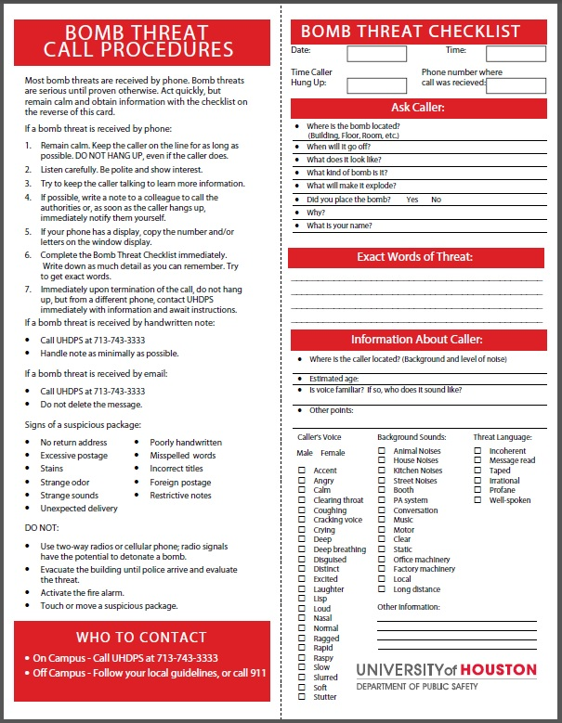
http://www.uh.edu/police/bomb_threat_checklist.pdf

Attachment 14 – UH Emergency Alert Notification System Information

UH Emergency ALERT Notification System
In a campus emergency, The University of Houston will activate the UH Emergency Alert Notification System to provide critical information. The UH Emergency Alert Notification System utilizes the following methods to send UH Emergency Alerts:
- The UH Emergency Operations Center website: www.uh.edu/emergency
    - UH Office of Emergency Management Facebook page (http://www.facebook.com/UHEMB)
    - UH Office of Emergency Management Twitter page (http://twitter.com/UHEMB)
    - E-mail
    - Phone
    - SMS Text Messaging
    - Alertus beacons
    - Outdoor Warning Sirens (if shelter-in-place or lockdown action required)

The University of Houston has the potential to face many different hazards and threats. The threats may require varying degrees of action to be taken. The University of Houston Office of Emergency Management will utilize the following terms to communicate to the campus community.

General Notification
Purpose: To raise awareness
- This type of message addresses a possible threat
- An example of when this type of message may be used is to monitor tropical storms that may enter the Gulf of Mexico.
- This message is distributed through:
  - UH Emergency Operations Center website: www.uh.edu/emergency
  - UH Office of Emergency Management Facebook page (http://www.facebook.com/UHEMB)
  - UH Office of Emergency Management Twitter page (http://twitter.com/UHEMB)

Advisory
Purpose: To raise awareness and to advise the campus to take mitigation and preparedness measures
- This type of message addresses a threat that currently exists
- Examples of when this type of message may be used is to advise the campus that there are several infectious disease cases in the Houston area or that UH is in the cone of uncertainty for a hurricane that is still days away.
- This message is distributed through:
  - UH Emergency Operations Center website: www.uh.edu/emergency
  - UH Office of Emergency Management Facebook page (http://www.facebook.com/UHEMB)
  - UH Office of Emergency Management Twitter page (http://twitter.com/UHEMB)
  - E-mail

Emergency Alert
Purpose: Requires immediate action (Evacuation, Shelter-in-place, or Lockdown)
- This type of message addresses a threat that is imminent or has actualized
- Examples of when this type of message may be used include, but are not limited to: an active shooter, an explosion, an unknown or uncontrolled chemical release, tornado damage to campus, or an approaching hurricane (12-36 hours away)
- This message is distributed Campus-Wide through all available mediums:
  - UH Emergency Operations Center website: www.uh.edu/emergency
  - UH Office of Emergency Management Facebook page (http://www.facebook.com/UHEMB)
  - UH Office of Emergency Management Twitter page (http://twitter.com/UHEMB)
  - E-mail
  - Phone
  - SMS Text Messaging
  - Alertus beacons
  - Outdoor Warning Sirens (if shelter-in-place or lockdown action required)

Attachment 15 – UH Outdoor Warning Siren System Information

Outdoor Warning Siren System Fact Sheet
Background:
The University of Houston’s Outdoor Warning Siren System is part of the emergency alert notification system. The system is designed to alert students, faculty, staff and visitors of impending outdoor danger. The system is activated by Department of Public Safety in the event of an emergency when it may be unsafe to be outdoors. The Outdoor Warning Siren System provides a quick method of notifying the entire main campus with an audible tone that can be heard outdoors alerting students, faculty and staff to seek shelter indoors. Also, during a real emergency, the Outdoor Warning Siren System is used in conjunction with other communication channels like e-mail, UH Emergency Operations Center website (www.uh.edu/emergency) and text messaging.
Types of Incidents:
The types of incidents that may require activation of the siren system are:
- Severe weather conditions (Tornado warning or other dangerous conditions)
- Major hazardous material incidents
- An armed and hostile individual on campus
- Other conditions that may require an emergency shelter in place action
Stay Informed:
In the event of an actual emergency, the PIER notification system will be used in conjunction with the siren system to disseminate further information to the UH community. All outdoor warning siren alerts are accompanied by PIER alert message. All community members are strongly encouraged to keep their contact information up to date in PeopleSoft so they can receive emergency messages. You can find instructions for updating your cell phone number, email address and other contact information at www.uh.edu/emergency
Testing:
On the first Wednesday of each month, an audible test of the outdoor warning siren system is conducted at 1PM.

Source: http://www.uh.edu/emergency-management/emergency-alert-notification/siren/

Frequently Asked Questions
What is the UH Outdoor Warning Siren System?
The University of Houston Outdoor Warning Siren System is designed to alert persons on campus of an emergency situation that requires them to seek shelter indoors for their safety. There are three sirens located on the highest points of campus so that it can effectively alert persons outdoors throughout the campus.
When is it used?
The UH Outdoor Warning Siren System will only be used when there is an imminent threat to the lives and safety of people on the UH campus where it is unsafe to be outdoors. This threat could come in the form of severe weather, criminal violence, such as an active shooter on campus, or an environmental threat such as a hazardous chemical release, or some other emergency situation.
What does it sound like?
Listen >>
What should I do if I hear the UH Outdoor Warning Siren System?
When you hear the Outdoor Warning Siren System you should seek shelter immediately. When seeking shelter, do so by accessing the closest available building in an interior room that is away from windows. Remain inside until the warning has expired or you receive the “all clear” notification from emergency personnel and/or via text message. Updates will be available at www.uh.edu/emergency
Why can’t I hear the Outdoor Warning Siren System inside?
The Outdoor Warning Siren System is an outdoor warning system designed only to alert those who are outside that something dangerous is approaching. For those indoors, text messages, and emails will be distributed as well when the Outdoor Warning Siren System is activated.
Why don’t the outdoor warning sirens sound an all-clear signal?
The campus community should be indoors awaiting notification from email or, text messages.
How can I get alerts when I’m inside?
To ensure you receive emergency email notifications and text messages, please verify your information in the myUH system (faculty/staff instructions | student instructions). Also, go to www.uh.edu/emergency for emergency information.
What should I do during a system test?
The monthly test takes place the first Wednesday of the month at 1pm. You should continue your regular activities during a system test but be cognizant of the tone for future reference. You do not need to take any special actions during a test.

Source: http://www.uh.edu/emergency-management/faq/

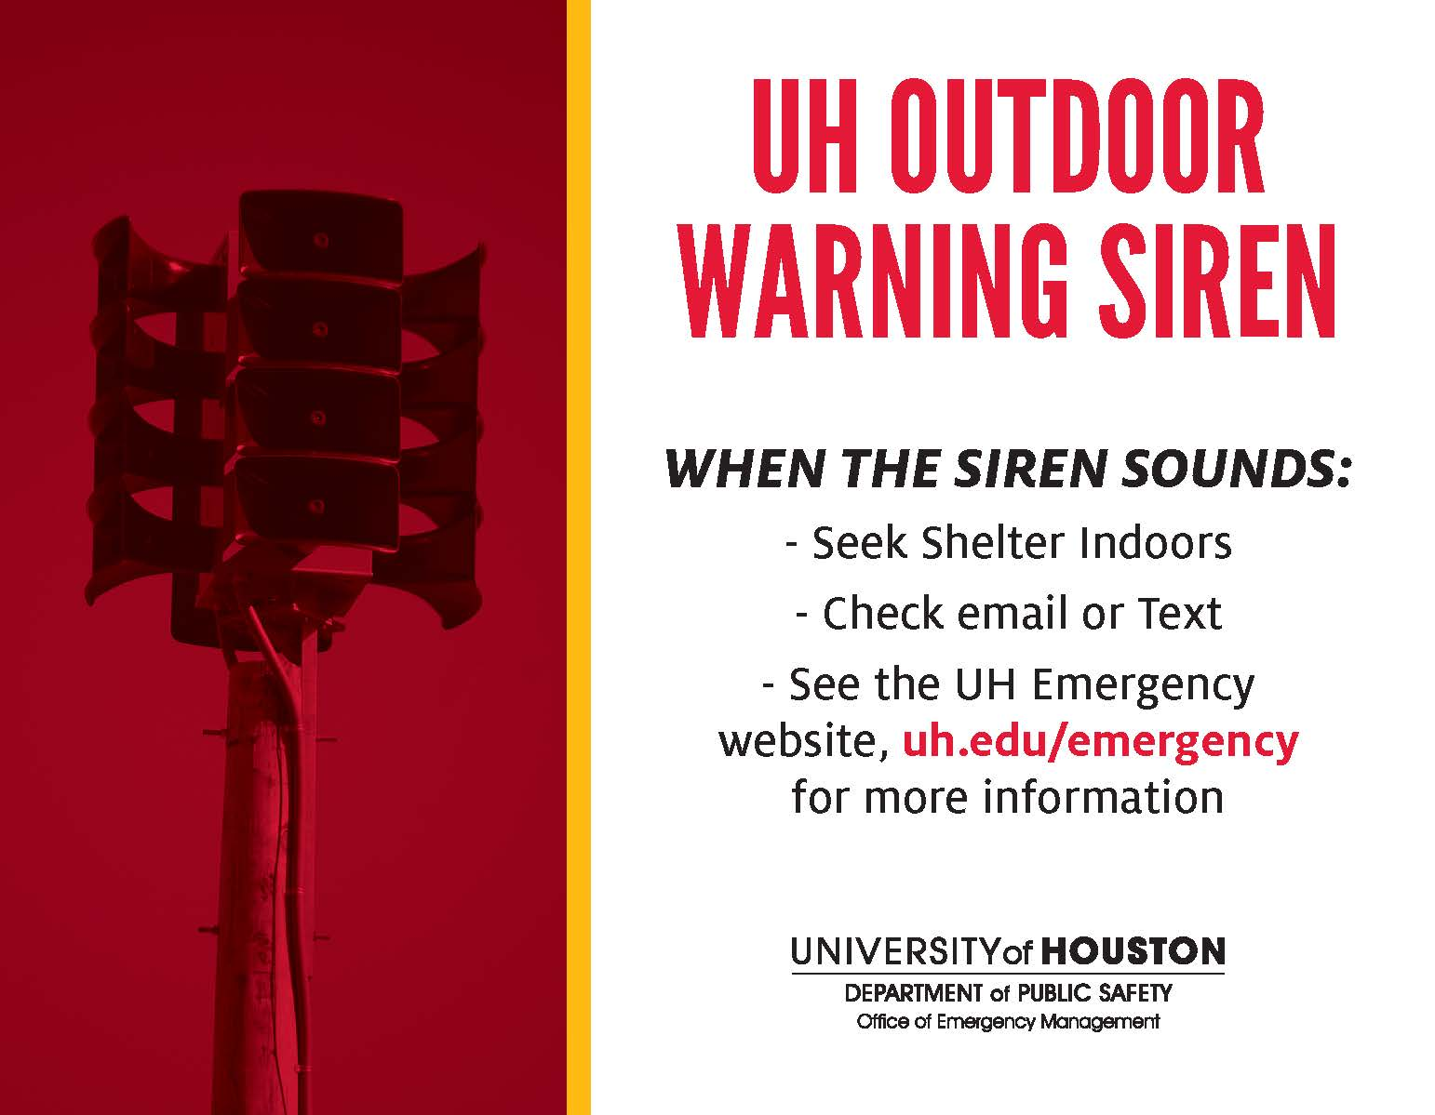

Attachment 16 – NIMS/ICS Training

FEMA Website:
http://www.fema.gov/

IS -100.HE: An Introduction to ICS or IS100.b: Introduction to Incident Command System
http://www.training.fema.gov/EMIWeb/IS/courseOverview.aspx?code=IS-100.HE
http://www.training.fema.gov/EMIWeb/IS/courseOverview.aspx?code=IS-100.b

IS- 200: ICS for Single Resources and Initial Action Incidents
http://www.training.fema.gov/EMIWeb/IS/courseOverview.aspx?code=IS-200.b

IS-700: NIMS, An Introduction
http://www.training.fema.gov/EMIWeb/IS/courseOverview.aspx?code=IS-700.a

IS-800.B: National Response Framework, An Introduction
http://www.training.fema.gov/EMIWeb/IS/courseOverview.aspx?code=IS-800.b

ICS-300: Intermediate ICS for Expanding Incidents
ICS-400: Advanced Incident Command
Search for these courses here: https://www.preparingtexas.org/index.aspx

Additional course opportunities:
https://www.preparingtexas.org/index.aspx

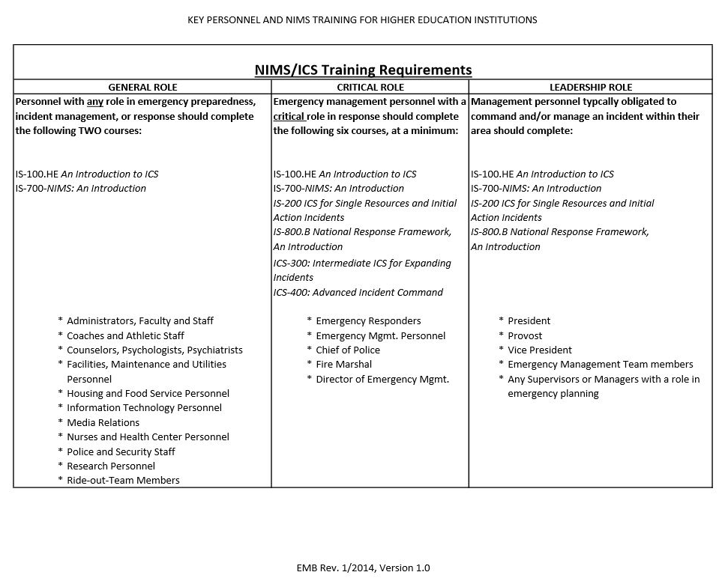http://www.uh.edu/emergency-management/training-and-outreach/nims/uh-nims-training-requirements-2014.pdf

Attachment 17 – ICS Features

Incident Command System (ICS) Features

The 14 essential ICS features are listed below:

Standardization:
▪ Common Terminology: Using common terminology helps to define organizational functions, incident facilities, resource descriptions, and position titles.

Command:
▪ Establishment and Transfer of Command: The command function must be clearly established from the beginning of an incident. When command is transferred, the process must include a briefing that captures all essential information for continuing safe and effective operations.

▪ Chain of Command and Unity of Command: Chain of command refers to the orderly line of authority within the ranks of the incident management organization. Unity of command means that every individual has a designated supervisor to whom he or she reports at the scene of the incident. These principles clarify reporting relationships and eliminate the confusion caused by multiple, conflicting directives. Incident managers at all levels must be able to control the actions of all personnel under their supervision.

▪ Unified Command: In incidents involving multiple jurisdictions, a single jurisdiction with multiagency involvement, or multiple jurisdictions with multiagency involvement, Unified Command allows agencies with different legal, geographic, and functional authorities and responsibilities to work together effectively without affecting individual agency authority, responsibility, or accountability.

Planning/Organizational Structure:
▪ Management by Objectives: Includes establishing overarching objectives; developing strategies based on incident objectives; developing and issuing assignments, plans, procedures, and protocols; establishing specific, measurable objectives for various incident management functional activities and directing efforts to attain them, in support of defined strategies; and documenting results to measure performance and facilitate corrective action.

▪ Modular Organization: The Incident Command organizational structure develops in a modular fashion that is based on the size and complexity of the incident, as well as the specifics of the hazard environment created by the incident.

▪ Incident Action Planning: Incident Action Plans (IAPs) provide a coherent means of communicating the overall incident objectives in the context of both operational and support activities.

▪ Manageable Span of Control: Span of control is key to effective and efficient incident management. Within ICS, the span of control of any individual with incident management supervisory responsibility should range from three to seven subordinates.
From: http://training.fema.gov/EMIWeb/is/ICSResource/assets/reviewMaterials.pdf

Facilities and Resources:
▪ Incident Locations and Facilities: Various types of operational support facilities are established in the vicinity of an incident to accomplish a variety of purposes. Typical designated facilities include Incident Command Posts, Bases, Camps, Staging Areas, Mass Casualty Triage Areas, and others as required.

▪ Comprehensive Resource Management: Maintaining an accurate and up-to-date picture of resource utilization is a critical component of incident management. Resources are defined as personnel, teams, equipment, supplies, and facilities available or potentially available for assignment or allocation in support of incident management and emergency response activities.

Communications/Information Management
▪ Integrated Communications: Incident communications are facilitated through the development and use of a common communications plan and interoperable communications processes and architectures.

▪ Information and Intelligence Management: The incident management organization must establish a process for gathering, analyzing, sharing, and managing incident-related information and intelligence.

Professionalism:
▪ Accountability: Effective accountability at all jurisdictional levels and within individual functional areas during incident operations is essential. To that end, the following principles must be adhered to:

▪ Check-In: All responders, regardless of agency affiliation, must report in to receive an assignment in accordance with the procedures established by the Incident Commander.
▪ Incident Action Plan: Response operations must be directed and coordinated as outlined in the IAP.
▪ Unity of Command: Each individual involved in incident operations will be assigned to only one supervisor.
▪ Personal Responsibility: All responders are expected to use good judgment and be accountable for their actions.
▪ Span of Control: Supervisors must be able to adequately supervise and control their subordinates, as well as communicate with and manage all resources under their supervision.
▪ Resource Tracking: Supervisors must record and report resource status changes as they occur.

▪ Dispatch/Deployment: Personnel and equipment should respond only when requested or when dispatched by an appropriate authority.
From: http://training.fema.gov/EMIWeb/is/ICSResource/assets/reviewMaterials.pdf

Attachment 18 – UH CERT Training
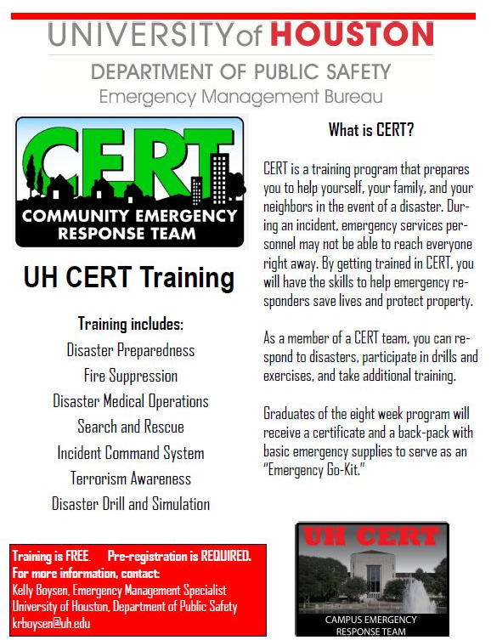

Attachment 19 – Department/Building After-Action Report Template

[Incident/ Exercise Name – After Action Report | [Pick the date]  [Year]
[Author of the AAR] Report Completed: [Date] |  | [Department /Building Name]

Contents
EXPLANATION OF TERMS 38
INTRODUCTION 39
AFTER ACTION REPORT OVERVIEW 39
CONCLUSION AND NEXT STEPS 41
IMPROVEMENT PLANNING MATRIX 41

EXPLANATION OF TERMS

Examples:
AAR After Action Report
CAD Computer Aided Dispatch
COH City of Houston
EOC Emergency Operations Center
HFD Houston Fire Department
IC Incident Command
ICP Incident Command Post
ICS Incident Command System
NIMS National Incident Management System
OEM Office of Emergency Management
PIO Public Information Officer
UH University of Houston
UHDPS University of Houston Department of Public Safety
UHEOC University of Houston Emergency Operations Center

INTRODUCTION
Include brief synopsis of incident here.

Sequence of events:
Include detailed sequence of events here, if available.

AFTER ACTION REPORT (AAR) OVERVIEW
This report is a compilation of information from the different departments and staff who participated in the response to [list incident/exercise here]. The information was gathered by [list departments here and various sources of information for the report]

The recommendations in this AAR should be viewed with considerable attention to the needs for a safe campus. In some cases, departments may determine that the benefits of implementation are insufficient to outweigh cost. In other cases, departments may identify alternative solutions that are more effective. However, each department should review the recommendations and determine the most appropriate action and time needed for implementation.

The issues addressed in this AAR are being requested to be reviewed and thoroughly examined for the appropriation of needed resources to ensure the functions of incident response; stabilization and notification are efficient and effective.
Incident Overview:
- University of Houston – [Insert incident/exercise location here]
Duration:
[Insert incident/exercise time]
Sponsor:
[Insert Sponsor here, if applicable]
Funding Source:
[Insert funding source here or if no funding, insert “No funding allocated”]
Focus:
Check appropriate area(s) below.
Prevention:
Response
Recovery
Other

Classification:
Check appropriate area(s) below.
Unclassified
For Official Use Only (FOUO)
By Invitation Only

Activity or Scenario:
Check appropriate area(s) below.
Fire
Severe Weather
Hazardous Material Release
Bomb Threat
Medical Emergency
Power Outage
Evacuation
Lockdown
Special Event
Other
Location:
[Insert incident/exercise location here]

Participating Organizations:
[Insert organizations here]

Strengths
List strengths here.

Areas of Improvement
List Areas of Improvement here.

Recommendations
List Recommendations here.

CONCLUSION AND NEXT STEPS
Insert Conclusion here.

IMPROVEMENT PLANNING MATRIX
Activity/Function | Improvement Action | Responsible Party | Status

