Organizational Chart Call Tree

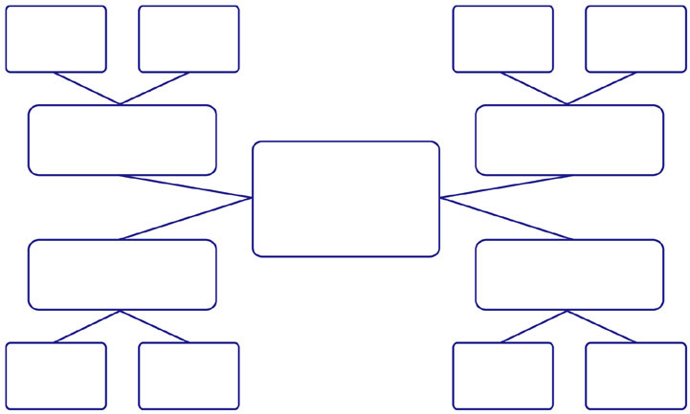

Name

Phone

Email

Name

Phone

Email

Name

Phone

Email

Name

Phone

Email

Name

Phone

Email

Name

Phone

Email

Name

Phone

Email

Name

Phone

Email

Name

Phone

Email

Name

Phone

Email

Name

Phone

Email

Name

Phone

Email

Name

Phone

Email