PROJECT TITLE
Project sub-title (if applicable)

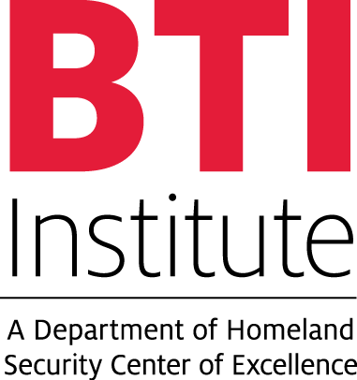

Submitted: <Date>
Performer: <Name and Affiliation>
Research Periods:
Theme Area:
Theme question:

<Use 11-point Arial font, or larger, throughout the document. Limit to 5 pages. >
<White Papers must not contain proprietary information. >

ABSTRACT
<Brief overview of your idea. Explain how your idea is consistent with the selection criteria.>

INTRODUCTION
Should address the following items:
<What are the specific Homeland Security (HS) challenges (problems/unknowns/gaps) being addressed?>
<How did you identify the challenges? What evidence is there that they exist? What is their magnitude?>
<How well do the specified challenges fit within the BTI INSTITUTE mission? Choose and refer to a category from the DHS Integrated Product Teams R&D Report. Alternatively, refer to other policy documents from DHS (e.g., the DHS 5-Year Strategic Plan 2015-2019, and the Quadrennial Homeland Security Review) or DHS components (e.g., the S&T Visionary Goals, the CBP Vision and Strategy 2020, or the U.S. Border Patrol Strategic Plan)>
<Does the research to meet those challenges have a strong potential for advancing the state-of-the-art and contributing significantly to the DHS mission? How will this work impact/benefit DHS and its component agencies? What are the expected new capabilities? What are the negative impacts if the challenges go unmet or the consequences if solutions are delayed?>
<Challenges that are more appropriately addressed by efforts that are not within the mission of BTI INSTITUTE cannot be considered for competition topic areas. We are interested in why these HS challenges currently are not being adequately addressed or sufficiently funded. What funding gaps exist (either private or public)? What existing efforts are addressing the problem? What level of support (money, collaboration, or related research) currently exists to address this problem? Why are current approaches believed to be inadequate or not sufficiently timely?>

METHODS
Should include, where applicable:
<State clearly and succinctly the types of research or professional/workforce development projects that could address the targeted HS challenges. State the main goal these projects should have.>
<List the specific objectives in support of the goal above. Are they original and innovative? Please specify why the desired objectives are necessary in the context of the stated HS Challenges>
<State clearly and succinctly the types of deliverables (outputs) that could be produced by the kind of projects discussed above (e.g., Journal Publications, Conference Publications, Gadgets, Software Products, Systems, Data Sets, Policy Documents, Webinars, and Annual Reports). Please specify why the desired outcomes are necessary in the context of the stated HS Challenges >
<Description of measures that could be used to evaluate project and progress performance – how could BTI INSTITUTE quantify success in addressing the HS Challenges discussed. Please also specify how BTI INSTITUTE could assess the potential impact of the deliverables (outputs) produced.>

ANTICIPATED OUTCOMES
<How will the results from the study benefit DHS?>
REFERENCES (Optional; but if you refer to a specific document, please include the complete citation.)

