HUMAN RESOURCES
HRMS PS 9.0
ePerformance Transfer Guide

Step 1: Navigate via the bread crumbs to “Transfer Document” as per the screenshot.
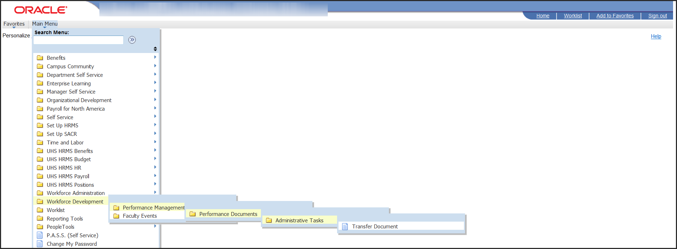

Step 2: Enter Employee name.
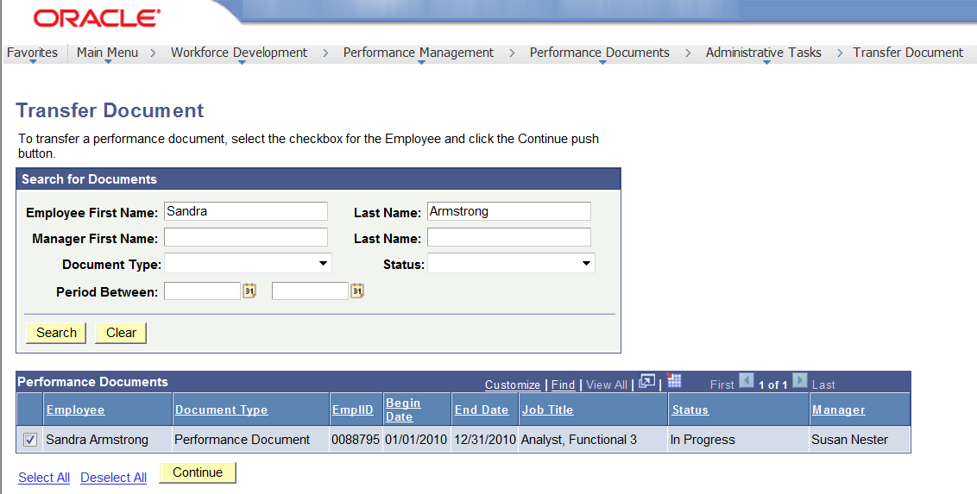
Or enter Manager’s name to select employee(s). Select the employee you wish to tranfer by clicking on the checkbox next to the employee’s name and click “Continue”
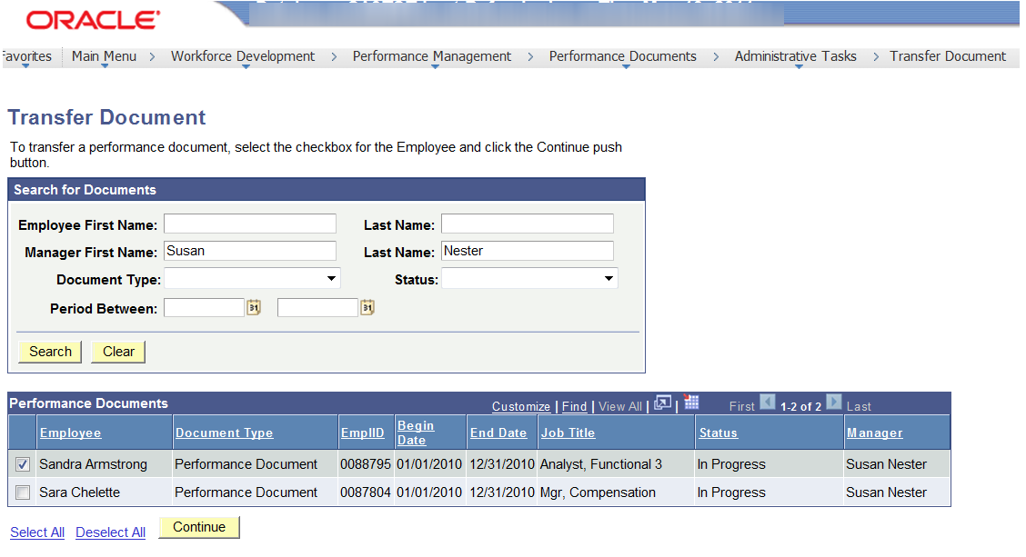

Step 3: Click the “Select a Manager” link to populate the search window.
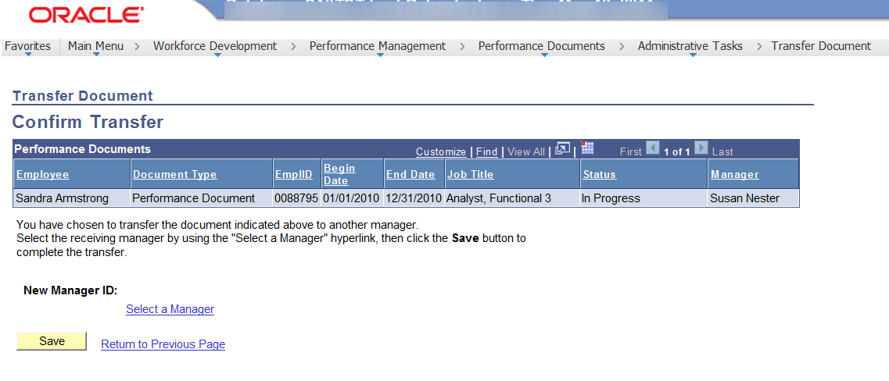
Step 4: Enter Manager’s name to populate results. Select the Manager by clicking on the button and then click “OK”.
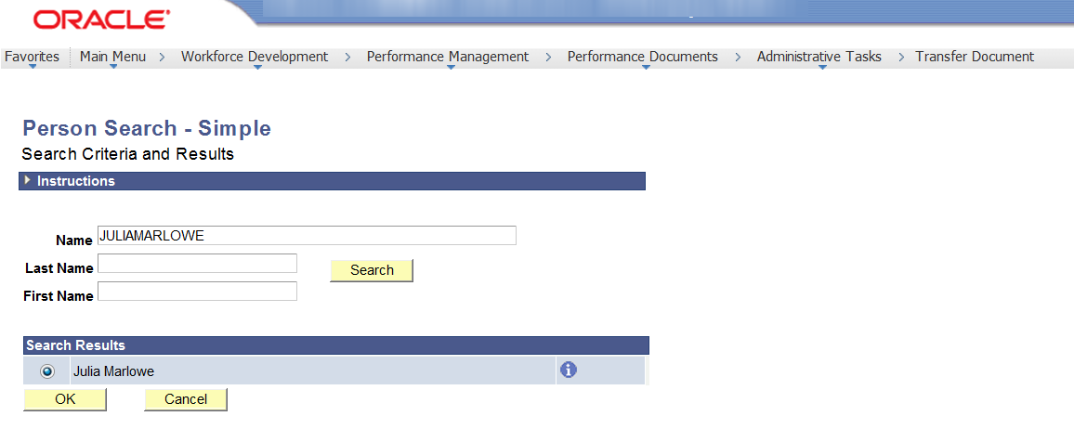
Step 5: Click the “Save” button, the Confirmation screen will appear, click “OK” you have now transferred the document.
