University of Houston System - PaymentWorks
Frequently Asked Questions for Initiators (UH System Staff)
Contents
System Basics 2
When will I need to use PaymentWorks? 2
What is the turnaround time from vendor registration to vendor setup? 2
If a current UH System vendor is not in PaymentWorks, can I still pay them? 2
Will our current vendors have to re-register in PW? 3
What if a vendor has multiple email addresses? 3
Access and Roles 3
What are the roles in PaymentWorks? 3
What credentials do I use to log in to PaymentWorks as an initiator? 3
How do I request access to be an initiator? 3
When I log in, what should I see? 4
Procedure 4
How do I navigate to invite a vendor? 4
Do I use the same procedure to invite a reimbursee? 4
Which agency number should I use for employee vendor setup? 4
Do I need to send the Vendor Supplemental Form to the vendor? 4
Do I need to collect the Vendor Supplemental Form from the vendor? 4
Will the department be notified when a vendor’s registration is returned for additional information? 5
Will the department be notified when a vendor’s registration is completed? 5
Once a vendor is registered through UH System with PaymentWorks, do they need to be re-invited for updates? 5
I am inviting an individual for reimbursement, but the only options are Product or Service, what do I choose? 5
What if a vendor does not want to use PaymentWorks? 5
Troubleshooting 6
How can I get help within PaymentWorks? 6
If I have technical issues in PaymentWorks, who do I contact? 6
I don’t have the option to resend the invitation. 6
A vendor contacted PaymentWorks support and never received an answer. 6
I did not receive an email when a new vendor I invited was setup, but they are marked complete. 7
I received an error when I tried to send a vendor invitation. 7
My vendor did not receive the invitation email. 7
Should I followup with a vendor that hasn’t completed their forms? 7
Can I cancel an invitation? 8

System Basics

When will I need to use PaymentWorks?
UH System Staff must use PaymentWorks to:
- Invite New Vendors to UH
- Allow a current vendor to add or change their Remittance Address
- Allow a current vendor to add or change their ACH

What is the turnaround time from vendor registration to vendor setup?
If we can do business with the vendor, setup generally takes 1-2 weeks from the vendor’s full and accurate registration in PaymentWorks through vendor setup in PeopleSoft, providing the vendor ID number.

This depends largely on the vendor’s participation and quick response to any returns. Once the vendor submits the registration, PaymentWorks reviews several pieces of information and then UH System Vendor ID reviews the documentation to determine if we can do business with the vendor. Either stage could result in a return of the file to the vendor for updated information. If we can do business with a vendor based on their provided information, the vendor is generally setup in 1-2 weeks.

If a current UH System vendor is not in PaymentWorks, can I still pay them?
Yes. As long as the vendor is setup in PeopleSoft with the correct remit to and payment information, then you can continue to pay the vendor. Once a change needs to be may to their vendor file, though, they will need to be invited in PaymentWorks to make those changes.

Will our current vendors have to re-register in PW?
No. It is not required unless they need to make a change to their information with UH System. However, we will eventually ask vendors that we actively use to setup through PaymentWorks for their protection and ours.

What if a vendor has multiple email addresses?
One vendor often will. If they are the same tax ID, then they will still be one vendor in our system and PW will keep straight which email address setup each ACH and remittance address.

Access and Roles

What are the roles in PaymentWorks?
- UHS Initiator
  - Invites Vendors
  - Monitors for Vendor ID Number
  - This is the base role provided by UH System. If you have access to PaymentWorks as a UH staff member, then you have the ability to invite vendors.
- Vendor
  - Completes their Information Online
- PaymentWorks (PW)
  - Collects and Validates Vendor Information
  - Vendor Info from PW Drives to PeopleSoft (PS), does not replace PS’s Vendor Database
  - Despite the name, it does not issue payments for the UH System.
- UHS Vendor ID
  - Reviews documentation and validation file and determines if we can do business based on the info provided.

What credentials do I use to log in to PaymentWorks as an initiator?
Your UH System credentials should be used to log in.

How do I request access to be an initiator?
Only staff of UH System campuses can request access to be initiators. This access must be granted by the Accounts Payable office of your campus, who will coordinate with IT to allow your single sign-on to be acceptable.

When I log in, what should I see?
This is the main PaymentWorks page after successful login:
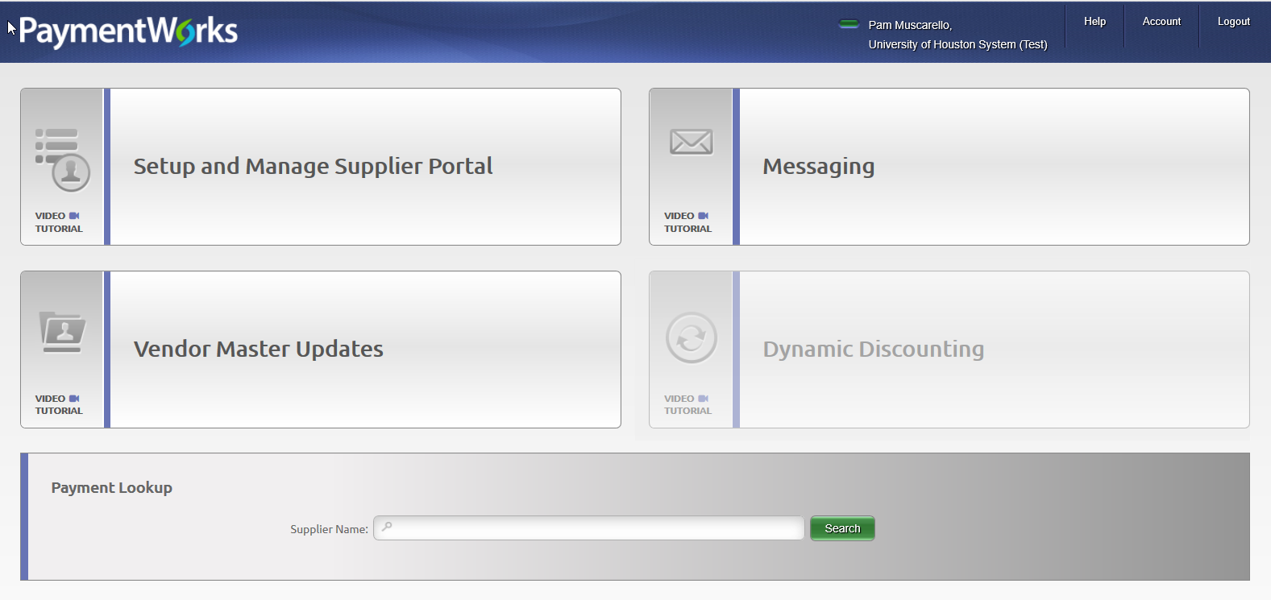

Procedure

How do I navigate to invite a vendor?
Vendor Master Updates – New Vendors, then click “Send Invitation.” See the Invite Vendors in 3 Easy Steps procedure.

Do I use the same procedure to invite a reimbursee?
Yes. However, for UHS employee reimbursees, please invite them and have them setup their PaymentWorks vendor account with a non-UHS email address.

Which agency number should I use for employee vendor setup?
Agency number is per the employee’s campus. 00783 (UHS), 00730 (UH), 00784 (UHD), 00759 (UHCL), or 00765 (UHV) should be selected. The agency number for employee vendor setup is required by the state system TINS.

Do I need to send the Vendor Supplemental Form to the vendor?
No. The link to the supplemental form is in the invitation to the vendor and within PaymentWorks itself.

Do I need to collect the Vendor Supplemental Form from the vendor?
No. The vendor will complete the form and upload it as part of their registration in PaymentWorks.

Will the department be notified when a vendor’s registration is returned for additional information?
No message is sent to the initiator when a vendor’s registration is returned for additional information, but the initiator can monitor the status online in PaymentWorks by navigating Vendor Master Updates – New Vendors, and reviewing the status under New Vendor Registration. If a vendor’s registration is recycled for additional information, it will be noted as “Returned” as in the picture below.
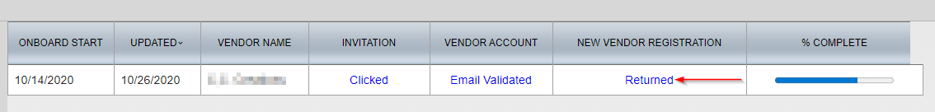

Will the department be notified when a vendor’s registration is completed?
Yes. The initiator will receive an email when a vendor setup is complete, and the email will include the vendor ID number. The initiator can monitor the status online in PaymentWorks by navigating Vendor Master Updates – New Vendors, and reviewing the status under New Vendor Registration.

Once a vendor is registered through UH System with PaymentWorks, do they need to be re-invited for updates?
No. Once a vendor is registered through PaymentWorks as a UH System vendor, the vendor need only log in and update their records (remit address, ACH, company name, etc.) to trigger a change with the UH System.

I am inviting an individual for reimbursement, but the only options are Product or Service, what do I choose?
Service is fine, but anything works. This field does not impact the situation around the relationship between this vendor/reimbursee and UH.

What if a vendor does not want to use PaymentWorks?
UH System will only take vendor registrations through PaymentWorks.

Troubleshooting

How can I get help within PaymentWorks?
Navigate in PaymentWorks to Help – For Initiators for topics. Also, there are video tutorials in certain locations.
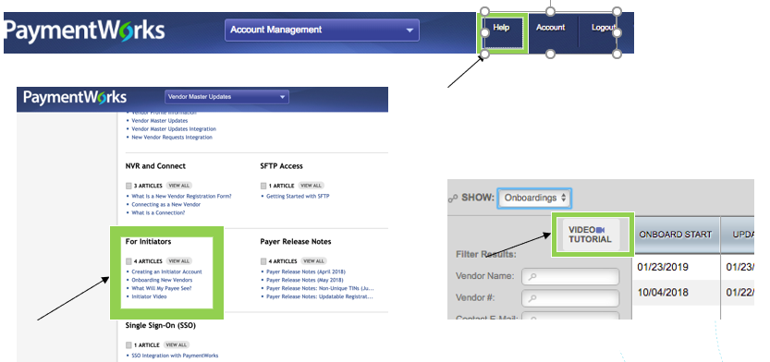

If I have technical issues in PaymentWorks, who do I contact?
UH System staff and vendors can contact PaymentWorks Support at support@paymentworks.com.

I don’t have the option to resend the invitation.
If your vendor has already used the invitation to setup an account, the invitation can no longer be resent.

A vendor contacted PaymentWorks support and never received an answer.
Give it a day or two, and if the vendor still receives no answer, forward the vendor’s message (provided it has no protected information) to PaymentWorks support directly and cc the vendor.

I did not receive an email when a new vendor I invited was setup, but they are marked complete.
Look in your spam, junk, or other quarantined messages. Make sure that you have enabled messages in PaymentWorks by navigating to Account – Personal Information.
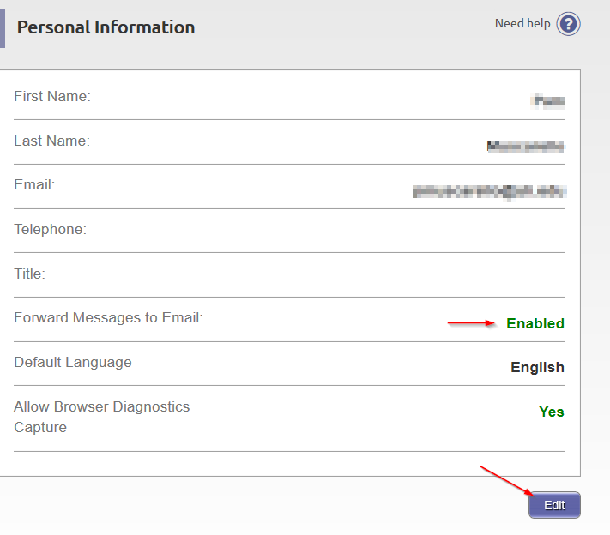

I received an error when I tried to send a vendor invitation.
If you receive the error “An invitation was previously sent to this email address,” then another colleague has already invited the vendor. The system does not allow a second invite to the same email address.

My vendor did not receive the invitation email.
Have the vendor look in their spam, junk, or other quarantined messages. Then verify that the email address is accurate. If it is, navigate in PaymentWorks to Vendor Master Updates – New Vendors, click on the button under the header Invitation, and then click Resend Invitation. Use the same process if you need to change the vendor’s email address.

Should I followup with a vendor that hasn’t completed their forms?
You can, but the PaymentWorks system will automatically send reminders:
- 1st reminder – three days
- 2nd reminder – seven days
- 3rd reminder – 14 days
- 4th reminder – 21 days
- 5th reminder – 28 days

Can I cancel an invitation?
No. PaymentWorks does not allow a cancelled invitation. However, you may cancel reminders by navigating in PaymentWorks to Vendor Master Updates – New Vendors, click on the button under the header Invitation, and then click Cancel Reminders.

