PeopleSoft
Curriculum Management Training
Schedule Class Meetings
Navigation: Main Menu > Curriculum Management > Schedule of Classes > Schedule Class Meetings

Goals: Changes to Meeting Patterns, and Instructors can be performed using this component. One may also use Maintain Schedule of Classes to make those changes. However, if you have COMBINED sections, this is the component that will allow you to make changes to Meeting Patterns and Instructors. FYI: Maintain Schedule of Classes will NOT allow you to make these changes for combined sections. You may NOT change the Enrollment Capacity for any sections here, the Enrollment Cntrl tab will only allow you to cancel sections.

When you first access Schedule Class Meetings, you will need to enter your identifying information. You may or may not enter the Class Nbr or Class Section. If you enter that information, the section will come up…if you do not enter the information, you will get a choice (see below) and you may select your section from those shown.

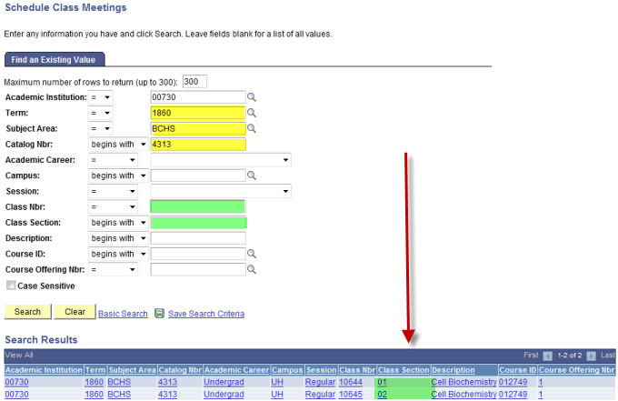
Not entering the Class Nbr or Class Section will give you all sections offered and you can choose

When you choose the section you will see only three tabs for this component:

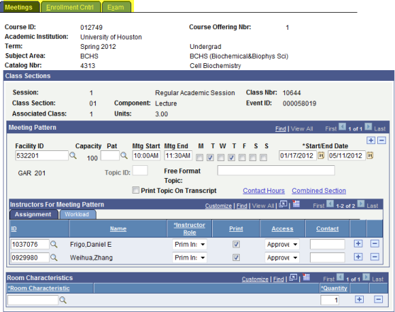

Note: UH does not use the Exam scheduling capabilities in PS, therefore we do not use that tab.

Tab 1 – Meetings Tab
You will see the section is a COMBINED SECTION. You may make changes to the following fields:
- Mtg Start
- Mtg End
- Days of the Week
- Instructor Information

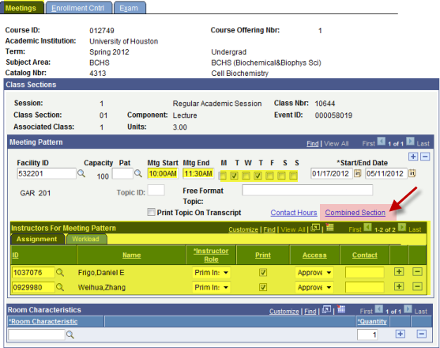

Note: When you make a change to any information in these fields for a combined section, it will automatically change the information for all the sections involved.

Tab 2 – Enrollment Cntrl Tab
You may not change Enrollment capacity here. The only thing the Enrollment Cntrl Tab will allow is to change the Class Status (from Active to Cancelled Section, Stop Further Enrollment, or Tentative). You will see the Enrollment Capacity field is “grayed” out, not allowing any changes.

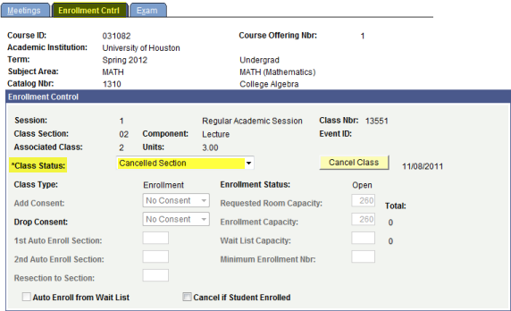

Note: If you cancel a section here, it will cancel ALL sections for the combined classes. If you only want to cancel ONE, then uncombined, and cancel the one section you wish to cancel.

Practice:
Access PeopleSoft, Sandbox SA9SBX
Find PeopleSoft URL information at http://www.uh.edu/infotech/php/template.php?nonsvc_id=536
Make sure you access SA9SBX, not another database. Login should be your regular PSID/password, unless you changed it just before the refresh. In that case it will be the one prior.

SA9SBX is normally refreshed every Friday morning and may be unavailable during the refresh process.

Access Schedule Class Meetings and perform the following tasks:

What is the complete navigation in PS to Schedule Class Meetings?

For BCHS 4313 (01) change the instructor to Amy Sater only.

For BCHS 4313 (02) change the meeting pattern to MW 2:30pm-4pm.

Add yourself as an instructor to BCHS 4313 (01) in addition to anyone else who may be listed.

A scheduler calls on the phone and is having an issue with a combined section. She needs to change the time from TTH 10am-11:30am to MW 1pm-2:30pm. She said she is trying to change it but the fields are grayed out. From her conversation, what component is she looking at?

How will you help her resolve the issue? List the steps below:

